Supplementary
Title: Hyperglycemia-associated immunometabolic rewiring worsens mitochondrial dysfunction and inflammatory imbalance during Burkholderia cepacia infection
Authors: Supriyo Mukherjee^{1*}, Aishwariya Madhavan^{1*}, Monalisa Biswas¹, Yajna S. Phaneendra Mallimoggala¹, Soujanya Ganapati Bhat¹, Priyajit Changdar², Sindhura Lakshmi Koulmane Laxminarayana³, Chiranjay Mukhopadhyay⁴, Somasish Ghosh Dastidar⁵, Ranita Ghosh Dastidar^{1#}
ORCID and Email ID:
Supriyo Mukherjee: 0000-0001-5854-7197, supriyo.kmcmpl2023@learner.manipal.edu; Aishwariya Madhavan: 0000-0002-2410-7027, aishwariya.kmcmpl2023@learner.manipal.edu; Monalisa Biswas: 0000-0002-1186-3907, monalisa.b@manipal.edu; Yajna S. Phaneendra Mallimoggala: 0000-0001-7009-4223, moggala.y@learner.manipal.edu; Soujanya Ganapati Bhat: 0009-0005-9500-2440, soujanya.kmcmpl2025@learner.manipal.edu; Priyajit Changdar: 0009-0005-7756-6197, priyajit.kmcmpl2022@learner.manipal.edu; Sindhura Lakshmi Koulmane Laxminarayana: 0000-0002-8925-0000, sindhura.lakshmi@manipal.edu; Chiranjay Mukhopadhyay: 0000-0003-0402-1143, chiranjay.m@manipal.edu; Somasish Ghosh Dastidar: 0000-0003-4123-1801, somasish.gd@manipal.edu; Ranita Ghosh Dastidar: 0000-0001-6773-1113, ranita.gd@manipal .edu
Affiliation:
¹Department of Biochemistry, Kasturba Medical College, Manipal Academy of Higher Education, Manipal 576104, Karnataka, India
²Department of Physiology, Kasturba Medical College, Manipal Academy of Higher Education, Manipal 576104, Karnataka, India
³Department of Pathology, Kasturba Medical College, Manipal Academy of Higher Education, Manipal 576104, Karnataka, India
⁴Department of Microbiology, Kasturba Medical College, Manipal Academy of Higher Education, Manipal 576104, Karnataka, India
⁵Department of Anatomy, Kasturba Medical College, Manipal Academy of Higher Education, Manipal 576104, Karnataka, India

*First Author: Supriyo Mukherjee and Aishwariya Madhavan contributed equally
#Corresponding Author: Ranita Ghosh Dastidar^{1#}, Email: ranita.gd@manipal.edu, ORCID: 0000-0001-6773-1113, Phone No. – (+91) 8088652524
Supplementary Figure S1. MTT assay confirms time- and dose-dependent metabolic viability loss during Burkholderia cepacia infection. K562 cellular metabolic activity was longitudinally assessed from 0 to 48 hours post-infection utilizing an MTT assay. Cells were cultured under normoglycemic (5.5 mM glucose) or hyperglycemic (15 mM glucose) conditions and evaluated either uninfected or following B. cepacia infection at an MOI of (A) 1:10 and (B) 1:25. These data directly corroborate the cytotoxicity profiles observed in the primary Trypan Blue exclusion assays. Data are presented as mean ± SD of independent biological replicates (n = 3). Statistical significance was assessed utilizing a two-way ANOVA followed by Tukey’s multiple comparisons test (*p < 0.05, ***p < 0.001, ****p < 0.0001).

Supplementary Figure S2. Sequential flow cytometry gating strategy for the evaluation of mitochondrial function and reactive oxygen species. Representative flow cytometric plots demonstrating the hierarchical gating strategy utilized across all experimental cohorts (representative image shown from the uninfected normoglycemic control group). Events were initially gated on FSC-A versus SSC-A to exclude cellular debris (Cells), followed by doublet exclusion utilizing FSC-A versus FSC-H (Singlets). Viable cells were subsequently identified by gating on the negative population for the LIVE/DEAD™ Fixable Near-IR viability dye (Viable Cells). This purified, viable singlet population was then utilized to quantify cytosolic and mitochondrial ROS (H2DCFDA and MitoSOX™ Red co-staining, respectively) and mitochondrial membrane potential (JC-1 dye). All downstream functional median fluorescence intensity (MFI) and population frequency data were derived exclusively from this final viable gate.

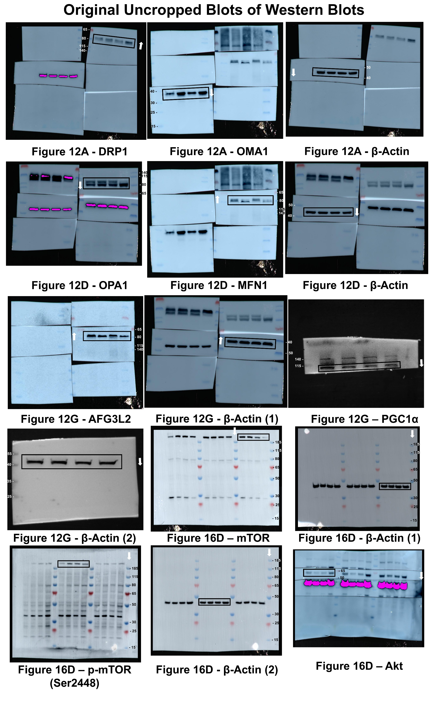
Supplementary Figure S3. Original, uncropped immunoblot images corresponding to the main text Figure 12 and Figure 16. Uncropped chemiluminescent images representing the mitochondrial dynamics, quality control, and biogenesis markers. Full-length membranes are shown for the fission mediators DRP1 and OMA1, the fusion-associated proteins OPA1 and MFN1, the matrix protease AFG3L2, the biogenesis coactivator PGC-1α, NLRP3, Caspase-3, total mTOR, phosphorylated mTOR (Ser2448), total Akt and their respective β-actin loading controls. K562 cells were cultured under normoglycemic (5.5 mM) or hyperglycemic (15 mM) conditions and evaluated either uninfected (-) or infected with B. cepacia at an MOI of 1:25 for 3 hours (+). Solid black boxes indicate the precisely cropped regions presented in the main manuscript figure. White arrows indicate the top-to-bottom direction of electrophoresis. Molecular weight ladder markers (kDa) are indicated adjacent to the respective blots.
Supplementary Table S1. Oligonucleotide primer sequences utilized for quantitative real-time PCR (qRT-PCR).
Gene Name | Forward primer (5’- 3’) | Reverse Primer (5’- 3’) | T_{m}
IL-1B | CCTGAGCACCTTCTTTCCCT | GCTCCATATCCTGTCCCTGG | 57 °C
IL-6 | TCGGTCCAGTTGCCTTCTCC | TGAGTGGCTGTCTGTGTGGG | 59.5 °C
TNF-α | GTTACCTGGGTTGCCAAGC | ACGGCCTTGCTCTTGTTTTC | 56.5 °C
IL-18 | GACCAAGTTCTCTTCATTGACCA | CTTCACAGAGATAGTTACAGCCA | 54.5 °C
NLRP3 | CGACTTCAATGGGGAGGAGA | TTCAATGCTGTCTTCCTGGC | 56 °C
NFkB1 | GGTGCGGCTCATGTTTACAG | CTCCAGTCACACATCCAGCT | 56.6 °C

