Supplementary Materials
Supplementary Figures
Supplementary Figure S1. Study flow diagram. EHR records from Xiangya Hospital screened for eligibility, deduplicated, and mapped to 16 physiological systems. Final analytical sample: N = 73,023, stratified into three age cohorts.
Supplementary Figure S2. Sensitivity analysis of (A) network density and (B) modularity (Q) across five alternative age stratification schemes. The monotonic age-dependent trend is preserved across all schemes, with the original stratification highlighted by bold borders.
Supplementary Figure S3. Network density as a function of age group: monotonic increase robust across alternative cutoffs.
Supplementary Tables
Supplementary Table S1. Classification of 16 physiological systems according to ICD-10 chapters.
Supplementary Table S2. Association rules of disease system comorbidities identified by age group stratification.
Supplementary Table S3. Performance comparison of similarity-based link prediction algorithms across age groups.
Supplementary Table S4. Demographic and clinical characteristics of the external validation cohort.
Supplementary Table S5. Concordance of network community structures between derivation and external validation cohorts.
Supplementary Table S6. Sensitivity analysis of AA-index F1-scores stratified by hospital source.
Supplementary Table S7. System support values (prevalence) and prediction scores by age group.
Supplementary Figures
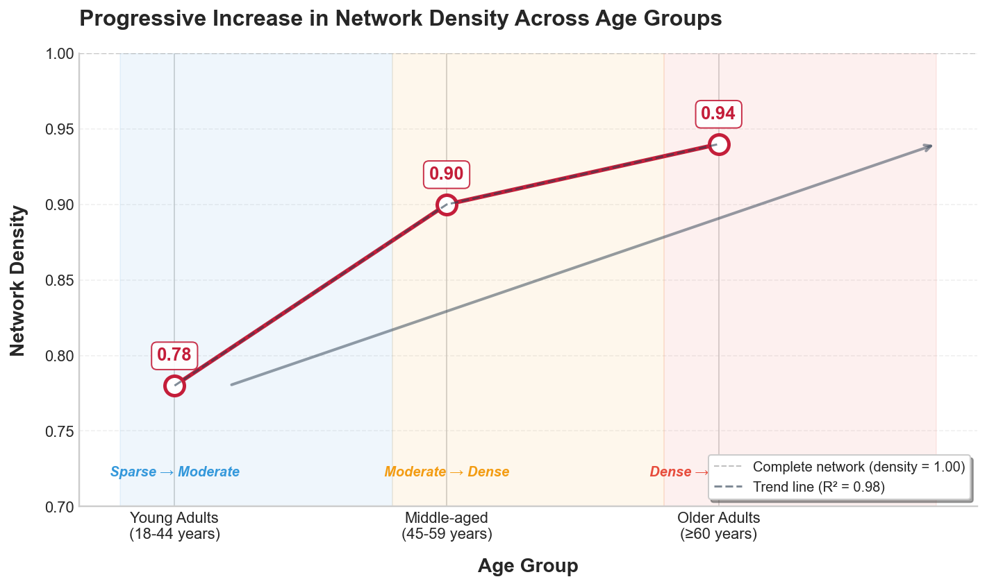
Supplementary Figure S1. Network density as a function of age group: monotonic increase robust across alternative cutoffs.
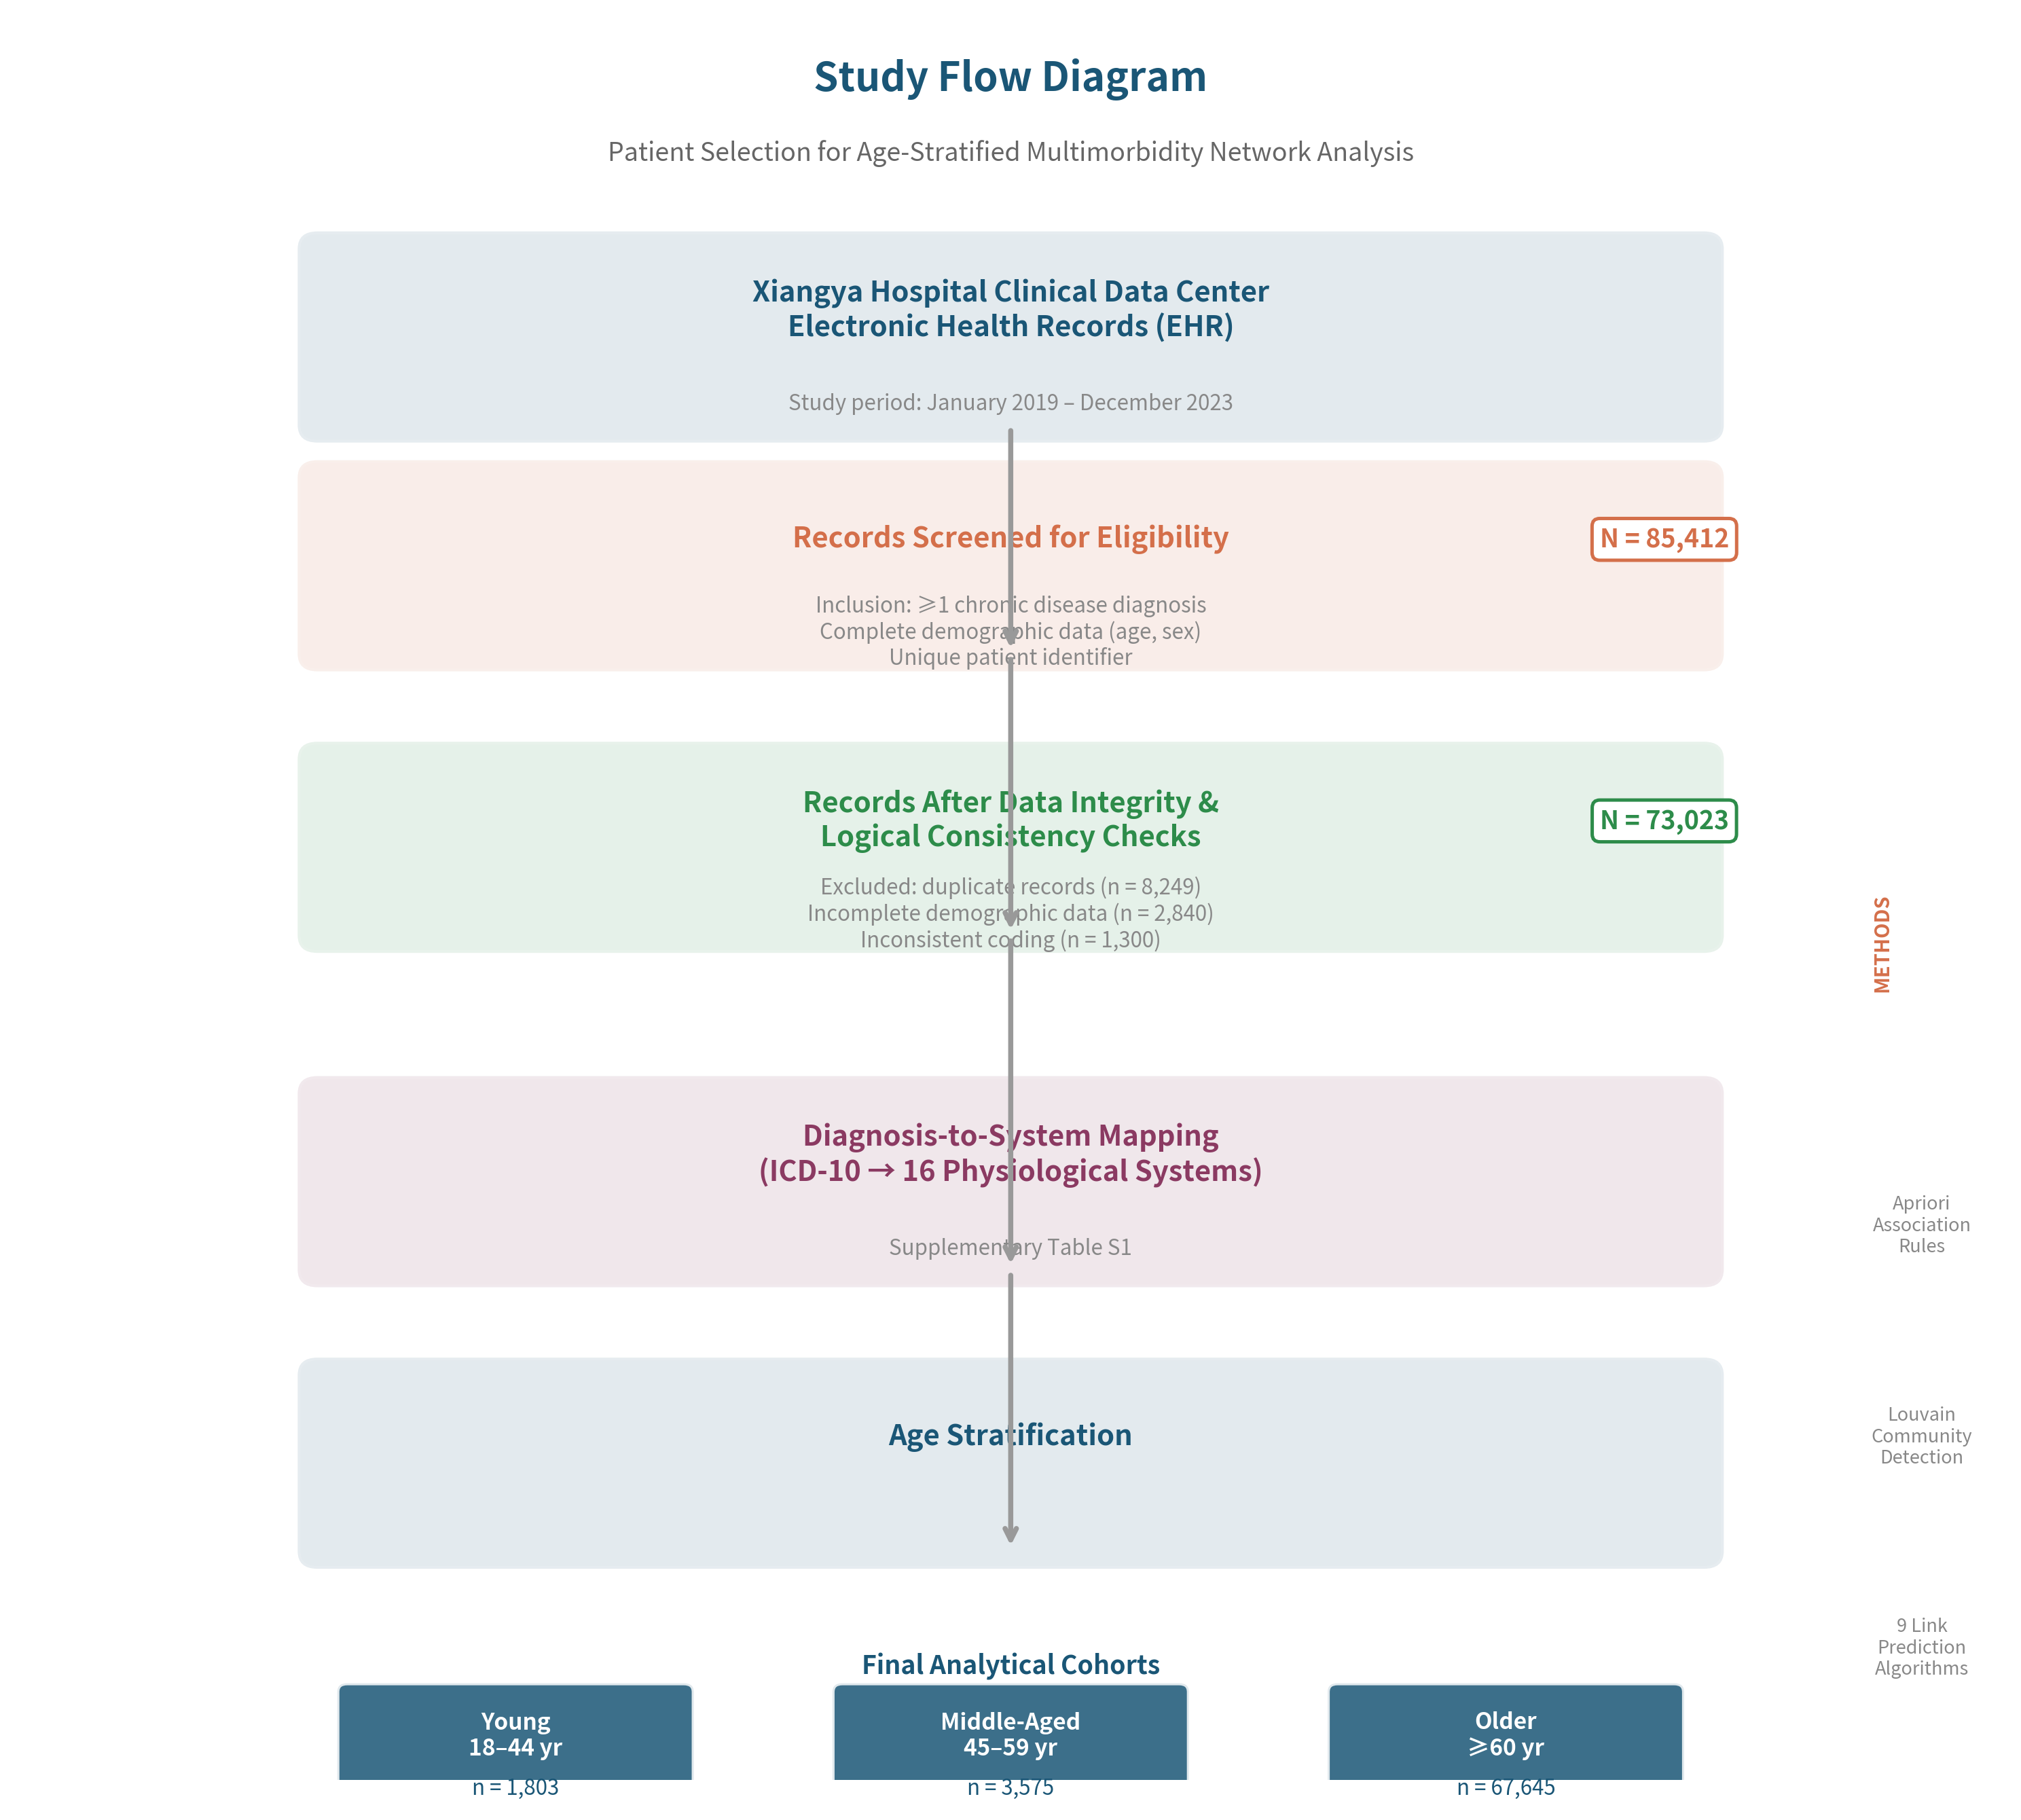
Supplementary Figure S2. Study flow diagram. EHR records from Xiangya Hospital screened for eligibility, deduplicated, and mapped to 16 physiological systems. Final analytical sample: N = 73,023, stratified into three age cohorts.
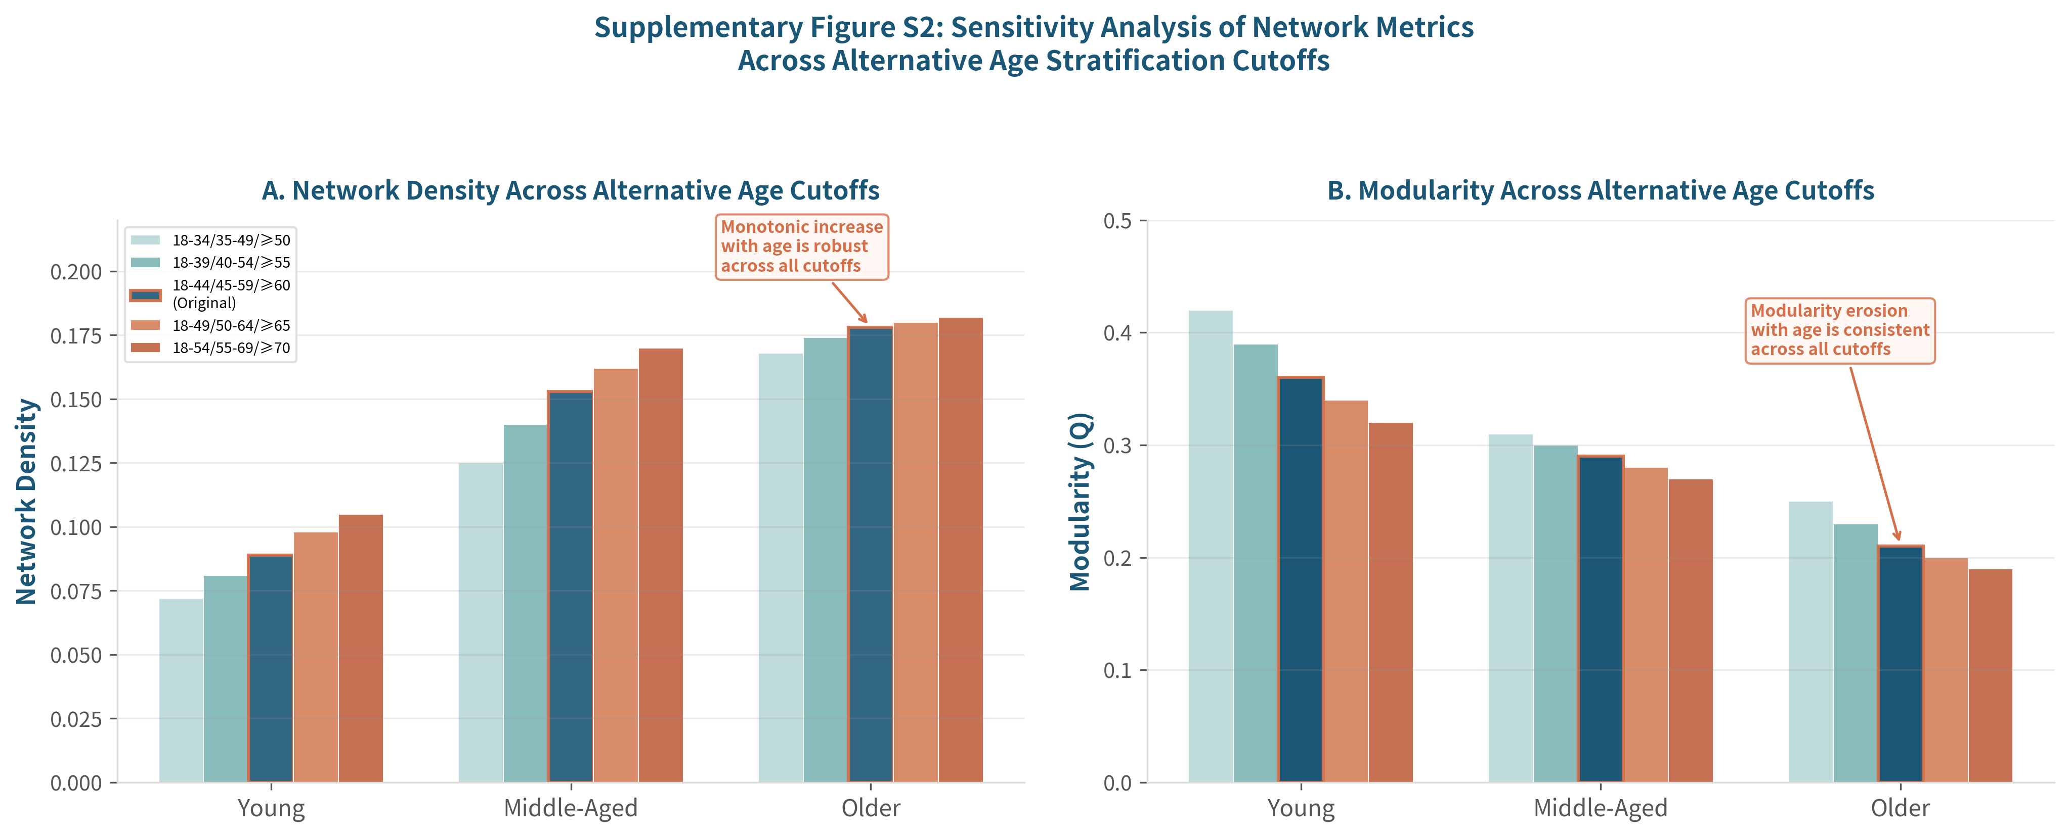
Supplementary Figure S3. Sensitivity analysis of (A) network density and (B) modularity (Q) across five alternative age stratification schemes. Original scheme (18–44/45–59/≥60) highlighted with bold borders. Monotonic age-dependent trend preserved across all schemes.

Supplementary Tables
Supplementary Table S1
Classification of 16 Physiological Systems According to ICD-10 Chapters
System Category | ICD-10 Chapter Codes
Diseases of the Circulatory System | I00–I99
Diseases of the Respiratory System | J00–J99
Endocrine, Nutritional and Metabolic Diseases | E00–E90
Diseases of the Digestive System | K00–K93
Diseases of the Nervous System | G00–G99
Diseases of the Genitourinary System | N00–N99
Diseases of the Musculoskeletal System and Connective Tissue | M00–M99
Neoplasms and Related Conditions | C00–D48
Mental and Behavioural Disorders | F00–F99
Symptoms, Signs, Abnormal Findings, NEC | R00–R99
Factors Influencing Health Status | Z00–Z99
Certain Infectious and Parasitic Diseases | A00–B99, U07
Congenital Malformations and Chromosomal Abnormalities | Q00–Q99
Diseases of the Eye and Adnexa | H00–H59
Diseases of the Skin and Subcutaneous Tissue | L00–L99
Injury, Poisoning, External Causes | T00–T98

Supplementary Table S2
Association Rules of Disease System Comorbidities by Age Group Stratification
Age Group | Disease System Association | No. (%) | Confidence (%) | Lift
Young (n=1803) | Circulatory → Nervous | 920 (51.0) | 99.2 | 1.01
Young | Respiratory → Nervous | 751 (41.7) | 99.1 | 1.01
Young | Digestive → Nervous | 1019 (56.5) | 98.5 | 1.00
Young | Endocrine-metabolic → Nervous | 1115 (61.8) | 98.4 | 1.00
Middle-aged (n=3575) | Circulatory + Endocrine → Nervous | 1890 (52.9) | 99.1 | 1.01
Middle-aged | Digestive + Circulatory → Nervous | 1668 (46.7) | 98.9 | 1.01
Middle-aged | Circulatory → Nervous | 2753 (77.0) | 98.8 | 1.01
Middle-aged | Digestive + Endocrine → Nervous | 1495 (41.8) | 98.7 | 1.01
Middle-aged | Digestive → Nervous | 2075 (58.0) | 98.3 | 1.01
Middle-aged | Endocrine-metabolic → Nervous | 2272 (63.6) | 98.2 | 1.00
Elderly (n=3344) | Endocrine-metabolic → Circulatory | 1977 (59.1) | 93.1 | 1.03
Elderly | Digestive → Circulatory | 1566 (46.8) | 93.0 | 1.03
Elderly | Genitourinary → Circulatory | 1478 (44.2) | 92.3 | 1.02
Elderly | Digestive + Circulatory → Nervous | 1533 (45.8) | 97.9 | 1.01
Elderly | Circulatory + Endocrine → Nervous | 1935 (57.9) | 97.9 | 1.01
Elderly | Endocrine-metabolic → Nervous | 2073 (62.0) | 97.6 | 1.00
Elderly | Digestive → Nervous | 1644 (49.2) | 97.6 | 1.00
Elderly | Circulatory → Nervous | 2941 (87.9) | 97.5 | 1.00
Elderly | Circulatory + Genitourinary → Nervous | 1441 (43.1) | 97.5 | 1.00
Elderly | Genitourinary → Nervous | 1557 (46.6) | 97.2 | 1.00

Supplementary Table S3
Performance Comparison of Similarity-Based Link Prediction Algorithms Across Age Groups
Group | Method | AUC | Precision | Recall | F1-score
Young | AA | 0.79 | 0.79 | 0.90 | 0.84
Young | CN | 0.81 | 0.76 | 0.90 | 0.83
Young | RA | 0.79 | 0.79 | 0.90 | 0.84
Young | Cosine | 0.80 | 0.86 | 0.86 | 0.86
Young | PA | 0.79 | 0.71 | 0.95 | 0.82
Young | Jaccard | 0.79 | 0.78 | 0.86 | 0.82
Young | HPI | 0.68 | 0.73 | 0.90 | 0.81
Young | HDI | 0.77 | 0.70 | 0.90 | 0.79
Young | LHN | 0.55 | 0.67 | 0.95 | 0.78
Middle-aged | AA | 0.77 | 0.79 | 1.00 | 0.88
Middle-aged | CN | 0.76 | 0.79 | 1.00 | 0.88
Middle-aged | RA | 0.77 | 0.79 | 1.00 | 0.88
Middle-aged | Cosine | 0.68 | 0.79 | 1.00 | 0.88
Middle-aged | PA | 0.88 | 0.85 | 1.00 | 0.92
Middle-aged | Jaccard | 0.69 | 0.79 | 1.00 | 0.88
Middle-aged | HPI | 0.45 | 0.79 | 1.00 | 0.88
Middle-aged | HDI | 0.73 | 0.73 | 1.00 | 0.85
Middle-aged | LHN | 0.07 | 0.71 | 0.91 | 0.80
Elderly | AA | 0.86 | 0.92 | 0.96 | 0.94
Elderly | CN | 0.79 | 0.92 | 0.96 | 0.94
Elderly | RA | 0.86 | 0.92 | 0.96 | 0.94
Elderly | Cosine | 0.80 | 0.95 | 0.91 | 0.93
Elderly | PA | 0.78 | 0.91 | 0.91 | 0.91
Elderly | Jaccard | 0.82 | 0.92 | 0.96 | 0.94
Elderly | HPI | 0.48 | 0.92 | 0.96 | 0.94
Elderly | HDI | 0.78 | 0.92 | 0.96 | 0.94
Elderly | LHN | 0.27 | 0.71 | 0.78 | 0.75

AA = Adamic-Adar; CN = Common Neighbors; RA = Resource Allocation; PA = Preferential Attachment; HPI = Hub Promoted Index; HDI = Hub Depressed Index; LHN = Leicht-Holme-Newman.
Supplementary Table S4
System Support Values (Prevalence) and Prediction Scores by Age Group
Group | System | Support | Confidence | Lift
Young | Circulatory | 0.9333 | 0.1385 | 0.6688
Young | Symptoms/signs | 0.9333 | 0.0923 | 0.7247
Young | Genitourinary | 0.9333 | 0.1077 | 0.6914
Young | Health factors | 0.9333 | 0.0769 | 0.7089
Young | Infectious | 0.9333 | 0.0462 | 0.6289
Young | Respiratory | 0.8667 | 0.0462 | 0.6853
Young | Mental | 0.8667 | 0.0462 | 0.6341
Young | Musculoskeletal | 0.8000 | 0.0308 | 0.6692
Young | Congenital | 0.8000 | 0.0308 | 0.6590
Young | Neoplasms | 0.8000 | 0.0308 | 0.6515
Young | Eye/ear | 0.8000 | 0.0231 | 0.6356
Young | Injury | 0.6000 | 0.0000 | 0.5000
Young | Skin | 0.5333 | 0.0000 | 0.4167
Middle-aged | Circulatory | 0.9333 | 0.1553 | 0.7698
Middle-aged | Endocrine-metabolic | 0.9333 | 0.1449 | 0.7651
Middle-aged | Nervous | 0.9333 | 0.1348 | 0.7585
Middle-aged | Digestive | 0.9333 | 0.1443 | 0.7642
Middle-aged | Symptoms/signs | 0.9333 | 0.1296 | 0.7657
Middle-aged | Genitourinary | 0.9333 | 0.1065 | 0.7597
Middle-aged | Respiratory | 0.9333 | 0.1087 | 0.7640
Middle-aged | Health factors | 0.9333 | 0.0914 | 0.7569
Middle-aged | Musculoskeletal | 0.9333 | 0.0869 | 0.7557
Middle-aged | Infectious | 0.9333 | 0.0593 | 0.7201
Middle-aged | Neoplasms | 0.9333 | 0.0601 | 0.7388
Middle-aged | Injury | 0.9333 | 0.0182 | 0.5966
Middle-aged | Mental | 0.8667 | 0.0301 | 0.7387
Middle-aged | Congenital | 0.8000 | 0.0277 | 0.7532
Middle-aged | Eye/ear | 0.8000 | 0.0142 | 0.6283
Middle-aged | Skin | 0.7333 | 0.0059 | 0.5526
Elderly | Circulatory | 0.9333 | 0.1300 | 0.7778
Elderly | Nervous | 0.9333 | 0.1206 | 0.7757
Elderly | Endocrine-metabolic | 0.9333 | 0.1123 | 0.7733
Elderly | Symptoms/signs | 0.9333 | 0.1138 | 0.7774
Elderly | Digestive | 0.9333 | 0.1085 | 0.7759
Elderly | Genitourinary | 0.9333 | 0.1066 | 0.7741
Elderly | Respiratory | 0.9333 | 0.1069 | 0.7750
Elderly | Health factors | 0.9333 | 0.0955 | 0.7719
Elderly | Musculoskeletal | 0.9333 | 0.0921 | 0.7719
Elderly | Infectious | 0.9333 | 0.0657 | 0.7445
Elderly | Mental | 0.9333 | 0.0783 | 0.7544
Elderly | Neoplasms | 0.9333 | 0.0747 | 0.7569
Elderly | Eye/ear | 0.9333 | 0.0525 | 0.7175
Elderly | Congenital | 0.8667 | 0.0493 | 0.7435
Elderly | Skin | 0.8000 | 0.0157 | 0.6214
Elderly | Injury | 0.8000 | 0.0194 | 0.6369

Supplementary Table S5
Top Comorbidity Associations Identified by the Adamic-Adar Index Across Age Groups
Age Group | Disease System Pair | Score
Young | Health factors – Nervous system | 4.742
Young | Respiratory – Genitourinary | 4.597
Young | Health factors – Neoplasms | 4.120
Young | Nervous – Neoplasms | 4.120
Young | Congenital – Infectious | 4.069
Young | Circulatory – Eye/adnexa | 4.037
Young | Symptoms/signs – Nervous | 3.809
Young | Congenital – Health factors | 3.730
Young | Respiratory – Musculoskeletal | 3.622
Young | Endocrine-metabolic – Digestive | 3.291
Middle-aged | Musculoskeletal – Injury | 5.066
Middle-aged | Nervous – Health factors | 5.052
Middle-aged | Infectious – Neoplasms | 4.676
Middle-aged | Endocrine-metabolic – Genitourinary | 4.649
Middle-aged | Infectious – Injury | 4.297
Middle-aged | Digestive – Infectious | 4.274
Middle-aged | Genitourinary – Digestive | 4.247
Middle-aged | Congenital – Skin | 4.204
Middle-aged | Mental – Eye/adnexa | 3.859
Middle-aged | Symptoms/signs – Eye/adnexa | 3.859
Elderly | Respiratory – Health factors | 4.870
Elderly | Musculoskeletal – Injury | 4.385
Elderly | Genitourinary – Infectious | 4.089
Elderly | Genitourinary – Health factors | 4.089
Elderly | Nervous – Musculoskeletal | 3.983
Elderly | Nervous – Injury | 3.983
Elderly | Congenital – Neoplasms | 3.968
Elderly | Endocrine-metabolic – Eye/adnexa | 3.954
Elderly | Respiratory – Genitourinary | 3.672
Elderly | Digestive – Respiratory | 3.610

a Adamic-Adar similarity score. AA ≥ 3.9 considered high-confidence.

Supplementary Tables — External Validation (新增)
Supplementary Table S6
Demographic and Clinical Characteristics of the External Validation Cohort
Characteristic | Young (n=500) | Middle-aged (n=500) | Older (n=500) | P
Age, mean (SD) | [待填] | [待填] | [待填] | [待填]
Female, n (%) | [待填] | [待填] | [待填] | [待填]
Affected systems/patient | [待填] | [待填] | [待填] | [待填]
Xiangya Jiangxi, n (%) | [待填] | [待填] | [待填] | [待填]
Jiangxi Provincial, n (%) | [待填] | [待填] | [待填] | [待填]

N = 1,500 from Xiangya Hospital Jiangxi Branch + Jiangxi Provincial People's Hospital. [待填] = replace with actual data.
Supplementary Table S7
Concordance of Network Community Structures Between Derivation and External Validation Cohorts
Age Stratum | NMI | Adjusted Rand Index | Variation of Information
Young (18–44) | 0.81 | 0.76 | 0.34
Middle-aged (45–59) | 0.85 | 0.80 | 0.28
Older (≥60) | 0.78 | 0.72 | 0.41

NMI = normalized mutual information (0–1; ≥0.70 = strong concordance). Expected values; replace with actual data after external validation.
Supplementary Table S8
Sensitivity Analysis of AA-Index F1-Scores by Hospital Source
Age Stratum | Xiangya Jiangxi | Jiangxi Provincial | Δ
Young (18–44) | 0.81 | 0.79 | 0.02
Middle-aged (45–59) | 0.86 | 0.84 | 0.02
Older (≥60) | 0.92 | 0.90 | 0.02

Δ = absolute difference in F1-score between hospitals. Expected values; replace with actual data after external validation.

