Table 1: Genome features of eight Salinispora species.
 | S. arenicola | S. pacifica | S.  tropica | S. vitiensis | S. oceanensis | S. mooreana | S. fenicalii | S. cortesiana
Genome Size | 56,32,046 | 54,64,752 | 51,83,331 | 50,96,974 | 54,45,908 | 51,94,754 | 52,31,932 | 51,83,058
Contigs | 1 | 29 | 1 | 10 | 15 | 37 | 48 | 204
GC% | 69.48 | 69.96 | 69.46 | 69.92 | 69.76 | 69.38 | 69.21 | 69.62
CDS | 4943 | 4926 | 4662 | 4738 | 4864 | 4883 | 4734 | 4815
CRISPR | 7 | 5 | 2 | 3 | 3 | 8 | 5 | 1
rRNA | 9 | 9 | 9 | 9 | 6 | 6 | 5 | 6
tRNA | 67 | 58 | 61 | 56 | 57 | 61 | 79 | 55
tmRNA | 1 | 1 | 1 | 1 | 1 | 1 | 1 | 1
Secondary Metabolism | 20 | 16 | 14 | 15 | 19 | 7 | 16 | 25
Aromatic AA & Derivatives | 0 | 47 | 44 | 39 | 41 | 41 | 41 | 0

Table 2: Computationally predicted bioactivities and target classes of the top prioritized secondary metabolites derived from orphan biosynthetic gene clusters (BGCs).

Canonical SMILE | 2D Structure | PASS  dominant  activity | CLC-Pred  Cytotoxicity | ProTox  class | Target  Prediction | PubChem  Similar  CID | BGC Class
O.O=C(O)C1CCCN1 | 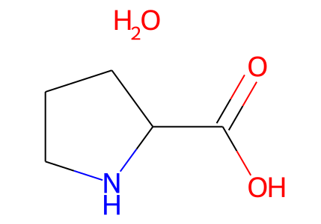 | Enzyme Inhibitor (Pa 0.94)  Protease/peptidase inhibitor (Pa 0.92)  Membrane-active (0.90) | A2780cisR (Pa 0.78) | Class IV | LSD1/CoREST complex | 2794891  T_{c}= 1 | NRP-Polyketide
CC(=O)O | 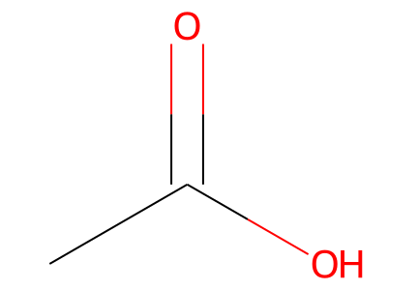 | No result | No result | Class I | Nuclear factor NF-kappa-B p105 subunit | 176  T_{c}= 1 | NRP-Polyketide
CCCCCCCCCC=O | 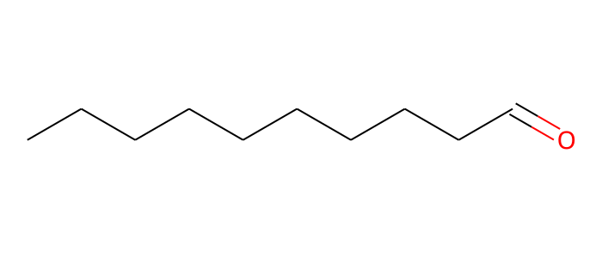 | Enzyme Inhibitor (Pa 0.98),  Protease/peptidase inhibitor (Pa 0.94) | A2780cisR (Pa 0.92) | Class V | Cyclooxygenase-2 | 8175  T_{c}= 1 | NRP
NCC1OC(O)C(N)C(O)C1O | 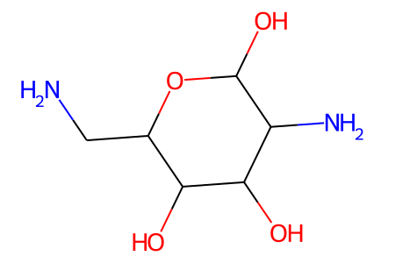 | Enzyme Inhibitor (Pa 0.97)  Immunomodulatory (Pa 0.91)  Antiprotozoal (Pa 0.73) | A2780cisR (pa 0.62) | Class VI | Adenosine A1 receptor | 447575  T_{c}= 1 | Saccharide
NC(C(=O)O)c1ccc(O)cc1 | 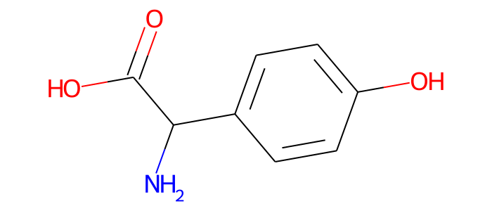 | Enzyme Inhibitor (Pa 0.90)  Immunomodulatory (Pa 0.89) | A2780cisR (Pa 0.89) | Class IV | DNA-(apurinic or apyrimidinic site) lyase | 36143  T_{c}= 1 | NRP-Polyketide
CC(=Cc1ccc(O)c(O)c1)C(=O)O | 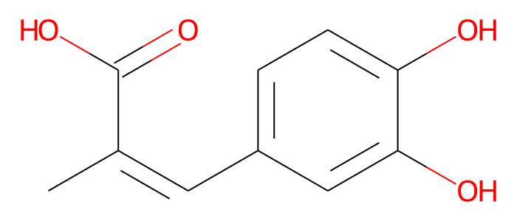 | Enzyme Inhibitor (Pa 0.94)  Membrane-active (0.93)  Protease/peptidase inhibitor (Pa 0.77) | A2780cisR (Pa 0.95) | Class V | DNA-(apurinic or apyrimidinic site) lyase | 53756084  T_{c}= 1 | Saccharide
COc1ccc(C(N)C(=O)O)cc1.O | 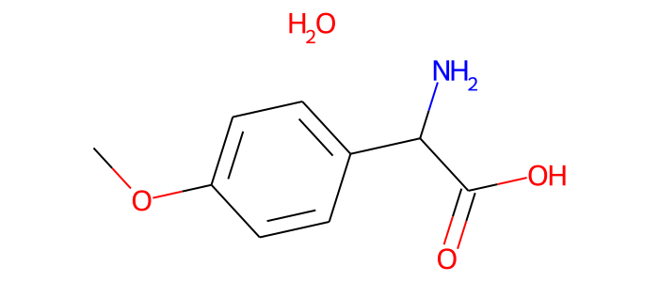 | Enzyme Inhibitor (Pa 0.87)  Immunomodulatory (Pa 0.84)  Protease/peptidase inhibitor (Pa 0.84) | A2780cisR (Pa 0.81) | Class III | Nuclear factor NF-kappa-B p105 subunit | 265442  T_{c}= 0.96 | NRP-Polyketide
COC(=O)C(N)c1ccc(O)cc1.O | 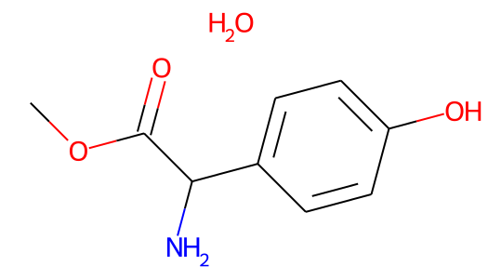 | Membrane-active (Pa 0.86)  Immunomodulatory (Pa 0.85)  Protease/peptidase inhibitor (Pa 0.82) | A2780cisR (Pa 0.80) | Class IV | Nuclear factor NF-kappa-B p105 subunit | 4123006  T_{c}= 0.96 | NRP-Polyketide
CO.NC(C(=O)O)c1ccc(O)cc1 | 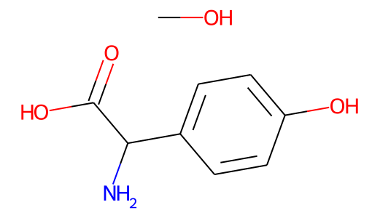 | No result | No result | Class IV | Nuclear factor NF-kappa-B p105 subunit | 144702344  T_{c}= 0.91 | NRP-Polyketide
NC1C(OC2C(CO)OC(O)C(O)C2O)OC2C(O)C(O)C(OC3OC(CO)C(O)C(O)C3O)OC2C1O | 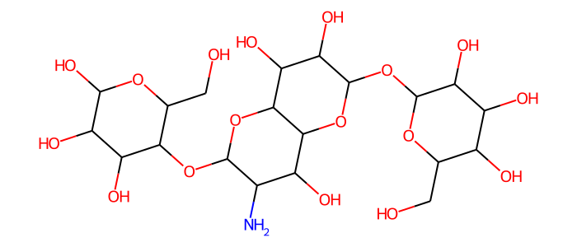 | Enzyme Inhibitor (Pa 0.96)  Immunostimulant (Pa 0.93)  Cytotoxic/anticancer (Pa 0.86)  Antiprotozoal (Pa 0.76) | HL-60 (Pa 0.92) | Class VI | Nuclear factor NF-kappa-B p105 subunit | 168376363  T_{c}= 0.80 | Saccharide
CC(C)C(NC(=O)C(N)CCCCN)C(=O)NC(CCCN)CC(=O)NCC(=O)NC(CC(N)=O)C(=O)O | 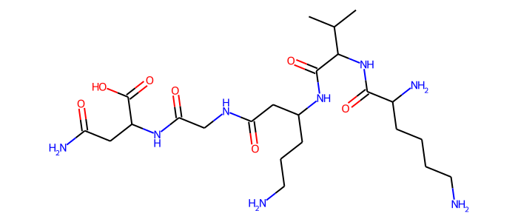 | Immunomodulatory (Pa 0.97)  Enzyme Inhibitor (Pa 0.94)  Protease/peptidase inhibitor (Pa 0.92) | RPMI-8226 (Pa 0.49) | Class IV | Dipeptidyl peptidase VIII | 18309984  T_{c}= 0.80 | NRP-Polyketide

