Mengqi Yuan^{1，*}, Fenglei Huo^{1，*,} Huiping Ren¹, Qiushuang Guo¹, Jing Lan^{1，#}
*Mengqi Yuan and Fenglei Huo are co-first authors.
¹Department of Prosthodontics, School and Hospital of Stomatology, Cheeloo College of Medicine, Shandong University & Shandong Key Laboratory of Oral Tissue Regeneration & Shandong Engineering Laboratory for Dental Materials and Oral Tissue Regeneration
Address: No.44-1 Wenhua Road West, 250012, Jinan, Shandong, China
Fax: +86 53188382923; E-mail: lanjing@sdu.edu.cn

Figure1c
Sdccag3 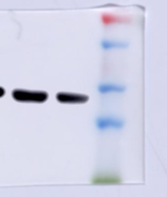
PPAR-γ 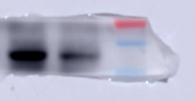
Runx2 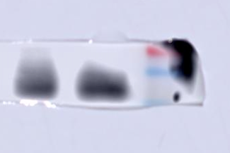
GAPDH 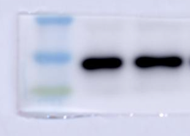
Figure2
Sdccag3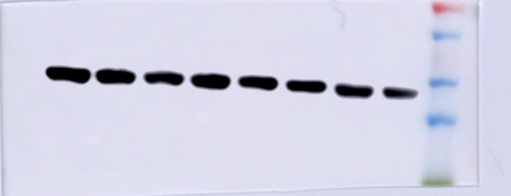
Runx2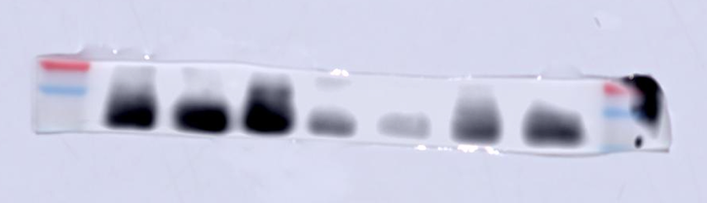
GAPDH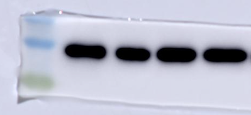
PPAR-γ