Supplementary materials
Entropy-driven electronic regulation of Co-centered active sites in high-entropy oxides for selective peroxymonosulfate activation
Wenzhe Yu ^{a ,b}, Haochen Ma ^{a ,b}, Wen Lu ^{a ,b}, Rui Liu ^{a ,b}, Bisheng Li ^{a ,b},.Leihong Zhao ^{b, c}, Sebastiao Famba ª, Hongjun Lin ^{a ,b} *
ª China-Mozambique Belt and Road Joint Laboratory on Smart Agriculture, Zhejiang Normal University, Jinhua 321004, China
^{b} Zhejiang Key Laboratory of Digital Intelligence Monitoring and Restoration of Watershed Environment, College of Geography and Environmental Sciences, Zhejiang Normal University, Jinhua, 321004, China
^{c} College of Jewelry, Shanghai Jian Qiao University, 201306, Shanghai, China
E-mail address: yuwenzhe@zjnu.edu.cn (Wenzhe Yu); mhc2717924389@zjnu.edu.cn (Haochen Ma); wonderfulwenlu@163.com (Wen Lu); ruiliu3@zjnu.edu.cn (Rui Liu); lbsheng@zjnu.edu.cn (Bisheng Li); Zhaolh@gench.edu.cn (Leihong Zhao); sebastiaofamba@gmail.com (Sebastiao Famba); hjlin@zjnu.cn (Hongjun Lin)
*Corresponding author. Tel: +86-15958459856. Email address: hjlin@zjnu.cn；ORCID: 0000-0002-0877-8189
Text S1. Chemicals and Reagents
Manganese(II) nitrate tetrahydrate (Mn(NO₃)₂·4H₂O), copper(II) nitrate trihydrate (Cu(NO₃)₂·3H₂O), Cobalt(II) nitrate hexahydrate (Co(NO₃)₂·6H₂O), D₂O, 1,4-benzoquinone (p-BQ), L-histidine (L-His), 5,5-dimethyl-1-pyrroline N-oxide (DMPO), 2,2,6,6-tetramethylpiperidinyl-1-oxide (TEMPO) were obtained from Aladdin Biochemical Technology Co.,Ltd. The typical pollutants employed in this study, including tetracycline (TC), sulfamethoxazole (SMX), levofloxacin (LEV), carbamazepine (CBZ), Ciprofloxacin (CIP), 4-Aminopyridine (4-AP), nitrobenzene (NB), benzoic acid (BA), nitrotetrazolium blue chloride (NBT), 9,10-diphenylanthracene (DPA) were also obtained from Aladdin Biochemical Technology Co.,Ltd. nickel(II) nitrate hexahydrate (Ni(NO₃)₂·6H₂O), iron(III) nitrate nonahydrate (Fe(NO₃)₃·9H₂O), potassium hydroxide(≥85.0%), dimethyl sulfoxide (DMSO), phenylmethyl sulfoxide (PMSO), furfuryl alcohol (FFA), NaCl, Na₂SO₄, Na₂CO₃, NaHCO₃, Na₂HPO₄ were purchased from Meryer Chemical Technology Co., Ltd. methanol (MeOH), ethanol (EtOH), tert-butanol (TBA) were supplied by Sinopharm Chemical Reagent Co., Ltd. KIT-6 cubic structure mesoporous molecular sieve were supplied by Jiangsu Xfnano Materials Tech Co., Ltd‌. All chemical reagent were used without further purification.

Text S2. Synthesis methods
Synthesis of meso-HEOs. In a typical synthesis, 1.0 mmol of Co(NO₃)₂, 0.5 mmol of Mn(NO₃)₂, 0.5 mmol of Fe(NO₃)₃, 0.5 mmol of Ni(NO₃)₂, and 0.5 mmol of Cu(NO₃)₂ were firstly dissolved in 3.0 mL of ethanol to make a stock solution. Then, the above solution was ultrasonically mixed with 0.50 g of KIT-6, followed by the evaporation of ethanol at room temperature under the gentle stirring. After that, the mixture was directly annealed at 550 ℃ for 4 h to form high-entropy metal oxides within mesoporous channels. Then, KIT-6 template was selectively removed by hot KOH and further cleaned with water/ethanol for three times. Finally, the product was collected after being dried at 60 ℃.
The meso-Co₃O₄, Fe₂O₃, CuO, MnO₂, NiO were synthesized by the same method, but the types of metal precursors were different. 3.0 mmol of Co(NO₃)₂, Fe(NO₃)₃, Cu(NO₃)₂, Mn(NO₃)₂, Ni(NO₃)₂ was dissolved in 3.0 mL of ethanol respectively, and the subsequent steps were the same as those of meso-HEOs.

Text S3. SMX rate and kinetic calculations
All SMX gradation experiments were conducted in triplicate to reduce experimental error. The SMX degradation efficiency was calculated by using Eq. (1) is as follows:
Where C₀ (initial time) and C_{t} (reaction time) represent the SMX concentration, respectively.
The SMX degradation kinetics was established according to the pseudo-first-order reaction kinetics. The normalization of k resulted in k’. The reaction kinetic Eq. (2) is as follows:
Where k (min⁻¹) and t (min) represent the pseudo-first-order reaction rate constant and reaction time; [SMX] denotes the SMX concentration at time t; [SMX]₀ or C_{SMX} represents the SMX initial concentration; C_{PMS} represents the initial PMS concentration; C_{Catalysts} represents the initial catalyst concentration.
All experimental conditions were as follows: [SMX]₀ = 5 mg L⁻¹, [catalysts]₀ = 0.1 g L⁻¹, [PMS]₀ = 0.33 mM, T = 25 °C, initial pH = 5.7.

Text S4. Theoretical calculations
All the calculations are performed in the framework of the density functional theory with the projector augmented plane-wave method, as implemented in the Vienna ab initio simulation package. The generalzied gradient approximation proposed by Perdew, Burke, and Ernzerhof is selected for the exchange-correlation potential 1. The long range van der Waals interaction is described by the DFT-D3 approach 2. The cut-off energy for plane wave is set to 500 eV. The energy criterion is set to 10−5 eV in iterative solution of the Kohn-Sham equation. A vacuum layer of 10-15 Å is added perpendicular to the sheet to avoid artificial interaction between periodic images. The Brillouin zone integration is performed using a 1x1x1 k-mesh. The DFT+U approach with the Dudayev scheme was employed for Co, Ni, Fe, Mn, using an effective Hubbard parameter U_{eff} =3.3 eV, 5.3 eV, 4.3 eV, 4.0 eV applied to the Co, Ni, Fe, Mn 3d states. All the structures are relaxed until the residual forces on the atoms have declined to less than 0.03 eV/Å.

Text S5. Electrochemical measurement.
The electrochemical properties were comprehensively characterized using a CHI660E electrochemical workstation with a conventional three-electrode system. The working electrode was prepared by uniformly depositing the as-synthesized meso-Co₃O₄ and meso-HEOs composite powders onto a conductive substrate, while a platinum mesh and Ag/AgCl electrode (saturated with KCl) were employed as the counter and reference electrodes, respectively. All electrochemical measurements were carried out in a 0.1 M Na₂SO₄ electrolyte solution at room temperature (25 ± 1°C). To ensure system stability, the open-circuit potential (OCP) was monitored until the potential drift was maintained below ±2 mV/min, typically requiring 15-20 minutes of stabilization. The electrocatalytic performance was then systematically evaluated through a series of electrochemical techniques: (i) linear sweep voltammetry (LSV) was performed at a scan rate of 5 mV/s within the potential window of 0 to 1.0 V vs. RHE, and (ii) electrochemical impedance spectroscopy (EIS) measurements were conducted in the frequency range from 100 kHz to 10 mHz with an AC amplitude of 10 mV at open-circuit potential 3.
Text S6. Competitive kinetics quantify the contribution of each reactive species.
The NB and BA were used as probes to determine the steady-state concentrations of SO₄^{•−}and •OH in the meso-HEOs/PMS system, and the NB, BA, and FFA degradation in the meso-HEOs/PMS system expressed as follows:
Integrating Eqs. S2-S4 can yield:
Then, [•OH]_{ss} , [SO₄•–]_{ss} and [¹O₂]_{ss} could be obtained:
After the steady-state concentrations of •OH, SO₄^{•−}, and ¹O₂ were determined, the contribution of ¹O₂ to SMX degradation was calculated using the following formula:
The concentrations of NB and BA at a given reaction time are denoted as [NB] and [BA], respectively. [NB]₀ and [BA]₀ represent the initial concentrations of NB and BA, respectively. The second-order rate constant of NB with •OH is represented as k_{NB, •OH} (3.9×10⁹ M⁻¹ s⁻¹), while the second-order rate constants of BA with •OH and SO₄^{•−} are denoted as k_{BA, •OH} (5.9×10⁹ M⁻¹ s⁻¹) and k_{BA,} _{SO4}^{•−} (1.2×10⁹ M⁻¹ s⁻¹), respectively. And the second-order rate constants of FFA with •OH and SO₄^{•−} and ¹O₂ are denotes as k_{FFA, •OH} (1.5×10¹⁰ M⁻¹ s⁻¹) and k_{FFA, SO4}^{•−} (1.3×10¹⁰ M⁻¹ s⁻¹), k_{FFA,} _{1O2} (1.2×10⁸ M⁻¹ s⁻¹), respectively 4, 5. The pseudo-first-order rate constants, k_{NB} and k_{BA}, can be determined from the plots of -ln([NB]/[NB]₀), -ln([BA]/[BA]₀), and -ln([FFA]/[FFA]₀) versus time, respectively 6. Where k_{SMX,1O2} k_{SMX},_{•OH}, k_{SMX, SO4}^{•−} represents the second-order reaction rate constants for SMX and ¹O₂ (1.3×10⁸ M⁻¹ s⁻¹), •OH (4.6×10⁹ M⁻¹ s⁻¹); SO₄^{•−} (2.2×10⁹ M⁻¹ s⁻¹). k_{obs, SMX} is the pseudo-first-order rate constant for TCH. R_{•OH}, R_{SO4}^{•−} and R_{1O2} denote the relative contributions of •OH, SO₄^{•−} and ¹O₂ to SMX degradation 7, 8, 9.
Text S7. Toxicity analysis of SMX and its degradation intermediate products
In this study, two in silico tools were used to predict the acute and chronic toxicity of SMX and its intermediates: the Ecological Structure–Activity Relationships (ECOSAR) program and the Toxicity Estimation Software Tool (T.E.S.T.). The ECOSAR program, recognized for its robust ecotoxicity evaluation capabilities, was employed to assess the toxicity of TCH and its degradation products. As part of the ECOSAR assessment, toxicity toward various aquatic organisms (fish, Daphnia, and green algae) was quantified by determining the 50% lethal concentration (LC₅₀) and 50% effective concentration (EC₅₀). The results were systematically categorized into four hazard levels according to the Globally Harmonized System of Classification and Labelling of Chemicals, thereby aligning with international standards.
Additionally, the T.E.S.T. system was applied to evaluate the toxicity of TCH prodrugs and their degradation intermediates, with a particular focus on endpoints such as bioaccumulation, developmental toxicity, and mutagenicity. This tool utilized quantitative structure–activity relationship (QSAR) modeling to predict toxicity by correlating chemical structures with toxicological effects.

Text S8. Toxicity assessment in mung bean seed cultivation experiment
Mung bean sprout cultivation experiment：A certain amount of mung beans with similar size and weight was first sterilized with 3% H₂O₂ for 30 min, followed by thorough rinsing with ultrapure water to remove residual H₂O₂. Filter papers were placed at the bottom of Petri dishes, and the mung beans were evenly divided into four groups according to their number, size, and weight. The four groups were treated with the SMX solution, meso-Co₃O₄ degraded solution, meso-HEOs degraded solution and ultrapure water, respectively, with the same volume of liquid added to each Petri dish. After recording the initial state of the mung beans, the Petri dishes were transferred to a constant-temperature incubator and cultivated at 25 °C with 50% relative humidity. During cultivation, the growth status of the mung beans was recorded every 24 h, and a small amount of the corresponding solution was added to maintain moisture. After 144 h of cultivation, the growth status of mung bean sprouts was recorded. Subsequently, ten sprouts were randomly selected from each group, and their root length and stem length were measured to evaluate the effects of different treatments on mung bean germination and growth.

Text S8. Assessment of toxicity by E. colic culture experiments
E. coli culture experiment: First, weigh 1.05 grams of Luria-Bertani (LB) culture medium powder, dissolve it in 50 mL pure water, and then transfer it to a conical flask. Sterilize the culture medium at 120°C under high pressure for 15 minutes. After sterilization, cool the culture medium to an appropriate temperature. Under sterile conditions, inoculate E. coli into the LB liquid culture medium and incubate it in a constant temperature shaker for 24 hours to obtain the bacterial suspension for the subsequent experiments. Then, prepare four conical flasks, each containing 50 mL of LB liquid culture medium, and add 50 mL of each of the four water bodies to the LB liquid culture medium, respectively, for bacterial culture in different experimental groups. After activation, inoculate the E. coli into this culture medium and incubate it under the same conditions for 12 hours. After cultivation, add 100 μL the culture liquid to 900 μL PBS, repeat the above steps until obtaining a 10⁻⁶ dilution. Then, take 30 μL each of the 10⁻³, 10⁻⁴, 10⁻⁵ and 10⁻⁶ dilutions, and uniformly spread them on the surface of the agar plate. Other treatment groups and the control group were operated in the same way. After coating, invert the agar plate and incubate it in the constant temperature incubator for 24 hours. After incubation, observe and record the growth of E. coli colonies on each plate.

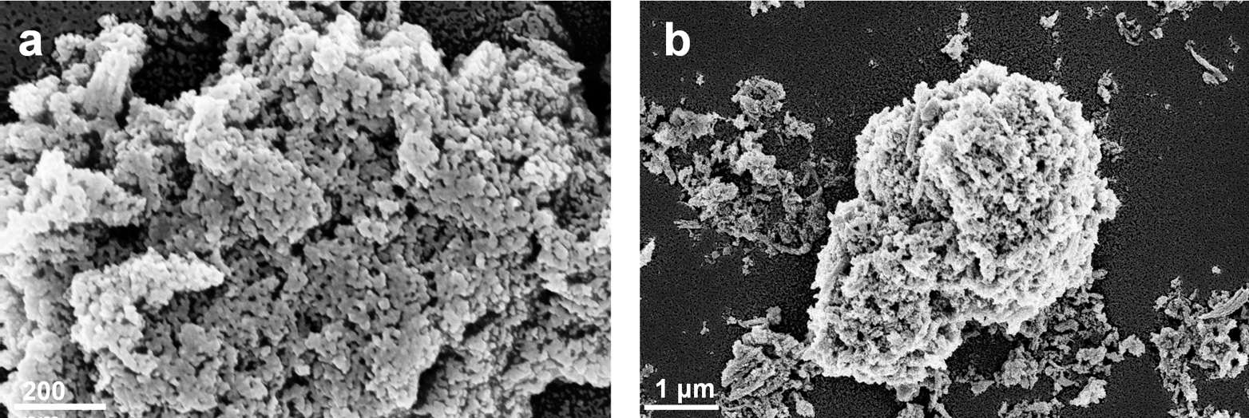
Figure S1. SEM characterization results of meso-HEOs.

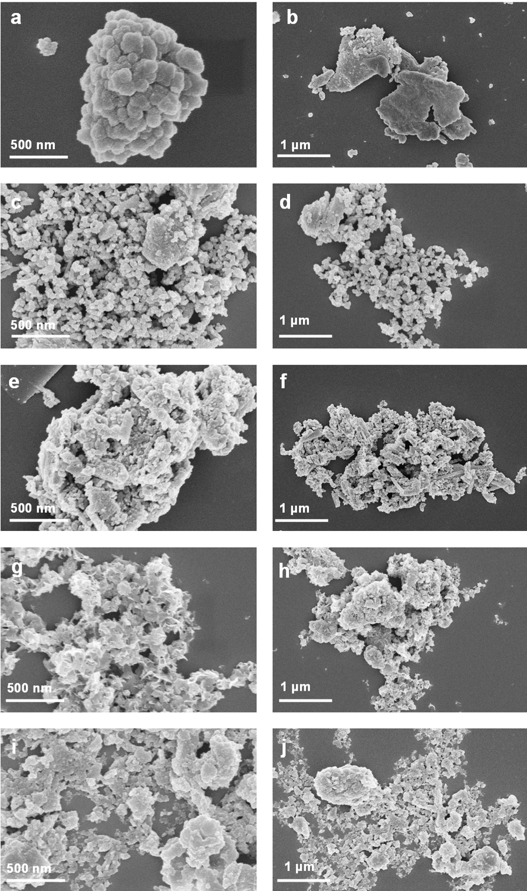
Figure S2. SEM characterization results of five corresponding monometallic oxide catalysts: (a-b) Co₃O₄; (c-d) Fe₂O₃; (e-f) CuO; (g-h) MnO₂; (i-j) NiO.
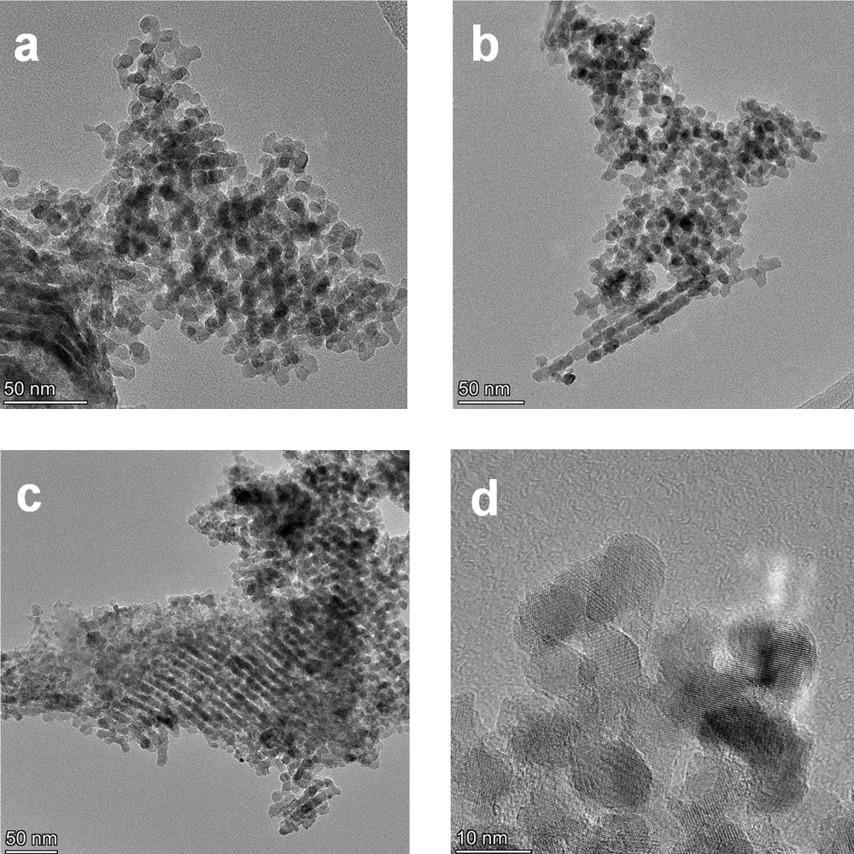
Figure S3. TEM characterization results of meso-HEOs.

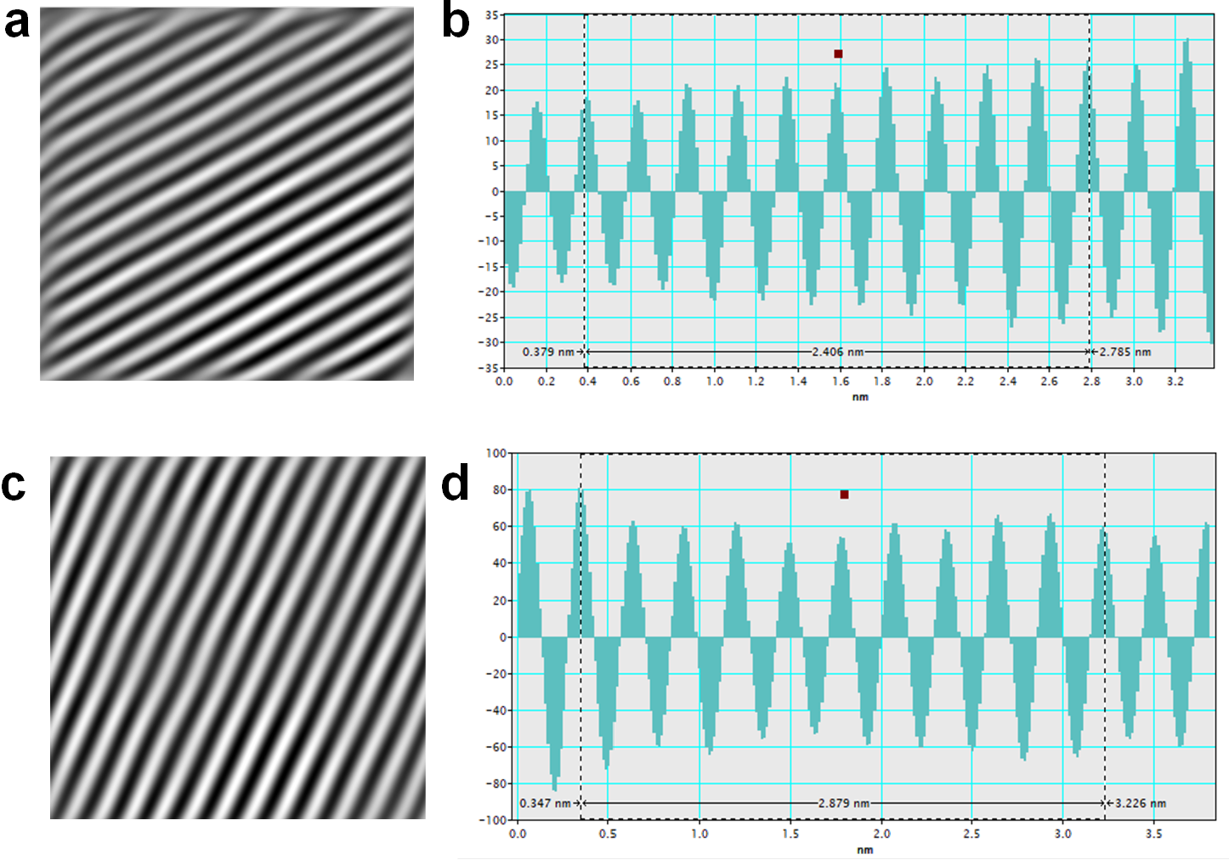
Figure S4. HRTEM characterization result of meso-HEOs. (a, c) The corresponding inverse FFT lattice fringes pattern of meso-HEOs and (b, d) the corresponding interplanar spacing diagram.

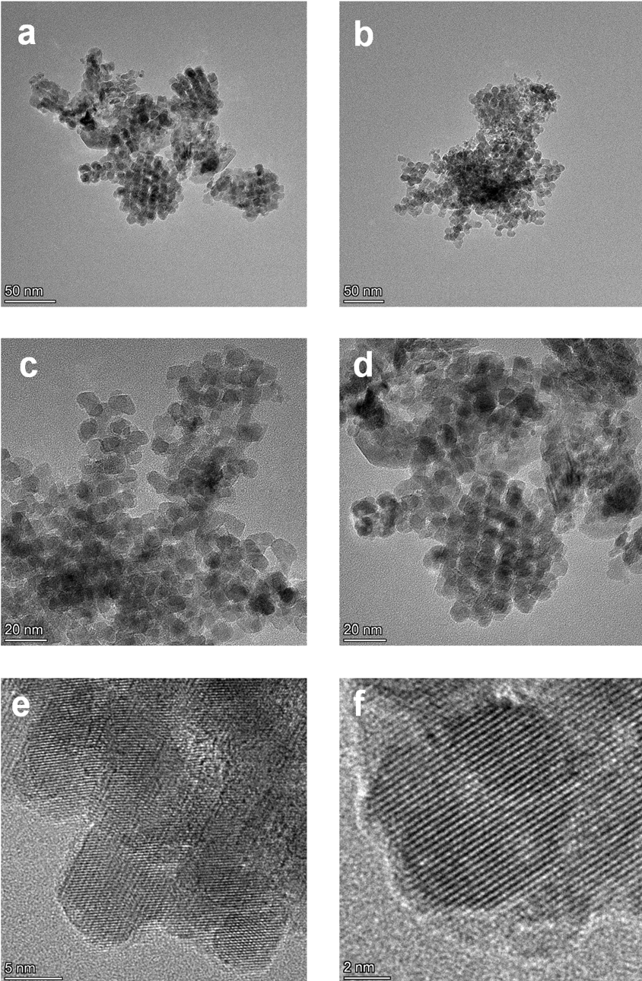
Figure S5. TEM characterization results of meso-Co₃O₄.

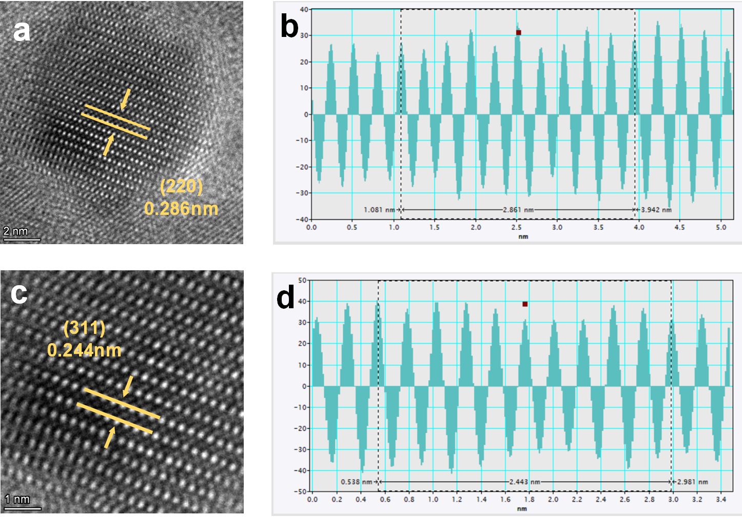
Figure S6. HRTEM characterization result of meso- Co₃O₄. (a, c) HRTEM of meso- Co₃O₄; (b, d) The corresponding inverse FFT lattice fringes pattern of interplanar spacing diagram.
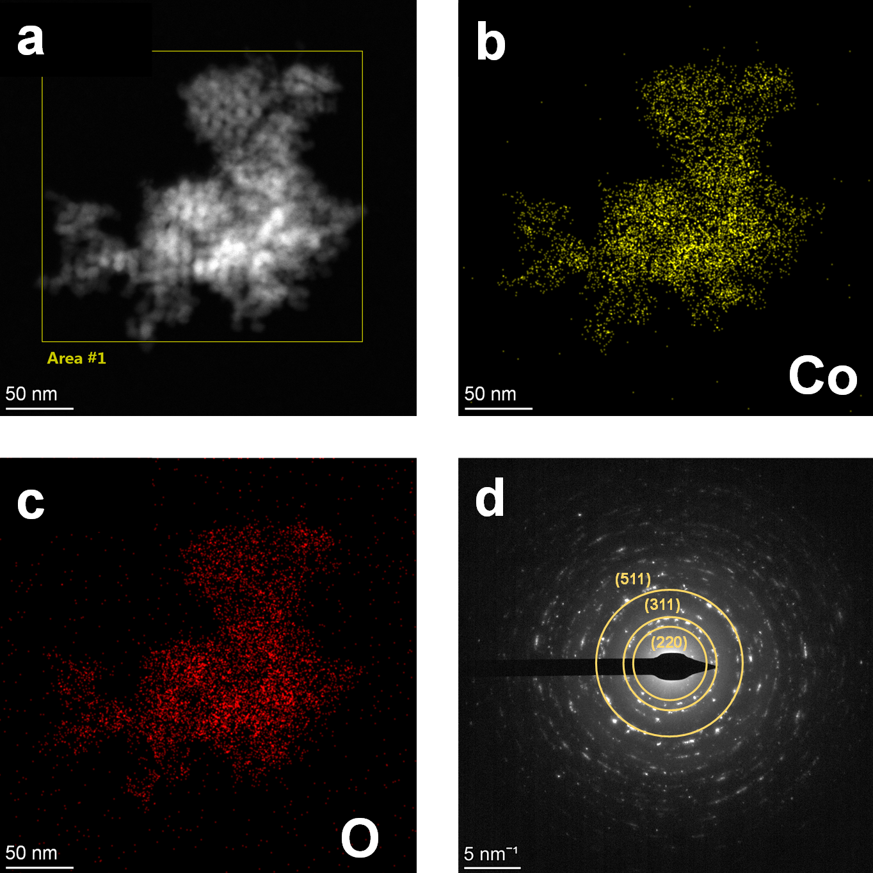
Figure S7. HAADF-STEM characterization result of meso- Co₃O₄. (a-c) HAADF-STEM image and corresponding EDX elemental mapping images;
(d) SAED pattern from.
Figure S8. The XRD patterns of four corresponding monometallic oxide catalysts.

Figure S9. Comparison of the high-resolution XPS spectra of (a) O 1s; (b) Co 2p; (c) Cu 2p; (b) Ni 2p; (b) Fe 2p; (b) Mn 2p of meso-HEOs catalysts before and after catalytic reactions in the meso-HEOs /PMS system.
Figure S10. (a) FT-EXAFS fitting curves of meso-HEOs and the reference samples Co foil, Co₂O₃, Co₃O₄, CoO, CoPc in k-space; (c) FT-EXAFS fitting curves of meso-HEOs in k-space.

Figure S11. (a) Degradation of SMX in the meso/PMS system (50mL) with different catalyst dosage and the corresponding (b) reaction rate constants.

Figure S12. (a) Degradation of SMX in the meso-HEOs/PMS system with different PMS dosage and the corresponding (b) reaction rate constants.

Figure S13. (a) Degradation of SMX in the meso-HEOs/PMS system with different SMX concentrations and the corresponding (b) reaction rate constants.

Figure S14. Degradation efficiencies of SMX across various reaction systems

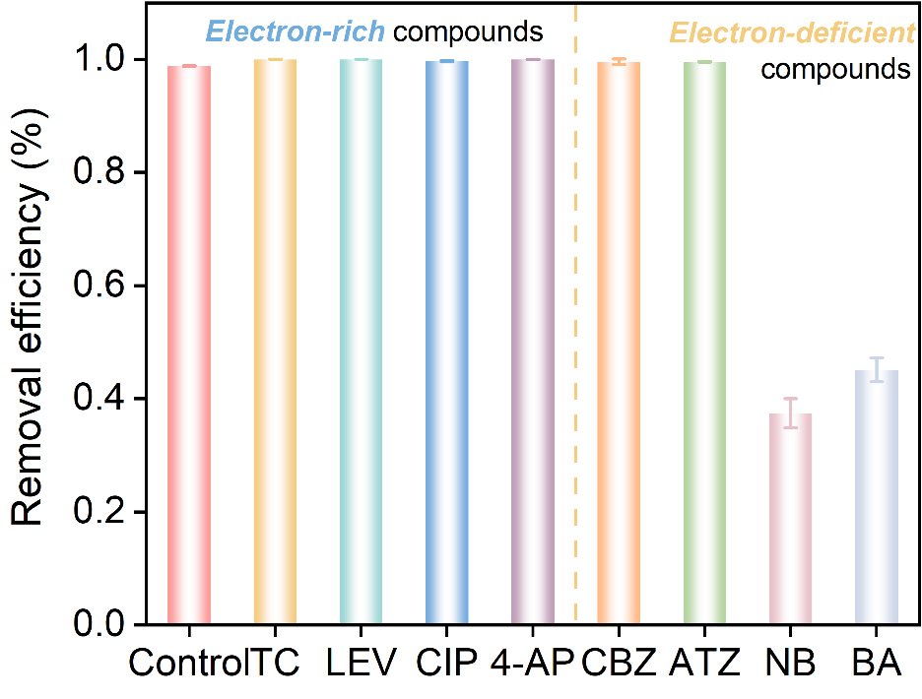
Figure S15. Degradation of various organic pollutants in the meso-HEOs/PMS system.

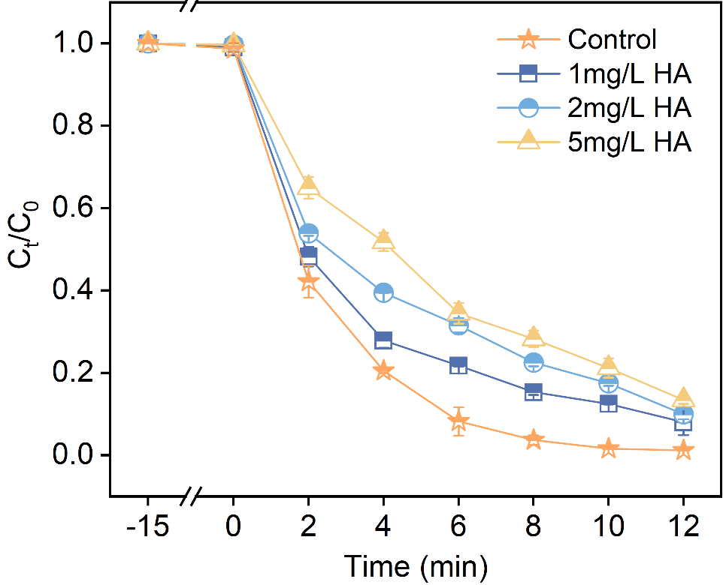
Figure S16. Effect of humic acid (HA) on meso-HEOs/PMS reaction system.

Figure S17. Evaluation of SMX removal using meso-HEOs/PMS systems with five cycles.

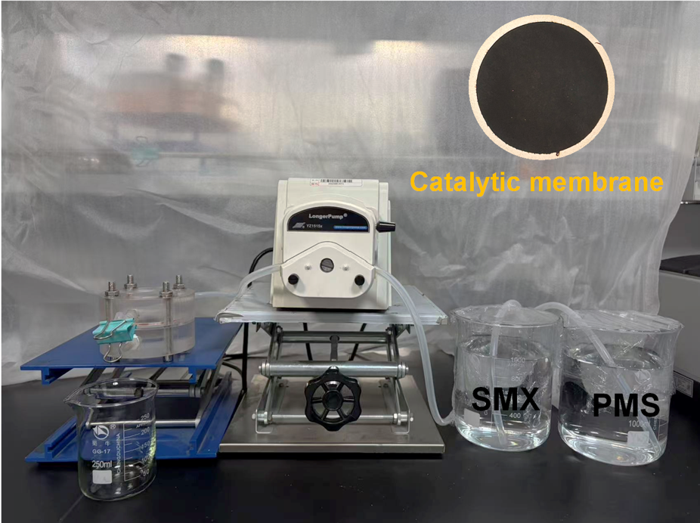
Figure S18. Photograph of the continuous flow reactor.

Figure S19. (a) TMPO spin-trapping EPR spectra for TMPO-¹O₂ in the meso-HEOs/PMS system; (b) DMPO spin-trapping EPR spectra for DMPO-•O₂– in the meso-HEOs/PMS system.

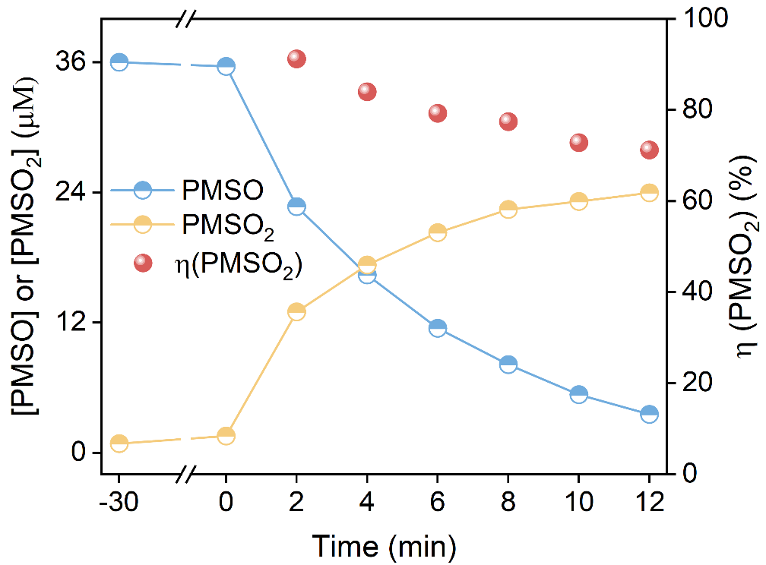
Figure S20. PMSO probe experiment in meso-HEOs/PMS system.

Figure S21. UV spectra of DPA transformation for determining ¹O₂ in the (a) meso-HEOs/PMS system and (b) meso-HEOs/PMS/TMPOL system.

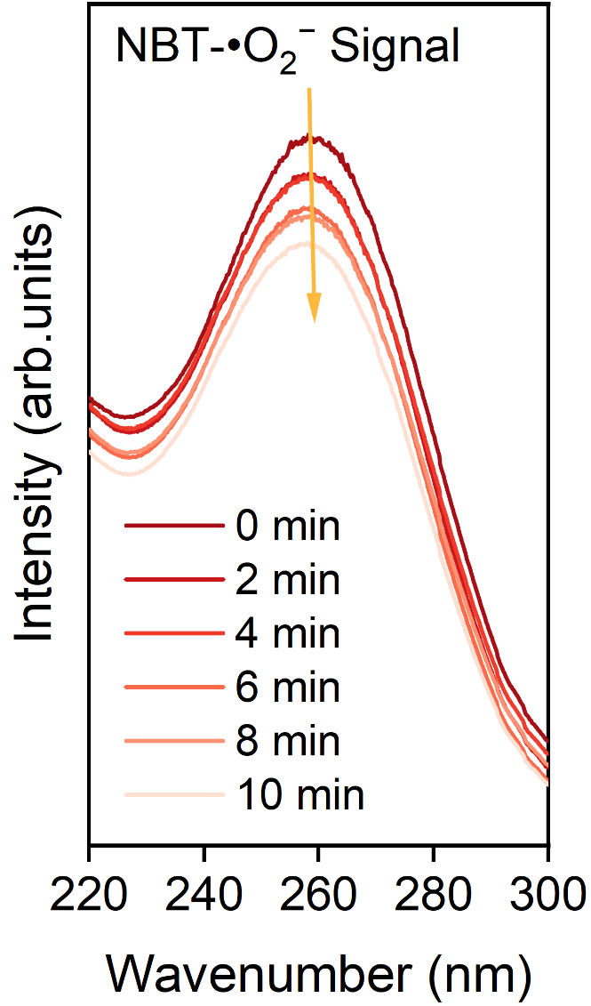
Figure S22. UV spectra of NBT transformation for determining •O₂⁻ in the meso-HEOs/PMS system.

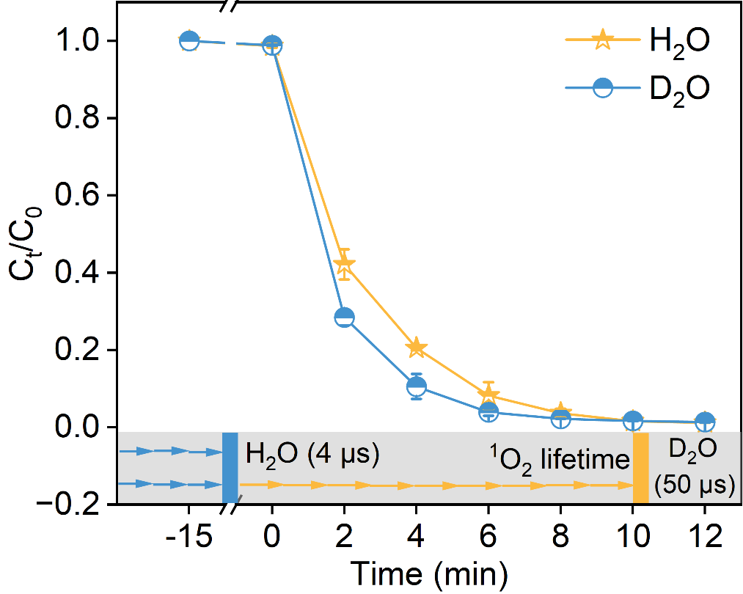
Figure S23. Comparative experiment of substituting H₂O with D₂O in meso-HEOs/PMS system.

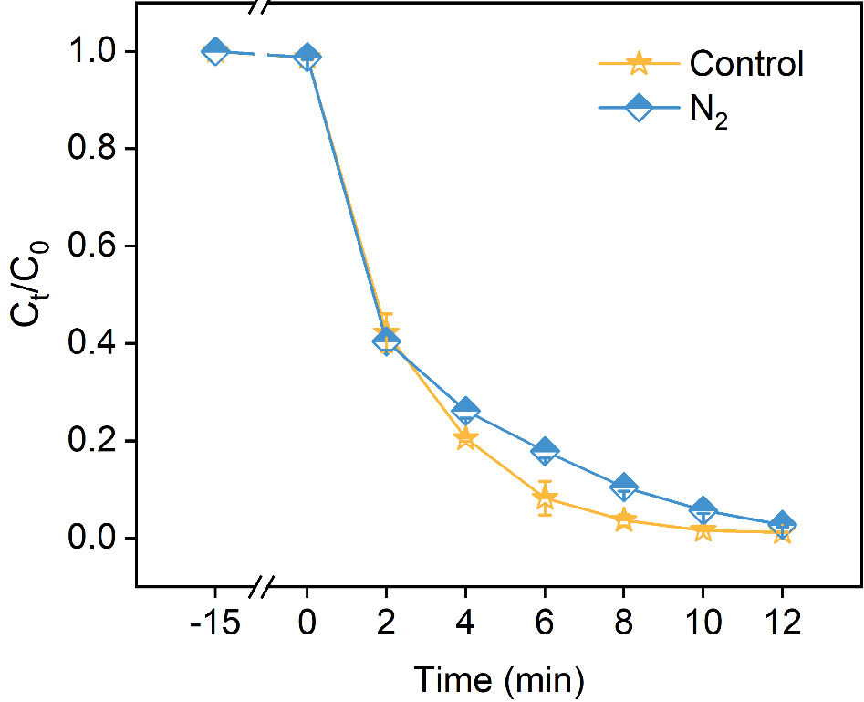
Figure S24. Comparison of SMX removal in meso-HEOs/PMS and with and without N₂ blowing. The error bars represent the standard deviation of three replicate tests.

Figure S25. Probe experiments to quantify the contribution of active species in the system. Comparison of the degradation efficiencies of NB, BA, and FFA in the meso-HEOs/PMS system. The error bars represent the standard deviation of three replicate tests.

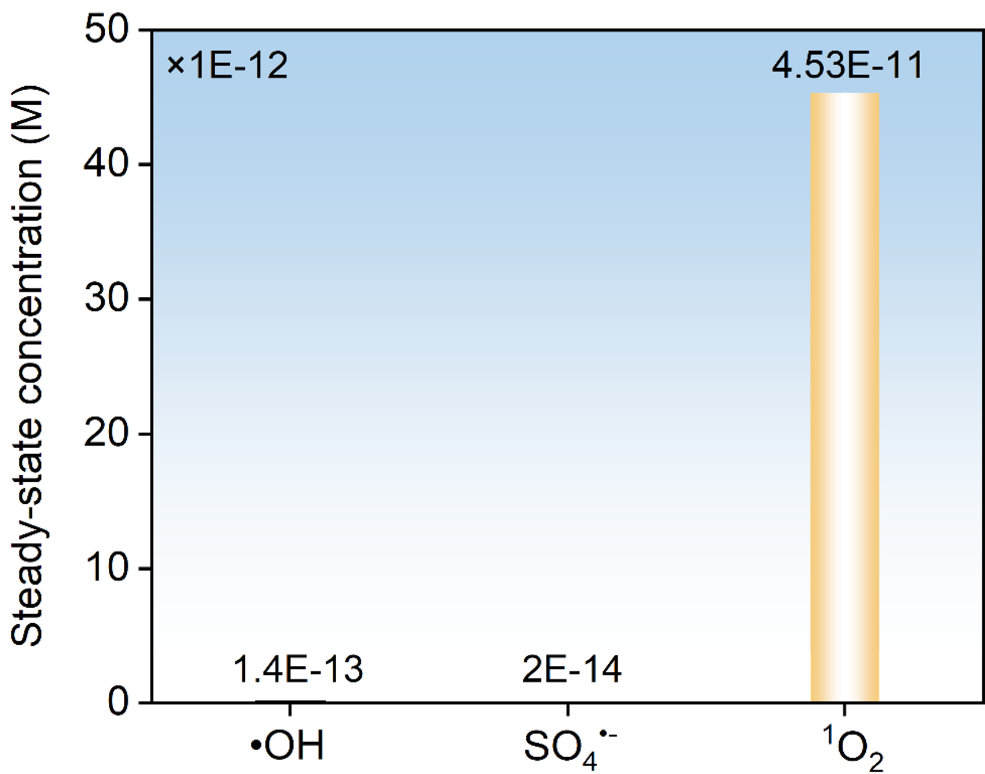
Figure S26. Steady-state concentrations of active species in meso-HEOs/PMS system.

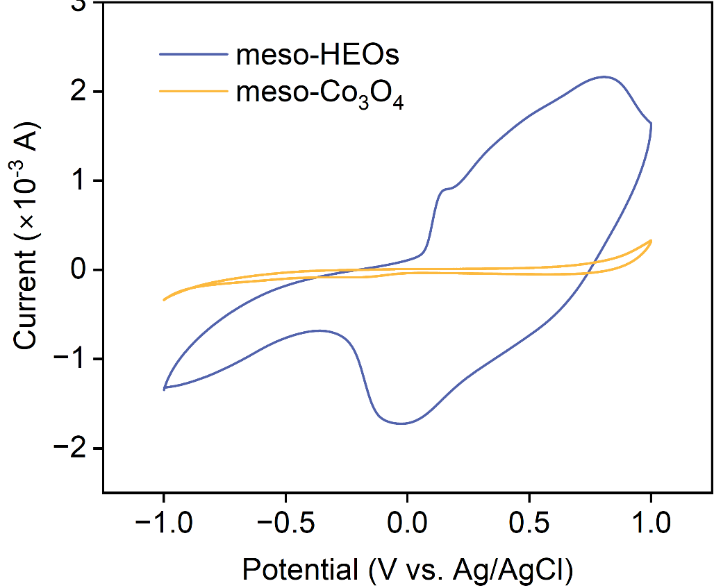
Figure S27. Cyclic voltammetric curves (CV curves) of meso-Co₃O₄ and meso-HEOs.

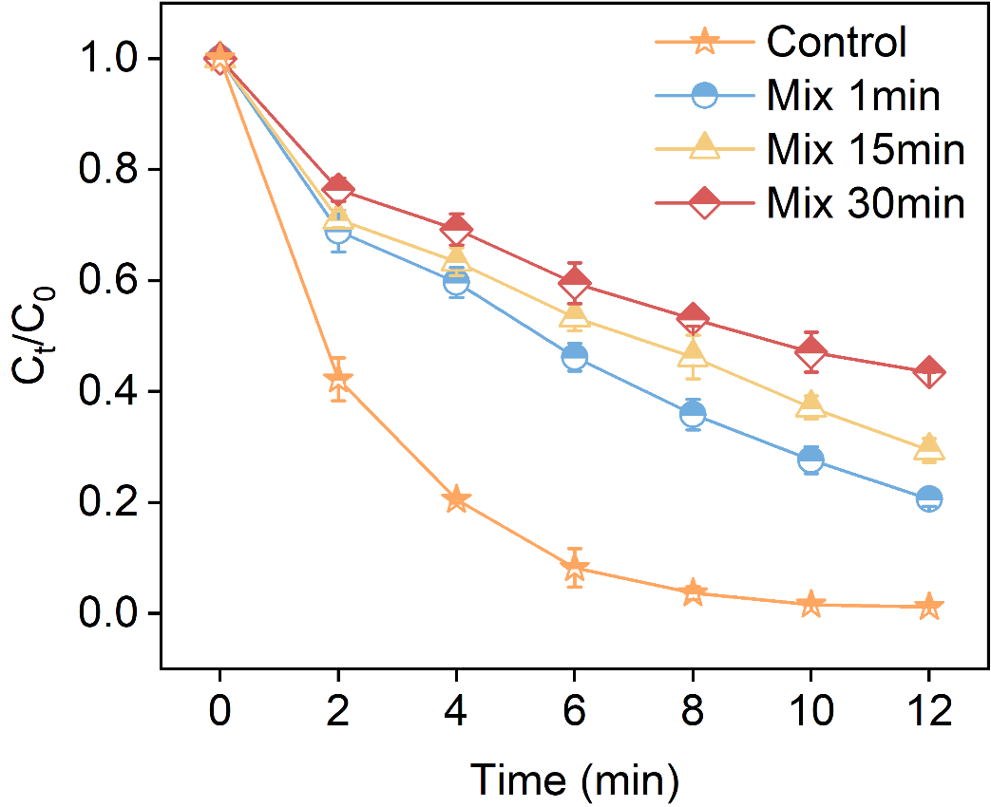
Figure S28. Pre-mixing experiments. The removal efficiency of SMX after mixing PMS and meso-HEOs. The error bars represent the standard deviation of three replicate tests.

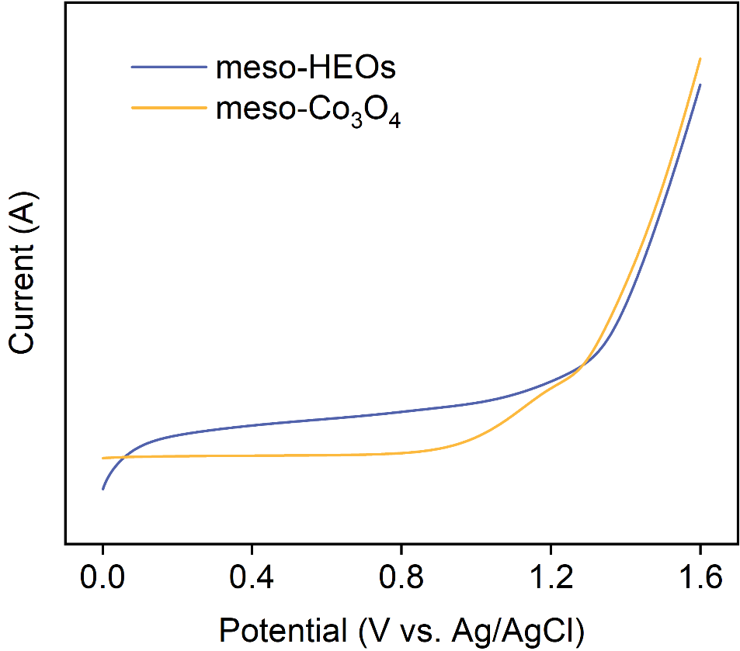
Figure S29. LSV curves of meso-Co₃O₄ and meso-HEOs.

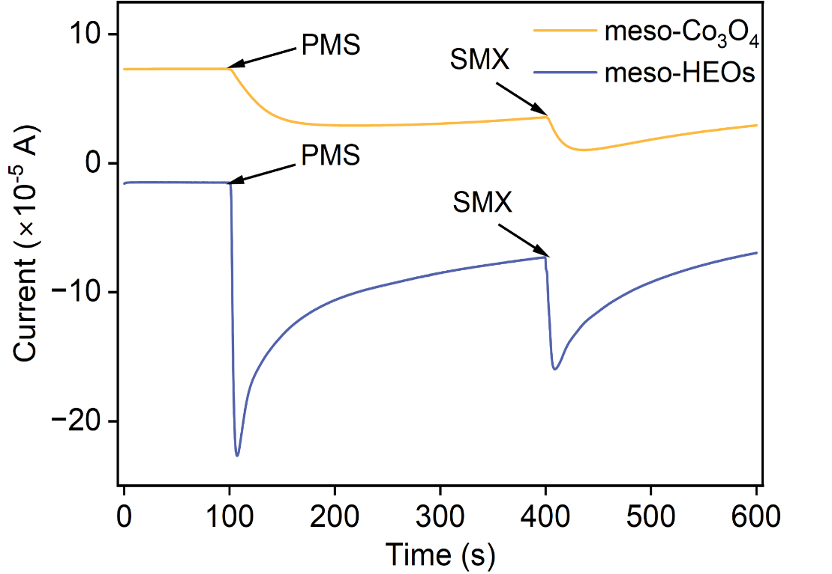
Figure S30. I-t curves of meso-Co₃O₄ and meso-HEOs.

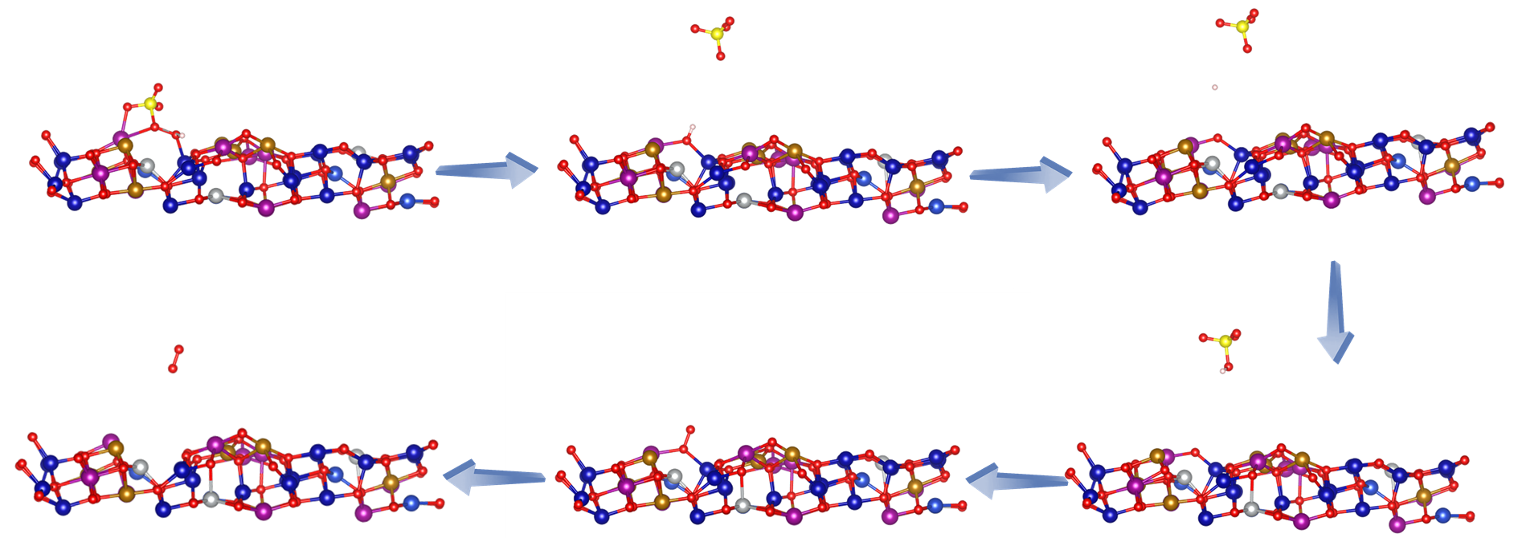
Figure S31. The *OO pathways analysis of generating ¹O₂ in the meso-HEOs/PMS system.

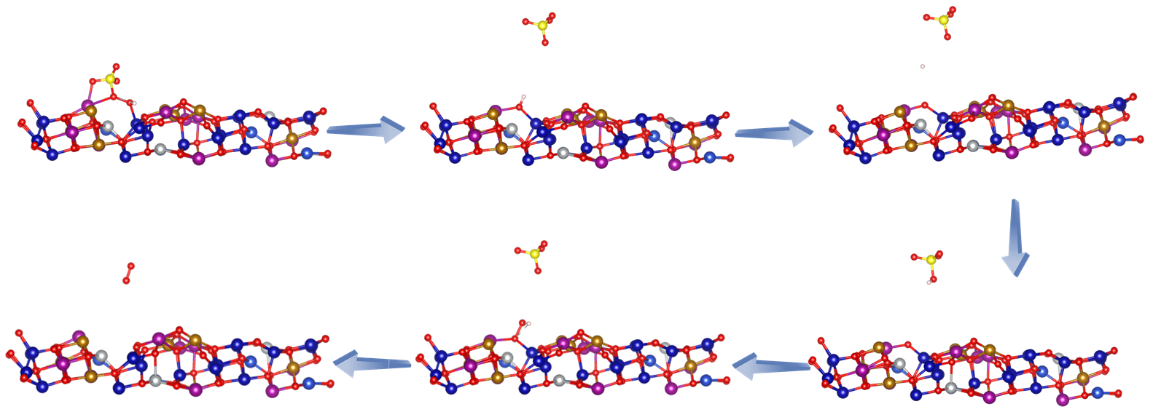
Figure S32. The *OOH pathways analysis of generating ¹O₂ in the meso-HEOs/PMS system.

Figure S33. Structure analysis of intermediates. LC-MS was employed to identify the m/z values of the SMX degradation intermediates in the meso-HEOs/PMS system, along with their corresponding structural formulas.

Figure S34. Structure analysis of intermediates. LC-MS was employed to identify the m/z values of the SMX degradation intermediates in the meso-HEOs/PMS system, along with their corresponding structural formulas.

Figure S35. Structure analysis of intermediates. LC-MS was employed to identify the m/z values of the SMX degradation intermediates in the meso-HEOs/PMS system, along with their corresponding structural formulas.

Figure S36. Toxicity evaluation of meso-HEOs/PMS system by T.E.S.T software.

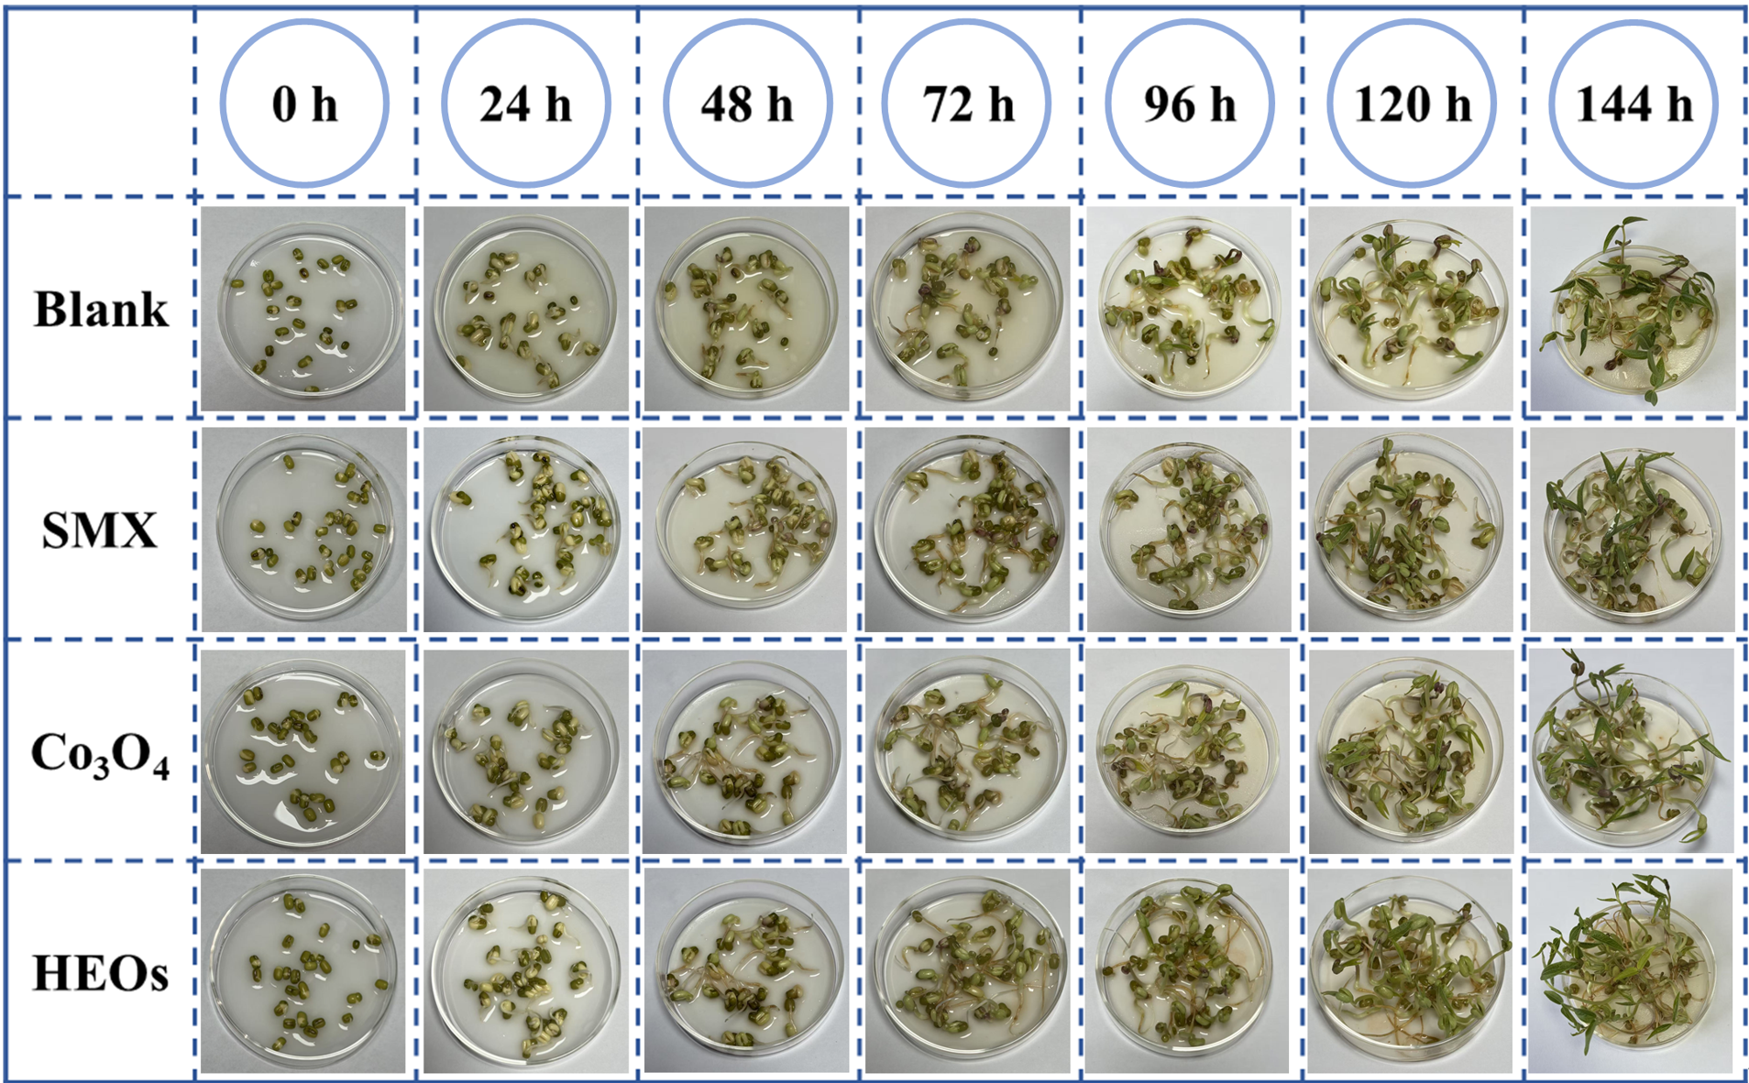
Figure S37. Toxicity assessment by bean sprout seed culture. Photographs of each group of Bean sprout seed growth during five consecutive days.

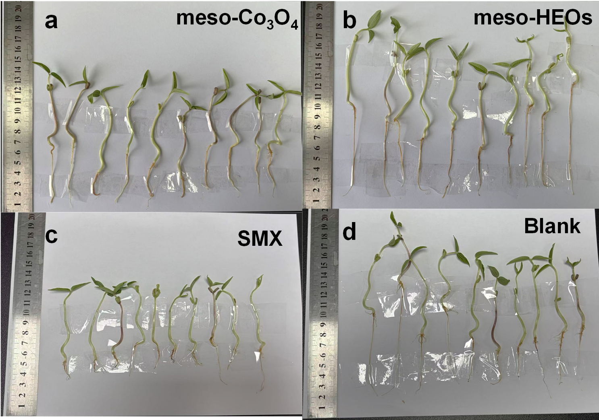
Figure S38. Photographs of each group of Bean sprout seed’ final fifth-day growth: (a) meso-Co₃O₄/PMS, (b) meso-HEOs/PMS, (c) SMX, and (d) Blank.

Figure S39. System boundaries for life cycle assessment during the removal of SMX using the meso-HEOs/PMS system.

Figure S40. System boundaries for life cycle assessment during the removal of SMX using the meso-Co₃O₄/PMS system.

Table S1. Element ratios of meso-HEOs electrocatalysts obtained from EDS mapping.
Element | Percentage (%)
Fe | 4.19725
Co | 17.8003
Ni | 6.90972
Cu | 11.0780
Mn | 4.33906
O | 55.6754

Table S2. Atomic ratios of meso-HEOs characterized by ICP-OES.
Sample | Fe | Co | Ni | Cu | Mn
Content ratios (%) | 11.94 | 25.20 | 12.24 | 8.29 | 11.72

Table S3. Structure parameters extracted from the EXAFS fitting of meso-HEOs and reference samples.
Sample | Shell | CN | R(Å) | σ²(Å²) | ΔE₀(eV) | R factor
Co foil | Co-Co | 12* | 2.49±0.01 | 0.0062 | 7.1±0.3 | 0.0006
sample | Co-O | 4.5±0.1 | 1.91±0.01 | 0.0016 | -7.4±0.4 | 0.0017
sample | Co-M | 3.1±0.1 | 2.86±0.01 | 0.0018 | -7.4±0.4 | 0.0017
sample | Co-M1 | 10.1±0.4 | 3.37±0.01 | 0.0096 | -7.4±0.4 | 0.0017

Table S4. Effect of conditional control (catalyst dosage, pollutant concentrations, PMS concentrations) on SMX removal in the meso-HEOs/PMS system.
Catalyst dosage (mg) | Removal efficiency (%) | k_{obs} (min⁻¹)
3 | 97.5 | 0.361
5 | 99.2 | 0.386
10 | 99.5 | 0.295
SMX concentration (mg L⁻¹) | Removal efficiency (%) | k_{obs} (min⁻¹)
3 | 99.4 | 0.613
5 | 99.2 | 0.386
10 | 90.7 | 0.177
PMS concentration (g L⁻¹) | Removal efficiency (%) | k_{obs} (min⁻¹)
0.1 | 94.1 | 0.236
0.2 | 99.2 | 0.386
0.3 | 97.6 | 0.306

Table S5. A comparison of kinetics in the recently reported Fenton-like catalysts for degradation of pollutant.
Catalyst  (g L⁻¹) | Cocatalyst  (mM) | Pollutant  (mg/L) | k_{obs} (min⁻¹) | Removal  efficiency | k-value  (min⁻¹ M⁻¹) | Ref.
HESACs (0.02) | [PMS]₀=0.5 | 2.25 | 0.39 | 100% | 17.55 | 10
HESO-600 (0.1) | [PMS]₀=3.29 | 25 | 0.083 | ≈100% | 6.31 | 11
LSMFNCC (0.05) | [PMS]₀=0.66 | 5 | 0.155 | 95% | 23.59 | 12
(Co_{0.2}Ni_{0.2}Mn_{0.2}Cu_{0.2}Zn_{0.2})₃O₄ (0.1) | [PMS]₀=1.64 | 20 | 0.064 | 97.9% | 7.80 | 13
NiMgZnCuCoO_{x} (0.1) | [PMS]₀=0.5 | 10 | 0.148 | ≈100% | 29.6 | 14
FeCoNiCuRu_{0.5}@NC (0.1) | [PMS]₀=0.5 | 10 | 0.158 | 99.9% | 31.6 | 15
LDHs/SCN-0.2 (0.2) | [PMS]₀=0.1 | 10 | 0.0605 | 91.1% | 30.25 | 16
HEOs-PAC(0.25) | [PMS]₀=1.0 | 10 | 0.1654 | 99.3% | 6.62 | 17
FeMnCoZnCu@NCNP@CA (0.25) | [PMS]₀=2.037 | 30 | 0.07 | 98% | 4.12 | 18
Meso-HEOs (0.1) | [PMS]₀=0.33 | 5 | 0.386 | 99.2% | 58.5 | This work

Table S6. Acute and chronic toxicity results of SMX and its degradation products predicted using the Ecological Structure-Activity Relationships system.
Possible products |  |  |  |  | Acute toxicity (mg L⁻¹) |  |  |  |  |  |  |  | Chronic toxicity (mg L⁻¹): ChV
 |  |  |  |  | fish  (LC₅₀) | daphnid  (LC₅₀) |  |  |  |  | green algae  (EC₅₀) |  | fish | daphnid |  |  | green algae
SMX |  |  |  |  | 267 |  | 6.43 |  |  | 21.8 |  |  | 5 |  | 0.068 |  | 11.1
P1 | 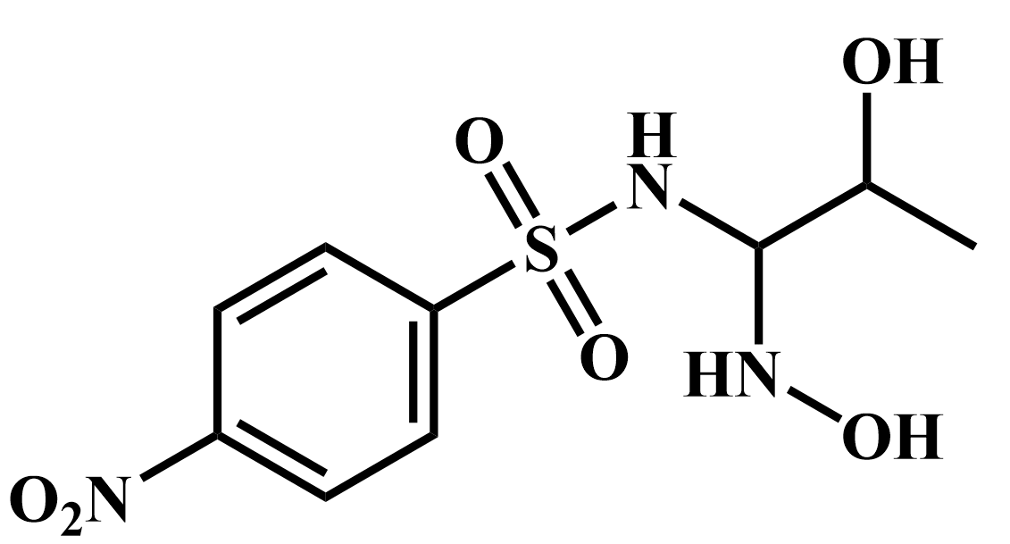 |  |  |  | 27400 |  |  | 2030 | 4300 |  |  |  | 6810 |  |  | 105 |  | 1010
P2 |  |  |  |  | 108 |  |  | 62.4 |  |  |  | 50.9 | 10.8 |  |  | 6.47 |  | 14
P3 |  |  |  |  | 116 |  |  | 65.4 |  |  |  | 47.7 | 11.3 |  |  | 6.29 |  | 12.4
P4 |  |  | 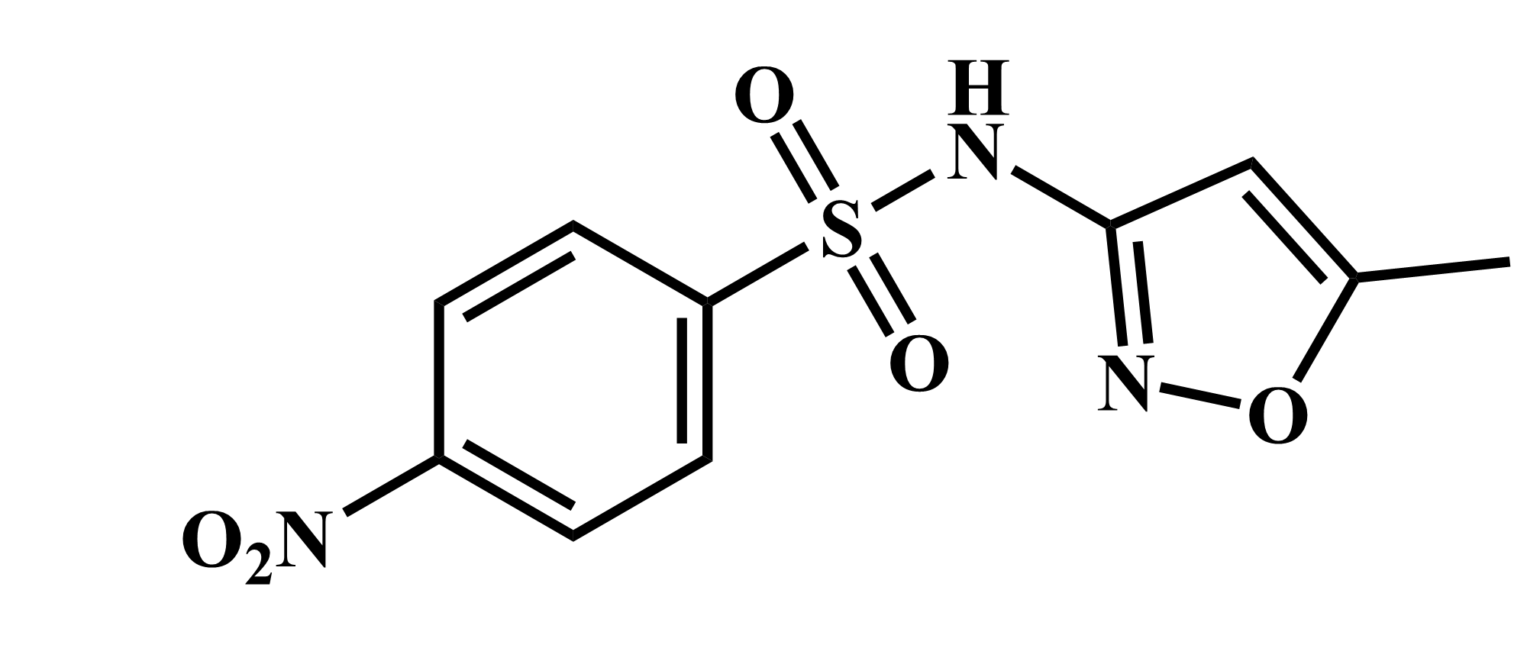 |  | 1170 |  |  | 619 |  |  |  | 342 | 105 |  |  | 49.3 |  | 76.2
P5 |  |  |  |  | 14300 |  |  | 6500 |  |  |  | 1940 | 1080 |  |  | 343 |  | 312
P6 |  |  |  |  | 28200 |  |  | 12600 |  |  |  | 3500 | 2080 |  |  | 633 |  | 538
P7 |  |  |  |  | 12900 |  |  | 5950 |  |  |  | 1870 | 987 |  |  | 325 |  | 309
P8 |  |  |  |  | 1010 |  |  | 539 |  |  |  | 309 | 91.7 |  |  | 44.1 |  | 70.4
P9 |  |  |  |  | 5580 |  |  | 2750 |  |  |  | 1130 | 460 |  |  | 179 |  | 214
P10 |  |  |  |  | 46200 |  |  | 20400 |  |  |  | 5390 | 3360 |  |  | 991 |  | 808
Toxicity was classified based on the Globally Harmonized System of Classification and Labeling of Chemicals. Very toxic (Red): LC₅₀/EC₅₀/ChV ≤ 1 mg L⁻¹, Toxic (Pink): 1 mg L−1<LC₅₀/EC₅₀/ChV≤10 mg L−1, Harmful (Yellow): 10 mg L⁻¹ < LC₅₀/EC₅₀/ChV ≤ 100 mg L⁻¹, Not harmful (Green): LC₅₀/EC₅₀/ChV > 100 mg L⁻¹.

Supplementary References
1. Perdew JP, Burke K, Ernzerhof M. Generalized Gradient Approximation Made Simple. Phys Rev Lett 77, 3865-3868 (1996).
2. Grimme S, Antony J, Ehrlich S, Krieg H. A consistent and accurate ab initio parametrization of density functional dispersion correction (DFT-D) for the 94 elements H-Pu. J Chem Phys 132, 154104 (2010).
3. Yao Z, et al. High-entropy alloys catalyzing polymeric transformation of water pollutants with remarkably improved electron utilization efficiency. Nat Commun 16, 148 (2025).
4. Gao L, Guo Y, Zhan J, Yu G, Wang Y. Assessment of the validity of the quenching method for evaluating the role of reactive species in pollutant abatement during the persulfate-based process. Water Res 221, 118730 (2022).
5. Wang S, Liu Y, Wang J. Peroxymonosulfate Activation by Fe–Co–O-Codoped Graphite Carbon Nitride for Degradation of Sulfamethoxazole. Environ Sci Technol 54, 10361-10369 (2020).
6. Li X, et al. CoN1O2 Single-Atom Catalyst for Efficient Peroxymonosulfate Activation and Selective Cobalt(IV)=O Generation. Angew Chem Int Ed 62, e202303267 (2023).
7. Zhang Z-Q, Duan P-J, Bai C-W, Chen X-J, Wang J, Chen F. Surface-hydroxylated single-atom catalyst with an isolated Co-O-Zn configuration achieves high selectivity in regulating active species. Nat Commun 16, 2376 (2025).
8. Miskoski S, Sánchez E, Garavano M, López M, Soltermann AT, Garcia NA. Singlet molecular oxygen-mediated photo-oxidation of tetracyclines: kinetics, mechanism and microbiological implications. Journal of Photochemistry and Photobiology B: Biology 43, 164-171 (1998).
9. Xu M, et al. Comparison of UVC and UVC/persulfate processes for tetracycline removal in water. Chem Eng J 384, 123320 (2020).
10. Sun Y, et al. Synthesize and application of high entropy single atom catalyst for PMS activation: Performance and mechanism. Sep Purif Technol 380, 135215 (2026).
11. Zhang L, Wang N, Wang F, Xu P, Han X, Du Y. Robust high-entropy spinel oxides for peroxymonosulfate activation: Stabilization effect and enhancement mechanism. Chem Eng J 488, 150826 (2024).
12. Ma L, et al. R-P phase high-entropy perovskite La_{0.5}Sr_{1.5}Mn_{0.2}Fe_{0.2}Ni_{0.2}Cu_{0.2}Co_{0.2}O₄ achieves complete PMS utilization via multi-pathway activation for efficient water purification. Chem Eng J 522, 168173 (2025).
13. Guan Y, et al. Lattice distortion effects in high-entropy oxides: Boosting PMS activation for effective and durable pollutant degradation. Sep Purif Technol 358, 130267 (2025).
14. Meng H, et al. Influence of entropy on catalytic performance of high-entropy oxides (NiMgZnCuCoO_{x}) in peroxymonosulfate-mediated acetaminophen degradation. Chemosphere 362, 142610 (2024).
15. Zhang Y, et al. Construction of functionally graded high-entropy alloy catalyst for peroxymonosulfate activation: Mechanism of radical/nonradical pathways. J Colloid Interface Sci 708, 139792 (2026).
16. Dong J, et al. Construction of S-scheme high-entropy layered double hydroxides nanosheets/carbon nitrides nanotubes heterojunction for various pollutants removal by photocatalytic peroxymonosulfate activation. Chem Eng Sci 321, 122803 (2026).
17. Chen Z, et al. High-entropy perovskite embedded in carbon-based catalyst toward peroxymonosulfate activation to degrade Rhodamine B: Performance and mechanism insights. Water Res 282, 123919 (2025).
18. Erum JKE, Alshahrani T, Yang X, Gao J. MOF-Derived Entropy-Stabilized Quinary Alloy@Cellulose Aerogel for Ultrafast Tetracycline Degradation via PMS Activation. Small Methods n/a, e02192 (2025).

