Distributed acoustic sensing reveals temporal occurrence, movement and vocal behaviour of singing fin whales in the Gibraltar-Alboran maritime corridor
Miriam Romagosa^{1*}, Dídac Diego Tortosa¹ and Arantza Ugalde¹
1-Marine Geosciences Department, Institute of Marine Sciences, CSIC, 08003 Barcelona, Spain.

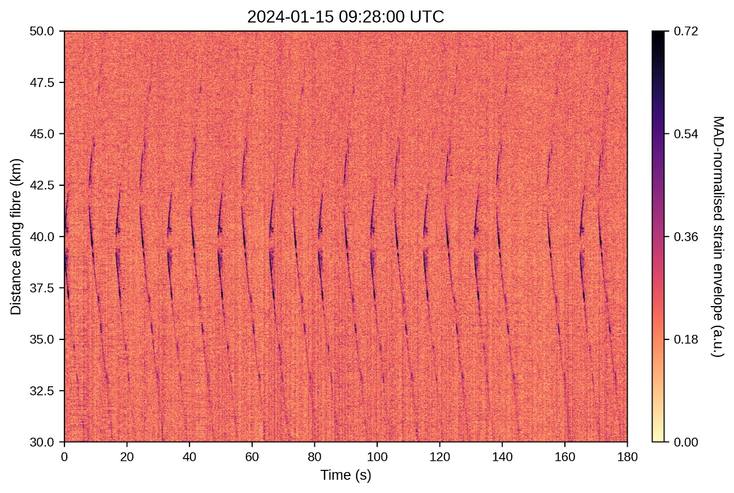
Figure S1. Time-distance map of the Hilbert envelope of DAS strain recorded along the Estepona cable on 15 January 2024, band-pass filtered between 18 and 25 Hz and normalised channel-wise by the median absolute deviation (MAD). Overlapping note clusters with differently oriented vertices are consistent with two simultaneously singing fin whales.

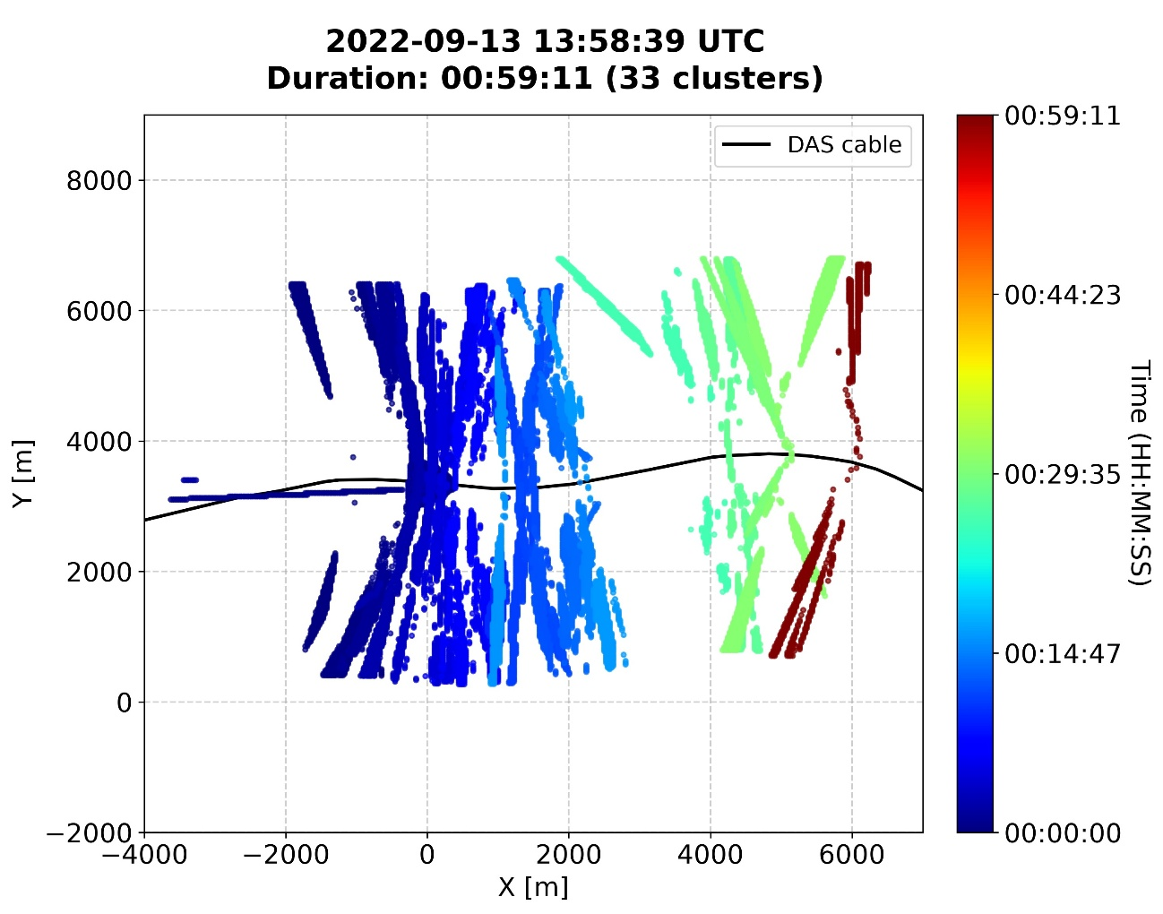
Figure S2. Example of candidate source locations estimated for 33 acoustic clusters of notes from a single fin whale song recorded on the Tarifa cable on 13 September 2022. Colours indicate the temporal progression of the song from its beginning (blue) to its end (red), and the black line represents the Tarifa cable. These candidate positions, together with their associated localization probabilities, constituted the input for the cable-relative movement analysis described in the Methods.
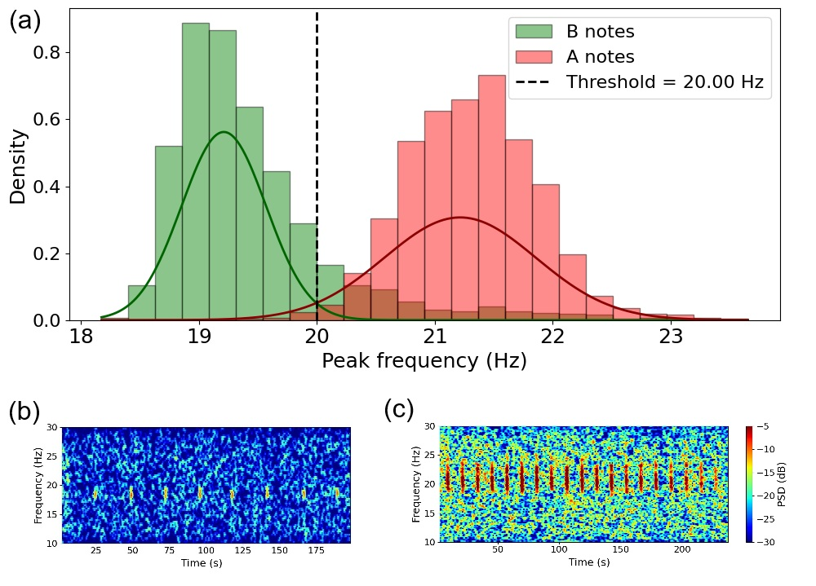
Figure S3. Classification of fin whale note types based on peak frequency. (a) Distribution of peak frequencies for all detected notes. A two-component Gaussian mixture model identified two distinct frequency groups corresponding to backbeats (B notes) and 20-Hz notes (A notes). The intersection between the fitted Gaussian components defined a classification threshold of 20 Hz (dashed line). (b) Example spectrogram of a song composed exclusively of B notes. (c) Example spectrogram of a song composed exclusively of A notes.

Table S1. Results of Friedman tests comparing fin whale song occurrence among four light regimes. The response variable was the proportion of daily singing occurrence within each diel period, with diel period (Night, Dawn, Day, and Dusk) treated as a repeated-measures factor and sampling day as the blocking factor. Significant p-values (p < 0.05) are shown in bold. n = number of sampling days included in the analysis; χ² = Friedman chi-square test statistic; df = degrees of freedom; p = two-tailed P value; Kendall's W = coefficient of concordance, reported as the effect size for the Friedman test. Effect sizes were classified as negligible (< 0.10), small (0.10–0.29), moderate (0.30–0.49), or large (≥ 0.50) following Cohen (1988)¹.
Study site | Days (n) | Friedman χ² | df | p | Kendall's W | Effect size¹
Tarifa | 21 | 18.18 | 3 | 0.0003 | 0.289 | Small
Estepona | 35 | 18.96 | 3 | 0.0004 | 0.181 | Small

Table S2. Post hoc Wilcoxon signed-rank tests comparing light regimes following significant Friedman tests. n = number of sampling days; Wilcoxon statistic = Wilcoxon signed-rank test statistic; adjusted p values were corrected for multiple comparisons using the Holm method. Statistically significant Holm-adjusted p-values < 0.05 are shown in bold.
Study site | Days (n) | Comparison | Wilcoxon statistic | Adjusted p (Holm)
Tarifa | 21 | Night vs Dawn | 0 | 0.025
 |  | Night vs Day | 109 | 1.000
 |  | Night vs Dusk | 15 | 0.608
 |  | Dawn vs Day | 0 | 0.002
 |  | Dawn vs Dusk | 0 | 0.172
 |  | Day vs Dusk | 75 | 1.000
Estepona | 35 | Night vs Dawn | 105 | 0.735
 |  | Night vs Day | 243 | 0.735
 |  | Night vs Dusk | 21 | 0.006
 |  | Dawn vs Day | 105 | 0.735
 |  | Dawn vs Dusk | 1 | 0.028
 |  | Day vs Dusk | 20 | 0.008

Table S3. Songs retained for cable-relative movement analysis after visual quality assessment. For each song, the table reports the study location, recording date, song identifier, number of clusters included in the trajectory analysis, proportion of variance explained by the first principal component and inferred movement direction along the cable axis.
Location | Date | Song ID | Clusters used | PC1 variance explained | Spearman correlation | Movement direction
Tarifa | 2022-08-15 | win_0000 | 432 | 0.980 | - 0.462 | Westward
Tarifa | 2022-08-23 | win_0001 | 123 | 0.924 | -0.331 | Westward
Tarifa | 2022-08-24 | win_0002 | 39 | 0.986 | -0.534 | Westward
Tarifa | 2022-08-25 | win_0003 | 24 | 0.925 | -0.370 | Westward
Tarifa | 2022-09-07 | win_0005 | 11 | 0.843 | 0.209 | Eastward
Tarifa | 2022-09-08 | win_0006 | 42 | 0.989 | -0.374 | Westward
Tarifa | 2022-09-13 | win_0009 | 93 | 0.919 | 0.652 | Eastward
Tarifa | 2022-09-14 | win_0010 | 86 | 0.908 | 0.333 | Eastward
Tarifa | 2022-09-15 | win_0011 | 78 | 0.977 | 0.010 | Eastward
Tarifa | 2022-09-19 | win_0013 | 116 | 0.912 | -0.186 | Westward
Tarifa | 2022-09-25 | win_0014 | 9 | 0.969 | -0.216 | Westward
Tarifa | 2022-09-26 | win_0015 | 548 | 0.981 | -0.263 | Westward
Tarifa | 2022-09-26 | win_0016 | 41 | 0.898 | 0.426 | Eastward
Tarifa | 2022-09-27 | win_0017 | 145 | 0.914 | 0.410 | Eastward
Tarifa | 2022-09-29 | win_0019 | 42 | 0.945 | 0.605 | Eastward
Tarifa | 2022-10-08 | win_0020 | 57 | 0.850 | -0.067 | Westward
Tarifa | 2022-10-09 | win_0021 | 96 | 0.900 | 0.644 | Eastward
Estepona | 2023-09-25 | win_0000 | 13 | 0.839 | 0.483 | Northward
Estepona | 2023-10-06 | win_0004 | 91 | 0.959 | -0.194 | Southward
Estepona | 2023-10-14 | win_0006 | 41 | 0.927 | -0.544 | Southward
Estepona | 2023-10-28 | win_0008 | 25 | 0.965 | 0.186 | Northward
Estepona | 2023-11-02 | win_0009 | 8 | 0.999 | -0.452 | Southward
Estepona | 2023-11-10 | win_0011 | 39 | 0.981 | 0.057 | Northward
Estepona | 2023-11-17 | win_0014 | 50 | 0.984 | 0.305 | Northward
Estepona | 2023-11-21 | win_0015 | 16 | 0.964 | 0.041 | Northward
Estepona | 2023-11-26 | win_0016 | 50 | 0.989 | -0.001 | Southward
Estepona | 2023-12-08 | win_0018 | 20 | 0.989 | -0.365 | Southward
Estepona | 2024-01-10 | win_0025 | 7 | 0.828 | 0.821 | Northward
Estepona | 2024-01-12 | win_0029 | 19 | 0.702 | -0.210 | Southward
Estepona | 2024-01-12 | win_0030 | 221 | 0.858 | 0.639 | Northward
Estepona | 2024-01-14 | win_0032 | 49 | 0.983 | -0.019 | Southward
Estepona | 2024-01-19 | win_0035 | 103 | 0.852 | -0.137 | Southward
Estepona | 2024-01-22 | win_0039 | 26 | 0.940 | 0.174 | Northward
Estepona | 2024-02-04 | win_0043 | 88 | 0.944 | -0.053 | Southward
Table S4. Song-level ordinary least-squares (OLS) models evaluating differences in median inter-note intervals (INI) among note-pair types. n INIs = number of INIs included in each model; R² = coefficient of determination; adjusted R² = coefficient of determination adjusted for the number of predictors; β ± SE = estimated location effect (Estepona relative to Tarifa) expressed as the regression coefficient (β) ± standard error (SE), in seconds; t = t-statistic for the location effect; p = two-tailed P value for the location effect.
Note-pair | n INIs | R² | Adjusted R² | Location effect (Estepona vs. Tarifa) β ± SE (s) | t | p
AA | 51 | 0.644 | 0.596 | 0.82 ± 0.88 | 0.93 | 0.353
AB | 27 | 0.555 | 0.422 | 1.15 ± 1.31 | 0.88 | 0.392
BA | 28 | 0.665 | 0.569 | 1.80 ± 1.25 | 1.43 | 0.168
BB* | 6 | 0.983 | 0.971 | 2.16 ± 0.17 | 12.82 | 0.001
*BB results should be interpreted with caution because only seven songs met the inclusion criteria and the model was affected by singularity/multicollinearity.
Table S5. Comparison of song-level median INIs between Tarifa and Estepona during the overlapping recording period (September–October). n = number of songs included for each study site; median INI = median inter-note interval (s); U = Mann–Whitney U test statistic; Mann–Whitney p = two-tailed P value from the Mann–Whitney U test; OLS location effect p = two-tailed P value for the location effect (Estepona vs. Tarifa) from the ordinary least squares model after accounting for seasonal variation.
Note-pair | Tarifa (n) | Estepona (n) | Tarifa median INI (s) | Estepona median INI (s) |  | U | Mann–Whitney p | OLS location effect p
AA | 12 | 9 | 11.86 | 12.03 | 30 |  | 0.095 | 0.373
AB | 11 | 2 | 13.99 | 15.92 | 2 |  | 0.103 | 0.410
BA | 10 | 5 | 11.62 | 13.02 | 10 |  | 0.075 | 0.186
BB note pairs were excluded because sample sizes were insufficient for robust statistical comparison between study sites.

