Table 1. Agro-morphological descriptors used for phenotypic characterization of 708 durum wheat (Triticum durum Desf.) accessions according to the UPOV TG/3/12 guidelines, including trait classification, states of expression, and growth stage for observation.
Qualitative traits
Abbreviation codes | Descriptor | Level of Expression |  |  | Types of traits | Type of assessment
PGH | Plant growth habit | Erect | 1 | 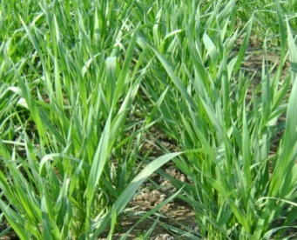 | QL | VS
PGH | Plant growth habit | Semi-erect | 3 | 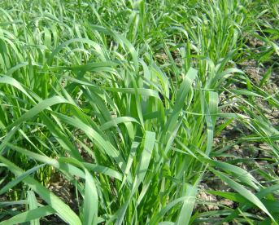 | QL | VS
PGH | Plant growth habit | Intermediate | 5 | 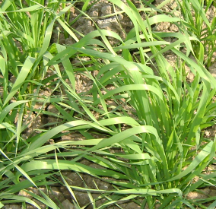 | QL | VS
PGH | Plant growth habit | Semi-Prostrate | 7 | 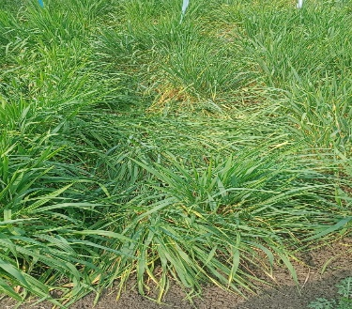 | QL | VS
PGH | Plant growth habit | Prostrate | 9 | 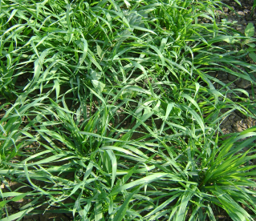 | QL | VS
F Col | Foliage color | Pale green | 1 | 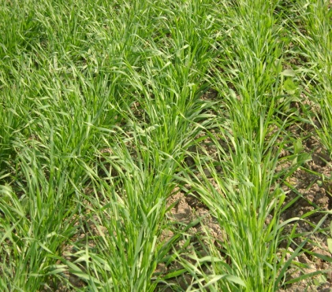 | QL | VG
F Col | Foliage color | Green | 5 | 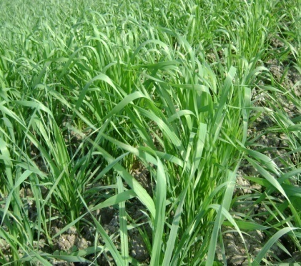 | QL | VG
F Col | Foliage color | Dark green | 9 | 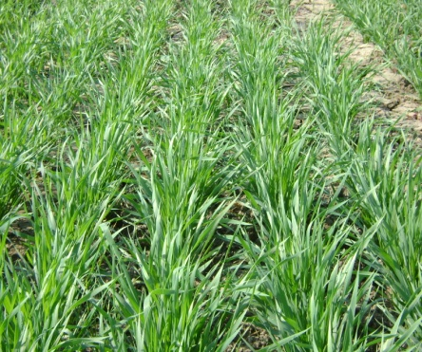 | QL | VG
FLAt | Flag leaf attitude | Erect | 1 | 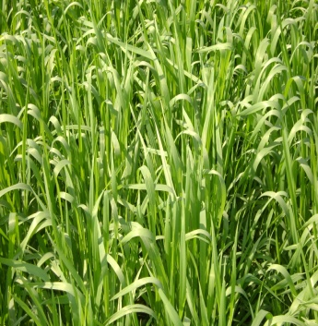 | QL | VG
FLAt | Flag leaf attitude | Semi-erect | 3 | 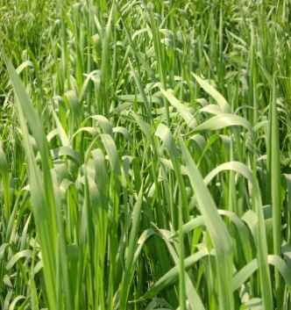 | QL | VG
FLAt | Flag leaf attitude | Drooping | 5 | 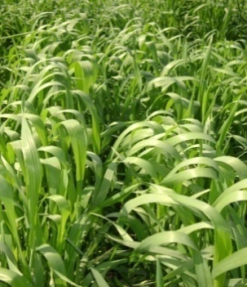 | QL | VG
FLAPi | Flag leaf : Anthocyanin colouration of auricles | Absent | 1 | 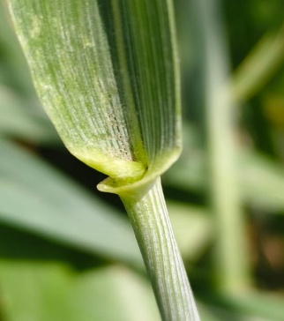 | QL | VS
FLAPi | Flag leaf : Anthocyanin colouration of auricles | Present | 9 | 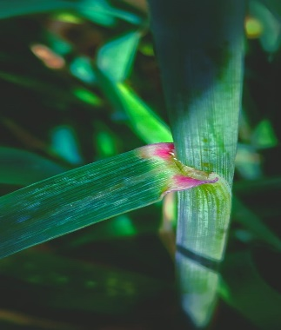 | QL | VS
FLAPb | Flag leaf : Hairs  on auricle | Absent | 1 |  | QL | VS
FLAPb | Flag leaf : Hairs  on auricle | Present | 9 |  | QL | VS
GC | Grain color | White | 1 | 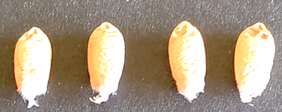 | QL | VG
GC | Grain color | Amber | 2 | 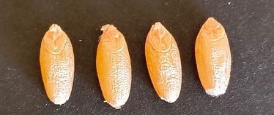 | QL | VG
GC | Grain color | Red | 3 | 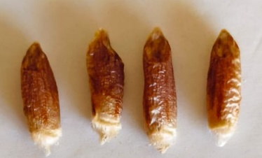 | QL | VG
GS | Grain shape | Round | 1 | 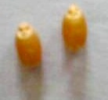 | QL | VG
GS | Grain shape | Ovate | 2 |  | QL | VG
GS | Grain shape | Oblong | 3 | 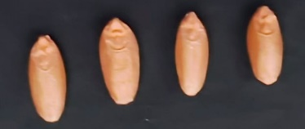 | QL | VG
GS | Grain shape | Elliptical | 4 |  | QL | VG
GCR | Grain crease | Sallow | 3 | 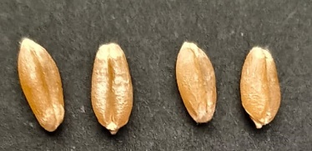 | QL | VG
GCR | Grain crease | Medium | 5 | 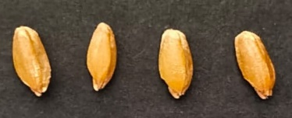 | QL | VG
GCR | Grain crease | Deep | 7 | 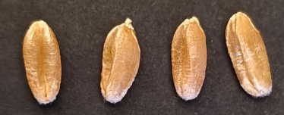 | QL | VG
BHL | Brush hair length | Absent/short | 3 | 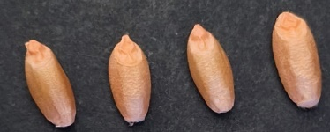 | QL | VG
BHL | Brush hair length | Medium | 5 | 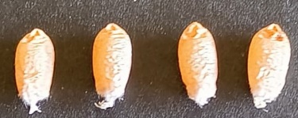 | QL | VG
BHL | Brush hair length | long | 7 |  | QL | VG
GGW | Grain germination width | Narrow | 3 | 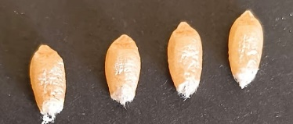 | QL | VG
GGW | Grain germination width | Medium | 5 |  | QL | VG
GGW | Grain germination width | Wide | 7 |  | QL | VG

Table 2. Analysis of variance (ANOVA) for five quantitative traits of 708 durum wheat (Triticum durum Desf.) accessions evaluated over two cropping seasons (2019–2020).
2019 |  | DH |  | PH |  | SL |  | TGW |  | GY
2019 | Df | Sum Sq | Mean Sq | Sum Sq | Mean Sq | Sum Sq | Mean Sq | Sum Sq | Mean Sq | Sum Sq | Mean Sq
Gen | 707 | 117644.8** | 166.4** | 384001.6** | 543.1** | 2228.8** | 3.2** | 121267.7** | 171.5** | 57667930.1** | 81567.1**
Rep | 1 | 263.6** | 263.6** | 537.8** | 537.8** | 1.3** | 1.3** | 860.3** | 860.3** | 8265.0** | 8265.0**
Block | 22 | 10.4** | 0.5** | 658.5** | 29.9** | 8.3** | 0.4** | 2227.2** | 101.2** | 6542.7** | 297.4**
Residuals | 685 | 512.5 | 0.7 | 14300.9 | 20.9 | 295.1 | 0.4 | 64094.0 | 93.6 | 102002.8 | 148.9
2020
Gen | 707 | 432164.5** | 611.3** | 418454.1 | 591.9** | 1900.0** | 2.7** | 70883.9** | 100.3** | 41749558.8** | 59051.7**
Rep | 1 | 19.2** | 19.2** | 645.3** | 645.3** | 12.1** | 12.1** | 206.6** | 206.6** | 49996.7** | 49996.7**
Block | 22 | 17.1** | 0.8** | 2277.3** | 103.5** | 40.5** | 1.8** | 53.1** | 2.4** | 94886.6** | 4313.0**
Residuals | 685 | 448.2 | 0.7 | 41073.6 | 60.0 | 480.6 | 0.7 | 902.7 | 1.3 | 620545.7 | 905.9
Overall
Gen | 707 | 444514.0** | 628.7** | 700084.2** | 990.2** | 2841.8** | 4.0** | 124836.5** | 176.6** | 79047169.3** | 111806.5**
Rep | 1 | 212.6** | 212.6** | 1180.7** | 1180.7** | 10.7** | 10.7** | 955.1** | 955.1** | 49458.8** | 49458.8**
Block | 22 | 15.2** | 0.7** | 1623.1** | 73.8** | 15.3** | 0.7** | 1154.2** | 52.5** | 53779.1** | 2444.5**
Year | 1 | 99210.7 | 99210.7 | 4309.7 | 4309.7 | 38.9 | 38.9 | 4798.1 | 4798.1 | 2093954.1 | 2093954.1
Gen:Year | 707 | 105295.3** | 148.9** | 102371.6** | 144.8** | 1287.1** | 1.8** | 67315.1** | 95.2** | 20370319.6** | 28812.3**
Residuals | 1393 | 1043.1 | 0.7 | 56689.7 | 40.7 | 812.0 | 0.6 | 66234.7 | 47.5 | 779001.6 | 559.2

Table 3. Genetic parameters and descriptive statistics for five quantitative traits of 708 durum wheat (Triticum durum Desf.) accessions evaluated during the growing season 2019-2020 and overall.
Environment | Statistic | DH | PH | SL | TGW | GY
2019 | Heritability | 0.97 | 0.96 | 0.86 | 0.45 | 0.99
2019 | Genotype Variance | 82.8** | 256.3** | 1.4** | 38.0** | 40768.8**
2019 | Residual Variance | 0.7 | 20.8 | 0.4 | 93.6 | 149.1
2019 | Grand Mean | 80.2 | 86.6 | 6.7 | 38.6 | 379.3
2019 | LSD | 1.69 | 8.86 | 1.20 | 12.74 | 24.16
2019 | CV | 1.07 | 5.27 | 9.77 | 25.09 | 3.22
2019 | n Replicates | 2 | 2 | 2 | 2 | 2
2020 | Heritability | 0.99 | 0.89 | 0.73 | 0.98 | 0.98
2020 | Genotype Variance | 305.3** | 244.6** | 1.0** | 49.3** | 28503.2**
2020 | Residual Variance | 0.7 | 60.6 | 0.7 | 1.3 | 906.3
2020 | Grand Mean | 92.0 | 89.1 | 6.9 | 36.0 | 324.9
2020 | LSD | 1.6 | 14.6 | 1.4 | 2.3 | 59.7
2020 | CV | 0.9 | 8.7 | 12.1 | 3.2 | 9.3
2020 | n Replicates | 2 | 2 | 2 | 2 | 2
Overall | Heritability | 0.76 | 0.85 | 0.55 | 0.46 | 0.74
Overall | Genotype Variance | 119.95** | 204.72** | 0.54** | 19.62** | 20484.38**
Overall | Gen X Loc Variance | 74.12** | 51.54** | 0.6** | 22.92** | 14215.55**
Overall | Residual Variance | 0.70 | 40.33 | 0.57 | 47.45 | 528.04
Overall | Grand Mean | 86.08 | 87.84 | 6.83 | 37.25 | 352.11
Overall | LSD | 14.81 | 15.39 | 1.37 | 9.08 | 203.19
Overall | CV | 0.97 | 7.23 | 11.09 | 18.49 | 6.53
DH; Days to heading, PH; Plant height, SL; Spike length, TGW; Thousand grain weight, GY; Grain yield, LSD; Least significant difference, CV; Coefficient of variance, *; 5%, **; 1%.

