Figure
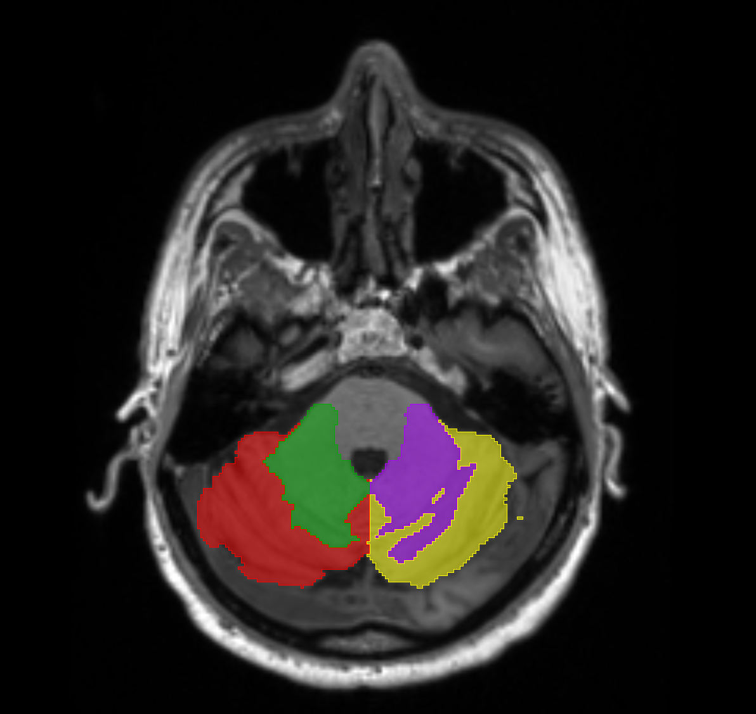
Figure S1. Schematic diagram of brain segmentation for the subjects. The red represents the right cerebellar gray matter, the green represents the right cerebellar white matter, the yellow represents the left cerebellar gray matter, and the purple represents the left cerebellar white matter.
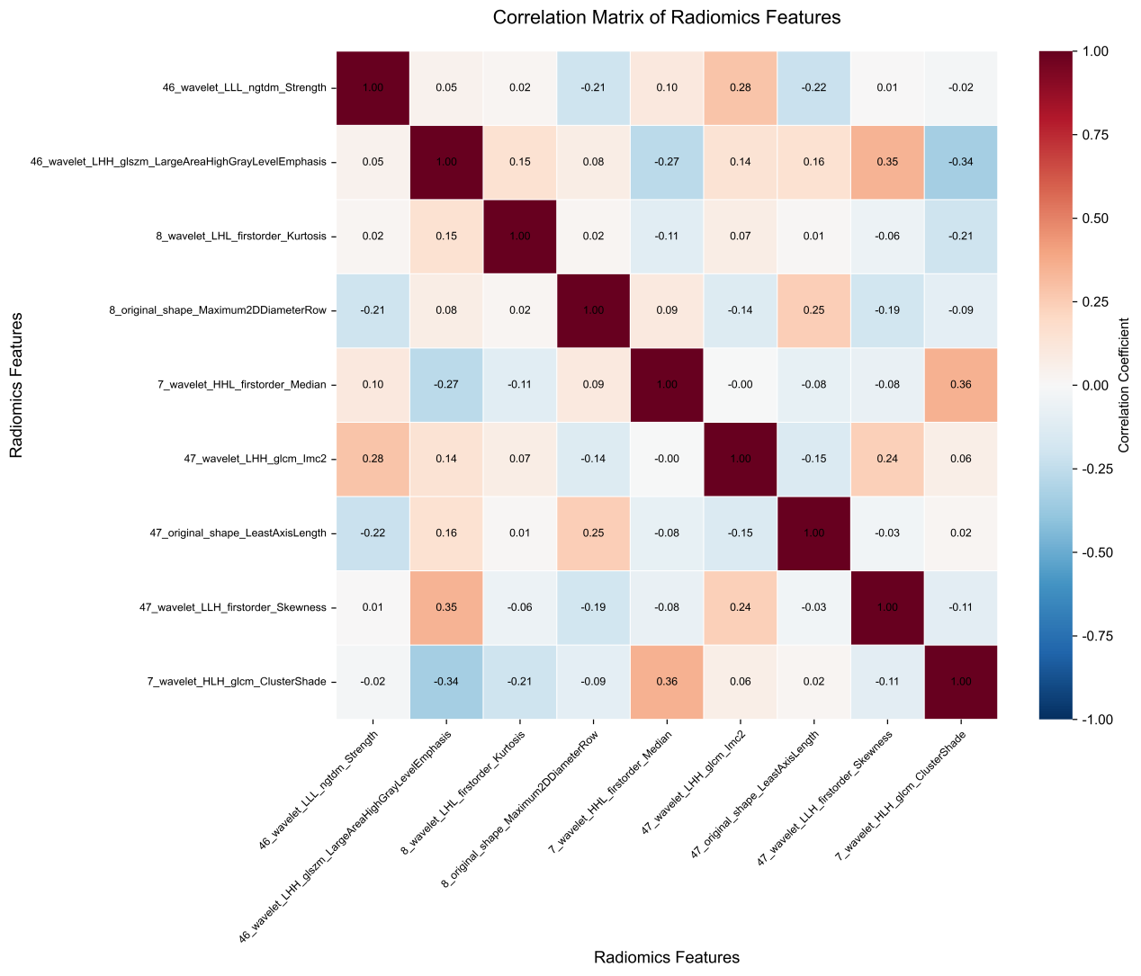

Figure S2. Correlation heatmap of radiomic features.

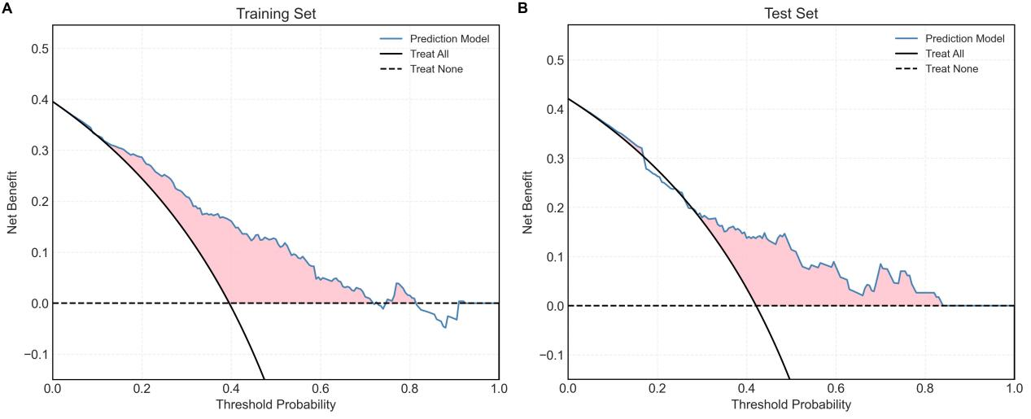
Figure S3. Decision curve analysis (DCA) plot of the radiomics model.

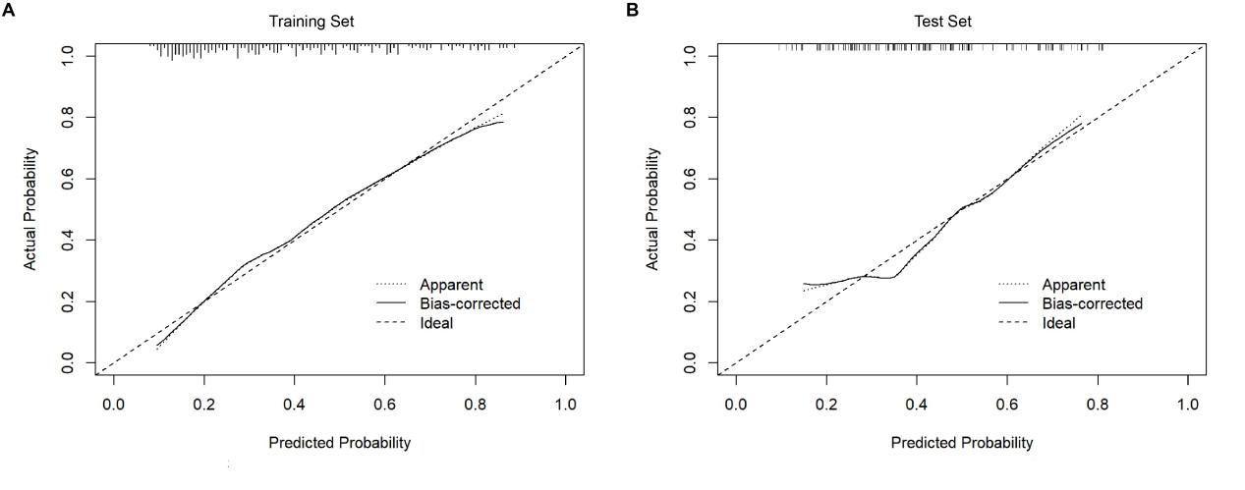
Figure S4. Calibration curve plot of the radiomics model.

