Supporting Information

Lanthanide-Based Metal–Organic Frameworks Solidified by Gelatin-Methacryloyl Hydrogels for Improving the Accuracy of Localization and Excision of Small Pulmonary Nodules

Haoran Ji^{1#}, Xiaofeng Wang^{2#}, Pei Wang¹, Yan Gong¹, Yun Wang¹, Chang Liu¹, Guangyu Ji^{1*}, Xiansong Wang^{1*}, and Mingsong Wang^{1*}

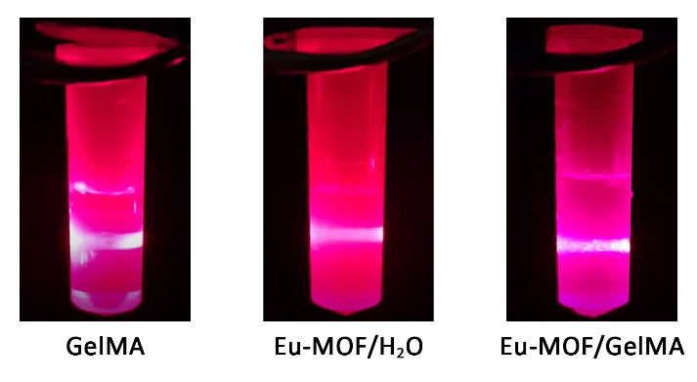
Fig. S1 Test of the Tyndall effect for the GelMA, Eu-MOF/H₂O, and Eu-MOF/GelMA suspensions.

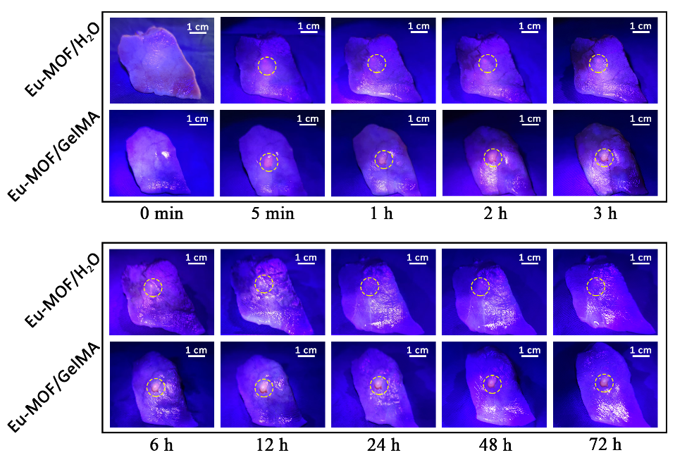
Fig. S2 Fluorescence images of a 72 h observation of porcine lung segments injected with Eu-MOF/H₂O and Eu-MOF/GelMA.

