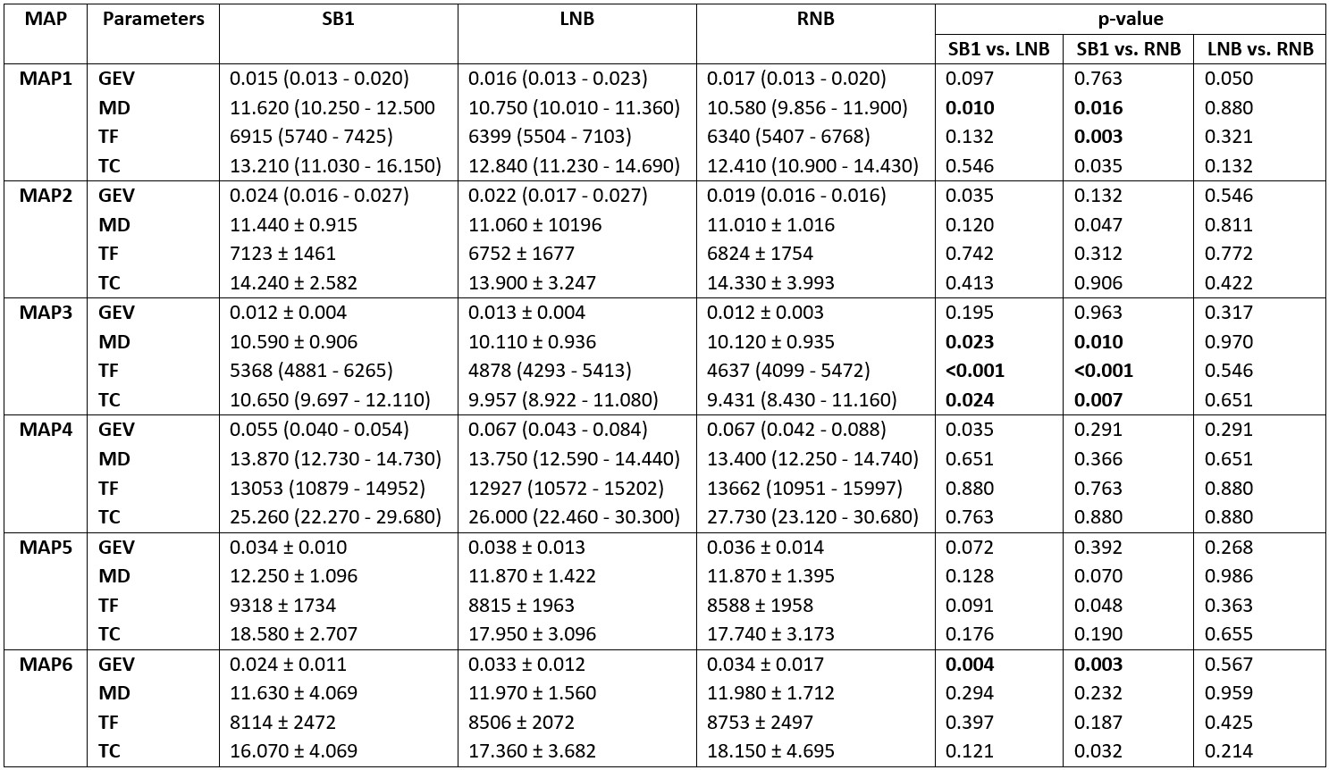
Table ST1: Microstate parameters of SB1 and SNB: The table shows the comparison of microstate parameters between groups (LNB v/s SB1, RNB v/s SB1, LNB v/s RNB) for GEV-global explained variance (%), MD- mean duration (ms), TF- Number of time frames (count), and TC- time coverage (%). The data is represented as Mean ± SD or median (IQR) based on the Gaussian distribution of the data; *p<0.05; **p<0.01; ***p<0.001

Table ST2: The microstate sources of Map 1 which were significant higher activity in LNB as compared to SB1. The table shows the coordinates of the voxels of the gyri showing significant activity along with the Brodmann area (BA) and lobe to which it belongs. L, Left; R, Right; A, Anterior; P, Posterior; S, Superior; I, Inferior

Structure | BA | Lobe | Hemisphere | X (MNI) | Y (MNI) | Z (MNI) | Voxel Value
Anterior Cingulate | 25 | Limbic | Right | 5 | 20 | -5 | -5.38927
Anterior Cingulate | 24 | Limbic | Right | 5 | 25 | -5 | -5.32824
Medial Frontal Gyrus | 11 | Frontal | Right | 10 | 25 | -10 | -5.2457
Anterior Cingulate | 32 | Limbic | Right | 10 | 20 | -10 | -5.17444
Anterior Cingulate | 32 | Limbic | Right | 5 | 25 | -10 | -5.16682
Superior Temporal Gyrus | 22 | Temporal | Right | 65 | -45 | 20 | -5.10249
Anterior Cingulate | 32 | Limbic | Right | 5 | 20 | -10 | -5.09006
Medial Frontal Gyrus | 11 | Frontal | Right | 10 | 25 | -15 | -4.9728
Anterior Cingulate | 32 | Limbic | Right | 5 | 30 | -10 | -4.95448
Superior Temporal Gyrus | 22 | Temporal | Right | 65 | -40 | 20 | -4.95287

Table ST3: The microstate sources of Map 3 which were significant higher activity in LNB as compared to SB1. The table shows the coordinates of the voxels of the gyri showing significant activity along with the Brodmann area (BA) and lobe to which it belongs. L, Left; R, Right; A, Anterior; P, Posterior; S, Superior; I, Inferior

Structure | BA | Lobe | Hemisphere | X (MNI) | Y (MNI) | Z (MNI) | Voxel Value
Anterior Cingulate | 24 | Limbic | Right | 5 | 25 | -5 | -5.56077
Anterior Cingulate | 24 | Limbic | Right | 5 | 30 | -5 | -5.39353
Medial Frontal Gyrus | 11 | Frontal | Right | 10 | 25 | -10 | -5.37881
Anterior Cingulate | 24 | Limbic | Right | 5 | 25 | 15 | -5.34985
Anterior Cingulate | 24 | Limbic | Right | 5 | 30 | 0 | -5.29223
Anterior Cingulate | 32 | Limbic | Right | 5 | 30 | -10 | -5.27544
Anterior Cingulate | 25 | Limbic | Right | 5 | 20 | -5 | -5.24676
Anterior Cingulate | 32 | Limbic | Right | 5 | 25 | -10 | -5.21965
Anterior Cingulate | 24 | Limbic | Left | -5 | 30 | 0 | -5.17685
Medial Frontal Gyrus | 25 | Frontal | Right | 10 | 30 | -15 | -5.13181
Superior Temporal Gyrus | 22 | Temporal | Right | 65 | -45 | 20 | -5.12607
Anterior Cingulate | 32 | Limbic | Right | 10 | 20 | -10 | -5.1125
Precentral Gyrus | 6 | Frontal | Right | 55 | -5 | 25 | -5.07796
Anterior Cingulate | 24 | Limbic | Right | 0 | 30 | 15 | -5.03468
Medial Frontal Gyrus | 11 | Frontal | Right | 10 | 25 | -15 | -5.03411
Anterior Cingulate | 24 | Limbic | Left | -5 | 25 | 15 | -5.03044
Inferior Parietal | 40 | Parietal | Right | 60 | -45 | 20 | -5.02381
Anterior Cingulate | 24 | Limbic | Left | -5 | 30 | 15 | -5.02085
Superior Temporal Gyrus | 22 | Temporal | Right | 65 | -45 | 15 | -5.01633
Anterior Cingulate | 24 | Limbic | Right | 5 | 30 | 15 | -5.01604
Medial Frontal Gyrus | 11 | Frontal | Right | 5 | 30 | -15 | -4.99686
Inferior Frontal Gyrus | 47 | Frontal | Right | 10 | 30 | -15 | -4.97424
Anterior Cingulate | 32 | Limbic | Right | 10 | 35 | -10 | -4.93638
Inferior Parietal | 40 | Parietal | Right | 65 | -45 | 25 | -4.93595
Precentral Gyrus | 6 | Frontal | Right | 65 | -5 | 25 | -4.91335
Precentral Gyrus | 6 | Frontal | Right | 65 | -5 | 30 | -4.90495
Inferior Parietal | 40 | Parietal | Right | 60 | -45 | 25 | -4.90005
Anterior Cingulate | 32 | Limbic | Right | 5 | 20 | -10 | -4.89519

Table ST4: The microstate sources of Map 3 which were significant higher activity in RNB as compared to SB1. The table shows the coordinates of the voxels of the gyri showing significant activity along with the Brodmann area (BA) and lobe to which it belongs. L, Left; R, Right; A, Anterior; P, Posterior; S, Superior; I, Inferior

Structure | BA | Lobe | Hemisphere | X  (MNI) | Y  (MNI) | Z  (MNI) | Voxel  Value
Middle Frontal Gyrus | 11 | Frontal | Left | -25 | 45 | -10 | -5.74044
Middle Frontal Gyrus | 11 | Frontal | Left | -25 | 40 | -5 | -5.71672
Middle Frontal Gyrus | 11 | Frontal | Left | -20 | 40 | -15 | -5.69853
Middle Frontal Gyrus | 11 | Frontal | Left | -25 | 45 | -5 | -5.63577
Superior Frontal Gyrus | 11 | Frontal | Left | -25 | 45 | -15 | -5.44764
Middle Frontal Gyrus | 11 | Frontal | Left | -25 | 40 | -10 | -5.425
Superior Frontal Gyrus | 11 | Frontal | Left | -25 | 50 | -15 | -5.35249
Inferior Frontal Gyrus | 47 | Frontal | Left | -20 | 30 | -5 | -5.32188
Middle Frontal Gyrus | 11 | Frontal | Left | -25 | 50 | -10 | -5.21834
Inferior Frontal Gyrus | 47 | Frontal | Left | -25 | 35 | -5 | -5.21283
Superior Frontal Gyrus | 11 | Frontal | Left | -20 | 40 | -20 | -5.13052
Superior Frontal Gyrus | 11 | Frontal | Left | -20 | 45 | -20 | -5.07048
Subcallosal | 11 | Frontal | Left | -10 | 25 | -10 | -5.01346
Middle Frontal Gyrus | 11 | Frontal | Left | -25 | 40 | -15 | -5.00157
Inferior Frontal Gyrus | 47 | Frontal | Left | -15 | 30 | -15 | -4.98807
Anterior Cingulate | 32 | Limbic | Left | -10 | 35 | -5 | -4.97906
Anterior Cingulate | 24 | Limbic | Left | -5 | 25 | -5 | -4.97861

Table ST5: The microstate sources of Map 6 which were significant higher activity in LNB as compared to SB1. The table shows the coordinates of the voxels of the gyri showing significant activity along with the Brodmann area (BA) and lobe to which it belongs. L, Left; R, Right; A, Anterior; P, Posterior; S, Superior; I, Inferior

Structure | BA | Lobe | Hemisphere | X (MNI) | Y (MNI) | Z (MNI) | Voxel Value
Superior Temporal Gyrus | 39 | Temporal | Right | 55 | -60 | 30 | -5.19153
Superior Temporal Gyrus | 22 | Temporal | Right | 65 | -45 | 20 | -5.19152
Inferior Parietal Lobule | 40 | Parietal | Right | 50 | -50 | 25 | -5.14467
Inferior Parietal Lobule | 40 | Parietal | Right | 60 | -45 | 20 | -5.01728
Superior Temporal Gyrus | 13 | Temporal | Right | 50 | -45 | 20 | -4.99799
Inferior Parietal Lobule | 40 | Parietal | Right | 65 | -45 | 25 | -4.99079
Superior Temporal Gyrus | 22 | Temporal | Right | 65 | -40 | 20 | -4.97761
Inferior Parietal Lobule | 40 | Parietal | Right | 65 | -40 | 25 | -4.97342
Superior Temporal Gyrus | 39 | Temporal | Right | 45 | -55 | 25 | -4.9287
Superior Temporal Gyrus | 13 | Temporal | Right | 55 | -45 | 20 | -4.92648
Superior Temporal Gyrus | 22 | Temporal | Right | 65 | -45 | 15 | -4.91474
Supra marginal Gyrus | 40 | Parietal | Right | 55 | -55 | 30 | -4.91336

Table ST6: The microstate sources of Map 6 which were significant higher activity in RNB as compared to SB1. The table shows the coordinates of the voxels of the gyri showing significant activity along with the Brodmann area (BA) and lobe to which it belongs. L, Left; R, Right; A, Anterior; P, Posterior; S, Superior; I, Inferior

Structure | BA | Lobe | Hemisphere | X  (MNI) | Y  (MNI) | Z  (MNI) | Voxel Value
Insula | 13 | Sub-lobar | Left | -30 | -25 | 15 | -5.01964
Cuneus | 18 | Occipital | -- | 0 | -75 | 10 | -4.91829
Cuneus | 23 | Occipital | Left | -5 | -75 | 10 | -4.88421

Table ST7: Significant functional connectivity differences identified by sLORETA analysis using Lagged Linear Connectivity, Lagged Non-linear Connectivity, and Instantaneous Phase Synchronization. Functional connectivity was computed using 128-channel EEG recordings across 70 regions of interest (ROIs) identified from microstate source localization and evaluated in six user-defined frequency bands (1–4, 4–8, 8–13, 13–30, 30–100, and 1–100 Hz). Only statistically significant connections are presented.
Connectivity Parameter | Group Comparison | Frequency Band (Hz) | Significant Brain Region Pairs
Lagged Linear Connectivity | LNB vs. SB1 | 4-8 | Superior Temporal Gyrus ↔ Inferior Parietal Lobule  Superior Temporal Gyrus ↔ Insula
Lagged Linear Connectivity | RNB vs. SB1 | 8-13 | Middle Frontal Gyrus ↔ Inferior Parietal Lobule
Lagged Linear Connectivity | RNB vs. SB1 | 13-30 | Superior Temporal Gyrus ↔ Anterior Cingulate  Superior Temporal Gyrus ↔ Superior Frontal Gyrus  Precentral Gyrus ↔ Inferior Parietal Lobule  Inferior Parietal Lobule ↔ Anterior Cingulate  Anterior Cingulate ↔ Anterior Cingulate
Lagged Non-linear Connectivity | RNB vs. SB1 | 8-13 | Superior Frontal Gyrus ↔ Inferior Parietal Lobule  Middle Frontal Gyrus ↔ Inferior Parietal Lobule  Inferior Parietal Lobule ↔ Inferior Frontal Gyrus
Lagged Non-linear Connectivity | RNB vs. SB1 | 13-30 | Superior Temporal Gyrus ↔ Anterior Cingulate  Superior Temporal Gyrus ↔ Middle Frontal Gyrus  Superior Temporal Gyrus ↔ Precentral Gyrus  Middle Frontal Gyrus ↔ Inferior Parietal Lobule

