Supplementary Materials
- CBPT for behavioral measures
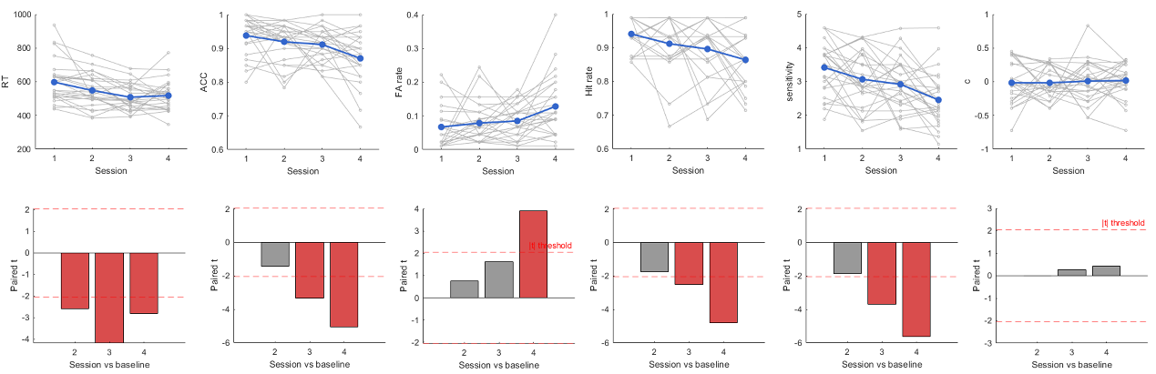
Figure S1. Behavioral performance across the four HDBR phases, including reaction time (RT), accuracy (ACC), false alarm rate (FA rate), hit rate, sensitivity (d’), and response criterion (c). Upper panels display individual participant trajectories (gray lines) and group means (blue lines) across sessions (1 = BDC-10, 2 = HDBR-4, 3 = HDBR-58, 4 = R-11). Bottom panels show observed paired t-statistics for each post-baseline session versus BDC-10, derived from a cluster-based permutation test (10,000 permutations). Red bars indicate comparisons exceeding the cluster-forming threshold (dashed lines, α = 0.05, df = 25); gray bars indicate non-significant comparisons.
- Pairwise CBPT for ACW-θ
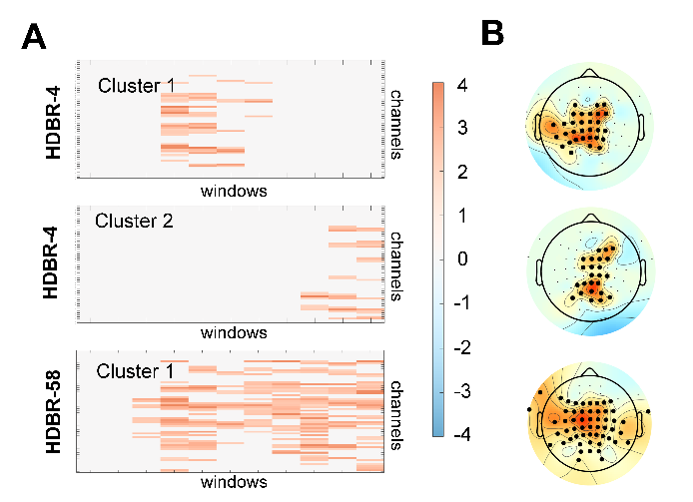
Figure S2. Significant clusters between BDC-10 and other HDBR phases for the theta band. (A) Spatial distribution of t-value from pairwise CPBT. (B) Significant clusters identified after cluster-level correction.
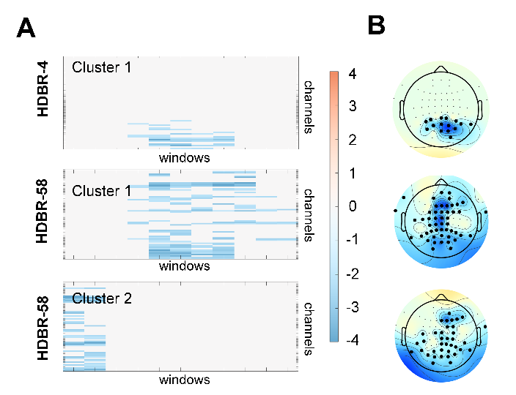
Figure S3. Significant clusters between R-11 and other HDBR phases for the theta band. (A) Spatial distribution of t-value from pairwise CPBT. (B) significant clusters identified after cluster-level correction.
- Leave-one-out cross-validation (LOOCV) prediction
To investigate whether regional ACW could predict individual behavioral performance, we constructed multiple linear regression (MLR) models for each HDBR phase and frequency band separately. Taking channel-level ACW values as independent variables and behavioral measures (ACC, RT, d’, and c) as dependent variables, we implemented a nested feature selection and cross-validation procedure as follows. First, for each behavioral measure, we computed the Pearson correlation between the behavioral scores and the ACW values at each of the 64 EEG channels across participants. Channels were then rank-ordered according to the correlation coefficients in descending order. Second, starting from k = 1, we selected the top k channels and fed the corresponding ACW features into an MLR model. Third, leave-one-out cross-validation (LOOCV) was applied to evaluate the prediction model. In each fold, data from one participant were held out as the test set while the remaining participants served as the training set. The MLR model was fitted on the training set, and the behavioral score of the held-out participant was predicted. This procedure was repeated until every participant had been tested. The predicted behavioral scores were then correlated with the actual scores across all participants to assess model performance. This process was iterated by increasing k (i.e., adding the next most correlated channel), and the optimal model was identified when yielding the highest correlation between predicted and actual behavioral scores. Furthermore, we examined the standardized regression weights of the selected channels in the optimal model to determine the relative contribution of each brain region to the prediction of individual behavioral performance.
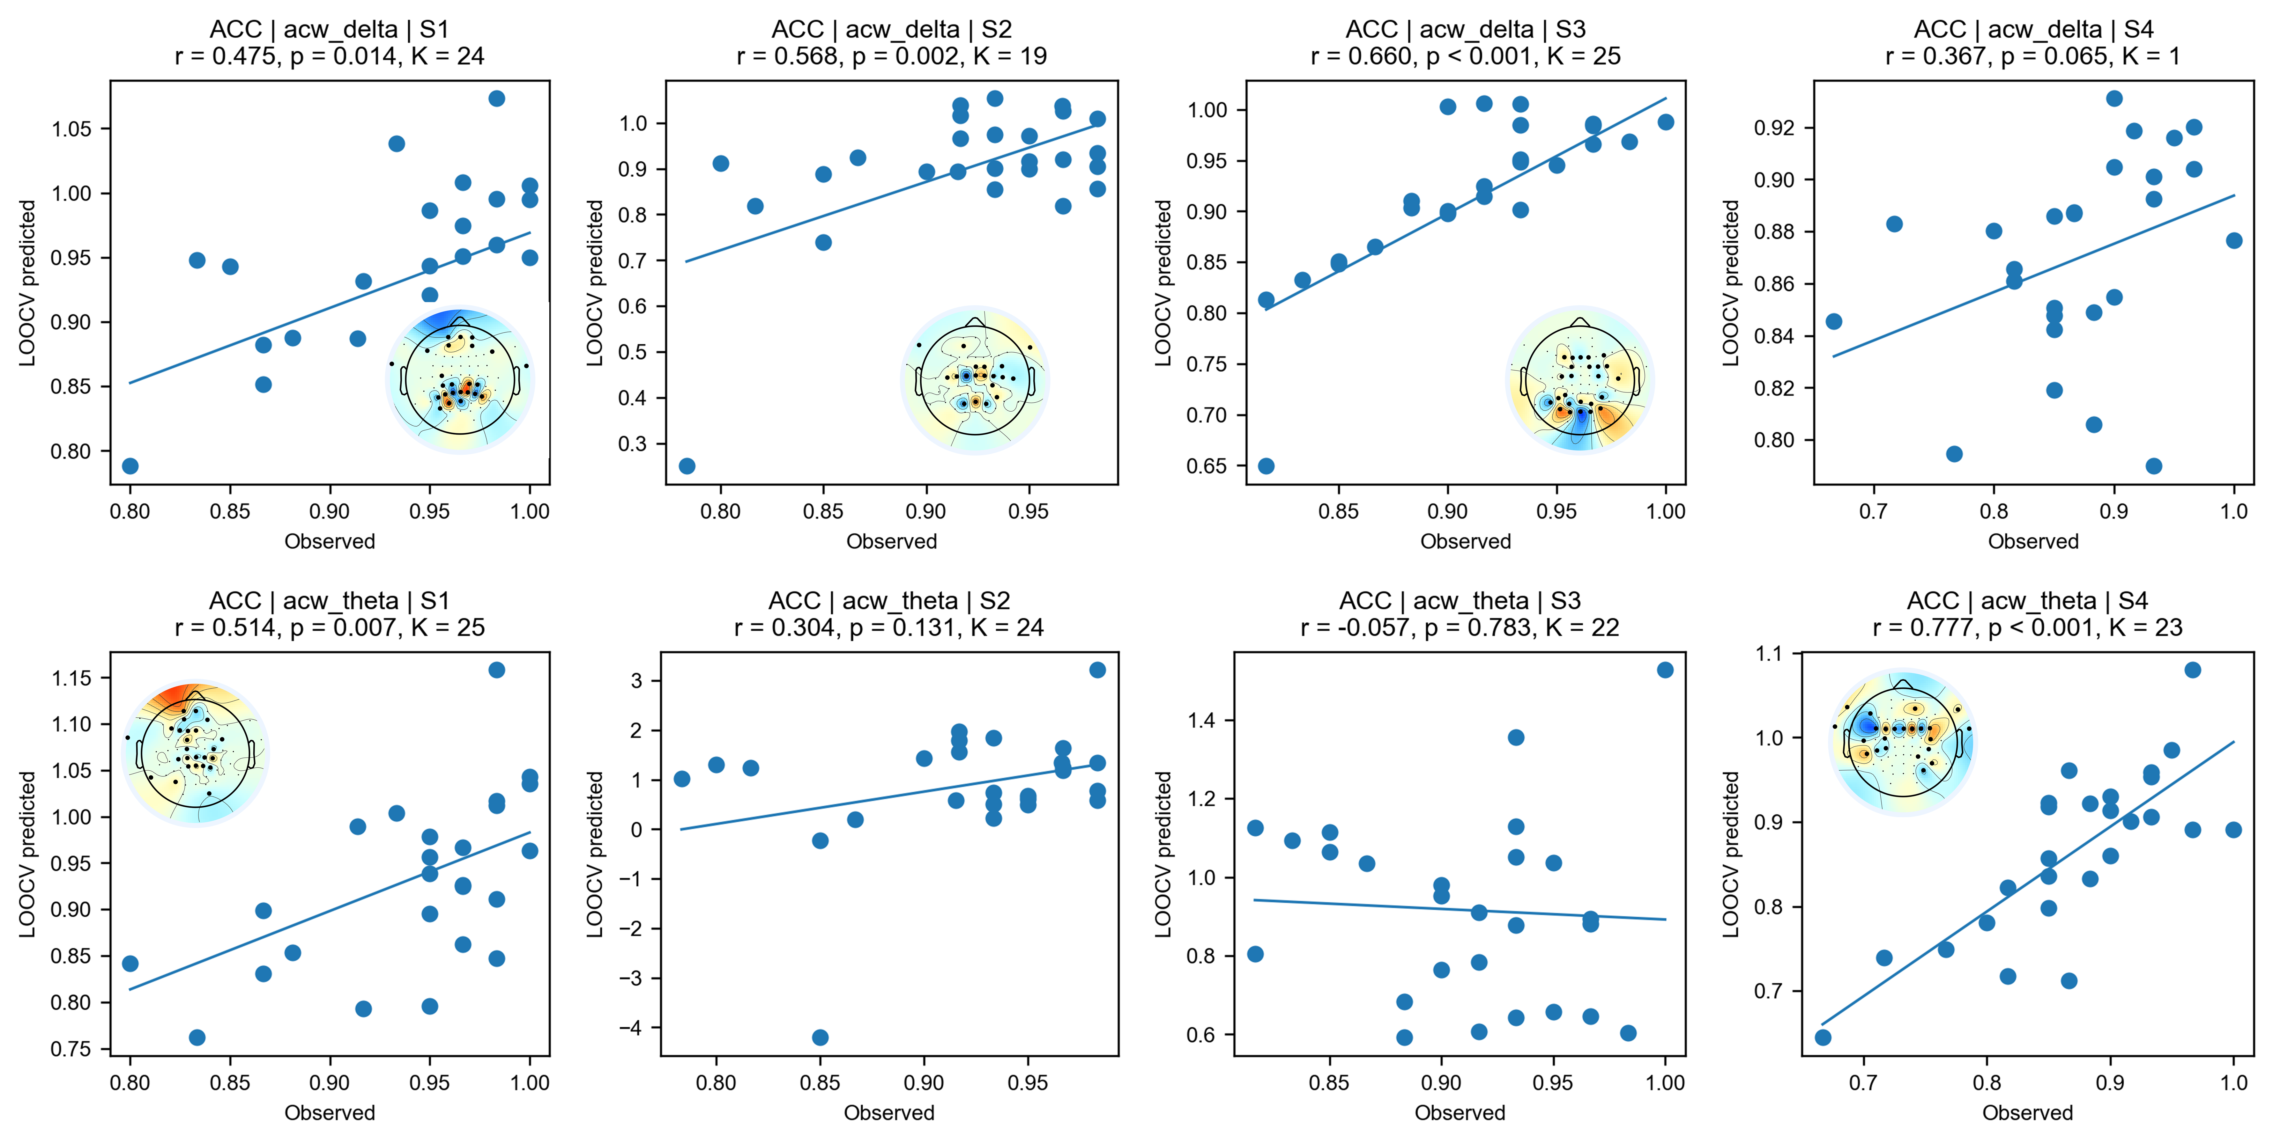
Figure S4. LOOCV-based prediction of ACC from channel-level ACW. Upper: for the delta band, significant predictions of ACC were observed during BDC-10, HDBR-4 and HDBR-58, with the correlations between empirical and predicted ACC increasing across the HDBR phases. The significant channels involved the prefrontal, central and central-parietal regions. Bottom: for the theta band, significant predictions of ACC were observed only during BDC-10 and R-11. The significant channels mainly involved the prefrontal and central regions.
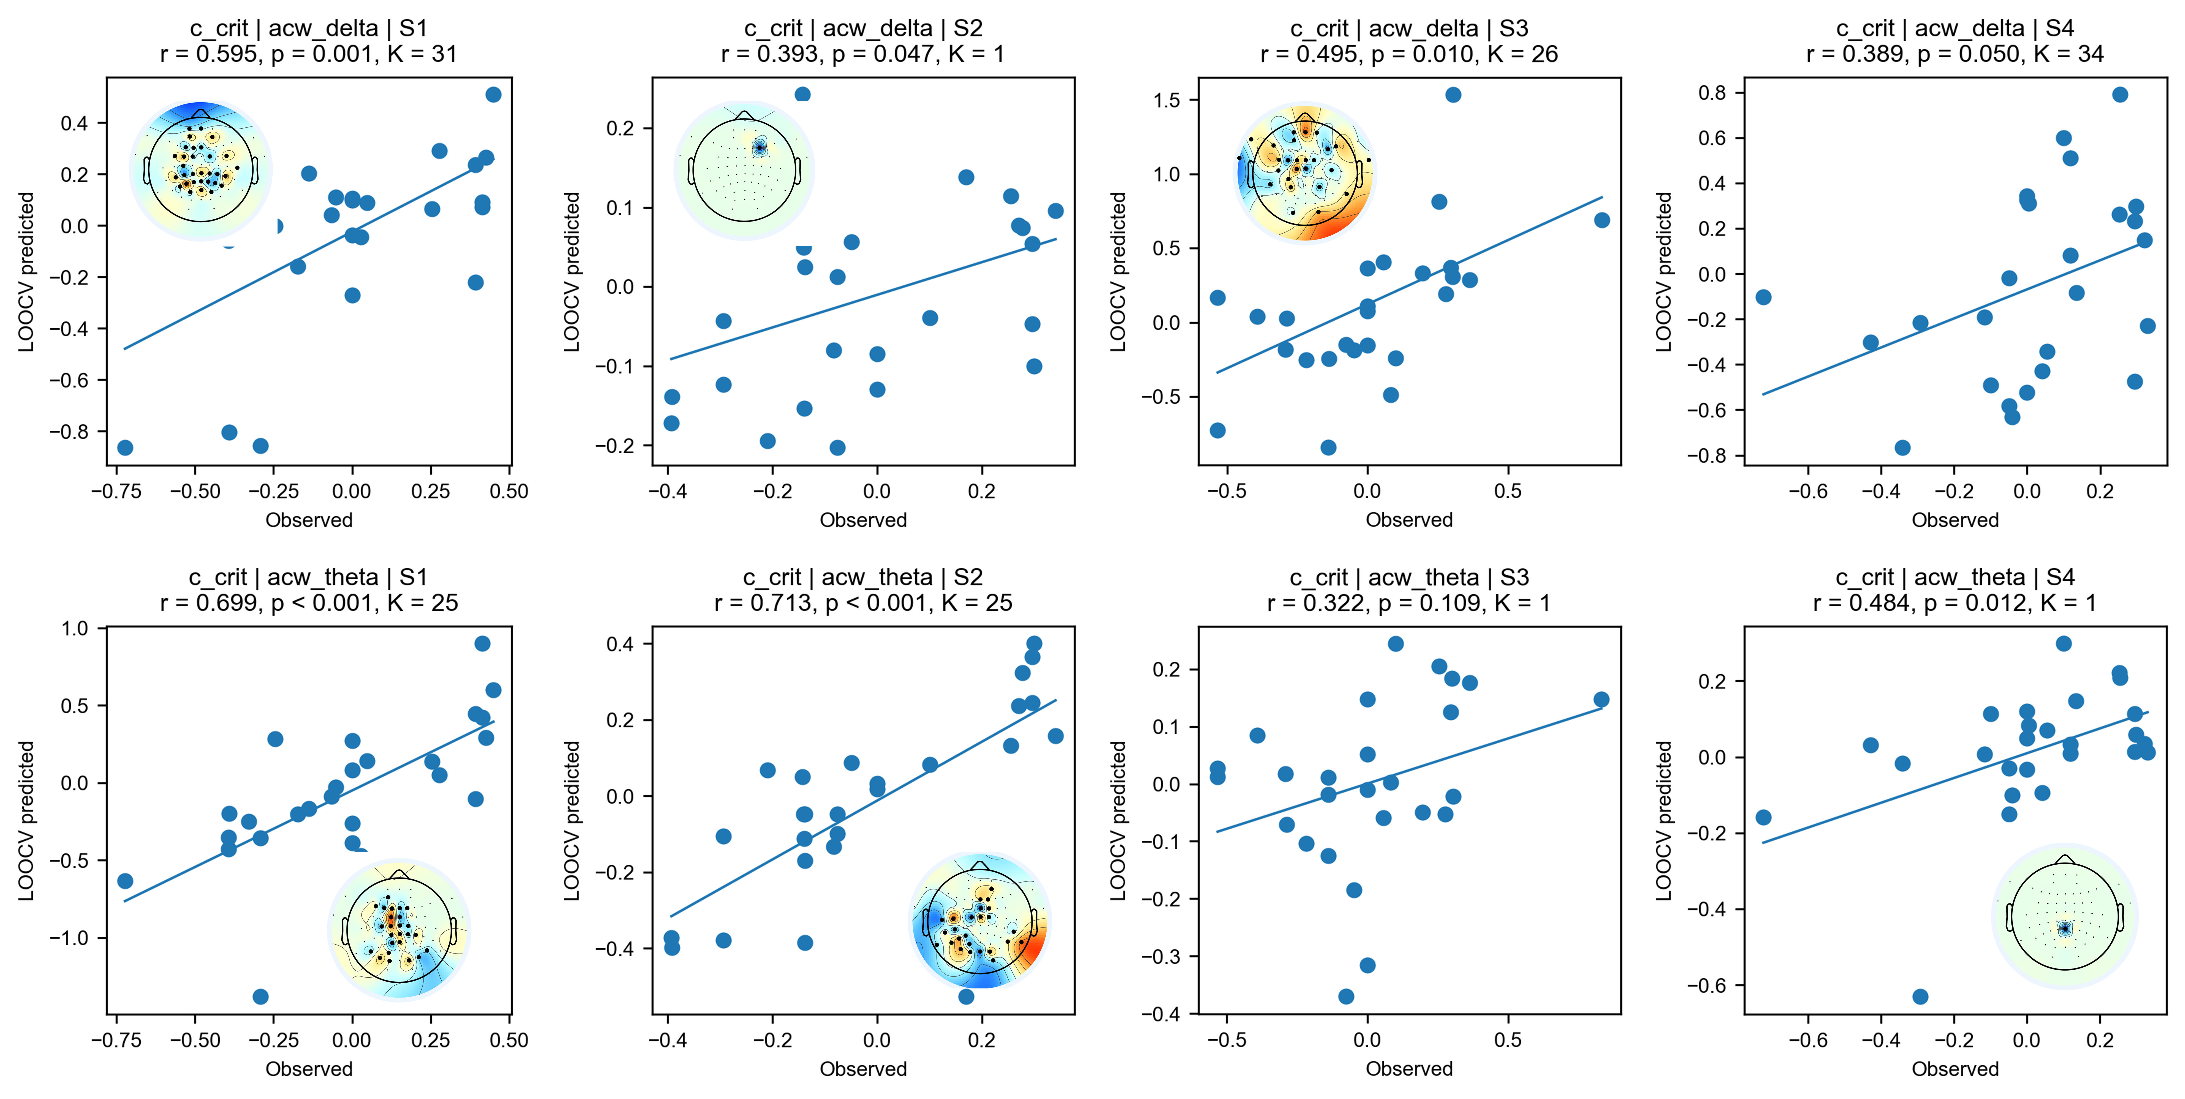
Figure S5. LOOCV-based prediction of criterion from channel-level ACW. Upper: for the delta band, significant predictions were observed during BDC-10, HDBR-4 and HDBR-58. Bottom: for the theta band, significant predictions were observed during BDC-10, HDBR-4 and R-11.
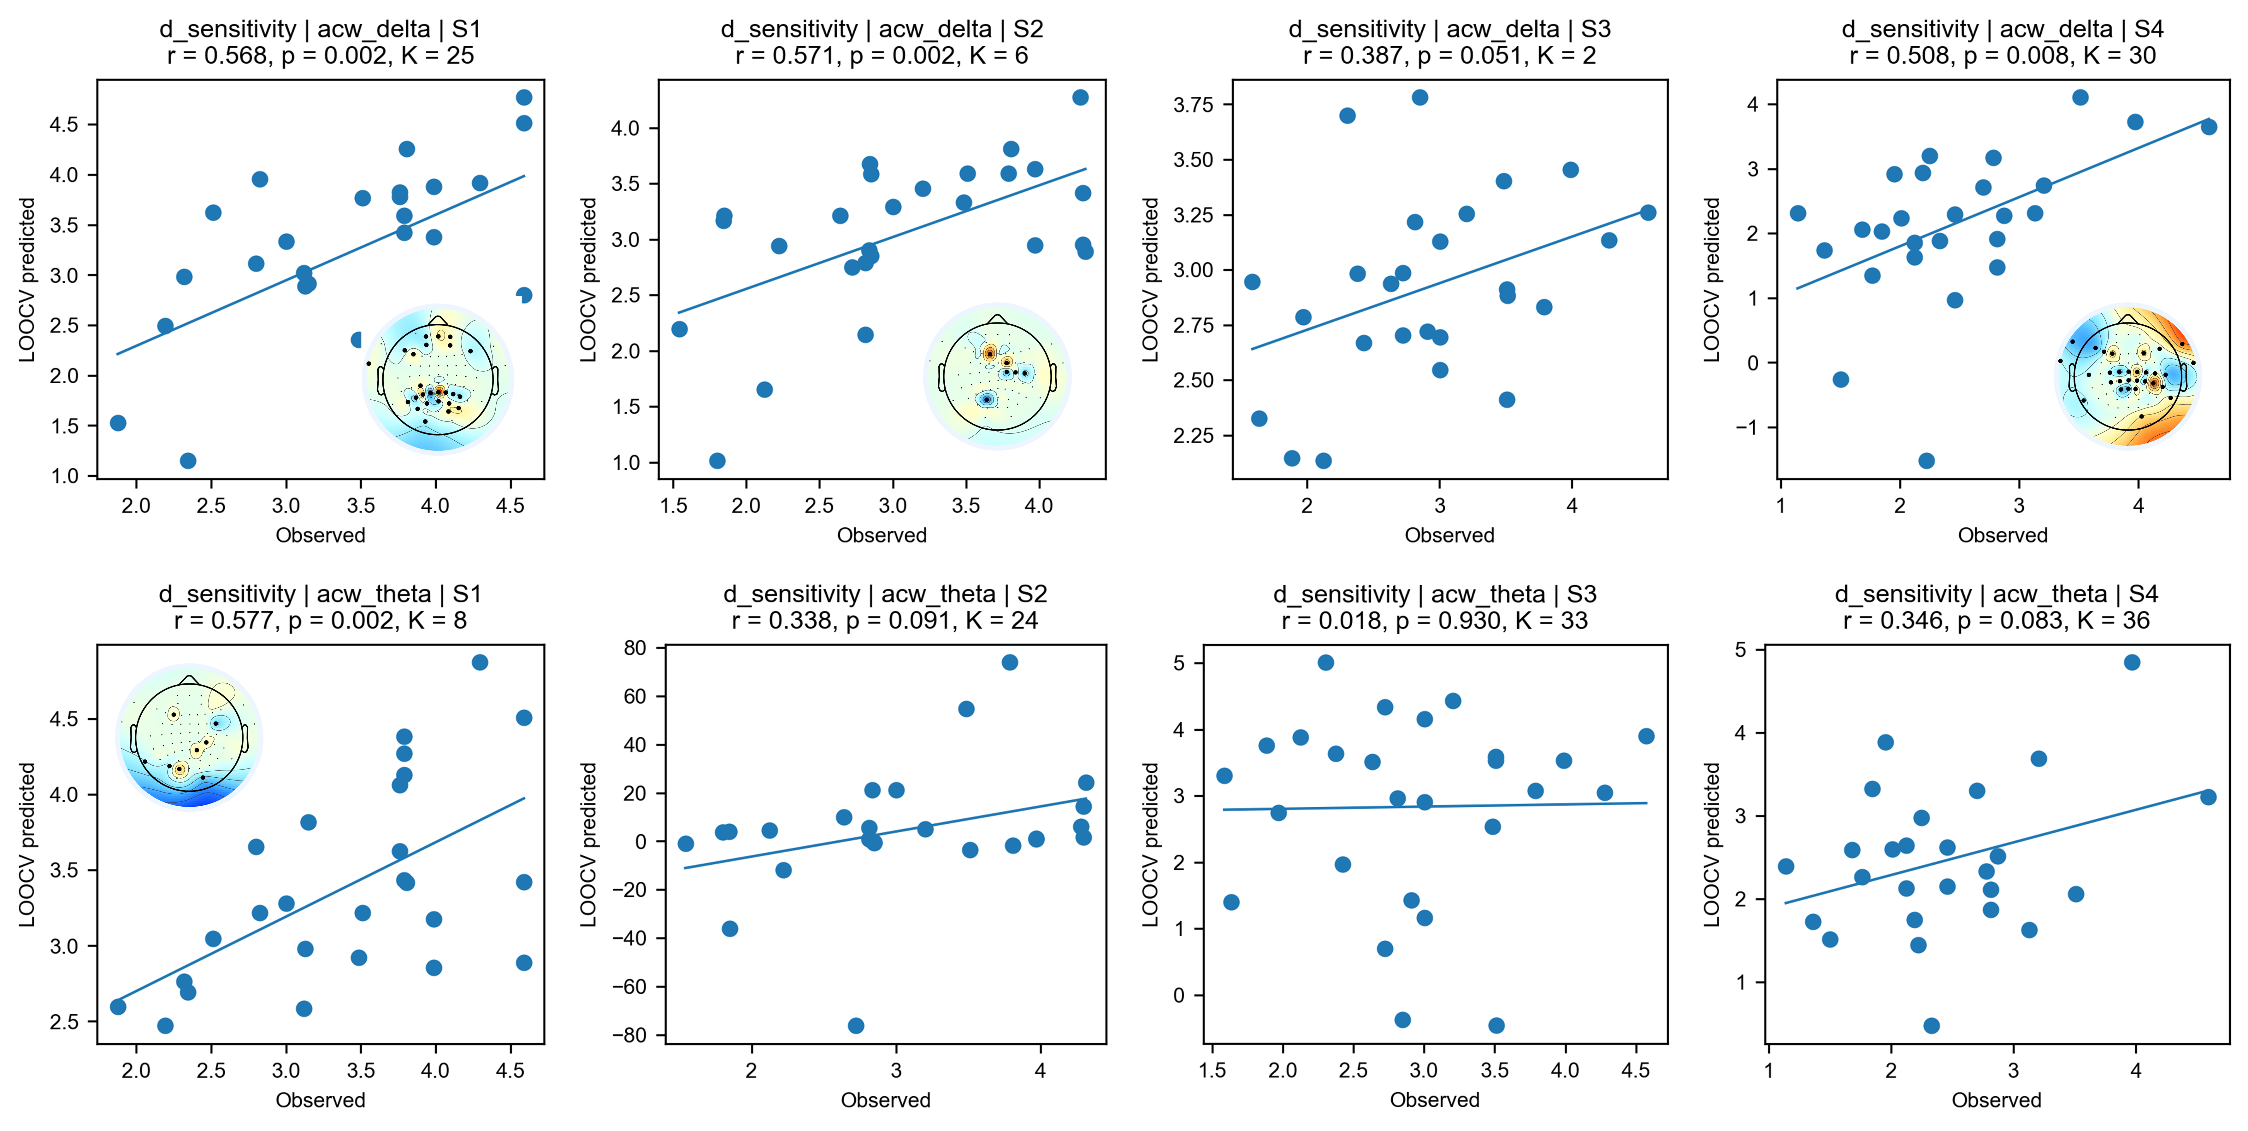
Figure S6. LOOCV-based prediction of d’ from channel-level ACW. Upper: for the delta band, significant predictions were observed during BDC-10, HDBR-4 and R-11. Bottom: for the theta band, significant prediction was observed only during BDC-10.
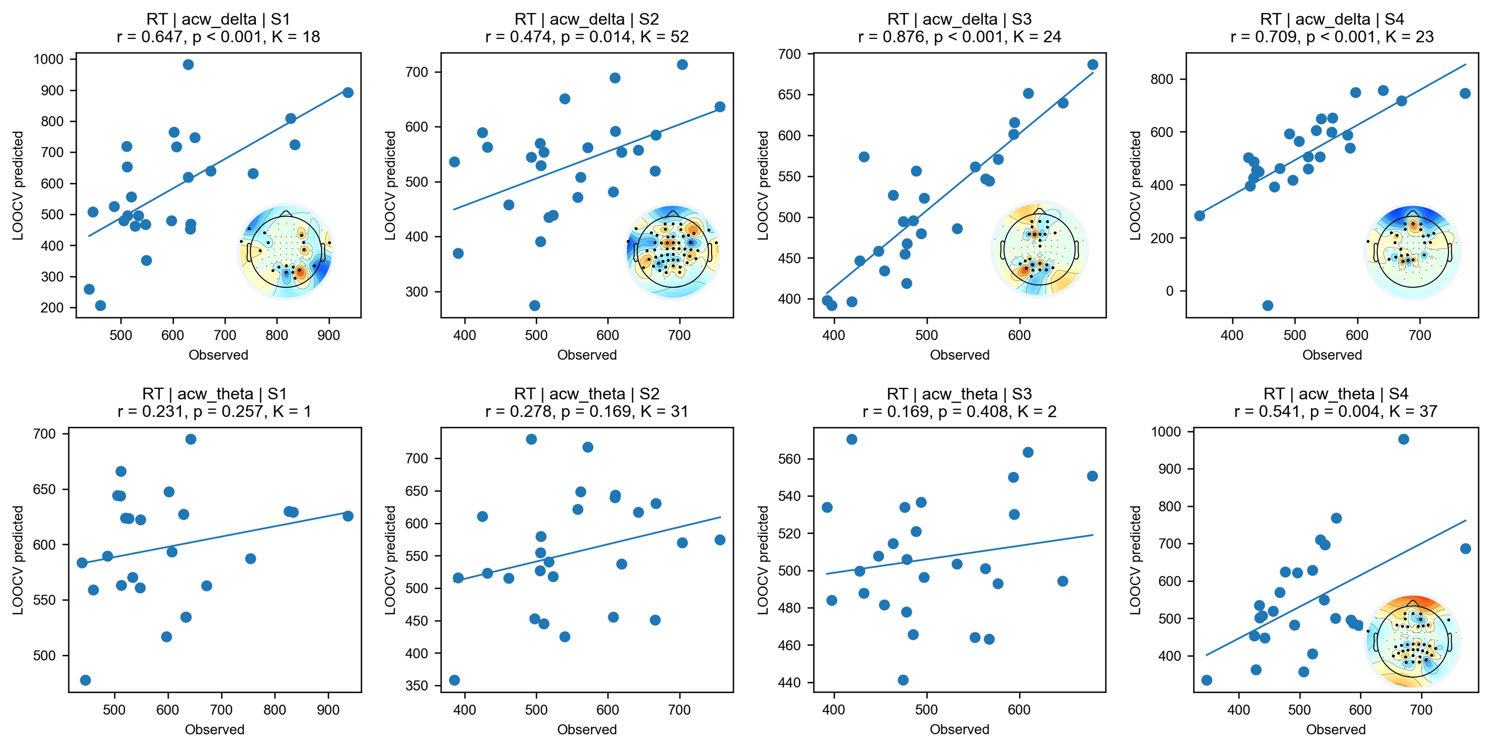
Figure S7. LOOCV-based prediction of RT from channel-level ACW. Upper: for the delta band, significant predictions were observed across all the HDBR phases. Bottom: for the theta band, significant prediction was observed only during R-11.

- Model Parameters
Following Jansen and Rit (1995), fixed parameters of the JR model were set as follows:
Table S1. Fixed parameters
Parameter | Description | Value | Unit
e₀ | Maximum firing rate | 2.5 | s⁻¹
v₀ | Potential at 50% maximum firing rate | 6 | mV
r | Steepness of the sigmoid function | 0.56 | mV⁻¹
C₁ | Synaptic contacts:  pyramidal → excitatory interneurons | 135 | --
C₂ | Synaptic contacts:  excitatory interneurons → pyramidal | 0.6 C₁ | --
C₃ | Synaptic contacts:  pyramidal → inhibitory interneurons | 0.25 C₁ | --
C₄ | Synaptic contacts:  inhibitory interneurons → pyramidal | 0.5 C₁ | --
p(t) | spontaneous background firing rate from neighboring cortical columns and subcortical structures, | , | s⁻¹

- Model fitting
  - Coarse grid search
In the first stage, a coarse grid search was performed to identify the optimal parameter regions that best reproduce the empirical ACW data. The parameter pairs (A, B) and (a, b) were varied separately, with the other pair fixed at standard values. The ranges are shown in Table S2, centering on the standard Jansen-Rit parameter values and spanning a broad region to capture the optimal parameters that best fit the empirical data.
Table S2. The coarse grid search parameters
Parameter | Description | Search range | Step size | Reference value
A | Maximum amplitude of excitatory PSP | [1, 5] mV | 0.05 | 3.25 mV
B | Maximum amplitude of inhibitory PSP | [8, 40] mV | 0.5 | 22 mV
a | Excitatory synaptic rate constant | [50, 150] s⁻¹ | 1 | 100 s⁻¹
b | Inhibitory synaptic rate constant | [20, 80] s⁻¹ | 1 | 50 s⁻¹
For the gain constant model, the best fitting solutions reached χ² = 9.1 for both the deceasing and increasing trajectories. Multiple (A, B) combinations produced equivalent χ² scores, only one example trajectory was listed in Table S3 and Fig. S3.
Table S3. Best-fitting parameter trajectory for the coarse gain constant model
 | Phase | A (mV) | B (mV) | ACW-δ (s) |  |  |  | ACW-θ (s)
 |  |  |  | Simulated |  | real |  | Simulated | real
decreasing A  (χ² = 9.1, r(δ) = 0.982, r(θ) = 0.616) | BDC-10 | 3.3 | 11 | 0.1667 | 0.1730 |  | 0.0493 |  |  | 0.0502
decreasing A  (χ² = 9.1, r(δ) = 0.982, r(θ) = 0.616) | HDBR-4 | 1.4 | 12.5 | 0.1880 | 0.1880 |  | 0.0493 |  |  | 0.0488
decreasing A  (χ² = 9.1, r(δ) = 0.982, r(θ) = 0.616) | HDBR-58 | 1.3 | 10.5 | 0.1773 | 0.1780 |  | 0.0480 |  |  | 0.0487
decreasing A  (χ² = 9.1, r(δ) = 0.982, r(θ) = 0.616) | R-11 | 3.3 | 11 | 0.1667 | 0.1700 |  | 0.0493 |  |  | 0.0502
increasing A  (χ² = 9.1, r(δ) = 0.978, r(θ) = 0.616) | BDC-10 | 3.1 | 11 | 0.1667 | 0.1730 |  | 0.0493 |  |  | 0.0502
increasing A  (χ² = 9.1, r(δ) = 0.978, r(θ) = 0.616) | HDBR-4 | 4.1 | 37 | 0.1893 | 0.1880 |  | 0.0493 |  |  | 0.0488
increasing A  (χ² = 9.1, r(δ) = 0.978, r(θ) = 0.616) | HDBR-58 | 4.1 | 34 | 0.1787 | 0.1780 |  | 0.0480 |  |  | 0.0487
increasing A  (χ² = 9.1, r(δ) = 0.978, r(θ) = 0.616) | R-11 | 3.3 | 11 | 0.1667 | 0.1700 |  | 0.0493 |  |  | 0.0502
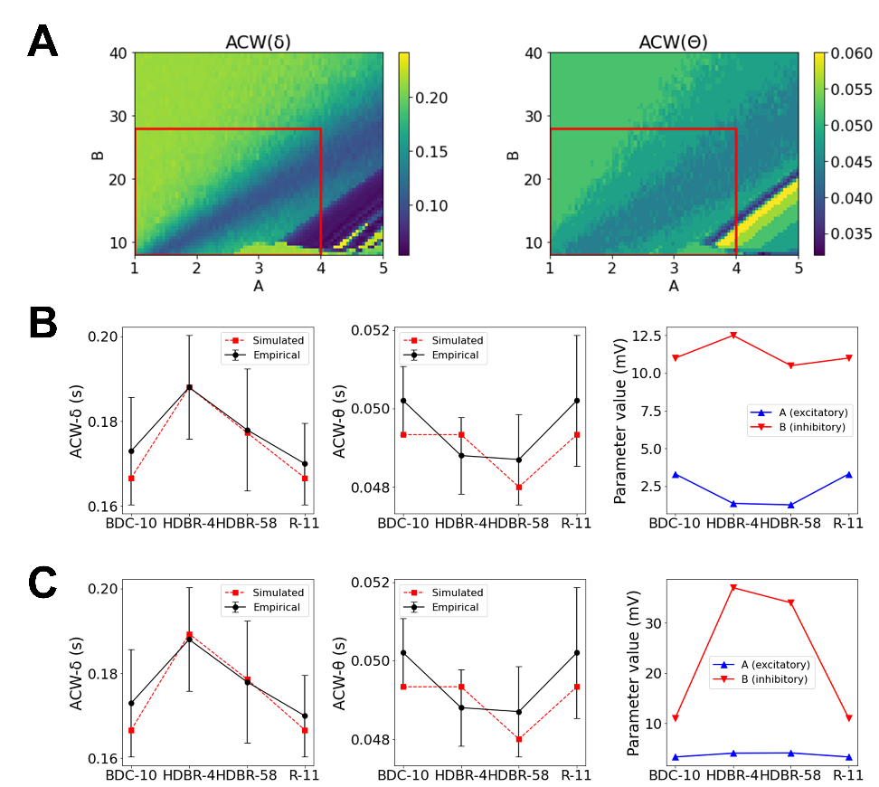
Figure S8. Jansen-Rit neural mass modeling of ACW across HDBR phases. (A) Simulated ACW-δ and ACW-θ as a function of gain constant parameters. (B) Phase-specific distributions of optimal (A, B) parameter pairs for decreasing model (left: ACW-δ; middle: ACW-θ), and simulated ACW-δ using optimal parameters across four phases (right). (C) Phase-specific distributions of optimal (A, B) parameter pairs for increasing model (left: ACW-δ; middle: ACW-θ), and simulated ACW-δ using optimal parameters across four phases (right).
For the rate constant model, the best fitting solutions reached χ² = 6.6 for the deceasing trajectory and χ² = 6.0 for the increasing trajectories. Multiple (a, b) combinations produced equivalent χ² scores, only one example trajectory was listed in Table S4 and Fig. S4.
Table S4. Best-fitting parameter trajectory for the coarse rate constant model
 | Phase | a (s⁻¹) | b (s⁻¹) | ACW-δ (s) |  |  |  | ACW-θ (s)
 | Phase | a (s⁻¹) | b (s⁻¹) | Simulated |  | real |  | Simulated | real
decreasing a  (χ² = 6.6, r(δ) = 0.774, r(θ) = 0.557) | BDC-10 | 55 | 23 | 0.18 | 0.173 |  | 0.0507 |  |  | 0.0502
decreasing a  (χ² = 6.6, r(δ) = 0.774, r(θ) = 0.557) | HDBR-4 | 53 | 22 | 0.1827 | 0.188 |  | 0.0493 |  |  | 0.0488
decreasing a  (χ² = 6.6, r(δ) = 0.774, r(θ) = 0.557) | HDBR-58 | 51 | 21 | 0.1773 | 0.178 |  | 0.0493 |  |  | 0.0487
decreasing a  (χ² = 6.6, r(δ) = 0.774, r(θ) = 0.557) | R-11 | 62 | 77 | 0.1707 | 0.17 |  | 0.0493 |  |  | 0.0502
increasing a  (χ² = 6.0, r(δ) = 0.920, r(θ) = 0.577 | BDC-10 | 55 | 23 | 0.18 | 0.173 |  | 0.0507 |  |  | 0.0502
increasing a  (χ² = 6.0, r(δ) = 0.920, r(θ) = 0.577 | HDBR-4 | 60 | 23 | 0.188 | 0.188 |  | 0.0493 |  |  | 0.0488
increasing a  (χ² = 6.0, r(δ) = 0.920, r(θ) = 0.577 | HDBR-58 | 63 | 27 | 0.1787 | 0.178 |  | 0.0493 |  |  | 0.0487
increasing a  (χ² = 6.0, r(δ) = 0.920, r(θ) = 0.577 | R-11 | 59 | 25 | 0.172 | 0.17 |  | 0.0493 |  |  | 0.0502
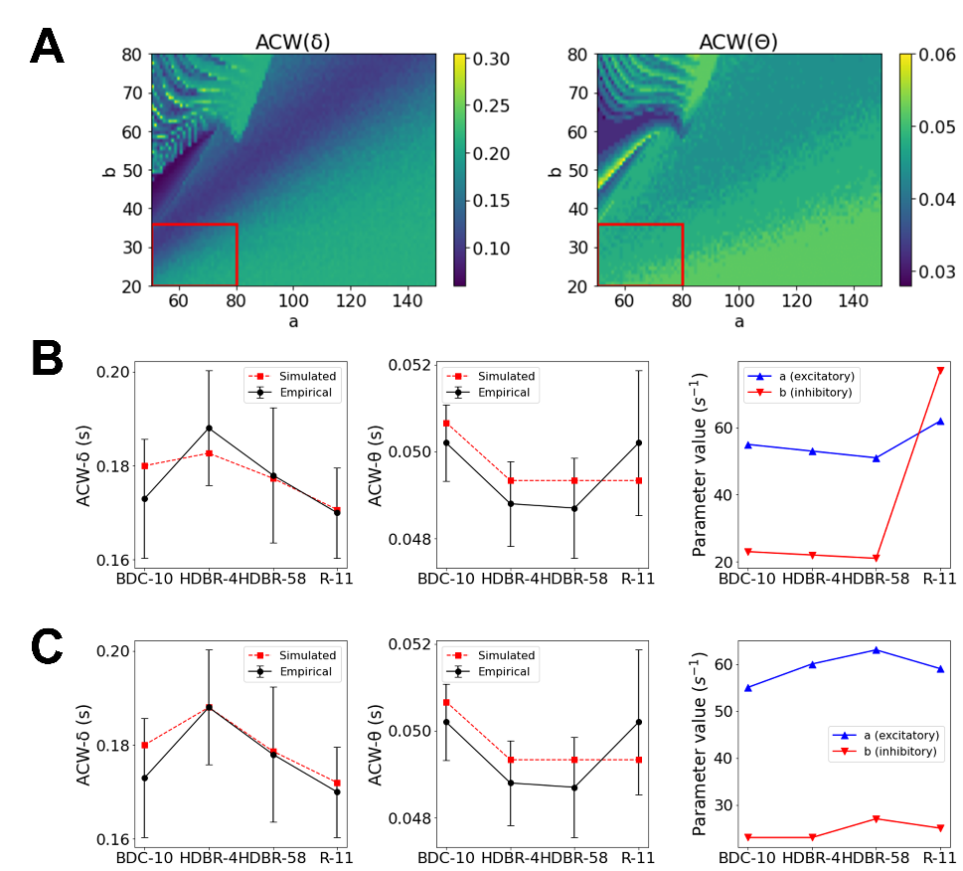
Figure S9. Jansen-Rit neural mass modeling of ACW across HDBR phases. (A) Simulated ACW-δ and ACW-θ as a function of rate constant parameters. (B) Phase-specific distributions of optimal (a, b) parameter pairs for decreasing a model (left: ACW-δ; middle: ACW-θ), and simulated ACW-δ using optimal parameters across four phases (right). (C) Phase-specific distributions of optimal (a, b) parameter pairs for increasing model (left: ACW-δ; middle: ACW-θ), and simulated ACW-δ using optimal parameters across four phases (right).
  - Refined grid search
Based on the coarse search results, we further refined the search grid for two parameter pairs (Table S5), the refined search improved the goodness of fit. However, the gain constant model (χ² = 4.9) remained inferior to the rate constant model (χ² = 3.9). So, we adopted the rate constant model in the main text. The results of refined search were shown in Table S6-S11 and Fig. S10-S12.
Table S5. The refined grid search parameters
Parameter | Description | Search range | step
A | Maximum amplitude of excitatory PSP | [1, 4] mV | 0.02
B | Maximum amplitude of inhibitory PSP | [8, 28] mV | 0.2
a | Excitatory synaptic rate constant | [50, 80] s⁻¹ | 0.2
b | Inhibitory synaptic rate constant | [20, 36] s⁻¹ | 0.2
Table S6. Best-fitting parameter trajectory for the refined gain constant model
 | Phase | A (mV) | B (mV) | ACW-δ (s) |  |  |  | ACW-θ (s)
 |  |  |  | Simulated |  | real |  | Simulated | real
decreasing A  (χ² = 4.9, r(δ) = 0.985, r(θ) = 0.924) | BDC-10 | 3.2 | 9.6 | 0.168 | 0.173 |  | 0.0507 |  |  | 0.0502
decreasing A  (χ² = 4.9, r(δ) = 0.985, r(θ) = 0.924) | HDBR-4 | 1.2 | 10.8 | 0.188 | 0.188 |  | 0.0493 |  |  | 0.0488
decreasing A  (χ² = 4.9, r(δ) = 0.985, r(θ) = 0.924) | HDBR-58 | 1 | 8.2 | 0.1773 | 0.178 |  | 0.048 |  |  | 0.0487
decreasing A  (χ² = 4.9, r(δ) = 0.985, r(θ) = 0.924) | R-11 | 3.2 | 9.6 | 0.168 | 0.17 |  | 0.0507 |  |  | 0.0502
increasing A  (χ² = 6.4, r(δ) = 0.985, r(θ) = 0.999) | BDC-10 | 3.2 | 9.6 | 0.168 | 0.173 |  | 0.0507 |  |  | 0.0502
increasing A  (χ² = 6.4, r(δ) = 0.985, r(θ) = 0.999) | HDBR-4 | 3.3 | 27.2 | 0.188 | 0.188 |  | 0.048 |  |  | 0.0488
increasing A  (χ² = 6.4, r(δ) = 0.985, r(θ) = 0.999) | HDBR-58 | 3.4 | 27 | 0.1773 | 0.178 |  | 0.048 |  |  | 0.0487
increasing A  (χ² = 6.4, r(δ) = 0.985, r(θ) = 0.999) | R-11 | 3.2 | 9.6 | 0.168 | 0.17 |  | 0.0507 |  |  | 0.0502

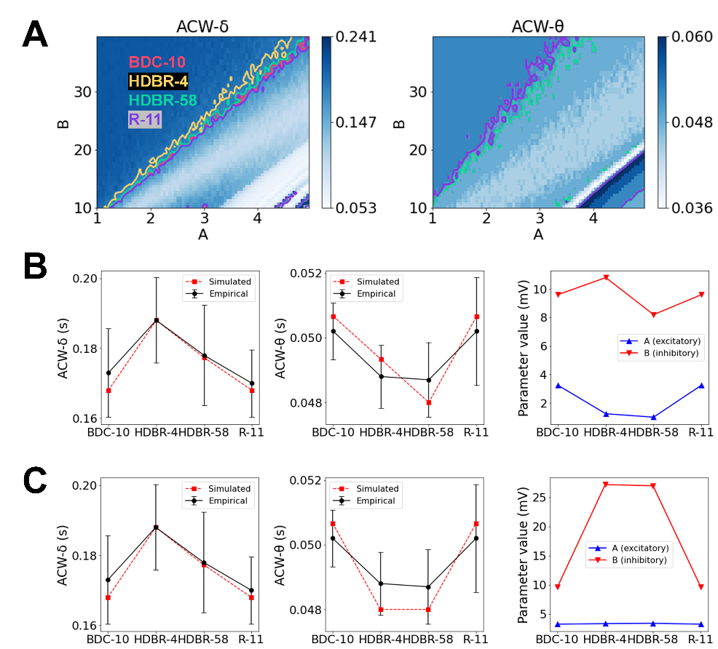
Figure S10. Jansen-Rit model fitting results for the refined gain model. (A) ACW-δ (left) and ACW-θ (right) landscapes in the parameter space. Contour lines indicate the empirical ACW values at each HDBR phase (note that the BDC-10/R-11 and HDBR-4/HDBR-58 contours nearly overlap in the ACW-θ landscape, consistent with the non-significant pairwise differences reported for these phase pairs). (B) Best-fitting results for the decreasing model. Left: simulated vs. empirical ACW-δ; middle: simulated vs. empirical ACW-θ; right: optimal A and B trajectories across HDBR phases. (C) Best-fitting results for the increasing model. Left: simulated vs. empirical ACW-δ; middle: simulated vs. empirical ACW-θ; right: optimal A and B trajectories across HDBR phases.
The best-fitting parameters for gain constant model were listed in Table S7-S8 and plotted in Fig. S6 for both the increasing and decreasing A trajectories. Then, the ratios of A/B were calculated to characterize the robustness of the ratio trajectories induced by HDBR (Fig. S7).
Table S7. Best-fitting parameters for the refined gain constant model with increasing A
 | increasing A-- χ² = 6.392, r(δ) = 0.985, r(θ) = 0.999
 | BDC-10 |  | HDBR-4 |  | HDBR-58 |  | R-11
 | A | B | A | B | A | B | A | B
1 | 3.2 | 9.6 | 3.3 | 27.2 | 3.4 | 27 | 3.2 | 9.6
2 |  |  |  |  | 3.5 | 27.8 | 3.2 | 9.6
3 |  |  |  |  |  | 27.6 | 3.2 | 9.6
4 |  |  |  |  |  | 27.2 | 3.2 | 9.6
5 |  |  |  |  | 3.6 | 27.4 | 3.2 | 9.6
Table S8. Best-fitting parameters for the refined gain constant model with decreasing A
 | decreasing A-- χ² = 4.899, r(δ) = 0.985, r(θ) = 0.924
 | BDC-10 |  | HDBR-4 |  | HDBR-58 |  | R-11
 | A | B | A | B | A | B | A | B
1 | 3.2 | 9.6 | 1.2 | 10.8 | 1 | 8.2 | 3.2 | 9.6
2 |  |  |  |  | 1.1 | 8.8 | 3.2 | 9.6
3 |  |  |  |  |  | 9 | 3.2 | 9.6
4 |  |  |  |  |  | 9.2 | 3.2 | 9.6
5 |  |  |  |  | 1.2 | 9.6 | 3.2 | 9.6
6 |  |  |  |  |  | 9.8 | 3.2 | 9.6
7 |  |  |  |  |  | 10 | 3.2 | 9.6
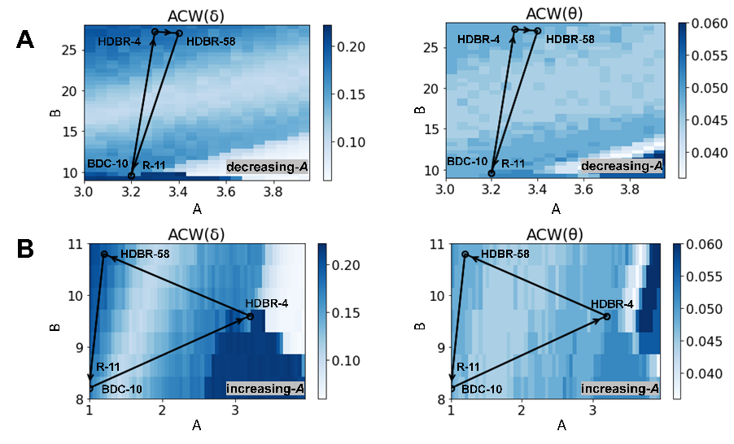
Figure S11. The parameter space and optimal fitting trajectories for the gain constant model. (A) Optimal decreasing trajectory for the gain constant model plotted on the ACW-δ and ACW-θ parameter space. (B) Optimal increasing trajectory for the gain constant model plotted on the ACW-δ and ACW-θ parameter space.
Table S9. Best-fitting parameter trajectory for the refined rate constant model
 | Phase | a (s⁻¹) | b (s⁻¹) | ACW-δ (s) |  |  |  | ACW-θ (s)
 | Phase | a (s⁻¹) | b (s⁻¹) | Simulated |  | real |  | Simulated | real
decreasing a  (χ² = 3.9, r(δ) = 0.998, r(θ) = 0.999) | BDC-10 | 52.8 | 22.2 | 0.1733 | 0.173 |  | 0.0507 |  |  | 0.0502
decreasing a  (χ² = 3.9, r(δ) = 0.998, r(θ) = 0.999) | HDBR-4 | 52.2 | 20.6 | 0.188 | 0.188 |  | 0.0493 |  |  | 0.0488
decreasing a  (χ² = 3.9, r(δ) = 0.998, r(θ) = 0.999) | HDBR-58 | 51 | 21 | 0.1773 | 0.178 |  | 0.0493 |  |  | 0.0487
decreasing a  (χ² = 3.9, r(δ) = 0.998, r(θ) = 0.999) | R-11 | 52.8 | 22.6 | 0.1707 | 0.17 |  | 0.0507 |  |  | 0.0502
increasing a  (χ² = 3.9, r(δ) = 0.998, r(θ) = 0.999) | BDC-10 | 50.8 | 21.6 | 0.1733 | 0.173 |  | 0.0507 |  |  | 0.0502
increasing a  (χ² = 3.9, r(δ) = 0.998, r(θ) = 0.999) | HDBR-4 | 56.2 | 22.8 | 0.188 | 0.188 |  | 0.0493 |  |  | 0.0488
increasing a  (χ² = 3.9, r(δ) = 0.998, r(θ) = 0.999) | HDBR-58 | 56.4 | 23.8 | 0.1773 | 0.178 |  | 0.0493 |  |  | 0.0487
increasing a  (χ² = 3.9, r(δ) = 0.998, r(θ) = 0.999) | R-11 | 52.8 | 22.6 | 0.1707 | 0.17 |  | 0.0507 |  |  | 0.0502
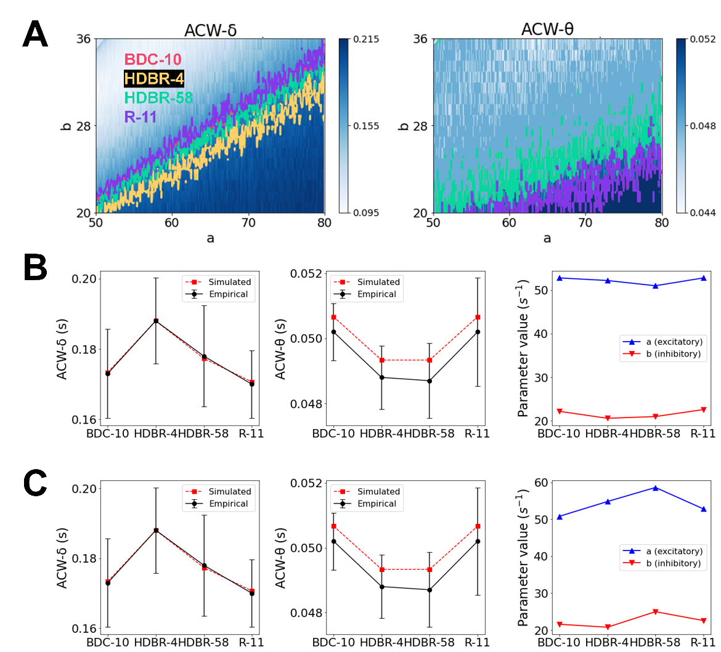
Figure S12. Jansen-Rit model fitting results for the refined rate model. (A) ACW-δ (left) and ACW-θ (right) landscapes in the parameter space. Contour lines indicate the empirical ACW values at each HDBR phase (note that the BDC-10/R-11 and HDBR-4/HDBR-58 contours nearly overlap in the ACW-θ landscape, consistent with the non-significant pairwise differences reported for these phase pairs). (B) Best-fitting results for the decreasing model. Left: simulated vs. empirical ACW-δ; middle: simulated vs. empirical ACW-θ; right: optimal a and b trajectories across HDBR phases. (C) Best-fitting results for the increasing model. Left: simulated vs. empirical ACW-δ; middle: simulated vs. empirical ACW-θ; right: optimal a and b trajectories across HDBR phases.
Table S10. Best-fitting parameters for the refined rate gain model with increasing a
 | increasing a-- χ² = 3.8615, r(δ) = 0.9996, r(θ) = 0.9988
 | BDC-10 |  | HDBR-4 |  | HDBR-58 |  | R-11
 | a | b | a | b | a | b | a | b
1 | 52.8 | 22.2 | 52.2 | 20.6 | 51 | 21 | 52.8 | 22.6
2 |  |  |  |  | 51.2 | 21.8 | 52.8 | 22.6
3 |  |  |  |  | 51.6 | 21 | 52.8 | 22.6
4 | 52.8 | 22.2 | 52.2 | 20.8 | 51 | 21 | 52.8 | 22.6
5 |  |  |  |  | 51.2 | 21.8 | 52.8 | 22.6
6 |  |  |  |  | 51.6 | 21 | 52.8 | 22.6
Table S11. Best-fitting parameters for the refined rate constant model with decreasing a
 | decreasing a-- χ² = 3.8615, r(δ) = 0.9996, r(θ) = 0.9988
 | BDC-10 |  | HDBR-4 |  | HDBR-58 |  | R-11
 | a | b | a | b | a | b | a | b
1 | 50.8 | 21.6 | 56.2 | 22.8 | 56.4 | 23.8 | 52.8 | 22.6
2 |  |  |  |  | 63 | 27 | 52.8 | 22.6
3 |  |  |  |  | 69.2 | 28.8 | 52.8 | 22.6
4 | 50.8 | 21.6 | 55.6 | 21 | 56.4 | 23.8 | 52.8 | 22.6
5 | 50.8 | 21.6 | 55.6 | 21.2 | 56.4 | 23.8 | 52.8 | 22.6
6 | 50.8 | 21.6 | 55.6 | 21.2 | 63 | 27 | 52.8 | 22.6
7 | 50.8 | 21.6 | 59.4 | 22.6 | 63 | 27 | 52.8 | 22.6
8 | 50.8 | 21.6 | 65 | 26 | 69.2 | 28.8 | 52.8 | 22.6
9 | 50.8 | 21.6 | 68.8 | 25.8 | 69.2 | 28.8 | 52.8 | 22.6
The increasing rate model had 418 more equivalent solutions, so we did not list all here.
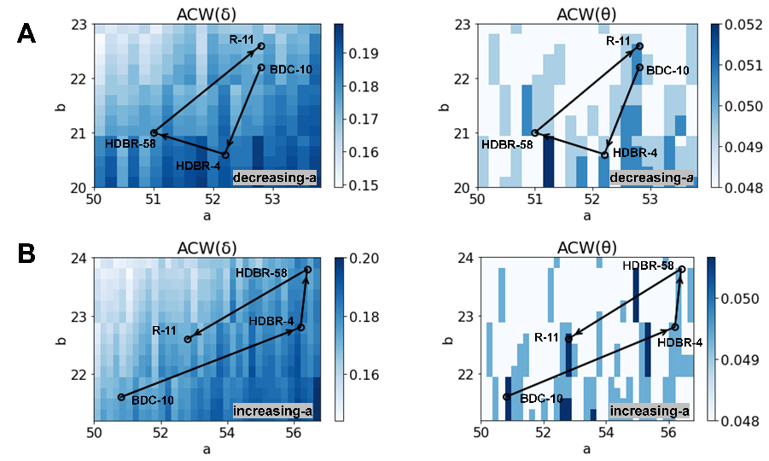
Figure S13. The parameter space and optimal fitting trajectories for the rate constant model. (A) Optimal decreasing trajectory for the rate constant model plotted on the ACW-δ and ACW-θ parameter space. (B) Optimal increasing trajectory for the rate constant model plotted on the ACW-δ and ACW-θ parameter space.

