Supplementary Information
Physical Water Scarcity
We have calculated the mean annual precipitation (mm/year) (Supplementary Figure 8) the mean annual discharge (i.e. available freshwater, mm/year) defined by the sum of surface and subsurface runoff after routing (Supplementary Figure 9) over the globe for different climate scenarios (historical, RCP2.6, RCP7.0 and RCP8.5). We found that the mean annual discharge is lower than the precipitation for most of the earth confirming actual water available for the use is lesser than the actual precipitation.
The spatial distribution of the population worldwide relative to water availability is the leading cause of water scarcity¹. We have calculated the availability per capita for freshwater at 0.5° grid and found 88.9% (89.5%) at the beginning considering GPWv4² (HYDE3.2³) population datasets, and ${89.8}_{-0.3}^{+0.4} ({89.7}_{-0.5}^{+0.3}$), ${{93.8}_{-0.5}^{+0.6} (94.2}_{-0.4}^{+0.7}$), and ${90.5}_{-0.7}^{+1.2}\%$ (${90.2}_{-1.4}^{+1.4})$ (of the world's population lives under 5000 m³/cap/yr of water availability at the end of the century for SSP1-RCP2.6, SSP3-RCP7.0 Murakami and Yamagata (2019)⁴ (and SSP5-RCP8.5 scenarios considering Jones and O’Neill (2016)⁵) population datasets respectively (Supplementary Table 6, Supplementary Table 7, Supplementary Table 8, Supplementary Table 9, Supplementary Figure 10, and Supplementary Figure 11). The analysis shows that the population facing acute water stress having access to freshwater less than 500 m³/cap/year will increase from 44.6% (45.1%) to ${54.9}_{-1.7}^{+1.1}\% ({47.6}_{-2.5}^{+2.1}\%$), ${66.6}_{-3.3}^{+2.8}\% ({59.8}_{-6.1}^{+5.6}\%)$, and ${55.6}_{-1.8}^{+4.2}\% ({47.0}_{-2.6}^{+5.7}\%)$ for SSP1-RCP2.6, SSP3-RCP7.0, and SSP5-RCP8.5 scenarios, respectively comprising about half of the world’s population. These values were obtained using the threshold value defined for availability per capita (APC) as a water stress indicator ^{6,7}.
The spatial distribution of APC for different scenarios (Supplementary Figure 12 and Supplementary Figure 13) suggests a reduction in the per capita freshwater availability in western, central, and southern Africa, eastern USA, and few places in the west and south-east Asia. In contrast, Asia, the middle east and south America will be more freshwater availability per capita in the future compared to the past. The increment in freshwater availability per capita is not significant, and people in northern and eastern Africa, the Middle East, West Asia and some parts of South and East Asia will face water scarcity. The percentage of people facing overall water stress will be approximately the same in the future compared to the past, but the future population at the end of the 21st century will vary from 6.9 billion (SSP1) to 12.6 billion (SSP3)⁸ with different spatial distribution (Supplementary Figure 14 and Supplementary Figure 15). This population growth makes the total number of affected people due to water stress vary from 5.4 billion in the past to 6.2 – 11.8 billion in the future. These values will also be affected by the varying distribution of population within the country due to many climatic-socioeconomic factors for each SSPs scenario along with the population growth. The results show that approximately 61.2% (62.7%) of the world population should have been faced high and acute water stress at the beginning of the century, defined using the threshold of 1000 m³/capita/year available freshwater (Supplementary Table 6, Supplementary Table 7, Supplementary Table 8, and Supplementary Table 9). The value has discrepancies with a previously suggested value of 35%⁹ (calculated using APC) and 28%¹⁰ (calculated using APC and WWR). Even though the number of people affected due to water scarcity varies for various studies, we found that the spatial distribution of physical water-scarce regions at the beginning of the century for our analysis is consistent with the previous studies^{9–13}.

References for supplementary information
1. Kummu, M. et al. The world’s road to water scarcity: Shortage and stress in the 20th century and pathways towards sustainability. Sci. Rep. 6, 1–16 (2016).
2. gpw-v4-population-count-adjusted-to-2015-unwpp-country-totals-rev11-citation. doi:10.7927/H4PN93PB.
3. Klein Goldewijk, K., Beusen, A., Doelman, J. & Stehfest, E. Anthropogenic land use estimates for the Holocene – HYDE 3.2. Earth Syst. Sci. Data 9, 927–953 (2017).
4. Murakami, D. & Yamagata, Y. Estimation of Gridded Population and GDP Scenarios with Spatially Explicit Statistical Downscaling. Sustainability 11, 2106 (2019).
5. Jones, B. & O’Neill, B. C. Spatially explicit global population scenarios consistent with the Shared Socioeconomic Pathways. Environ. Res. Lett. 11, (2016).
6. Shiklomanov, I. A. Assessment of water resources and water availability in the world. 88 p. : (1997).
7. Falkenmark, M., Lundqvist, J. & Widstrand, C. Macro-scale water scarcity requires micro-scale approaches. Nat. Resour. Forum 13, 258–267 (1989).
8. KC, S. & Lutz, W. The human core of the shared socioeconomic pathways: Population scenarios by age, sex and level of education for all countries to 2100. Glob. Environ. Chang. 42, 181–192 (2017).
9. Kummu, M., Ward, P. J., De Moel, H. & Varis, O. Is physical water scarcity a new phenomenon? Global assessment of water shortage over the last two millennia. Environ. Res. Lett. 5, (2010).
10. Wada, Y. et al. Global monthly water stress: 2. Water demand and severity of water stress. Water Resour. Res. 47, 1–17 (2011).
11. Oki, T. & Quiocho, R. E. Economically challenged and water scarce: identification of global populations most vulnerable to water crises. Int. J. Water Resour. Dev. 36, 416–428 (2020).
12. Gude, V. G. Desalination and water reuse to address global water scarcity. Rev. Environ. Sci. Biotechnol. 16, 591–609 (2017).
13. Liu, J. et al. Earth ’ s Future Water scarcity assessments in the past , present , and future Earth ’ s Future. Earth{\textquotesingle}s Futur. 5, 545–559 (2017).

Supplementary Tables
Supplementary Table 1: Base Scenario Experimental settings, and data used for analysis
 | Discharge | Population | GDP
Historical-GPW | H08 ISIMIP3a | GPWv4 | TG18
Historical-HYDE | H08 ISIMIP3a | HYDE3.2 | TG18
Future126-MY19 | H08 ISIMIP3b SSP1-RCP2.6 | MY19 SSP1 | MY19 SSP1
Future126-JO16 | H08 ISIMIP3b SSP1-RCP2.6 | JO16 SSP1 | MY19 SSP1
Future370-MY19 | H08 ISIMIP3b SSP3-RCP7.0 | MY19 SSP3 | MY19 SSP3
Future370-JO16 | H08 ISIMIP3b SSP3-RCP7.0 | JO16 SSP3 | MY19 SSP3
Future585-MY19 | H08 ISIMIP3b SSP5-RCP8.5 | MY19 SSP1 & OECD* | MY19 SSP1 & OECD*
Future585-JO16 | H08 ISIMIP3b SSP5-RCP8.5 | JO16 SSP5 | MY19 SSP1 & OECD*
*denotes the data were not provided by the original source hence prepared by the authors
Supplementary Table 2: Sensitivity Analysis Experimental setting, and data used for analysis
 | Discharge | Population | GDP
Historical-MY126 | H08 ISIMIP3a | MY19 SSP1 | MY19 SSP1
Historical-MY370 | H08 ISIMIP3a | MY19 SSP3 | MY19 SSP3
Historical-MY585 | H08 ISIMIP3a | MY19 SSP1 & OECD* | MY19 SSP1 & OECD*
Future126-GPW | H08 ISIMIP3b SSP1-RCP2.6 | GPWv4 | MY19 SSP1
Future370-GPW | H08 ISIMIP3b SSP3-RCP7.0 | GPWv4 | MY19 SSP3
Future585-GPW | H08 ISIMIP3b SSP5-RCP8.5 | GPWv4 | MY19 SSP1 & OECD*
Future126-MY-TG | H08 ISIMIP3b SSP1-RCP2.6 | MY19 SSP1 | TG18
Future370-MY-TG | H08 ISIMIP3b SSP3-RCP7.0 | MY19 SSP3 | TG18
Future585-MY-TG | H08 ISIMIP3b SSP5-RCP8.5 | MY19 SSP1 & OECD* | TG18
Historical-JO126 | H08 ISIMIP3a | JO16 SSP1 | MY19 SSP1
Historical-JO370 | H08 ISIMIP3a | JO16 SSP3 | MY19 SSP3
Historical-JO585 | H08 ISIMIP3a | JO16 SSP5 | MY19 SSP1 & OECD*
Future126-HYDE | H08 ISIMIP3b SSP1-RCP2.6 | HYDE3.2 | MY19 SSP1
Future370-HYDE | H08 ISIMIP3b SSP3-RCP7.0 | HYDE3.2 | MY19 SSP3
Future585-HYDE | H08 ISIMIP3b SSP5-RCP8.5 | HYDE3.2 | MY19 SSP1 & OECD*
Future126-JO-TG | H08 ISIMIP3b SSP1-RCP2.6 | JO16 SSP1 | TG18
Future370-JO-TG | H08 ISIMIP3b SSP3-RCP7.0 | JO16 SSP3 | TG18
Future585-JO-TG | H08 ISIMIP3b SSP5-RCP8.5 | JO16 SSP5 | TG18
*denotes the data were not provided by the original source hence prepared by the authors

Supplementary Table 3: Statistical analysis (Welch’s t-test and Mood’s Median test) using country scale data
Scenario/ Experiment setting |  | APC |  |  |  | GPC
Future | Historical | Welch’s t-test | p-value | Mood’s Median test | p-value | Welch’s t-test | p-value | Mood’s Median test | p-value
Future126-MY19 | Historical-GPW | -0.69 | 0.49 | 1.28 | 0.26 | 26.16 | 1.02e-77 | 324.27 | 1.70e-72
Future370-MY19 | Historical-GPW | -0.62 | 0.54 | 0.18 | 0.67 | 10.35 | 1.75e-21 | 112.61 | 2.62e-26
Future585-MY19 | Historical-GPW | -1.78 | 0.08 | 0.02 | 0.89 | 37.33 | 1.55e-11 | 342.35 | 1.96e-76
Future126-JO16 | Historical-HYDE | -0.51 | 0.61 | 0.46 | 0.50 | 14.45 | 1.01e-34 | 283.46 | 1.32e-63
Future370-JO16 | Historical-HYDE | -1.00 | 0.32 | 1.58 | 0.21 | 7.04 | 1.58e-11 | 92.09 | 8.26e-22
Future585-JO16 | Historical-HYDE | -0.20 | 0.84 | 0.45 | 0.50 | 17.90 | 9.30e-46 | 323.48 | 2.53e-72

Supplementary Table 4: Statistical analysis (Welch’s t-test and Mood’s Median test) using grid-scale data
Scenario/ Experiment setting |  | APC |  |  |  | GPC
Future | Historical | Welch’s t-test | p-value | Mood’s Median test | p-value | Welch’s t-test | p-value | Mood’s Median test | p-value
Future126-MY19 | Historical-GPW | 14.41 | 5.44e-47 | 864.56 | 4.97e-190 | 170.47 | 0.00 | 26152.82 | 0.00
Future370-MY19 | Historical-GPW | -2.93 | 3.30e-03 | 66.41 | 3.66e-16 | 87.56 | 0.00 | 10153.98 | 0.00
Future585-MY19 | Historical-GPW | 13.86 | 1.21e-43 | 643.55 | 5.64e-142 | 203.71 | 0.00 | 29888.31 | 0.00
Future126-JO16 | Historical-HYDE | -3.46 | 5.31e-04 | 37.35 | 9.87e-10 | 78.46 | 0.00 | 4162.38 | 0.00
Future370-JO16 | Historical-HYDE | -5.92 | 3.32e-09 | 345.88 | 3.35e-77 | 50.34 | 0.00 | 1022.82 | 0.00
Future585-JO16 | Historical-HYDE | -4.24 | 2.18e-05 | 81.46 | 1.79e-19 | 92.55 | 0.00 | 6162.66 | 0.00

Supplementary Table 5: Statistical analysis (Welch’s t-test and Mood’s Median test) for new water scarce grids of future (i.e., the year 2099)
Scenario/ Experiment setting | Future | Future126-MY19 | Future370-MY19 | Future585-MY19 |  | Future126-JO16 | Future370-JO16 | Future585-JO16
Scenario/ Experiment setting | Historical | Historical-GPW | Historical-GPW | Historical-GPW |  | Historical-HYDE | Historical-HYDE | Historical-HYDE
APC  (mm/year) | Welch’s t-test | 0.35 | -1.04 | -0.17 |  | -1.66 | -2.93 | -2.05
APC  (mm/year) | p-value | 0.73 | 0.30 | 0.86 |  | 0.096 | 0.003 | 0.041
APC  (mm/year) | Mood’s Median test | 0.20 | 0.0 | 0.17 |  | 16.94 | 38.55 | 59.71
APC  (mm/year) | p-value | 0.65 | 1.0 | 0.68 |  | 3.85e-05 | 5.326e-10 | 1.09e-14
Population Density  (capita/km²) | Welch’s t-test | -0.89 | -5.00 | -2.12 |  | -17.03 | -13.06 | -17.04
Population Density  (capita/km²) | p-value | 0.38 | 1.6 | 0.06 |  | 1.11e-63 | 8.80e-38 | 1.52e-63
Population Density  (capita/km²) | Mood’s Median test | 9.8 | 96.0 | 1.5 |  | 942.84 | 1528.650 | 1015.15
Population Density  (capita/km²) | p-value | 0.002 | 1.15 | 0.22 |  | 4.7e-207 | 0.0 | 9.16e-223
GDP-PPP  (USD/year) | Welch’s t-test | -2.44 | -4.97 | -1.35 |  | 10.40 | -4.36 | 6.09
GDP-PPP  (USD/year) | p-value | 0.04 | 1.82 | 0.20 |  | 3.95e-25 | 1.35e-05 | 1.23e-09
GDP-PPP  (USD/year) | Mood’s Median test | 16.2 | 96.0 | 0.0 |  | 2313.09 | 119.15 | 2058.17
GDP-PPP  (USD/year) | p-value | 5.70e-05 | 1.15e-22 | 1.0 |  | 0.00 | 9.70e-28 | 0.00

Supplementary Table 6: Population affected due to Physical Water Stress for SSP1-RCP2.6 Scenario
Description /Remarks |  | Very High Water Stress |  | High Water Stress |  | Moderate Water stress |  | Low Water Stress |  | No Water Stress
Availability per capita (APC) (m³/cap/year) |  | <500 |  | 500-1000 |  | 1000-1700 |  | 1700-5000 |  | 5000<
 |  | * | ** | * | ** | * | ** | * | ** | * | **
Population Distribution (%) for various GCM Simulations for the year 2099 | GFDL-ESM4 | 55.8 | 49.7 | 13.4 | 15.1 | 8.5 | 11.3 | 12.4 | 13.9 | 10.0 | 10.0
 | MRI-ESM2-0 | 55.9 | 48.4 | 13.3 | 16.3 | 8.8 | 10.9 | 12.1 | 13.9 | 10.0 | 10.5
 | MPI-ESM1-2-HR | 56.0 | 48.8 | 13.1 | 15.9 | 8.9 | 11.0 | 12.2 | 14.2 | 9.8 | 10.1
 | IPSL-CM6A-LR | 55.5 | 48.0 | 13.0 | 15.9 | 9.0 | 11.2 | 12.5 | 14.7 | 10.0 | 10.2
 | UKESM1-0-LL | 53.2 | 45.1 | 14.4 | 16.5 | 8.9 | 11.8 | 13.0 | 15.8 | 10.5 | 10.9
 | Ensemble Mean | 54.9 | 47.6 | 13.5 | 15.9 | 9.0 | 11.9 | 12.4 | 14.3 | 10.1 | 10.4
* Calculated using Murakami and Yamagata (2019) population data
* Calculated using Jones and O’Neil (2016) population data

Supplementary Table 7: Population affected due to Physical Water Stress for SSP3-RCP7.0 Scenario
Description /Remarks |  | Very High Water Stress |  | High Water Stress |  | Moderate Water stress |  | Low Water Stress |  | No Water Stress
Availability per capita (APC) (m³/cap/year) |  | <500 |  | 500-1000 |  | 1000-1700 |  | 1700-5000 |  | 5000<
 |  | * | ** | * | ** | * | ** | * | ** | * | **
Population Distribution (%) for various GCM Simulations for the year 2099 | GFDL-ESM4 | 69.4 | 65.4 | 11.0 | 14.1 | 6.3 | 7.3 | 7.7 | 8.1 | 5.7 | 5.2
 | MRI-ESM2-0 | 67.8 | 62.6 | 11.2 | 14.8 | 6.6 | 7.8 | 8.3 | 9.2 | 6.1 | 5.7
 | MPI-ESM1-2-HR | 66.9 | 59.8 | 10.9 | 15.9 | 7.2 | 8.6 | 8.8 | 10.1 | 6.1 | 5.7
 | IPSL-CM6A-LR | 66.6 | 61.4 | 11.7 | 14.4 | 7.0 | 8.4 | 8.3 | 9.6 | 6.5 | 6.2
 | UKESM1-0-LL | 63.3 | 53.7 | 12.3 | 18.9 | 7.8 | 10.1 | 9.9 | 11.2 | 6.7 | 6.1
 | Ensemble Mean | 66.6 | 59.8 | 11.5 | 16.0 | 7.1 | 8.8 | 8.6 | 9.6 | 6.3 | 5.7
* Calculated using Murakami and Yamagata (2019) population data
** Calculated using Jones and O’Neil (2016) population data

Supplementary Table 8: Population affected due to Physical Water Stress for SSP5-RCP8.5 Scenario
Description /Remarks |  | Very High Water Stress |  | High Water Stress |  | Moderate Water stress |  | Low Water Stress |  | No Water Stress
Availability per capita (APC) (m³/cap/year) |  | <500 |  | 500-1000 |  | 1000-1700 |  | 1700-5000 |  | 5000<
 |  | * | ** | * | ** | * | ** | * | ** | * | **
Population Distribution (%) for various GCM Simulations for the year 2099 | GFDL-ESM4 | 59.8 | 52.7 | 11.7 | 15.2 | 8.8 | 9.9 | 11.4 | 13.8 | 8.4 | 8.4
 | MRI-ESM2-0 | 58.5 | 51.6 | 12.9 | 15.2 | 8.2 | 10.4 | 11.5 | 13.3 | 9.0 | 9.5
 | MPI-ESM1-2-HR | 54.6 | 45.2 | 13.0 | 15.8 | 9.1 | 11.5 | 13.1 | 16.3 | 10.2 | 11.2
 | IPSL-CM6A-LR | 56.3 | 50.4 | 13.5 | 13.9 | 8.1 | 10.2 | 12.6 | 15.1 | 9.5 | 10.4
 | UKESM1-0-LL | 53.8 | 44.4 | 14.2 | 16.1 | 9.3 | 12.7 | 12.9 | 16.7 | 9.9 | 10.2
 | Ensemble Mean | 55.6 | 47.0 | 13.5 | 16.3 | 8.9 | 11.2 | 12.5 | 15.7 | 9.5 | 9.9
* Calculated using Murakami and Yamagata (2019) population data
** Calculated using Jones and O’Neil (2016) population data

Supplementary Table 9: Population affected due to Physical Water Stress for all considered scenarios
Description /Remarks |  | Very High Water Stress |  | High Water Stress |  | Moderate Water stress |  | Low Water Stress |  | No Water Stress
Availability (m³/cap/year) |  | <500 |  | 500-1000 |  | 1000-1700 |  | 1700-5000 |  | 5000<
Method of Consideration of Mean for different GCM |  | * | ** | * | ** | * | ** | * | ** | * | **
Population Distribution (%)  (Historical, 2000) *** | APC | 44.6 | 45.1 | 16.6 | 17.6 | 11.8 | 11.3 | 15.9 | 15.5 | 11.1 | 10.5
Population Distribution (%)  SSP1-RCP2.6  (Future ,2099) | APC | 54.9 | 47.6 | 13.5 | 15.9 | 9.0 | 11.9 | 12.4 | 14.3 | 10.1 | 10.4
Population Distribution (%)  SSP3-RCP7.0  (Future, 2099) | APC | 66.6 | 59.8 | 11.5 | 16.0 | 7.1 | 8.8 | 8.6 | 9.6 | 6.3 | 5.7
Population Distribution (%)  SSP5-RCP8.5  (Future, 2099) | APC | 55.6 | 47.0 | 13.5 | 16.3 | 8.9 | 11.2 | 12.5 | 15.7 | 9.5 | 9.9
* Calculated Using analysis of Ensemble Mean of H08 output for different GCMs considering GPWv4 database for historical and Murakami and Yamagata (2019) for Future Gridded Population
** Calculated using Ensemble Mean of H08 output for different GCMs considering HYDE3.2 database for historical and Jones and O’Neill (2016) for Future Gridded Population
*** Historical scenario considers observed climate only

Supplementary Figures
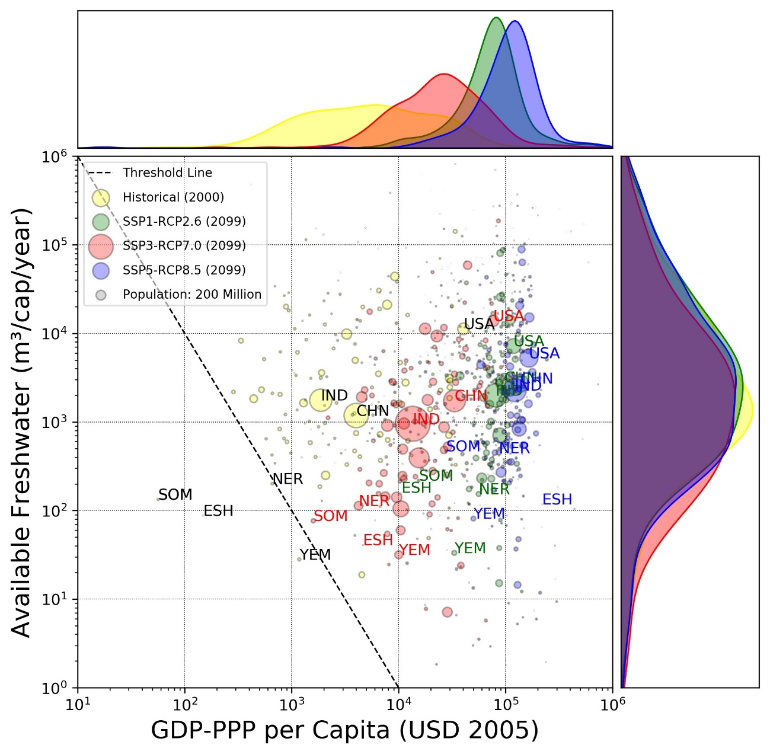
Supplementary Figure 1: Country-level scatter plot for APC vs GDP-PPP per Capita and density plot considering the number of countries for various socio-economic and climate scenario with each circle corresponding to a country and the size of the circle corresponding to the population of the country. Yellow, Green, Red and Blue colours represent historical, SSP1-RCP2.6, SSP3-RCP7.0 and SSP5-RCP8.5 scenarios respectively and the dashed line represents threshold value for physical and economic water scarcity. The analysis was performed considering the HYDE3.2 dataset for the historical year 2000 population and Jones and O’Neill (2016) for the future year 2099 population.

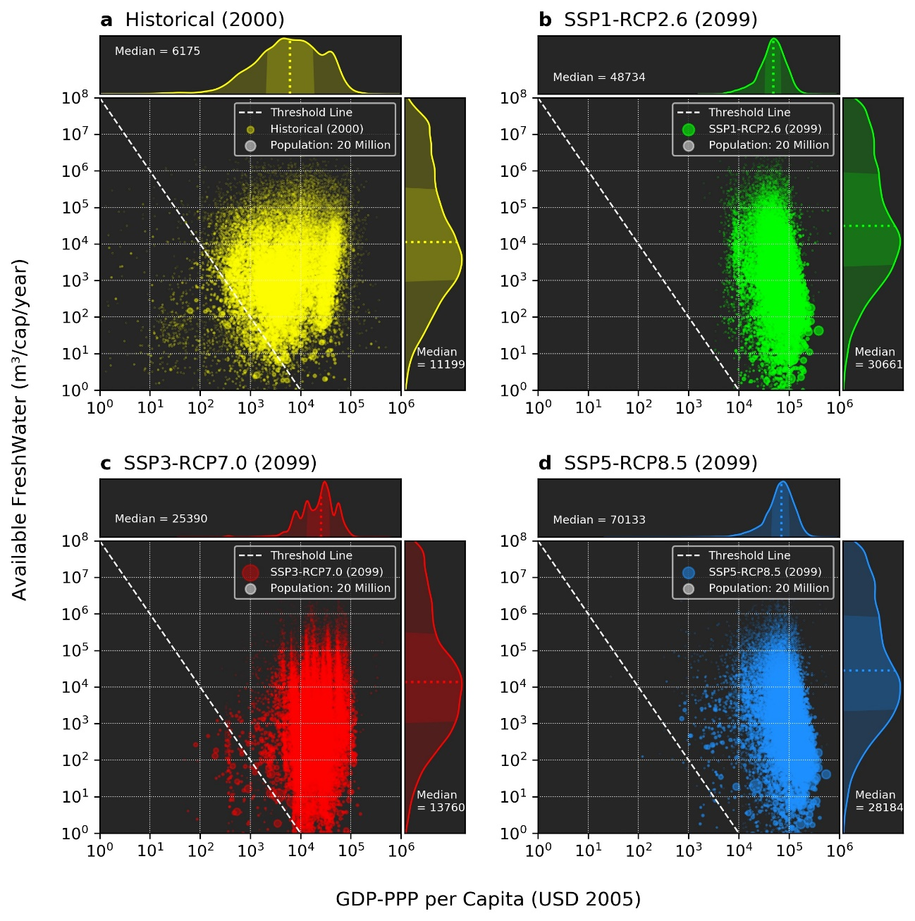
Supplementary Figure 2: Grid level scatter plot for APC vs GDP-PPP per Capita and density plot considering the number of grids for various socio-economic and climate scenarios for (a) Historical (2000), (b) SSP1-RCP2.6 (2099), (c) SSP3-RCP7.0 (2099) and, (d) SSP5-RCP8.5 (2099), grid values represented as circles and dashed line represents threshold value for physical and economical water scarcity, density plot showing dotted colour lines (yellow, lime, red, and blue) as the median, dark shaded as the interquartile range (first and third quartiles), white circle legend represent the grid size of 20 million population. The analysis was performed considering the GPWv4 dataset for the historical year 2000 population and Murakami and Yamagata (2019) for the future year 2099 population.
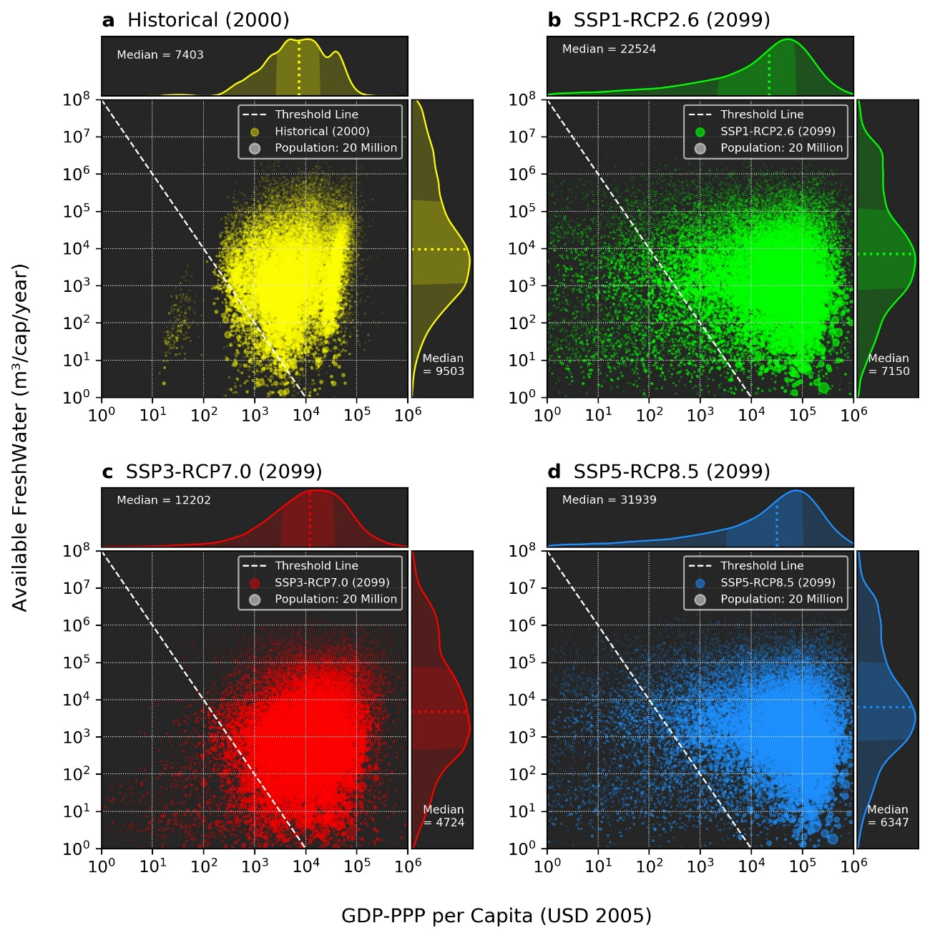
Supplementary Figure 3: Grid level scatter plot for APC vs GDP-PPP per Capita and density plot considering the number of grids for various socio-economic and climate scenarios for (a) Historical (2000), (b) SSP1 RCP2.6 (2099), (c) SSP3 RCP7.0 (2099) and, (d) SSP5 RCP8.5 (2099), grid values represented as circles and dashed line represents threshold value for physical and economical water scarcity, density plot showing dotted colour lines (yellow, lime, red, and blue) as the median, dark shaded as the interquartile range (first and third quartiles), white circle legend represent the grid size of 20 million population. The analysis was performed considering the HYDE3.2 dataset for the historical year 2000 population and Jones and O’Neill (2016) for the future year 2099 population.
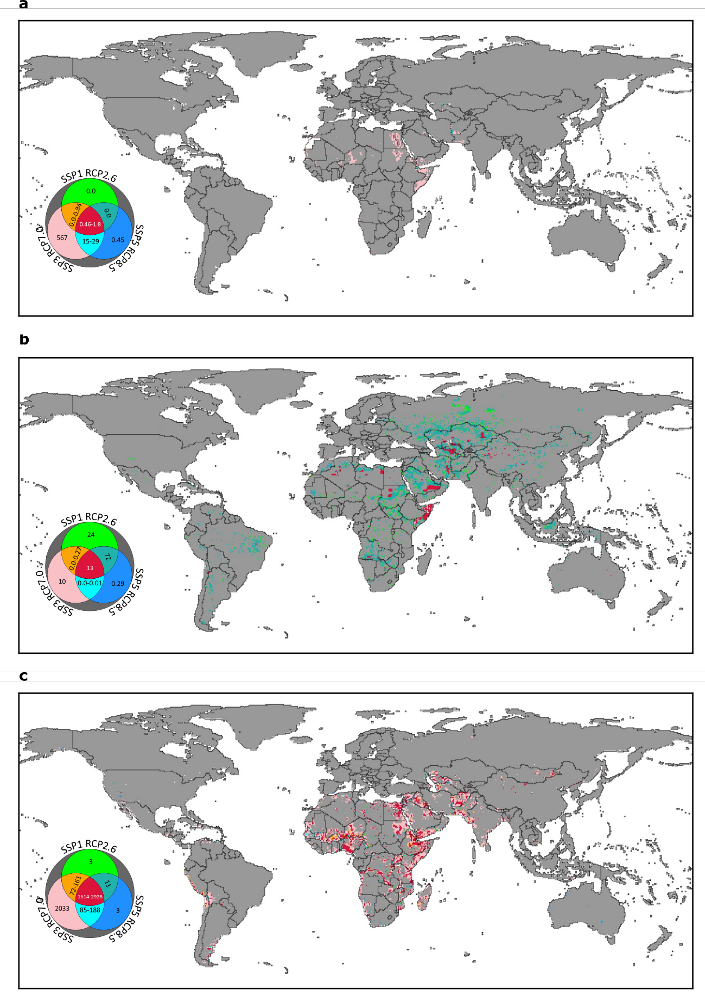
Supplementary Figure 4:Water Scarce (Physical and Economically Challenged) Regions in future (2099) with possible combinations, the values inside the circular legend shows the number of people (in million) facing scarcity problem considering (a) Historical freshwater availability, (b) Historical population, and (c) Historical GDP for GPWv4 historical population dataset and Murakami and Yamagata (2019) future population dataset.
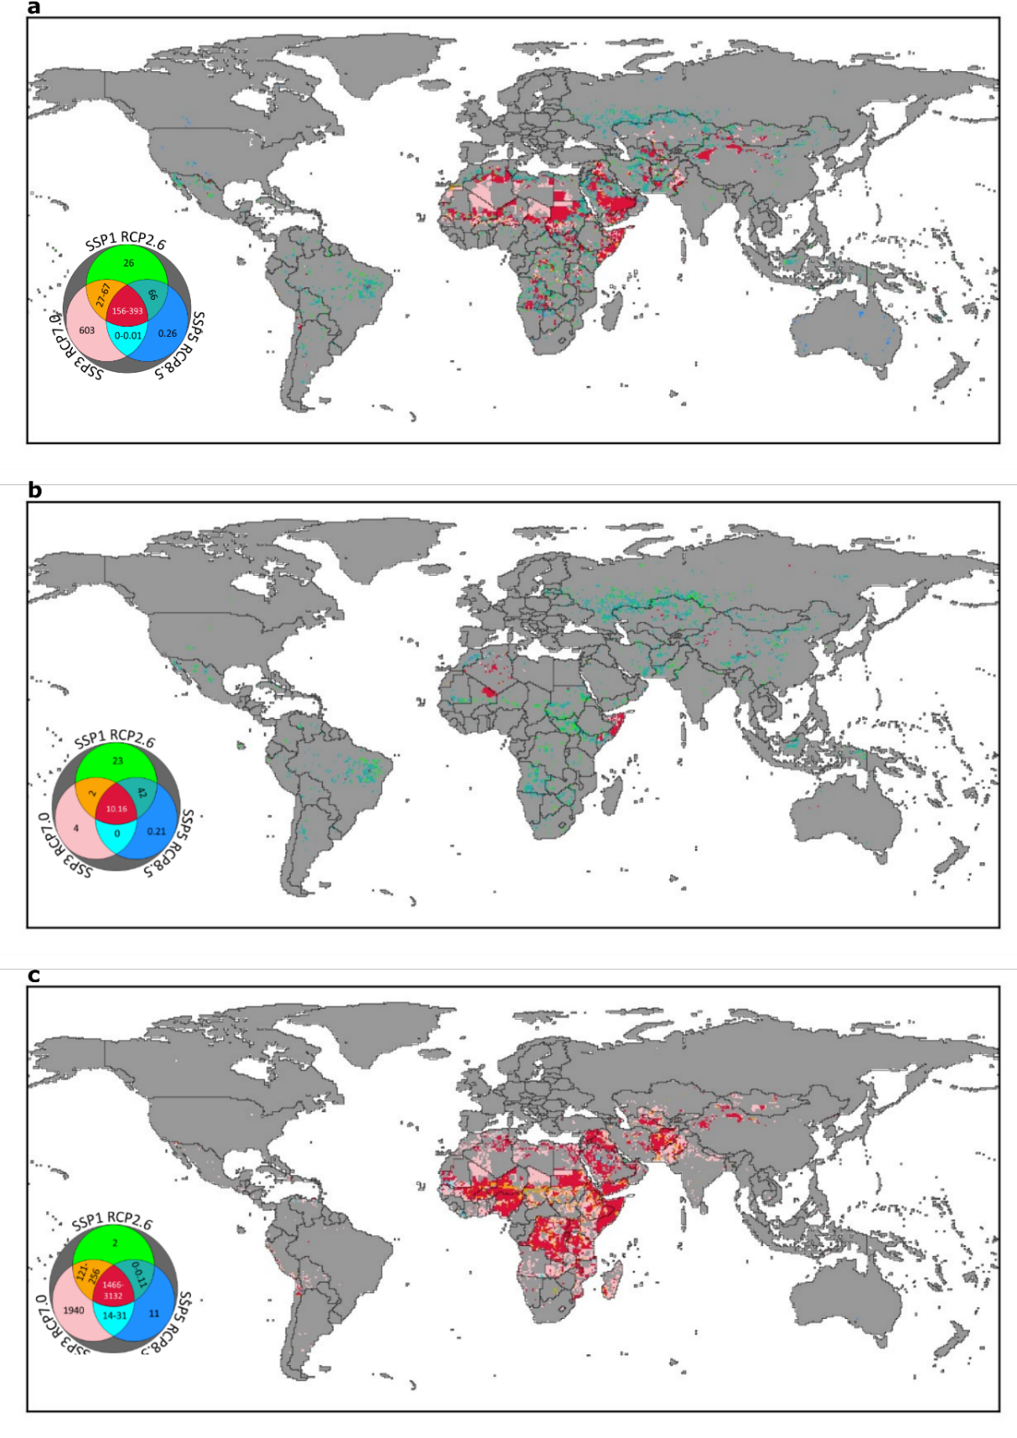
Supplementary Figure 5: Water Scarce (Physical and Economically Challenged) Regions in future (2099) with possible combinations, the values inside the circular legend shows the number of people (in million) facing scarcity problem considering (a) Historical freshwater availability, (b) Historical population, and (c) Historical GDP for HYDE3.2 historical population dataset and Jones and O’Neill (2016) future population dataset.

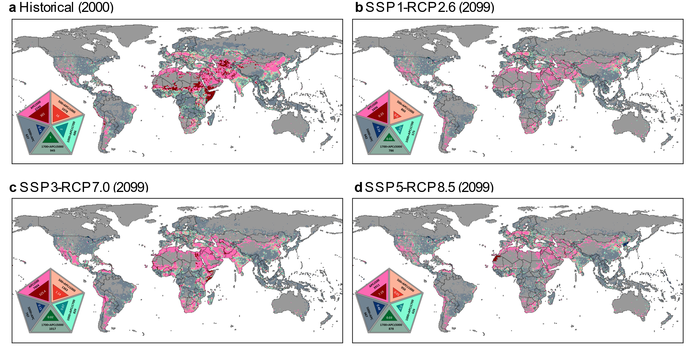
Supplementary Figure 6: Water Limited but economically mitigable denoted using light shade colours and non-mitigable regions represented using dark shades of colour with numbers in big triangles in legends showing the population facing physical scarcity with different threshold and small triangle within big triangles showing population facing both physical and economical water scarcity for (a) Historical (2000), (b) SSP1-RCP2.6 (2099), (c) SSP3-RCP7.0 (2099), and (d) SSP5-RCP8.5 (2099), calculated considering gridded population by GPWv4 for historical and Murakami and Yamagata (2019) for future scenarios.

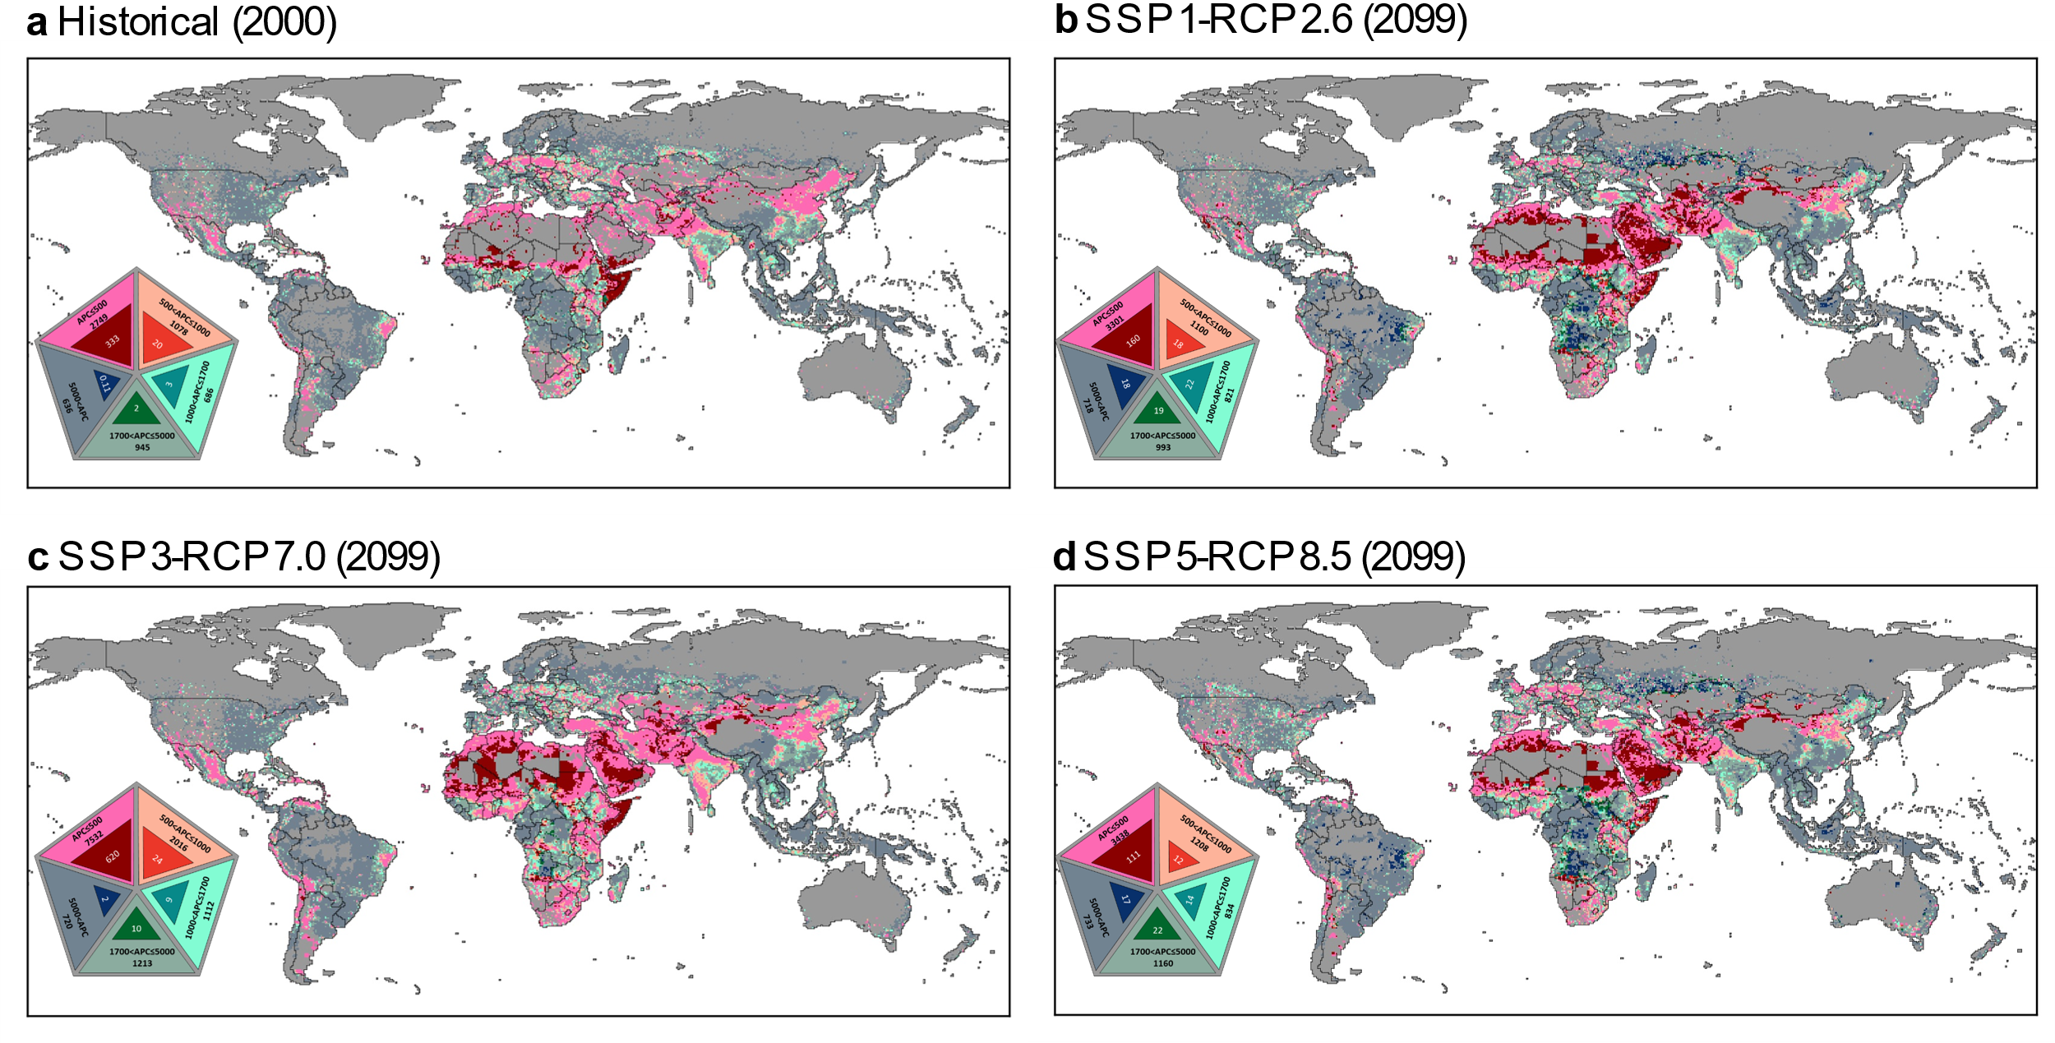
Supplementary Figure 7: Water Limited but economically mitigable denoted using light shade colours and non-mitigable regions represented using dark shades of colour with numbers in big triangles in legends showing the population facing physical scarcity with different threshold and small triangle within big triangles showing population facing both physical and economical water scarcity for (a) Historical (2000), (b) SSP1-RCP2.6 (2099), (c) SSP3-RCP7.0 (2099), and (d) SSP5-RCP8.5 (2099, ), calculated considering gridded population by HYDE3.2 database for Historical and Jones and O’Neill (2016) for future scenarios.

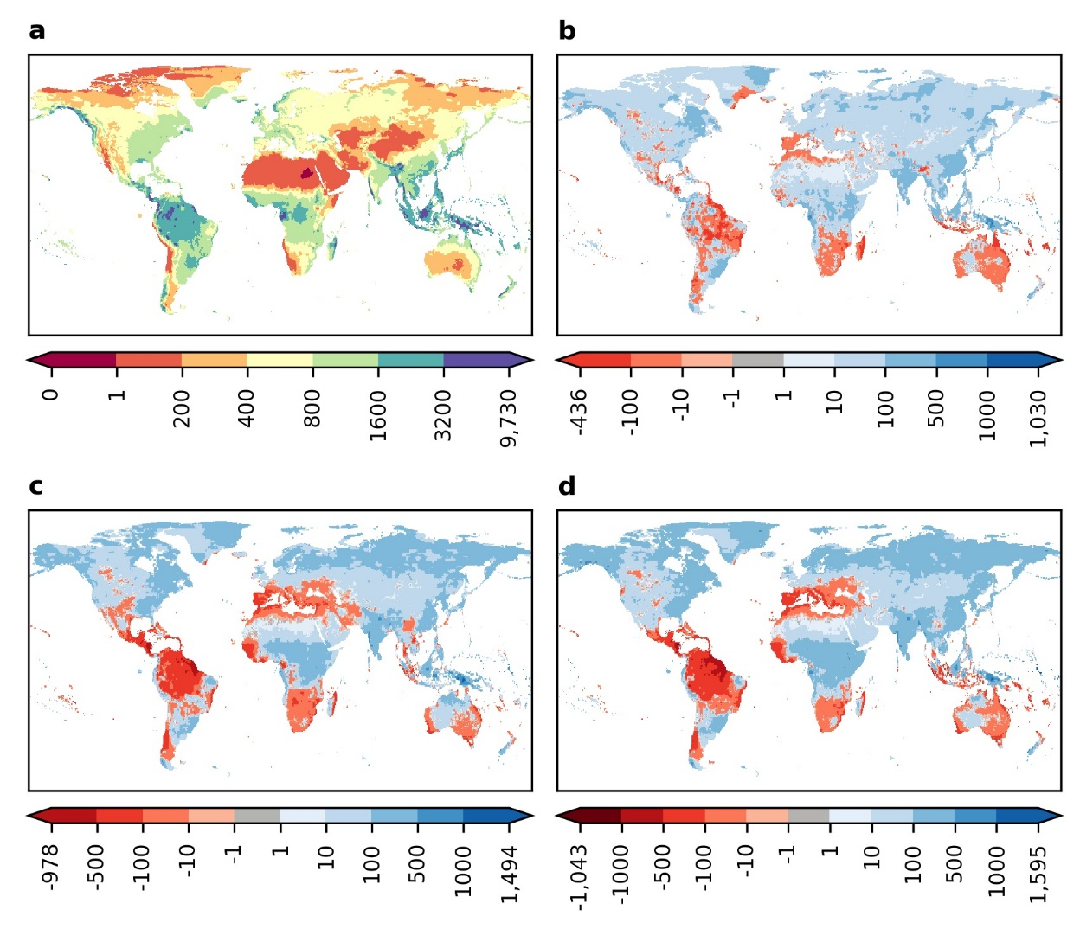
Supplementary Figure 8: Distribution of mean annual precipitation (mm/year) (a) Historical (2000), and the difference between (b) SSP1-RCP2.6(2099) and Historical (2000), (c) SSP3-RCP7.0 (2099) and Historical (2000), and (d) SSP5-RCP8.5 (2099) and Historical (2000).
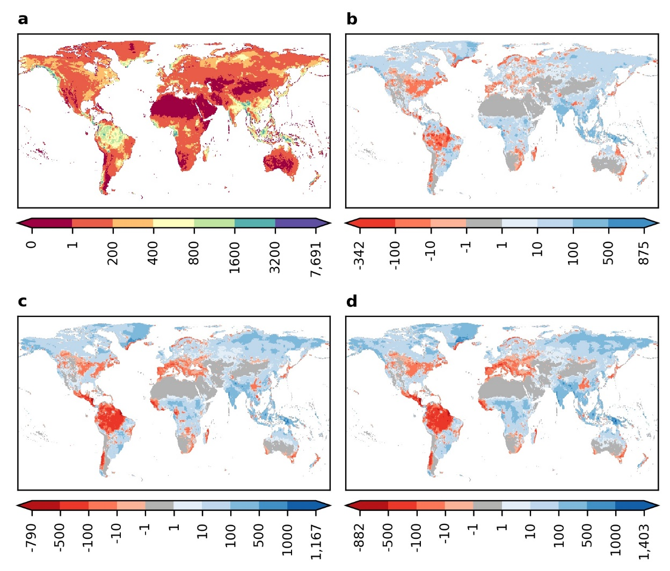
Supplementary Figure 9: Distribution of mean annual discharge (mm/year) (a) Historical (2000), and the difference between (b) SSP1-RCP2.6(2099) and Historical (2000), (c) SSP3-RCP7.0 (2099) and Historical (2000), and (d) SSP5-RCP8.5 (2099) and Historical (2000).
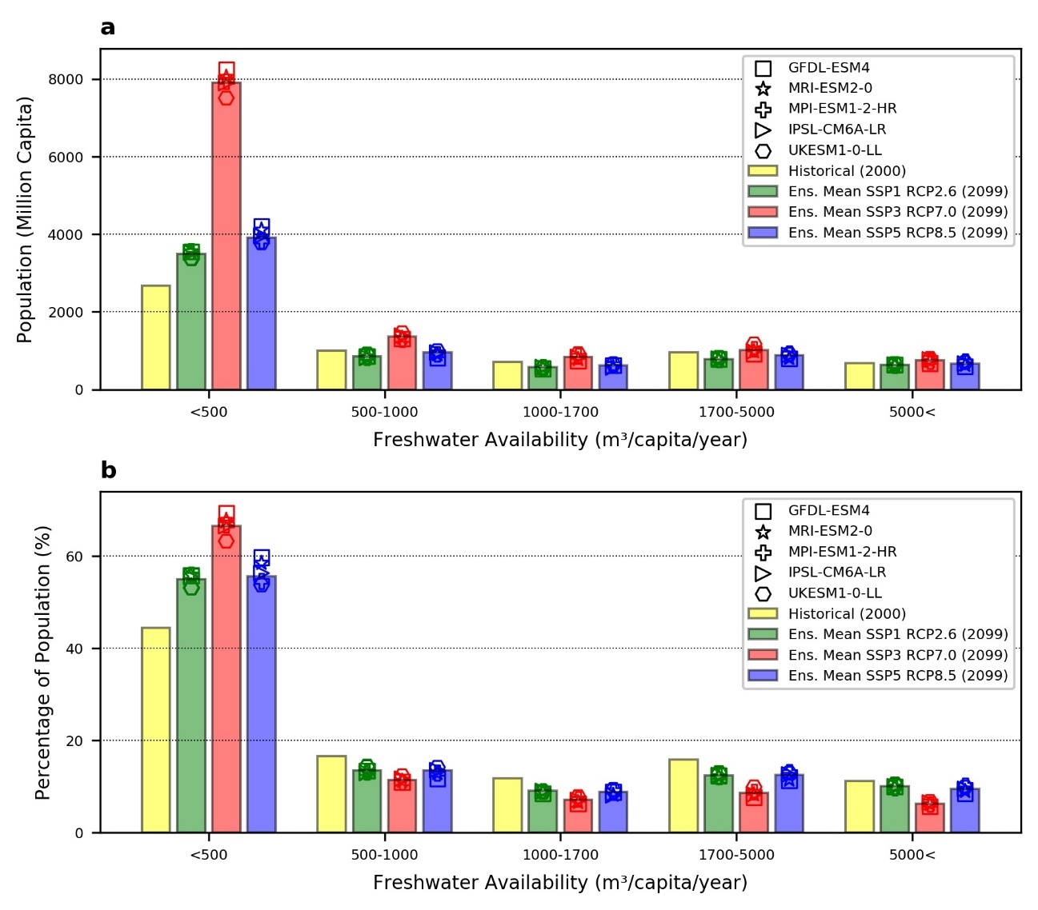
Supplementary Figure 10: Histogram of the (a) Million Population and (b) Percentage of Population in terms of freshwater availability (m3/cap/year) calculated considering gridded population by GPWv4 for historical and Murakami and Yamagata (2019) for future scenarios.
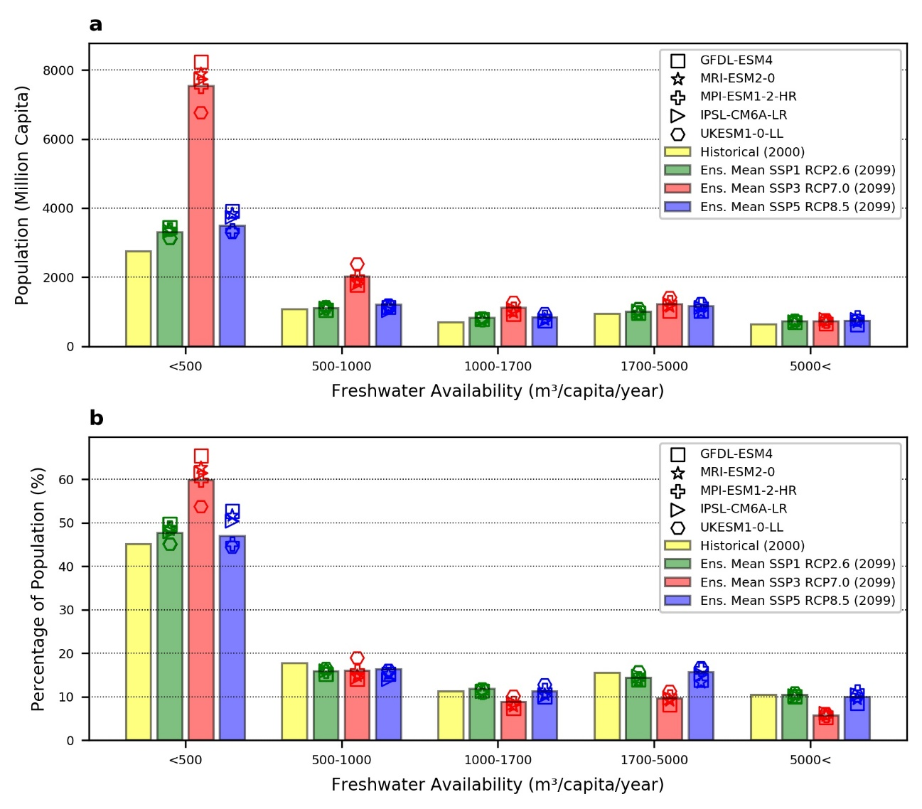
Supplementary Figure 11: Histogram of the (a) Million Population and (b) Percentage of Population in terms of freshwater availability (m3/cap/year) calculated considering gridded population by HYDE 3.2 for historical and Jones and O’Neill (2016) for future scenarios.

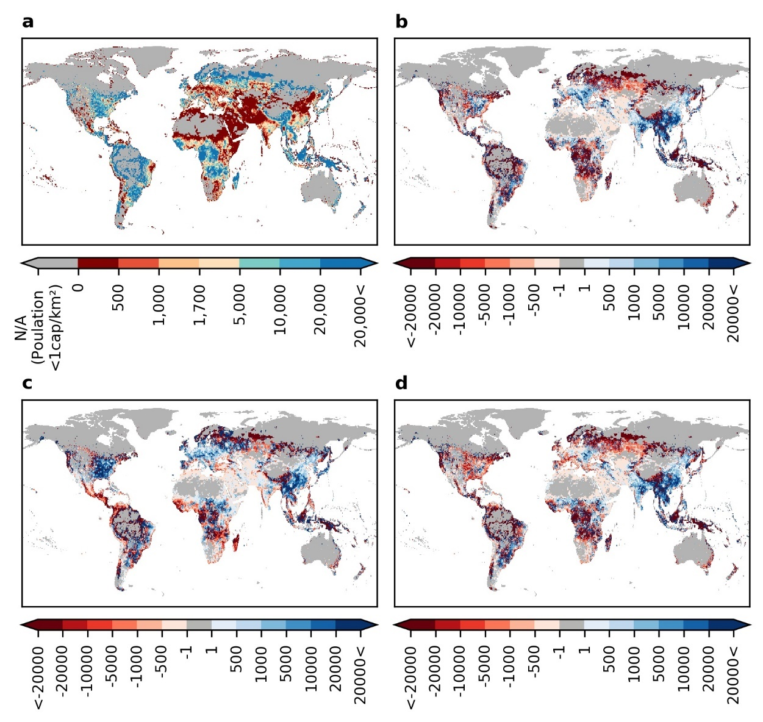
Supplementary Figure 12: Distribution of freshwater availability in (m³/cap/year) (a) Historical (2000), and the difference between (b) SSP1-RCP2.6(2099) and Historical (2000), (c) SSP3-RCP7.0 (2099) and Historical (2000), and (d) SSP5-RCP8.5 (2099) and Historical (2000), calculated considering gridded population by GPWv4 for historical and Murakami and Yamagata (2019) for future scenarios.
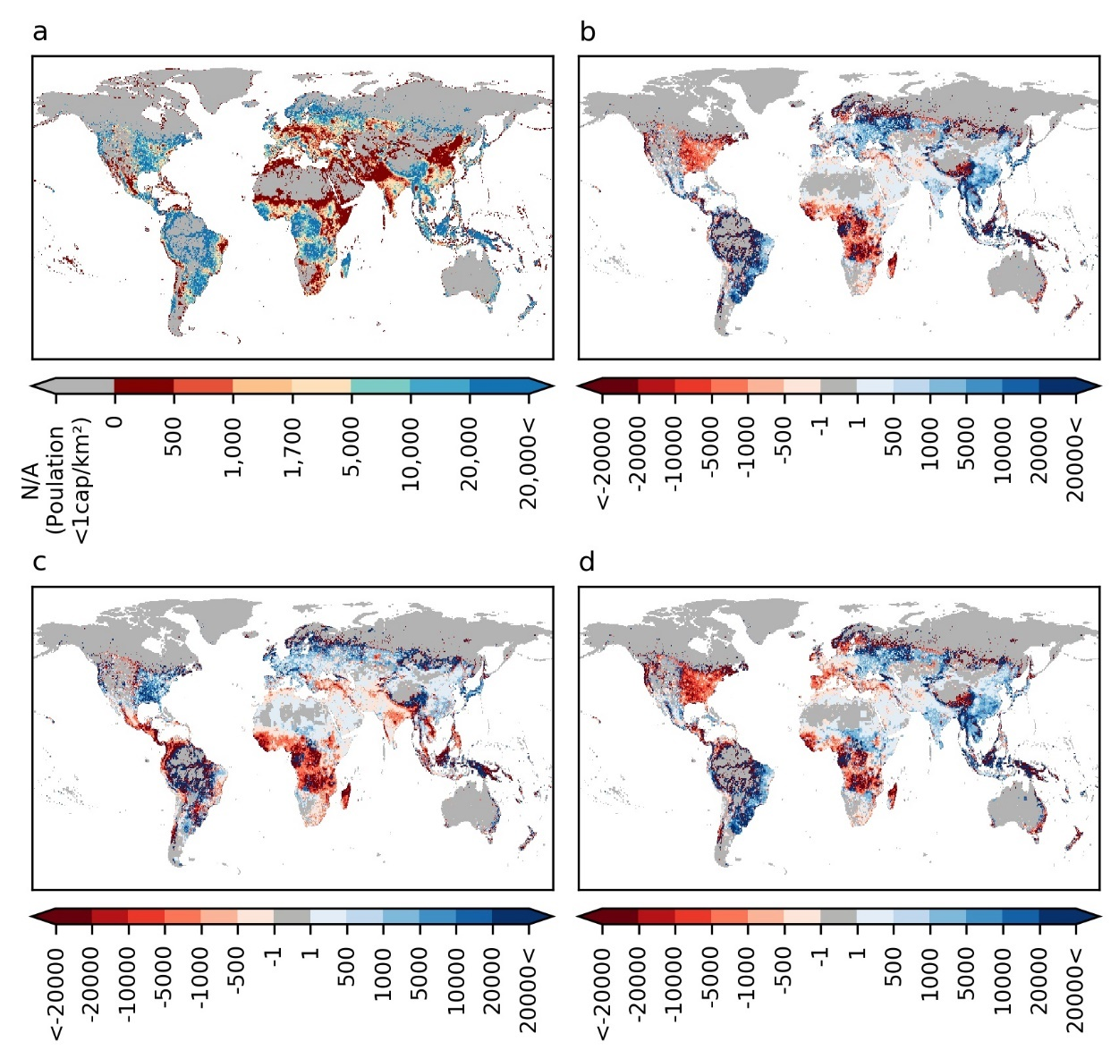
Supplementary Figure 13: Distribution of freshwater availability in (m³/cap/year) (a) Historical (2000), and the difference between (b) SSP1-RCP2.6(2099) and Historical (2000), (c) SSP3-RCP7.0 (2099) and Historical (2000), and (d) SSP5-RCP8.5 (2099) and Historical (2000), calculated considering gridded population by HYDE3.2 database for Historical and Jones and O’Neill (2016) for future scenarios.

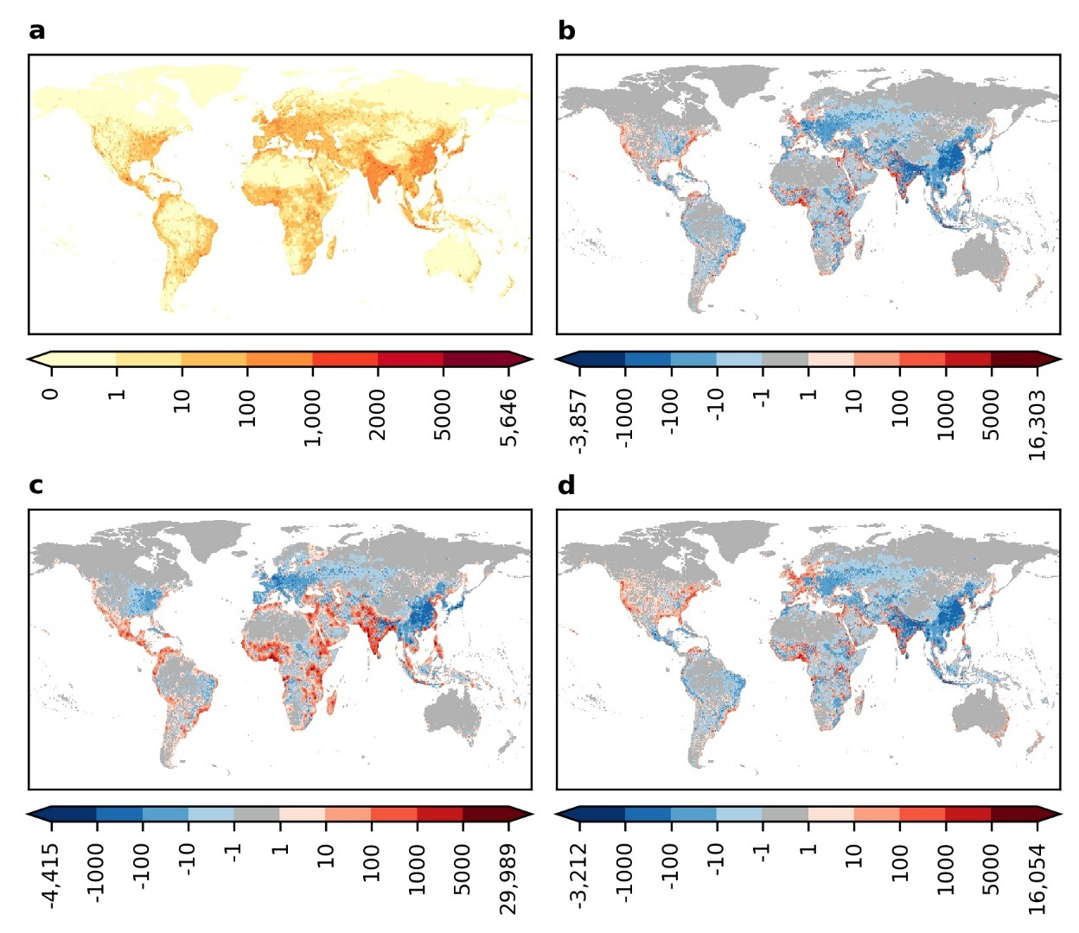
Supplementary Figure 14: Population Distribution over globe (capita/km2) (a) Historical (2000), and difference between (b) SSP1 (2099) and Historical (2000) ,(c) SSP3 (2099) and Historical (2000), and (d) SSP5 (2099) and Historical (2000) ), calculated considering gridded population by GPWv4 for historical and Murakami and Yamagata (2019) for future scenarios.
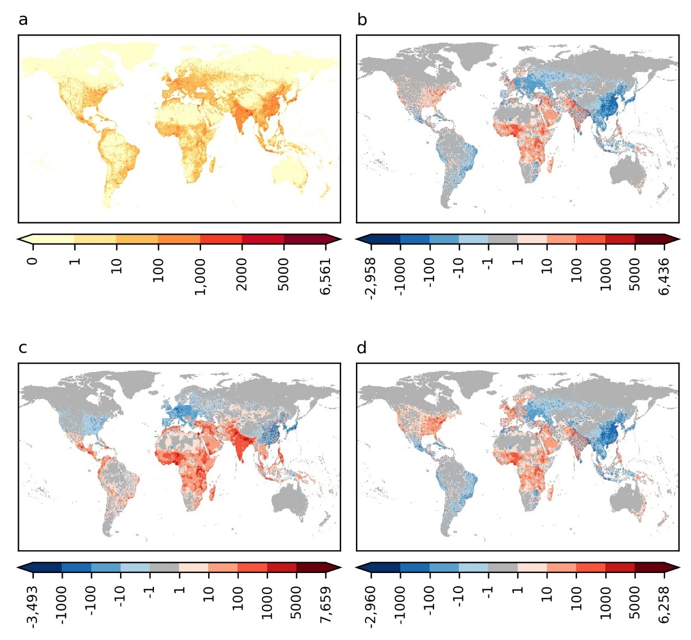
Supplementary Figure 15: Population Distribution over globe (capita/km2) (a) Historical (2000), and difference between (b) SSP1 (2099) and Historical (2000) ,(c) SSP3 (2099) and Historical (2000), and (d) SSP5 (2099) and Historical (2000) ), calculated considering gridded population by HYDE3.2 database for Historical and Jones and O’Neill (2016) for future scenarios.

