Sonochemical Fabrication of a Stable SERS Platform with Silver Nanoparticles on PCL Nanofibers

Aliakbar Ebrahimi^{1,2,}*, Erhan Piskin^{1,3,}*
¹Nanotechnology and Nanomedicine Division, Hacettepe University, Beytepe, Ankara, Türkiye.
²Department of Biomedical Engineering, Ankara Yildirim Beyazit University, Ankara, Türkiye.
³NanoBMT R&D: Nanobiyomedtek Biyomedikal ve Biyoteknoloji Sanayi ve Ticaret Limited Sirketi, Mugla, Türkiye.
* aliakbarebra82@gmail.com

Supplementary Results

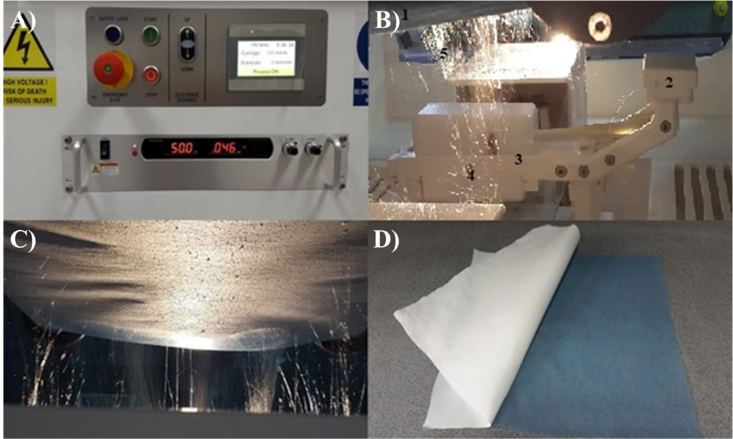
Figure S1. Electroplated film production with Nanospider® system A) Control unit; B) 1) Collector roll (fabric), 2) Polymer solution loading to carrier (polymer resorvir), 3) Polymer resorvier (carrier), 4) Feeding wire(bottom) and solution spraying part, and 5) Nanofibers collection on roll surface; C) Nanofibers formed during operation; D) Nanofiber film (white-curled) collected on the surface of collector roll (fabric, blue).

