Supplementary Information for

In situ Measurement of Airborne Particle Concentration in a Real Dental Office: Implications for Disease Transmission
Maryam Ravazi¹, Zahid Butt², Helen Chen², Zhongchao Tan^{1*}
¹ Department of Mechanical and Mechatronics Engineering, University of Waterloo, Waterloo, ON, Canada, N2L 3G1
²School of Public Health and Health Systems, University of Waterloo, Waterloo, ON, Canada, N2L 3G1
*tanz@uwaterloo.ca, Phone: 001 226-929-8021

Study design of real operation with the patient
In the second part of this study, the number concentrations were measured for three dental operations with real patients. The air ventilation system was blocked, and the door was closed, however, it was opened several times during the operations.
Table S- 1 summarizes the conditions for these three operations. The first and second operations were done in the large room $4×5×3 m$ ($W×L×H$). The sampling tube was 30 cm away from the patient’s head in the left hands side of the doctor's chair. The sampling tube was blocked several times by the doctor’s arm during the operation. In the first operation, the air purifier was running in periodic mode between low speed (153 CFM) and turbo speed (406 CFM), while it was off for second and third operations. The third operation was conducted in a small room. The sampling tube was 30 cm away from the patient’s head. The sampling tube was located on the opposite side of the doctor to avoid blockage.
Table S- 1. Dental operation conditions
 | Dental operation |  | Room size | Air purifier | Room condition before the operation |  | Room condition after operation
 | Type of operation | duration | Room size | Air purifier | Temperature (⁰C) | Humidity  (%) | Temperature (⁰C) | Humidity  (%)
Operation 1 | Filling with 1 root canal  High/low-speed handpieces | 88 min | Large (Room A) | On | 21.9 | 60 | 23.6 | 58
Operation 2 | Filling with 1 root canal  High/low-speed handpieces | 33 min | Large  (Room A) | Off | 24.7 | 54 | 24.9 | 49
Operation 3 | Crown insertion  High/low-speed handpieces | 73 min | Small  (Room B) | Off | 23.3 | 51 | 24.3 | 51

Field campaign with real patients
Figure S- 1, Figure S- 2, and Figure S- 3 demonstrate the number concentration of <0.5, 0.5, 1, 2.5, and 5 𝜇m particles during three dental procedures. The horizontal lines mark the background concentrations of <0.5 and 0.5 𝜇m particles. The moments that door was open are shown with Asterisks in the fig, which last less than a minute.
The first operation was conducted in 2 parts, shown in by patterned area. The higher concentrations entered the room from outside. After closing the door, the number concentration was reduced by the air purifier. Moreover, the concentration peaks were observed, in the moments that the door was open. The major fraction of particles was generated in the second part of the operation. During this time, the air purifier was running at low speed in 7 min and turbo speed in 7 min. In the first 7 min, the removal rate was 0.28 (#/cm³min) and the second 7 min was 1.14 (#/cm³min), 4 times faster than the time with low speed.
The second operation was conducted in a single part, and no considerable particles were measured. Similar to the fist operation, the number concentration of outside was higher than inside. The number concentration in the third operation was higher than the first two operations. The third operation was conducted in 2 parts. Higher values of concentration coming from outside are observed in this operation comparing to the first two because APS was closer to the door in 3rd operation.

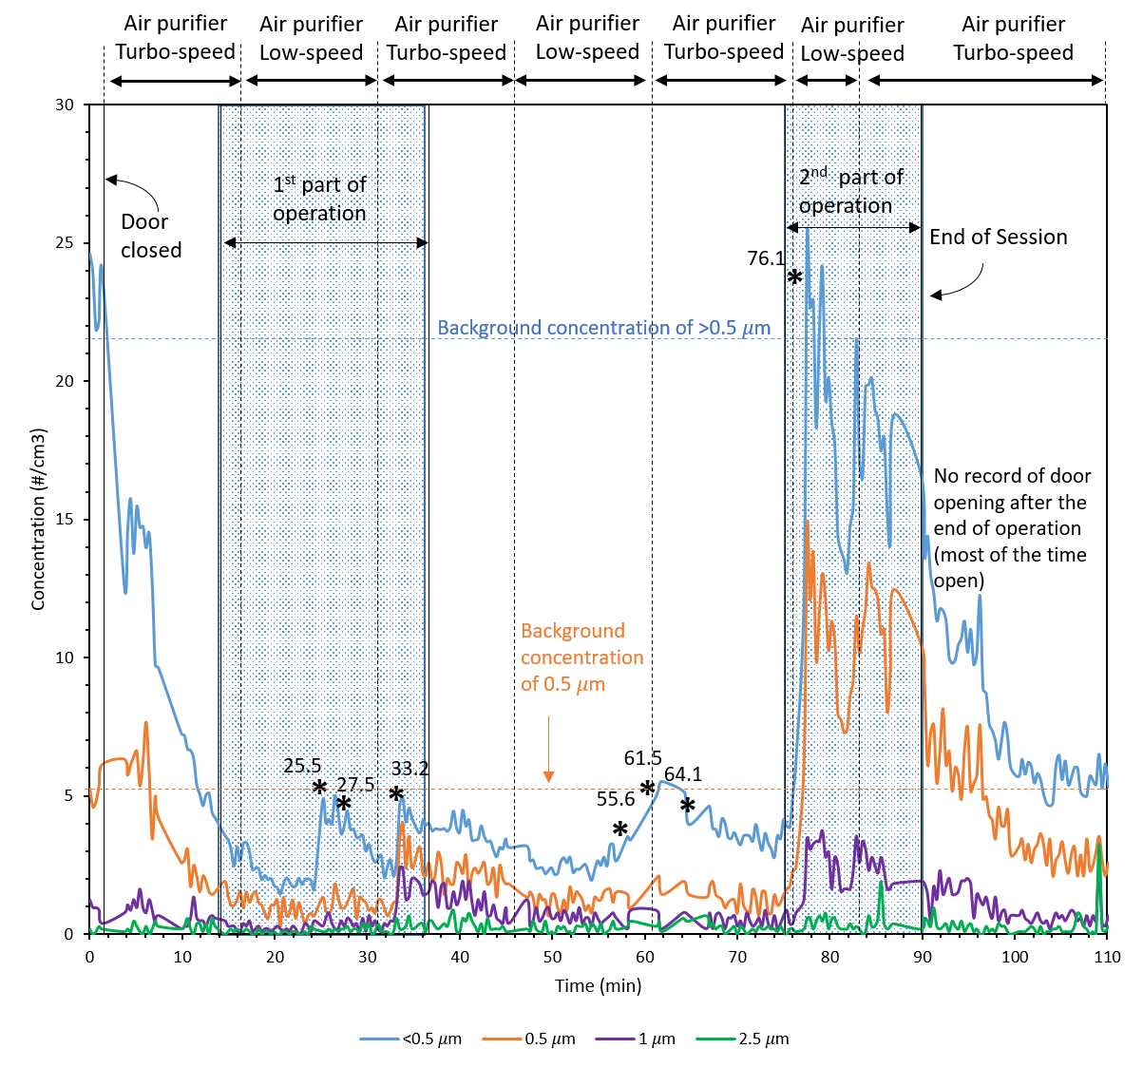
Figure S- 1 Operation 1 in room A (Large room)

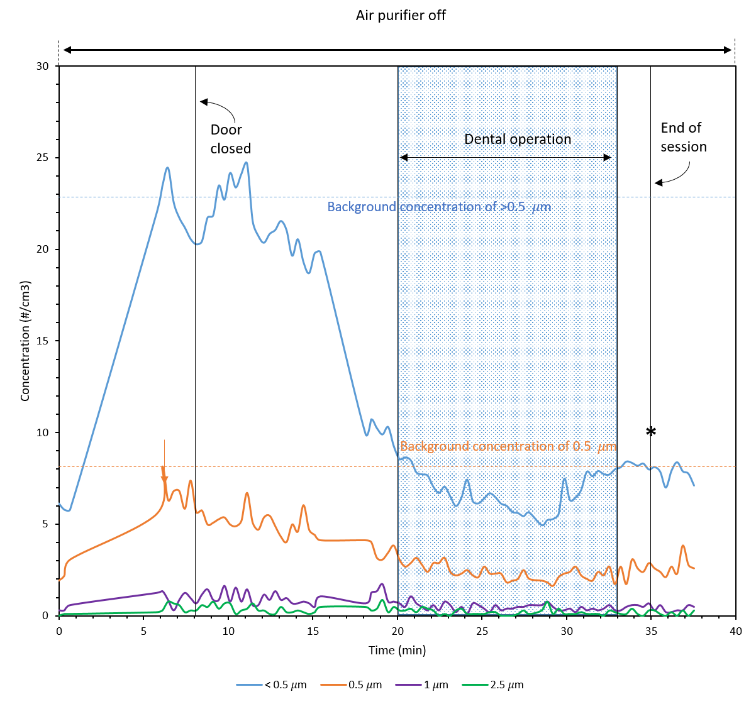
Figure S- 2 Operation 2 in room A (Large room)

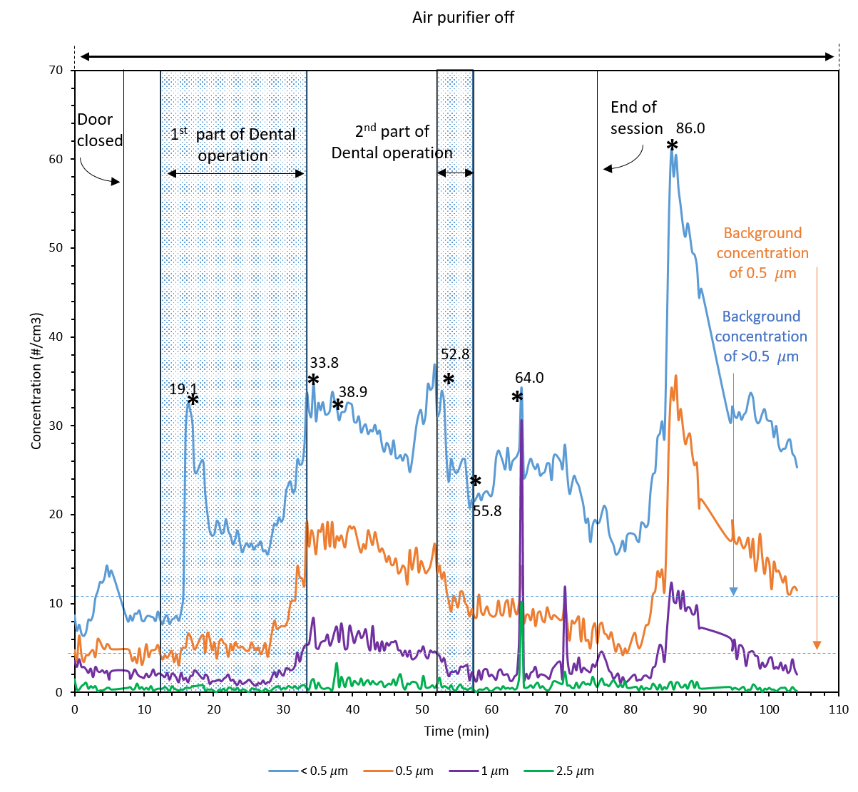
Figure S- 3 Operation 3 in room B (small room)

