Supplemental Material
Unsupervised clustering identifies sub-phenotypes and reveals pre-dialysis hyperlactatemia as a novel outcome predictor in dialysis-requiring sepsis-associated acute kidney injury

Chun-Fu Lai, Vin-Cent Wu, Jung-Hua Liu, Shuei-Liong Lin and Yung-Ming Chen

Supplementary Figures
Figure S1. Consensus matrix heat maps and cluster-consensus plots.
Figure S2. Consensus cumulative distribution function plots.
Figure S3. Comparisons of baseline demographic characteristics across the three subphenotypes of patients with dialysis-requiring sepsis-associated acute kidney injury.
Figure S4. Comparisons of baseline clinical characteristics upon initialising RRT across the three subphenotypes of patients with dialysis-requiring sepsis-associated acute kidney injury.
Figure S5. Additional unsupervised clustering of patients with dialysis-requiring sepsis-associated acute kidney injury.
Figure S6. Validation in the NEP-AKI-D cohort.
Figure S7. Association of hyperlactatemia with mortality in the validation cohort.
Figure S8. Comparison of cumulative incidence function with Kaplan-Meier estimates.

Supplementary Tables
Table S1. Demographic and clinical characteristics of patients stratified by serum lactate level upon initialising renal replacement therapy.
Table S2. Demographic and clinical characteristics of analyzed patients in the validation cohort (NEP-AKI-D).

Supplementary Methods

Clinical assessments of patients

Dialysis initiation

The NEP-AKI-D study

Validation cohort and patients’ outcomes

Reference to the Supplementary Methods

Figure S1. Consensus matrix heat maps and cluster-consensus plots. (A-E) Consensus matrix heat maps of 1,397 patients with dialysis-requiring sepsis-associated acute kidney injury. Each pairwise consensus of all participant is color-coded by the blue color gradient scale. The darkest blue color represents perfect consensus when two patients grouped together, while the white color represent perfect consensus when two patients grouped separately. The cluster memberships are marked by colored rectangles between the dendrogram and heat map. Graphics of the consensus matrices are depicted for different cluster size: (A) k=2, (B) k=3, (C) k=4, (D) k=5, (E) k=6. (F) Cluster-consensus plots illustrated the mean of all pairwise consensus values between members within each cluster. Clusters are indicated by color marks. The plots are grouped by different cluster size k which is marked on the horizontal axis. The mean consensus value on the vertical axis depicts the stability of the clusters. Clustering with k = 3 generated all clusters with a mean consensus value more than 0.7, indicating good stability of the cluster membership.
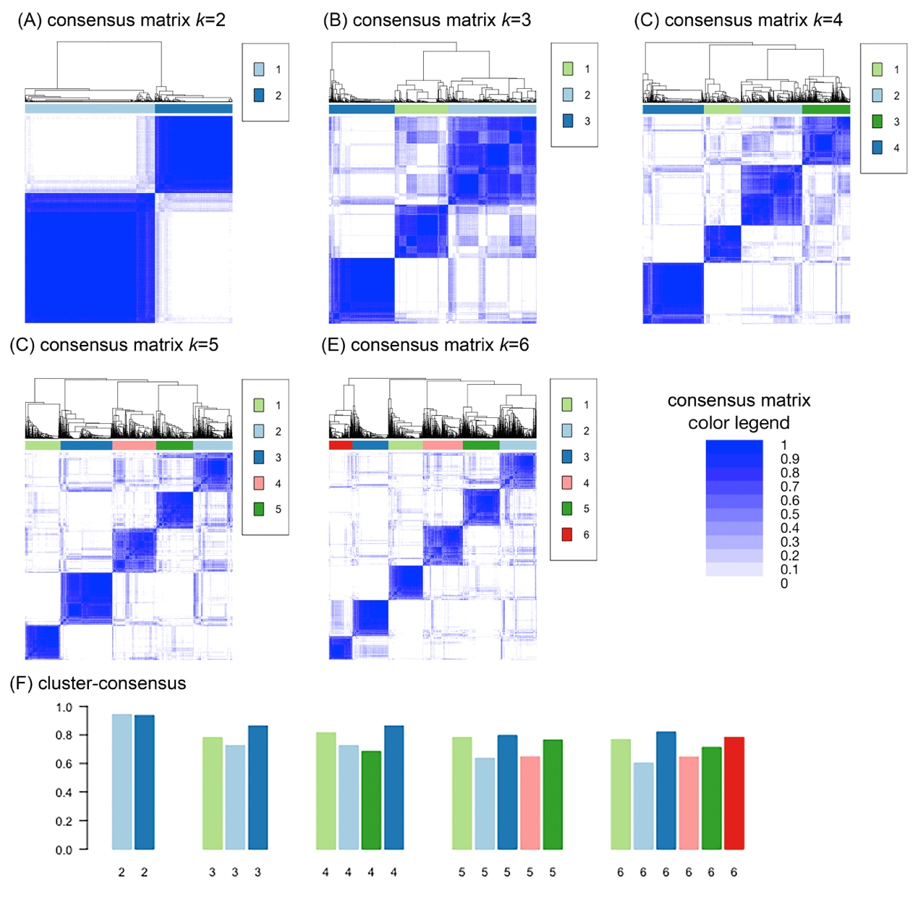

Figure S2. Consensus cumulative distribution function plots. (A) Consensus cumulative distribution function (CDF) of the consensus matrix estimated by a histogram of 100 bins. Different CDFs for each cluster size k are labeled by different colors. (B) Delta area plot shows the changes in the area under the CDF curve comparing cluster size k and k-1. Of note, the changes of area under CDF curve did not conspicuously increase when the cluster size k was more than 3.
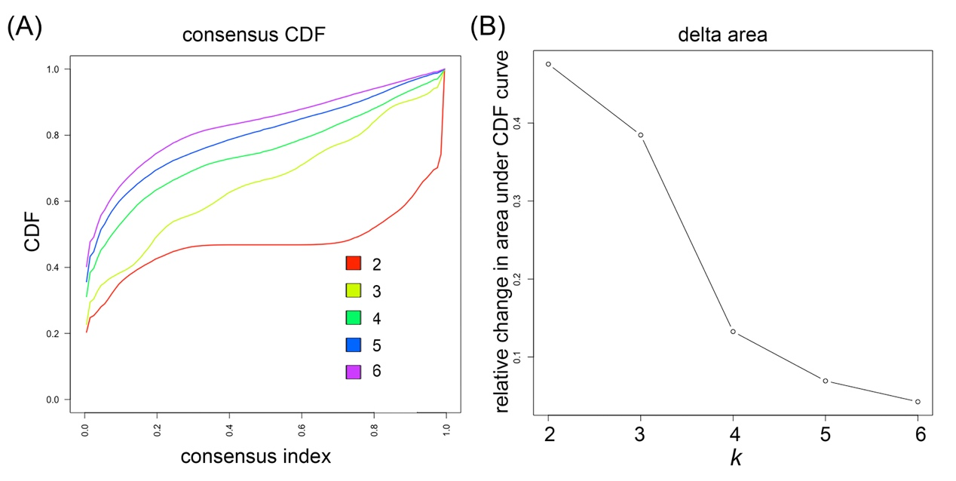
Figure S3. Comparisons of baseline demographic characteristics across the three subphenotypes of patients with dialysis-requiring sepsis-associated acute kidney injury. Continuous variables are illustrated by violin plots with median (thick lines) and interquartile range (dotted lines). Categorical variables are presented as percentages (cluster 1: green; cluster 2: yellow; cluster 3). Characteristics were compared among the groups using one-way analysis of variance, the Kruskal–Wallis test, the two-sample t-test, the Mann–Whitney U test, and the chi-square test, as indicated. * p <0.05; ** p <0.01; *** p <0.001; **** p <0.0001.
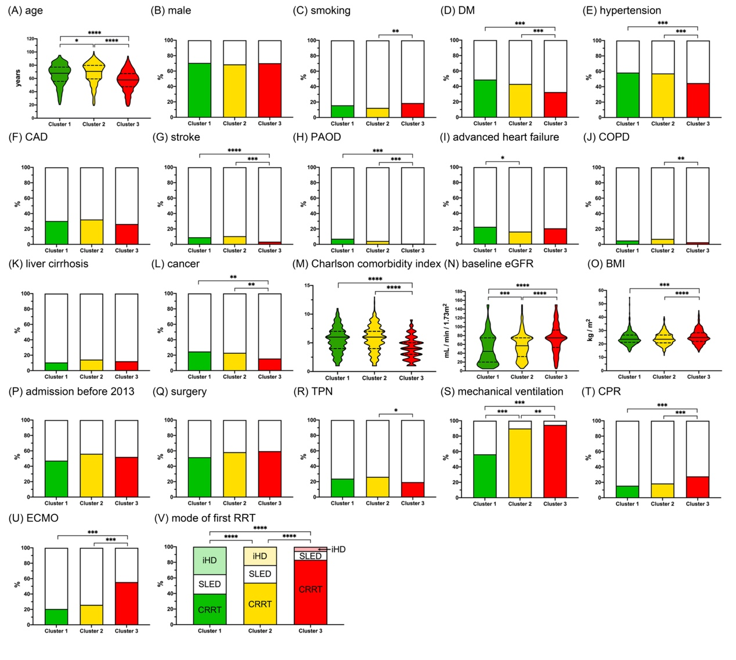

Figure S4. Comparisons of baseline clinical characteristics upon initialising RRT across the three subphenotypes of patients with dialysis-requiring sepsis-associated acute kidney injury. Continuous variables are illustrated by violin plots with median (thick lines) and interquartile range (dotted lines). Categorical variables are presented as percentages (cluster 1: green; cluster 2: yellow; cluster 3: red). Characteristics were compared among the groups using one-way analysis of variance, the Kruskal–Wallis test, the two-sample t-test, the Mann–Whitney U test, and the chi-square test, as indicated. * p <0.05; ** p <0.01; *** p <0.001; **** p <0.0001.
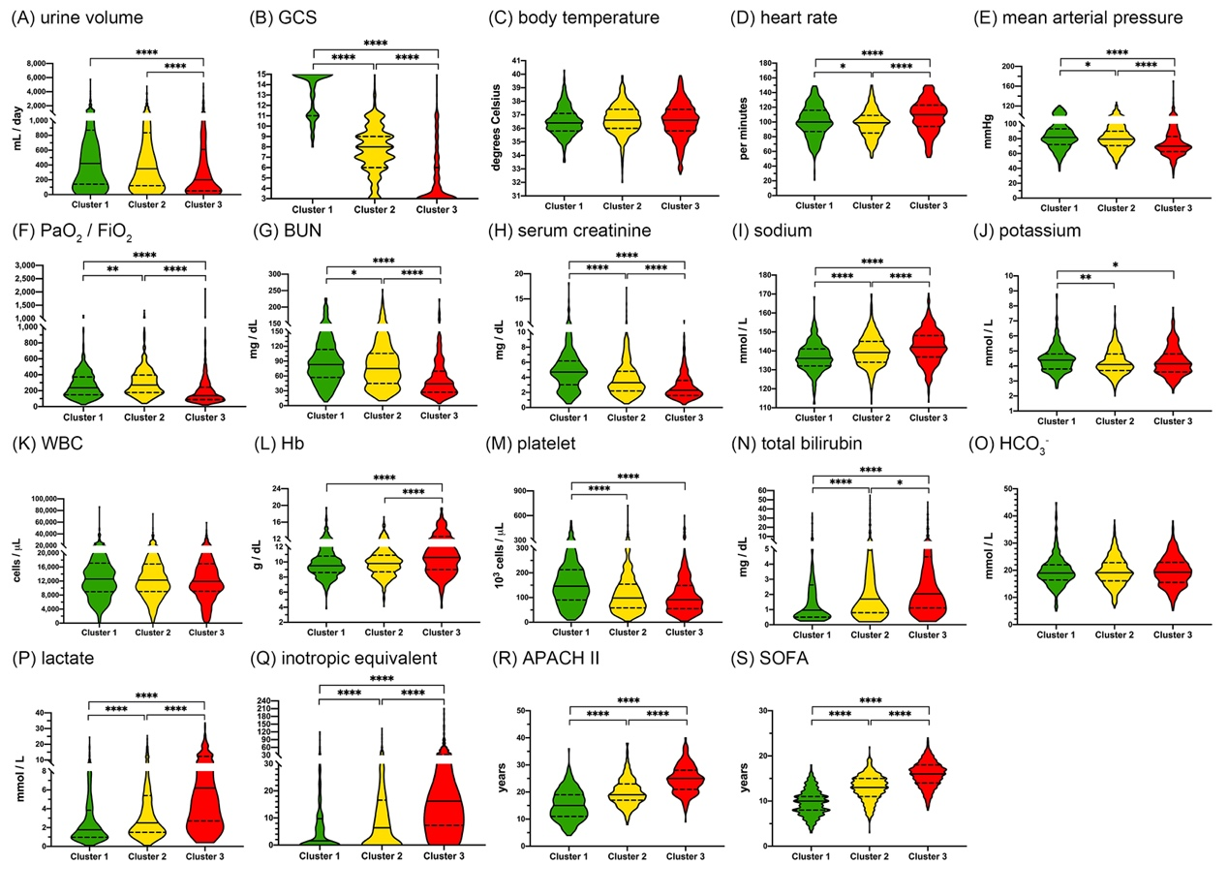

Figure S5. Additional unsupervised clustering of patients with dialysis-requiring sepsis-associated acute kidney injury. (A) This clustering approach was performed by principal component analysis of the 22 clinical parameters (see Methods) using the K-nearest neighbour graph structure embedding and Louvain community algorithm. Two clusters were identified and visualised by the Uniform Manifold Approximation and Projection (UMAP) dimensional reduction. (B-F) Violin plots showed the different features between the two clusters. **** p <0.0001. (G) Kaplan–Meier curves of patient survival stratified by the two clusters.
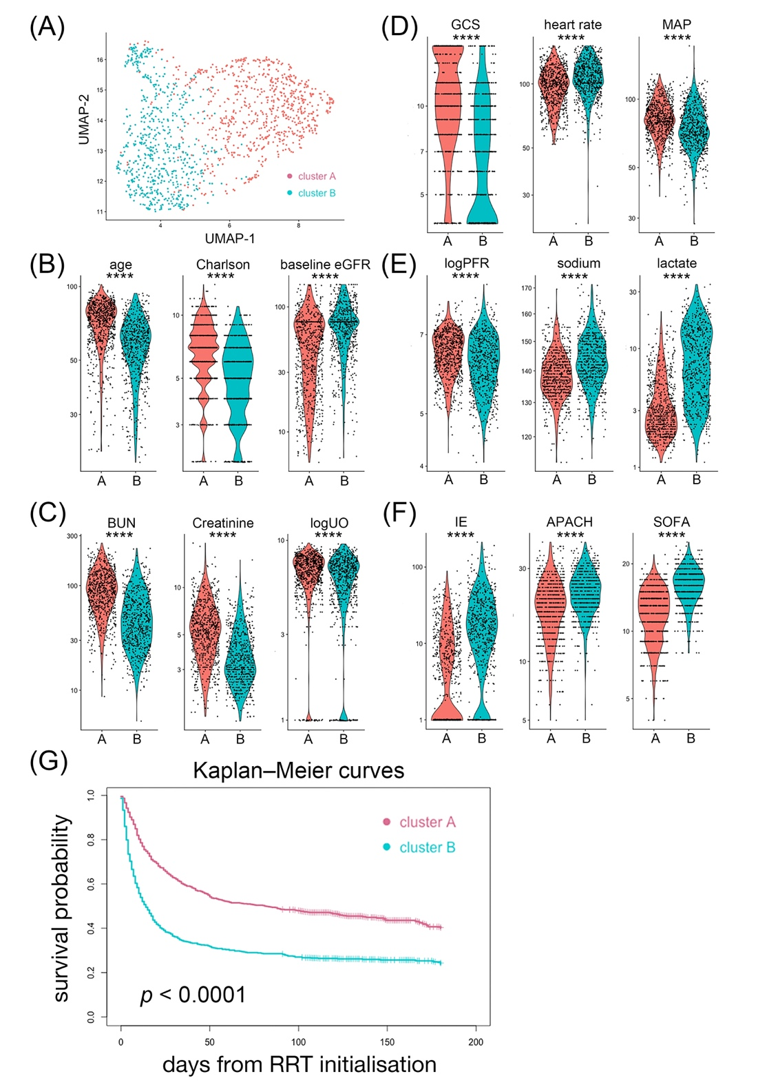
Abbreviations: Charlson, Charlson Comorbidity Index; eGFR, estimated glomerular filtration rate; BUN, blood urea nitrogen; logUO, logarithm of urine volume; GCS, Glasgow Coma Scale; BT, body temperature; MAP, mean arterial pressure; logPFR, logarithm of the PaO2 to fraction of inspired oxygen ratio; IE, inotropic equivalent; APACH, Acute Physiology and Chronic Health Evaluation II score; SOFA, sequential organ failure assessment score.

Figure S6. Validation in the NEP-AKI-D cohort. A total of 1,872 patients with dialysis-requiring AKI and hospitalized in ICU between January 2014 and December 2016 were screened. Among them, 190 patients who underwent surgery during the index hospitalization, were diagnosed to have sepsis defined by the Sepsis-3 criteria, had a serum lactate measurement upon initialising RRT and were followed upon 90 days after hospital discharge were analysed as the validation cohort.
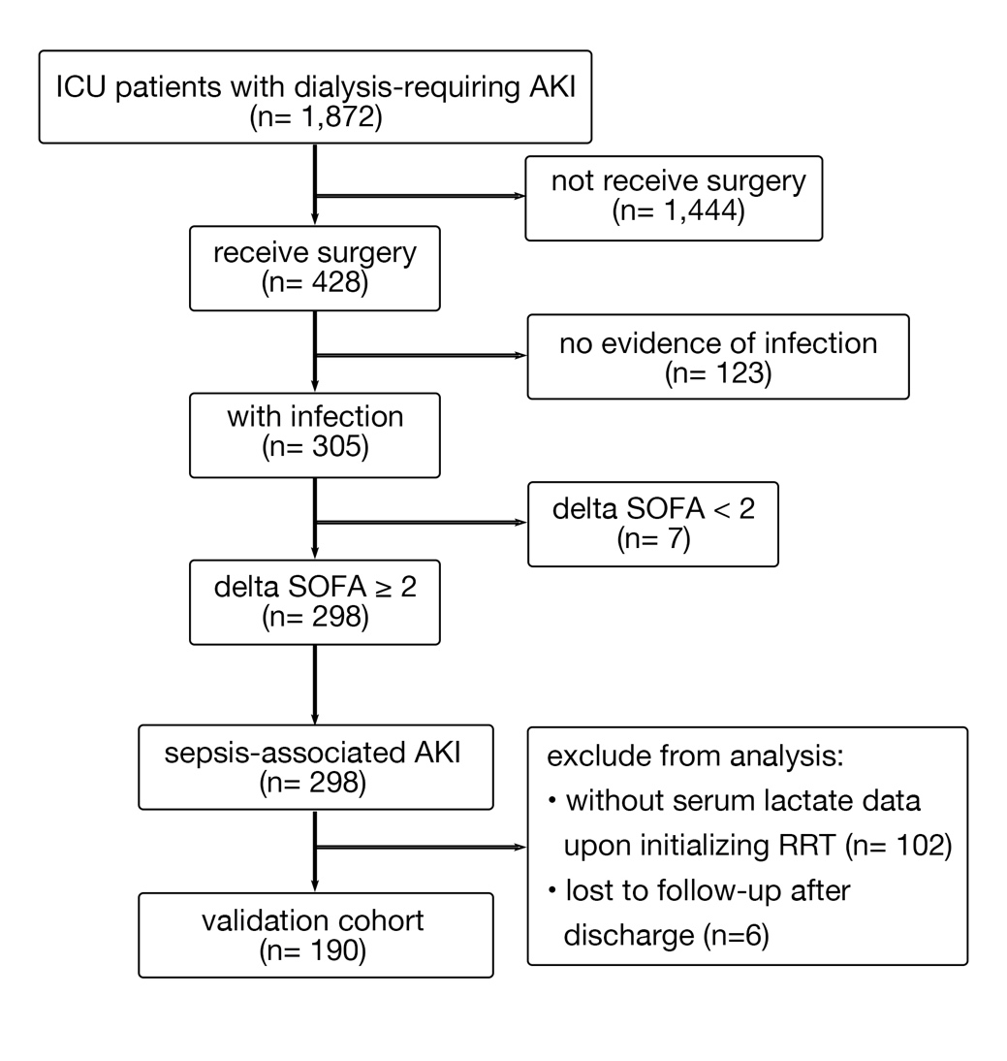
Abbreviations: NEP-AKI-D: nationwide epidemiology and prognosis of dialysis-requiring acute kidney injury study; AKI, acute kidney injury; ICU, intensive care unit; SOFA, sequential organ failure assessment score; RRT, renal replacement therapy

Figure S7. Association of hyperlactatemia with mortality in the validation cohort. A total of 190 critically ill patients with dialysis-requiring SA-AKI from the NEP-AKI-D cohort were analysed. This figure illustrates the unadjusted and adjusted hazard ratios with 95% confidence intervals of hyperlactatemia of ≥ 3.1 mmol/L upon initialising RRT for mortality 90 days after hospital discharge. Multivariable Cox regression model 1: age, sex, baseline eGFR, Charlson Comorbidity Index, and hyperlactatemia of ≥ 3.1 mmol/L upon initialising RRT; model 2: all variables in model 1 and MAP upon initialising RRT; model 3: all variables in model 2 and SOFA score upon initialising RRT.
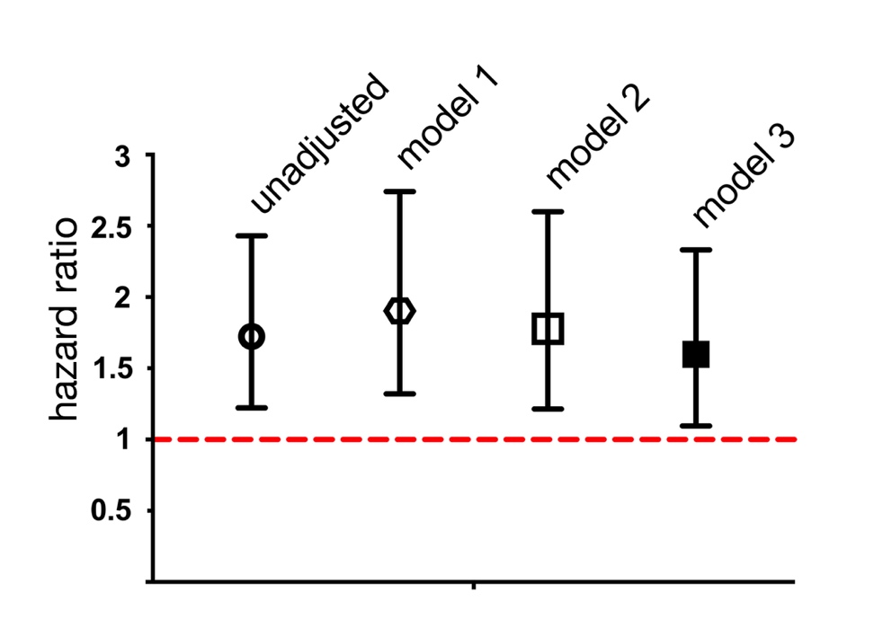
Abbreviations: SA-AKI, sepsis-associated acute kidney injury; NEP-AKI-D: nationwide epidemiology and prognosis of dialysis-requiring acute kidney injury study; RRT, renal replacement therapy; eGFR, estimated glomerular filtration rate; MAP, mean arterial pressure; SOFA, total Sequential Organ Failure Assessment score.

Figure S8. Comparison of cumulative incidence function with Kaplan-Meier estimates. Overlaid cumulative incident function of being free of dialysis (red lines, with death as a competing risk) and the corresponding naïve incidence function (Kaplan–Meier curve) (blue lines, censors for death), stratified by the threshold of serum lactate level of 3.1 mmol/L upon initialising renal replacement therapy (RRT). Because many patients with hyperlactatemia died early and were censored in the Cox model, Kaplan–Meier function overestimated the incidence of being free of dialysis and lost the discriminative capacity of hyperlactatemia of ≥ 3.1 mmol/L.
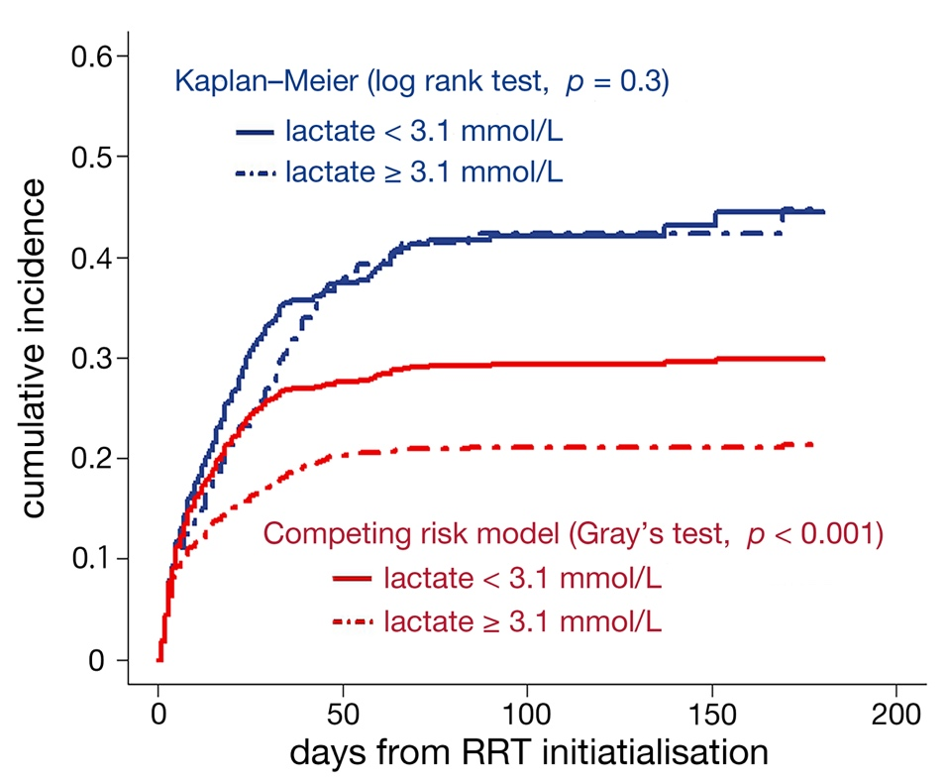

Table S1. Demographic and clinical characteristics of patients stratified by serum lactate level upon initialising renal replacement therapy.
Variables | Serum lactate < 3.1 mmol/L  (n=720) | Serum lactate ≥ 3.1 mmol/L  (n=677) | p value
Demographic characteristics
Age, years | 65.76 ± 16.13 | 61.75 ± 16.4 | <0.001
Male sex | 508 (70.56%) | 465 (68.69%) | 0.47
Current smoker or ex-smoker | 120 (16.67%) | 94 (13.88%) | 0.17
Diabetes mellitus | 311 (43.19%) | 267 (39.44%) | 0.18
Hypertension | 411 (57.08%) | 337 (49.78%) | 0.008
Coronary artery disease | 221 (30.69%) | 197 (29.1%) | 0.52
Stroke | 63 (8.75%) | 48 (7.09%) | 0.28
Peripheral arterial occlusive disease | 35 (4.86%) | 21 (3.1%) | 0.1
Advanced heart failure, NYHA Fc III or IV | 135 (18.75%) | 134 (19.79%) | 0.64
Chronic obstructive pulmonary disease | 43 (5.97%) | 29 (4.28%) | 0.2
Liver cirrhosis | 89 (12.36%) | 88 (13%) | 0.74
Cancer | 165 (22.92%) | 130 (19.2%) | 0.11
Charlson Comorbidity Index | 5.34 ± 2.26 | 4.95 ± 2.19 | <0.001
Baseline eGFR, ml/min/1.73m² | 55.93 ± 33.94 | 65.35 ± 30.15 | <0.001
Body mass index, kg/m² | 24.14 ± 4.8 | 24.86 ± 4.78 | 0.005
Index admission year before 2013 | 364 (50.56%) | 371 (54.8%) | 0.12
Surgery | 390 (54.17%) | 406 (59.97%) | 0.03
Total parenteral nutrition | 196 (27.22%) | 132 (19.5%) | <0.001
Mechanical ventilation | 556 (77.22%) | 600 (88.63%) | <0.001
Cardiopulmonary resuscitation | 114 (15.83%) | 175 (25.85%) | <0.001
ECMO | 175 (24.31%) | 299 (44.17%) | <0.001
Source of sepsis
Respiratory tract | 433 (60.14%) | 405 (59.82%) | 0.92
Intraabdominal | 66 (9.17%) | 41 (6.06%) | 0.03
Skin or soft-tissue | 67 (9.31%) | 53 (7.83%) | 0.35
Genitourinary tract | 69 (9.58%) | 49 (7.24%) | 0.13
Device or catheter associated | 199 (27.64%) | 165 (24.37%) | 0.17
Blood stream | 157 (21.81%) | 129 (19.05%) | 0.2
Others / Unknown | 210 (29.17%) | 196 (28.95%) | 0.96
Indication for dialysis initiation
Azotaemia with symptoms | 470 (65.28%) | 264 (39%) | <0.001
Fluid overload | 299 (41.53%) | 324 (47.86%) | 0.02
Electrolyte imbalance | 79 (10.97%) | 76 (11.23%) | 0.93
Metabolic acidosis | 94 (13.06%) | 184 (27.18%) | <0.001
Oliguria | 452 (62.78%) | 489 (72.23%) | <0.001
Others | 41 (5.69%) | 61 (9.01%) | 0.02
Modality at the first RRT |  |  | <0.001
CRRT | 327 (45.42%) | 505 (74.59%)
SLED | 167 (23.19%) | 107 (15.81%)
iHD | 226 (31.39%) | 65 (9.6%)
Clinical data upon initialising RRT
Urine volume, mL/day (median [IQR]) | 407.5 (131-910) | 240 (60-621) | <0.001
Glasgow Coma Scale | 9.30 ± 3.88 | 7.12 ± 3.9 | <0.001
Body temperature, degree Celsius | 36.63 ± 1.02 | 36.53 ± 1.28 | 0.12
Heart rate, beats per minute | 98.72 ± 20.36 | 104.77 ± 20.9 | <0.001
Mean arterial pressure, mmHg | 81.71 ± 15.93 | 75.34 ± 16.13 | <0.001
Ratio of PaO2 to fraction of inspired oxygen (median [IQR]) | 232.8 (150.6-361.7) | 195.6 (116.1-346.5) | <0.001
Blood urea nitrogen, mg/dL | 89.91 ± 44.37 | 57.17 ± 36.91 | <0.001
Serum creatinine, mg/dL | 4.35 ± 2.36 | 3.11 ± 1.98 | <0.001
Sodium, mmol/L | 138.55 ± 7.95 | 141.3 ± 8.67 | <0.001
Potassium, mmol/L | 4.36 ± 0.86 | 4.26 ± 0.91 | 0.04
White blood cells, 10³cells/μL | 13.4 ± 7.03 | 14.09 ± 8.74 | 0.11
Hemoglobin, g/dL | 9.72 ± 1.75 | 10.72 ± 2.49 | <0.001
Platelets, 10³cells/μL | 131.93 ± 89.11 | 119.81 ± 86.33 | 0.01
Total bilirubin, mg/dL | 4.44 ± 7.86 | 4.51 ± 6.93 | 0.85
Bicarbonate, mmol/L | 20.24 ± 5.2 | 18.71 ± 5.33 | <0.001
Lactate, mmol/L | 1.57 ± 0.7 | 9.11 ± 5.47 | <0.001
Inotropic equivalent, μg/kg/min (median [IQR]) | 2.88 (0-9.84) | 15.4 (6.4-29.47) | <0.001
APACH II score (median [IQR]) | 19 (14.75-23) | 21 (18-25) | <0.001
SOFA score (median [IQR]) | 12 (9-14) | 15 (12-17) | <0.001
90 days after hospital discharge
Outcome |  |  | <0.001
Mortality | 405 (56.25%) | 496 (73.26%)
Dialysis-dependent | 102 (14.17%) | 37 (5.47%)
Being free of dialysis | 213 (29.58%) | 144 (21.27%)

Data are presented as mean (standard deviation) or number (%), unless otherwise specified. Abbreviations: RRT, renal replacement therapy; NYHA Fc, New York Heart Association functional class; eGFR, estimated glomerular filtration rate; ECMO, extracorporeal membrane oxygenation; CRRT, continuous renal replacement therapy; SLED, sustained low efficiency dialysis; iHD, intermittent haemodialysis; IQR, interquartile range; APACH, Acute Physiology and Chronic Health Evaluation; SOFA, sequential organ failure assessment.

Table S2. Demographic and clinical characteristics of analyzed patients in the validation cohort (NEP-AKI-D). (n=190)
Demographic characteristics
Age, years | 64.25 ± 16.48
Male sex | 124 (65.26%)
Current smoker or ex-smoker | 33 (17.37%)
Diabetes mellitus | 85 (44.74%)
Hypertension | 111 (58.42%)
Coronary artery disease | 45 (23.68%)
Stroke | 16 (3.16%)
Peripheral arterial occlusive disease | 7 (3.68%)
Advanced heart failure, NYHA Fc III or IV | 33 (17.37%)
Chronic obstructive pulmonary disease | 12 (6.32%)
Liver cirrhosis | 27 (14.21%)
Cancer | 55 (28.95%)
Charlson Comorbidity Index | 6.22 ± 3.11
Baseline eGFR, ml/min/1.73m² | 69.43 ± 40.21
Mechanical ventilation | 181 (95.26%)
Cardiopulmonary resuscitation | 29 (15.26%)
Source of sepsis
Respiratory tract | 107 (56.32%)
Intraabdominal | 53 (27.89%)
Skin or soft-tissue | 11 (5.79%)
Genitourinary tract | 68 (35.79%)
Blood stream | 68 (35.79%)
Others / Unknown | 29 (15.26%)
Indication for dialysis initiation
Azotaemia with symptoms | 90 (47.37%)
Fluid overload | 145 (76.32%)
Electrolyte imbalance | 56 (29.47%)
Metabolic acidosis | 80 (42.11%)
Oliguria | 122 (64.21%)
Others | 15 (7.89%)
Modality at the first RRT
CRRT | 92 (48.42%)
SLED | 17 (8.95%)
iHD | 81 (42.63%)
Clinical data upon initialising RRT
Urine volume, mL/day (median [IQR]) | 300 (100-877.5)
Glasgow Coma Scale | 7.94 ± 3.95
Body weight, kg | 70.42 ± 14.13
Body temperature, degree Celsius | 36.54 ± 1.14
Heart rate, beats per minute | 103.21 ± 21.12
Mean arterial pressure, mmHg | 80.78 ± 19.46
Ratio of PaO2 to fraction of inspired oxygen (median [IQR]) | 245.2 (161.1-362.3)
Blood urea nitrogen, mg/dL | 77.57 ± 50.42
Serum creatinine, mg/dL | 4.27 ± 2.33
Sodium, mmol/L | 140.66 ± 7.55
Potassium, mmol/L | 4.46 ± 1.04
White blood cells, 10³cells/μL | 14.32 ± 9.59
Hemoglobin, g/dL | 9.66 ± 1.82
Platelets, 10³cells/μL | 122.33 ± 94.33
Total bilirubin, mg/dL | 3.66 ± 6.22
Bicarbonate, mmol/L | 18.77 ± 5.94
Lactate, mmol/L | 6.47 ± 7.95
Inotropic equivalent, μg/kg/min (median [IQR]) | 7.4 (0-20.6)
APACH II score (median [IQR]) | 23 (19-28)
SOFA score (median [IQR]) | 13 (10-16)
90 days after hospital discharge
Mortality | 133 (70%)
Dialysis-dependent | 7 (3.68%)
Being free of dialysis | 50 (26.32%)

Data are presented as mean (standard deviation) or number (%), unless otherwise specified. Abbreviations: NEP-AKI-D: nationwide epidemiology and prognosis of dialysis-requiring acute kidney injury study; NYHA Fc, New York Heart Association functional class; eGFR, estimated glomerular filtration rate; RRT, renal replacement therapy; CRRT, continuous renal replacement therapy; SLED, sustained low efficiency dialysis; iHD, intermittent haemodialysis; IQR, interquartile range; APACH, Acute Physiology and Chronic Health Evaluation; SOFA, sequential organ failure assessment.

Supplementary Methods
Clinical assessments of patients
All data in the National Taiwan University Hospital Study Group on Acute Renal Failure (NSARF) database were prospectively collected on a standardized form [1]. We extracted the following demographic data obtained at intensive care unit (ICU) admission: age, sex, smoking history, diabetes mellitus (defined by using oral antidiabetic agents or insulin), hypertension (using anti-hypertensive drugs or systolic and diastolic blood pressure >140/90 mmHg), coronary arterial disease (defined by the diagnostic code and positive electrocardiographic findings), stroke (ischemic or hemorrhagic), peripheral arterial occlusive disease (defined by clinical or imaging diagnosis), advanced heart failure (defined as New York Heart Association functional class III or IV), chronic obstructive pulmonary disease (with long-term bronchodilators), and liver cirrhosis (defined by image studies with computed tomography or sonography). Cancer was recorded according to diagnostic codes prior to admission. Patients with associated diseases were assessed using the Charlson Comorbidity Index [2]. Baseline serum creatinine was determined as the lowest value measured within 180 days before the index admission, or the nadir value before dialysis during the index admission if the patient did not have any creatinine measurement within the previous 180-day period [1]. Baseline estimated glomerular filtration rate was calculated by four-variable Modification of Diet in Renal Disease equation [3].
The worst physiological and laboratory values during the 24-hour period before the first dialysis were collected. Serum lactate levels and body mass index were missing in 142 (10.16%) and 47 (3.36%) of individuals, respectively. All other variables were missing for less than 0.6%. Missing data was imputed using Multivariate Imputation by Chained Equation. The severity scores including the Glasgow Coma Scale, the Sequential Organ Failure Assessment score [4], and the Acute Physiology and Chronic Health Evaluation II score were measured. The doses of inotropic therapies (expressed as inotropic equivalent [μg/kg/min] = dopamine + dobutamine + 100×epinephrine + 100×norepinephrine + 100×isoprotenolol + 15×milrinone)[5], usages of mechanical ventilation, total parenteral nutrition, surgery, and extracorporeal membrane oxygenation were also recorded.
Dialysis initiation
The indications for dialysis initiation included but not limited to: (1) azotaemia, defined as blood urea nitrogen >80 mg/dL or serum creatinine > 2 mg/dL, with uremic syndrome, such as confusion, platelet dysfunction, pericarditis, or uremic pneumonitis; (2) refractory fluid overload, defined by a central venous pressure level > 12 mmHg or pulmonary arterial wedge pressure>18 mmHg; (3) refractory hyperkalemia > 5.5 mmol/L (4) refractory metabolic acidosis with a pH <7.2; (5) oliguria (urine output < 400 mL/24h) or anuria refractory to diuretics. The modality of dialysis was documented as either continues renal replacement therapy, sustained low efficiency dialysis, or intermittent haemodialysis according the attending physician and adjusted by the critical care nephrologists based on the disease evolutions.
The NEP-AKI-D study
The nationwide epidemiology and prognosis of dialysis-requiring acute kidney injury (NEP-AKI-D) study was launched by the Consortium for Acute Kidney Injury and Renal Disease (CAKs) in Taiwan. This observational study prospectively enrolled critically ill patients with dialysis-requiring acute kidney injury (AKI) in intensive care units of the 30 participating hospitals. These hospitals distribute through the four geographic regions of Taiwan and have a 1:1 ratio of tertiary medical centers to regional hospitals in each geographic region.[6] All adults patients encountering dialysis-requiring AKI, defined by the Kidney Disease: Improving Global Outcomes criteria, in the seasonal sampled months (January, April, July, and October in study period) were enrolled. The exclusion criteria included patients who were younger than 20 years, received chronic dialysis before the index hospitalization, and died within 48 hours after ICU admission. The institutional review boards of each hospital approved this study and waived the need for informed consents because all personal information is de-identified (NRPB2014050014). The NEP-AKI-D study has been described previously.[6-9]
Validation cohort and patients’ outcomes
In the NEP-AKI-D study cohort, there were 1,872 critically ill patients encountering dialysis-requiring AKI between January 2014 and December 2016. We included patients who received surgery during the index hospitalization (n=428), because surgery is identified as an independent predictor for both mortality and weaning off dialysis in the NSARF cohort. Among them, we used Sepsis-3 criteria[4] to define sepsis and identified 298 patients with sepsis-associated (SA)-AKI. Comparing with other collected clinical variables in the NEP-AKI-D study, serum lactate measurements upon initialising renal replacement therapy (RRT) were less available. One hundred and two patients were excluded from analyses due to the lack of pre-dialysis serum lactate data. Six patients were also excluded because they lost to follow-up after hospital discharge. Finally, 190 patients were included as a validation cohort (Supplemental Fig. 6).
Demographic and clinical characteristics of the 190 patients are listed in Table S2. They were followed since the initialisation of RRT until death, 90 days after hospital discharge, or 180 days after the first dialysis, whichever came first. After a median follow-up of 33 (interquartile range 8-118.75) days, all-cause mortality occurred in 133 (70.00%). There were 7 (3.68%) patients were alive in dialysis dependency, while 50 (26.32%) were alive and wean from dialysis.

Reference to the Supplementary Methods
1. Wu VC, Huang TM, Lai CF, Shiao CC, Lin YF, Chu TS, Wu PC, Chao CT, Wang JY, Kao TW, Young GH, Tsai PR, Tsai HB, Wang CL, Wu MS, Chiang WC, Tsai IJ, Hu FC, Lin SL, Chen YM, Tsai TJ, Ko WJ, Wu KD, (2011) Acute-on-chronic kidney injury at hospital discharge is associated with long-term dialysis and mortality. Kidney Int 80: 1222-1230
2. Charlson ME, Pompei P, Ales KL, MacKenzie CR, (1987) A new method of classifying prognostic comorbidity in longitudinal studies: development and validation. J Chronic Dis 40: 373-383
3. Levey AS, Bosch JP, Lewis JB, Greene T, Rogers N, Roth D, (1999) A more accurate method to estimate glomerular filtration rate from serum creatinine: a new prediction equation. Modification of Diet in Renal Disease Study Group. Ann Intern Med 130: 461-470
4. Singer M, Deutschman CS, Seymour CW, Shankar-Hari M, Annane D, Bauer M, Bellomo R, Bernard GR, Chiche JD, Coopersmith CM, Hotchkiss RS, Levy MM, Marshall JC, Martin GS, Opal SM, Rubenfeld GD, van der Poll T, Vincent JL, Angus DC, (2016) The Third International Consensus Definitions for Sepsis and Septic Shock (Sepsis-3). JAMA 315: 801-810
5. Chen YS, Lin JW, Yu HY, Ko WJ, Jerng JS, Chang WT, Chen WJ, Huang SC, Chi NH, Wang CH, Chen LC, Tsai PR, Wang SS, Hwang JJ, Lin FY, (2008) Cardiopulmonary resuscitation with assisted extracorporeal life-support versus conventional cardiopulmonary resuscitation in adults with in-hospital cardiac arrest: an observational study and propensity analysis. Lancet 372: 554-561
6. Shiao CC, Wu PC, Wu VC, Lin JH, Pan HC, Yang YF, Lai TS, Huang TM, Wu CH, Yang WS, Wu CJ, Kao CC, Sun CY, Huang CT, Lee KH, Lin CY, Chen TC, Hu FC, Liou HH, Lu KC, Chien KL, Wang JJ, Kan WC, Kuo FC, Lin HY, Chen CM, You ZH, Tsai JP, Weng CJ, Chen HY, Chang CF, Hsu WD, Wu MS, Huang CC, Wu KD, Taiwan Consortium for Acute Kidney Injury Renal D, (2016) Nationwide epidemiology and prognosis of dialysis-requiring acute kidney injury (NEP-AKI-D) study: Design and methods. Nephrology (Carlton) 21: 758-764
7. Chen YY, Wu VC, Huang WC, Yeh YC, Wu MS, Huang CC, Wu KD, Fang JT, Wu CJ, Nsarf, Group C, (2018) Norepinephrine Administration Is Associated with Higher Mortality in Dialysis Requiring Acute Kidney Injury Patients with Septic Shock. J Clin Med 7
8. Wu VC, Chueh SJ, Chang JT, Hsu BG, Ostermann M, Chu TS, (2019) Acute Kidney Injury and Septic Shock-Defined by Updated Sepsis-3 Criteria in Critically Ill Patients. J Clin Med 8
9. Shiao CC, Chang YH, Yang YF, Lin ET, Pan HC, Chang CH, Huang CT, Kao MT, Chuang TF, Chen YC, Kan WC, Kuo FC, Chen TC, Chen YM, Wu CJ, Liou HH, Lu KC, Wu VC, Chu TS, Wu MS, Wu KD, Fang JT, Huang CC, (2020) Association between regional economic status and renal recovery of dialysis-requiring acute kidney injury among critically ill patients. Sci Rep 10: 14573

