Electronic Supplementary Information

Multiple Anion-Coordinated Assemblies Based on a C₂-Symmetric Stilbene-Hydrazone-Urea Ligand: Structural Transformations, Guest Encapsulation, and Photo-Responsive Behavior
Table of Contents

S1. General considerations 2
S2. Synthesis and characterization 2
S2.1 Synthesis of the ligand L 2
S2.2 Synthesis of anion complexes 8
S3. 2D NMR 12
S4. High-resolution ESI-MS spectra 13
S5. Structural calculation simulation in DFT 18
S6. UV-vis characterization 19
S7. Anion-induced structural transformation 21
S8. Host-Guest 24
S9 Light experiment 27
S10 Reference 30
S1. General considerations
All starting materials and reagents were purchased from commercial suppliers (Alfa Aesar, Sigma-Aldrich) and used as received unless otherwise stated. Dimethyl trans-stilbene-4,4′-dicarboxylate and 2-nitrobenzaldehyde were obtained from Alfa Aesar. All solvents were of reagent grade and used without further purification unless otherwise noted. ¹H NMR, ¹³C NMR, and ¹H–¹H COSY spectra were recorded at 298 K on a Bruker AVANCE III HD 400 MHz spectrometer. Chemical shifts are reported in ppm relative to residual solvent signals (¹H NMR: DMSO-d₆, δ 2.50 ppm; CD₃CN, δ 1.94 ppm; acetone-d₆, δ 2.05 ppm; ¹³C NMR: DMSO-d₆, δ 39.52 ppm). High-resolution mass spectra (HR-MS) were acquired using a Bruker Daltonics micrOTOF-Q II mass spectrometer operating in negative- or positive-ion electrospray ionization mode. UV-Vis spectra were recorded on a Shimadzu UV-2600 spectrophotometer using matched quartz cuvettes (path length 1 cm) in DMF or acetone solutions at room temperature. Photo-irradiation experiments were conducted using a 365 nm UV lamp (power density approximately 10 mW cm⁻²). Single-crystal X-ray diffraction data were collected on a Bruker D8 Venture diffractometer with Mo Kα radiation; structures were solved by direct methods and refined by full-matrix least-squares on F².

S2. Synthesis and characterization

S2.1 Synthesis of the ligand L
The synthetic route to ligand L is depicted in Scheme S1. The overall strategy employs a convergent approach in which the aldehyde building block d and the dihydrazide e are independently prepared and subsequently condensed under dynamic covalent conditions to furnish L.
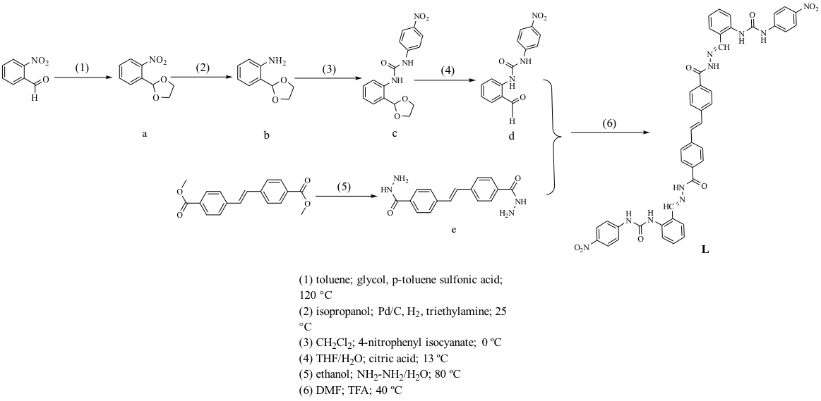
Scheme S1. Synthetic route to ligand L. Reagents and conditions: (a) ethylene glycol, p-TsOH, toluene, 120 °C, 48 h; (b) H₂, Pd/C, iPrOH, Et₃N, 20 h; (c) 4-nitrophenyl isocyanate, CH₂Cl₂, 0 °C to rt, 30 min; (d) citric acid, THF/H₂O, 13 °C, 48 h; (e) NH₂NH₂·H₂O, EtOH, 80 °C, 4 days; (f) TFA (cat.), DMF, 40 °C, 5 days.
Compound a (2-(1,3-dioxolan-2-yl)-1-nitrobenzene)
2-Nitrobenzaldehyde (3.0 g, 19.9 mmol) and p-toluenesulfonic acid (40 mg, 0.23 mmol) were dissolved in anhydrous toluene (35 mL) under nitrogen. Ethylene glycol (6 mL, 108 mmol) was added, and the reaction mixture was heated at 120 °C with azeotropic removal of water using a Dean–Stark trap for 48 hours. The cooled reaction mixture was transferred to a separatory funnel and washed sequentially with saturated aqueous NaHCO₃ (20 mL) and saturated NaCl solution (20 mL). The aqueous phase was back-extracted with CHCl₃ (2 × 15 mL). The combined organic phases were washed with saturated NaCl, dried over anhydrous MgSO₄, filtered, and concentrated under reduced pressure to afford compound a as a pale yellow oil (3.27 g, yield 85%). The product was stored under nitrogen at −20 °C. ¹H NMR (400 MHz, DMSO-d₆): δ 7.95 (d, J = 8.0 Hz, 1H), 7.75 (d, J = 4.1 Hz, 2H), 7.65 (dq, J = 8.8, 4.1 Hz, 1H), 6.31 (s, 1H), 3.96 (m, 2H), 3.93 (m, 2H) (Figure S1).

Figure S1. ¹H NMR spectrum (400 MHz, DMSO-d₆, 298 K) of compound a.
Compound b (2-(1,3-dioxolan-2-yl)aniline)
Compound a (1.2 g, 5.7 mmol) was dissolved in isopropanol (15 mL), and triethylamine (380 µL, 2.7 mmol) was added. Pd/C (10 wt%, 150 mg) was added and the flask was sealed with a rubber septum. The atmosphere was replaced with hydrogen gas (balloon) and the reaction was stirred at room temperature for 20 hours. The mixture was filtered through Celite, and the filtrate was transferred to a separatory funnel, diluted with CH₂Cl₂ (15 mL), and washed with saturated NaHCO₃ (15 mL) followed by saturated NaCl (15 mL). The organic layer was dried over anhydrous MgSO₄, filtered, and concentrated to give compound b as a clear pale yellow oil (748 mg, yield 78%), which was used directly in the next step without further purification.
Compound c
4-Nitrophenyl isocyanate (822 mg, 5.0 mmol) was dissolved in anhydrous CH₂Cl₂ (6 mL). Compound b (3.84 mmol) was dissolved in anhydrous CH₂Cl₂ (6 mL) and cooled to 0 °C in an ice bath. The isocyanate solution was added dropwise to the amine solution with stirring over 10 minutes, and the reaction was stirred at 0 °C to room temperature for 30 minutes. The precipitate was collected by filtration and washed with a small amount of diethyl ether/isopropanol to remove impurities, affording compound c as a white solid. ¹H NMR (400 MHz, DMSO-d₆): δ 10.10 (s, 1H), 8.25 (s, 1H), 8.20 (d, J = 9.2 Hz, 2H), 7.79 (d, J = 8.5 Hz, 1H), 7.70 (d, J = 9.2 Hz, 2H), 7.45 (dd, J = 7.7, 1.5 Hz, 1H), 7.38 (m, 1H), 7.13 (t, J = 7.7 Hz, 1H), 5.85 (s, 1H), 4.12 (m, 2H), 4.00 (m, 2H). ¹³C NMR (100 MHz, DMSO-d₆): δ 152.61, 147.06, 141.53, 137.01, 129.86, 128.14, 127.58, 125.72, 117.99, 101.45, 65.31 (Figures S2, S3).
Figure S2. ¹H NMR spectrum (400 MHz, DMSO-d₆, 298 K) of compound c.

Figure S3. ¹³C NMR spectrum (100 MHz, DMSO-d₆, 298 K) of compound c.
Compound d
Compound c (200 mg, 0.61 mmol) was dissolved in THF (8 mL) in a pressure-resistant vessel. Citric acid (233 mg, 1.21 mmol) dissolved in water (7 mL) was added slowly, and the reaction was stirred at 13 °C for 48 hours. The resulting precipitate was collected by filtration, washed with cold water, and dried to yield compound d as a pale solid (124 mg, yield 71%). ¹H NMR (400 MHz, CD₃CN): δ 10.54 (s, 1H), 10.12 (s, 1H), 9.94 (s, 1H), 8.49 (d, J = 8.5 Hz, 1H), 8.16 (d, J = 9.1 Hz, 2H), 7.80 (d, J = 7.1 Hz, 3H), 7.63 (t, J = 7.9 Hz, 1H), 7.22 (t, J = 7.4 Hz, 1H) (Figure S4).

Figure S4. ¹H NMR spectrum (400 MHz, DMSO-d₆, 298 K) of compound d.
Compound e (trans-stilbene-4,4′-dicarbohydrazide)
Dimethyl trans-stilbene-4,4′-dicarboxylate (100 mg, 0.34 mmol) was placed in a pressure-resistant tube. Hydrazine hydrate (6 mL) and anhydrous ethanol (3 mL) were added, and the tube was sealed. The reaction was stirred at 80 °C for 4 days under light-protected conditions, yielding a white suspension. The solid was collected by centrifugation and dried under vacuum to afford compound e as a white solid (87 mg, yield 87%). ¹H NMR (400 MHz, DMSO-d₆): δ 9.80 (s, 1H), 7.84 (d, J = 8.4 Hz, 2H), 7.69 (s, 2H), 7.42 (s, 1H), 4.49 (s, 2H) (Figure S5). Due to the limited solubility of e in common NMR solvents, ¹³C NMR characterization was not obtained.

Figure S5. ¹H NMR spectrum (400 MHz, DMSO-d₆, 298 K) of compound e.
Ligand L
Compound e (20 mg, 0.064 mmol) and compound d (38.5 mg, 0.128 mmol) were placed in a pressure-resistant tube. DMF (1 mL) was added, followed by trifluoroacetic acid (TFA, 12 µL, 0.16 mmol). The reaction was heated at 40 °C for 3 days, after which an additional 1 mL of DMF was added and heating continued for a further 2 days. The resulting yellow suspension was centrifuged, and the solid was washed with DMF (2 × 0.5 mL) and dried under vacuum to afford ligand L as a yellow solid (42 mg, yield 72%). ¹H NMR (400 MHz, DMSO-d₆): δ 12.38 (s, 1H), 11.43 (s, 1H), 9.69 (s, 1H), 8.59 (s, 1H), 8.26 (d, J = 6.8 Hz, 3H), 8.08–8.05 (m, 3H), 7.86 (s, 2H), 7.78 (d, J = 9.1 Hz, 2H), 7.65 (d, J = 8.0 Hz, 1H), 7.56 (s, 1H), 7.46 (d, J = 7.8 Hz, 1H), 7.18 (s, 1H) (Figure S6). Due to the very poor solubility of L, ¹³C NMR was not obtained. HR-ESI-MS: [L+Na]⁺ m/z 853.27 (calcd. 853.25) (Figure S7)
.

Figure S6. ¹H NMR spectrum (400 MHz, DMSO-d₆, 298 K) of L.
Figure S7. High-resolution mass spectrum of ligand L.
Crystal culture of L
L (2 mg) was dissolved in acetone (500 µL) with the addition of tetrapropylammonium hydroxide (TPAOH, 4 µL). The solution was stirred for 12 hours until clear, then filtered through a 0.22 µm PTFE membrane. Crystals were grown by slow vapor diffusion of diethyl ether at room temperature over 13 days. All crystal growth was performed under strictly light-protected conditions (amber vials wrapped in aluminium foil) to prevent E/Z isomerization of the C=C and C=N bonds. Yellow block crystals suitable for X-ray diffraction were obtained (Figure S8).
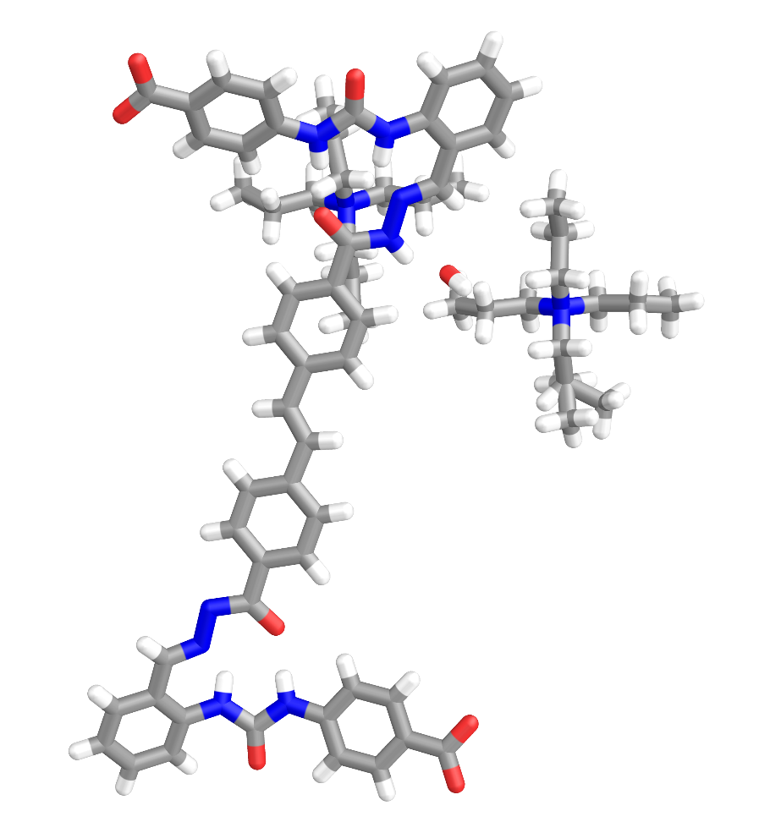
Figure S8. The crystal diagram of L

S2.2 Synthesis of anion complexes
General Procedure
All complexes were prepared by in situ mixing under light-protected conditions. Glass vials were wrapped in aluminium foil during preparation and storage. Complexes were characterized directly in solution without isolation as bulk solids, due to limited solution stability and solubility constraints. Stock solutions of tetraalkylammonium salts (0.625 mol/L in the appropriate deuterated solvent) were used throughout.
(TPA)₄[(Cl)₄L]
L (2 mg, 2.4 × 10⁻³ mmol) was dissolved in DMSO-d₆ (0.5 mL) with multiple sonication cycles. (TPA)Cl solution (5 µL, 0.625 mol/L, 4.0 equiv) was added, and the mixture was stirred in the dark at room temperature for 24 hours. The solution was filtered through a 0.22 µm organic membrane to remove undissolved material. ¹H NMR (400 MHz, DMSO-d₆): δ 12.42 (s, 1H), 11.24 (s, 1H), 10.00 (s, 1H), 8.68 (s, 1H), 8.25 (d, J = 6.8 Hz, 3H), 8.07–8.05 (m, 3H), 7.86 (d, J = 5.4 Hz, 2H), 7.79 (d, J = 9.1 Hz, 2H), 7.66 (d, J = 8.0 Hz, 1H), 7.55 (s, 1H), 7.44 (d, J = 7.8 Hz, 1H), 7.18 (s, 1H). Peaks at δ 3.11, 1.61, and 0.89 ppm are assigned to TPA⁺ (Figure S9). HR-ESI-MS: [(Cl)₄LK₂Na(TBA)]⁻ m/z 1146.01 (calcd. 1146.10) (Figure S18).
Figure S9. ¹H NMR spectra (400 MHz, 298 K) of (TPA)₄[(Cl)₄L] in Acetone-d₆ and L in DMSO-d₆.

Figure S10 ¹H NMR spectra (400 MHz, 298 K) of (TEA)₆[(PO₄)₂L₃] in Acetone-d₆.
(TBA)₄[(SO₄)₂L₃]
L (2 mg, 2.4 × 10⁻³ mmol) was dissolved in acetone-d₆ (0.5 mL) with multiple sonication cycles. (TBA)₂SO₄ solution (2.6 µL, 0.625 mol/L) was added, and the mixture was stirred in the dark at room temperature for 8 hours to yield a pale yellow clear solution. ¹H NMR (400 MHz, acetone-d₆): δ 8.54 (s, 2H), 8.35 (d, J = 8.3 Hz, 1H), 8.17 (d, J = 9.3 Hz, 2H), 8.11 (d, J = 7.2 Hz, 2H), 8.07 (d, J = 9.4 Hz, 1H), 7.77 (d, J = 8.1 Hz, 2H), 7.46 (s, 1H), 7.30 (t, J = 7.8 Hz, 1H), 7.03 (t, J = 7.4 Hz, 1H). Peaks at δ 3.40, 1.72, 1.38, and 0.90 ppm are assigned to TBA⁺ (Figure S11). HR-ESI-MS: [(SO₄)₂L₃K(TBA)(CH₃CN)₃(H₂O)₄]²⁻ m/z 1580.47 (calcd. 1580.52) (Figure S19).
Figure S11 ¹H NMR spectra (400 MHz, 298 K) of (TBA)₄[(SO₄)₂L₃] in Acetone-d₆.
(TBA)₆[(PO₄)₂L₃]
L (2 mg, 2.4 × 10⁻³ mmol) was dissolved in acetone-d₆ (0.5 mL). (TBA)₃PO₄ solution (2.6 µL, 0.625 mol/L) was added, and the mixture was stirred in the dark for 8 hours to yield a clear solution. HR-ESI-MS: [(PO₄)₂L₃(TBA)₄]²⁻ m/z 1825.97 (calcd. 1825.91) (Figure S23).
(TMA)₆[(PO₄)₂L₃] and (TEA)₆[(PO₄)₂L₃]
Prepared analogously to (TBA)₆[(PO₄)₂L₃] using (TMA)₃PO₄ or (TEA)₃PO₄ (prepared from equimolar H₃PO₄ and 3 equiv TMAOH or TEAOH). For (TEA)₆[(PO₄)₂L₃], a pale red clear solution was obtained. ¹H NMR (400 MHz, acetone-d₆): δ 8.47 (s, 1H), 8.43 (d, J = 8.2 Hz, 1H), 8.37 (d, J = 8.0 Hz, 2H), 8.21 (d, J = 9.0 Hz, 2H), 8.12 (d, J = 9.0 Hz, 2H), 7.64 (d, J = 8.1 Hz, 2H), 7.36 (s, 1H), 7.30 (d, J = 7.6 Hz, 1H), 7.16 (d, J = 8.0 Hz, 1H), 6.95 (t, J = 7.5 Hz, 1H). Peaks at δ 3.42 and 1.33 ppm are assigned to free TEA⁺; the peak at δ 2.56 ppm is assigned to encapsulated TEA⁺ within the helical cavity (Figure S10). HR-ESI-MS (Figures S21, S22).
(TMA)₁₀[(CO₃)₅L₅]
L (2 mg, 2.4 × 10⁻³ mmol) was dissolved in acetone-d₆ (0.5 mL). (TMA)₂CO₃ solution (2.6 µL, 0.625 mol/L; prepared from NaHCO₃ and TMAOH) was added, and the mixture was stirred in the dark for 8 hours to yield a yellow clear solution. ¹H NMR (400 MHz, acetone-d₆): δ 8.47–8.36 (m, 4H), 8.22 (d, J = 9.4 Hz, 2H), 8.16 (d, J = 9.4 Hz, 2H), 7.63 (d, J = 8.4 Hz, 2H), 7.37 (s, 1H), 7.29 (d, J = 7.7 Hz, 1H), 7.18–7.13 (m, 1H), 6.96–6.92 (m, 1H). The peak at δ 3.40 ppm is assigned to TMA⁺ (Figure S12). HR-ESI-MS: [(CO₃)₅L₅Na₄K₃]³⁻ m/z 1554.05 (calcd. 1554.02) (Figure S20).
Figure S12.¹H NMR spectra (400 MHz, 298 K) of (TBA)₄[(SO₄)₂L₃] in Acetone-d₆ Comparison chart with ¹H NMR spectrum of L in DMSO-d₆.
Phosphate complexes with different counter ions
Figure S13. ¹H NMR spectra (400 MHz, 298 K) of (TMA)₆[(PO₄)₂L₃]、(TEA)₆[(PO₄)₂L₃]、(TPA)₆[(PO₄)₂L₃] and (TBA)₆[(PO₄)₂L₃] in Acetone-d₆.
Trimellitic acid complexes
Figure S14.Continuous addition of [(COO)₃C₆H₃)]³⁻ to L monitored by ¹H NMR spectra (400 MHz, DMSO-d₆, 298 K).

S3. 2D NMR
¹H–¹H COSY spectra were recorded for (TEA)₆[(PO₄)₂L₃], (TBA)₄[(SO₄)₂L₃], and (TMA)₁₀[(CO₃)₅L₅] in acetone-d₆ at 298 K to confirm proton assignments and assess the symmetry of the assembled structures (Figures S15–S17). In all cases, the COSY correlations are consistent with the proposed symmetric assemblies and the proton assignments made from the ¹H NMR spectra.

Figure S15. ¹H-¹H COSY spectra of (TEA)₆[(PO₄)₂L₃] (400 MHz, Acetone-d₆, 298 K).
Figure S16. ¹H-¹H COSY spectra of (TBA)₄[(SO₄)₂L₃] (400 MHz, Acetone-d₆, 298 K).

Figure S17. ¹H-¹H COSY spectrum of (TMA)₁₀[(CO₃)₅L₅] (400 MHz, Acetone-d₆, 298 K).

S4. High-resolution ESI-MS spectra
HR-ESI-MS spectra were measured in negative-ion mode for all anion complexes. Isotope patterns were compared with theoretical distributions generated by Bruker DataAnalysis software.

Figure S18. HR ESI-mass spectrum of (TPA)₄[(Cl)₄L].

Figure S19. HR ESI-mass spectrum of (TBA)₄[(SO₄)₂L₃].
Figure S20. HR ESI-mass spectrum of (TMA)₁₀[(CO₃)₅L₅].
Figure S21.HR ESI-mass spectrum of (TMA)₆[(PO₄)₂L₃].

Figure S22. HR ESI-mass spectrum of (TEA)₆[(PO₄)₂L₃],(TPA)₆[(PO₄)₂L₃].
Figure S23.HR ESI-mass spectrum of (TBA)₆[(PO₄)₂L₃].
Figure S24. HR ESI-mass spectrum of [K(18C-6)]₆[(PO₄)₂L₃].
Figure S25. HR ESI-MS of 1.0 eq. of the trimesic acid complex.
Figure S26. HR ESI-MS of 3.5 eq. of the trimesic acid complex.

S5. Structural calculation simulation in DFT
All geometry optimizations were performed using the Gaussian 09 software package [S1]. Calculations employed the dispersion-corrected B3LYP-D3 functional [S2] with the 6-31G(d) basis set [S3,S4] and solvent effects modeled using the integral equation formalism polarizable continuum model (IEFPCM) with dichloroethane as solvent [S5,S6]. All optimized structures were confirmed as true energy minima by frequency analysis (no imaginary frequencies). The five isomeric configurations studied were: (E,E,E) all-trans; (Z,E,E) C=C cis, both C=N trans; (E,Z,E) C=C trans, one C=N cis; (E,Z,Z) C=C trans, both C=N cis; and (Z,Z,Z) all-cis. Relative energies and HOMO–LUMO gaps are summarized in Table S1.
Table S1. DFT-calculated relative energies and HOMO–LUMO gaps for isomeric configurations of ligand L (B3LYP-D3/6-31G(d), IEFPCM/DCE).
Configuration | Relative Energy (kcal mol⁻¹) | HOMO–LUMO Gap (eV)
(E,E,E) all-trans | 0 (reference) | 3.58
(Z,E,E) C=C cis | +8.4 | 3.41
(E,Z,E) one C=N cis | +6.1 | 3.49
(E,Z,Z) both C=N cis | +11.8 | 3.35
(Z,Z,Z) all-cis | +19.2 | 3.22
The (E,E,E) isomer is the global minimum and exhibits a HOMO–LUMO gap of 3.58 eV (corresponding to approximately 346 nm), in reasonable agreement with the experimental 365 nm irradiation wavelength.

Figure S27.DFT-optimized structures (B3LYP-D3/6-31G(d)) of the five isomeric configurations of ligand L. Color coding: C (gray), H (white), N (blue), O (red). Relative energies (kcal mol⁻¹) are given below each structure.

S6. UV-vis characterization
UV-Vis titration experiments were performed in DMF at room temperature. Stock solutions of L (5 × 10⁻⁵ M) were prepared, and incremental additions of anion salt stock solutions were made. After each addition, the solution was equilibrated for 5 minutes before recording the spectrum. Binding constants were determined by plotting ΔA at the wavelength of maximum change against anion concentration and fitting to a 1:1 binding model using nonlinear least-squares regression.
Figure S28.a) UV titration curve of the process of adding (TBA)₂SO₄ to the DMF solution of L; b) linear fitting graph [Ka = (2.34 ± 0.41) × 10⁵ M⁻¹].
Figure S29.a)UV titration curve of the process of adding [K(18-C-6)]₃PO₄ to the DMF solution of L; b) linear fitting graph [Ka = (3.63 ± 0.35) × 105 M⁻¹].
Figure S30.The transformation of (TBA)₄[(SO₄)₂L₃] into [K(18-C-6)]₆[(PO₄)₂L₃] and the UV comparison chart of (TEA)₆[(PO₄)₂L₃] and (TEA)₆[(PO₄)₂L₃].

S7. Anion-induced structural transformation
Structural transformation experiments were performed by adding the appropriate anion salt to preformed assembly solutions in acetone-d₆. Progress was monitored by ¹H NMR at intervals until the spectrum no longer changed (typically 3–6 hours at room temperature). Full transformation was confirmed by the complete disappearance of starting assembly NMR signals and their replacement by product assembly signals, and by HR-ESI-MS of the final solutions.
Figure S31. ¹H NMR spectra (400 MHz, 298 K) comparison diagram of (TMA)₁₀[(CO₃)₅L₅] to (TBA)₄[(SO₄)₂L₃] in Acetone-d₆.
Figure S32. ¹H NMR spectra (400 MHz, 298 K) comparison diagram of (TBA)₄[(SO₄)₂L₃] to (TMA)₁₀[(CO₃)₅L₅] in Acetone-d₆.
Figure S33. HR ESI-mass spectrum of (TBA)₄[(SO₄)₂L₃] to (TMA)₁₀[(CO₃)₅L₅].
Figure S34. ¹H NMR spectra (400 MHz, 298 K) comparison diagram of (TMA)₁₀[(CO₃)₅L₅] to [K(18-C-6)]₆[(PO₄)₂L₃] in Acetone-d₆.
Figure S35. HR ESI-mass spectrum of (TMA)₁₀[(CO₃)₅L₅] to [K(18-C-6)]₆[(PO₄)₂L₃].

Figure S36. ¹H NMR spectra (400 MHz, 298 K) comparison diagram of (TBA)₄[(SO₄)₂L₃] to [K(18-C-6)]₆[(PO₄)₂L₃] in Acetone-d₆.
Figure S37. HR ESI-mass spectrum of (TBA)₄[(SO₄)₂L₃] to [K(18-C-6)]₆[(PO₄)₂L₃].

S8. Host-Guest
Encapsulation experiments were performed by adding solid betaine (1 equiv relative to assembly) to solutions of the pre-assembled host complexes in acetone-d₆, followed by sonication and stirring in the dark for 12 hours before NMR characterization.
Figure S38. ¹H NMR spectra (400 MHz, 298 K) comparison diagram of betaine was added in [K(18-C-6)]₆[(PO₄)₂L₃] in Acetone-d₆.
Figure S39. ¹H NMR spectra (400 MHz, 298 K) comparison diagram of betaine was added in (TBA)₄[(SO₄)₂L₃] in Acetone-d₆.
Figure S40. HR ESI-MS of betaine was encapsulated in (TBA)₄[(SO₄)₂L₃].
Figure S41. a) Ultraviolet titration diagram of the process of adding betaine to acetone solution of (TBA)₄[(SO₄)₂L₃]；b) Linear fitting diagram [Ka = (1.60 ± 0.26) × 10⁵ M⁻¹].
Figure S42. ¹H NMR spectra comparison chart of betaine release (400 MHz, Acetone-d₆, 298 K).

S9 Light experiment
Solutions of the anion-coordinated assemblies in acetone-d₆ (approximately 2 mM) were placed in quartz NMR tubes and irradiated with a 365 nm UV lamp at a distance of approximately 5 cm. Samples were degassed prior to irradiation by three freeze–pump–thaw cycles. NMR spectra were recorded before irradiation and at regular intervals during irradiation until no further spectral changes were observed.
Figure S43. ¹H NMR spectra of (TBA)₄[(SO₄)₂L₃] after 365 nm light 36 h (400 MHz, Acetone-d₆, 298 K).
Figure S44. ¹H NMR spectra of (TBA)₆[(PO₄)₂L₃] after 365 nm light 26 h (400 MHz, Acetone-d₆, 298 K).
Figure S45. ¹H NMR spectra of (TMA)₁₀[(CO₃)₅L₅] after 365 nm light 24 h (400 MHz, Acetone-d₆, 298 K).

Figure S46. HR ESI-MS of (TBA)₆[(PO₄)₂L₃] after 365 nm light 26 h.
Figure S47. HR ESI-MS of (TMA)₁₀[(CO₃)₅L₅] after 365 nm light 24 h.
Figure S48. HR ESI-MS of (TBA)₄[(SO₄)₂L₃] after 365 nm light 36 h.

S10 Reference
- Frisch, M. J. et al. Gaussian 09, Revision D.01; Gaussian, Inc.: Wallingford, CT, 2013.
- C. Lee, W. Yang and R. G. Parr, Phys. Rev. B: Condens. Matter, 1988, 37, 785.
- R. Ditchfield, W. J. Hehre and J. A. Pople, J. Chem. Phys., 1971, 54, 724.
- W. J. Hehre, R. Ditchfield and J. A. Pople, J. Chem. Phys., 1972, 56, 2257.
- S. Ghosh and S. Hammes-Schiffer, J. Phys. Chem. Lett., 2015, 6, 1.
- A. Klamt, C. Moya and J. Palomar, J. Chem. Theory Comput., 2015, 11, 4220.

