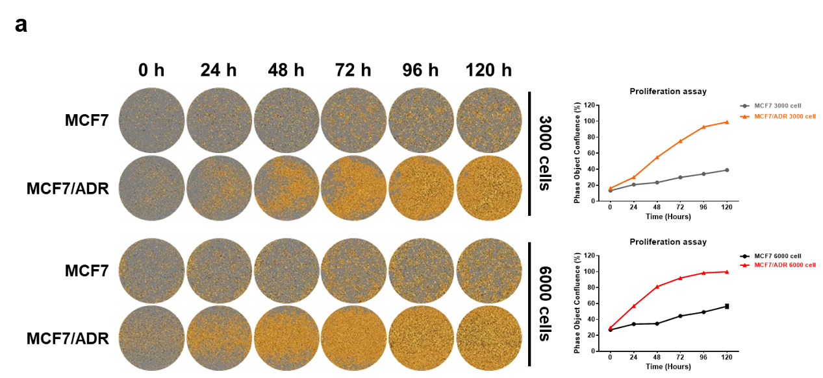

Supplementary Fig. 2. The proliferation of MCF7 and MCF7/ADR cells.
a. The proliferation of MCF7 parental and adriamycin-resistant MCF7/ADR cells were detected with Incucyte until 120 h (left panel). Statistical analysis of cell confluence (%) (right panel).

