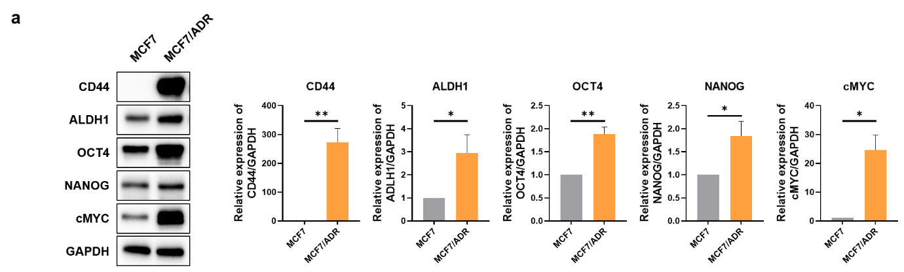

Supplementary Fig. 4. Expression levels of cancer stem cell markers in MCF7 and MCF7/ADR cells.
a. Expression of CD44, ALDH1, OCT4, NANOG, and cMYC proteins in MCF7 and MCF7/ADR cells was confirmed via immunoblotting (left panel). The corresponding immunoblotting results are presented in the graph (right panel).

