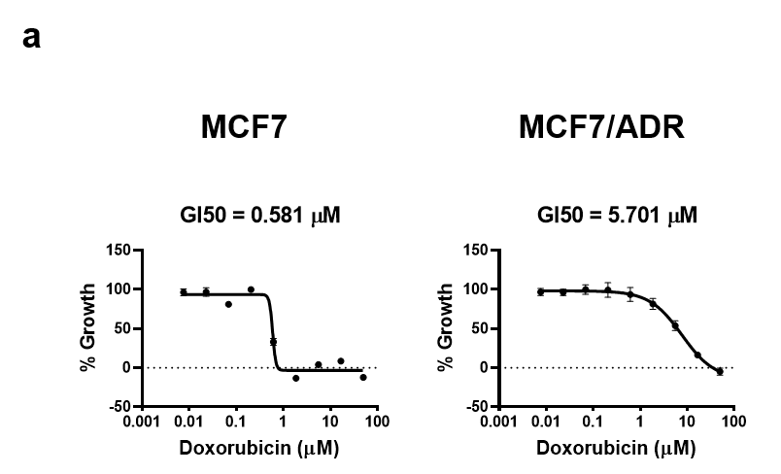

Supplementary Fig. 1. The growth inhibition of doxorubicin (adriamycin) and paclitaxel in MCF7 and MCF7/ADR cells.
a. The GI50 graph of adriamycin (doxorubicin) and paclitaxel in MCF7 parental and adriamycin-resistant MCF7/ADR cells.

