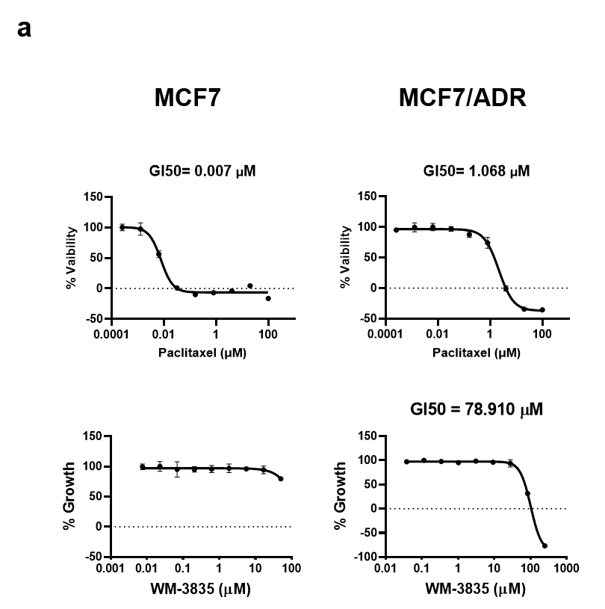

Supplementary Fig. 3. The growth inhibition of paclitaxel and WM-3835 in MCF7 and MCF7/ADR cells.
a. The GI50 graph of paclitaxel (upper panel) and WM-3835 (lower panel) in MCF7 parental and adriamycin-resistant MCF7/ADR cells.

