Graphical abstract
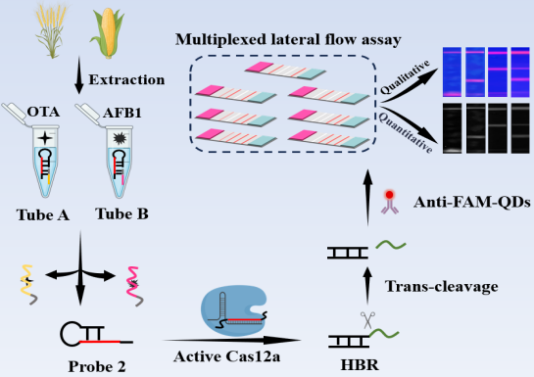
An enzyme-assisted signal amplification detection platform integrating simplified CRISPR/Cas12a with a lateral flow assay was developed for the highly efficient and multiplexed detection of mycotoxins.

