Supporting Information
CRISPR/Cas12a-based simplified lateral flow assay for sensitive detection of OTA and AFB1
Wenjun Jiang^{a#}, Yidan Zhu^{a#}, Jingyi Kangª, Ziyi Zhuª, Kun Qianª, Qian Xu ^{c*}, Qi Wangª, Yuling Qin^{a,b}, Li Wu^{a,b} and Haiwei Ji^{a,b*}
ª Jiangsu Key Laboratory of Advanced Medical Analysis and Public Health, Nantong Key Laboratory of Public Health and Medical Analysis, School of Public Health, Nantong University, Nantong, Jiangsu 226019, P. R. China.
^{b} The Jiangsu Province Boron Neutron Capture Therapy Center for Multi-Cancer Precision Targeted Treatment Technology and Engineering Research, Affiliated Hospital of Nantong University, No. 20 Xisi Road, Nantong 226019, P. R. China.
^{c} School of Artificial Intelligence and Computer Science, Nantong University, Nantong, Jiangsu 226019, P. R.China
* Corresponding authors: Correspondence and requests for materials should be addressed to Qian Xu & Haiwei Ji. E-mail: aicsxuqian@ntu.edu.cn (Qian Xu); jihaiwei64@ntu.edu.cn (ji haiwei).
# These authors contributed equally to this work.

Supplementary Figures
Probe design
As displayed in Fig. S1, we used the Oligo Analyzer software to simulate the structure and thermodynamic parameters of Probe 2, which conformed to the anticipated double-stranded structure. Chen et al. have demonstrated that, upon binding to its target, Cas12a cleaves single-stranded DNA (ssDNA) while leaving double-stranded DNA (dsDNA) intact [1]. This selectivity arises because activation of Cas12a triggers irreversible conformational changes, resulting in the formation of an open active center that is geometrically tailored for the flexible ssDNA. In contrast, the rigid double-helix structure of dsDNA is unable to access the active site due to steric hindrance. Cas12a exhibits indiscriminate cleavage of ssDNA, provided that the ssDNA has a minimum length of 4-10 nucleotides. The non-cleavage of dsDNA is absolute and structurally predetermined, remaining unaffected by the sequence length. Inspired by these findings, we designed a half-blocking reporter (HBR).
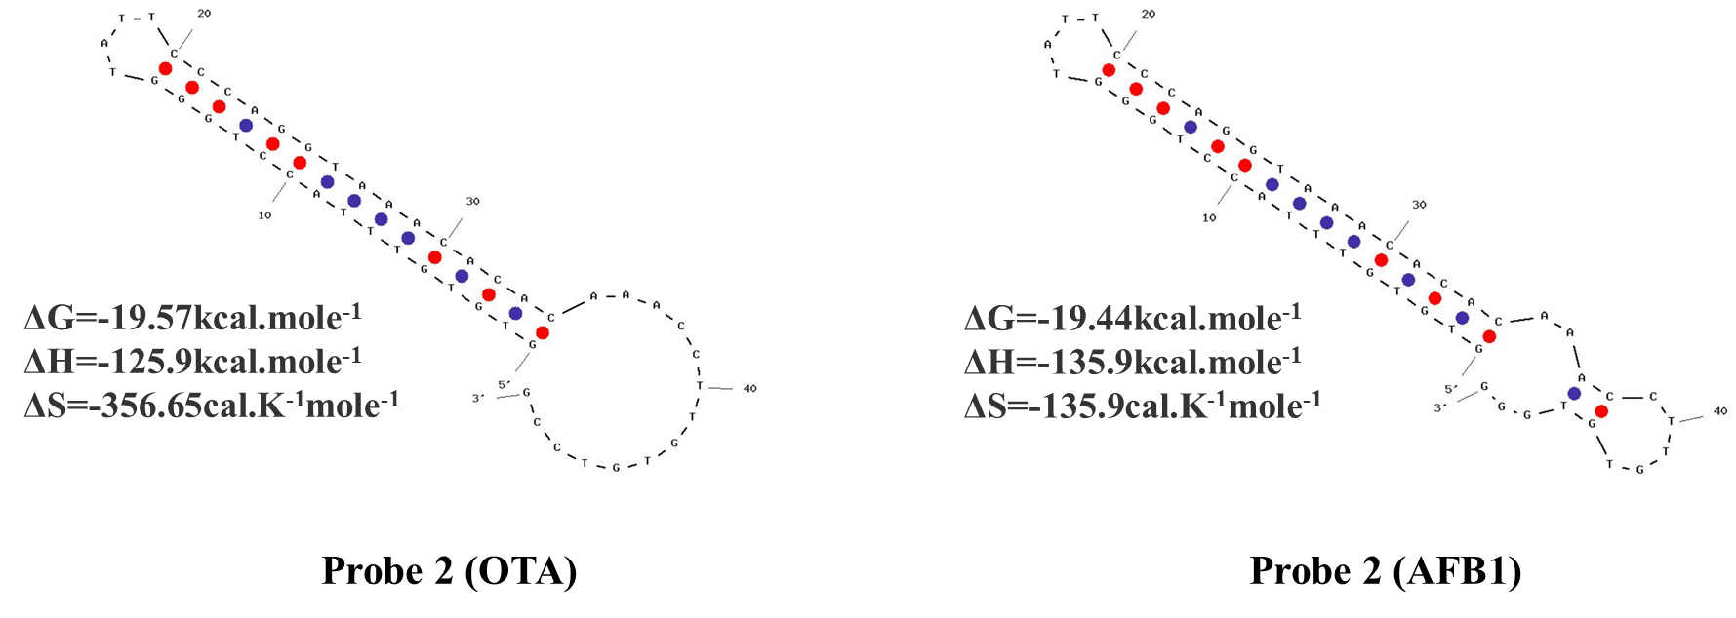
Fig. S1. The double-loop stem structure and thermal kinetic parameters of Probe 2 for OTA and AFB1 were simulated using the Oligo Analyzer Software.

Characterization of Anti-FAM-QDs
The Anti-FAM-QDs were synthesized through a cross-linking reaction between the carboxyl groups of water-soluble quantum dots and the amino groups of Anti-FAM, as illustrated in Fig. S2A. The freshly prepared EDC solution was employed to activate the carboxyl groups functionalized on the surface of quantum dots (QDs). Agarose gel electrophoresis analysis (Fig. S2B) demonstrated a reduced migration rate of Anti-FAM-QDs relative to unmodified QDs, which is attributable to increased steric hindrance. Additionally, as illustrated in Fig. S2C, Anti-FAM-QDs exhibited a characteristic protein absorption peak at 275 nm, indicating successful conjugation. Furthermore, as shown in Fig. S2D, the maximum emission peak of the QDs was observed at 605 nm, while the decreased fluorescence intensity of Anti-FAM-QDs is primarily attributed to the quenching effects induced by Anti-FAM adsorption and encapsulation. These results confirm the successful synthesis of Anti-FAM-QDs, thereby supporting subsequent experimental investigations.
Fig. S2. (A) Schematic diagram of Anti-FAM and QDs cross-linking reaction. (B) Agarose gel electrophoresis of QDs and Anti-FAM-QDs conjugates. The ultraviolet-visible (UV-vis) absorption (C) and the emission spectrum (D) of fluorescent QDs and Anti-FAM-QDs conjugate.

The affinity and specificity of OTA and AFB1 toward their respective aptamers have been well documented in previous studies [2-5]. Upon incubation of OTA or AFB1 with their aptamers at 37 °C for 45 minutes, a reduction in the characteristic nucleic acid absorbance at 260 nm, which indicates effective complex formation between the targets and aptamers, resulting in the release of Probe 2.
Fig. S3. UV-vis absorption of aptamer and its conjugates (A, B).

Fig. S4. Illustration of the CRISPR-Cas12a-mediated ssRNA substrate cleavage.

As shown in Fig. S5A, a capture antibody concentration ratio of 10:1 (0.5 mg/mL: 0.05 mg/mL) at T1 and T2 effectively minimized cross-reactivity. At a 15:1 ratio, an inconsistent T2 signal intensity was observed, likely due to insufficient coating concentration and a non-uniform distribution of capture antibodies on the nitrocellulose membrane. Therefore, a 10:1 ratio was selected for subsequent experiments, and the feasibility of downstream detection was experimentally confirmed (Fig. S5B).
Fig. S5. (A) Optimization of the concentration ratios of T1 and T2 in a multiplexed lateral flow assay. (B) Feasibility verification of downstream multiple detection.

Optimization of Experimental Conditions
To achieve optimal analytical performance of the proposed system for mycotoxin detection, a comprehensive evaluation of key experimental parameters was conducted. The background signal was minimized at a Probe 1 to Probe 2 concentration ratio of 3:1 (Fig. S6A and S6B). To maximize the trans-cleavage activity of Cas12a, the following conditions were determined to be optimal: 150 nM Cas12a, 150 nM crRNA, and 8 μL HBR (Fig. S7A-C). Further optimization indicated that a cleavage time of 15 min and a reaction temperature of 37 °C yielded the highest efficiency (Fig. S7D and 7E). As shown in Fig. S7F, a volume of 6 μL of Anti-FAM-QDs produced the strongest fluorescence signal and the highest signal-to-noise ratio (S/N), which was selected as the optimal condition. As shown in Fig. S7G, intact HBR signals were detectable even in the absence of the target when the SA concentration was 1 mg/mL, thereby confirming the suitability of this SA concentration for subsequent experiments. It is essential to note that insufficient SA concentration may result in excessive forward flow of HBR, potentially leading to false-positive results. Furthermore, as indicated in Fig. S7H, a signal reading time of 5 minutes was selected to effectively minimize background signal amplification and reduce the likelihood of false positives. Notably, prolonged reading times may induce a countercurrent chromatographic flow from the absorbent pad toward the nitrocellulose membrane. This reverse flow can trigger continuous release of Anti-FAM-QDs, which negatively affects both detection sensitivity and reaction kinetics [6].
Fig. S6. Different ratios of probe 1 to probe 2 for OTA (A) and AFB1 (B) analysis.

Fig. S7. Optimization results of MC-LFA. Concentration of Cas12a (A) and crRNA (B), volume of HBR (C), cleavage time (D), reaction temperature (E), signal label (F), concentration of SA (G), and signal reading time (H). Error bars indicate the standard deviation from three measurements.

The test strips were used to detect artificially simulated negative and positive samples for the assessment of batch-to-batch variability. Precision was evaluated by calculating intra- and inter-assay coefficients of variation (CV). Each batch was tested in parallel five times, and the CV values were calculated using the established formula: CV (%) = SD/Mean × 100%. “SD” denotes the standard deviation, while “Mean” refers to the arithmetic average. The CV calculated within and between batches reflects intra- and inter-batch variability, respectively. Positive control samples for OTA (0.5 ng/mL, 0.05 μg/mL, and 2 μg/mL) and AFB1 (5 ng/mL, 0.05 μg/mL, and 2 μg/mL) were selected at three distinct target concentration levels, as illustrated in Fig. S8A-B and Table S3. The observed within- and between-batch CVs were consistently below 10%, indicating low analytical variability and demonstrating that batch-to-batch differences have a negligible impact on assay performance. Furthermore, six additional mycotoxins—namely, aflatoxin B2 (AFB2), sterigmatocystin (STC), citrinin (CIT), zearalenone (ZEN), fumonisin B1 (FB1), and deoxynivalenol (DON)—were used as interfering substances to evaluate the selectivity and interference resistance of the test strips in the MC-LFA assay. The results showed minimal signals from these interferents (Fig. S8C, Fig. S9), thereby demonstrating the high selectivity of MC-LFA based on specific aptamer-target interactions. Moreover, the fluorescence signal intensity produced by the mycotoxin mixture was comparable to that generated by individual target mycotoxins alone, further underscoring the assay's excellent anti-interference capability. The storage temperature of the test strips represents a critical parameter that substantially affects their performance and applicability. To evaluate stability, the test strips were stored at 4°C and at ambient temperature for 21 days. As shown in Fig. S8D-E, OTA and AFB1 fluorescence intensity presented no significant variation on days 1, 7, 14, and 21. According to Table S4, the CV values for OTA were 3.71% at ambient temperature and 3.17% at 4 °C, while those for AFB1 were 5.66% at ambient temperature and 4.43% at 4 °C. These findings indicate that the developed MC-LFA sensor platform exhibits excellent stability and reproducibility during short-term storage across varying temperature conditions.
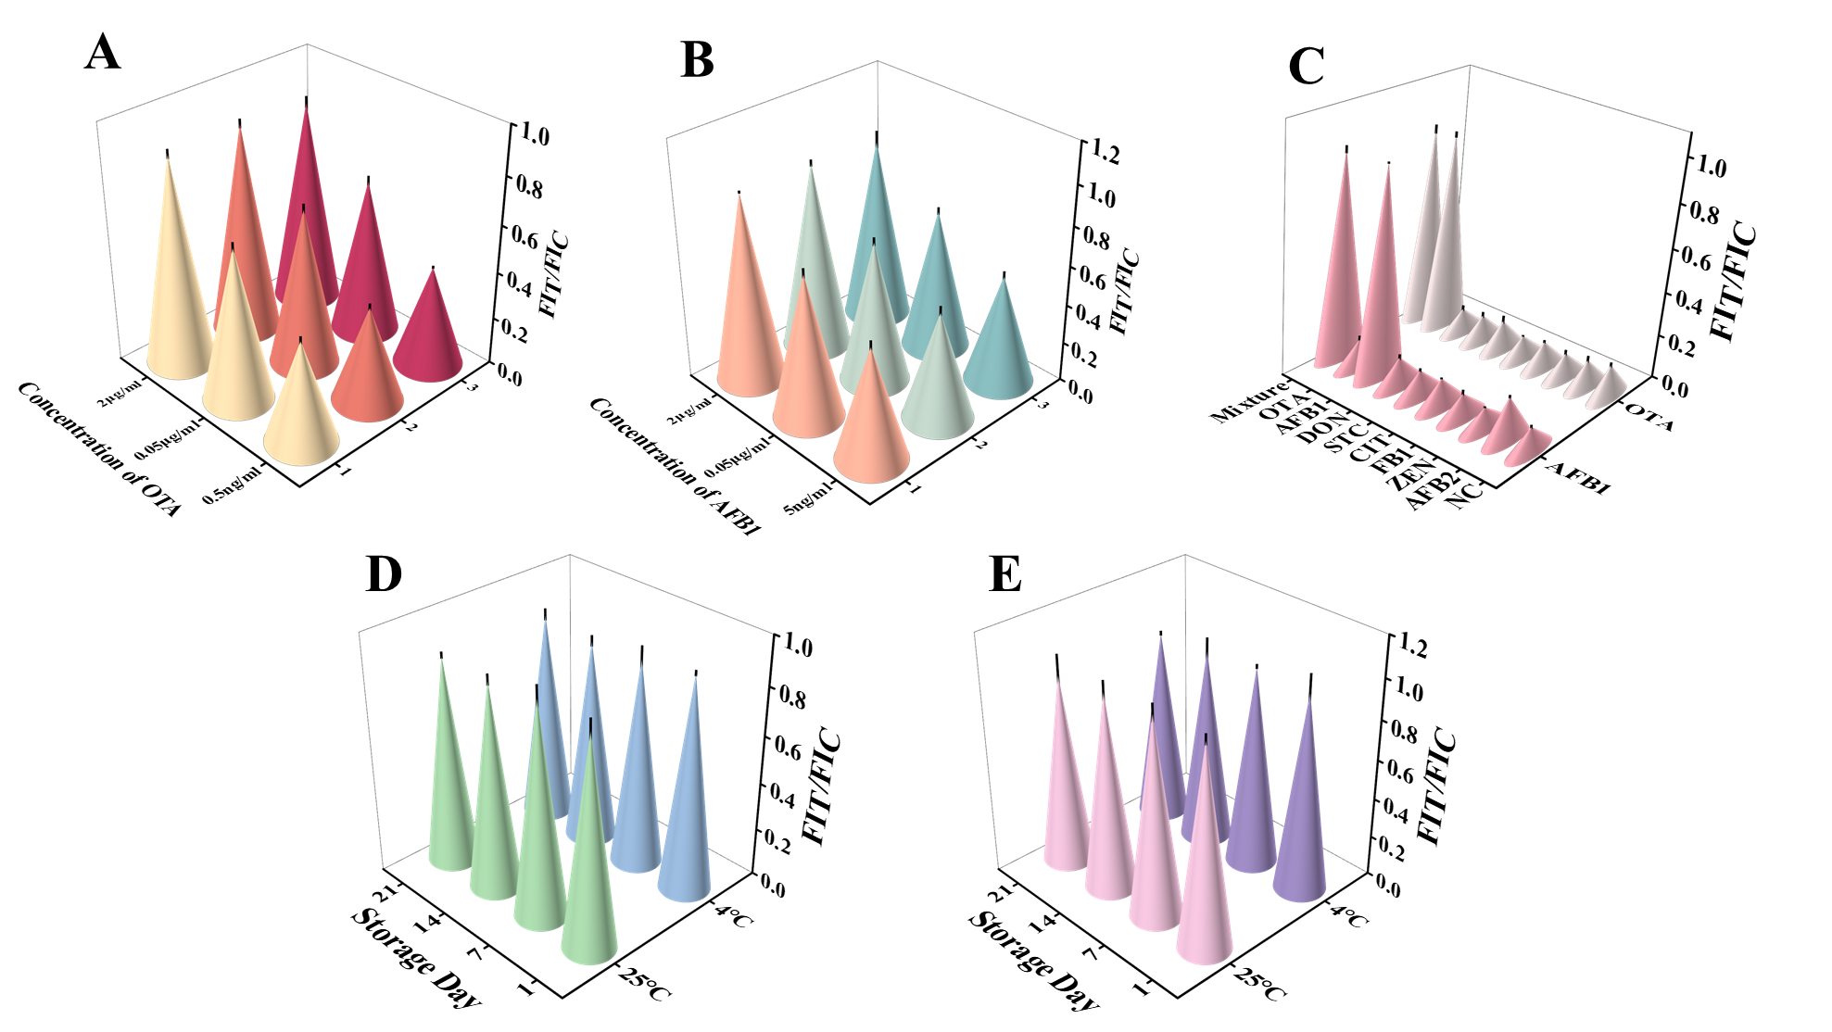
Fig. S8. Precision analysis of OTA (A) and AFB1 (B), error bars indicate the standard deviation from five measurements. (C) Specificity analysis of MC-LFA (The concentration of the mycotoxins was 2 μg/mL). Stability analysis of OTA (D) and AFB1 (E) at different storage temperatures. (The concentration of the OTA and AFB1 was 2 μg/mL and 4 μg/mL, respectively). Error bars indicate the standard deviation from three measurements.

Fig. S9. Fluorescence photographs of test strips for AFB1 and OTA detection in specific analysis. The above-mentioned mixture lacks AFB1, whereas the below-mentioned mixture lacks OTA.
Fig. S10. Detection of AFB1 and OTA with MC-LFA and commercial test strips in naturally moldy maize flour (A) and wheat flour (B).

Supplementary Tables
Table S1. The oligonucleotide sequences utilized in this work.
Name | Sequence (5’→3’)
Probe 1 (OTA) | GAT CGG GTG TGG GTG GCG TAA AGG GAG CAT CGG ACA CAA GGT TT
Aptamer (OTA) | GAT CGG GTG TGG GTG GCG TAA AGG GAG CAT
Probe 2 (OTA) | GTG TGT TTA CCT GGG TAT TCC CAG GTA AAC ACA CAA ACC TTG TGT CCG
Probe 1 (AFB1) | GTT GGG CAC GTG TTG TCT CTC TGT GTC TCG TGC CCT TCG CTA GGC CCA CA CAA GGT TT
Aptamer (AFB1) | GTT GGG CAC GTG TTG TCT CTC TGT GTC TCG TGC CCT TCG CTA GG
Probe 2 (AFB1) | GTG TGT TTA CCT GGG TAT TCC CAG GTA AAC ACA CAA ACC TTG TGT GGG
HBR1 (F, B) | 6-FAM-TTA TCT TAA AGC GCT TAA ATT TAC CAG CCT TTA TTA AT-BHQ1
HBR2 (H) | ATT AAT AAA GGC TGG TAA AT-HEX
HBR1 (B, F) | Biotin-TTA TCT TAA AGC GCT TAA ATT TAC CAG CCT TTA TTA AT-6-FAM
HBR2 (Dig) | ATT AAT AAA GGC TGG TAA AT-Dig
HBR2 (TAMRA) | ATT AAT AAA GGC TGG TAA AT-TAMRA
crRNA | UAA UUU CUA CUA AGU GUA GAU AAG GUU UGU GUG UUU ACC UG
ssDNA (F, B) | 6-FAM-TTA TCT TAA AGC GCT TAA ATT TAC CAG CCT TTA TTA AT-BHQ1
ssRNA (F, B) | 6-FAM-UUUUUU-BHQ1

Table S2. The MC-LFA is compared with previous methods for OTA and AFB1 detection.
Target | Detection method | Signal amplification | Linear range | LOD | Ref.
OTA | Lateral flow immunoassay | Bifunctional magneto-gold nanohybrid | 0.098-12.5 ng/mL | 0.094 ng/mL | [7]
OTA | Lateral flow immunoassay | Quantum dots | 0.08-2.5 μg/L | 0.04 μg/L | [8]
OTA | CHA-PTS | Gold nanoparticles | 100 pg/mL-10 μg/mL | 100 pg/mL | [9]
OTA | Dual-color FRET aptasensor | Carbon dots, MoS₂ | 0.05-50 ng/mL | 0.038 ng/mL | [10]
OTA | MC-LFA | Quantum dots | 50 pg/mL-2.5 μg/mL | 50 pg/mL | This work
AFB1 | SERS aptasensor | Ag @ Au core-shell NPs | 50-100000 pg/mL | 30 pg/mL | [11]
AFB1 | Multimode biosensor | Mxenes nano enzymes | 1.00-800.00 ng/mL | 0.61 ng/mL | [12]
AFB1 | Fluorescent aptasensor | AIEgens and graphene oxide | 0-3 ng/mL | 25.3 ng/mL | [13]
AFB1 | Lateral flow aptasensor | Polystyrene dyed particles | 0-0.05 μg/mL | 4.56 ng/mL | [14]
AFB1 | MC-LFA | Quantum dots | 0.5 ng/mL-5 μg/mL | 250 pg/mL | This work

Table S3. Precision analysis of MC-LFA.
Target | Spiked concentration (ng/mL) | Mean  (FI_{T}/FI_{C}) | Intra-assay |  | Inter-assay
Target | Spiked concentration (ng/mL) | Mean  (FI_{T}/FI_{C}) | SD (%) | CV (%) | SD (%) | CV (%)
OTA | 0.50 | 0.41 | 1.14 | 2.78 | 1.03 | 2.51
 | 50 | 0.65 | 0.26 | 0.40 | 0.78 | 1.20
 | 2000 | 0.87 | 1.03 | 1.18 | 0.90 | 1.03
AFB1 | 5 | 0.56 | 1.27 | 2.27 | 0.97 | 1.73
 | 50 | 0.72 | 1.14 | 1.58 | 0.67 | 0.93
 | 2000 | 0.94 | 3.47 | 3.69 | 1.41 | 1.50

Table S4. Stability analysis of MC-LFA.
Storage Day | OTA |  |  |  |  |  |  | AFB1
Storage Day | 25℃ |  |  | 4℃ |  |  |  | 25℃ |  |  |  | 4℃
Storage Day | Mean (FI_{T}/FI_{C}) |  | SD (%) | Mean (FI_{T}/FI_{C}) |  |  | SD (%) | Mean (FI_{T}/FI_{C}) |  |  | SD (%) | Mean (FI_{T}/FI_{C}) |  |  | SD (%)
1 | 0.88 | 4.50 |  | 0.90 |  | 1.23 |  | 1.00 |  | 2.69 |  | 0.99 |  | 8.64
7 | 0.90 | 4.78 |  | 0.86 |  | 4.99 |  | 1.00 |  | 4.50 |  | 1.00 |  | 1.24
14 | 0.87 | 2.36 |  | 0.84 |  | 2.36 |  | 0.98 |  | 5.25 |  | 0.97 |  | 6.24
21 | 0.87 | 1.41 |  | 0.87 |  | 2.46 |  | 0.95 |  | 9.74 |  | 0.95 |  | 1.25
Mean | 0.88 |  |  | 0.87 |  |  |  | 0.98 |  |  |  | 0.98
SD (%) | 3.26 |  |  | 2.76 |  |  |  | 5.45 |  |  |  | 4.34
CV (%) | 3.71 |  |  | 3.17 |  |  |  | 5.66 |  |  |  | 4.43

Table S5. Recoveries of different concentrations of AFB1 and OTA in maize and wheat samples (n=3).
Target | Sample | Spiked concentration (ng/mL) | Recovered concentration (ng/mL) | Recovery (%) | CV (%) | Photographs
OTA | Wheat | 0.50 | 0.46±0.01 | 92 | 1.51
 |  | 50 | 54.33±0.02 | 108.66 | 3.38
 |  | 2000 | 2142.89±0.02 | 107.14 | 1.89 | 
 | Maize | 0.50 | 0.56±0.01 | 112 | 2.37
 |  | 50 | 52.72±0.01 | 105.44 | 0.68 | 
 |  | 2000 | 2032.36±0.01 | 101.62 | 0.73
AFB1 | Wheat | 0.50 | 0.47±0.01 | 94 | 1.15 | 
 |  | 50 | 48.64±0.01 | 97.28 | 0.58 | 
 |  | 4000 | 4227±0.02 | 106.65 | 2.05 | 
 | Maize | 0.50 | 0.53±0.01 | 106 | 3.41 | 
 |  | 50 | 48.87±0.01 | 97.74 | 1.36 | 
 |  | 4000 | 4111.45±0.02 | 102.79 | 2.33 | 

Supplementary References
[1] J.S. Chen, E. Ma, L.B. Harrington, M. Da Costa, X. Tian, J.M. Palefsky, J.A. Doudna, CRISPR-Cas12a target binding unleashes indiscriminate single-stranded DNase activity, Science 2018;360:436-439. http://doi.org/10.1126/science.aar6245.
[2] C. Wang, L. Liu, Q. Zhao, Low Temperature greatly enhancing responses of aptamer electrochemical sensor for aflatoxin B1 using aptamer with short stem, ACS Sens. 2020;5:3246-3253. http://doi.org/10.1021/acssensors.0c01572.
[3] C. Wang, Y. Li, Q. Zhao, A signal-on electrochemical aptasensor for rapid detection of aflatoxin B1 based on competition with complementary DNA, Biosens. Bioelectron. 2019;144:111641. http://doi.org/10.1016/j.bios.2019.111641.
[4] X. Dou, G. Wu, Z. Ding, J. Xie, Construction of a nanoscale metal-organic framework aptasensor for fluorescence ratiometric sensing of AFB1 in real samples, Food Chem. 2023;416:135805. http://doi.org/10.1016/j.foodchem.2023.135805.
[5] G. Xu, J. Zhao, N. Liu, M. Yang, Q. Zhao, C. Li, M. Liu, Structure-guided post-SELEX optimization of an ochratoxin A aptamer, Nucleic Acids Res. 2019;47:5963-5972. http://doi.org/10.1093/nar/gkz336.
[6] S. Asghari, E. Ekrami, F. Barati, M. Avatefi, M. Mahmoudifard, The role of the nanofibers in lateral flow assays enhancement: a critical review, Int. J. Polym. Mater. 2023;72:1191-1204. http://doi.org/10.1080/00914037.2022.2090360.
[7] L. Hao, J. Chen, X. Chen, T. Ma, X. Cai, H. Duan, Y. Leng, X. Huang, Y. Xiong, A novel magneto-gold nanohybrid-enhanced lateral flow immunoassay for ultrasensitive and rapid detection of ochratoxin A in grape juice, Food Chem. 2021;336:127710. http://doi.org/10.1016/j.foodchem.2020.127710.
[8] H. Jiang, H. Su, K. Wu, Z. Dong, X. Li, L. Nie, Y. Leng, Y. Xiong, Multiplexed lateral flow immunoassay based on inner filter effect for mycotoxin detection in maize, Sens. Actuators B-Chem. 2023;374:132793. http://doi.org/10.1016/j.snb.2022.132793.
[9] Z. Zhong, L. Song, Y. He, B. Zhang, W. Chen, B. Liu, Y. Zhao, Detection of multiple mycotoxins based on catalytic hairpin assembly coupled with pregnancy test strip, Sens. Actuators B-Chem. 2022;350:130911. http://doi.org/10.1016/j.snb.2021.130911.
[10] C. Wang, C. Gu, X. Zhao, S. Yu, X. Zhang, F. Xu, L. Ding, X. Huang, J. Qian, Self-designed portable dual-mode fluorescence device with custom python-based analysis software for rapid detection via dual-color FRET aptasensor with IoT capabilities, Food Chem. 2024;457:140190. http://doi.org/10.1016/j.foodchem.2024.140190.
[11] Y. Zhao, Y. Yang, Y. Luo, X. Yang, M. Li, Q. Song, Double detection of mycotoxins based on SERS labels embedded Ag@Au core-shell nanoparticles, ACS Appl. Mater. Interfaces 2015;7:21780-21786. http://doi.org/10.1021/acsami.5b07804.
[12] Y. Kong, Y. Zhu, J. Song, Q. Liu, L. Song, X. Fei, X. Li, A novel multimode biosensor for sensitive detection of AFB1 in food based on Mxenes nano enzymes, Food Chem. 2023;426:136645. http://doi.org/10.1016/j.foodchem.2023.136645.
[13] Y. Jia, F. Wu, P. Liu, G. Zhou, B. Yu, X. Lou, F. Xia, A label-free fluorescent aptasensor for the detection of Aflatoxin B1 in food samples using AIEgens and graphene oxide, Talanta 2019;198:71-77. http://doi.org/10.1016/j.talanta.2019.01.078.
[14] P. Vijitvarasan, S. Cheunkar, S. Oaew, A point-of-use lateral flow aptasensor for naked-eye detection of aflatoxin B1, Food Control 2022;134:108767. http://doi.org/10.1016/j.foodcont.2021.108767.

