Example of a 5E-Based CT-STEM Lesson Plan
Design and Development of a Campus Smart Gate Based on Computer Vision (CV)
Suitable grade | Grade 11
Suggested time | Eight class periods (approximately 360 min; adjustable to local schedules)
Grouping | Teams of four students
Prerequisites | Basic block-based programming and introductory circuit knowledge
Unit overview：Students investigate facial-recognition workflows, configure a HUSKYLENS camera and Arduino Uno, construct a servo-controlled gate prototype, implement control logic in Mind+, test and debug the integrated system, and evaluate privacy, bias, and responsible-use issues.

Intended Learning Outcomes
Table 1. Intended learning outcomes of the unit
Domain | Students will be able to:
AI and science | Explain the facial-recognition (CV) workflow; distinguish facial attributes, face comparison, and face search; identify circuit components and describe basic energy transformations.
Technology and engineering | Connect HUSKYLENS and Arduino Uno, configure expansion modules, construct a gate prototype, and implement a block-based control program.
Computational thinking | Decompose the project, collect and represent data, design an algorithm, automate a response, test and debug the system, and iteratively refine the solution.
Communication and collaboration | Distribute roles, document procedures, present evidence, provide peer feedback, and revise a group design.
Responsible AI | Evaluate the benefits and risks of facial recognition, including privacy, security, and bias, and propose responsible-use safeguards.

Instructional Process
Engage
Stage | CT Practice | Teacher–Student Activities | Resources
Game and Topic |  | Game: Who Is It? Identify a Person from Facial Features.  Teacher: Select photographs of two classmates and cover them with shapes on the interactive whiteboard.  Reveal key features such as the eyes and nose one at a time and ask the class to identify the person.  Use a blurred image for one student, then apply image processing to sharpen it and compare recognition accuracy before and after processing.  Ask Students: How do humans recognize faces? Guide students to compare the facial features in the photographs with those of classmates, then introduce facial recognition.  Students: Observe facial features, participate in the guessing game, and consider how humans recognize faces. | Interactive Whiteboard  Students’ Personal Photographs
Set Context and Define Questions | Problem Abstraction  Problem Decomposition | Teacher: Play the video “Applications of Facial Recognition in Daily Life” and ask students to consider school-based applications. Show an example of a campus facial-recognition access-control system and ask:  What are its components, and how does it work?  What limitations does the current design have?  How could it be improved for usability?  Encourage students to discuss in groups and propose a creative design for a “Facial-Recognition Smart Campus Gate.” Provide Worksheet 3.1 to record ideas and discussion outcomes.  Students: Respond to the questions, form an initial understanding of facial-recognition principles and processes, clarify the project requirements, and record ideas on the worksheet.  Teacher: Play the video “Components and Operating Principles of an Access-Control System.” Guide students to decompose the complex project, as shown in Figure 1, and identify the inquiry questions:  How does facial recognition work, and what steps are involved?  How can HUSKYLENS and Arduino Uno be configured to automate facial recognition?  How can a circuit use the recognition signal to control the gate?  How can the gate be designed for efficiency, safety, aesthetics, and stability?  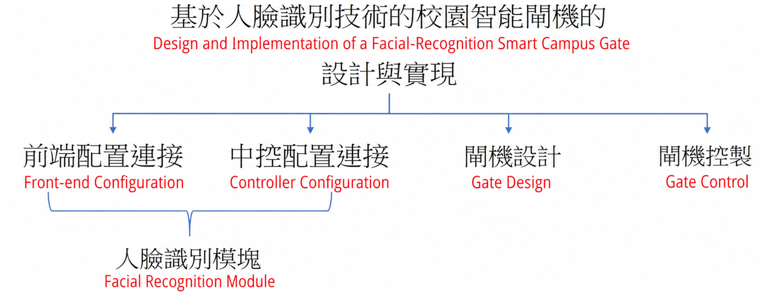  Figure 1. Task Decomposition for the Smart Gate  Students: Decompose the project and define the inquiry questions. | Video “Applications of Facial Recognition in Daily Life” and “Components and Operating Principles of an Access-Control System”  Example Image of a Campus Facial-Recognition Access-Control System  Learning Worksheet
Explore
Explore 1: Facial-Recognition Process and Principles
Explore Scientific Principle Through Hands-On Activities | Data Collection and Analysis | Teacher: Ask students to download human and animal face images from the internet and use the Facial Attributes, Face Comparison, and Face Search modules in the Tencent AI Experience Center to explore different applications of facial-recognition technology. Students record their procedures and results, then infer and summarize the workflows of the three application scenarios in Worksheet 3.2.  Students: Collect images online and use the Tencent AI Experience Platform to investigate different facial-recognition applications. | Tencent AI Experience Platform  Learning Worksheet
Explore Scientific Principle Through Hands-On Activities | Data Representation | Teacher: Ask students to select an appropriate representation for the facial-recognition workflow.  Students: Discuss the steps and represent the workflow as a diagram.
Explain
Explain 1: Facial-Recognition Process and Principles
Present and Explain | Pattern Recognition and Mapping | Teacher: Invite groups to demonstrate their procedures and findings. Question and explain key steps, then reorganize the process with students to consolidate their understanding of facial-recognition principles.  Students: Student representatives present their work to the class, using a diagram such as that shown in Figure 2. After the presentation, they respond to questions from the teacher and classmates and identify difficulties or unresolved questions encountered during the inquiry.  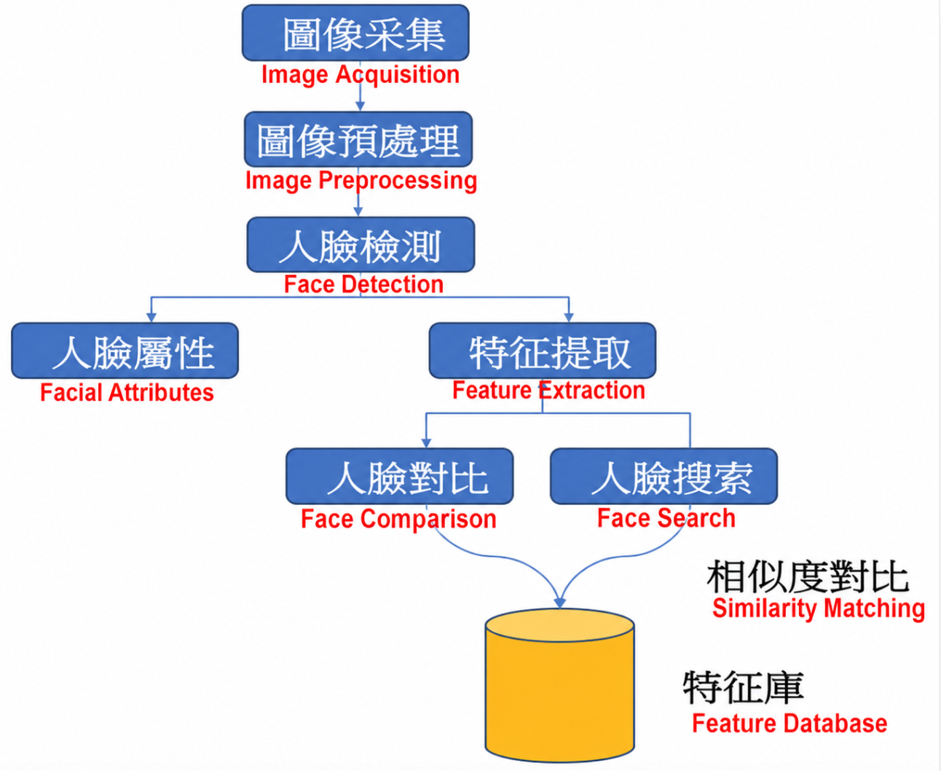  Figure 2. Facial-Recognition Workflows in Different Scenarios  Teacher: Play the video “Facial Recognition at a Gate.” In groups, students apply their understanding of different facial-recognition scenarios, select the appropriate method (face search) and explain the workflow.  Students: Select appropriate method of face search for the scenario, describe the gate-entry workflow, and complete Test 8.1. | Learning Worksheet  Video “Facial Recognition at a Gate”
Explore 2: Facial-Recognition Hardware—Connecting HUSKYLENS and Arduino Uno
Hardware and Face Enrollment | Data Collection and Analysis | Teacher: Provide self-directed learning resources, including the HUSKYLENS operating guide and tutorial videos. Give each group one HUSKYLENS AI camera and one Arduino Uno controller. Ask students to connect the devices, capture group members’ facial images, enroll the faces in HUSKYLENS, and summarize the enrollment procedure in Worksheet 3.3.  Students: Learn the related resources, connect HUSKYLENS to Arduino Uno as shown in Figure 3, capture and enroll group members’ faces, summarize the procedure, and record it on the worksheet.  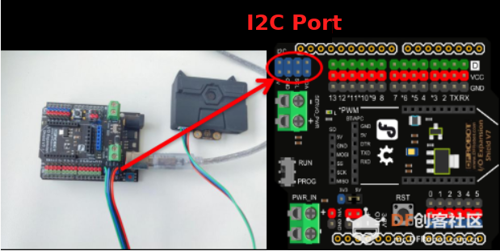  Figure 3. Circuit Connection | Hardware: Gravity HUSKYLENS AI Camera;  Arduino Uno Board  HUSKYLENS  Operating Guide and Tutorial Video  Learning Worksheet
Explain 2: Facial-Recognition Hardware
Demonstrate and Represent | Pattern Recognition and Representation | Teacher: Invite students to demonstrate how they use HUSKYLENS and explain key steps. Then ask: “We can currently learn and recognize one face. How can the device learn multiple faces in a single session?” Use students’ responses to explain and distinguish the two recognition modes. Ask students to show and explain both procedures in Worksheet 3.4.  Students: While student representatives demonstrate facial recognition using HUSKYLENS, the rest of the class observe carefully, identify operational problems, and raise questions. Also respond to the teacher’s guiding questions, document the procedures for the two recognition modes on the worksheet, and try to use the multiple-face enrollment and recognition mode. | Learning Worksheet
Explore 3: Circuit Connections Between Facial Recognition and Expansion Modules
Circuit Inquiry | Data Representation | Teacher: Provide a preconnected physical circuit, as shown in Figure 4. Ask students to identify its components and determine what is missing. When they identify the power source, connect the Arduino Uno to a computer with a USB cable. Students then determine whether the circuit is series or parallel, draw a circuit diagram from the physical connections, explain the functions it can perform in Worksheet 3.5, and identify the associated energy conversions.  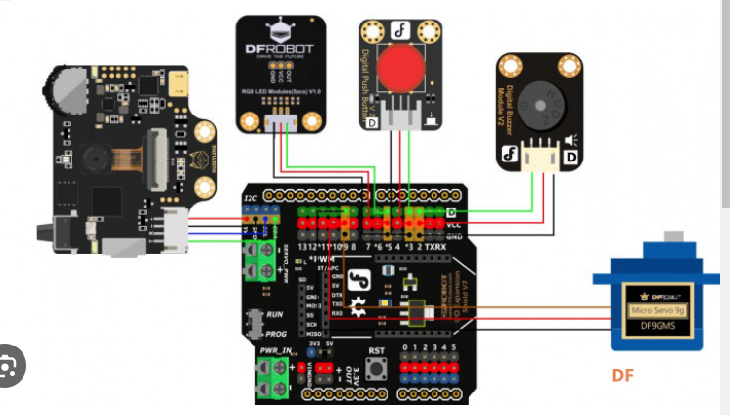  Figure 4. Expected Circuit Connection  Students: Analyze the circuit, classify its type, draw the circuit diagram, explain its functions, and describe the energy-conversion process. | Arduino Uno Board  LED Display  MP3 Module  Servo Motor  Learning Worksheet
Explain 3: Circuit Connections Between Facial Recognition and Expansion Modules
Explain Circuit | Pattern Recognition  and Representation | Teacher: Use projection to explain key Arduino Uno components, including the USB port, external power connector, digital pins, and analog pins, and show how the board connects to expansion modules. This prepares students for later extension and transfer tasks.  Students: Listen carefully to the teacher’s explanation, connect the Arduino Uno to the required components, and complete the basic circuit connections, thereby developing foundational knowledge of hardware interfacing. | Arduino Uno Development Board  Projector
Explore 4: Designing and Building the Gate
Prototype  Design | Data Collection and Analysis | Teacher: Ask students to research smart gates online, including their structure, form, appearance, and functions. Students analyze existing designs, generate creative ideas, and build a prototype.  Students: Collect and analyze information and build a smart-gate model. | LEGO Bricks  Cardboard  Servo Motor
Explain 4: Gate Design and Construction
Present and Refine | Pattern Representation | Teacher: Ask groups to present their proposed smart-gate models. Encourage peer feedback and help groups refine their ideas. Remind students to consider safety, convenience, aesthetics, and feasibility during implementation.  Students: Present the proposed model, incorporate teacher and peer feedback, refine the design, and complete construction.
Elaborate
Note: The HUSKYLENS camera has already learned the designated face data and only needs to determine whether a detected face matches an enrolled identity. Students have connected the hardware modules according to their designs. The core task is now to design the algorithm and implement it in Mind+. Because groups may propose different ideas while available expansion hardware is limited, the teacher should closely monitor feasibility. The example implementation uses the RGB LED on pin 5 of the controller. A green light indicates a recognized authorized face; the gate opens automatically, the LED display shows “Access granted. Please enter,” and text-to-speech plays the message. After the person enters, the gate closes. For an unknown face, the servo remains stationary, the display shows “Face recognition failed,” text-to-speech plays the message, and the RGB LED flashes red.
Program in Mind+ | Algorithmic Thinking | Teacher: Ask students to draw a flowchart for their design and use standard flowchart symbols correctly.  Students: Draw a flowchart for their proposed solution using appropriate symbols, as illustrated in Figure 5.  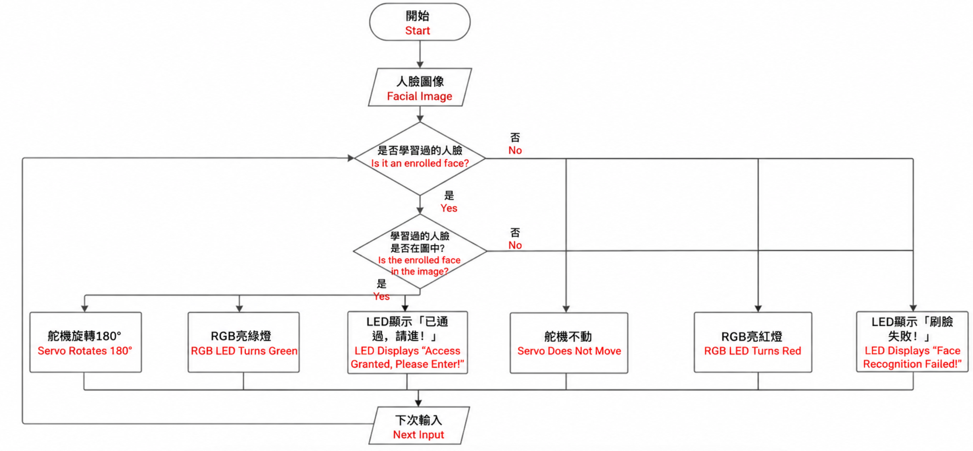  Figure 5. Expected Flowchart | Learning Worksheet
Program in Mind+ | Automation / Simulation | Teacher: Provide a partially completed programming task (Appendix 8). Ask students to use their knowledge to complete the program in Mind+.  Students: Add the missing code blocks according to their knowledge and project requirements and complete the partially structured programming task. | Mind+ Platform
Program in Mind+ | Testing and Evaluation | Students: Upload the completed program to the connected hardware and debug it. Seek help from the teacher or peers when necessary.  Teacher: Check each group’s program execution and provide targeted guidance based on identified problems. | Mind+ Platform
Iterative Optimization | Iterative Optimization | Teacher: Students will discover that the current program can recognizes only one classmate. Ask them to iteratively revise the existing code so the smart gate can recognize multiple members of the group, detect non-group members, and generate an appropriate response.  Students: Extend and transfer their existing code-block knowledge to complete a more complex task. | Mind+ Platform  Additional Expansion Boards
Present and Summarize | Generalization and Reflection | Teacher: Each group presents its project. The teacher and classmates provide feedback on strengths, limitations, and future improvements. Play the video “Why Can AI Be Concerning? Ethical Bias, Facial-Recognition Privacy, and Autonomous-Vehicle Safety.” Guide students to evaluate AI critically and pursue responsible, human-centered innovation. Conclude with project reflection and summarize lessons for future course design and implementation.  Students: Present group products, participate in peer review, and use feedback for continued improvement. Recognize that AI provides major benefits but may also create negative consequences, and therefore should be used in accordance with AI ethics. Complete the project summary report in Appendix 3.6, reflect on problems encountered during project-based learning, and strengthen learning transfer. | Project Scoring Rubric  Video “Why Can AI Be Concerning? Ethical Bias, Facial-Recognition Privacy, and Autonomous-Vehicle Safety”
Evaluate
- Formative Assessment
Engage Rubric:
Students complete the design worksheet (Appendix 3.1).
The teacher scores the worksheet (Appendix 7.1).
Explore 1 Rubric:
Students use the Facial Attributes, Face Comparison, and Face Search modules and complete the student worksheet (Appendix 3.2).
The teacher scores the worksheet (Appendix 7.2).
Explain 1 Rubric:
Student oral presentation (Appendix 7.3).
Test item (Appendix 8.1).
Explore 2 Rubric:
Students use the HUSKYLENS facial-recognition camera to capture, enroll, and recognize faces and complete the worksheet (Appendix 3.3).
The teacher scores the worksheet (Appendix 7.4).
Explain 2 Rubric:
Student oral presentation (Appendix 7.3).
Students use HUSKYLENS for single-face and multiple-face enrollment and recognition and complete the worksheet (Appendix 3.4).
The teacher scores the worksheet (Appendix 7.5).
Explore 3 Rubric:
Students identify the circuit connections, draw a circuit diagram from the physical setup, explain its functions, and complete the worksheet (Appendix 3.5).
The teacher scores the worksheet (Appendix 7.6).
Explain 3 Rubric:
Student oral presentation (Appendix 7.3).
Explain 4 Rubric:
Student presentation (Appendix 7.7).
Elaborate Rubric:
Students submit an algorithm flowchart, which the teacher scores (Appendix 7.8).
Students complete the partially structured programming task, and the teacher scores the block-based code (Appendix 7.9).

- Summative Assessment
The final project is assessed through combined teacher and peer evaluation (Appendix 7.10).
Project summary report (Appendix 3.6).

Appendices
- Video Resources
(1) “Applications of Facial Recognition in Daily Life” https://www.bilibili.com/video/BV1vL4y1t7EV/?spm_id_from=333.337.search-card.all.click&vd_source=2ccbc91941de926f4c8503aee1cc4067
(2) “Components and Operating Principles of an Access-Control System” https://www.bilibili.com/video/BV1Tt411Y7uP/?spm_id_from=pageDriver&vd_source=2ccbc91941de926f4c8503aee1cc4067
(3) “Facial Recognition at a Gate” https://haokan.baidu.com/v?pd=wisenatural&vid=6030339110515970419
(4) “HUSKYLENS AI Camera—Face Recognition” https://www.youtube.com/watch?v=WxL7t_6fbN4
(5) “Why Can AI Be Concerning? Ethical Bias, Facial-Recognition Privacy, and Autonomous-Vehicle Safety” youtube.com/watch?v=cTD9vc54K0U

- Teaching Platforms
- Tencent AI Open Platform https://ai.qq.com/
- Mind+ https://mindplus.cc/en.html

- Learning Worksheet
  - Smart-Gate Concept Worksheet
Group Members: ______________________________ Date: ____________
Answer the following questions based on “Applications of Facial Recognition in Daily Life”:
1. How do you understand facial-recognition technology, and where can it be used in daily life? ______________________________
2. We use the school’s facial-recognition entrance every day. Identify the components of the smart gate and explain how it works: ______________________________
3. What problems exist in the current access-control system, and how could it be improved? ______________________________
4. Using the teacher’s example, work in a group to design a “Facial-Recognition Smart Campus Gate.” Briefly explain its structure and functions.

5. Concept Sketch: “Facial-Recognition Smart Campus Gate”

What components are included in your group’s smart gate?
What functions does your group’s smart gate provide?

  - Facial-Recognition Technology Experience
Group Members: ______________________________ Date: ____________

Facial-Recognition Technology Experience
Scenario | Requirement | Procedure | Result
Attributes | Use a Human Face Image
 | Use an Animal Face Image
Comparison | Same-Face Images
 | Different-Face Images
 | Human vs. Animal Face
Search | Search One Face Image
Comparison of the Three Techniques:
Questions:
Summary and Reflection:

  - Using HUSKYLENS
Group Members: ______________________________ Date: ____________

Using HUSKYLENS
Task | Procedure
Connect Arduino Uno
Face Capture
Face Enrollment
Face Recognition
Questions:
Summary and Reflection:

  - Single-Face and Multiple-Face Enrollment and Recognition
Group Members: ______________________________ Date: ____________

HUSKYLENS Enrollment Modes
Mode | Procedure
Single-Face Mode
Multiple-Face Mode
Similarities:
Differences:
Questions:
Summary and Reflection:

  - Identify the Hardware Circuit Connections
Group Members: ______________________________ Date: ____________

1. Identify the components of the circuit: ______________________________
2. Determine whether the circuit is series or parallel: ______________________________
3. Draw the circuit diagram from the physical connections:

- 4. Identify the functions the circuit can perform: ______________________________
- 5. Identify the energy conversions in the circuit: ______________________________

  - Project Summary Report
Project Summary Report Worksheet
Name: __________________ Student ID: ____________

1. What problem did your group address? What major stages did the project include? What knowledge, technical, teamwork, or other problems did you encounter, and how did you solve them? ______________________________
2. What did you learn from the project? What specific knowledge and skills did you gain? ______________________________
3. Did your group’s product achieve the intended functions? What limitations remain, and how could it be improved? ______________________________
4. Which experiences from this project will help you complete similar projects more effectively in the future? ______________________________

4. Materials List
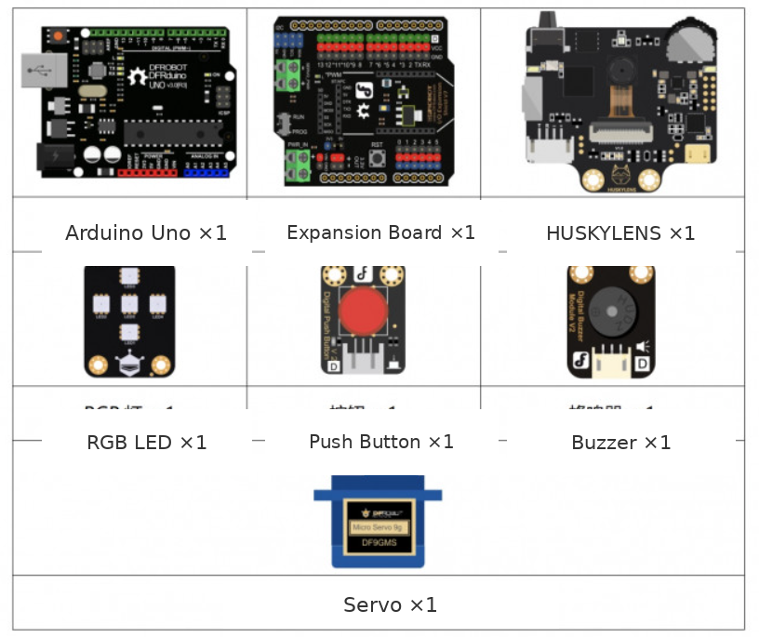

5. User Documentation
(1) Gravity HUSKYLENS AI Camera https://wiki.dfrobot.com.cn/_SKU_SEN0305_Gravity__HUSKYLENS_%E4%BA%BA%E5%B7%A5%E6%99%BA%E8%83%BD%E6%91%84%E5%83%8F%E5%A4%B4#target_44
(2) HUSKYLENS Face-Enrollment Procedure https://mc.dfrobot.com.cn/thread-305595-1-1.html

6. Partially Structured Programming Task
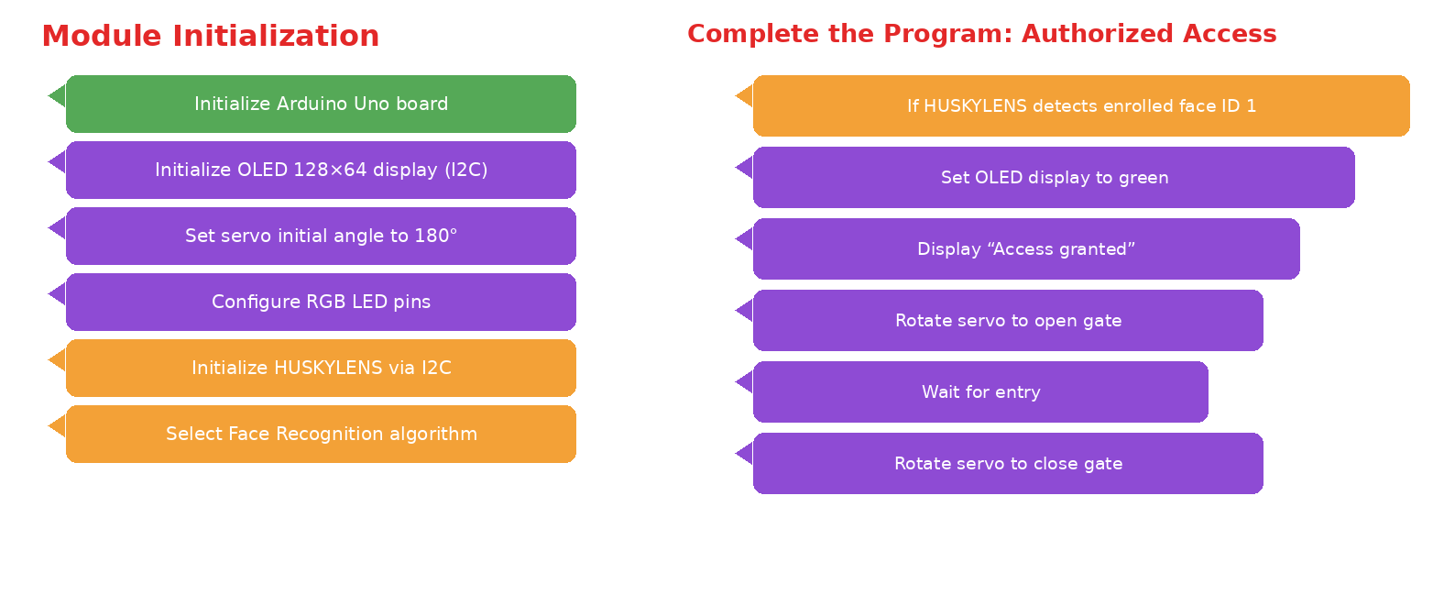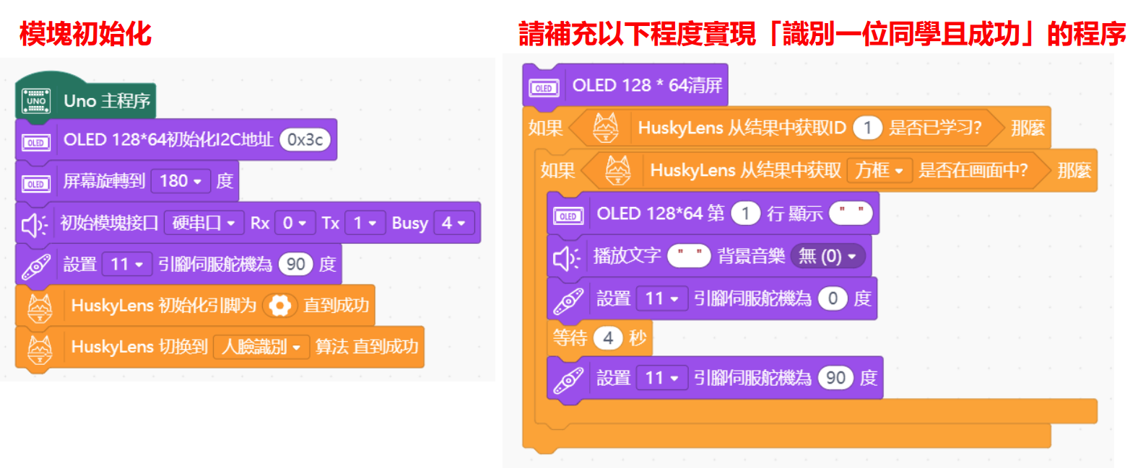

7. Assessment Rubrics
  - Concept Sketch: “Facial-Recognition Smart Campus Gate”
 | 0 | 1 | 2 | 3 | 4
Understanding | Did Not Participate | No understanding; no applications identified. | Partial understanding; some errors; identifies at least three applications. | Accurate understanding; explains at least three applications. | Accurate, in-depth explanation of applications and benefits.
Analysis | Did Not Participate | No analysis of principles or components. | Partial analysis; incomplete or partly inaccurate. | Accurate analysis of principles and components. | In-depth analysis of principles and components.
Critical Thinking | Did Not Participate | No problems or improvements identified. | Identifies problems; improvements lack originality. | Original improvements with limited justification. | Original improvements with strong justification.
Innovation | Did Not Participate | Copies an existing design; components and functions are unclear. | Copies an existing design; explains components and functions. | Adds a self-designed module and explains its components and functions. | Adds an innovative module with a clear explanation.
Participation | Did Not Participate | Minimal participation; disrupts others. | Minimal participation; does not disrupt others. | Participates throughout; occasionally distracted. | Fully engaged and focused throughout.
Collaboration | Did Not Participate | Refuses to collaborate. | Collaborates, with some conflict. | Collaborates effectively. | Collaborates effectively and coordinates team tasks.

  - Facial-Recognition Technology Experience
 | 0 | 1 | 2 | 3 | 4
Operational Skill | Did Not Participate | Does not complete the three activities. | Completes activities; key steps are missing. | Completes and records all steps; results are correct. | Completes all steps; detailed explanation; correct results.
Analysis and Representation | Did Not Participate | Does not extract or represent the three workflows. | Represents the workflows; information is incomplete or partly inaccurate. | Accurate workflows; limited comparison. | Accurate workflows; in-depth comparison.

  - Group Presentation Peer-Assessment Form
Group | Accuracy (0–4) | Delivery (0–4) | Time (0–4) | Total (0–12)
1
2
3
4
5
6

  - Using HUSKYLENS
 | 0 | 1 | 2 | 3 | 4
Operational Skill | Did Not Participate | Cannot connect HUSKYLENS and Arduino Uno. | Connects the devices; face capture is incomplete. | Connects and captures a face; recognition is incomplete. | Completes all steps.
Analysis and Representation | Did Not Participate | Cannot describe the steps. | Partial or partly inaccurate description. | Complete description. | Accurate and complete description.

  - HUSKYLENS Recognition Modes
 | 0 | 1 | 2
Operational Skill | Did Not Participate | Does not use multiple-face mode. | Uses multiple-face mode correctly.
Analysis and Representation | Did Not Participate | Does not compare the two modes effectively. | Compares the two modes effectively.

  - Identify the Hardware Circuit Connections
 | 0 | 1 | 2
Circuit Components | Did Not Participate | Cannot identify the components. | Identifies the components correctly.
Circuit Type | Did Not Participate | Classifies the circuit incorrectly. | Classifies the circuit correctly.
Circuit Diagram | Did Not Participate | Circuit diagram is inaccurate or missing. | Draws an accurate circuit diagram.
Circuit Function | Did Not Participate | Function is incorrect or missing. | Explains the function correctly.

  - Smart-Gate Model
Group | Aesthetics (0–4) | Creativity (0–4) | Communication (0–4) | Collaboration (0–4) | Total (0–16)
1
2
3
4
5
6

  - Algorithm Flowchart
Group | Readability (0–4) | Standards Compliance (0–4) | Accuracy (0–4) | Total (0–12)
1
2
3
4
5
6

  - Partially Structured Programming Task
 | 0 | 1 | 2
Code Development | Did Not Participate | Task incomplete. | Task complete.
Code Upload | Did Not Participate | Code not uploaded. | Code uploaded successfully.
Code Debugging | Did Not Participate | Hardware not fully connected or debugged. | System connected and debugged to meet requirements.

7.10 Project Assessment
 | 1 | 2 | 3 | 4 | 5 | Score
Product | Incomplete. | Partly functional; no code; unstable; little innovation. | Functional; stable; correct code; little innovation. | Functional; programmed; stable; some innovation. | Fully functional; programmed; robust; highly innovative.
Presentation | Unclear roles and explanation; basic slides. | Clear roles; unclear explanation; basic slides. | Clear roles; partly clear explanation; slides or display board. | Clear roles and explanation; varied presentation. | Clear roles; polished visuals; engaging delivery.

8. Test
