Supplementary Information
Contextualizing CNN attribution maps using predefined image-derived descriptors in medicinal plant seed classification
Su-Min Chin^{a,b}, Yea-Jin Park^{a,b}, Dae-Hyun Jung^{a,b,*}
ª Department of Smart Farm Science, Kyung Hee University, Yongin, Gyeonggi-do, Republic of Korea; e-mail: sgn08178@khu.ac.kr, lou0412@khu.ac.kr
^{b} BK21 Interdisciplinary Program in IT-Bio Convergence System, Kyung Hee University, Yongin, Republic of Korea
* Corresponding author, e-mail address: daehyun@khu.ac.kr

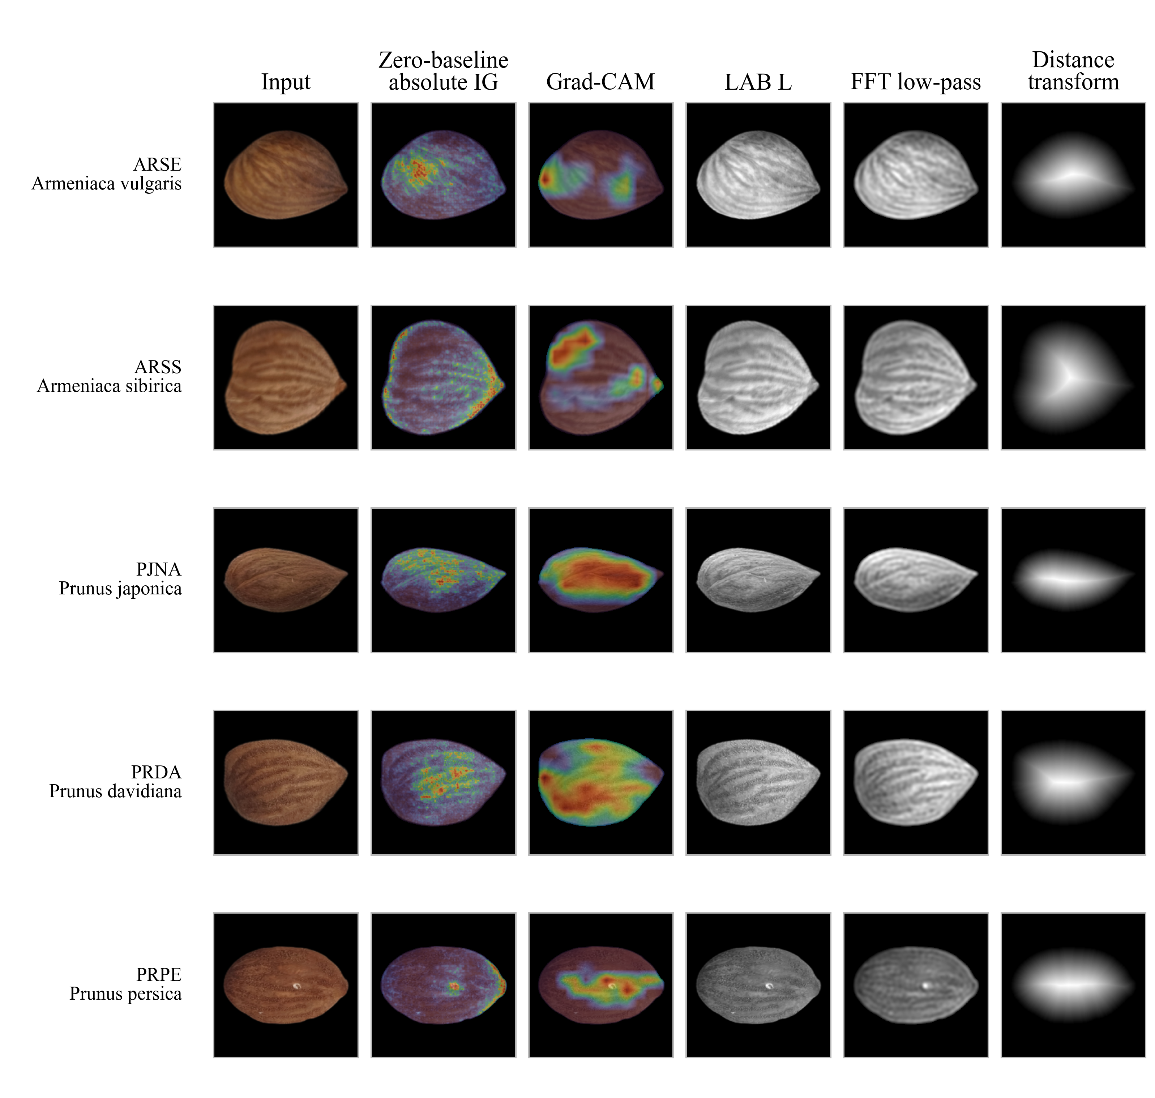
Supplementary Fig. S1 Representative attribution and descriptor examples. Representative test images from each class are shown with zero-baseline absolute IG, ConvNeXt-Small Grad-CAM, and selected descriptor maps. Grad-CAM used the final selected layer (stages.2.blocks.26). Examples do not represent within class variability.

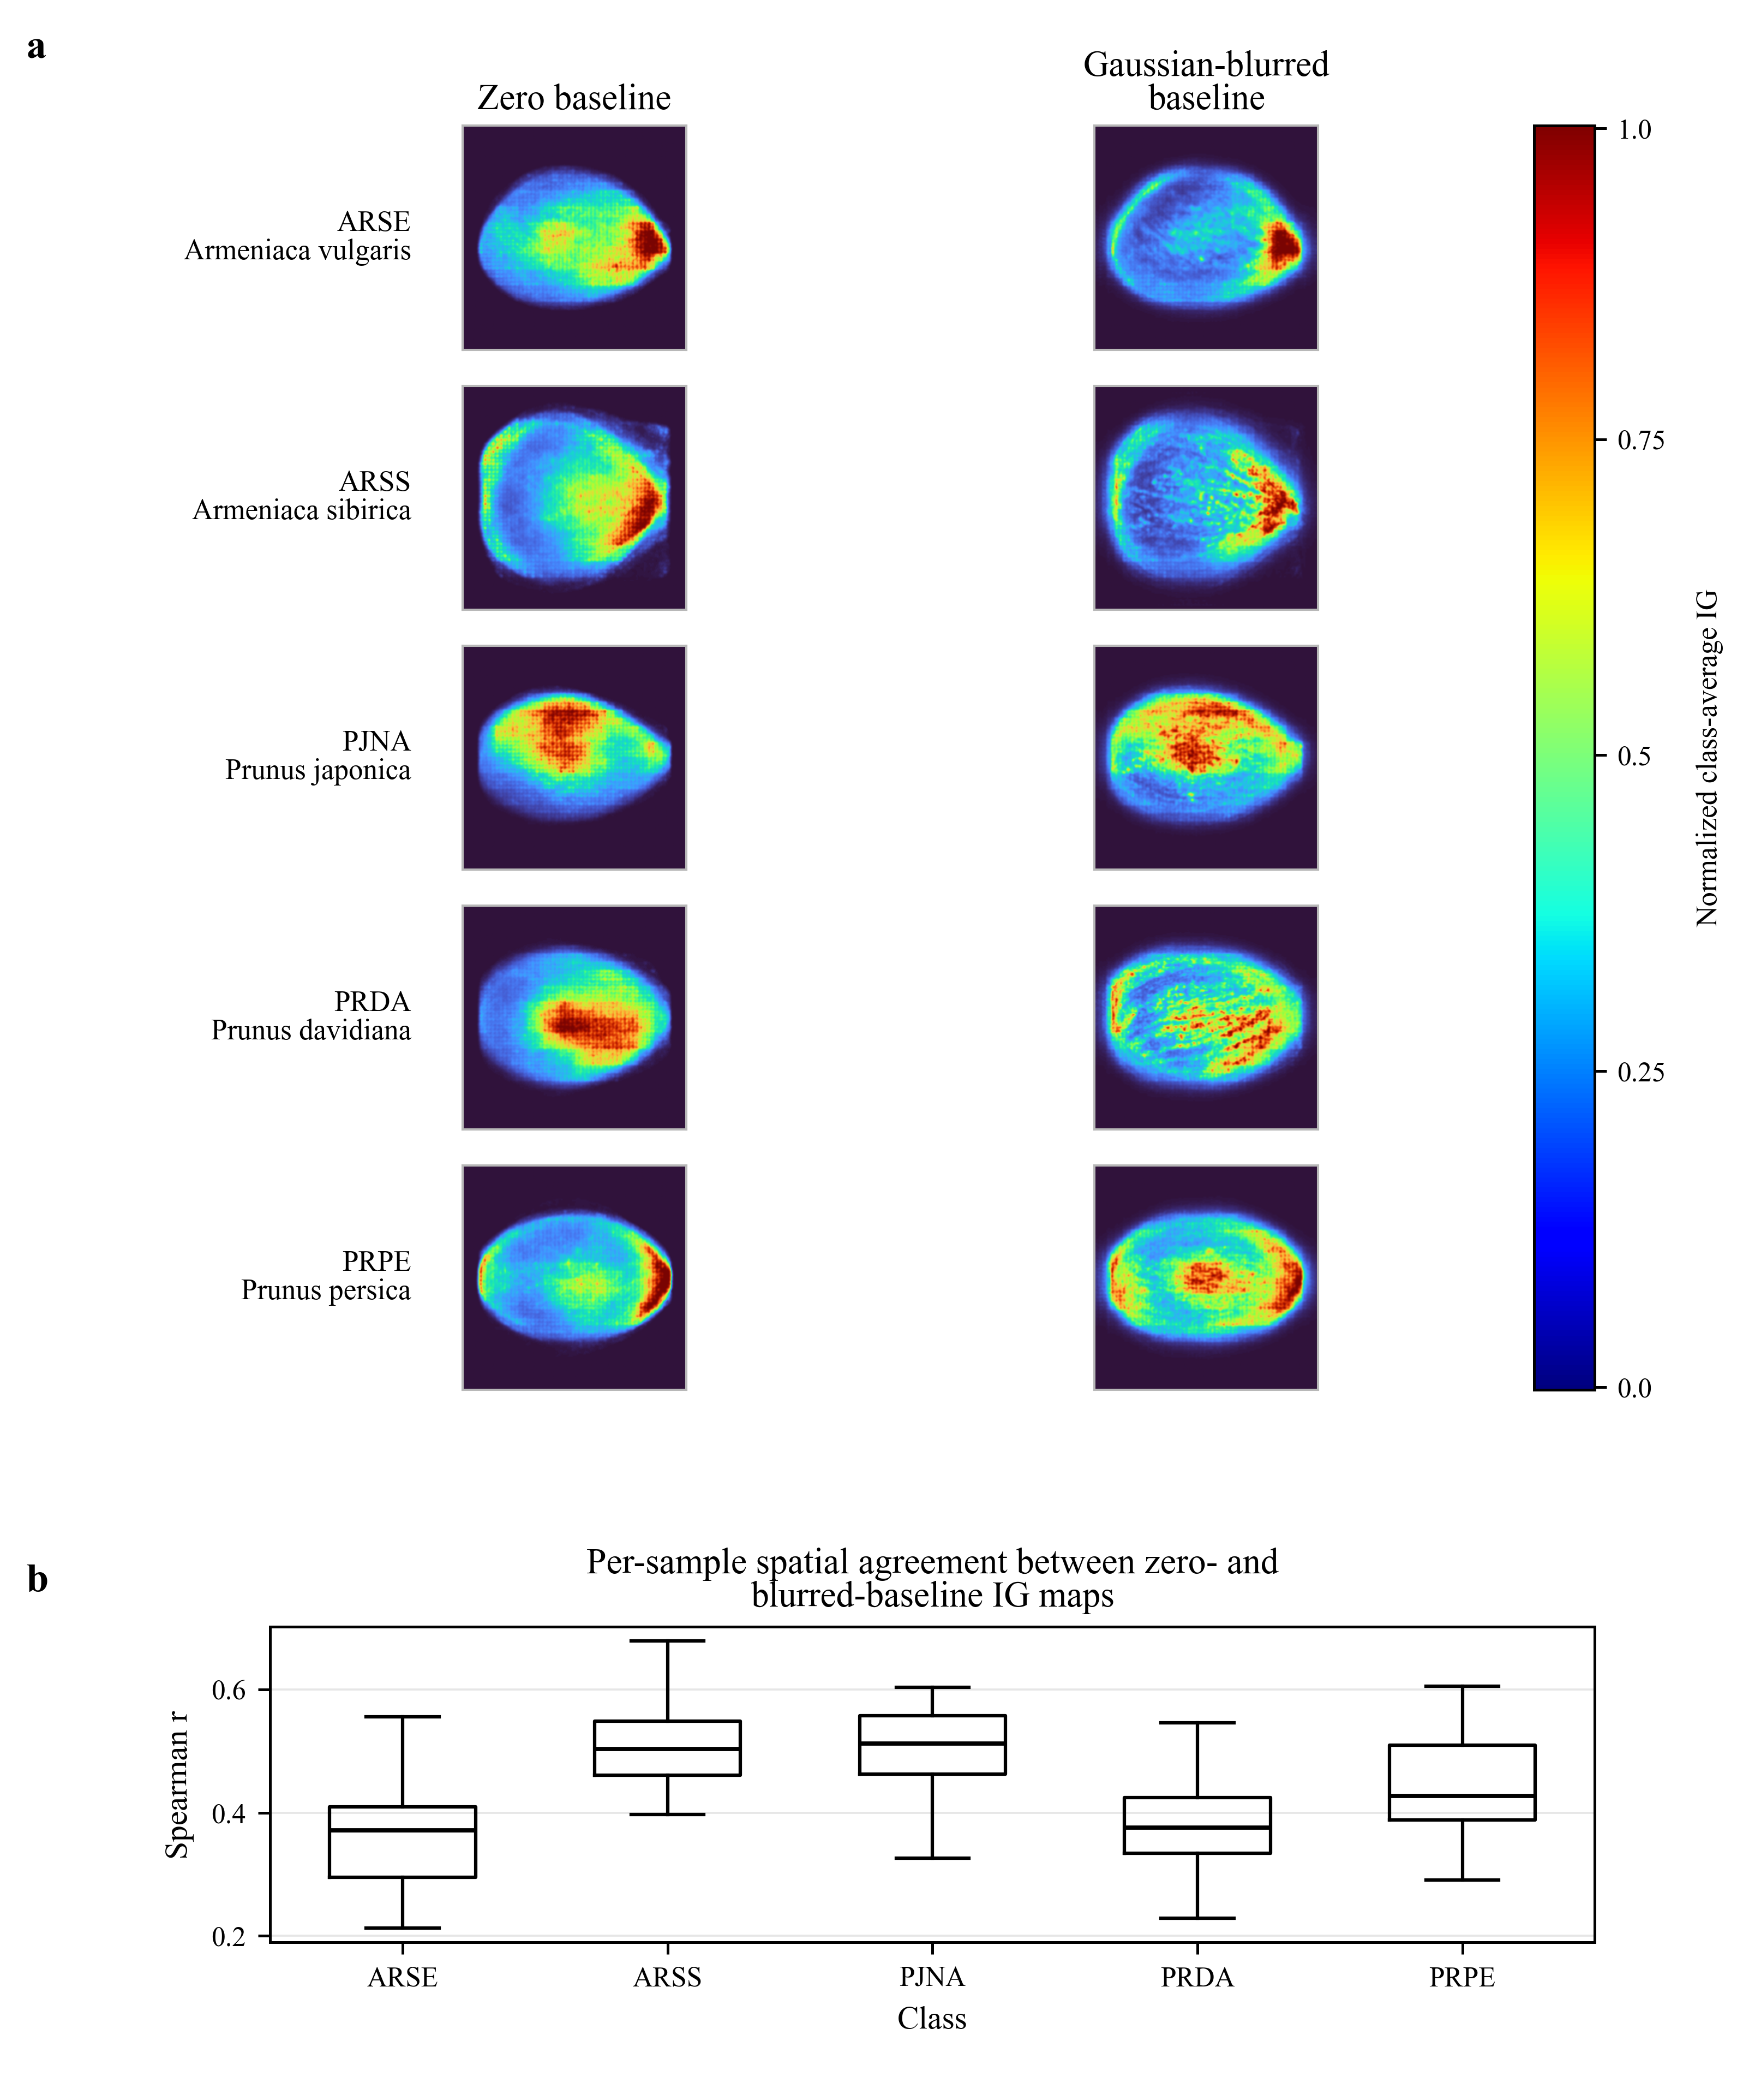
Supplementary Fig. S2 Comparison of zero-baseline and Gaussian-blurred baseline IG maps. Class-average absolute IG maps are shown for zero-baseline IG and IG with a Gaussian-blurred baseline with sigma = 20, computed from the ConvNeXt-Small test-set samples. The lower panel summarizes per-sample spatial agreement between the two baseline choices using Spearman correlation. The comparison is descriptive and does not replace the primary zero-baseline absolute IG analysis.
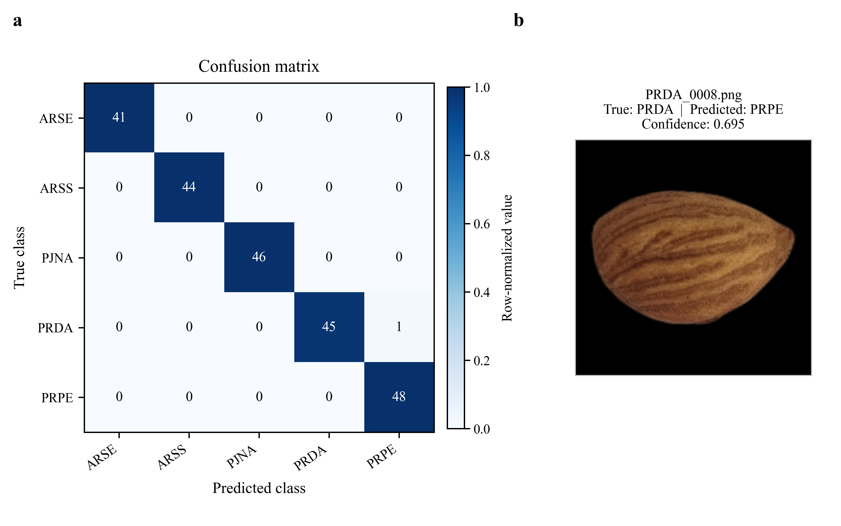
Supplementary Fig. S3 ConvNeXt-Small test-set confusion matrix and misclassified sample. The confusion matrix shows row-normalized classification results with cell counts annotated. The single misclassified test sample in the final ConvNeXt-Small per-sample prediction output is shown with its true class, predicted class, and model confidence. No additional misclassified examples were added beyond those present in the prediction file.

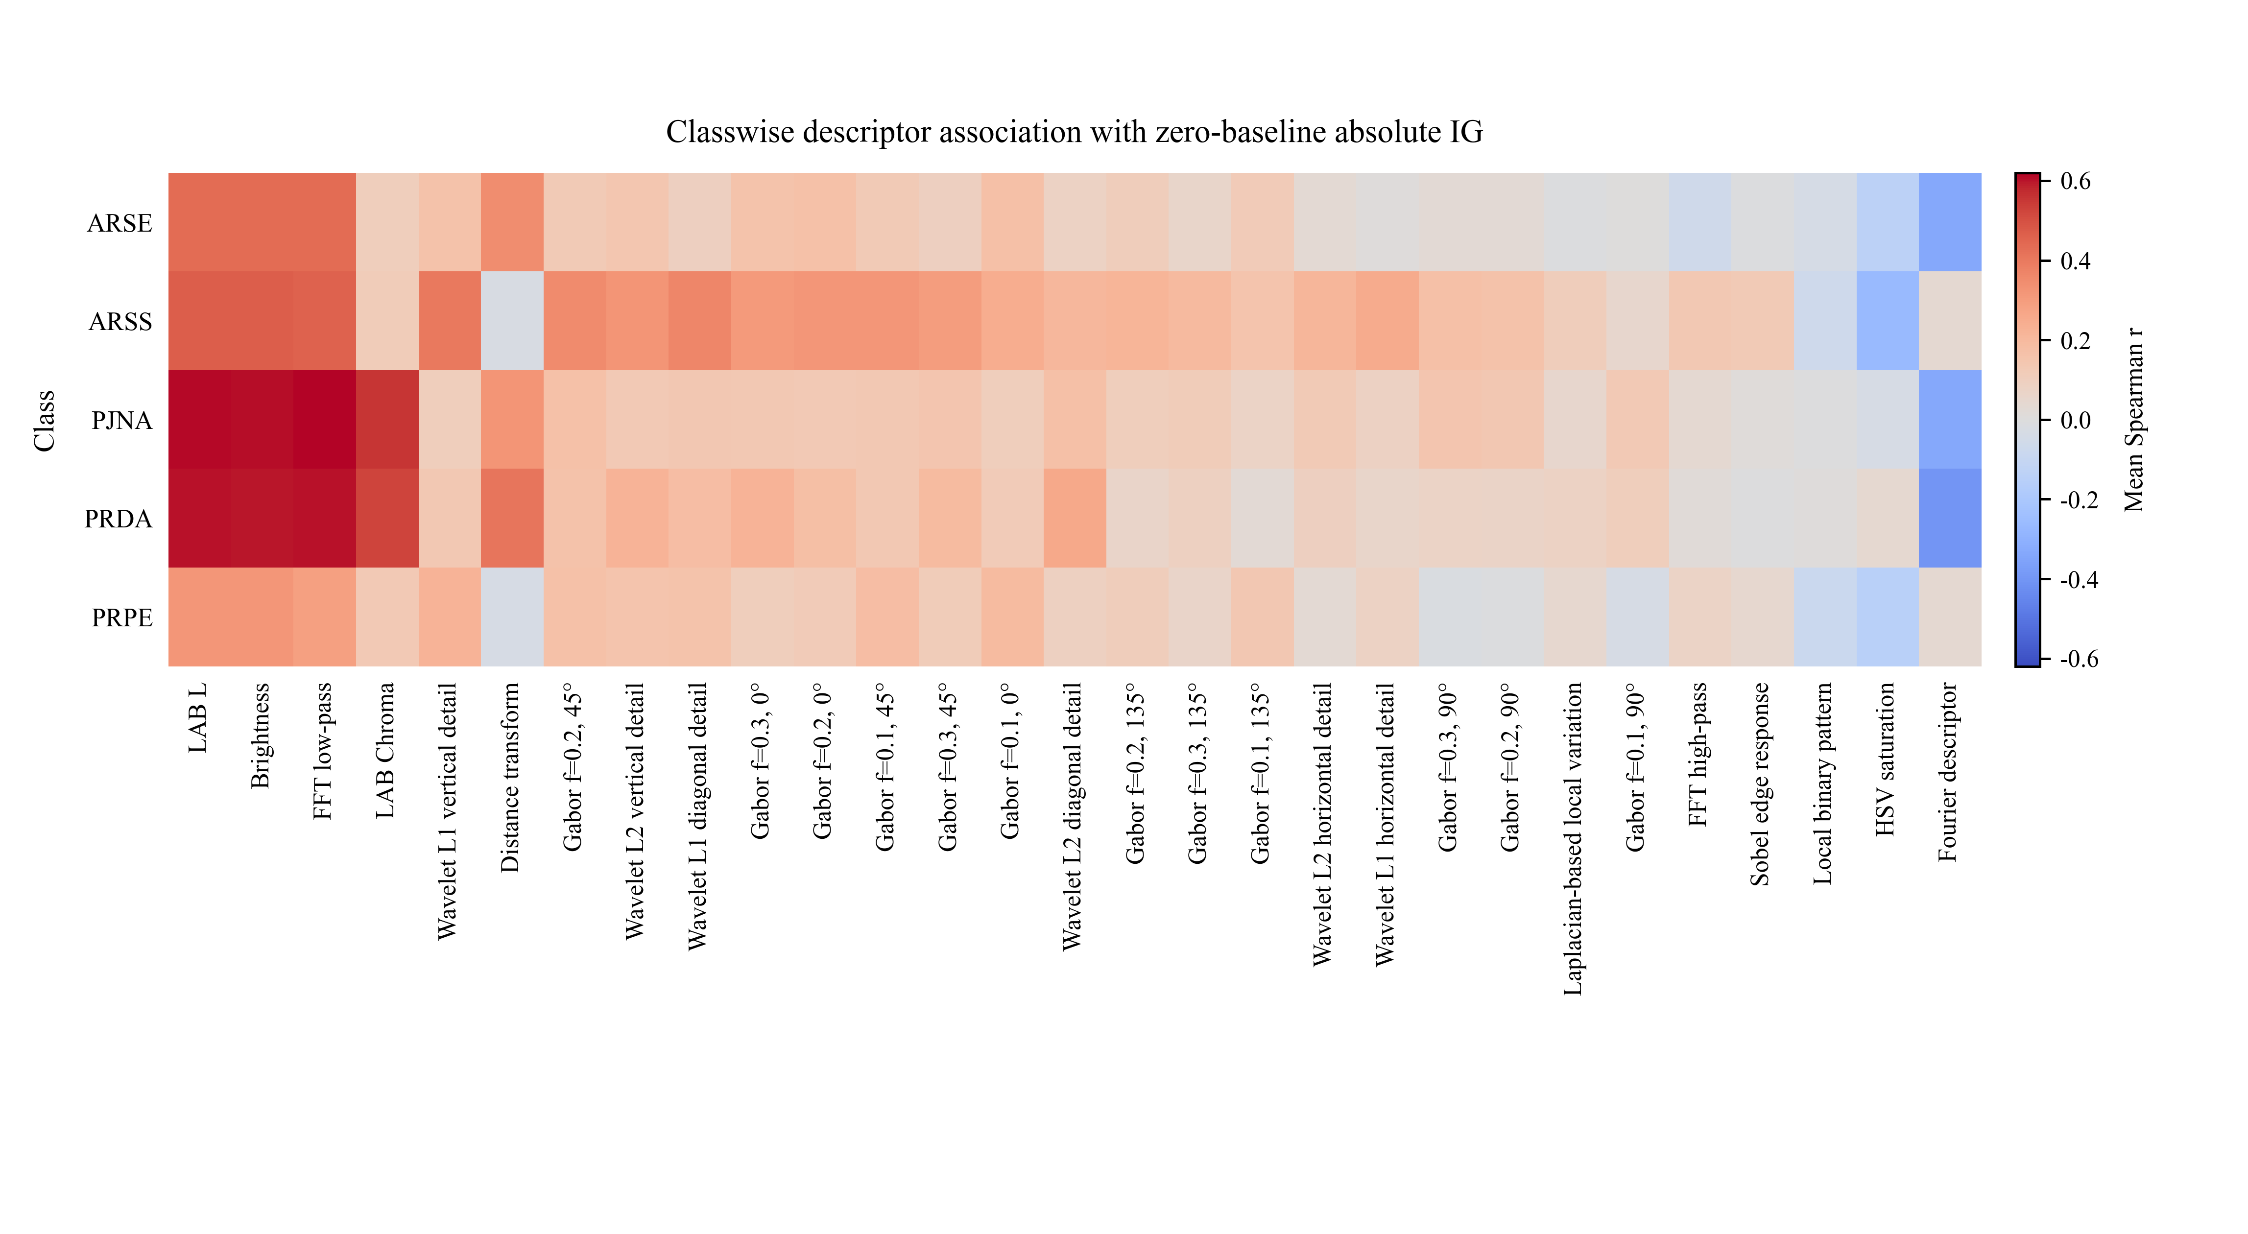
Supplementary Fig. S4 Classwise descriptor associations for zero-baseline absolute Integrated Gradients. Heatmap values show classwise mean Spearman correlations between predefined descriptor maps and zero-baseline absolute IG maps. Descriptors are ordered by the overall zero-baseline absolute IG descriptor summary. The figure provides a supplementary classwise view of the descriptor association analysis.

Supplementary Table S1. Full list of 29 descriptor maps and parameters
Descriptor | Category | Visual property | Main parameters
LAB L | Color and intensity | Lightness in CIELAB color space | CIELAB L channel.
Brightness | Color and intensity | Mean RGB intensity | Mean RGB/grayscale intensity.
FFT low-pass | Spatial frequency | Low spatial-frequency intensity structure | FFT low-pass filtering; low-pass ratio = 0.25.
LAB Chroma | Color and intensity | Chroma magnitude in CIELAB color space | Chroma magnitude from LAB color components.
Wavelet L1 vertical detail | Spatial frequency | Wavelet detail coefficients | Wavelet db2; level 1; vertical detail.
Distance transform | Edge and shape | Mask-derived interior distance | Distance of each foreground pixel from the seed boundary.
Gabor response (f = 0.2, theta = 45 deg) | Texture | Orientation- and frequency-selective texture response | Gabor response; frequency = 0.2; theta = 45 deg.
Wavelet L2 vertical detail | Spatial frequency | Wavelet detail coefficients | Wavelet db2; level 2; vertical detail.
Wavelet L1 diagonal detail | Spatial frequency | Wavelet detail coefficients | Wavelet db2; level 1; diagonal detail.
Gabor response (f = 0.3, theta = 0 deg) | Texture | Orientation- and frequency-selective texture response | Gabor response; frequency = 0.3; theta = 0 deg.
Gabor response (f = 0.2, theta = 0 deg) | Texture | Orientation- and frequency-selective texture response | Gabor response; frequency = 0.2; theta = 0 deg.
Gabor response (f = 0.1, theta = 45 deg) | Texture | Orientation- and frequency-selective texture response | Gabor response; frequency = 0.1; theta = 45 deg.
Gabor response (f = 0.3, theta = 45 deg) | Texture | Orientation- and frequency-selective texture response | Gabor response; frequency = 0.3; theta = 45 deg.
Gabor response (f = 0.1, theta = 0 deg) | Texture | Orientation- and frequency-selective texture response | Gabor response; frequency = 0.1; theta = 0 deg.
Wavelet L2 diagonal detail | Spatial frequency | Wavelet detail coefficients | Wavelet db2; level 2; diagonal detail.
HSV Saturation | Color and intensity | Saturation in HSV color space | HSV saturation channel.
FFT high-pass | Spatial frequency | High spatial-frequency intensity structure | FFT high-pass component using low-pass ratio = 0.25.
Local binary pattern | Texture | Local binary texture pattern | LBP radius = 2; n_points = 16; method = uniform.
Sobel edge response | Edge and shape | First-order edge response | Sobel gradient magnitude.
Laplacian-based local variation | Edge and shape | Second-order intensity response | Laplacian-based local variation.
Fourier descriptor | Edge and shape | Contour-derived shape representation | Fourier descriptor; number of components = 20.
Wavelet L1 horizontal detail | Spatial frequency | Wavelet detail coefficients | Wavelet db2; level 1; horizontal detail.
Wavelet L2 horizontal detail | Spatial frequency | Wavelet detail coefficients | Wavelet db2; level 2; horizontal detail.
Gabor response (f = 0.1, theta = 135 deg) | Texture | Orientation- and frequency-selective texture response | Gabor response; frequency = 0.1; theta = 135 deg.
Gabor response (f = 0.1, theta = 90 deg) | Texture | Orientation- and frequency-selective texture response | Gabor response; frequency = 0.1; theta = 90 deg.
Gabor response (f = 0.2, theta = 135 deg) | Texture | Orientation- and frequency-selective texture response | Gabor response; frequency = 0.2; theta = 135 deg.
Gabor response (f = 0.2, theta = 90 deg) | Texture | Orientation- and frequency-selective texture response | Gabor response; frequency = 0.2; theta = 90 deg.
Gabor response (f = 0.3, theta = 135 deg) | Texture | Orientation- and frequency-selective texture response | Gabor response; frequency = 0.3; theta = 135 deg.
Gabor response (f = 0.3, theta = 90 deg) | Texture | Orientation- and frequency-selective texture response | Gabor response; frequency = 0.3; theta = 90 deg.

Supplementary Table S2. Full Spearman association results for zero-baseline absolute IG
Rank | Descriptor | Category | Mean r | SD | n | FDR p
1 | LAB L | Color and intensity | 0.4857 | 0.1586 | 225 | <0.0001
2 | Brightness | Color and intensity | 0.4849 | 0.1569 | 225 | <0.0001
3 | FFT low-pass | Spatial frequency | 0.4804 | 0.1695 | 225 | <0.0001
4 | LAB Chroma | Color and intensity | 0.2898 | 0.2568 | 225 | <0.0001
5 | Wavelet L1 vertical detail | Spatial frequency | 0.2032 | 0.1324 | 225 | <0.0001
6 | Distance transform | Edge and shape | 0.2007 | 0.2312 | 225 | <0.0001
7 | Gabor response (f = 0.2, theta = 45 deg) | Texture | 0.1935 | 0.1233 | 225 | <0.0001
8 | Wavelet L2 vertical detail | Spatial frequency | 0.1930 | 0.1156 | 225 | <0.0001
9 | Wavelet L1 diagonal detail | Spatial frequency | 0.1879 | 0.1342 | 225 | <0.0001
10 | Gabor response (f = 0.3, theta = 0 deg) | Texture | 0.1822 | 0.1160 | 225 | <0.0001
11 | Gabor response (f = 0.2, theta = 0 deg) | Texture | 0.1800 | 0.1102 | 225 | <0.0001
12 | Gabor response (f = 0.1, theta = 45 deg) | Texture | 0.1786 | 0.1168 | 225 | <0.0001
13 | Gabor response (f = 0.3, theta = 45 deg) | Texture | 0.1693 | 0.1231 | 225 | <0.0001
14 | Gabor response (f = 0.1, theta = 0 deg) | Texture | 0.1662 | 0.0962 | 225 | <0.0001
15 | Wavelet L2 diagonal detail | Spatial frequency | 0.1624 | 0.1154 | 225 | <0.0001
16 | Gabor response (f = 0.2, theta = 135 deg) | Texture | 0.1196 | 0.0957 | 225 | <0.0001
17 | Gabor response (f = 0.3, theta = 135 deg) | Texture | 0.1042 | 0.0971 | 225 | <0.0001
18 | Gabor response (f = 0.1, theta = 135 deg) | Texture | 0.1016 | 0.1028 | 225 | <0.0001
19 | Wavelet L2 horizontal detail | Spatial frequency | 0.0980 | 0.1176 | 225 | <0.0001
20 | Wavelet L1 horizontal detail | Spatial frequency | 0.0963 | 0.1273 | 225 | <0.0001
21 | Gabor response (f = 0.3, theta = 90 deg) | Texture | 0.0798 | 0.1162 | 225 | <0.0001
22 | Gabor response (f = 0.2, theta = 90 deg) | Texture | 0.0771 | 0.1155 | 225 | <0.0001
23 | Laplacian-based local variation | Edge and shape | 0.0572 | 0.0735 | 225 | <0.0001
24 | Gabor response (f = 0.1, theta = 90 deg) | Texture | 0.0519 | 0.1227 | 225 | <0.0001
25 | FFT high-pass | Spatial frequency | 0.0411 | 0.0911 | 225 | <0.0001
26 | Sobel edge response | Edge and shape | 0.0351 | 0.0922 | 225 | <0.0001
27 | Local binary pattern | Texture | -0.0356 | 0.0404 | 225 | <0.0001
28 | HSV Saturation | Color and intensity | -0.1064 | 0.1675 | 225 | <0.0001
29 | Fourier descriptor | Edge and shape | -0.1973 | 0.2322 | 225 | <0.0001
Supplementary Table S3. Full Spearman association results for positive IG
Rank |  | Descriptor |  | Category |  | Mean r |  | SD |  | n |  | FDR p
1 | Brightness |  | Color and intensity |  | 0.1538 |  | 0.0573 |  | 225 |  | <0.0001
2 | LAB L |  | Color and intensity |  | 0.1531 |  | 0.0568 |  | 225 |  | <0.0001
3 | FFT low-pass |  | Spatial frequency |  | 0.1389 |  | 0.0623 |  | 225 |  | <0.0001
4 | Gabor response (f = 0.2, theta = 45 deg) |  | Texture |  | 0.0577 |  | 0.0489 |  | 225 |  | <0.0001
5 | Gabor response (f = 0.3, theta = 0 deg) |  | Texture |  | 0.0559 |  | 0.0471 |  | 225 |  | <0.0001
6 | Gabor response (f = 0.2, theta = 0 deg) |  | Texture |  | 0.0555 |  | 0.0509 |  | 225 |  | <0.0001
7 | Gabor response (f = 0.3, theta = 45 deg) |  | Texture |  | 0.0539 |  | 0.0509 |  | 225 |  | <0.0001
8 | LAB Chroma |  | Color and intensity |  | 0.0508 |  | 0.0683 |  | 225 |  | <0.0001
9 | Wavelet L2 vertical detail |  | Spatial frequency |  | 0.0455 |  | 0.0310 |  | 225 |  | <0.0001
10 | Gabor response (f = 0.1, theta = 45 deg) |  | Texture |  | 0.0440 |  | 0.0326 |  | 225 |  | <0.0001
11 | Distance transform |  | Edge and shape |  | 0.0420 |  | 0.0460 |  | 225 |  | <0.0001
12 | Gabor response (f = 0.1, theta = 0 deg) |  | Texture |  | 0.0418 |  | 0.0315 |  | 225 |  | <0.0001
13 | Wavelet L1 vertical detail |  | Spatial frequency |  | 0.0415 |  | 0.0288 |  | 225 |  | <0.0001
14 | Wavelet L1 diagonal detail |  | Spatial frequency |  | 0.0410 |  | 0.0322 |  | 225 |  | <0.0001
15 | Wavelet L2 diagonal detail |  | Spatial frequency |  | 0.0390 |  | 0.0314 |  | 225 |  | <0.0001
16 | Gabor response (f = 0.2, theta = 135 deg) |  | Texture |  | 0.0389 |  | 0.0358 |  | 225 |  | <0.0001
17 | Gabor response (f = 0.3, theta = 135 deg) |  | Texture |  | 0.0372 |  | 0.0389 |  | 225 |  | <0.0001
18 | Gabor response (f = 0.2, theta = 90 deg) |  | Texture |  | 0.0349 |  | 0.0430 |  | 225 |  | <0.0001
19 | Gabor response (f = 0.3, theta = 90 deg) |  | Texture |  | 0.0334 |  | 0.0435 |  | 225 |  | <0.0001
20 | Wavelet L2 horizontal detail |  | Spatial frequency |  | 0.0313 |  | 0.0361 |  | 225 |  | <0.0001
21 | Wavelet L1 horizontal detail |  | Spatial frequency |  | 0.0272 |  | 0.0353 |  | 225 |  | <0.0001
22 | Gabor response (f = 0.1, theta = 135 deg) |  | Texture |  | 0.0244 |  | 0.0265 |  | 225 |  | <0.0001
23 | Laplacian-based local variation |  | Edge and shape |  | 0.0198 |  | 0.0231 |  | 225 |  | <0.0001
24 | Gabor response (f = 0.1, theta = 90 deg) |  | Texture |  | 0.0196 |  | 0.0321 |  | 225 |  | <0.0001
25 | Sobel edge response |  | Edge and shape |  | 0.0113 |  | 0.0250 |  | 225 |  | <0.0001
26 | FFT high-pass |  | Spatial frequency |  | 0.0105 |  | 0.0233 |  | 225 |  | <0.0001
27 | Fourier descriptor |  | Edge and shape |  | -0.0413 |  | 0.0462 |  | 225 |  | <0.0001
28 | Local binary pattern |  | Texture |  | -0.0644 |  | 0.0740 |  | 225 |  | <0.0001
29 | HSV Saturation |  | Color and intensity |  | -0.0795 |  | 0.0825 |  | 225 |  | <0.0001
Supplementary Table S4. Full Spearman association results for ConvNeXt-Small Grad-CAM
Rank | Descriptor | Category | Mean r | SD | n | FDR p
1 | Distance transform | Edge and shape | 0.6191 | 0.2158 | 224 | <0.0001
2 | LAB Chroma | Color and intensity | 0.4097 | 0.2472 | 224 | <0.0001
3 | HSV Saturation | Color and intensity | 0.3022 | 0.1691 | 224 | <0.0001
4 | FFT low-pass | Spatial frequency | 0.1778 | 0.2430 | 224 | <0.0001
5 | LAB L | Color and intensity | 0.1584 | 0.2321 | 224 | <0.0001
6 | Brightness | Color and intensity | 0.1529 | 0.2303 | 224 | <0.0001
7 | Gabor response (f = 0.1, theta = 0 deg) | Texture | 0.0395 | 0.1496 | 224 | 0.0001
8 | Local binary pattern | Texture | 0.0354 | 0.0317 | 224 | <0.0001
9 | Wavelet L2 diagonal detail | Spatial frequency | 0.0279 | 0.1570 | 224 | 0.0093
10 | Gabor response (f = 0.3, theta = 0 deg) | Texture | 0.0135 | 0.1379 | 224 | 0.1558
11 | Gabor response (f = 0.2, theta = 0 deg) | Texture | 0.0028 | 0.1378 | 224 | 0.7623
12 | Wavelet L2 vertical detail | Spatial frequency | -0.0077 | 0.1492 | 224 | 0.4564
13 | Gabor response (f = 0.1, theta = 45 deg) | Texture | -0.0299 | 0.1284 | 224 | 0.0007
14 | Gabor response (f = 0.3, theta = 45 deg) | Texture | -0.0412 | 0.1320 | 224 | <0.0001
15 | Gabor response (f = 0.1, theta = 135 deg) | Texture | -0.0457 | 0.1351 | 224 | <0.0001
16 | Gabor response (f = 0.2, theta = 45 deg) | Texture | -0.0523 | 0.1273 | 224 | <0.0001
17 | Wavelet L1 vertical detail | Spatial frequency | -0.0560 | 0.1475 | 224 | <0.0001
18 | Gabor response (f = 0.1, theta = 90 deg) | Texture | -0.0564 | 0.1879 | 224 | <0.0001
19 | Gabor response (f = 0.3, theta = 135 deg) | Texture | -0.0667 | 0.1497 | 224 | <0.0001
20 | Laplacian-based local variation | Edge and shape | -0.0678 | 0.1011 | 224 | <0.0001
21 | Gabor response (f = 0.3, theta = 90 deg) | Texture | -0.0702 | 0.1718 | 224 | <0.0001
22 | Gabor response (f = 0.2, theta = 90 deg) | Texture | -0.0746 | 0.1828 | 224 | <0.0001
23 | Gabor response (f = 0.2, theta = 135 deg) | Texture | -0.0800 | 0.1478 | 224 | <0.0001
24 | Sobel edge response | Edge and shape | -0.0906 | 0.0973 | 224 | <0.0001
25 | Wavelet L1 diagonal detail | Spatial frequency | -0.0911 | 0.1681 | 224 | <0.0001
26 | Wavelet L2 horizontal detail | Spatial frequency | -0.0957 | 0.1661 | 224 | <0.0001
27 | FFT high-pass | Spatial frequency | -0.1403 | 0.1083 | 224 | <0.0001
28 | Wavelet L1 horizontal detail | Spatial frequency | -0.1759 | 0.1471 | 224 | <0.0001
29 | Fourier descriptor | Edge and shape | -0.6234 | 0.2163 | 224 | <0.0001

Supplementary Table S5. Full descriptor summary classification results
Supplementary Table S5a. Descriptor feature subsets
Feature set | Maps | Features
All valid descriptor maps | 29 | 174
Selected 10-map set | 10 | 60
Top 3 IG-associated subset | 3 | 18
Top 5 IG-associated subset | 5 | 30
Top 7 IG-associated subset | 7 | 42
Low or negative IG-associated subset | 4 | 24
Edge and shape subset | 4 | 24
Color and intensity subset | 4 | 24
Spatial frequency subset | 8 | 48
Texture-only subset | 13 | 78
Texture and wavelet-detail subset | 19 | 114
Supplementary Table S5b. Classification performance
Feature set | Maps | Features | Classifier | Accuracy | Macro F1
All valid descriptor maps | 29 | 174 | Logistic regression | 0.9778 | 0.9785
All valid descriptor maps | 29 | 174 | RBF SVM | 0.9733 | 0.9742
Selected 10-map set | 10 | 60 | Logistic regression | 0.9511 | 0.9522
Selected 10-map set | 10 | 60 | RBF SVM | 0.9244 | 0.9257
Top 3 IG-associated subset | 3 | 18 | Logistic regression | 0.8044 | 0.8045
Top 3 IG-associated subset | 3 | 18 | RBF SVM | 0.7289 | 0.7305
Top 5 IG-associated subset | 5 | 30 | Logistic regression | 0.9111 | 0.9127
Top 5 IG-associated subset | 5 | 30 | RBF SVM | 0.8756 | 0.8787
Top 7 IG-associated subset | 7 | 42 | Logistic regression | 0.9111 | 0.9124
Top 7 IG-associated subset | 7 | 42 | RBF SVM | 0.9244 | 0.9246
Low or negative IG-associated subset | 4 | 24 | Logistic regression | 0.8622 | 0.8668
Low or negative IG-associated subset | 4 | 24 | RBF SVM | 0.8222 | 0.8273
Edge and shape subset | 4 | 24 | Logistic regression | 0.8622 | 0.8632
Edge and shape subset | 4 | 24 | RBF SVM | 0.7822 | 0.7841
Color and intensity subset | 4 | 24 | Logistic regression | 0.8889 | 0.8908
Color and intensity subset | 4 | 24 | RBF SVM | 0.8267 | 0.8299
Spatial frequency subset | 8 | 48 | Logistic regression | 0.9467 | 0.9480
Spatial frequency subset | 8 | 48 | RBF SVM | 0.8889 | 0.8904
Texture-only subset | 13 | 78 | Logistic regression | 0.9600 | 0.9614
Texture-only subset | 13 | 78 | RBF SVM | 0.9378 | 0.9399
Texture and wavelet-detail subset | 19 | 114 | Logistic regression | 0.9644 | 0.9657
Texture and wavelet-detail subset | 19 | 114 | RBF SVM | 0.9333 | 0.9356

