Supplementary materials
Supplementary Figures
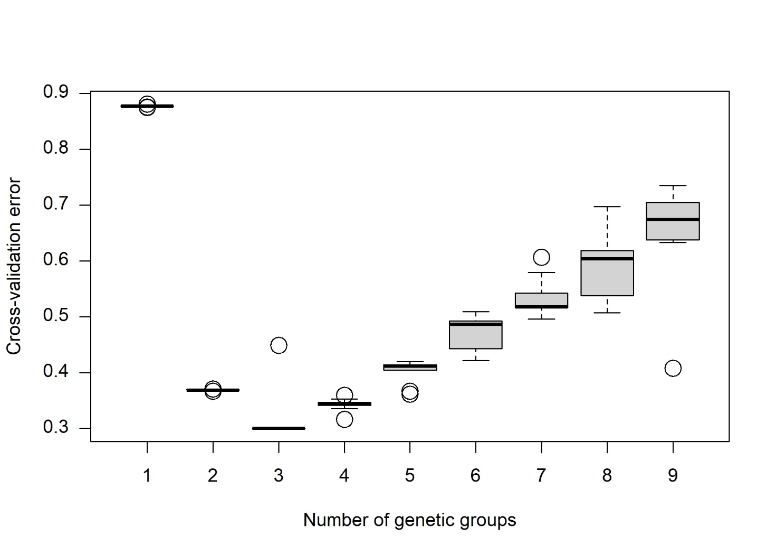
Figure S1. Determination of the optimal number of genetic clusters (K) using ADMIXTURE. ADMIXTURE ten-fold cross-validation error rates for K=1 to K=9 and 10 independent runs.

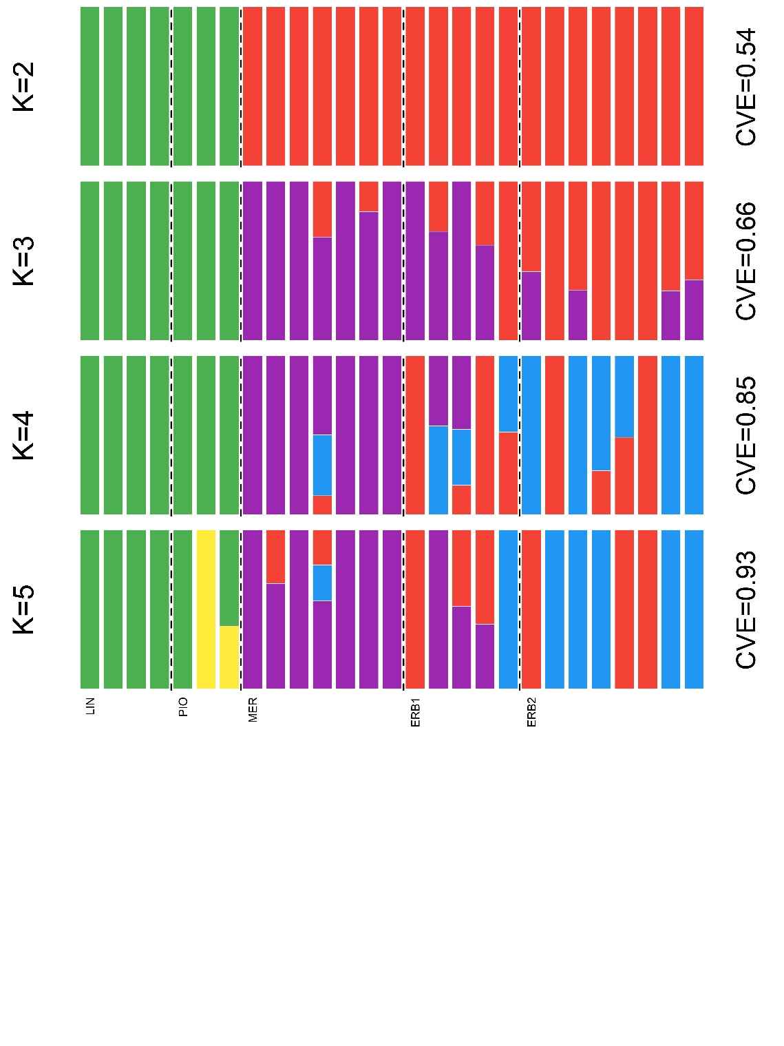
Figure S2. Population structure within the Monolistra pavani populations in the Larian Triangle. ADMIXTURE coefficients for K genetic clusters, with their respective cross-validation error (CVE).
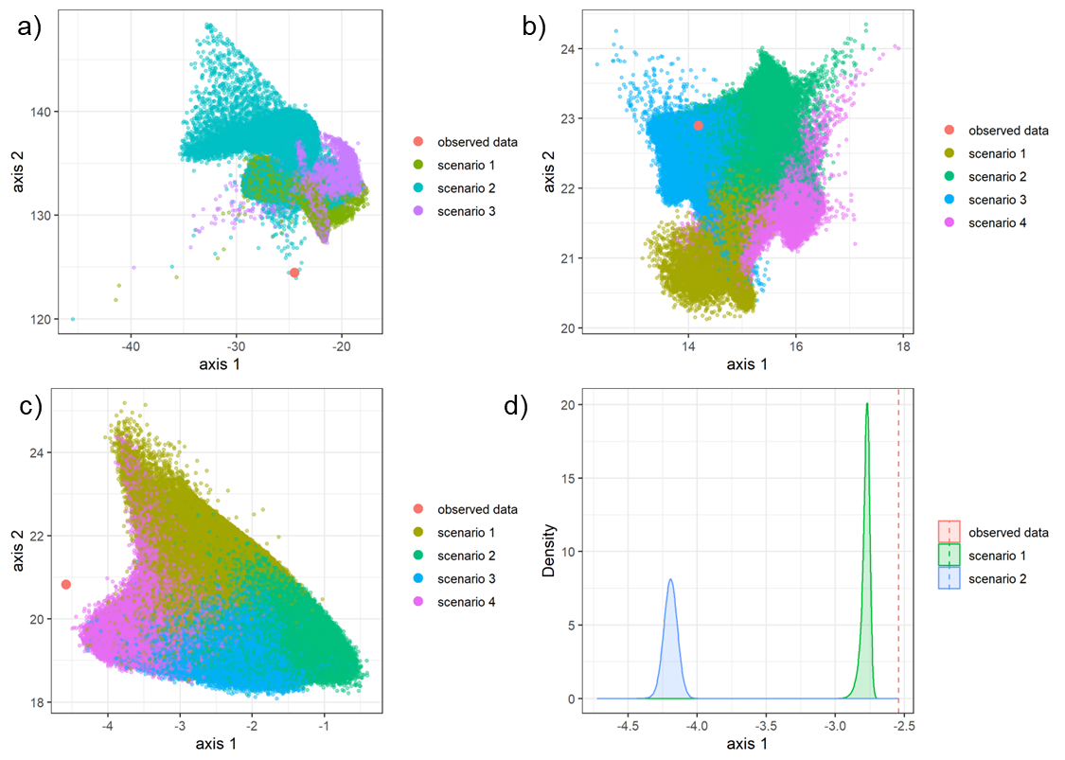
Figure S3. Evaluation of demographic scenarios. Projection of the training and observed datasets on the first two linear discriminant analysis (LDA) axes for (a) Step 1, (b) Step 2.1 and (c) 2.2, and (d) on the single LDA axis for Step 3. The location of the observed dataset in the LDA projection is indicated by a red dot (Steps 1, 2.1 and 2.2, a-c) or a red line (Step 3).

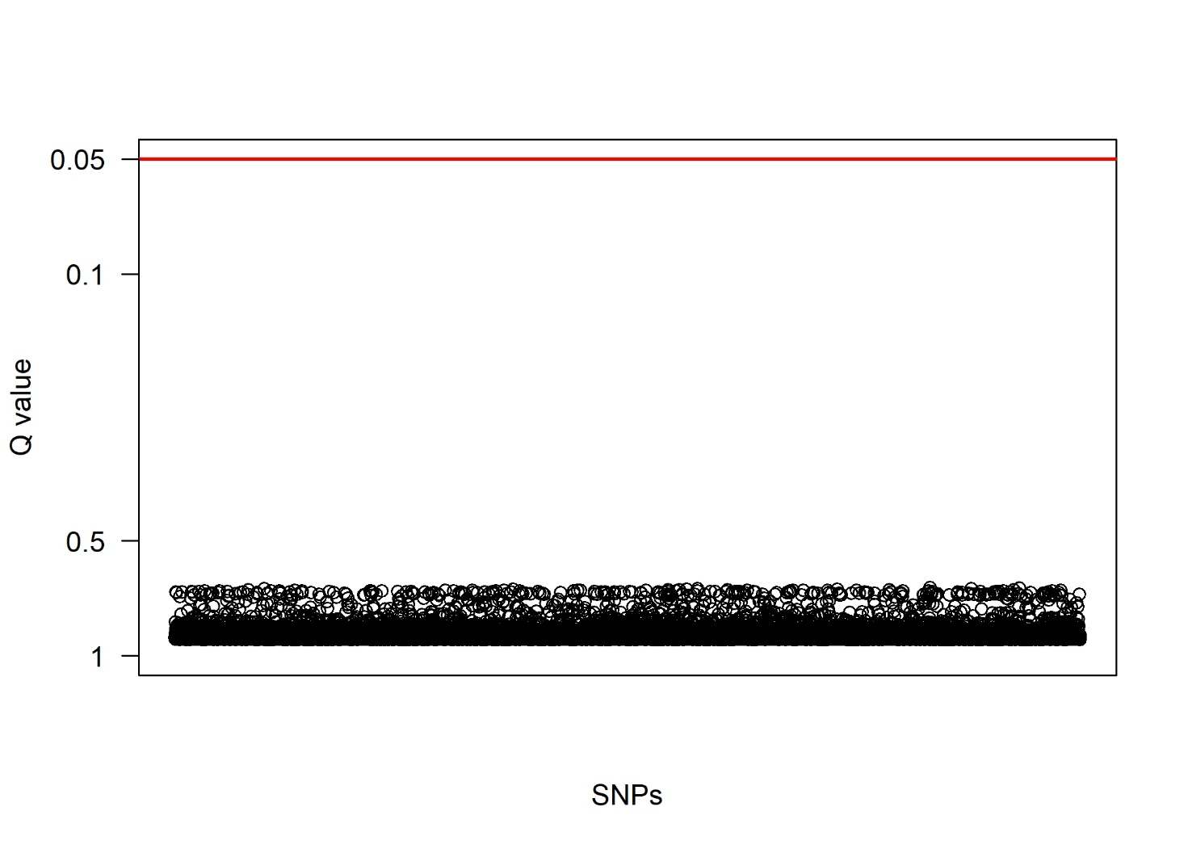
Figure S4. Genetic differentiation associated with cave/spring habitats. Manhattan plot of −log₁₀(q-values) indicating that no loci exhibit differentiation greater than expected under neutrality. The red horizontal line represents a false discovery rate of Q-value = 0.05.

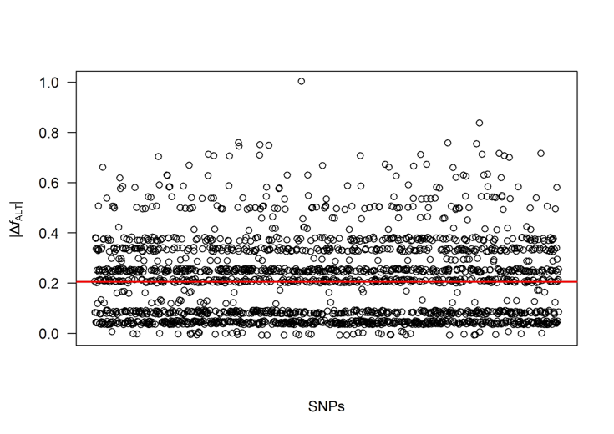
Figure S5. Results of genotype-pigmentation phenotype associations. Absolute difference in minor allele frequency (|Δ_{ALT}|) between pigmented and non-pigmented individuals in the spring population MER1 of Monolistra pavani. The horizontal line represents the mean |Δ_{ALT}| across SNPs.

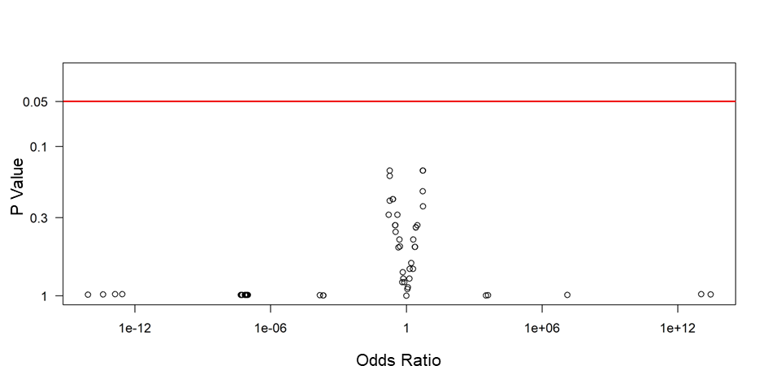
Figure S6. Results of logistic regression analysis of binary pigmentation phenotype. Volcano plot of −log₁₀(P values) as a function of log2(Odds Ratio). The horizontal line represents a threshold of P value = 0.05.
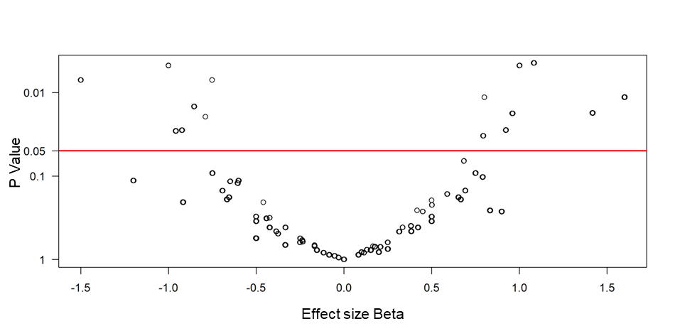
Figure S7. Results of linear regression analysis of ordinal pigmentation phenotype. Volcano plot of −log₁₀(P values) as a function of the effect size (beta). The horizontal line represents a threshold of P value = 0.05.

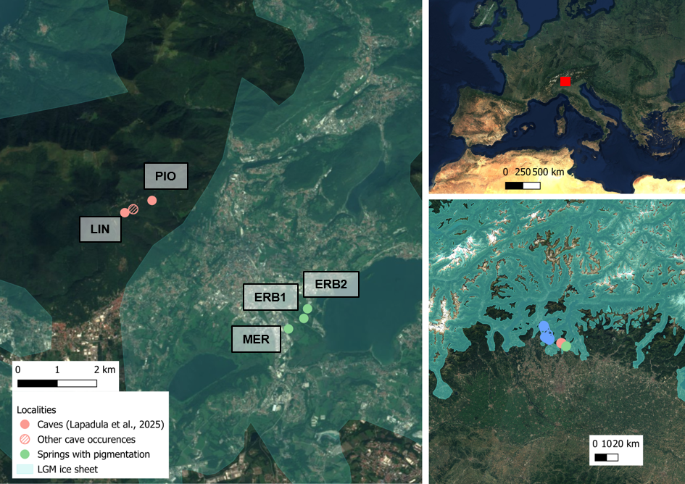
Figure S8. Ice sheet extent during the Last Glacial Maximum, and proximity of cave and spring populations to the ice margins (Ehlers et al., 2011). Geographic information was viewed and analyzed in QGIS 3.40.12 (Copernicus Sentinel-2 cloudless by EOX; QGIS Development Team, 2013).

Supplementary Tables

Supplementary Table S1. Field surveys performed across springs between 2019 and 2025. For each of the five springs: number of 5-minute visual surveys; total number of Monolistra individuals across surveys per month; number of pigmented individuals across surveys per month (in red).
Spring | Year | Month
Spring | Year | January | February | April | May | June | July | August | October | November | December
Erba 1 | 2019 | - | 10; 2; 0 | - | - | - | - | - | - | - | -
 | 2020 | - | - | - | - | - | - | - | - | - | 7; 0; 0
 | 2021 | - | - | - | - | - | 7; 15; 4 | 7; 0; 0 | 6; 4; 0 | - | -
 | 2022 | - | - | - | 5; 12; 2 | 5; 6; 5 | - | - | - | - | -
 | 2024 | - | - | 8; 7; 0 | - | - | - | - | - | 16; 0; 0 | 10; 1; 0
 | 2025 | 10; 9; 3 | 10; 6; 1 | - | - | - | - | - | - | - | -
Erba 2 | 2019 | - | 5; 0; 0 | - | - | - | 2; 3; 0 | - | - | - | -
 | 2020 | - | - | - | - | - | - | - | - | - | 2; 0; 0
 | 2021 | - | - | - | - | - | - | 2; 0; 0 | - | - | -
 | 2022 | - | - | - | 2; 0; 0 | 1; 17; 4 | - | - | - | - | -
 | 2024 | - | - | 4; 0; 0 | - | - | - | - | - | 6; 6; 2 | 4; 11; 2
 | 2025 | 3; 2; 0 | 4; 4; 0 | - | - | - | - | - | - | - | -
Merone 1 | 2019 | - | 26; 225; 44 | - | - | - | - | - | - | - | -
 | 2020 | 7; 43; 10 | - | - | - | - | - | - | 12; 18; 0 | 6; 30; 0 | -
 | 2021 | - | - | - | - | - | 8; 32; 4 | - | 8; 10; 0 | - | -
 | 2022 | - | - | - | 6; 54; 0 | 5; 41; 0 | - | - | - | - | -
 | 2024 | - | - | 8; 3; 0 | - | - | - | - | - | 16; 147; 15 | 10; 74; 16
 | 2025 | 10; 81; 14 | 10; 77; 17 | - | - | - | - | - | - | - | 8; 60; 1
Merone 2 | 2019 | - | 3; 0; 0 | - | - | - | - | - | - | - | -
Gringhelon | 2024 | - | - | 12; 0; 0 | - | - | - | - | - | 6; 0; 0 | -

Table S2. ddRADseq statistics. Species and geographic and habitat subdivision of Monolistra populations. Total reads: number of demultiplixed reads; Merged stacks: number of individuals de novo stacks; Catalog loci: number of paired-end loci matching a catalog locus; Datasets: mean percentage of missing data (Missing) and mean depth of coverage among loci (Cov) per individual for Dataset 1 (all species considered in the phylogeny), Dataset 2 (M. pavani, including the west group), Dataset 3 (only the east group) and Dataset 4 (only the spring populations). Accession numbers: * denotes samples whose sequences were retrieved from published datasets (Lapadula et al., 2025; ENA project PRJEB97081). Data for all other samples were generated in this study (ENA project PRJEB122998).
Species | Group | Pop code | Locality | Sample ID | Total reads | Loci reconstruction 1 |  |  |  | Loci reconstruction 2 |  |  |  | Dataset 1 |  | Dataset 2 |  | Dataset 3 |  | Dataset 4 |  | Accession number
 |  |  |  |  |  | Merged stacks |  | Catalog loci |  | Merged stacks |  | Catalog loci
 |  |  |  |  |  | Number | Cov | Number | Cov | Number | Cov | Number | Cov | Missing | Cov | Missing | Cov | Missing | Cov | Missing | Cov | Accession number
M. pavani | East spring | MER | Merone | MER_19-02 | 4334154 | 65699 | 28.82 | 57507 | 27.97 | 69957 | 27.89 | 64236 | 27.65 | 0.66 | 56.52 | 1.86 | 54.41 | 2.14 | 53.55 | 0.00 | 57.66 | ERS30955250
M. pavani | East spring | MER | Merone | MER_19-03 | 7681146 | 117887 | 20.26 | 109478 | 20.70 | 121735 | 19.39 | 115394 | 19.63 | 37.20 | 9.81 | 41.94 | 8.46 | 43.13 | 8.64 | 0.00 | 9.92 | ERS30955251
M. pavani | East spring | MER | Merone | MER_19-07 | 3352979 | 42812 | 34.20 | 35954 | 33.39 | 46285 | 32.98 | 41227 | 33.19 | 0.83 | 52.58 | 1.82 | 50.85 | 2.04 | 49.17 | 0.00 | 52.02 | ERS30955252
M. pavani | East spring | MER | Merone | MER_19-08 | 5259611 | 57387 | 41.15 | 48304 | 40.84 | 61820 | 39.48 | 54732 | 40.11 | 1.75 | 84.42 | 6.66 | 80.92 | 6.93 | 78.34 | 0.00 | 82.08 | ERS30955253
M. pavani | East spring | MER | Merone | MER_19-09 | 5751298 | 44356 | 57.82 | 36647 | 57.84 | 47595 | 55.80 | 41825 | 56.88 | 1.66 | 96.34 | 2.27 | 92.25 | 2.50 | 89.48 | 0.00 | 92.06 | ERS30955254
M. pavani | East spring | MER | Merone | MER_22-01 | 7211006 | 50455 | 62.10 | 41575 | 62.48 | 54013 | 60.13 | 47274 | 61.29 | 2.33 | 117.50 | 3.87 | 112.36 | 3.92 | 110.04 | 0.00 | 116.95 | ERS30955255
M. pavani | East spring | MER | Merone | MER_22-02 | 521645 | 23066 | 9.95 | 19224 | 9.27 | 25154 | 9.29 | 22335 | 8.91 | 28.86 | 10.84 | 37.13 | 9.40 | 38.64 | 9.43 | 0.00 | 10.48 | ERS30955256
M. pavani | East spring | ERB1 | Erba 1 | ERB1_21-01 | 1024301 | 31740 | 14.12 | 26442 | 13.77 | 34524 | 13.36 | 30847 | 13.40 | 6.54 | 16.69 | 12.65 | 14.50 | 13.88 | 14.40 | NA | NA | ERS30955257
M. pavani | East spring | ERB1 | Erba 1 | ERB1_21-02 | 7171636 | 47639 | 64.31 | 38159 | 65.26 | 51371 | 61.92 | 44518 | 63.54 | 2.83 | 117.25 | 3.78 | 111.09 | 3.83 | 109.11 | NA | NA | ERS30955258
M. pavani | East spring | ERB1 | Erba 1 | ERB1_22-01 | 6524568 | 59970 | 46.81 | 50120 | 46.25 | 64411 | 45.46 | 57312 | 46.02 | 1.61 | 103.70 | 2.58 | 97.11 | 2.77 | 95.03 | NA | NA | ERS30955259
M. pavani | East spring | ERB1 | Erba 1 | ERB1_22-02 | 4348444 | 48943 | 38.14 | 40621 | 37.67 | 52772 | 36.48 | 46954 | 37.14 | 0.99 | 70.02 | 1.94 | 63.33 | 2.17 | 61.91 | NA | NA | ERS30955260
M. pavani | East spring | ERB1 | Erba 1 | ERB1_22-03 | 3032880 | 55388 | 26.55 | 48062 | 26.04 | 59043 | 25.63 | 54017 | 25.71 | 0.73 | 46.04 | 2.15 | 40.79 | 2.52 | 39.85 | NA | NA | ERS30955261
M. pavani | East spring | ERB2 | Erba 2 | ERB2_19-01 | 3620033 | 37332 | 41.89 | 30348 | 40.69 | 40368 | 39.00 | 35519 | 38.88 | 2.11 | 57.03 | 3.58 | 54.00 | 4.08 | 53.05 | NA | NA | ERS30955262
M. pavani | East spring | ERB2 | Erba 2 | ERB2_19-02 | 4669693 | 44136 | 45.10 | 35597 | 45.27 | 47914 | 42.96 | 42018 | 44.10 | 0.93 | 74.60 | 1.96 | 70.35 | 1.98 | 69.42 | NA | NA | ERS30955263
M. pavani | East spring | ERB2 | Erba 2 | ERB2_22-02 | 2591706 | 43609 | 26.97 | 36650 | 26.33 | 47155 | 25.84 | 42452 | 26.01 | 0.86 | 42.61 | 2.16 | 37.86 | 2.51 | 37.16 | NA | NA | ERS30955264
M. pavani | East spring | ERB2 | Erba 2 | ERB2_22-04 | 3794740 | 57494 | 31.00 | 49557 | 30.26 | 61239 | 29.96 | 55945 | 30.26 | 0.68 | 59.48 | 1.70 | 52.89 | 2.12 | 51.67 | NA | NA | ERS30955265
M. pavani | East spring | ERB2 | Erba 2 | ERB2_22-05 | 2221011 | 51211 | 20.86 | 44450 | 20.45 | 54524 | 20.06 | 50044 | 20.31 | 1.86 | 33.70 | 4.66 | 28.93 | 5.88 | 28.39 | NA | NA | ERS30955266
M. pavani | East spring | ERB2 | Erba 2 | ERB2_22-06 | 5870098 | 49937 | 49.85 | 41107 | 49.83 | 53691 | 48.23 | 47727 | 49.66 | 1.74 | 96.31 | 2.42 | 88.80 | 2.45 | 86.83 | NA | NA | ERS30955267
M. pavani | East spring | ERB2 | Erba 2 | ERB2_22-08 | 4366276 | 60112 | 32.62 | 51651 | 31.74 | 64182 | 31.59 | 58749 | 32.16 | 0.90 | 67.16 | 1.48 | 60.65 | 1.57 | 59.53 | NA | NA | ERS30955268
M. pavani | East spring | ERB2 | Erba 2 | ERB2_22-10 | 1952571 | 46518 | 19.58 | 39954 | 19.03 | 49972 | 18.80 | 45892 | 19.23 | 1.61 | 31.01 | 3.91 | 26.84 | 4.89 | 26.46 | NA | NA | ERS30955269
M. pavani | East cave | PIO | Buco del Piombo | PIO_19-04 | 1078813 | 30489 | 15.86 | 25634 | 15.48 | 33092 | 15.08 | 29443 | 14.93 | 3.98 | 18.19 | 7.17 | 16.96 | 7.98 | 16.79 | NA | NA | ERS26771800 *
M. pavani | East cave | PIO | Buco del Piombo | PIO_19-05 | 4258979 | 47194 | 40.07 | 39615 | 39.80 | 50853 | 38.43 | 44898 | 38.75 | 1.34 | 68.30 | 1.56 | 64.56 | 1.74 | 63.48 | NA | NA | ERS26771801 *
M. pavani | East cave | PIO | Buco del Piombo | PIO_22-01 | 1439807 | 37108 | 17.22 | 31903 | 16.68 | 39713 | 16.57 | 35833 | 16.29 | 4.45 | 24.76 | 9.61 | 21.33 | 11.22 | 20.93 | NA | NA | ERS26771802 *
M. pavani | East cave | LIN | Lino | LIN_19-01 | 6002434 | 43028 | 60.06 | 35068 | 60.84 | 46212 | 58.02 | 40273 | 58.97 | 2.02 | 101.13 | 2.18 | 95.56 | 2.24 | 94.41 | NA | NA | ERS26771794 *
M. pavani | East cave | LIN | Lino | LIN_19-02 | 8703270 | 55249 | 68.73 | 45573 | 68.57 | 58486 | 67.38 | 51066 | 68.04 | 10.55 | 146.48 | 11.41 | 140.51 | 11.44 | 138.63 | NA | NA | ERS26771795 *
M. pavani | East cave | LIN | Lino | LIN_19-03 | 6677546 | 42059 | 70.50 | 33360 | 72.42 | 45412 | 67.69 | 38893 | 69.69 | 2.23 | 114.23 | 2.87 | 108.82 | 2.75 | 107.05 | NA | NA | ERS26771796 *
M. pavani | East cave | LIN | Lino | LIN_20-07 | 6687259 | 68224 | 44.98 | 59832 | 43.00 | 71814 | 44.22 | 65562 | 43.86 | 2.02 | 108.98 | 2.55 | 105.18 | 2.42 | 103.97 | NA | NA | ERS26771799 *
M. pavani | West cave | COS | El Cos | COS_22-02 | 267570 | 56968 | 19.66 | 50255 | 19.01 | 60313 | 19.09 | 54762 | 18.34 | 4.85 | 36.15 | 6.52 | 32.19 | NA | NA | NA | NA | ERS26771792 *
M. pavani | West cave | TAN | La Tana | TAN_22-01 | 2015949 | 36953 | 21.83 | 31868 | 22.23 | 40015 | 20.80 | 35145 | 20.25 | 4.81 | 29.62 | 6.87 | 26.15 | NA | NA | NA | NA | ERS26771807 *
M. pavani | West cave | FER | Ca Del Ferrè | FER_22-01 | 6978106 | 63522 | 46.82 | 54428 | 45.67 | 67515 | 45.93 | 60090 | 45.16 | 6.26 | 104.23 | 6.55 | 99.95 | NA | NA | NA | NA | ERS26771793 *
M. pavani | West cave | SCE | Cava Scerri | SCE_22-01 | 1683125 | 33939 | 19.82 | 29028 | 19.12 | 36696 | 18.85 | 32483 | 18.08 | 5.98 | 24.20 | 8.86 | 21.71 | NA | NA | NA | NA | ERS26771803 *
M. pavani | West cave | SCE | Cava Scerri | SCE_22-02 | 4879094 | 43850 | 44.08 | 36734 | 44.63 | 47444 | 42.21 | 41014 | 41.59 | 4.25 | 71.48 | 4.46 | 67.62 | NA | NA | NA | NA | ERS26771804 *
M. pavani | West cave | SCE | Cava Scerri | SCE_22-03 | 3584854 | 43021 | 32.39 | 36699 | 32.44 | 46384 | 31.02 | 40578 | 30.36 | 3.92 | 53.28 | 4.34 | 46.68 | NA | NA | NA | NA | ERS26771805 *
M. pavani | West cave | SCE | Cava Scerri | SCE_22-04 | 2363635 | 37123 | 24.82 | 31816 | 24.76 | 40116 | 23.64 | 35107 | 23.13 | 4.60 | 35.96 | 6.85 | 31.00 | NA | NA | NA | NA | ERS26771806 *
M. bergomas | North | CAR | Carigun | CAR_20-03 | 1313455 | 28544 | 23.10 | 22203 | 21.72 | NA | NA | NA | NA | 3.31 | 25.06 | NA | NA | NA | NA | NA | NA | ERS26771739 *
M. bergomas | North | CAR | Carigun | CAR_20-04 | 2240907 | 33860 | 32.37 | 26064 | 30.85 | NA | NA | NA | NA | 2.37 | 41.03 | NA | NA | NA | NA | NA | NA | ERS26771740 *
M. bergomas | North | CAR | Carigun | CAR_22-01 | 3172232 | 46305 | 34.22 | 37452 | 32.04 | NA | NA | NA | NA | 1.97 | 60.02 | NA | NA | NA | NA | NA | NA | ERS26771741 *
M. bergomas | North | CAR | Carigun | CAR_22-02 | 2103704 | 44521 | 23.75 | 36155 | 21.85 | NA | NA | NA | NA | 2.51 | 41.00 | NA | NA | NA | NA | NA | NA | ERS26771742 *
M. bergomas | North | CAR | Carigun | CAR_22-03 | 335711 | 14759 | 11.11 | 11411 | 9.80 | NA | NA | NA | NA | 50.38 | 11.59 | NA | NA | NA | NA | NA | NA | ERS26771743 *
M. bergomas | North | CAR | Carigun | CAR_22-04 | 260341 | 14055 | 8.65 | 10836 | 7.98 | NA | NA | NA | NA | 58.83 | 10.13 | NA | NA | NA | NA | NA | NA | ERS26771744 *
M. bergomas | North | CAR | Carigun | CAR_22-05 | 4018222 | 52952 | 37.45 | 42850 | 34.69 | NA | NA | NA | NA | 2.22 | 74.34 | NA | NA | NA | NA | NA | NA | ERS26771745 *
M. bergomas | North | SCA | Grotta dello Scavo | SCA_22-01 | 1301967 | 36286 | 18.55 | 29875 | 16.22 | NA | NA | NA | NA | 5.70 | 24.32 | NA | NA | NA | NA | NA | NA | ERS26771754 *
M. bergomas | North | SCA | Grotta dello Scavo | SCA_22-02 | 1901752 | 42099 | 23.21 | 34412 | 21.35 | NA | NA | NA | NA | 2.82 | 35.42 | NA | NA | NA | NA | NA | NA | ERS26771755 *
M. bergomas | North | SCA | Grotta dello Scavo | SCA_22-04 | 495846 | 24389 | 10.13 | 19351 | 9.30 | NA | NA | NA | NA | 30.81 | 12.29 | NA | NA | NA | NA | NA | NA | ERS26771757 *
M. bergomas | North | SCA | Grotta dello Scavo | SCA_22-05 | 3868534 | 49155 | 38.43 | 38994 | 36.64 | NA | NA | NA | NA | 2.95 | 70.50 | NA | NA | NA | NA | NA | NA | ERS26771758 *
M. bergomas | North | GIB | Gibelì | GIB_19-01 | 2811632 | 40718 | 37.17 | 31101 | 35.46 | NA | NA | NA | NA | 9.61 | 55.67 | NA | NA | NA | NA | NA | NA | ERS26771750 *
M. bergomas | North | GIB | Gibelì | GIB_19-02 | 2748633 | 40670 | 36.50 | 31388 | 35.09 | NA | NA | NA | NA | 9.53 | 52.82 | NA | NA | NA | NA | NA | NA | ERS26771751 *
M. bergomas | South | OPR | Opreno | OPR_19-01 | 4189919 | 46205 | 52.42 | 35279 | 52.14 | NA | NA | NA | NA | 9.58 | 87.46 | NA | NA | NA | NA | NA | NA | ERS26771752 *
M. bergomas | South | OPR | Opreno | OPR_19-03 | 2765903 | 39963 | 40.83 | 30961 | 40.24 | NA | NA | NA | NA | 8.90 | 58.75 | NA | NA | NA | NA | NA | NA | ERS26771753 *
M. bergomas | South | USC | Uscera | USC_22-01 | 4278120 | 46607 | 53.70 | 35823 | 53.16 | NA | NA | NA | NA | 12.71 | 90.59 | NA | NA | NA | NA | NA | NA | ERS26771760 *
M. bergomas | South | USC | Uscera | USC_22-02 | 305859 | 19653 | 9.08 | 15346 | 8.53 | NA | NA | NA | NA | 46.47 | 10.43 | NA | NA | NA | NA | NA | NA | ERS26771761 *
M. bergomas | South | USC | Uscera | USC_22-03 | 2237325 | 45617 | 29.02 | 36220 | 28.14 | NA | NA | NA | NA | 11.80 | 50.81 | NA | NA | NA | NA | NA | NA | ERS26771762 *
M. bergomas | South | USC | Uscera | USC_22-04 | 705129 | 28471 | 14.90 | 22219 | 14.45 | NA | NA | NA | NA | 19.78 | 18.81 | NA | NA | NA | NA | NA | NA | ERS26771763 *
M. bergomas | South | VAL | Valdadda | VAL_20-01 | 1174956 | 33937 | 20.66 | 26416 | 20.23 | NA | NA | NA | NA | 13.82 | 29.64 | NA | NA | NA | NA | NA | NA | ERS26771766 *
M. bergomas | South | VAL | Valdadda | VAL_20-03 | 5134492 | 69746 | 41.97 | 58758 | 39.27 | NA | NA | NA | NA | 10.28 | 105.82 | NA | NA | NA | NA | NA | NA | ERS26771767 *
M. boldorii | West | FAU | San Faustino | FAU_22-01 | 1463682 | 35547 | 19.57 | 28312 | 18.57 | NA | NA | NA | NA | 16.26 | 26.35 | NA | NA | NA | NA | NA | NA | ERS26771747 *
M. boldorii | West | FAU | San Faustino | FAU_22-02 | 4299363 | 46958 | 40.79 | 36998 | 39.44 | NA | NA | NA | NA | 14.53 | 71.51 | NA | NA | NA | NA | NA | NA | ERS26771748 *
M. boldorii | East | PUR | Bus Pursì | PUR_22-01 | 3778982 | 80198 | 24.70 | 70084 | 22.88 | NA | NA | NA | NA | 12.64 | 59.83 | NA | NA | NA | NA | NA | NA | ERS26771773 *
M. boldorii | East | PUR | Bus Pursì | PUR_22-02 | 12464 | 861 | 5.83 | 647 | 4.71 | NA | NA | NA | NA | 99.73 | 6.45 | NA | NA | NA | NA | NA | NA | ERS26771774 *
M. boldorii | East | PUR | Bus Pursì | PUR_22-03 | 3872442 | 45812 | 40.11 | 36351 | 38.63 | NA | NA | NA | NA | 13.12 | 68.27 | NA | NA | NA | NA | NA | NA | ERS26771775 *
M. boldorii | East | PUR | Bus Pursì | PUR_22-04 | 8522193 | 95168 | 44.74 | 81130 | 42.31 | NA | NA | NA | NA | 20.14 | 137.84 | NA | NA | NA | NA | NA | NA | ERS26771776 *
M. boldorii | East | PUR | Bus Pursì | PUR_22-05 | 2992788 | 54627 | 27.62 | 45786 | 26.21 | NA | NA | NA | NA | 13.24 | 50.52 | NA | NA | NA | NA | NA | NA | ERS26771777 *
M. boldorii | East | QUA | Bus del Quai | QUA_19-01 | 1125167 | 36337 | 14.80 | 29383 | 14.36 | NA | NA | NA | NA | 14.68 | 18.32 | NA | NA | NA | NA | NA | NA | ERS26771778 *
M. boldorii | East | QUA | Bus del Quai | QUA_19-03 | 3201748 | 41217 | 35.09 | 32470 | 34.47 | NA | NA | NA | NA | 12.03 | 52.68 | NA | NA | NA | NA | NA | NA | ERS26771779 *
M. boldorii | East | QUA | Bus del Quai | QUA_19-04 | 1732060 | 36914 | 21.33 | 29500 | 21.05 | NA | NA | NA | NA | 12.38 | 28.83 | NA | NA | NA | NA | NA | NA | ERS26771780 *
M. berica | NA | VEJ | La Veja | VEJ_22-01 | 4960959 | 63696 | 23.91 | 51258 | 20.21 | NA | NA | NA | NA | 24.07 | 35.96 | NA | NA | NA | NA | NA | NA | ERS26771768 *
M. berica | NA | VEJ | La Veja | VEJ_22-03 | 2120694 | 56458 | 13.73 | 45785 | 12.20 | NA | NA | NA | NA | 27.02 | 18.29 | NA | NA | NA | NA | NA | NA | ERS26771770 *
M. berica | NA | VEJ | La Veja | VEJ_22-04 | 1522132 | 40784 | 14.28 | 31004 | 13.16 | NA | NA | NA | NA | 29.06 | 16.56 | NA | NA | NA | NA | NA | NA | ERS26771771 *
M. berica | NA | VEJ | La Veja | VEJ_22-05 | 4301202 | 48100 | 27.11 | 36110 | 25.29 | NA | NA | NA | NA | 24.14 | 33.03 | NA | NA | NA | NA | NA | NA | ERS26771772 *

Table S3. DIYABC-RF parameter priors for the four demographic reconstructions. Mean and standard deviation (SD) specified only for the priors with normal distribution.
Step | Parameter | Description | Distribution | Min | Max | Mean | SD
1 | N1 | Cave sample size | Uniform | 1000 | 1000000 | NA | NA
1 | N2 | Spring sample size | Uniform | 1000 | 1000000 | NA | NA
1 | N2b | Spring founder effect | Uniform | 100 | 100000 | NA | NA
1 | N1b | Cave founder effect | Uniform | 100 | 100000 | NA | NA
1 | t1 | Split time | Uniform | 2000 | 50000 | NA | NA
1 | db | Founder effect duration | Uniform | 100 | 1000 | NA | NA
2.1 | Nanc | Ancestral population sample size | Uniform | 10000 | 1000000 | NA | NA
2.1 | N1a | Cave bottleneck | Uniform | 1000 | 50000 | NA | NA
2.1 | N1b | Cave expansion | Uniform | 100000 | 500000 | NA | NA
2.1 | N2a | Spring bottleneck | Uniform | 1000 | 50000 | NA | NA
2.1 | N2b | Spring expansion | Uniform | 100000 | 500000 | NA | NA
2.1 | t | Split time | Uniform | 2000 | 50000 | NA | NA
2.2 | N1 | Cave sample size | Uniform | 1000 | 100000 | NA | NA
2.2 | N2a | Spring bottleneck | Uniform | 1000 | 50000 | NA | NA
2.2 | N2b | Spring expansion | Uniform | 100000 | 500000 | NA | NA
2.2 | Nf1 | Spring strong founder effect | Uniform | 10 | 1000 | NA | NA
2.2 | Nf2 | Spring mild founder effect | Uniform | 1000 | 10000 | NA | NA
2.2 | db | Founder effect duration | Uniform | 10 | 1000 | NA | NA
2.2 | t | Split time | Uniform | 2000 | 50000 | NA | NA
3 | Nanc | Ancestral population sample size | Normal | 100000 | 550000 | 215000 | 70000
3 | N1a | Cave sample size for scenario 1 | Normal | 10000 | 20000 | 15000 | 2000
3 | N2a | Spring sample size for scenario 1 | Normal | 10000 | 175000 | 135000 | 20000
3 | t1a | Split time for scenario 1 | Normal | 35000 | 50000 | 45000 | 5000
3 | N1b | Cave sample size for scenario 2 | Normal | 10000 | 40000 | 10000 | 10000
3 | N2b | Spring sample size for scenario 2 | Normal | 100000 | 500000 | 300000 | 100000
3 | Nf | Spring founder effect | Normal | 1000 | 10000 | 5000 | 2500
3 | t1b | Split time for scenario 2 | Normal | 5000 | 50000 | 25000 | 10000
3 | db | Founder effect duration | Normal | 50 | 1000 | 500 | 300

Table S4. Genetic differentiation among Monolistra pavani localities. Lower triangle: pairwise F_{ST} (Weir and Cockerham estimator). Upper triangle: 95% confidence interval obtained from 1,000 bootstrap replicates over loci.
 | LIN | PIO | MER | ERB1 | ERB2
LIN | - | 0.061 - 0.086 | 0.476 - 0.491 | 0.488 - 0.504 | 0.449 - 0.465
PIO | 0.074 | - | 0.396 - 0.412 | 0.399 - 0.416 | 0.376 - 0.392
MER | 0.484 | 0.404 | - | 0.008 - 0.015 | 0.020 - 0.026
ERB1 | 0.496 | 0.408 | 0.011 | - | 0.005 - 0.011
ERB2 | 0.457 | 0.384 | 0.023 | 0.008 | -

Table S5. DIYABC-RF model choice for the four demographic reconstructions. For each step, the most likely scenario was determined as the scenario showing the highest classification vote, and the lowest classification error.
Step | Classification vote |  |  |  | Classification error |  |  |  | Selected scenario | Posterior probability
Step | Scenario 1 | Scenario 2 | Scenario 3 | Scenario 4 | Scenario 1 | Scenario 2 | Scenario 3 | Scenario 4 | Selected scenario | Posterior probability
1 | 0.37 | 0.40 | 0.23 |  | 0.54 | 0.41 | 0.43 |  | 2 | 0.57
2.1 | 0.00 | 0.18 | 0.82 | 0 | 0.14 | 0.04 | 0.05 | 0.05 | 3 | 0.84
2.2 | 0.32 | 0.09 | 0.16 | 0.43 | 0.19 | 0.16 | 0.28 | 0.23 | 4 | 0.54
3 | 1.00 | 0.00 |  |  | 0.00 | 0.00 |  |  | 1 | 1.00

Table S6. DIYABC-RF parameter estimation for Steps 2 and 3 of the demographic reconstructions. Posterior mean, median, and distribution of parameters, and associated prior (global) and posterior (local) error rates with the mean or the median taken as point estimate.. 90% coverage represents the proportion of true simulated values located between the estimated 5% and 95% quantiles.
Step | Parameters | Posterior point estimates |  |  |  |  | Prior errors |  | Posterior errors |  | 90% coverage
Step | Parameters | Mean | Median | 5% quantile | 95% quantile | SD | Mean | Median | Mean | Median | 90% coverage
2.1 | N1a | 14242 | 14745 | 9717 | 17799 | 2111 | 0.26 | 0.24 | 0.13 | 0.14 | 0.91
2.1 | N2b | 136997 | 134444 | 104100 | 174285 | 21404 | 0.26 | 0.26 | 0.11 | 0.11 | 0.88
2.1 | Nanc | 230768 | 201669 | 97370 | 546573 | 70085 | 0.44 | 0.44 | 0.26 | 0.17 | 0.92
2.1 | t1 | 43375 | 43885 | 35548 | 49565 | 4765 | 0.25 | 0.27 | 0.10 | 0.08 | 0.89
2.2 | N1 | 9364 | 4381 | 1465 | 39195 | 7144 | 0.40 | 0.38 | 0.51 | 0.25 | 0.89
2.2 | N2b | 295980 | 302045 | 108409 | 488309 | 107437 | 0.34 | 0.34 | 0.41 | 0.40 | 0.91
2.2 | Nf2 | 5880 | 5935 | 1572 | 9774 | 2676 | 0.44 | 0.44 | 0.59 | 0.69 | 0.90
2.2 | t1 | 24439 | 22899 | 5164 | 47036 | 10017 | 0.34 | 0.35 | 0.57 | 0.50 | 0.90
2.2 | db | 519 | 527 | 53 | 972 | 297 | 0.93 | 0.84 | 1.80 | 0.43 | 0.90
3 | N1a | 13978 | 13978 | 11772 | 16243 | 1237 | 0.05 | 0.05 | 0.08 | 0.02 | 0.92
3 | N2a | 135785 | 135747 | 113275 | 159287 | 11323 | 0.05 | 0.05 | 0.07 | NA | 0.92
3 | Nanc | 270991 | 267650 | 187883 | 372561 | 32191 | 0.07 | 0.07 | 0.09 | 0.05 | 0.91
3 | t1a | 43497 | 43624 | 37204 | 49266 | 3736 | 0.05 | 0.05 | 0.07 | 0.08 | 0.91

Table S7. BLAST results for loci identified as associated with cave vs spring localities. Among the 251 sequences identified, 40 sequences produced significant BLAST hits, of which only three matched a predicted protein.
ddRAD locus | Species | Genomic distribution | Predicted protein | Align. length | Query length | Query Cover | E value | Per. Ident. | Accession
CLocus_10566 | Nautilus macromphalus | chromosome: X  POSITION: 26945850 - 26945717 |  | 136 | 281 | 47 | 1.12E-31 | 87.5 | OZ330418
CLocus_1067 | Cypraea tigris | chromosome: 6  POSITION: 49839955 - 49840001 |  | 47 | 280 | 17 | 0.000697 | 89.362 | OZ384944
CLocus_11061 | Ceratothoa steindachneri | chromosome: 22  POSITION: 30032073 - 30032012 |  | 62 | 280 | 25 | 1.49E-10 | 90.323 | OZ018338
CLocus_11155 | Glyphotaelius pellucidus | chromosome: 24  POSITION: 19385592 - 19385562 |  | 31 | 280 | 11 | 0.003 | 100 | OW386561
CLocus_11298 | Fragaria moschata | chromosome: 6  POSITION: 19461069 - 19461097 |  | 29 | 280 | 10 | 0.032 | 100 | OZ076524
CLocus_12028 | Parribacus antarcticus | chromosome: 12  POSITION: 32449010 - 32448968 |  | 43 | 280 | 15 | 0.009 | 90.698 | OZ415978
CLocus_125696 | Nomophila noctuella | chromosome: 3  POSITION: 8800449 - 8800422 |  | 28 | 280 | 10 | 0.12 | 100 | OY292484
CLocus_12917 | Eunicea knighti | chromosome: 17  POSITION: 13474570 - 13474532 |  | 40 | 358 | 11 | 0.012 | 92.5 | OZ247668
CLocus_132101 | Scyllarides latus | chromosome: 70  POSITION: 11687983 - 11688032 |  | 51 | 281 | 18 | 3.24E-07 | 92.157 | OZ282266
CLocus_132120 | Zoropsis spinimana | chromosome: 12  POSITION: 21241082 - 21241207 |  | 126 | 280 | 45 | 3.11E-32 | 88.889 | OZ285083
CLocus_132492 | Parribacus antarcticus | chromosome: 33  POSITION: 28408885 - 28408919 |  | 35 | 280 | 13 | 0.000697 | 97.143 | OZ415999
CLocus_132589 | Cladonia diversa | chromosome: 6  POSITION: 670836 - 670863 |  | 28 | 280 | 10 | 0.12 | 100 | OZ208678
CLocus_1335 | Tenrec ecaudatus | mRNA  POSITION: 705 - 766 | Eukaryotic translation initiation factor 1-like (LOC142459847) | 62 | 280 | 22 | 1.16E-06 | 87.097 | XM_075561806
CLocus_13592 | Scythris productella | chromosome: 27  POSITION: 25657506 - 25657543 |  | 38 | 280 | 14 | 0.000697 | 94.737 | OZ360517
CLocus_13780 | Thysanoteuthis rhombus | chromosome: 36  POSITION: 7956792 - 7956819 |  | 28 | 280 | 10 | 0.12 | 100 | OY735233
CLocus_14448 | Thysanoteuthis rhombus | chromosome: 8  POSITION: 72536877 - 72536936 |  | 61 | 280 | 22 | 8.96E-08 | 88.525 | OY735205
CLocus_14873 | Scyllarides latus | chromosome: 30  POSITION: 12812242 - 12812291 |  | 50 | 280 | 18 | 1.50E-05 | 90 | OZ282226
CLocus_15229 | Tethysbaena scabra | chromosome: 12  POSITION: 21921368 - 21921238 |  | 131 | 282 | 46 | 3.20E-17 | 80.916 | OZ195321
CLocus_16483 | Scyllarides latus | chromosome: 15  POSITION: 23401454 - 23401502 |  | 49 | 280 | 18 | 2.49E-08 | 93.878 | OZ282211
CLocus_16532 | Tethysbaena scabra | chromosome: 16  POSITION: 20081913 - 20082049 |  | 138 | 280 | 87 | 5.06E-50 | 94.928 | OZ195325
CLocus_17654 | Timema cristinae | chromosome: 3_Tce_b3v08  POSITION: 186089 - 186204 | Uncharacterized protein | 117 | 281 | 41 | 2.50E-08 | 78.632 | OC316695
CLocus_20525 | Hypomecis atomaria | chromosome: 6  POSITION: 21399445 - 21399477 |  | 33 | 280 | 11 | 0.032 | 96.97 | OZ023285
CLocus_20560 | Mythimna pallens | chromosome: 21  POSITION: 105660 - 105633 |  | 28 | 284 | 10 | 0.12 | 100 | OY540845
CLocus_24991 | Acanthocardia echinata | chromosome: 6  POSITION: 8652151 - 8652122 |  | 30 | 280 | 11 | 0.009 | 100 | OZ377316
CLocus_26895 | Myxine glutinosa | mRNA  POSITION: 158 - 289 | HemK methyltransferase 2, ETF1 glutamine and histone H4 lysine (HEMK2) | 132 | 280 | 47 | 8.53E-43 | 92.424 | XM_068120031
CLocus_2884 | Darwinula stevensoni | chromosome: DSTB1V02_LOCUS1658  POSITION: 31227 - 31358 (intergenic) |  | 132 | 280 | 94 | 6.64E-39 | 90.909 | LR899680
CLocus_30278 | Alnus incana | chromosome: 2  POSITION: 34767406 - 34767376 |  | 31 | 354 | 9 | 0.15 | 96.774 | OZ222490
CLocus_30340 | Ceratothoa steindachneri | chromosome: 22  POSITION: 60261923 - 60261975 |  | 53 | 281 | 19 | 3.24E-07 | 90.566 | OZ018338
CLocus_3230 | Pinctada margaritifera | chromosome: 9  POSITION: 67294864 - 67294898 |  | 36 | 280 | 13 | 0.032 | 94.444 | OZ369151
CLocus_33252 | Cypraea tigris | chromosome: 35  POSITION: 22947161 - 22947207 |  | 47 | 280 | 17 | 0.000697 | 89.362 | OZ384973
CLocus_34539 | Pocota personata | chromosome: X  POSITION: 15807998 - 15807970 |  | 29 | 283 | 10 | 0.033 | 100 | OY720433
CLocus_3804 | Celypha rufana | chromosome: Z  POSITION: 39780090 - 39780063 |  | 28 | 283 | 10 | 0.12 | 100 | OZ311082
CLocus_50996 | Leptopterna dolabrata | chromosome: 5  POSITION: 46947662 - 46947689 |  | 28 | 280 | 10 | 0.12 | 100 | OX940979
CLocus_59114 | Acanthurus coeruleus | chromosome: 19  POSITION: 17735949 - 17735976 |  | 28 | 347 | 8 | 0.15 | 100 | OZ368139
CLocus_61535 | Scyllarides latus | chromosome: 30  POSITION: 12812250 - 12812291 |  | 42 | 280 | 15 | 0.000194 | 92.857 | OZ282226
CLocus_7054 | Potamogeton nodosus | chromosome: 13  POSITION: 10079213 - 10079186 |  | 28 | 281 | 10 | 0.12 | 100 | OZ335112
CLocus_7428 | Microcaecilia unicolor | chromosome: 14  POSITION: 39160143 - 39160187 |  | 46 | 280 | 16 | 8.96E-08 | 95.652 | LR594645
CLocus_7464 | Aroga velocella | chromosome: 20  POSITION: 11117701 - 11117728 |  | 28 | 277 | 10 | 0.12 | 100 | OZ363648
CLocus_7746 | Donax variegatus | chromosome: 6  POSITION: 79708067 - 79708040 |  | 28 | 281 | 10 | 0.12 | 100 | OZ207838
CLocus_8245 | Scolopendra cretica | chromosome: 11  POSITION: 26816908 - 26816881 |  | 28 | 280 | 10 | 0.12 | 100 | OZ306298

