Supplementary information for
Application of pier waste sludge for catalytic activation of proxy-monosulfate and phenol elimination from a petrochemical wastewater
Feyzollah Khoshtinat ª, Tayebeh Tabatabaie ª, Bahman Ramavandi ^{b,c}, Seyedenayat Hashemi ^{b,c}
ª Department of Environment, Bushehr Branch, Islamic Azad University, Bushehr, Iran
^{b} Department of Environmental Health Engineering, Faculty of Health and Nutrition, Bushehr University of Medical Sciences, Bushehr, Iran
^{c} Systems Environmental Health and Energy Research Center, The Persian Gulf Biomedical Sciences Research Institute, Bushehr University of Medical Sciences, Bushehr, Iran
Corresponding authors: T. Tabatabaie (E-mail: tabatabaie@iaubushehr.ac.ir, B. Ramavandi (E-mail: b.ramavandi@bpums.ac.ir)
Conflict of interest: None
Content:
-Characteristics of petrochemical wastewater studied
-FE-SEM images
-FTIR spectra
-Thermograms

Table S1. Characteristics of studied petrochemical wastewater (n=12).
Parameter | pH | COD  (mg/L) | BOD₅  (mg/L) | TDS  (mg/L) | EC  (mmhos/cm) | Phenol  (mg/L)
Average value | 4.1 | 1395 | 715 | 1732 | 3226 | 51.34
Standard deviation | 1.03 | 207 | 93 | 94 | 168 | 12
Minimum | 3.23 | 987 | 412 | 1242 | 2279 | 32
Maximum | 7.79 | 1728 | 974 | 2350 | 4368 | 258

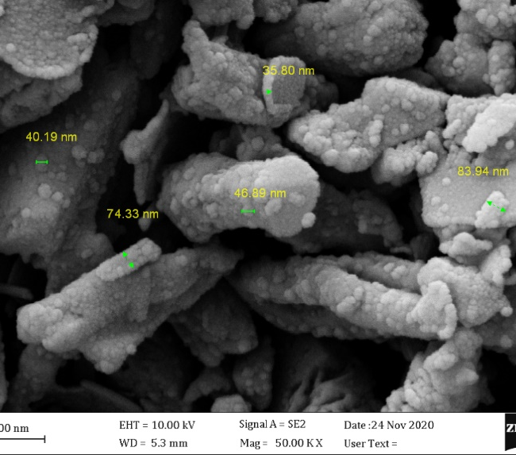
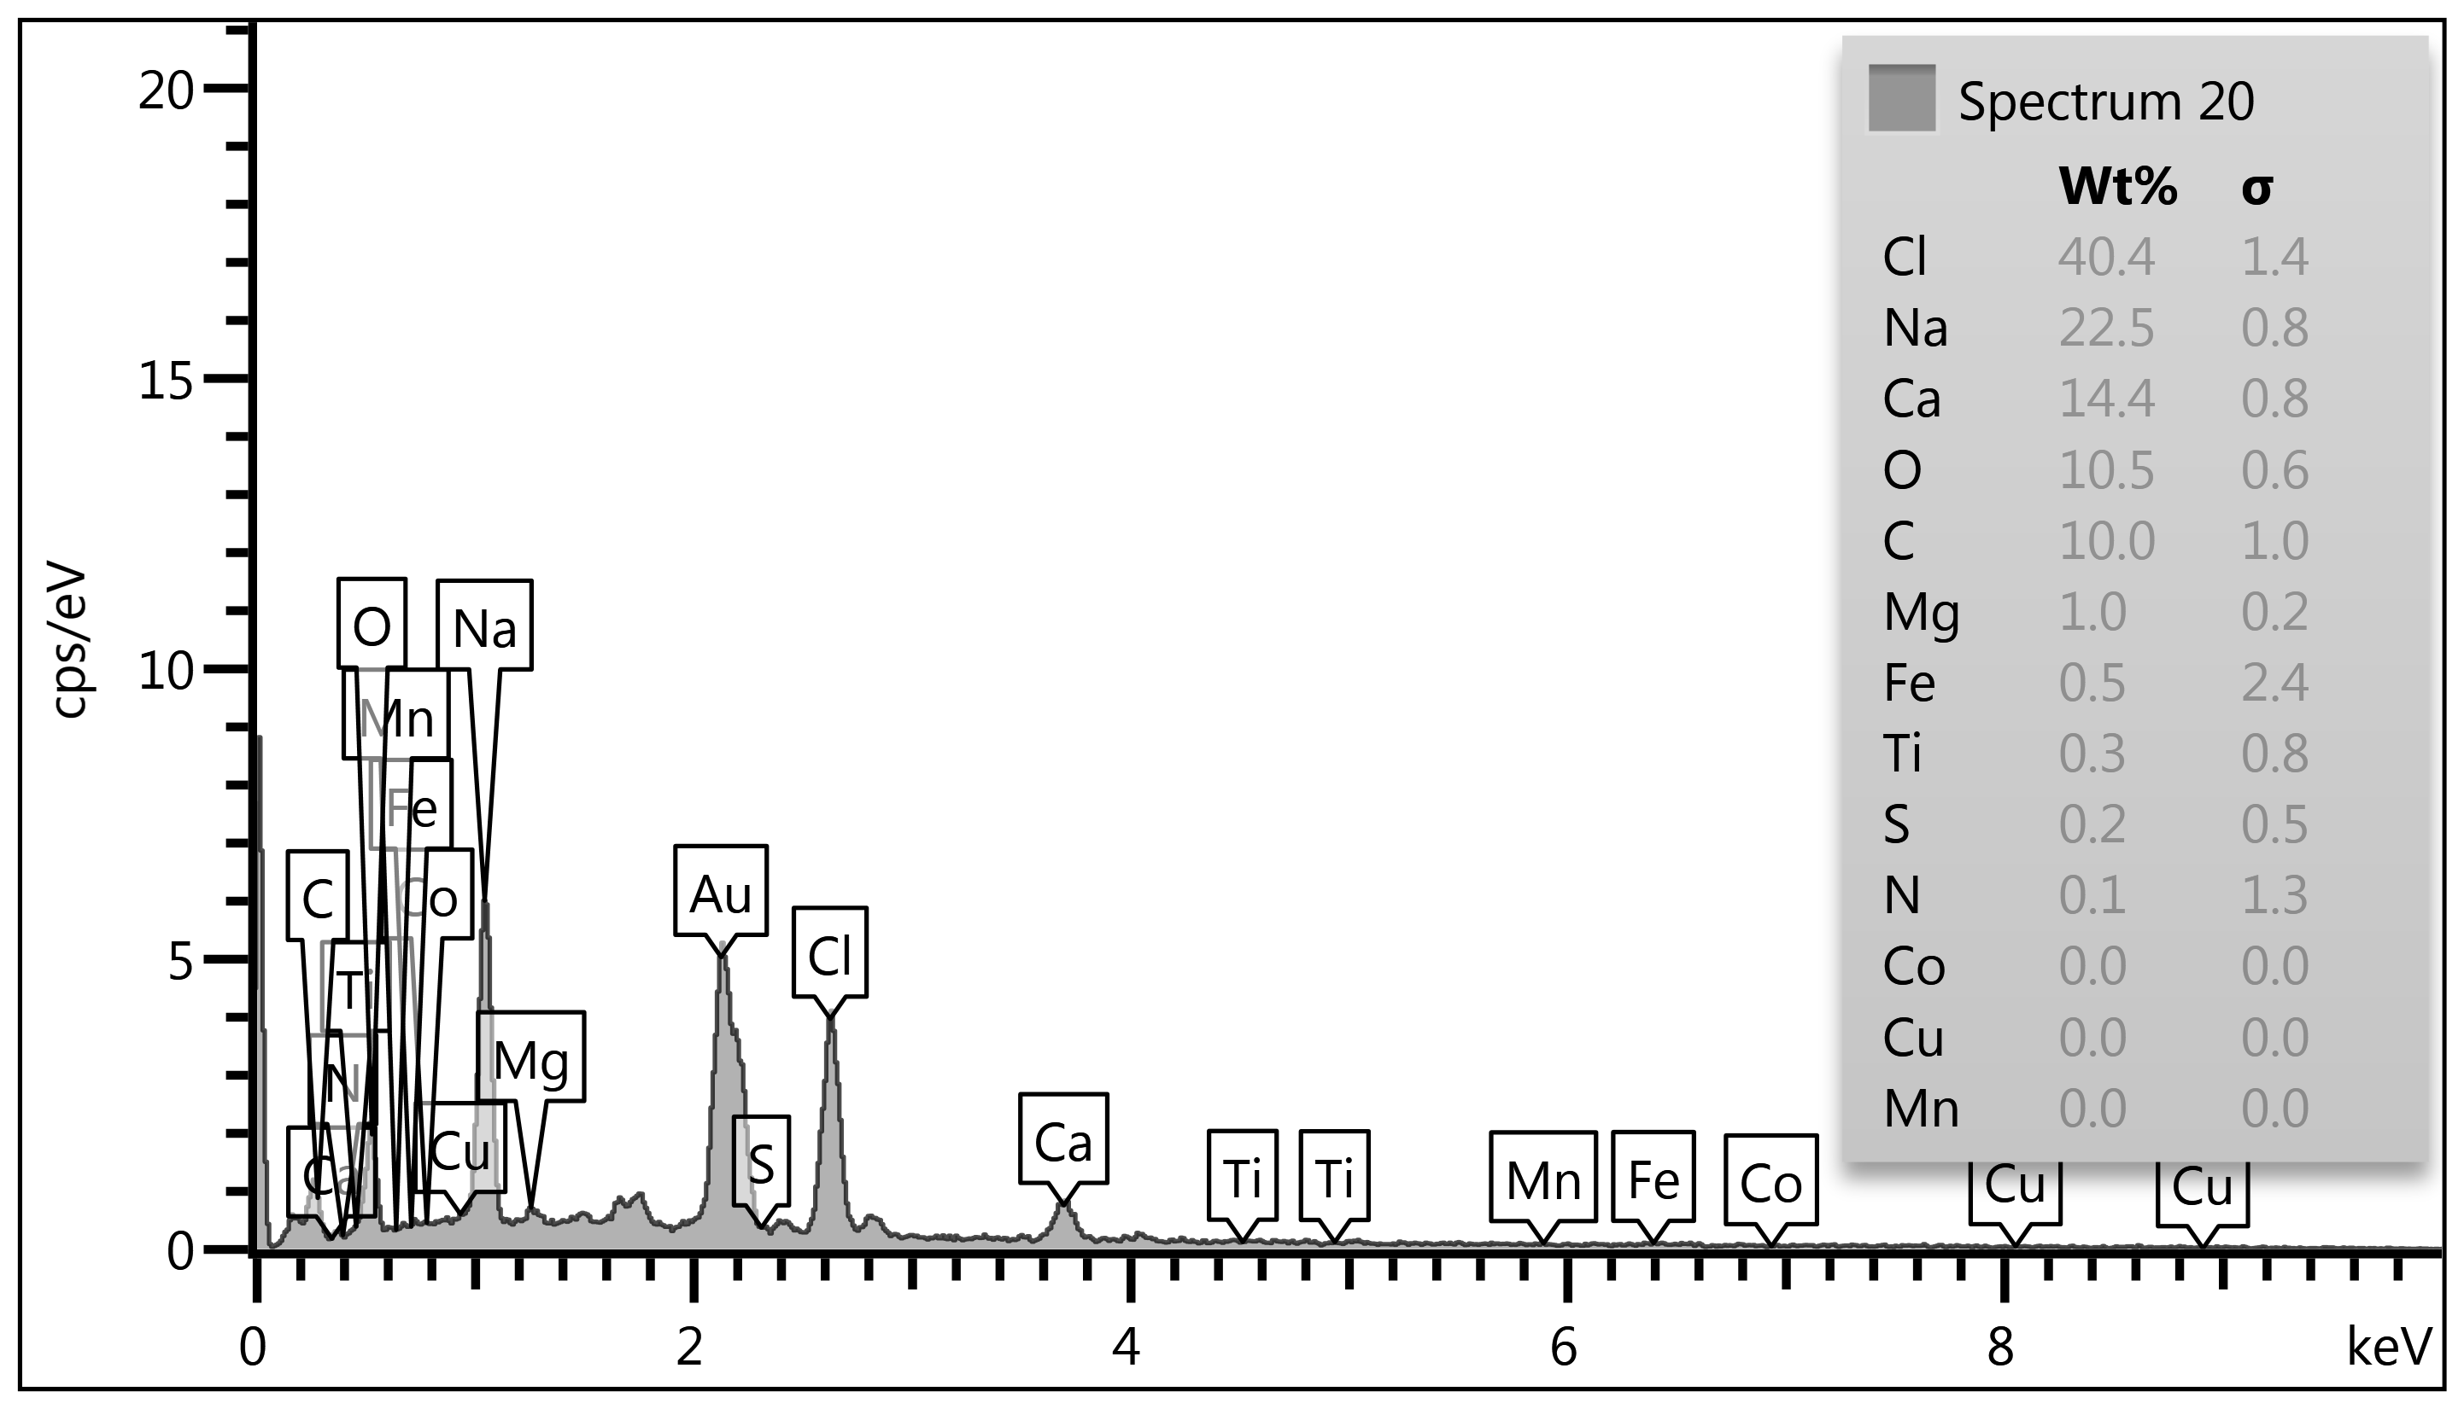
(b)
(a)
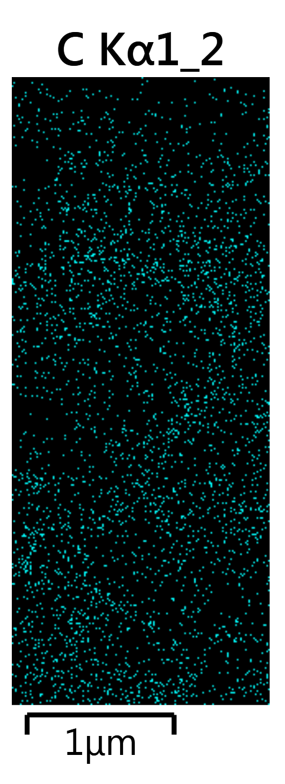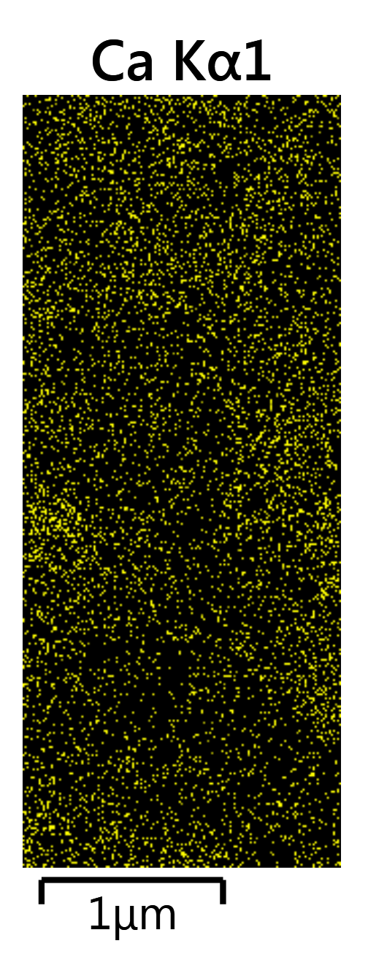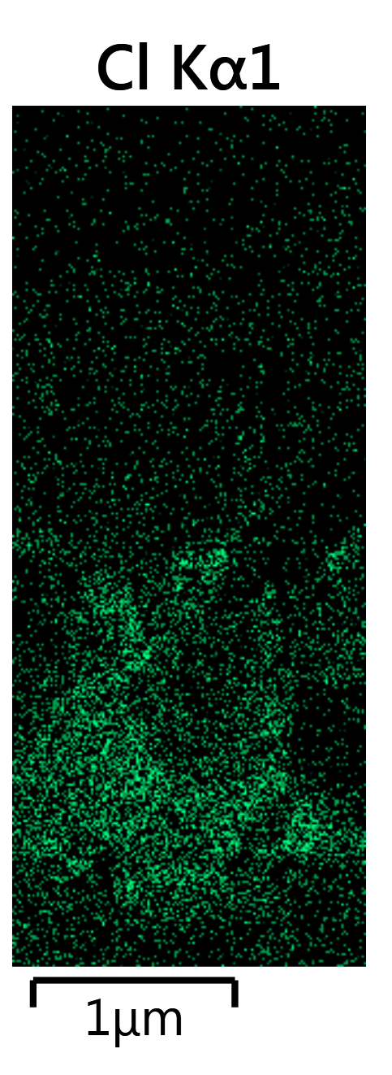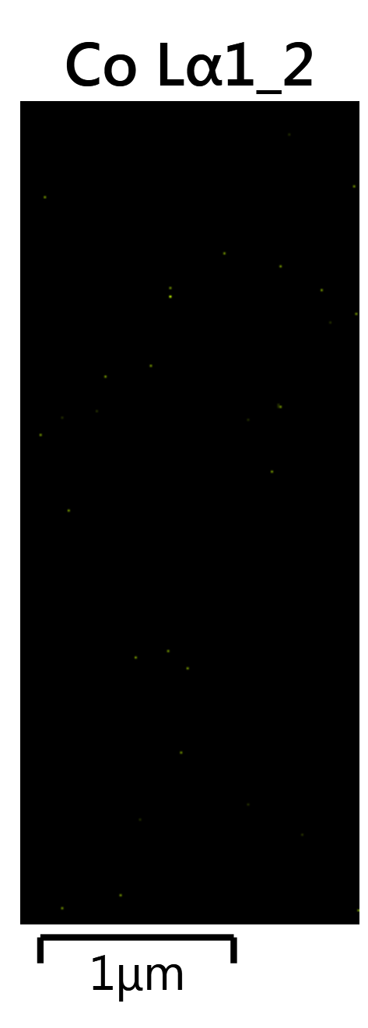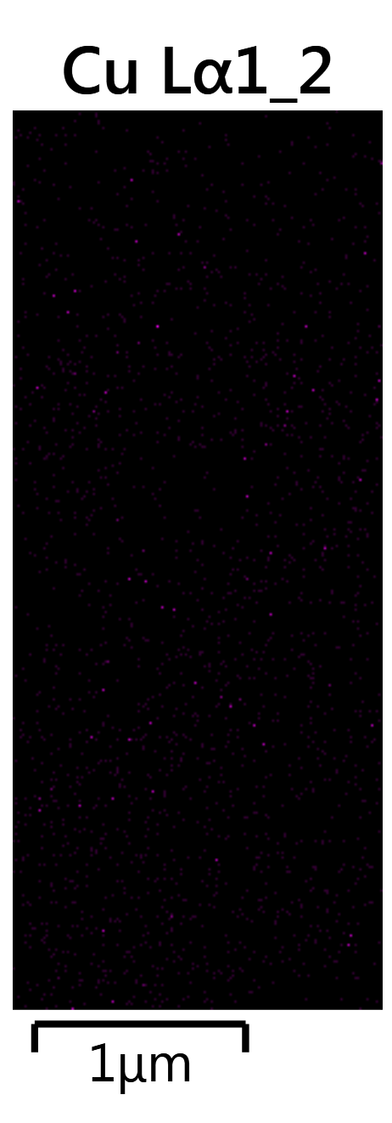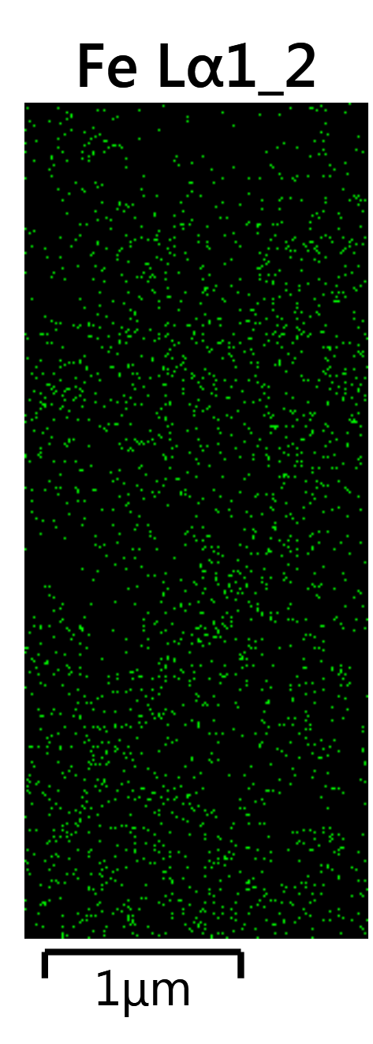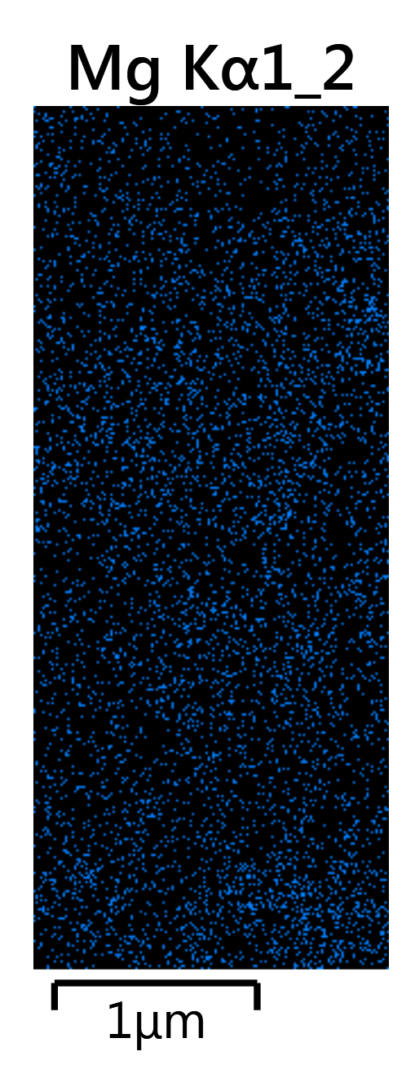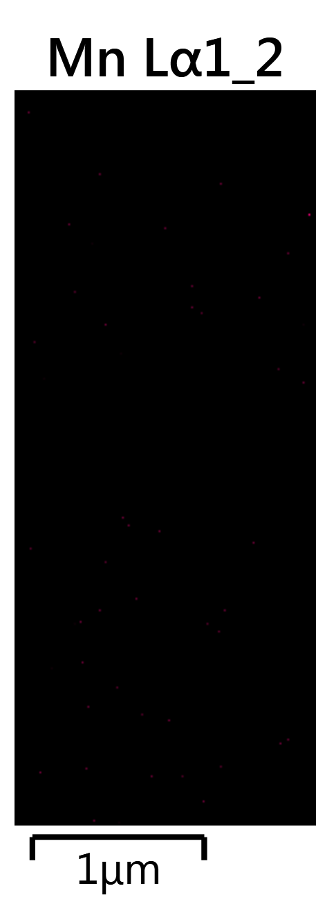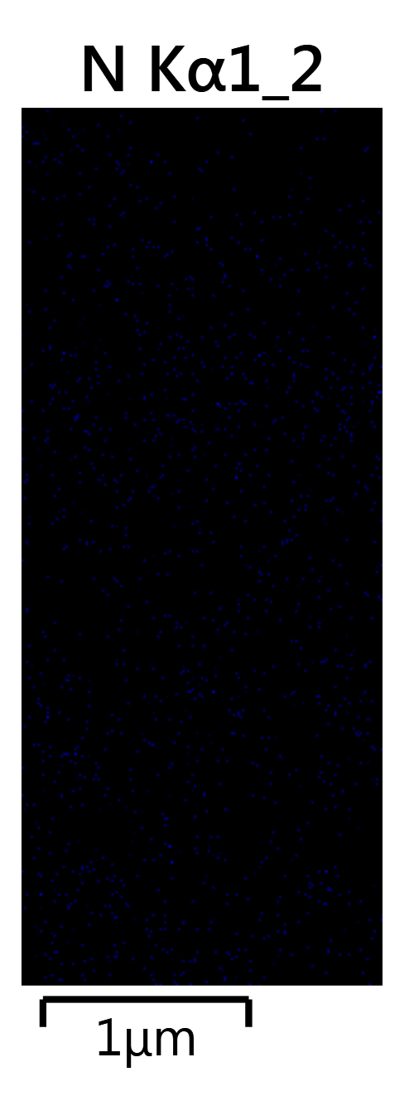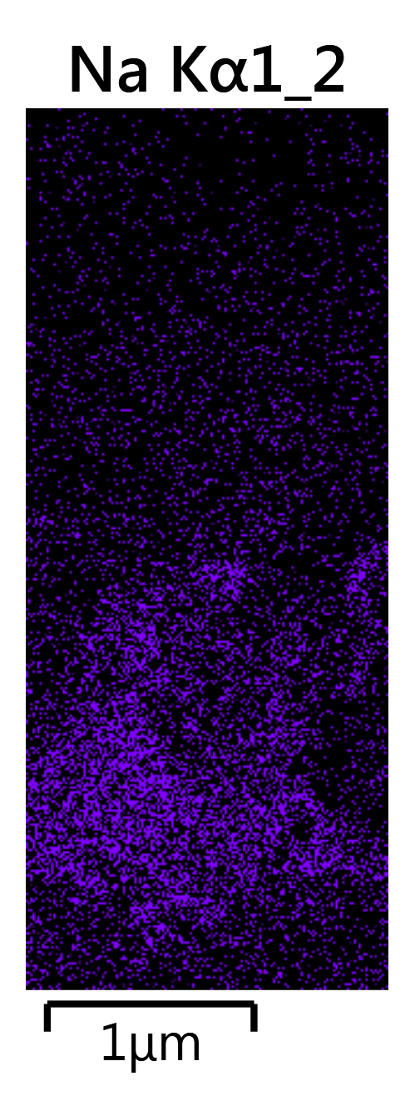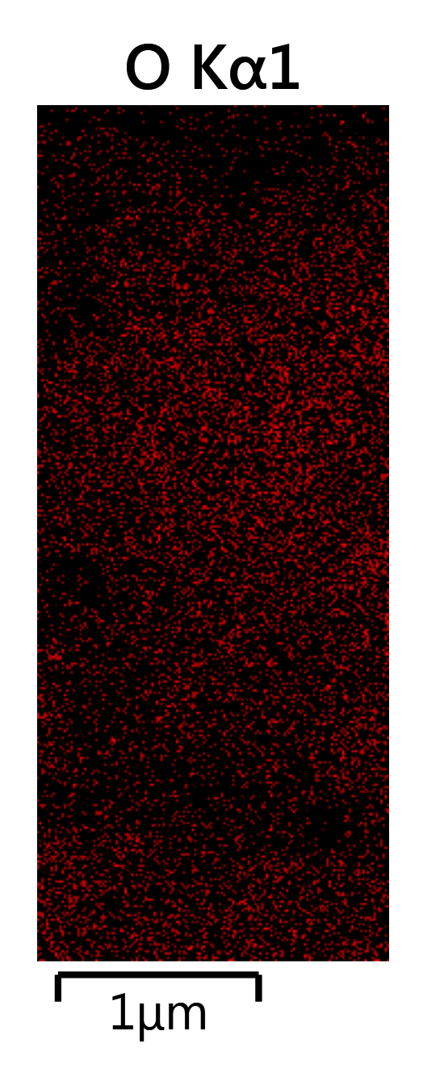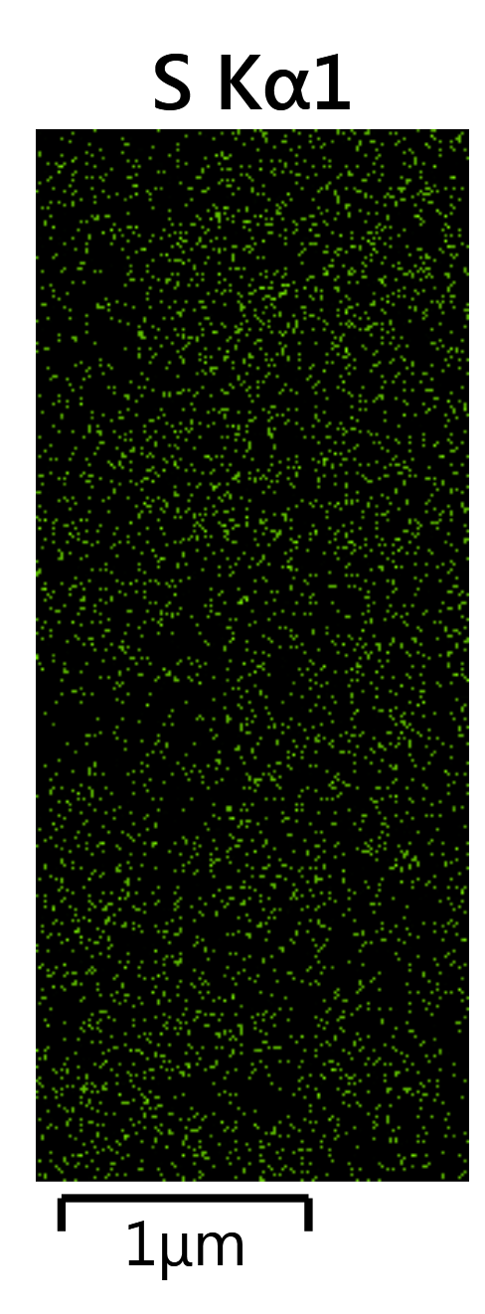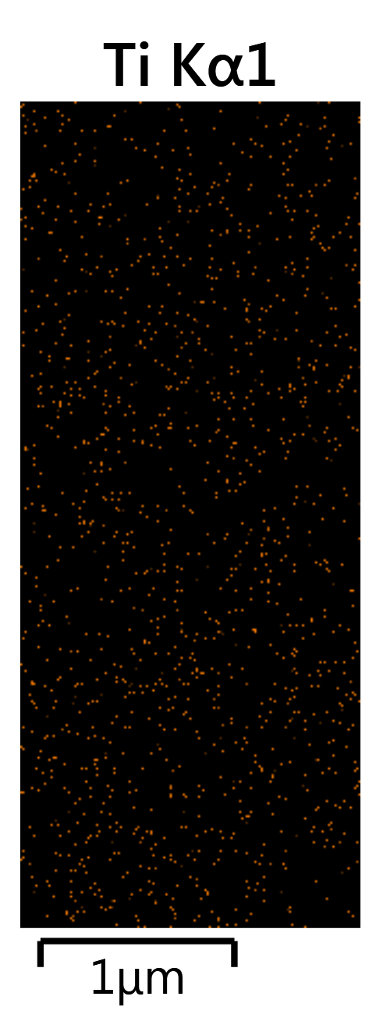
(c)
Fig. S1. (a) FE-SEM images at two different magnifications (b) graphs from the EDX test and (c) elemental analysis map of the dock sludge sample before phenol removal.

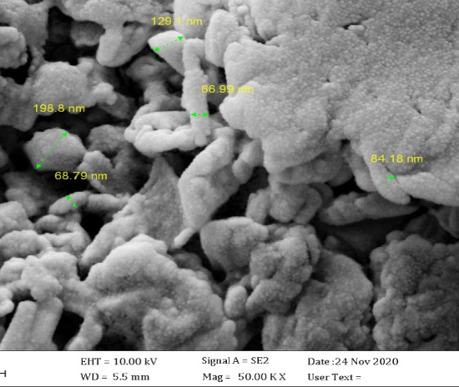
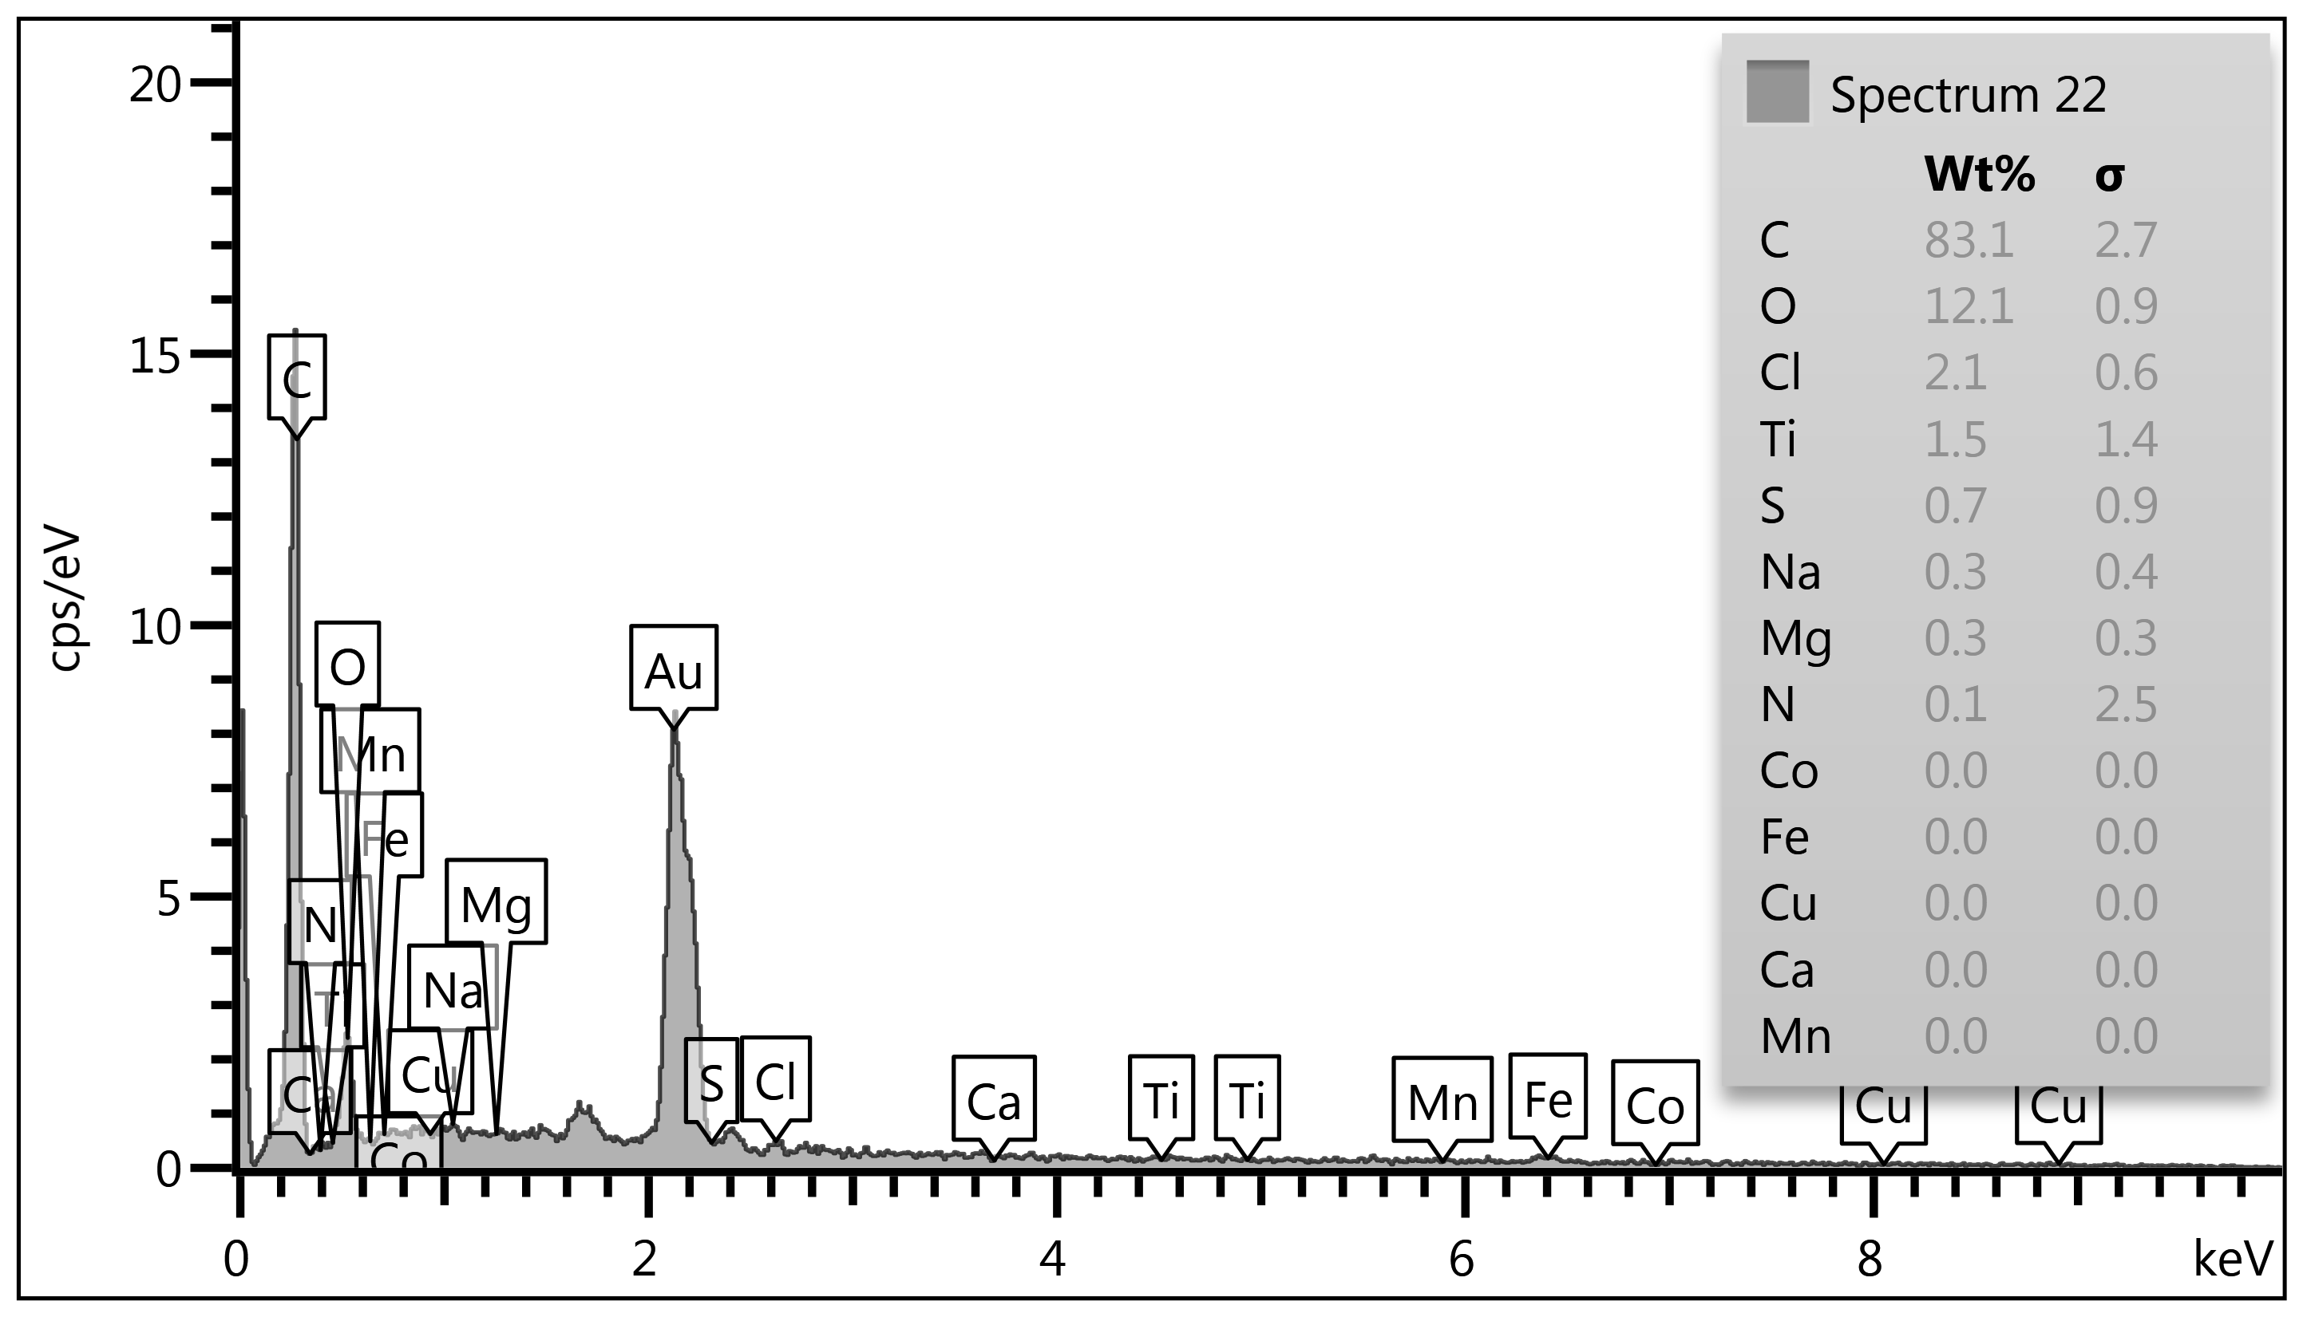
(c)
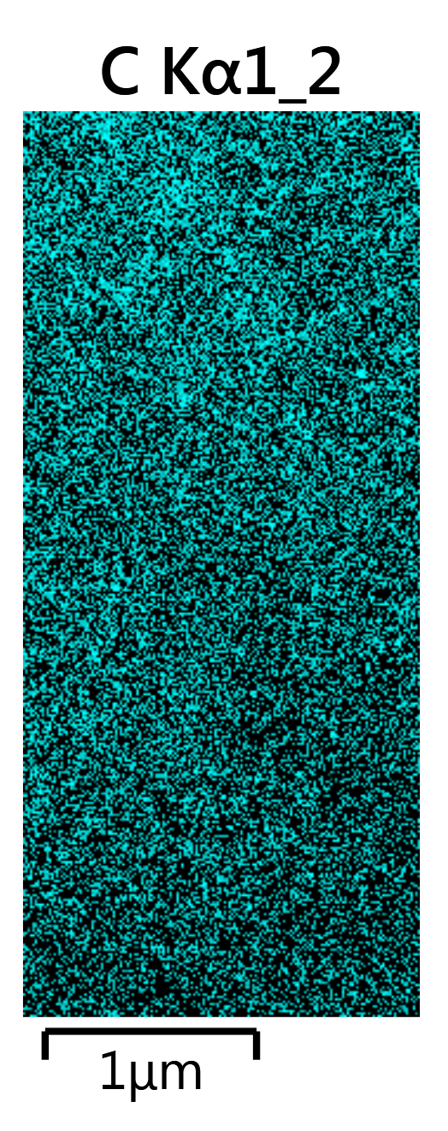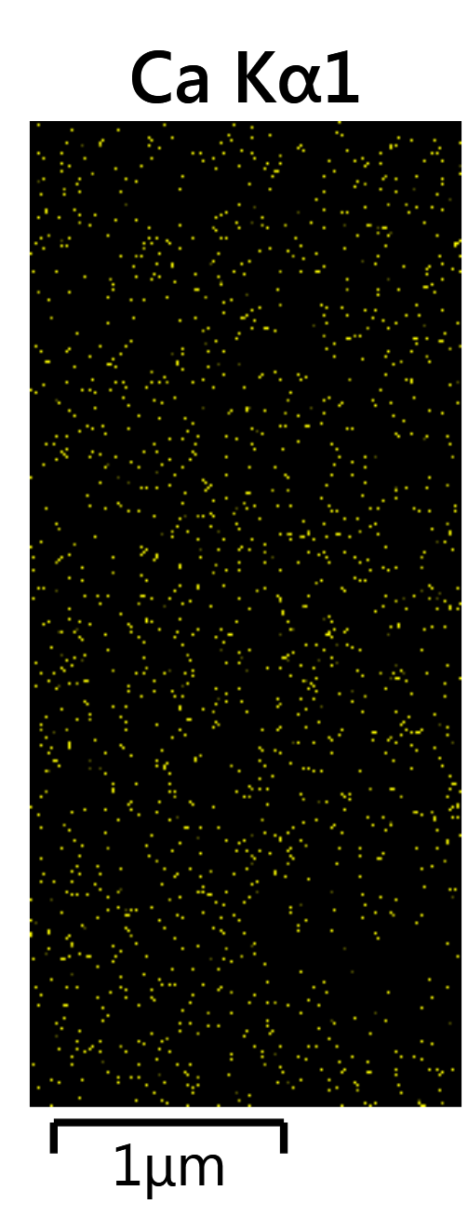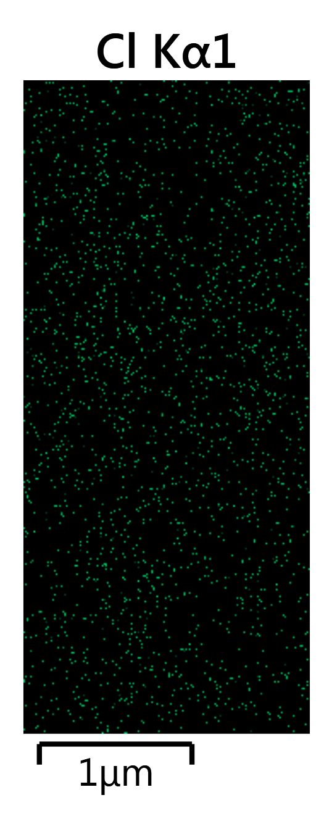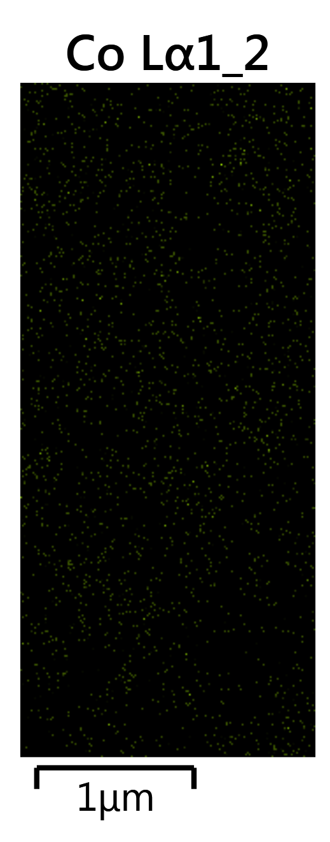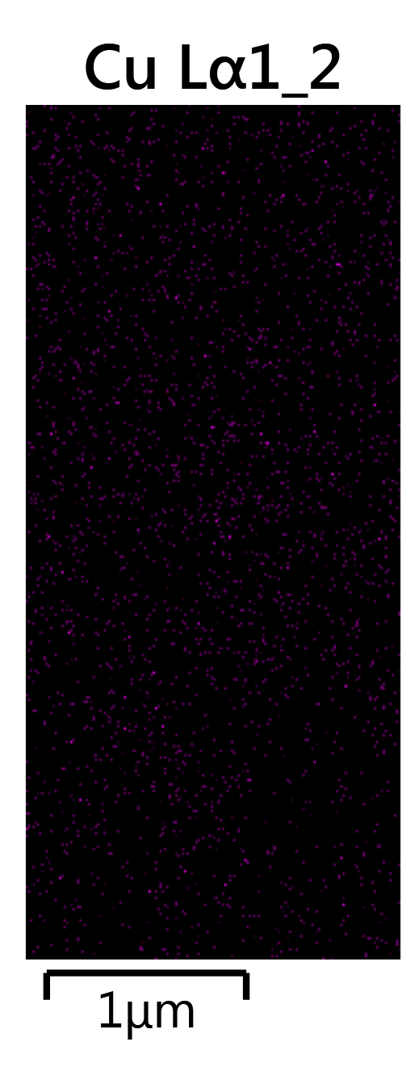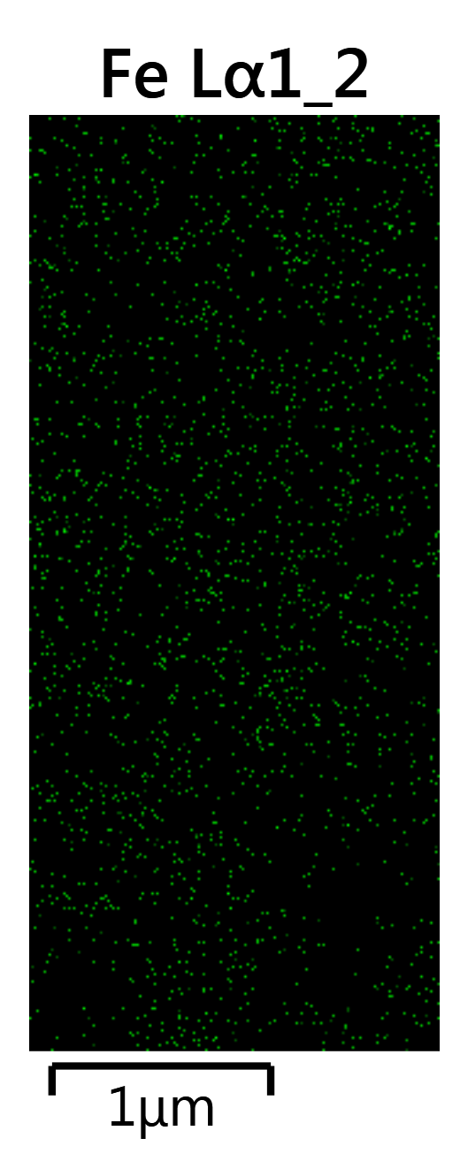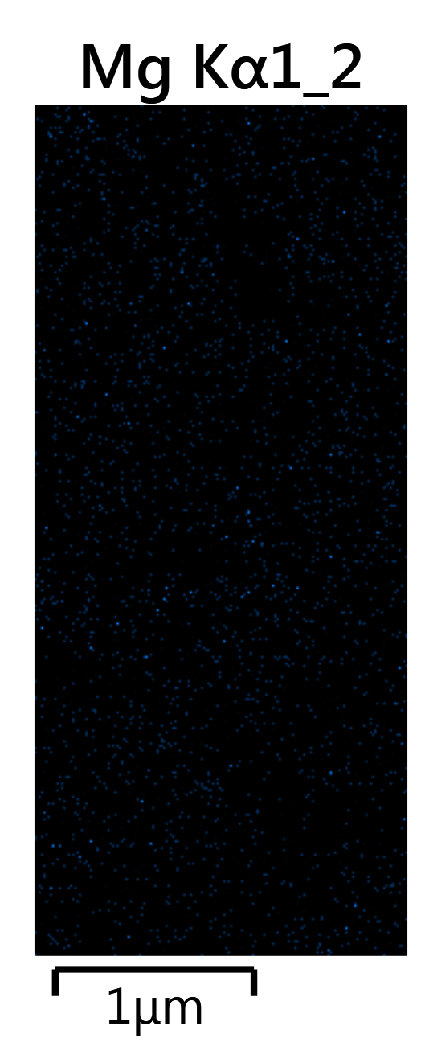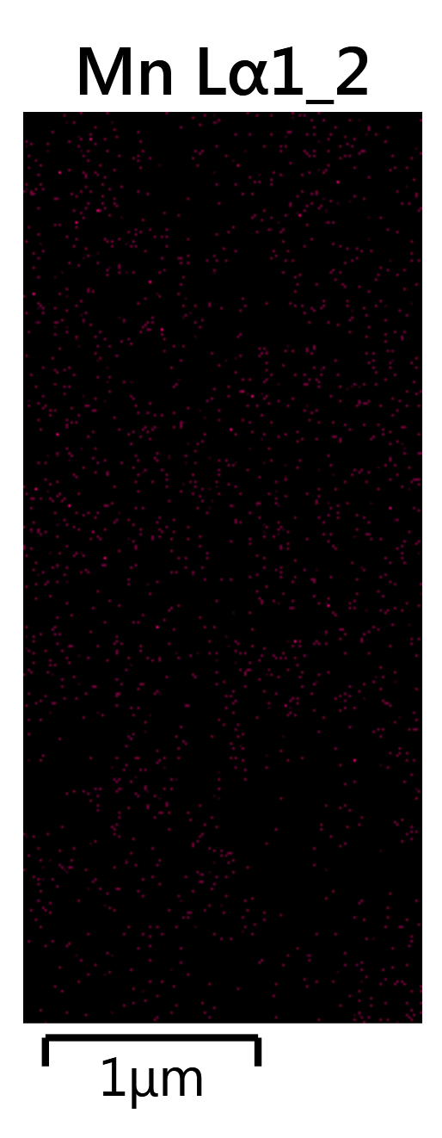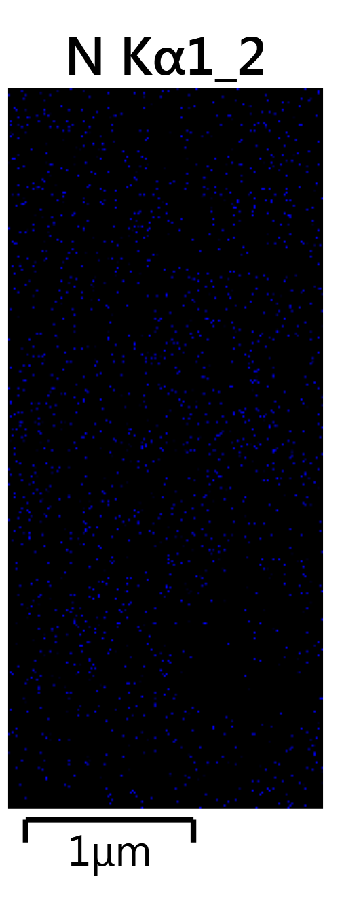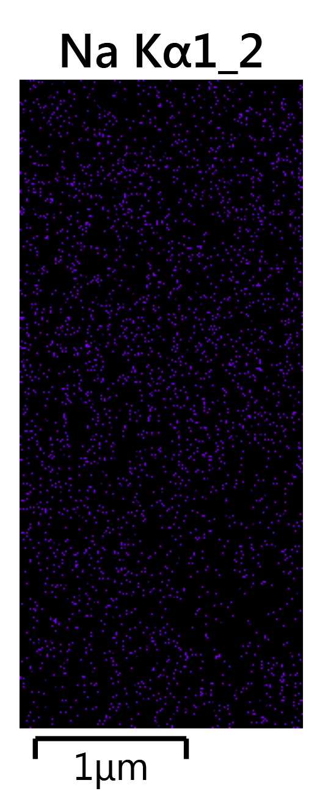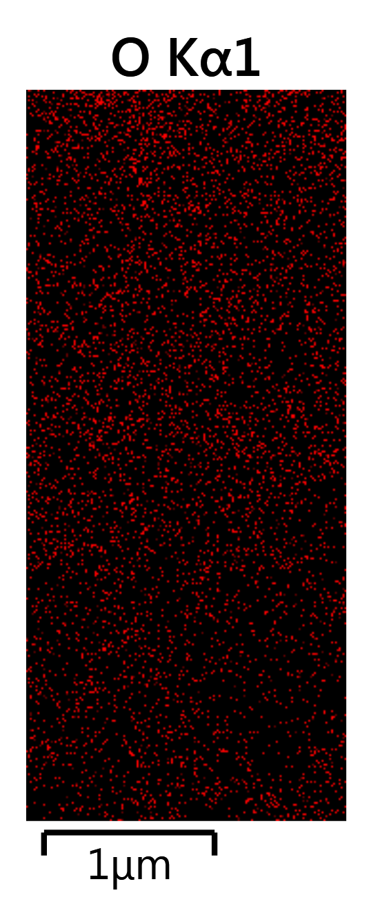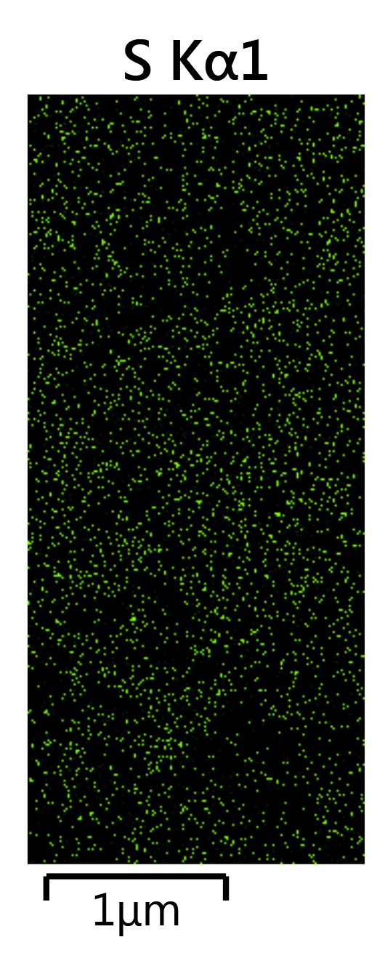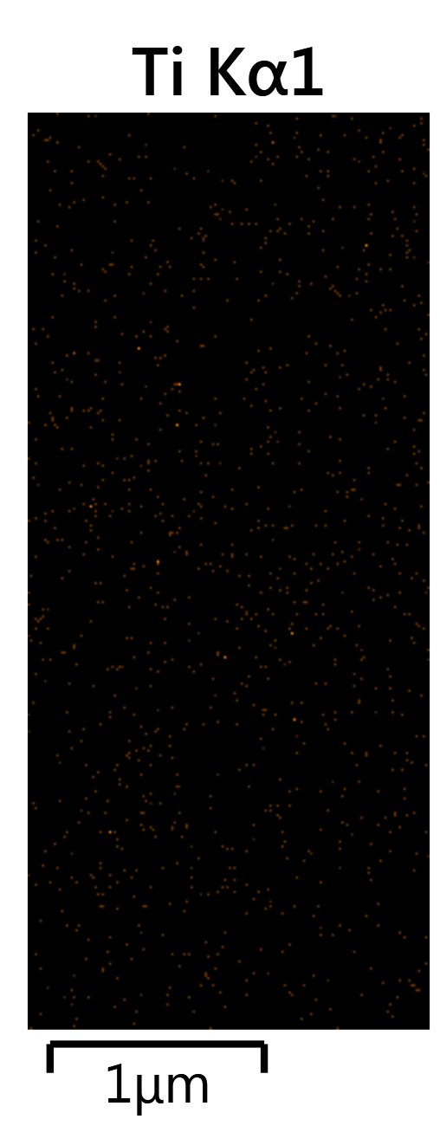
(d)
Fig. S2. (a and b) FE-SEM images in two different magnifications (c) graphs obtained from the EDX test and (d) elemental analysis maps related to dock sludge samples after removal of phenol from petrochemical wastewater.

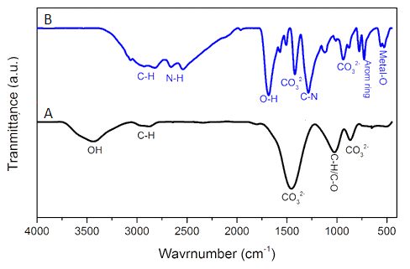
Fig. S3. FTIR spectra of samples of (A) pier waste sludge before reaction, (B) pier waste sludge after removal of phenol from petrochemical wastewater.

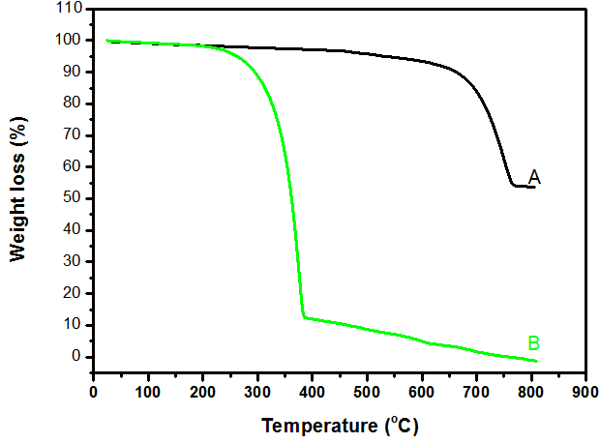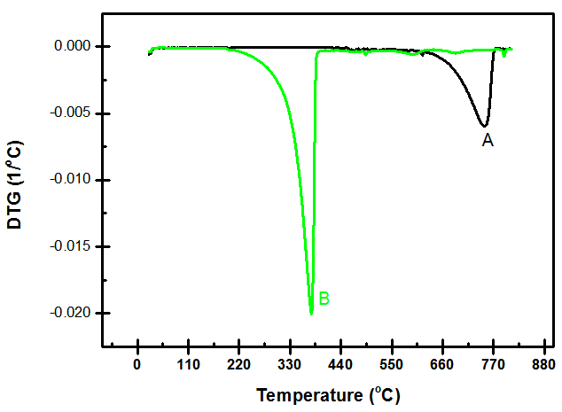
(b)
(a)
Fig. S4. Thermograms of (a) TGA and (b) DTG related to samples of (A) pier waste sludge before reaction, (B) pier waste sludge after removal of phenol from petrochemical wastewater.

