Figure 1. Temporal and Spatial Changes in the Global Burden of Ischemic Stroke, 1990–2023.
(a) Trends in the population-weighted age-standardized incidence rate (ASIR) of ischemic stroke (IS) worldwide from 1990 to 2023. (b) Estimated annual percentage change (EAPC) in ASIR across countries between 1990 and 2023. (c–d) Global spatial distribution of IS ASIR in 2004 and 2023. ASIR values were classified into four categories (Low, Lower-middle, Upper-middle, and High) according to country-level quartiles. (e) Detailed global distribution of ASIR in 2023. (f) Distribution of ASIR in East and Southeast Asia. (g) Trends in ASIR stratified by socio-demographic index (SDI) groups. (h–i) Trends in the global population and the number of incident IS cases from 1990 to 2023. In panels (h–i), solid lines represent point estimates and shaded areas represent 95% uncertainty intervals (UIs).
Figure 2. Changes in the Distribution of Ischemic Stroke Burden Along the Socio-demographic Index Gradient
(a–b) Concentration curves of the age-standardized incidence rate (ASIR) of ischemic stroke in 1990 and 2023. The x-axis represents the cumulative proportion of the population ranked from low to high SDI, and the y-axis represents the cumulative proportion of burden (population-weighted ASIR). The diagonal dashed line indicates the line of perfect equality. The degree of deviation from this line reflects the concentration of disease burden along the socio-demographic index (SDI) gradient and corresponds to the direction and magnitude of the concentration index (CI). (c–d) Slope index of inequality (SII) analyses of ASIR in 1990 and 2023. The x-axis represents the relative rank based on SDI, constructed from cumulative population proportions and estimated using the midpoint of each population segment. The y-axis represents country-level ASIR (per 100,000 population). Point size is proportional to population weight. The red line indicates the population-weighted least-squares regression fit with its confidence band. The regression slope represents the SII and reflects the absolute difference in ASIR between the lowest and highest SDI levels. (e) Country-level trajectories of ASIR versus socio-demographic index (SDI) from 1990 to 2020. Each colored line represents one country, with colors gradually changing from yellow (earlier years) to green (later years). The black curve represents the overall smoothed trend. The inset scatter plot on the right shows the relationship between ASIR and SDI in 2023, grouped according to the long-term direction of national ASIR trends (decreasing vs. increasing).

Figure 3. Transition Patterns of Ischemic Stroke Burden and Associations With Risk Exposures
(a) Global distribution of IS burden transition patterns between 2004 and 2023. Countries and territories were classified into three groups (2004-dominant, 2023-dominant, and Consistent), illustrating spatial clustering and temporal changes in burden patterns. (b) SHAP beeswarm plots of risk exposures stratified by transition pattern. The x-axis represents SHAP values (marginal contributions of features to model output), and each point represents one observation. Colors indicate feature values from low to high. Within each panel, features are ranked according to global importance, showing the distribution of exposure contributions across different burden transition patterns. (c) Country-level spatial distribution of key risk exposures based on quartile classification. Shown are summary exposure values (SEVs) for high BMI, high dietary trans-fat intake, high dietary sodium intake, low seafood omega-3 fatty acid intake, low milk intake, high processed meat intake, low bone mineral density, low calcium intake, and high systolic blood pressure. Colors indicate quartile groups: Lowest (<25%), Lower middle (25–50%), Upper middle (50–75%), and Highest (>75%). (d) Single-exposure two-way fixed-effects (TWFE) estimates for LASSO-selected SEV exposures (2004–2023). Separate models were fitted for each exposure, including country fixed effects (αᵢ) and year fixed effects (γₜ). Points represent regression coefficients (β), indicating the change in IS ASIR (per 100,000 population) associated with a one-unit increase in SEV; horizontal bars indicate 95% confidence intervals (CIs), and the vertical dashed line denotes β = 0. SEV definition: ages ≥20 years; both sexes. A total of 4,080 country–year observations from 204 countries (2004–2023) were included. (e) Forest plot of coefficients from the multi-exposure TWFE model (2004–2023). LASSO-selected exposures (identified from the 2023 cross-sectional dataset and candidate exposures with ≥95% coverage) were simultaneously included in a model with country and year fixed effects. Points represent conditional association coefficients (β) and horizontal bars indicate 95% confidence intervals; the dashed line denotes β = 0. SEV definition: ages ≥20 years; both sexes. Outcome: IS ASIR (per 100,000 population).
Figure 4. National Trends in Ischemic Stroke Burden and Associations With Risk Exposures in South Korea
(a) Temporal trend in the age-standardized incidence rate (ASIR) of ischemic stroke in South Korea from 1990 to 2023. The solid line represents annual point estimates and the shaded area represents the 95% uncertainty interval (UI). (b) Forest plot of single-exposure time-series associations between risk exposures (summary exposure values, SEVs) and IS incidence in South Korea. Models were specified as ASIR ~ SEV + year. Points represent regression coefficients (β), horizontal bars indicate 95% confidence intervals (CIs), and the vertical dashed line denotes the null effect (β = 0). Colors distinguish dietary exposures, metabolic exposures, and the exposure of primary interest (high BMI). (c) Partial regression plot for high BMI exposure after adjustment for temporal trends using the Frisch–Waugh–Lovell approach. The x-axis represents BMI-SEV residuals after removing year effects, and the y-axis represents ASIR residuals after removing year effects. The regression line represents the BMI effect adjusted for year and corresponds to the association estimated in the primary model.

Figure 5. Performance and Interpretability Analysis of Individual-Level Prediction Models for Ischemic Stroke
(a) Receiver operating characteristic (ROC) curves of five machine learning models, including deep neural network (DNN), gradient boosting (GB), random forest (RF), logistic regression (LR), and extreme gradient boosting (XGBoost), for binary classification of stroke outcomes. Area under the curve (AUC) values are shown for each model. (b) ROC curves of DNN models with different numbers of input features (10, 7, and 5). Corresponding AUC values and 95% confidence intervals (CIs) are shown. The diagonal dashed line indicates the random-classification baseline (AUC = 0.5). (c) Global feature importance plot of the 7-feature DNN model. The x-axis represents mean absolute SHAP values, indicating the overall contribution of each feature to model output. Features include age, family history of hypertension (HE_HPfh1), triglycerides (HE_TG), body fat mass measured by bioelectrical impedance analysis (BIA_BFM), body mass index (HE_BMI), body fat percentage (BIA_PBF), and obesity status (HE_obe). (d) SHAP beeswarm plot of the same 7-feature DNN model. The x-axis represents SHAP values, where positive values increase predicted risk and negative values decrease predicted risk. Each point represents one sample, and colors indicate feature values from low (blue) to high (red). (e) SHAP force plot for a representative individual predicted as positive (outcome = 1), with a model output of f(x) = 1.00. The x-axis shows the transition from the baseline prediction to the individual prediction. Red segments indicate feature contributions increasing predicted risk, whereas blue segments indicate feature contributions decreasing predicted risk. Key features and corresponding values are labeled. (f) SHAP force plot for a representative individual predicted as negative (outcome = 0), with a model output of f(x) = 0.36. The format is identical to that in panel (e) and illustrates the individual-level decision pathway. (g) Correlation matrix of the seven key features. Bubble color indicates the direction of correlation (blue, positive; red, negative), bubble size represents correlation strength (larger bubbles indicate larger |r| values), and values within bubbles indicate correlation coefficients. Features include age, family history of hypertension (HE_HPfh1), triglycerides (HE_TG), body mass index (HE_BMI), obesity status (HE_obe), body fat percentage (BIA_PBF), and body fat mass (BIA_BFM).
Figure 6. Intrinsic Interpretability of the Kolmogorov–Arnold Network (KAN) Model for Ischemic Stroke Prediction
(a) Receiver operating characteristic (ROC) curve of the KAN model for binary classification of stroke outcomes. The area under the curve (AUC) was 0.78. (b) Schematic illustration of the KAN architecture. Seven input features are connected to the output node through learnable edge functions, with each connection representing a nonlinear mapping. (c) Explicit mathematical expression extracted from the trained KAN model, representing the relationship between input features and predicted risk. (d) Feature contribution decomposition for a representative sample. The x-axis represents contribution magnitude to the intermediate node (node(1,0)) and the final output. Bar direction indicates positive (right) or negative (left) contributions. The legend identifies the target node. (e) Example of a learned edge function in the KAN model (age → node(1,0)). Scatter points represent mapped training samples in the standardized input space, and the orange curve represents the fitted function (R² = 0.93). Marker positions for Samples 1–4 illustrate that the marginal effect of age on the intermediate representation/output is not constant and may exhibit saturation- or threshold-like patterns.
Figure 7. BMI-Stratified SHAP Analysis and External Validation of the 7-Feature DNN Model
(a–d) SHAP beeswarm plots of the 7-feature DNN model stratified by body mass index (BMI): (a) underweight group (<18.5 kg/m²), (b) normal-weight group (18.5–24.0 kg/m²), (c) overweight group (24.0–27.0 kg/m²), and (d) obese group (≥27.0 kg/m²). In each panel, the x-axis represents SHAP values, where positive values increase predicted risk and negative values decrease predicted risk. Each point represents one sample, and colors indicate feature values from low (blue) to high (red). Features shown include age, family history of hypertension (HE_HPfh1), triglycerides (HE_TG), BMI (HE_BMI), obesity status (HE_obe), body fat mass (BIA_BFM), and body fat percentage (BIA_PBF). (e) Receiver operating characteristic (ROC) curve of the 7-feature DNN model in an independent external validation cohort (n = 50). The orange curve represents model performance, and the diagonal dashed line indicates the random-classification baseline (AUC = 0.5). The AUC was 0.669 (95% confidence interval: 0.496–0.821).
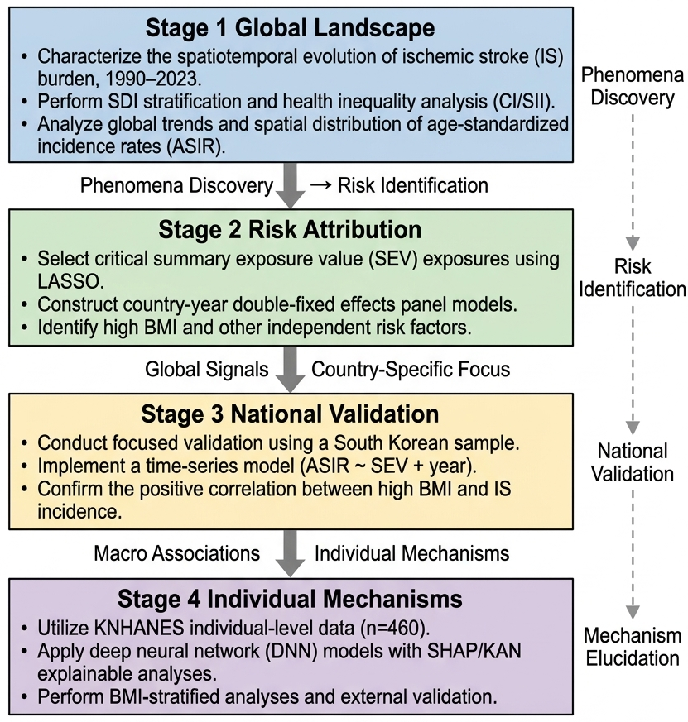
Figure S1. Overall Study Design
This study consisted of four stages: (1) a global burden and health inequality analysis of ischemic stroke based on GBD 2023; (2) identification of key risk exposures using LASSO regression and a two-way fixed effects model; (3) validation of associations at the national level in Korea; and (4) development of an individual-level predictive model and interpretability analysis based on KNHANES data.

