Comparative Radiolabelling of PSMA I&T and Somatostatin Analogues with ¹⁷⁷Lu and ⁹⁰Y: The Impact of SPE Purification

Martin Kraihammer¹, Clemens Decristoforo¹, Adriana Knoll¹, Taraneh Sadat Zavvar¹, Elisabeth von Guggenberg¹, Christine Rangger¹, Roland Haubner¹, Emanuel Sporer^{1*}

¹ Department of Nuclear Medicine, Medical University Innsbruck, Innsbruck, Austria

* Corresponding Author: emanuel.sporer@i-med.ac.at

Supplementary material
Table S1. Results from RP-HPLC analysis of [¹⁷⁷Lu]Lu-PSMA I&T. Analytical results and activity amounts used for synthesis are given as mean values ± standard deviation with n=5 batches for each row of data. RCP = radiochemical purity. t_{R} = retention time.
[¹⁷⁷Lu]Lu-PSMA I&T | overall RCP | unbound Lu-177 | impurity A  (t_{R} around 6 min) | activity amounts used for synthesis
with SPE purification | 97.27±  0.38 % | 0.03±  0.04 % | 1.00±0.16 % | 24.2±0.6 GBq
with SPE purification | 97.06±  0.21 % | 0.05±  0.06 % | 1.16±0.06 % | 31.9±0.8 GBq
with SPE purification | 96.73±  0.24 % | 0.02±  0.01 % | 1.18±0.11 % | 38.9±1.8 GBq
without SPE purification | 98.29±  0.31 % | 0.10±  0.07 % | 0.20±0.03 % | 24.5±0.4 GBq
without SPE purification | 97.78±  0.29 % | 0.06±  0.08 % | 0.34±0.13 % | 31.9±0.6 GBq
without SPE purification | 97.87±  0.32 % | 0.04±  0.04 % | 0.31±0.04 % | 38.9±1.2 GBq
Table S2. Radiochemical impurities analysed for [¹⁷⁷Lu]Lu-PSMA I&T batches according to iTLC with silica gel as stationary phase and either sodium citrate 0.1M (mobile phase A) or methanol/ammonium acetate 1M 1:1 ^{v}/_{v} (mobile phase B) as mobile phase. Results are given as means ± standard deviation (sd) in percent. Number of batches are denoted in brackets (n). p-values denote evaluation of statistical significance between the two production methods for the same starting activity levels. Statistical significance is marked with an asterisk (*).
[¹⁷⁷Lu]Lu-PSMA I&T | Radiochemical impurities in %  (mobile phase A) | p- value | Radiochemical impurities in %  (mobile phase B) | p- value | activity amounts used for synthesis
with SPE purification  (n =5 for each row) | 0.10±0.16 % | 0.111 | 0.09±0.04 % | 0.071 | 24.2±0.6 GBq
with SPE purification  (n =5 for each row) | 0.06±0.04 % | 0.516 | 0.05±0.01 % | 0.183 | 31.9±0.8 GBq
with SPE purification  (n =5 for each row) | 0.02±0.004 % | 0.016* | 0.09±0.04 % | 0.341 | 38.9±1.8 GBq
without SPE purification  (n =5 for each row) | 0.11±0.07 % | 0.111 | 0.05±0.01 % | 0.071 | 24.5±0.4 GBq
without SPE purification  (n =5 for each row) | 0.05±0.02 % | 0.516 | 0.08±0.10 % | 0.183 | 31.9±0.6 GBq
without SPE purification  (n =5 for each row) | 0.05±0.01 % | 0.016* | 0.06±0.04 % | 0.341 | 38.9±1.2 GBq
Table S3. Results from RP-HPLC analysis of [¹⁷⁷Lu]Lu-DOTA-TATE. Analytical results and activity amounts used for synthesis are given as mean values ± standard deviation with n=5 batches for each row of data. RCP = radiochemical purity. t_{R} = retention time.
[¹⁷⁷Lu]Lu-DOTA-TATE | overall RCP | unbound Lu-177 | main impurity  (t_{R} around 16 min) | activity amounts used for synthesis
with SPE purification | 97.12±  1.10 % | 0.05±  0.01 % | 0.63±0.05 % | 15.0±2.4 GBq
with SPE purification | 96.83±  0.20 % | 0.04±  0.004 % | 0.72±0.05 % | 24.5±0.2 GBq
with SPE purification | 96.32±  0.26 % | 0.05± 0.01 % | 0.69±0.10 % | 32.0±1.0 GBq
without SPE purification | 96.57±  0.24 % | 0.46± 0.25 % | 0.66±0.03 % | 15.0±3.6 GBq
without SPE purification | 96.47±  0.55 % | 0.20±  0.06 % | 0.56±0.08 % | 24.4±0.6 GBq
without SPE purification | 95.99± 0.55 % | 0.18±  0.09 % | 0.57±0.06 % | 32.0±0.5 GBq
Table S4. Radiochemical impurities analysed for [¹⁷⁷Lu]Lu-DOTA-TATE batches according to iTLC with silica gel as stationary phase and either sodium citrate 0.1M (mobile phase A) or methanol/ammonium acetate 1M 1:1 ^{v}/_{v} (mobile phase B) as mobile phase. Results are given as means ± standard deviation (sd) in percent. Number of batches are denoted in brackets (n). p-values denote evaluation of statistical significance between the two production methods for the same starting activity levels. Statistical significance is marked with an asterisk (*).
[¹⁷⁷Lu]Lu-DOTA-TATE | Radiochemical impurities in %  (mobile phase A) | p-value | Radiochemical impurities in %  (mobile phase B) | p-value | activity amounts used for synthesis
with SPE purification  (n =5 for each row) | 0.01±0.01 % | 0.008* | 0.13±0.07 % | 0.151 | 15.0±2.4 GBq
with SPE purification  (n =5 for each row) | 0.02±0.02 % | 0.008* | 0.12±0.08 % | 0.595 | 24.5±0.2 GBq
with SPE purification  (n =5 for each row) | 0.05±0.09 % | 0.135 | 0.16±0.06 % | 0.246 | 32.0±1.0 GBq
without SPE purification  (n =5 for each row) | 0.44±0.21 % | 0.008* | 0.08±0.03 % | 0.151 | 15.0±3.6 GBq
without SPE purification  (n =5 for each row) | 0.18±0.09 % | 0.008* | 0.09±0.06 % | 0.595 | 24.4±0.6 GBq
without SPE purification  (n =5 for each row) | 0.11±0.04 % | 0.135 | 0.13±0.02 % | 0.246 | 32.0±0.5 GBq
Table S5. Results from RP-HPLC analysis of [⁹⁰Y]Y-DOTA-TOC. Analytical results and activity amounts used for synthesis are given as mean values ± standard deviation with n=5 batches for each row of data. RCP = radiochemical purity. t_{R} = retention time.
[⁹⁰Y]Y-DOTA-TOC | overall RCP | unbound Y-90 | activity amounts used for synthesis
with SPE purification | 96.93±0.77 % | 0.12±0.10 % | 4.1±0.02 GBq
with SPE purification | 96.13±0.42 % | 0.13±0.08 % | 6.8±2.0 GBq
without SPE purification | 97.46±1.41 % | 0.25±0.09 % | 4.0±0.8 GBq
without SPE purification | 96.71±1.17 % | 0.32±0.09 % | 7.9±1.0 GBq
Table S6. Radiochemical impurities analysed for [⁹⁰Y]Y-DOTA-TOC batches according to iTLC with silica gel as stationary phase and either sodium citrate 0.1M (mobile phase A) or methanol/ammonium acetate 1M 1:1 ^{v}/_{v} (mobile phase B) as mobile phase. Results are given as means ± standard deviation (sd) in percent. Number of batches are denoted in brackets (n). p-values denote evaluation of statistical significance between the two production methods for the same starting activity levels. Statistical significance is marked with an asterisk (*).
[⁹⁰Y]Y-  DOTA-TOC | Radiochemical impurities in %  (mobile phase A) | p-value | Radiochemical impurities in %  (mobile phase B) | p-value | activity amounts used for synthesis
with SPE purification  (n =5 for each row) | 0.05±0.03 % | 0.008* | 0.19±0.10 % | 0.008* | 4.1±0.02 GBq
with SPE purification  (n =5 for each row) | 0.04±0.03 % | 0.024* | 0.18±0.09 % | 0.802 | 6.8±2.0 GBq
without SPE purification  (n =5 for each row) | 0.24±0.07 % | 0.008* | 0.09±0.02 % | 0.008* | 4.0±0.8 GBq
without SPE purification  (n =5 for each row) | 0.21±0.13 % | 0.024* | 0.19±0.12 % | 0.802 | 7.9±1.0 GBq

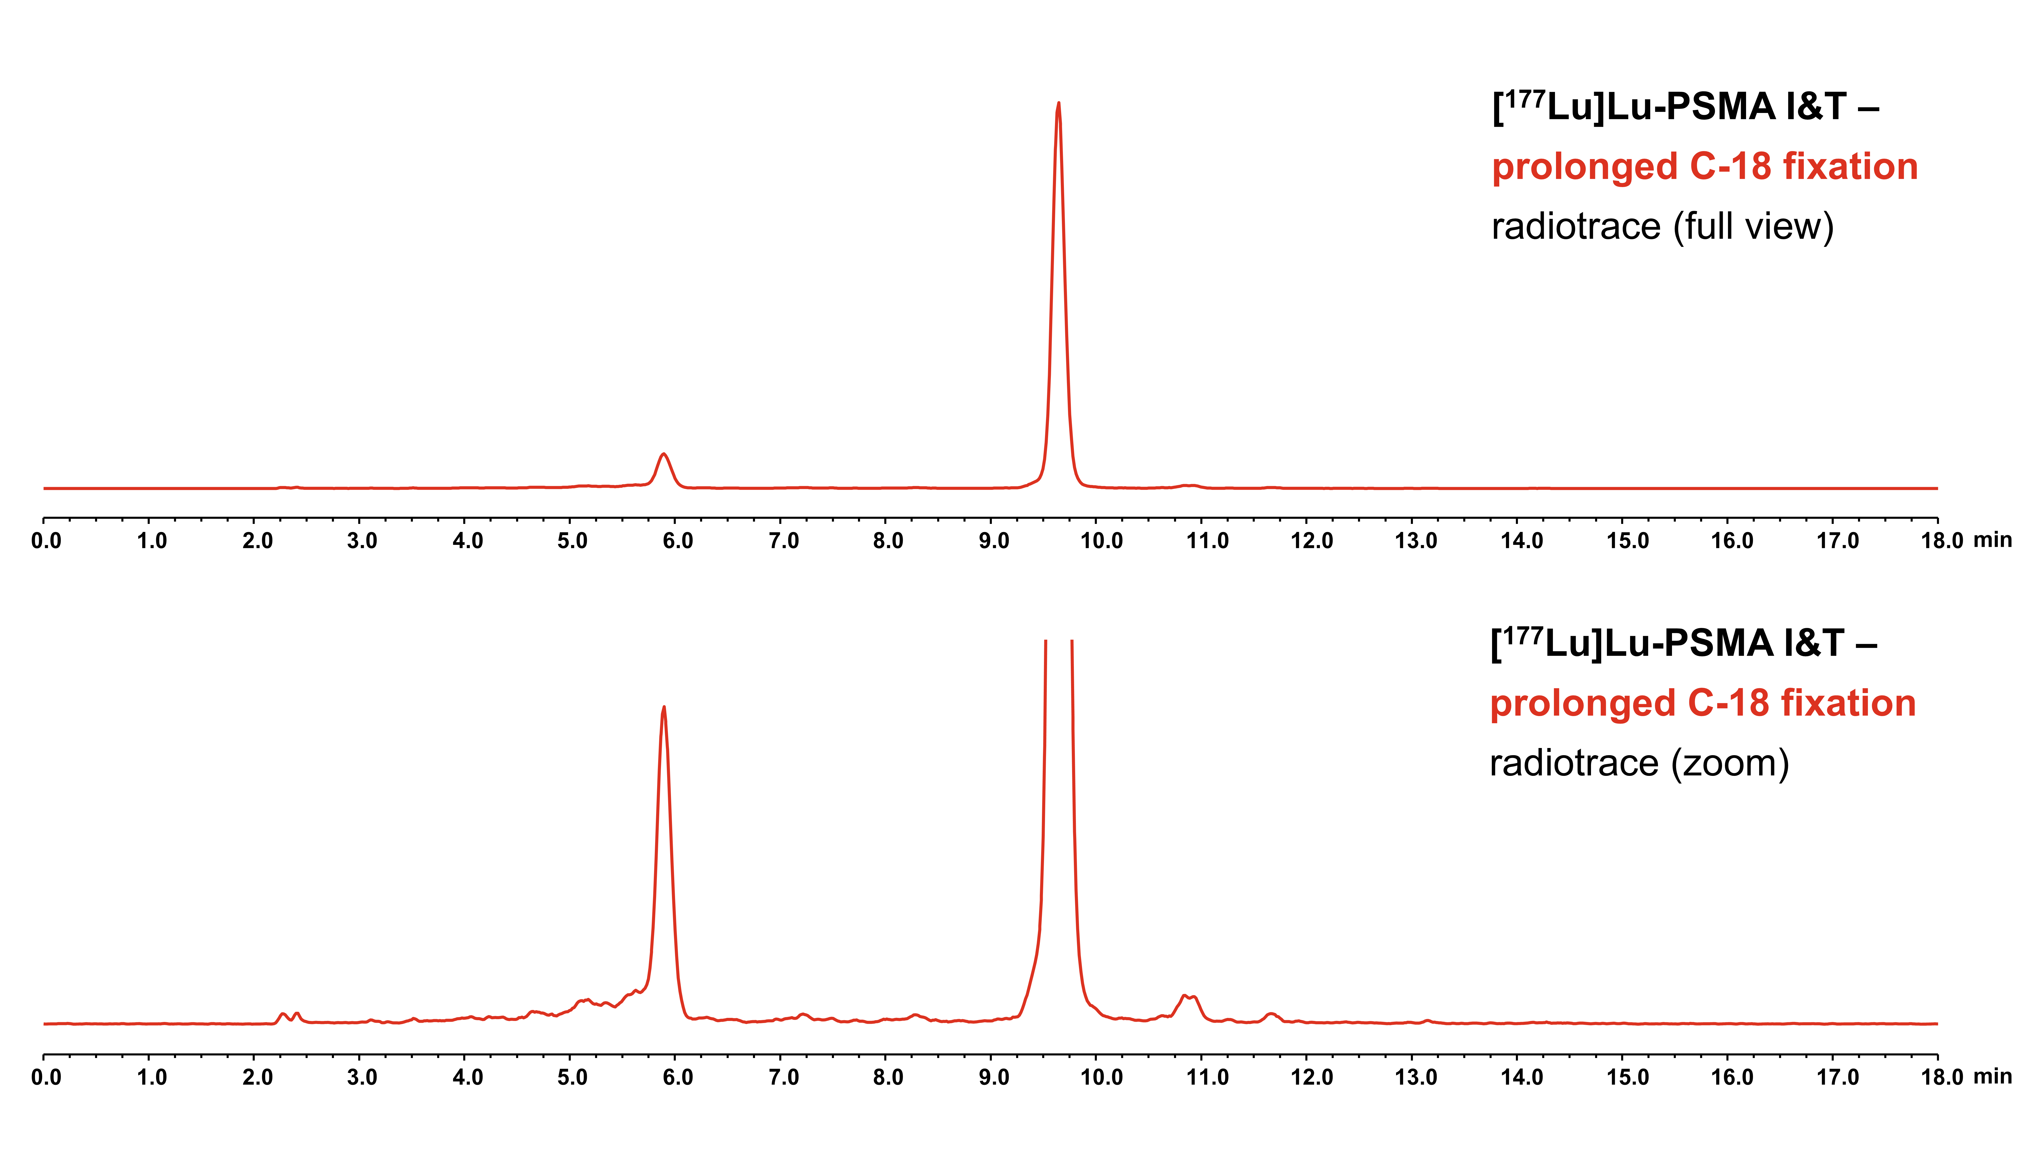
Figure S1. Radiochromatogram of a batch of [¹⁷⁷Lu]Lu-PSMA I&T with prolonged residence time on the C-18 cartridge during SPE purification. A major increase of the main impurity peak with a retention time of 5.9 minutes amounting to 8.60 % of relaitve area is apparent in the radiotrace of RP-HPLC analysis, therefore not allowing to meet the product release parameter of RCP ≥95.0%. Upper panel: full radiochromatogram without zoom. Lower panel: zoom of signal axis of the radiotrace to give a better view of impurity peaks.

