Supplementary files:
Exceptional Heat Stress Drives Coral Bleaching Across Japan in 2024
Fabian Gösser ^{1,2*}, Ayaka Umeda Paul ^{2, 3}, Jue Alef A. Lalas ^{1, 4}, Joseph D. DiBattista ^{5, 6}, Sylvain Agostini ⁷, Brigitte Sommer ⁸, James Davis Reimer ^{1,9}

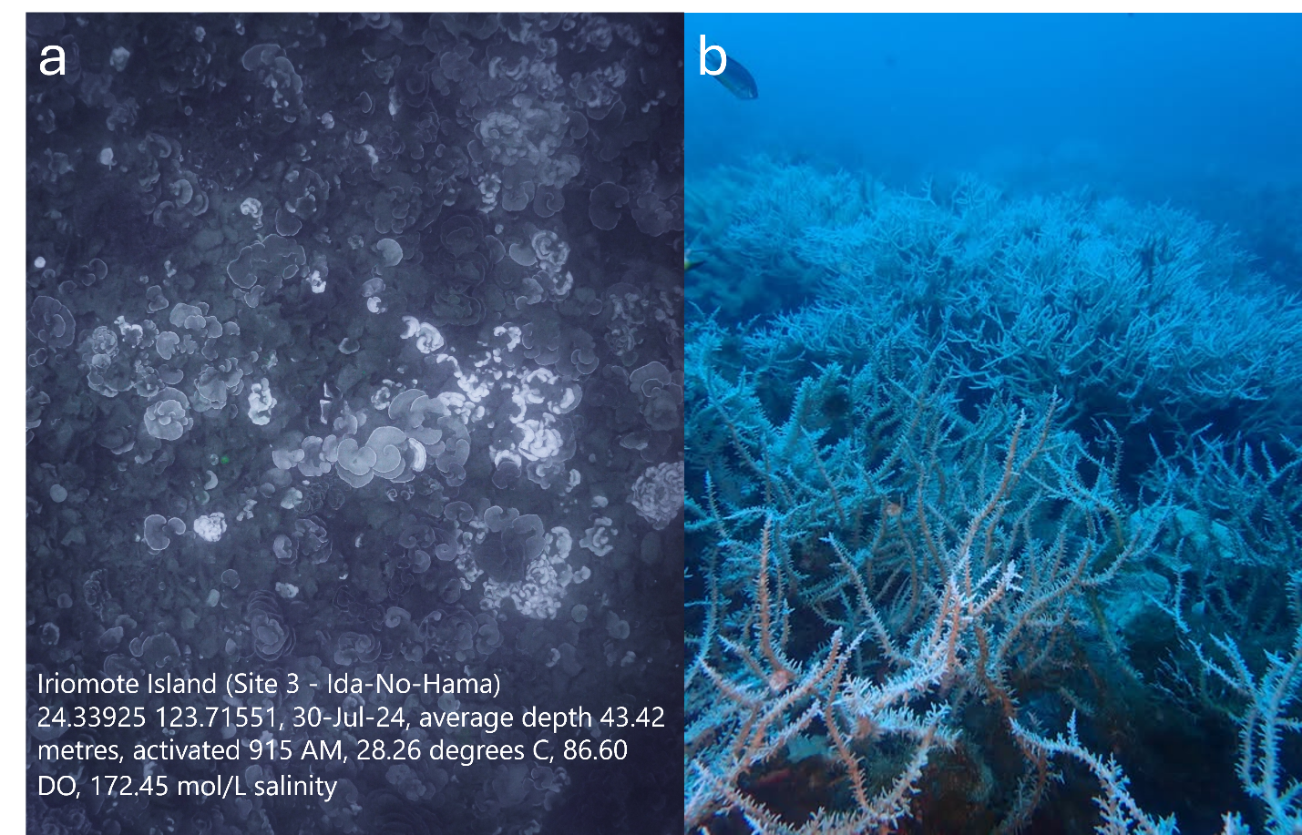
Supplement Figure 1: Deep coral bleaching at Idahama, Iriomote, where a drop-camera was deployed. A) Bleaching of Pachyseris sp. at depth >40 m with info from sensors deployed with the camera. B) Bleaching of thickets of Acropora sp. at >30 m along the reef slope.

