Supplementary Information

Interactome modules underlie shared spatiotemporal patterns in psychiatric and neurodegenerative disorders

Authors:
Kalyani B. Karunakaran^{1*}, Suhas Ganesh¹, Jayant Mahadevan¹, Meera Purushottam¹, N. Balakrishnan², Ken-ichi Amemori³, Sanjeev Jain¹, Biju Viswanath¹

Affiliations:
¹ Molecular Genetics Lab, Department of Psychiatry, National Institute of Mental Health and Neurosciences, Bangalore, India
² Supercomputer Education and Research Centre, Indian Institute of Science, Bangalore, India
³ Institute for the Advanced Study of Human Biology, Kyoto University, Kyoto, Japan
*Correspondence to: Kalyani B. Karunakaran (kalyanithepebble@gmail.com)

This file contains:
- Supplementary Methods 1 to 6
- Supplementary Notes 1 to 4
- Supplementary Figures 1 to 12
- Supplementary References 1 to 16
Supplementary Methods 1
Syndrome network construction
Direct interactions (MI:0407) and physical associations (MI:0915) of the proteins encoded by the disease-associated genes were compiled from Human Protein Reference Database (HPRD)² and the Biological General Repository for Interaction Datasets (BioGRID).³ The interactomes were visualized using Cytoscape.⁴
Of the 59 HD-associated genes, 29 were interconnected through 459 intermediate interactors and 4,227 PPIs, together constituting the HD network of 488 nodes (genes represented as nodes and PPIs as edges in network diagrams). Similarly, 17 of the 29 PD-associated genes were interconnected through 840 nodes and 11,566 edges, forming the PD network of 857 nodes. Thirteen of the 34 OCD-associated genes were interconnected through 171 nodes and 940 edges, forming the OCD network of 184 nodes. Eighteen of the 31 SZ-associated genes were interconnected through 434 nodes and 3,862 edges, forming the SZ network of 452 nodes. Twelve of the 20 BD-associated genes were interconnected through 205 nodes and 1,237 edges, forming the BD network of 217 nodes. Pairwise overlaps between these syndrome networks were also observed: HD-PD (97 nodes), HD-OCD (27 nodes), HD-SZ (49 nodes), HD-BD (33 nodes), PD-OCD (25 nodes), PD-SZ (89 nodes), PD-BD (41 nodes), OCD-SZ (20 nodes), OCD-BD (7 nodes), and SZ-BD (37 nodes). The combined union network across all five syndromes consisted of 1,862 nodes and 20,072 edges.
Supplementary Methods 2
Network module identification
Following the methodology detailed by Li et al.,⁵ we decomposed the five respective syndrome networks into 44 topological modules using the Cytoscape plugin MCODE.⁶ The parameters for module identification were as follows: degree cut-off = 2, node score cutoff = 0.2, k-core = 2, and maximum depth = 100, include loops: false, haircut: true, fluff: false, k-core = 2, maximum depth from seed = 100. Thirteen modules were identified from the PD network (PD-1 to PD-13), 9 each from the HD (HD-1 to HD-9) and OCD (OCD-1 to OCD-9) networks, 7 from the SZ network (SZ-1 to SZ-7), and 6 from the BD network (BD-1 to BD-6). The enrichment of the identified modules for specific biological processes (Gene Ontology⁷) was computed using WebGestalt.⁸ The module figures were created using Cytoscape.⁹
Supplementary Methods 3
Spatial and temporal expression profiles
We examined RNA-sequencing data from 26 brain structures sampled across ten developmental stages from the BrainSpan Atlas¹⁰ to identify clusters of syndromes genes with distinct expression signatures, analyzing spatial and temporal aspects separately. The temporal expression data covered 31 temporal points, which were grouped into ten developmental stages. These stages included early (8-12 pcw), early-mid (13-17 pcw), late-mid (19-24 pcw), and late prenatal (25-37 pcw) stages, early (4 months) and late infancy (10 months-1 year), early (2-4 years) and late childhood (8-11 years), adolescence (13-19 years), and adulthood (21-40 years). Expression data for 115 syndrome genes and 1,826 syndrome network genes were available in the dataset.
To replicate the spatial patterns seen with BrainSpan atlas data, we used RNA-seq data from 13 brain regions of adult donors available in GTEx.¹¹ To identify regional specificities of the spatial clusters, we examined adult microarray data available in the Allen Brain Atlas.¹² Normalized microarray data was available for 29,130 genes from the brains of six healthy donors, each dissected into 363-946 samples – yielding a total of 3702 samples – from 232 structures (classified into 13 higher-tier areas) in the brain.
Supplementary Methods 4
Hierarchical clustering of expression profiles
Log₂ transformation was performed on all probe intensity (or RPKM, where RPKM is Reads Per Kilobase Million) values to reduce the influence of extreme values. Hierarchical clustering was conducted on a data matrix containing the log₂probe intensity (or RPKM) values of the syndrome-linked and syndrome network genes across various brain structures and developmental stages, using the Morpheus software.¹³ Pairwise distances in the data matrix were calculated using Pearson correlation, and closely linked clusters were identified using the average linkage method.
Supplementary Methods 5
Brain region enrichment analysis
After clustering the spatial expression profiles, we asked whether a substantial number of genes within a particular spatial cluster exhibited a significant bias toward high expression in any of the structures in the dataset. We compiled a list of genes highly expressed in any of the structures relative to others, as described by Rouillard et al.,¹⁴ in the form of a gene matrix transposed (GMT) file. This GMT file was uploaded as a custom database to WebGestalt⁸ for performing an over-representation analysis (ORA) with the spatial cluster genes. Statistical significance of the overlap between the list of genes belonging to a spatial cluster and the genes highly expressed in a specific structure was computed using the hypergeometric distribution. In this method, p-value is computed from the probability of k successes in n draws (without replacement) from a finite population of size N containing exactly K objects with an interesting feature.
$$P \left(X=k\right)=\frac{\left({K \atop k}\right)\left({N-K \atop n-k}\right)}{\left({N \atop n}\right)}$$
Population size N = Number of genes expressed in the human brain
Number of successes in the population K = Number of genes highly expressed in a specific structure
Sample size n = Number of genes belonging to a spatial cluster
Number of successes in the sample k = K ∩ n
The p-values derived from ORA were corrected for multiple hypothesis using the BH method. In this method, the hypergeometric p-values are sorted from small to large, and multiplied by the total number of tests and then divided by its rank order. P-value < 0.05 after BH correction was considered to be statistically significant.
Supplementary Methods 6
Functional enrichment analyses
The enrichment of the clusters for the genes associated with specific biological processes (Gene Ontology¹⁵) was computed using WebGestalt.⁸ WebGestalt calculates the distribution of genes belonging to a particular functional category in the input list and compares it with the background distribution of genes in that category among all the genes annotated with any functional category in the selected database. Statistical significance of enrichment was assessed using the hypergeometric test and corrected for multiple hypotheses using the BH method. Annotations with a BH-corrected p-value < 0.05 were considered significant.

Supplementary Note 1
Replication of spatial clusters using GTEx data
We tested whether the two (BrainSpan) spatial clusters identified from the interactome genes could be recapitulated using GTEx data. Hierarchical clustering revealed two spatial clusters (Supplementary Fig. 1a): GTEx spatial cluster 1 and GTEx spatial cluster 2, which significantly overlapped with spatial cluster 1 (FDR-corrected p-value = 1.97E-08) and spatial cluster 2 (FDR-corrected p-value = 6.58E-08), respectively.
Although neither cluster showed statistically significant syndrome affiliations after FDR correction, uncorrected p-values indicated a significant enrichment of GTEx spatial cluster 2 for SZ network genes, with HD network genes following a similar enrichment trend (Supplementary Fig. 1b). Both HD and SZ exhibited comparable enrichment ratios in spatial cluster 2 (Supplementary Fig. 1c). Conversely, OCD and PD networks showed similar enrichment trends. While these findings did not reach statistical significance, they aligned with the syndrome affiliations observed for spatial clusters derived from BrainSpan data.
Next, we identified network modules enriched in the two GTEx spatial clusters. No statistically significant module enrichments were detected; however, certain trends emerged. In GTEx spatial cluster 1, 12 of the 21 modules with an enrichment ratio greater than 1 were associated with PD (seven modules) or OCD (five modules). In spatial cluster 2, 11 of the 15 modules with an enrichment ratio greater than 1 were associated with SZ (five), BD (two), or HD (four).

Supplementary Note 2
Regional specificities of syndrome networks
To determine whether spatial signals for each syndrome emanated from across the full networks, we examined whether the syndrome networks themselves – prior to any reorganization through hierarchical clustering and regardless of (disease) network membership – showed any enrichment in specific brain structures. Only the HD and PD networks showed enrichment that survived FDR correction (Supplementary Fig. 2). The SZ network showed enrichment that did not survive correction, while the OCD and BD networks showed no enrichment. Overall, there was no clear indication that the spatial signals were produced uniformly from across the syndrome networks (Supplementary Fig. 2).

Supplementary Note 3

Regional specificities underlying co-emerging syndrome network signals

To identify brain regions underlying the co-emergence of specific syndrome network signals, we used higher-spatial-resolution microarray data from the Allen Brain Atlas, covering 232 brain structures. We identified five spatial clusters (Supplementary Fig. 5). Spatial cluster 1 showed expression signals from specific regions including cerebellar structures; spatial cluster 2 showed some cerebellar expression along with strong signals in cerebral nuclei, subcortical structures, diencephalon, midbrain, and limbic system; spatial cluster 3 resembled cluster 2 but also included frontal, parietal, temporal, occipital, insular, white matter, and additional limbic structures; spatial cluster 4 showed broad expression across cerebellar, subcortical, and cortical regions; and spatial cluster 5 showed predominantly cerebellar expression.

BrainSpan cluster 1, which had shown enrichment for OCD and PD network genes, now significantly overlapped with spatial clusters 1 and 5 (Supplementary Fig. 6a), which were over-enriched for PD and OCD networks, respectively, though not at statistical significance (Supplementary Fig. 6b, f). BrainSpan cluster 2, which had shown enrichment for HD and BD networks, now significantly overlapped with spatial clusters 3 and 4, enriched for BD (not statistically significant) and HD (statistically significant) networks, respectively (Supplementary Fig. 6d, e).

These results indicate that higher spatial resolution splits larger BrainSpan clusters into more specific sub-clusters. Cerebellar regions likely underlie the co-emergence of OCD and PD signals, while frontal, diencephalic, parietal, and temporal regions may contribute to the co-emergence of HD and BD signals (Supplementary Fig. 7). These network enrichments do not correspond to network modules as observed in the BrainSpan data.

Supplementary Note 4
Temporal clusters of syndromes genes and networks
Hierarchical clustering of temporal expression profiles across ten developmental stages divided the syndrome-associated genes into four clusters (Supplementary Fig. 9a): temporal cluster 1 with 44 genes expressed throughout development, temporal cluster 2 with 19 genes expressed in prenatal stages, temporal cluster 3 with 35 genes expressed from late prenatal to adulthood, and temporal cluster 4 with 17 genes expressed in the late prenatal stage. Although no statistically significant enrichments were found (Supplementary Fig. 9b), trends indicated that BD and SZ genes were enriched temporal cluster 2, PD genes enriched cluster 3, and OCD genes enriched cluster 4 (Supplementary Fig. 9c).
On the other hand, clustering of 1,826 network genes revealed significant syndrome enrichments. The network genes could be grouped into four temporal clusters based on hierarchical clustering (Supplementary Fig. 10a,b): temporal cluster 1 (316 genes), expressed throughout all developmental stages and significantly enriched for BD and SZ genes, temporal cluster 2 (750 genes), expressed from early to late prenatal stages and enriched for OCD genes, temporal cluster 3 (497 genes), expressed from late prenatal stages to adulthood (not enriched for any syndrome networks), and temporal cluster 4 (263 genes), expressed predominantly in the late prenatal stage and enriched for SZ genes. The temporal trends of these clusters were confirmed through enrichment analysis of highly and moderately expressed genes across developmental stages (Supplementary Fig. 10c). Spatial cluster 1, enriched in foetal brain structures, significantly overlapped with temporal cluster 2, which was predominantly expressed during prenatal stages (Supplementary Fig. 10d). Both clusters were enriched for OCD-associated genes. Spatial cluster 2, enriched in adult brain structures, significantly overlapped with temporal cluster 1, which showed expression throughout developmental stages, with significant signals during late infancy, late childhood, adolescence, and adulthood.
Among full networks, only BD showed nominal stage-specific enrichment (adolescence; p-value = 0.031, not FDR-significant). In contrast, ten network modules (HD-1/2/3, OCD-1/9, PD-1/2/3/5, SZ-6) showed significant stage-specific enrichment (Supplementary Fig. 11). We examined whether specific modules were enriched in the hierarchical temporal clusters (Supplementary Fig. 10a). In some cases (e.g., SZ-1/3/6 in cluster 4), they did; in others, enrichments were broader, e.g., temporal cluster 1 showed enrichment for SZ-2/7, but also for PD-4; and temporal cluster 2 for OCD-1, but also for HD-2/9 and PD-3/5 (Supplementary Fig. 10e).
Unlike hierarchical clustering, Mfuzz time-series takes dynamic temporal variation of expression into account.¹⁶ Therefore, we suspected that sharp module-to-network matches may emerge from this time-aware method. Four time-series clusters with distinct trajectories emerged (Supplementary Fig. 12a). Two clusters showed statistically significant syndrome enrichments (Supplementary Fig. 12b). Time-series cluster 2, with high expression in the early prenatal stage and a declining trend in subsequent stages, was enriched for the OCD network. Correspondingly, this cluster was enriched for OCD-2 & OCD-4 (Supplementary Fig. 12c). Time-series cluster 4, with expression peaking in the early prenatal stage and early childhood, was enriched for the SZ network, and correspondingly for SZ-3 & SZ-6.

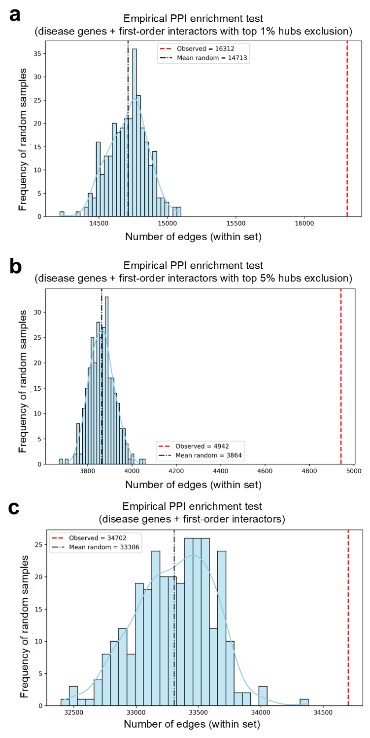
Supplementary Figure 1: Hub-exclusion sensitivity analyses. True number of edges within the network of disease genes and their first-order interactors (red dashed line) and histograms of edge counts from 300 degree-matched subsets from the human interactome (mean shown as a black dashed line): a top 1% hubs excluded; b top 5% hubs excluded; c no hubs excluded.

Supplementary Figure 2: HD- and PD-linked genes from family studies. Genes are shown as nodes and PPIs as edges. Sub-networks from our combined network containing genes implicated in a HD and b PD by family-based studies and functional evidence (gene symbols shown in bold); green nodes: GWAS-sourced HD-linked genes in our analysis; orange nodes: GWAS-sourced PD-linked genes in our analysis.

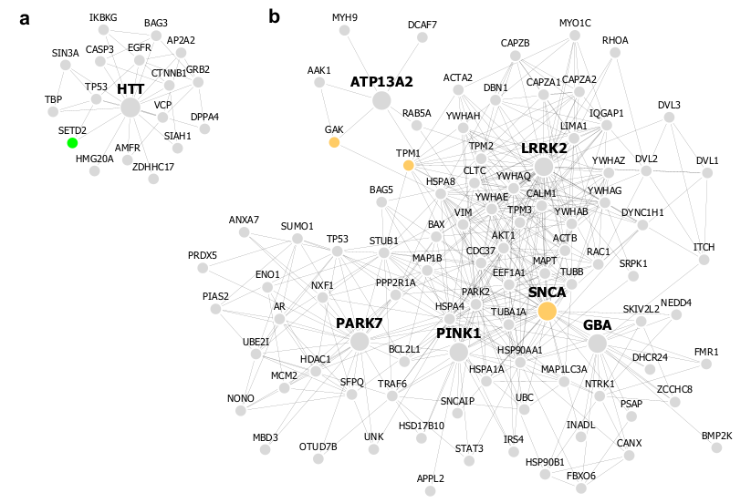

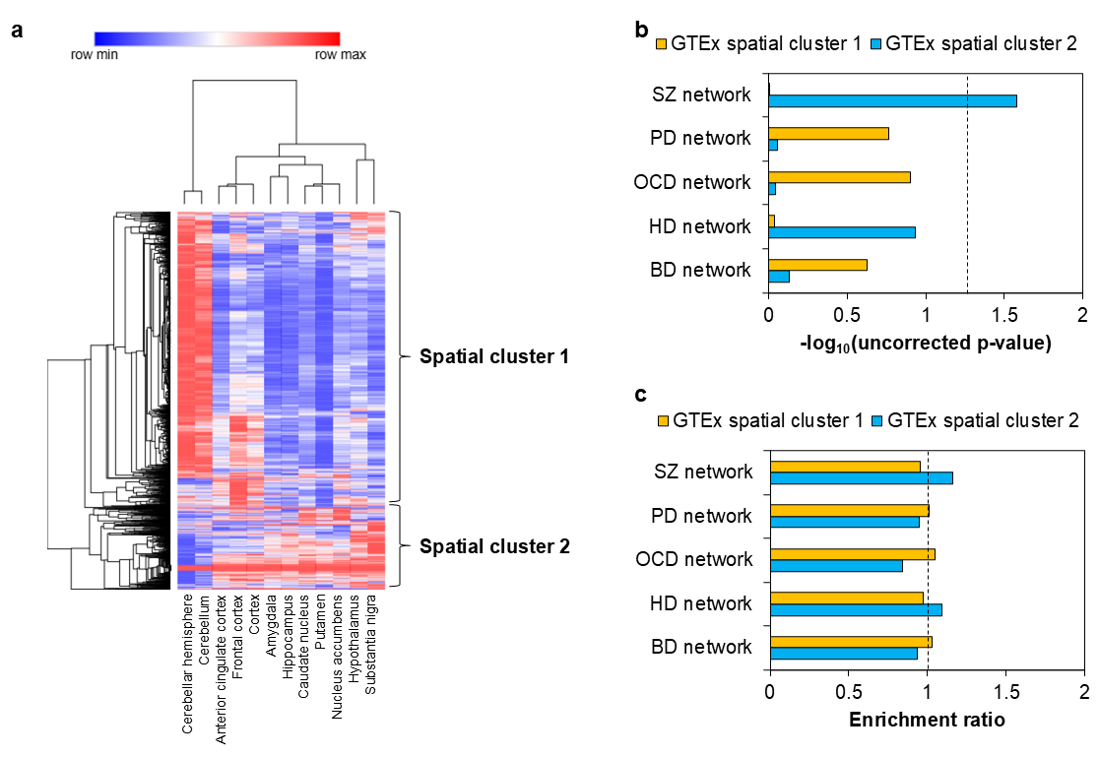
Supplementary Figure 3: Recapitulation of the two spatial clusters using GTEx data. a Dichotomized expression of 1843 syndrome network genes across 12 brain structures in GTEx (labelled on bottom horizontal axis). Gene expression across these structures was hierarchically clustered by computing pairwise distances between the data points (log2-transformed TPM values) using Pearson correlation, and identifying closely linked clusters using the average linkage method. The clustered heat map was generated using the Morpheus software. b Syndrome affiliations of clusters were examined based on statistically significant enrichment of genes belonging to specific syndrome networks. The dashed black line indicates the significance threshold (uncorrected p-value < 0.05, i.e. -log10(p-value) > 1.30103); note that these p-values do not survive FDR correction. c Enrichment ratios of clusters for genes belonging to specific syndrome networks. Ratios indicate the observed frequency of syndrome network genes in spatial clusters relative to their expected frequency (based on their distribution in the universal set of genes). The dashed black line indicates the enrichment threshold (ratio > 1).

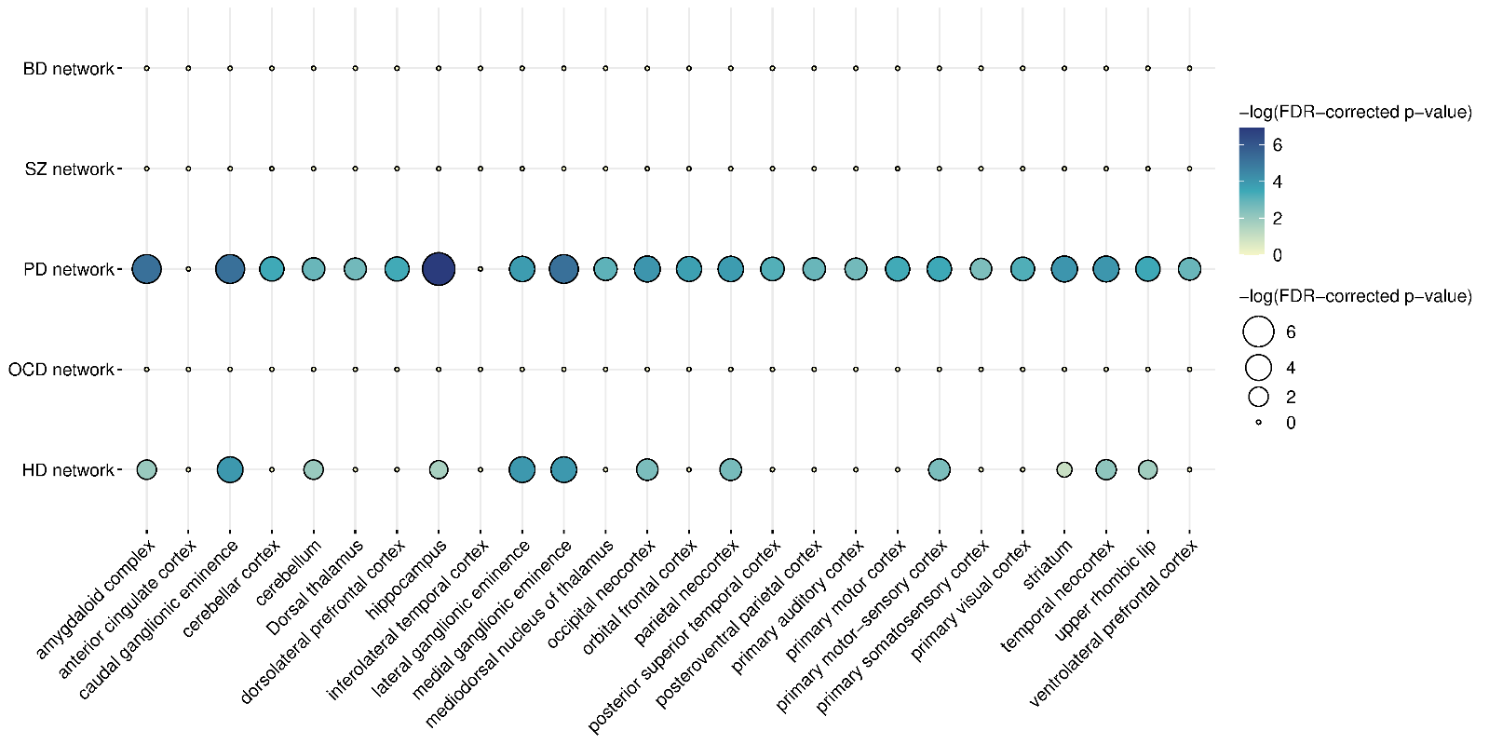Supplementary Figure 4: Regional specificities of syndrome networks. The balloon plot shows the enrichment of genes highly expressed in specific brain structures (X-axis) for different syndrome networks (Y-axis). The size and colour of the circle indicate the FDR-corrected statistical significance of enrichment (shown as -log₁₀(p-value)); larger circles and deeper circles indicate higher statistical significance.

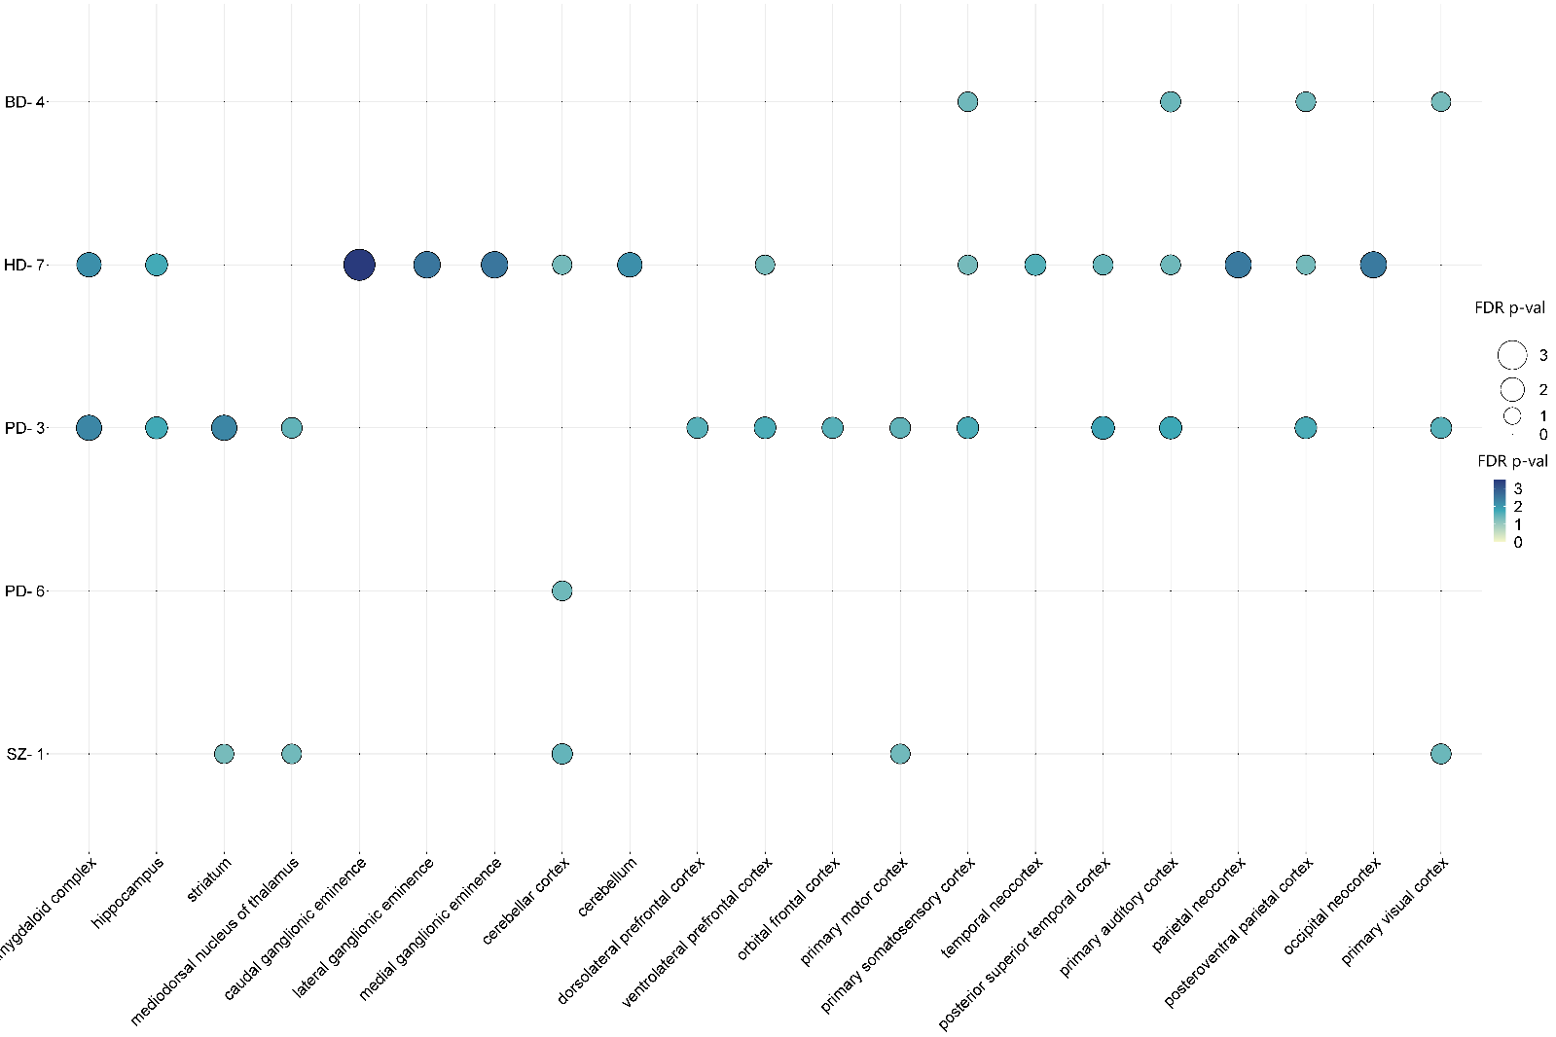
Supplementary Figure 5: Regional specificities of syndrome network modules. The balloon plot shows the enrichment of genes highly expressed in specific brain structures (X-axis) for different syndrome network modules (Y-axis). The size and colour of the circle indicate the FDR-corrected statistical significance of enrichment (shown as -log₁₀(p-value)); larger circles and deeper circles indicate higher statistical significance.

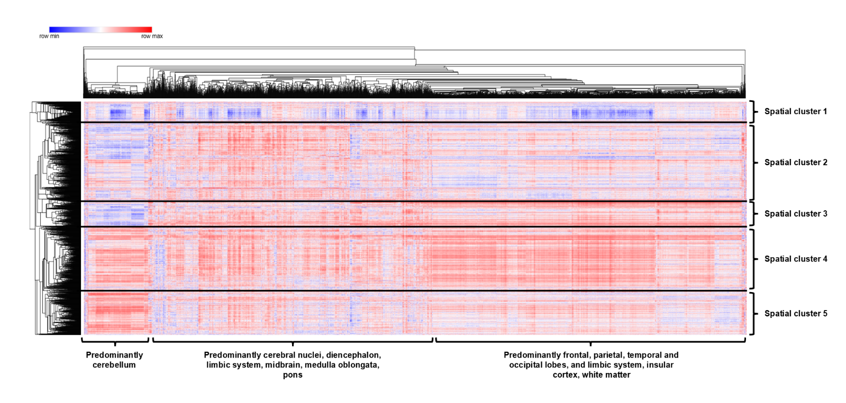
Supplementary Figure 6: Spatial clusters of syndrome network genes identified based on Allen Brain Atlas microarray data. The figure shows the expression patterns of 1746 syndrome network genes (vertical axis) across 232 brain structures (horizontal axis) in the microarray data from Allen Brain Atlas. Relative gene expression of each of the genes across the regions was hierarchically clustered by computing pairwise distances between the data points (log₂-transformed probe intensities) using Pearson correlation and identifying closely linked clusters using the average linkage method. The clustered heat map was generated using the Morpheus software.

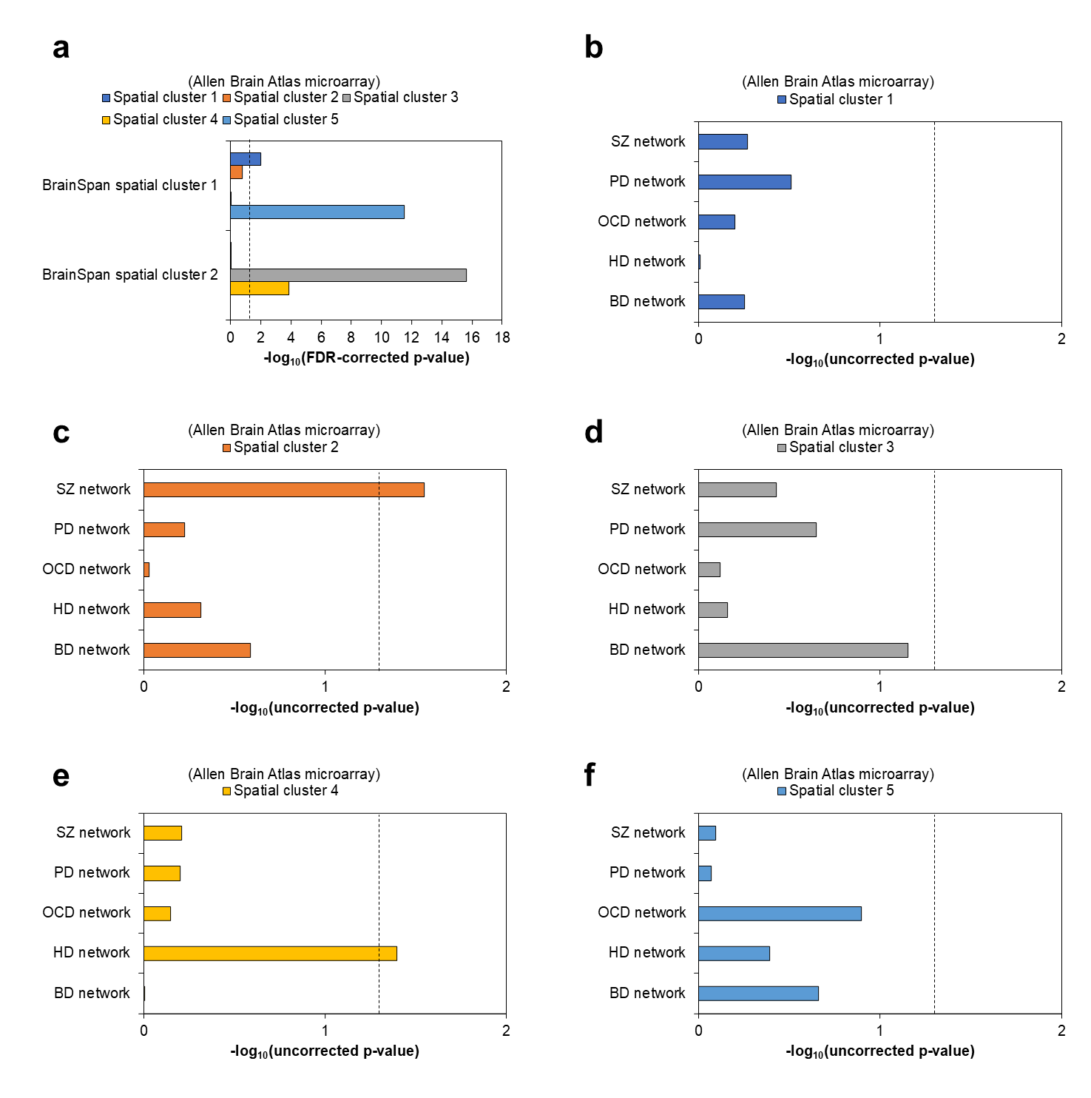Supplementary Figure 7: Syndrome affiliations of Allen Brain Atlas (ABA) microarray spatial clusters. a Statistical significance of overlap of the two BrainSpan clusters with the five ABA microarray clusters. The dashed black line indicates the significance threshold after Benjamini-Hochberg correction for multiple hypotheses (p-value < 0.05, i.e. -log₁₀(p-value) > 1.30103). Syndrome affiliations of b-f ABA microarray clusters 1-5 were examined based on statistically significant enrichment of genes belonging to specific syndrome networks. The dashed black line indicates the significance threshold (uncorrected p-value < 0.05, i.e. -log₁₀(p-value) > 1.30103); note that these p-values do not survive FDR correction.

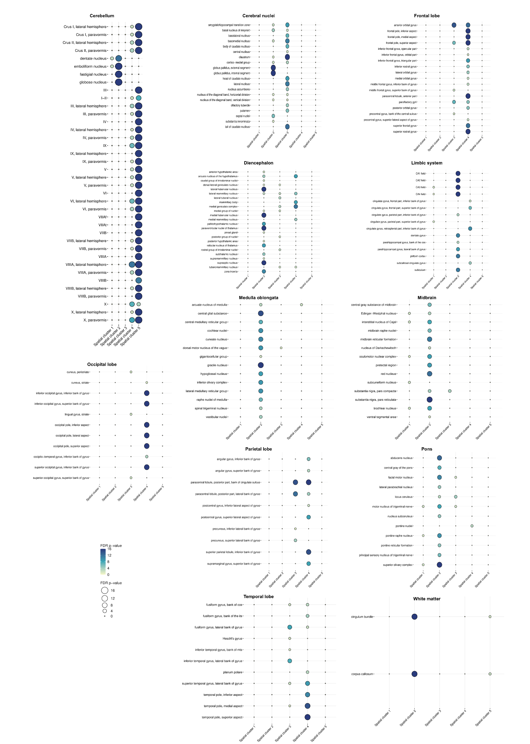
Supplementary Figure 8: Differential enrichment patterns of the ABA microarray spatial clusters in specific regions. The balloon plot shows the enrichment of ABA microarray spatial clusters (X-axis) for genes showing high expression in specific structures (Y-axis) grouped into 12 higher-tier areas. The size and colour of the circle indicate the FDR-corrected statistical significance of enrichment (shown as -log₁₀(p-value)); larger circles and deeper circles indicate higher statistical significance.

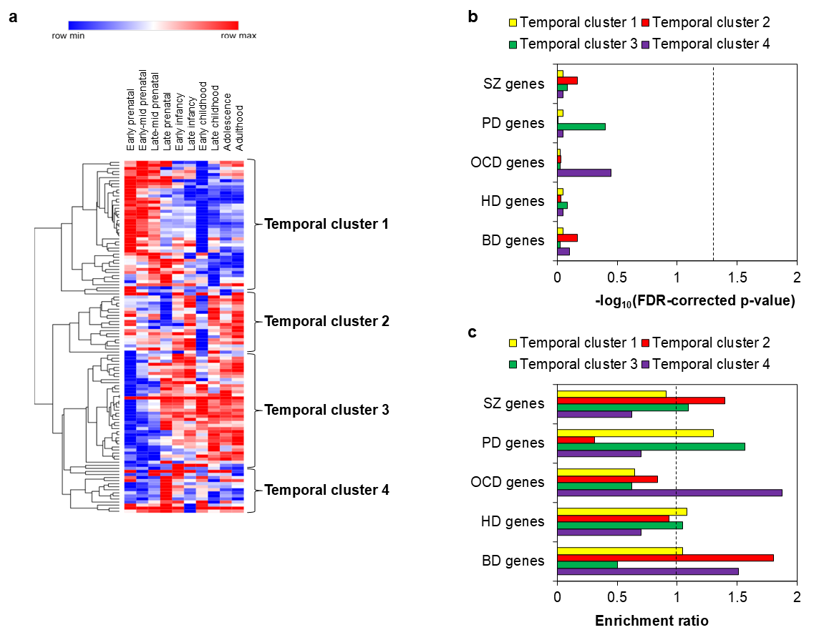
Supplementary Figure 9: Temporal clusters of syndrome-associated genes identified based on BrainSpan Atlas data. a Average expression of 115 syndrome-associated genes across ten developmental stages (labelled on top horizontal axis). Gene expression across these structures was hierarchically clustered by computing pairwise distances between the data points (log₂-transformed RPKM values) using Pearson correlation, and identifying closely linked clusters using the average linkage method. The clustered heat map was generated using the Morpheus software. b Syndrome affiliations of clusters were examined based on statistically significant enrichment of genes associated with specific syndromes. The dashed black line indicates the significance threshold after Benjamini-Hochberg correction for multiple hypotheses (p-value < 0.05, i.e. -log₁₀(p-value) > 1.30103). c Enrichment ratios of clusters for syndrome-specific genes. Ratios indicate the observed frequency of syndrome-associated genes in spatial clusters relative to their expected frequency (based on their distribution in the universal set of genes). The dashed black line indicates the enrichment threshold (ratio > 1).

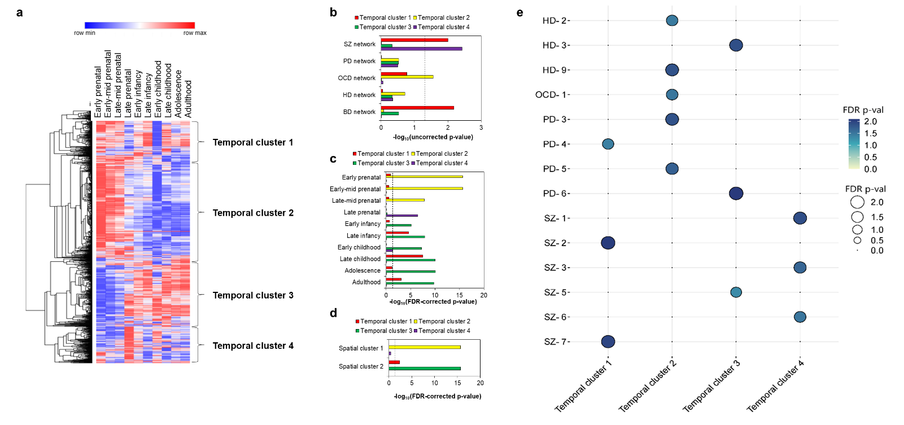Supplementary Figure 10: Temporal clusters of syndrome network genes identified based on BrainSpan Atlas data. a Average expression of 1,826 syndrome network genes across ten developmental stages (labelled on top horizontal axis). Gene expression across these structures was hierarchically clustered by computing pairwise distances between the data points (log₂-transformed RPKM values) using Pearson correlation, and identifying closely linked clusters using the average linkage method. The clustered heat map was generated using the Morpheus software. b Syndrome affiliations of clusters were examined based on statistically significant enrichment of genes belonging to specific syndrome networks. The dashed black line indicates the significance threshold (uncorrected p-value < 0.05, i.e. -log10(p-value) > 1.30103); note that these p-values do not survive FDR correction. c Enrichment of the temporal clusters for genes highly expressed in specific developmental stages. The dashed black line indicates the significance threshold after Benjamini-Hochberg correction for multiple hypotheses (p-value < 0.05, i.e. -log₁₀(p-value) > 1.30103). d Statistical significance of overlap of the two BrainSpan spatial clusters with the four temporal clusters. The dashed black line indicates the significance threshold after Benjamini-Hochberg correction for multiple hypotheses (p-value < 0.05, i.e. -log₁₀(p-value) > 1.30103). e Enrichment of the temporal clusters for specific syndrome network modules. The balloon plot shows the enrichment of the four temporal clusters (X-axis) for genes belonging to different modules (Y-axis). The size and colour of the circle indicate the FDR-corrected statistical significance of enrichment (shown as -log₁₀(p-value)); larger circles and deeper circles indicate higher statistical significance.

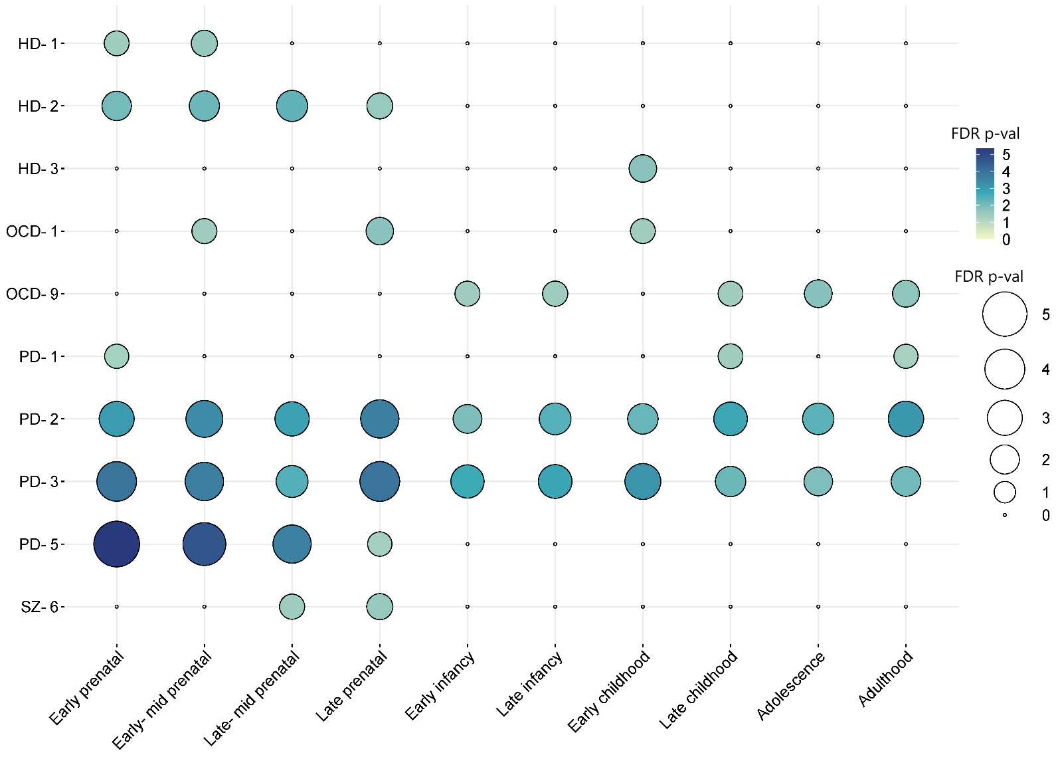
Supplementary Figure 11: Temporal specificities of syndrome network modules. The balloon plot shows the enrichment of genes highly expressed in specific developmental stages (X-axis) for different syndrome network modules (Y-axis). The size and colour of the circle indicate the FDR-corrected statistical significance of enrichment (shown as -log₁₀(p-value)); larger circles and deeper circles indicate higher statistical significance.

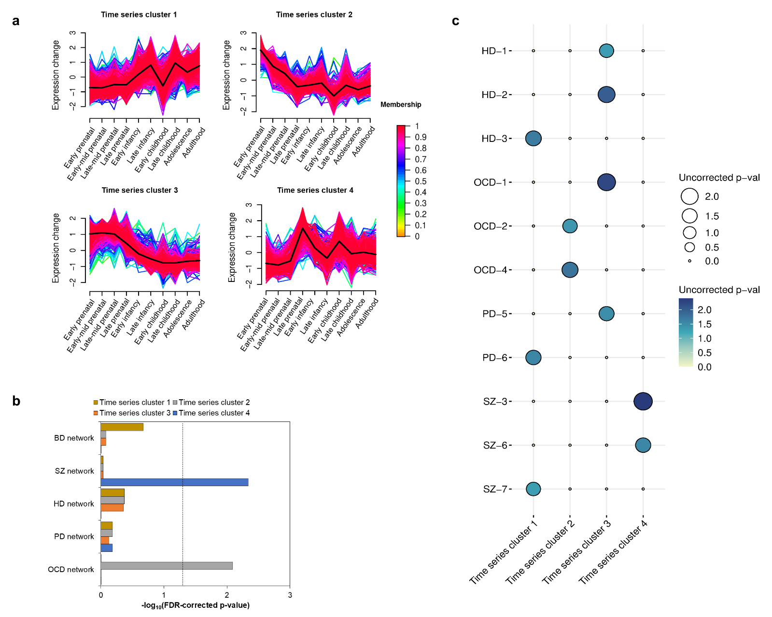
Supplementary Figure 12: Network-level time-series clusters capture distinct syndrome affiliations and temporal specificities. a Four temporally distinct clusters were identified from syndrome network genes based on expression data partitioned into ten developmental stages. Clustering was performed on log₂-transformed Reads Per Kilobase Million (RPKM) values using hierarchical clustering with average linkage. Each line in a time-series cluster represents a specific gene, with colour indicating the degree of adherence of that gene to the dominant expression trend (solid black line). b The syndrome affiliations of the time-series clusters were examined using their statistically significant enrichments among genes belonging to specific syndrome networks. The dashed black line indicates the significance threshold after Benjamini-Hochberg correction for multiple hypotheses (p-value < 0.05, i.e. -log₁₀(p-value) > 1.30103). c Enrichment of the time-series clusters for specific syndrome network modules is shown. The balloon plot shows the enrichment of the four time-series clusters (X-axis) for genes belonging to different modules (Y-axis). The size and colour of the circles indicate the FDR-corrected statistical significance of the enrichments (shown as -log₁₀(p-value)); larger circles and deeper colours correspond to higher statistical significance.

Supplementary References
1. Buniello, A. et al. The NHGRI-EBI GWAS Catalog of published genome-wide association studies, targeted arrays and summary statistics 2019. Nucleic acids research 47, D1005-D1012 (2019).
2. Keshava Prasad, T. et al. Human protein reference database—2009 update. Nucleic acids research 37, D767-D772 (2009).
3. Stark, C. et al. BioGRID: a general repository for interaction datasets. Nucleic acids research 34, D535-D539 (2006).
4. Smoot, M.E., Ono, K., Ruscheinski, J., Wang, P.-L. & Ideker, T. Cytoscape 2.8: new features for data integration and network visualization. Bioinformatics 27, 431-432 (2011).
5. Li, J. et al. Integrated systems analysis reveals a molecular network underlying autism spectrum disorders. Molecular systems biology 10, 774 (2014).
6. Bader, G.D. & Hogue, C.W. An automated method for finding molecular complexes in large protein interaction networks. BMC bioinformatics 4, 1-27 (2003).
7. Consortium, G.O. The Gene Ontology (GO) database and informatics resource. Nucleic acids research 32, D258-D261 (2004).
8. Liao, Y., Wang, J., Jaehnig, E.J., Shi, Z. & Zhang, B. WebGestalt 2019: gene set analysis toolkit with revamped UIs and APIs. Nucleic acids research (2019).
9. Shannon, P. et al. Cytoscape: a software environment for integrated models of biomolecular interaction networks. Genome research 13, 2498-2504 (2003).
10. Sunkin, S.M. et al. Allen Brain Atlas: an integrated spatio-temporal portal for exploring the central nervous system. Nucleic acids research 41, D996-D1008 (2012).
11. Consortium, G. The Genotype-Tissue Expression (GTEx) pilot analysis: Multitissue gene regulation in humans. Science 348, 648-660 (2015).
12. Hawrylycz, M.J. et al. An anatomically comprehensive atlas of the adult human brain transcriptome. Nature 489, 391 (2012).
13. Starruß, J., De Back, W., Brusch, L. & Deutsch, A. Morpheus: a user-friendly modeling environment for multiscale and multicellular systems biology. Bioinformatics 30, 1331-1332 (2014).
14. Rouillard, A.D. et al. The harmonizome: a collection of processed datasets gathered to serve and mine knowledge about genes and proteins. Database 2016(2016).
15. Consortium, G.O. The gene ontology resource: 20 years and still GOing strong. Nucleic acids research 47, D330-D338 (2019).
16. Kumar, L. & Futschik, M.E. Mfuzz: a software package for soft clustering of microarray data. Bioinformation 2, 5 (2007).

