Supplementary material

Reading guide
This file contains Supplementary Figures S1-S4 and their captions. Numerical results, participant flow, sensitivity envelopes, a column-level data dictionary and source/output integrity records are provided separately in Supplementary Data Sheet 1.
Dataset-specific roles must not be read as one shared severity scale. For Li_ST002477 and GSE272381, A/B/C denote Control/Mild/Severe. For Reyes, A/B/C denote healthy control/non-COVID ARDS/COVID-19 ARDS. Unbiased Energy U and MMD² U estimates are used for calibrated inference; non-negative empirical V forms are used for descriptive geometry. Central 95% equal-size resampling ranges are stability summaries, not confidence intervals.

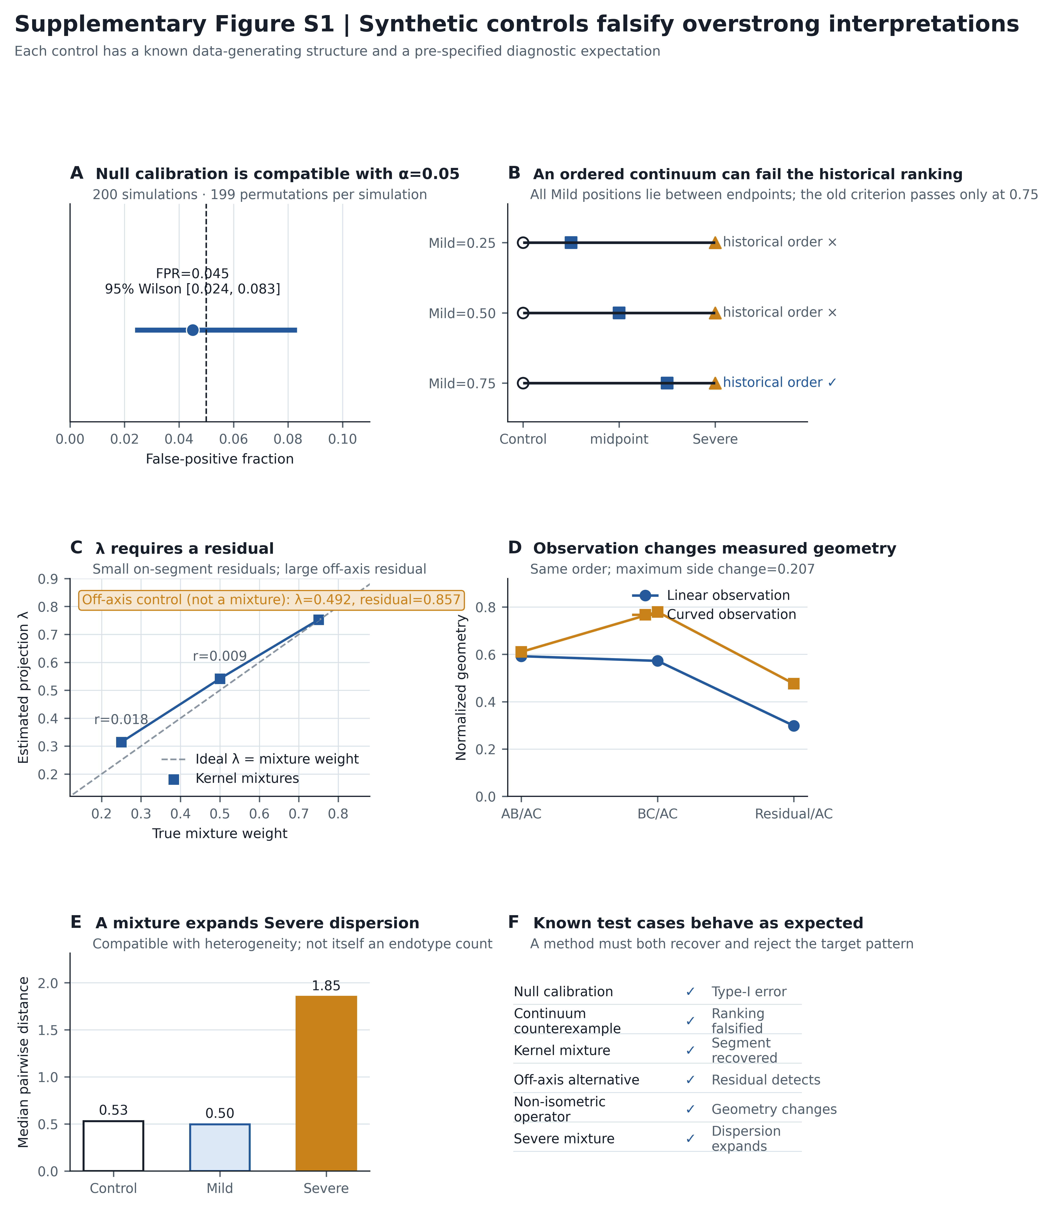
Supplementary Figure S1. Synthetic implementation controls for the revised geometry. (A) Null calibration. (B) One-dimensional counterexample demonstrating that a truly intermediate Mild state can fail the historical full ranking. (C) Kernel-mixture recovery; the off-axis control is reported separately because it has no true mixture weight, showing why projection λ requires an orthogonal residual. (D) Geometry change under a non-isometric observation operator. (E) Mixture-driven Severe dispersion. (F) Diagnostic pass ledger for all specified test cases. These controls test implementation behavior, not empirical biology.

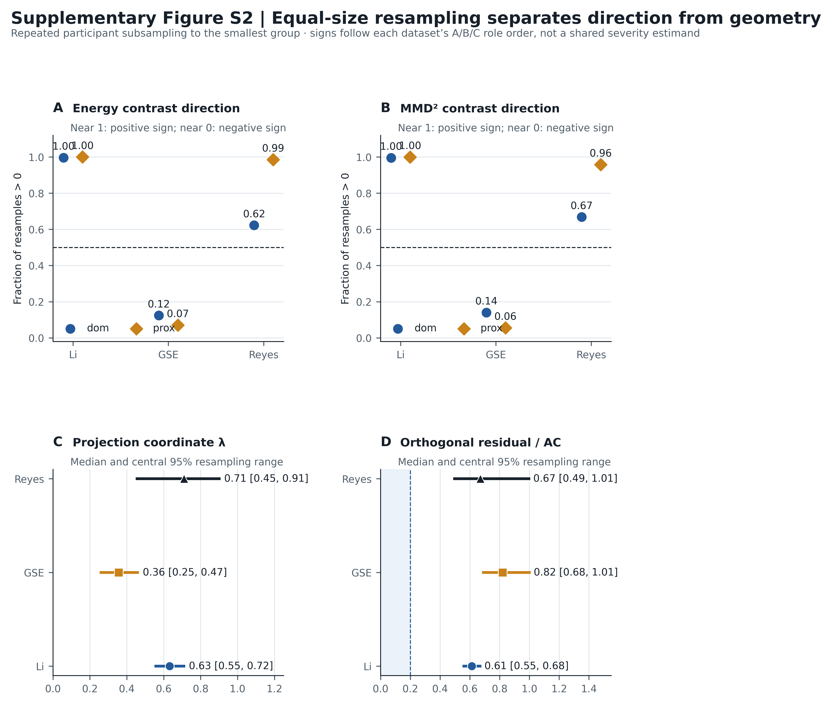
Supplementary Figure S2. Equal-size geometry sensitivity. (A-B) Fractions of repeated equal-size participant subsamples with positive dominance or relative-proximity contrasts for Energy and MMD². Signs follow each dataset's A/B/C role order and are not a shared severity estimand. (C-D) Median and central 95% resampling ranges for the kernel projection coordinate and orthogonal residual. These are stability diagnostics, not confidence intervals.

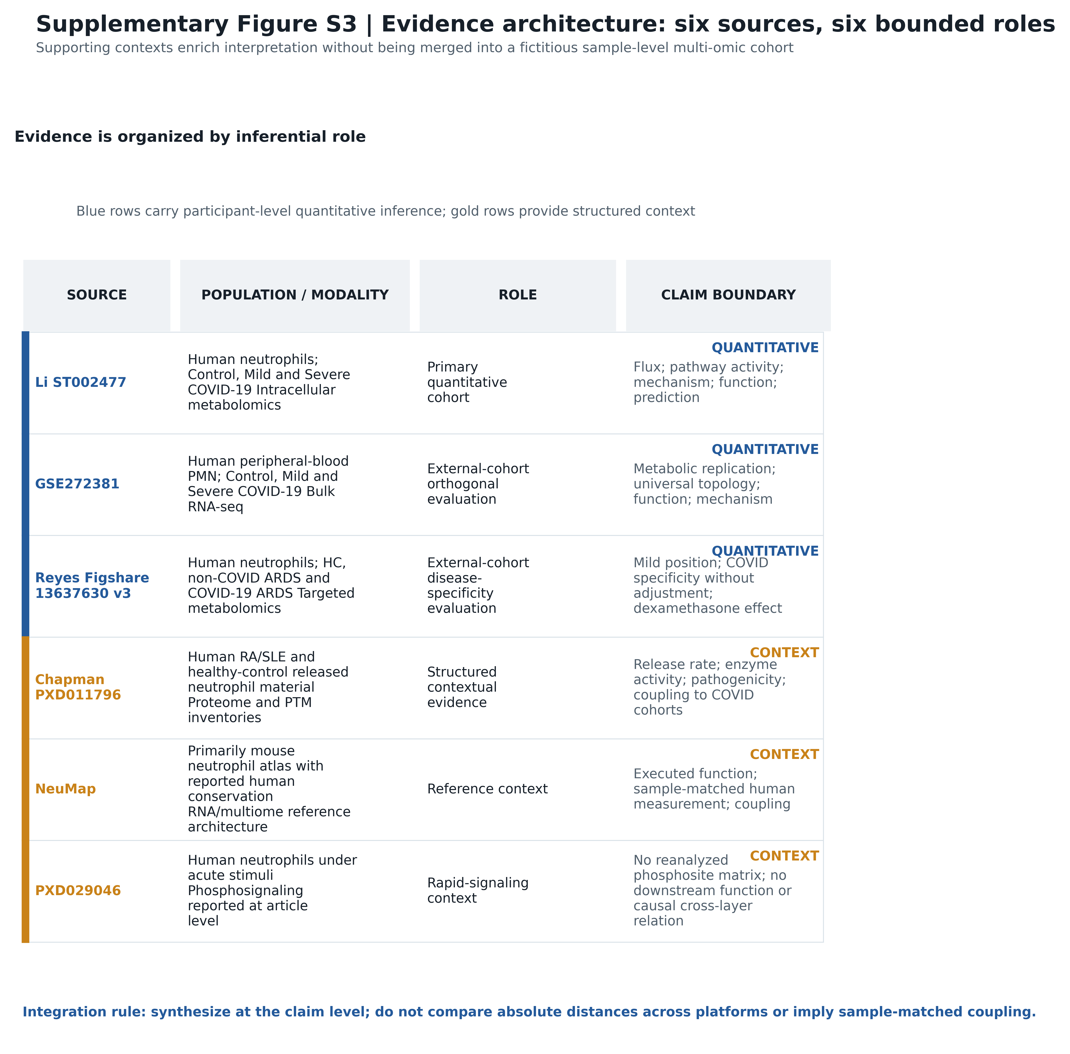
Supplementary Figure S3. Evidence architecture. Six sources are separated by population, modality, inferential role and claim boundary. The three participant-level cohorts supply quantitative inference; released-material composition, reference state architecture and rapid phosphosignaling provide structured context. No sample-level multi-omic integration or causal coupling is implied.

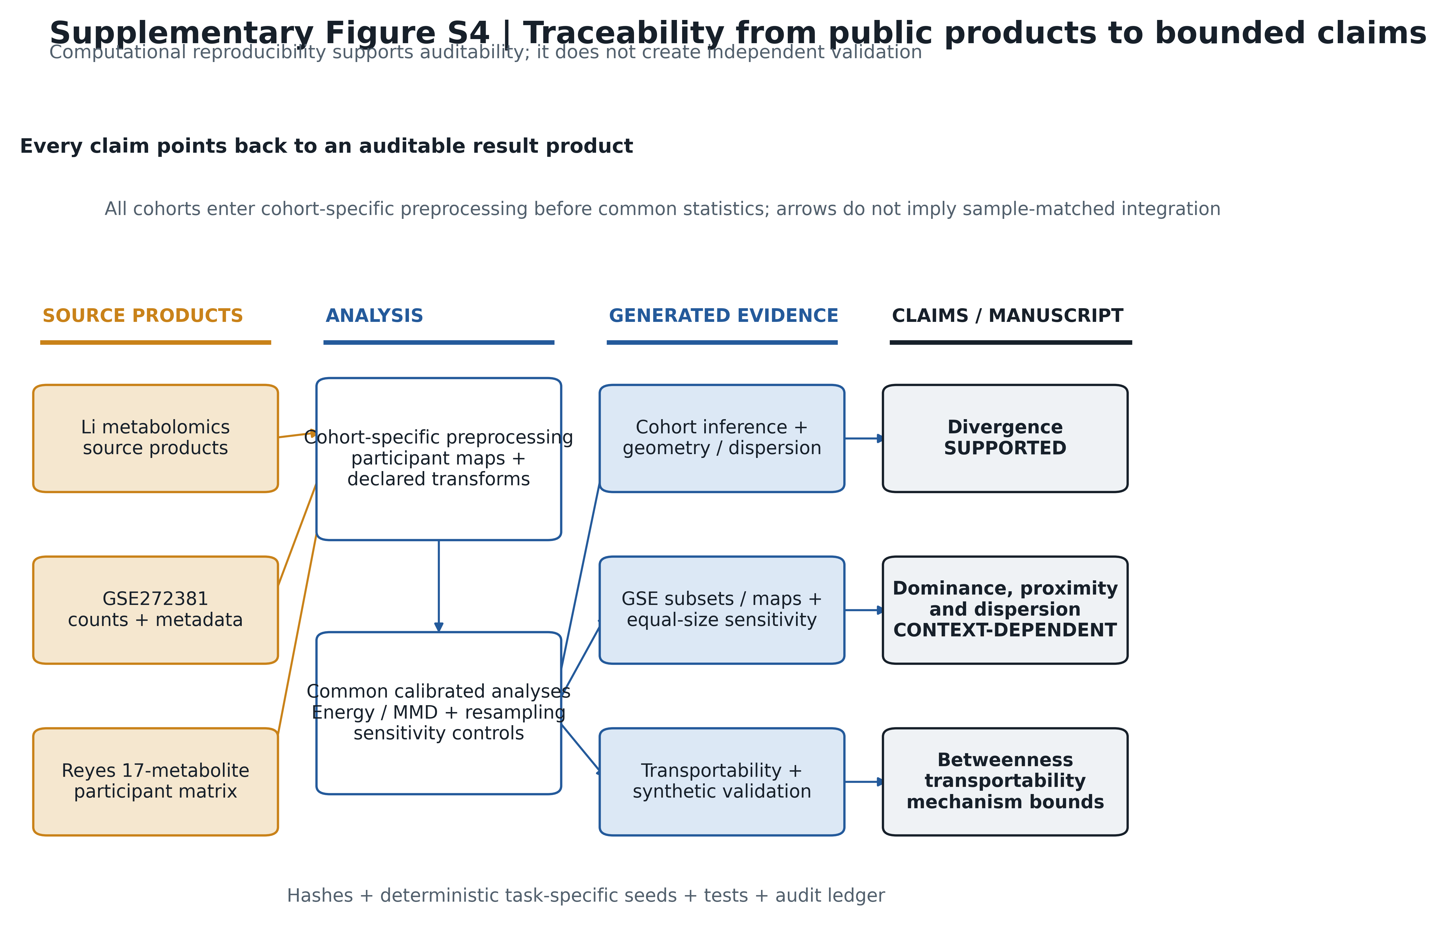
Supplementary Figure S4. Reproducibility and traceability map. Each cohort enters cohort-specific preprocessing before the common calibrated analyses. Result products then support claim-specific synthesis; arrows do not imply sample-matched integration or a one-to-one mapping between one cohort and one claim. Computational traceability supports auditability but does not convert a same-team public-data reanalysis into independent validation.

Supplementary Data Sheet 1 index
Table | Worksheet | Contents | Essential interpretation boundary
S1 | Cohort_Inference | Global and pairwise divergence, dominance and relative-proximity estimates | U estimates support calibrated inference; they are not geometric side lengths
S2 | Geometry | Non-negative sides, normalized shape, normalized triangle excess and kernel projection | Projection quantities are defined only in the kernel-mean embedding
S3 | Dispersion | Pairwise, robust-center and PCA dispersion summaries | Descriptive dispersion does not establish endotypes or mechanism
S4 | Li_Ablation | Six controlled Li analysis arms | D3 remains conditional on a fixed label-informed source product
S5 | GSE_10of12 | All 66 possible ten-of-twelve Severe subsets | Enumeration bounds unknown membership; it does not reconstruct source purity
S6 | GSE_Repeat_Maps | All six COV-34 × COV-40 preparation-time maps | Alternative preparations are not independent participants
S7 | Balanced_Sensitivity | Equal-size participant-resampling summaries | Central 95% ranges are stability diagnostics, not confidence intervals
S8 | Transportability | Li-minus-GSE normalized-geometry comparison | Observed non-invariance does not disprove every latent order
S9 | Synthetic_Validation | Typed synthetic-control ledger | Validates analysis behavior, not empirical biology
S10 | Reyes_Flow | Participant-level Reyes analysis map | Recorded dexamethasone is observational exposure
S11 | Measurement_Discriminators | Six assumption-dependent measurement discriminators matching main Table 2 | No listed measurement alone proves a universal mechanism
S12 | Claim_Boundaries | Allowed and disallowed interpretation by claim type | Claim calibration is part of the scientific result
S13 | Claim_Evidence | Evidence, counterevidence and final wording for central claims | Supporting and limiting evidence must be read together
S14 | GSE_Sample_Map | Public samples, participant mapping, inclusion status and deterministic preparation rule | The 66 subsets bound unresolved purity membership but do not reconstruct it
S15 | Run_Configuration | Seeds, permutation counts, bootstrap validity, bandwidths and software versions | Exact configuration is part of computational reproducibility
S16 | Data_Dictionary | Type, scale, definition, missingness and derivation for every submitted column | Machine-readable semantics are explicit rather than inferred from column names
S17 | Integrity | Source, code and generated-output hashes with roles kept distinct | Hash identity verifies files, not scientific validity
S18 | Table_Index | Worksheet-to-source crosswalk | Sheet numbering is an editorial index, not an inferential hierarchy
S19 | README | Scope, conventions and missing-value codes | Read before reusing any worksheet

Data-quality note
The numerical outputs were regenerated from the verified sources before assembly using 5,000 requested and 5,000 valid primary-cohort bootstrap replicates, with no failed replicates. Generated-output and source/code hashes are recorded separately. Across the submitted tables, no unexpected infinite numeric values or complete duplicate rows were detected. Expected missing values are coded and explained for quantities that were not estimated or are mathematically inapplicable. String-valued intervals were split into numeric endpoints, mixed-type synthetic-control fields were separated into typed columns, and the workbook schema stores quantitative fields as numbers rather than text.

