Supplemental Information for

Genetic βAR Signaling Modifies Clonal Hematopoiesis-Associated Mortality in Patients with Atherosclerotic Cardiovascular Disease

Supplemental Tables and Figures

Supplemental Table 1. International Classification of Diseases (ICD) codes used to define prevalent ASCVD.

Supplemental Table 2. Baseline Characteristics of the study participants between participants carrying CHIP with VAF <10% vs ≥10%.
Supplemental Table 3. Effects of CHIP with all-cause mortality and CV death.
Supplemental Table 4. Associations of Beta-blocker usage with death.
Supplemental Table 5. Interaction effects between Beta-blocker usage and CHIP for death.
Supplemental Table 6. Associations of β2-adrenergic receptor (ADRB2) rs1042718 with death.
Supplemental Table 7. Interaction effects between 5 ADRB genotypes and CHIP for all-cause mortality.
Supplemental Table 8. Interaction effects between β2-adrenergic receptor (ADRB2) rs1042718 and CHIP subtypes for all-cause mortality and CV death.
Supplemental Table 9. Interaction effects between β2-adrenergic receptor (ADRB2) rs1042718 and CHIP subtypes for all-cause mortality and CV death when excluding individuals with hematologic malignancy at baseline.
Supplemental Table 10. Associations of β2-adrenergic receptor (ADRB2) rs1042718 with CHIP and large CHIP.
Supplemental Table 11. Interaction effects between β2-adrenergic receptor (ADRB2) rs1042713 and CHIP for all-cause mortality and CV death.

Supplemental Figure 1. Flowchart of the study population.
Supplemental Figure 2. Distribution of gene-specific CHIP subtypes among CHIP carriers (VAF ≥ 2%) with established ASCVD in the UK Biobank.
Supplemental Figure 3. All-cause mortality stratified by CHIP carrier status and β2-adrenergic receptor (ADRB2) rs1042713 genotype.

Supplemental Method

1. UKB Whole exome sequencing

Genomic DNA from blood samples for the UK Biobank was sequenced at the Regeneron Genetics Center from the UK Biobank. Briefly, multiplexed DNA libraries were created and IDT’s xGen probe library was used for exome target capture. The multiplexed samples were pooled and sequenced using 75 base pair paired-end reads on the Illumina Novaseq 6000 platform using the S2 flow cells. Sample-specific FASTQ files, representing all the reads generated for that sample, were then aligned to the GRCh38 genome reference with BWA-mem2. The resultant binary alignment file (BAM) for each sample contained the mapped reads’ genomic coordinates, quality information, and the degree to which a particular read differed from the reference at its mapped location. Aligned reads in the BAM file were then evaluated to identify and flag duplicate reads with the Picard3 MarkDuplicates tool, producing an alignment file with all potential duplicate reads marked for exclusion in downstream analyses. Upon completion of variant calling, individual sample BAM files were converted to fully lossless CRAM files using samtools.

Following completion of sample sequencing, samples showing disagreement between genetically determined and reported sex, high rates of heterozygosity/contamination (D-stat > 0.4), low sequence coverage (less than 85% of targeted bases achieving 20X coverage) or genetically identified sample duplicates, and WES variants discordant with genotyping chip were excluded. The CRAM files were then submitted by the Regeneron Genetics Center to the UK Biobank data repository for distribution.

The first 50k release prioritized individuals with whole body MRI imaging data, enhanced baseline measurements, hospital episode statistics (HES), and/or linked primary care records. Additionally, one disease area was selected for enrichment: individuals with admission to hospital with a primary diagnosis of asthma (ICD10 J45 or J46). With the addition of the additional 150k samples, the 200k release includes 1,135 parent-offspring pairs, 3,855 full-sibling pairs, including 101 trios, 27 monozygotic twin pair and 7,461 second degree genetically determined relationships.
Exomes were captured with the IDT xGen Exome Research Panel v1.0 including supplemental probes. The basic design targets 39 Mbp of the human genome (19,396 genes). Multiplexed samples were sequenced with dual-indexed 75x75 bp paired-end reads on the Illumina NovaSeq 6000 platform using S2 (initial 50k release) and S4 flow cells (all subsequent samples). A different IDT v1.0 oligo lot was used in the initial 50k sequencing than was used in the sequencing of all subsequent samples. Inclusion of this information as a covariate in downstream analyses is recommended. In each sample and among targeted bases, coverage exceeds 20X at 95.2% of sites on average. Complete sequencing protocols are described in detail by the summary manuscript (https://pubmed.ncbi.nlm.nih.gov/33087929/).
Primary and secondary analysis for the UKB 200k release was performed with an updated Functional Equivalence (FE) protocol that retains original quality scores in the CRAM files (referred to as the OQFE protocol, https://www.medrxiv.org/content/10.1101/2020.11.02.20222232v1). The OQFE protocol aligns and duplicate-marks all raw sequencing data (FASTQs) to the full GRCh38 reference in an alt-aware manner as described in the original FE manuscript (https://pubmed.ncbi.nlm.nih.gov/30279509/). The OQFE CRAMs were then called for small variants with DeepVariant to generate per-sample gVCFs. These gVCFs were aggregated and joint-genotyped with GLnexus (https://www.biorxiv.org/content/10.1101/572347v1) to create a single multi-sample VCF (pVCF) for all UKB 200k samples. PLINK files were derived directly from this pVCF. To ensure that the UKB 200k data supports a broad range of analyses, no variant- or sample-level filters were pre-applied to the pVCF or PLINK files. The publicly released pVCF is the direct output of GLnexus, from which the PLINK files are generated. The pVCF contains allele-read depths and genotype qualities for all genotypes from which variant- and sample-level QC metrics can be calculated and to which analysis-specific filters can be applied. Examples of such filtering are described in the UKB 200K preprint (https://www.medrxiv.org/content/10.1101/2020.11.02.20222232v1).
Please note that the OQFE protocol differs from both previous UKB 50k releases, SPB and FE, which are described below for reference. All UKB 200k samples were processed from FASTQ with the OQFE docker (https://hub.docker.com/r/dnanexus/oqfe). Further details are provided in the WES FAQ at https://www.ukbiobank.ac.uk/media/cfulxh52/uk-biobank-exome-release-faq_v9-december-2020.pdf
In the original protocol, the SPB pipeline first converted all raw sequencing data to FASTQs according to Illumina NovaSeq best practices and aligned those reads to the GRCh38 reference genome with BWA-mem to generate a CRAM file for each sample. After read-duplicate marking, SNVs and indels were called for with WeCall (GenomicsPLC), generating a gVCF per sample. These gVCFs were joint genotyped using GLnexus (https://www.biorxiv.org/content/10.1101/572347v1) to create a single, unfiltered project-level VCF (pVCF). Genotype depth filters (SNV DP≥7, indel DP≥10) were applied prior to variant site filters requiring at least one variant genotype passing an allele balance filter (heterozygous SNV AB>0.15, heterozygous indel<0.20), resulting in a second 'filtered' pVCF.
To maximize data utility and ease of use, an additional "Functionally Equivalent" (FE) pVCF was generated from FASTQs, following the primary analysis protocol described in the 2018 manuscript (PMID: 30279509) and then subject to GATK 3.0 variant calling and hard filtering of variants with inbreeding coefficient<-0.03 or without at least one variant genotype of DP≥10, GQ≥20 and, if heterozygous, AB≥0.20.

2. UKB CHIP:

An array of Variant Allele Frequencies (VAFs) corresponding to each Clonal Haematopoiesis of Indeterminate Potential (CHIP) variant in Field 30106. Data is derived from exome sequence data Category 170.

Supplemental Table 1. International Classification of Diseases (ICD) codes used to define prevalent ASCVD.

Diagnosis | ICD codes
ASCVD | Any from 'Coronary artery disease', 'Ischemic stroke', or 'Peripheral artery disease' below
Coronary artery disease | ICD-9: 410, 4109, 411, 4119, 412, 4129, 4140, 4148, 4149  ICD-10: I21, I21.0, I21.1, I21.2, I21.3, I21.4, I21.9, I22, I22.0, I22.1, I22.8, I22.9, I23, I23.0, I23.1, I23.2, I23.3, I23.4, I23.5, I23.6, I23.8, I24, I24.0, I24.1, I24.8, I24.9, I25.1, I25.2, I25.5, I25.6, I25.8, I25.9
Ischemic stroke | ICD-9: 434, 4340, 4341, 4349, 436  ICD-10: I63, I63.0, I63.1, I63.2, I63.3, I63.4, I63.5, I63.6, I63.8, I63.9, I64
Peripheral artery disease | ICD-9: 4400, 4402, 4438, 4439  ICD-10: I70.0, I70.00, I70.01, I70.2, I70.20, I70.21, I70.8, I70.80, I70.9, I70.90, I73.8, I73.9

ASCVD, atherosclerotic cardiovascular disease; ICD, International Classification of Diseases.

Supplemental Table 2. Baseline Characteristics of the study participants between participants carrying CHIP with VAF <10% vs ≥10%.

 | Total (%) (N=10,333) | CHIP Non-carriers (%) (N=10,060) | CHIP Carriers (%) (N=177) | P
Age, yr, mean (SD) | 60.99±6.53 | 60.91±6.56 | 63.75±4.94 | 1.3E-13
Female, n (%) | 6585(63.73%) | 6401(63.63%) | 184(67.4%) | 0.585
Ever smoker, n (%) | 6045(58.5%) | 5868(58.33%) | 274(64.84%) | 0.175
BMI, kg/m², mean (SD) | 28.85±4.95 | 28.86±4.96 | 28.59±4.36 | 0.639
SBP, mmHg, mean (SD) | 142.77±19.5 | 142.67±19.48 | 146.28±19.82 | 1.9E-03
DBP, mmHg, mean (SD) | 81.37±10.7 | 81.37±10.69 | 81.29±11.04 | 0.482
C-reactive protein, mg/L, mean (SD) | 3.24±5.15 | 3.23±5.1 | 3.6±6.92 | 0.417
Diabetes mellitus, n (%) | 2249(21.77%) | 2184(21.71%) | 65(23.81%) | 0.557
HDL cholesterol, mean (SD) | 1.2±0.31 | 1.2±0.31 | 1.2±0.32 | 0.924
LDL cholesterol, mean (SD) | 1.93±0.5 | 1.93±0.5 | 1.9±0.48 | 0.466
β-blocker usage, n (%) | 3282(31.76%) | 3190(31.71%) | 92(33.7%) | 0.663
All-casue death, n (%) | 2304(22.3%) | 2205(21.92%) | 99(36.26%) | 2.9E-05
CV death, n (%) | 1074(10.39%) | 1030(10.24%) | 44(16.12%) | 7.7E-03
Follow-up days, day, median (Q1, Q3) | 6029(5667,6352) | 6033(5670.75,6353) | 5889(4773,6260) | 1.3E-05

BMI, body mass index; SBP, systolic blood pressure; DBP, diastolic blood pressure; HDL, high-density lipoprotein; LDL, low-density lipoprotein; CRP, C-reactive protein; VAF, variant allele fraction; CV death, cardiovascular death; Q1, first quartile; Q3, third quartile.
Supplemental Table 3. Effects of CHIP with all-cause mortality and CV death.

Outcome | CHIP | HR | 95%CI | P | Model
All-cause death | VAF2 | 1.72 | 1.45-2.03 | <.0001 | Model 1
All-cause death | VAF2 | 1.31 | 1.10-1.55 | 0.002 | Model 2
CV death | VAF2 | 1.77 | 1.39-2.26 | <.0001 | Model 1
CV death | VAF2 | 1.36 | 1.07-1.74 | 0.014 | Model 2
All-cause death | VAF10 | 1.79 | 1.47-2.19 | <.0001 | Model 1
All-cause death | VAF10 | 1.35 | 1.10-1.65 | 0.004 | Model 2
CV death | VAF10 | 1.70 | 1.25-2.29 | 0.001 | Model 1
CV death | VAF10 | 1.29 | 0.95-1.74 | 0.103 | Model 2
All-cause death | DNMT3A | 1.40 | 1.11-1.78 | 0.005 | Model 1
All-cause death | DNMT3A | 1.16 | 0.92-1.48 | 0.215 | Model 2
CV death | DNMT3A | 1.37 | 0.96-1.95 | 0.080 | Model 1
CV death | DNMT3A | 1.16 | 0.81-1.65 | 0.419 | Model 2
All-cause death | TET2 | 1.60 | 1.05-2.43 | 0.028 | Model 1
All-cause death | TET2 | 1.14 | 0.75-1.74 | 0.546 | Model 2
CV death | TET2 | 2.02 | 1.17-3.49 | 0.012 | Model 1
CV death | TET2 | 1.52 | 0.88-2.64 | 0.134 | Model 2
All-cause death | ASXL1 | 2.35 | 1.65-3.35 | <.0001 | Model 1
All-cause death | ASXL1 | 1.51 | 1.06-2.15 | 0.024 | Model 2
CV death | ASXL1 | 2.74 | 1.70-4.43 | <.0001 | Model 1
CV death | ASXL1 | 1.74 | 1.07-2.81 | 0.025 | Model 2

Model 1: Univariate model. Model 2: Multivariable-adjusted models were adjusted for age, sex, genetic ancestry (Principal Components [PC] 1-10), smoking status, diabetes, body mass index, systolic blood pressure (SBP), diastolic blood pressure (DBP), high-density lipoprotein (HDL) cholesterol, low-density lipoprotein (LDL) cholesterol, and C-reactive protein (CRP).
VAF, variant allele fraction; HR, hazard ratio; CI, confidence interval.

Supplemental Table 4. Associations of Beta-blocker usage with death.

Outcome | HR | 95%CI | P | Model
All-cause death | 1.11 | 1.02-1.21 | 0.019 | Model 1
All-cause death | 1.00 | 0.92-1.10 | 0.956 | Model 2
CV death | 1.35 | 1.19-1.52 | <.0001 | Model 1
CV death | 1.16 | 1.02-1.33 | 0.022 | Model 2

Model 1: Univariate model. Model 2: Multivariable-adjusted models were adjusted for age, sex, genetic ancestry (Principal Components [PC] 1-10), smoking status, diabetes, body mass index, systolic blood pressure (SBP), diastolic blood pressure (DBP), high-density lipoprotein (HDL) cholesterol, low-density lipoprotein (LDL) cholesterol, and C-reactive protein (CRP).

VAF, variant allele fraction; HR, hazard ratio; CI, confidence interval.

Supplemental Table 5. Interaction effects between Beta-blocker usage and CHIP for death.
Outcome | Interaction | HR | 95%CI | P
All-cause death | BB*VAF2 | 1.09 | 0.76-1.54 | 0.653
CV Death | BB*VAF2 | 1.00 | 0.60-1.66 | 0.989

Multivariable-adjusted models were adjusted for age, sex, genetic ancestry (Principal Components [PC] 1-10), smoking status, diabetes, body mass index, systolic blood pressure (SBP), diastolic blood pressure (DBP), high-density lipoprotein (HDL) cholesterol, low-density lipoprotein (LDL) cholesterol, and C-reactive protein (CRP).
VAF, variant allele fraction; HR, hazard ratio; CI, confidence interval.

Supplemental Table 6. Associations of β2-adrenergic receptor (ADRB2) rs1042718 with death.
Outcome | EA/NEA | HR | 95%CI | P | Model
All-cause death | A/C | 1.02 | 0.94-1.10 | 0.623 | Model 1
All-cause death | A/C | 1.03 | 0.95-1.11 | 0.486 | Model 2
CV death | A/C | 1.01 | 0.90-1.13 | 0.905 | Model 1
CV death | A/C | 1.00 | 0.90-1.13 | 0.950 | Model 2

Model 1: Univariate model. Model 2: Multivariable-adjusted models were adjusted for age, sex, genetic ancestry (Principal Components [PC] 1-10), smoking status, diabetes, body mass index, systolic blood pressure (SBP), diastolic blood pressure (DBP), high-density lipoprotein (HDL) cholesterol, low-density lipoprotein (LDL) cholesterol, and C-reactive protein (CRP).
EA/NEA, effect allele/non-effect allele; HR, hazard ratio; CI, confidence interval.

Supplemental Table 7. Interaction effects between 5 ADRB genotypes and CHIP for all-cause mortality.

Interaction | EA/NEA | Gene | HR | 95%CI | P
rs1042718*VAF2 | A/C | ADRB2 | 0.55 | 0.38-0.81 | 0.003
rs1042713*VAF2 | A/G | ADRB2 | 1.34 | 1.06-1.71 | 0.016
rs1801253*VAF2 | G/C | ADRB1 | 1.09 | 0.84-1.42 | 0.524
rs1801252*VAF2 | G/A | ADRB1 | 0.92 | 0.64-1.32 | 0.641
rs1042714*VAF2 | G/C | ADRB2 | 1.02 | 0.81-1.28 | 0.891

Multivariable-adjusted models were adjusted for age, sex, genetic ancestry (Principal Components [PC] 1-10), smoking status, diabetes, body mass index, systolic blood pressure (SBP), diastolic blood pressure (DBP), high-density lipoprotein (HDL) cholesterol, low-density lipoprotein (LDL) cholesterol, and C-reactive protein (CRP).
EA/NEA, effect allele/non-effect allele; VAF, variant allele fraction; HR, hazard ratio; CI, confidence interval.

Supplemental Table 8. Interaction effects between β2-adrenergic receptor (ADRB2) rs1042718 and CHIP subtypes for all-cause mortality and CV death.
Outcome | Interaction | EA/NEA | HR | 95%CI | P
All-cause death | rs1042718*VAF2 | A/C | 0.55 | 0.38-0.81 | 0.003
All-cause death | rs1042718*VAF10 | A/C | 0.60 | 0.38-0.94 | 0.025
All-cause death | rs1042718*DNMT3 | A/C | 0.51 | 0.28-0.93 | 0.028
All-cause death | rs1042718*ASXL1 | A/C | 0.50 | 0.23-1.07 | 0.073
All-cause death | rs1042718*TET2 | A/C | 0.58 | 0.23-1.45 | 0.243
CV death | rs1042718*VAF2 | A/C | 0.53 | 0.31-0.93 | 0.026
CV death | rs1042718*VAF10 | A/C | 0.59 | 0.30-1.15 | 0.123
CV death | rs1042718*DNMT3 | A/C | 0.54 | 0.22-1.49 | 0.163
CV death | rs1042718*ASXL1 | A/C | 0.37 | 0.13-1.10 | 0.075
CV death | rs1042718*TET2 | A/C | 0.32 | 0.12-1.73 | 0.251

Multivariable-adjusted models were adjusted for age, sex, genetic ancestry (Principal Components [PC] 1-10), smoking status, diabetes, body mass index, systolic blood pressure (SBP), diastolic blood pressure (DBP), high-density lipoprotein (HDL) cholesterol, low-density lipoprotein (LDL) cholesterol, and C-reactive protein (CRP).
EA/NEA, effect allele/non-effect allele; VAF, variant allele fraction; HR, hazard ratio; CI, confidence interval.

Supplemental Table 9. Interaction effects between β2-adrenergic receptor (ADRB2) rs1042718 and CHIP subtypes for all-cause mortality and CV death when excluding individuals with hematologic malignancy at baseline.

Outcome | Interaction | EA/NEA | HR | 95%CI | P
All-cause death | rs1042718*VAF2 | A/C | 0.59 | 0.40-0.86 | 0.007
All-cause death | rs1042718*VAF10 | A/C | 0.65 | 0.42-1.03 | 0.064
CV death | rs1042718*VAF2 | A/C | 0.59 | 0.34-1.02 | 0.061
CV death | rs1042718*VAF10 | A/C | 0.69 | 0.35-1.35 | 0.277

Multivariable-adjusted models were adjusted for age, sex, genetic ancestry (Principal Components [PC] 1-10), smoking status, diabetes, body mass index, systolic blood pressure (SBP), diastolic blood pressure (DBP), high-density lipoprotein (HDL) cholesterol, low-density lipoprotein (LDL) cholesterol, and C-reactive protein (CRP).
EA/NEA, effect allele/non-effect allele; VAF, variant allele fraction; HR, hazard ratio; CI, confidence interval.

Supplemental Table 10. Associations of β2-adrenergic receptor (ADRB2) rs1042718 with CHIP and large CHIP.

Outcome | EA/NEA | HR | 95%CI | P
VAF2 | A/C | 1.07 | 0.88-1.30 | 0.653
VAF10 | A/C | 1.01 | 0.80-1.28 | 0.989

EA/NEA, effect allele/non-effect allele; VAF, variant allele fraction; HR, hazard ratio; CI, confidence interval.

Supplemental Table 11. Interaction effects between β2-adrenergic receptor (ADRB2) rs1042713 and CHIP for all-cause mortality and CV death.
Outcome | Interaction | EA/NEA | HR | 95%CI | P
All-cause death | rs1042713*VAF2 | A/G | 1.34 | 1.06-1.71 | 0.016
All-cause death | rs1042713*VAF10 | A/G | 1.31 | 0.99-1.75 | 0.063
CV death | rs1042713*VAF2 | A/G | 1.62 | 1.15-2.29 | 0.006
CV death | rs1042713*VAF10 | A/G | 1.49 | 0.98-2.28 | 0.065

Multivariable-adjusted models were adjusted for age, sex, genetic ancestry (Principal Components [PC] 1-10), smoking status, diabetes, body mass index, systolic blood pressure (SBP), diastolic blood pressure (DBP), high-density lipoprotein (HDL) cholesterol, low-density lipoprotein (LDL) cholesterol, and C-reactive protein (CRP).
VAF, variant allele fraction; HR, hazard ratio; CI, confidence interval.

Supplemental Figures

Supplemental Figure 1. Flowchart of the study population.

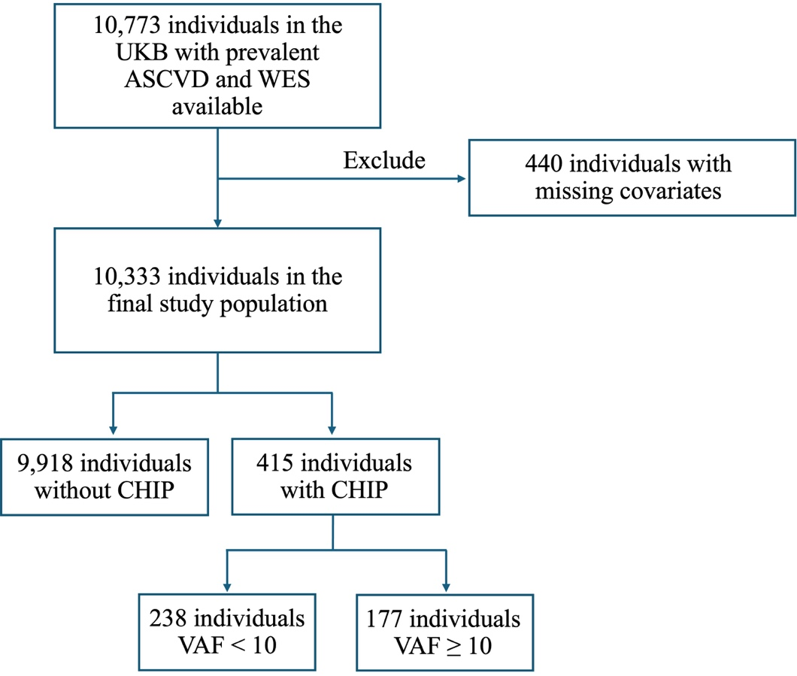

CHIP, clonal hematopoiesis of indeterminate potential; VAF, variant allele fraction.

Supplemental Figure 2. Distribution of gene-specific CHIP subtypes among CHIP carriers (VAF ≥ 2%) with established ASCVD in the UK Biobank.
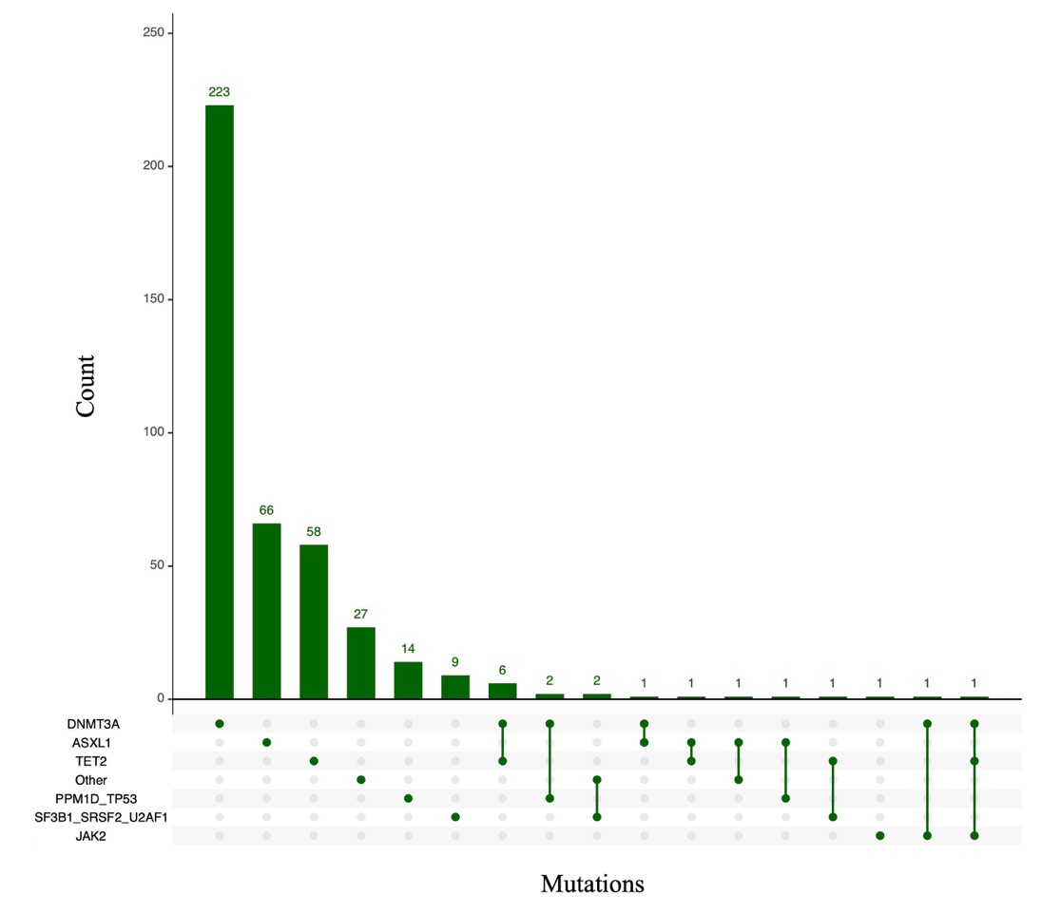

UpSet plot showing a matrix layout of the number of CHIP carriers with mutations in the indicated genes for any CHIP (VAF ≥ 2%). Each matrix column represents a combination of mutated driver genes. Each corresponding bar represents the number of participants with mutations in the indicated genes.

Supplemental Figure 3. All-cause mortality stratified by CHIP carrier status and β2-adrenergic receptor (ADRB2) rs1042713 genotype.
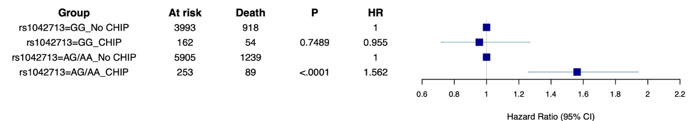

Among those with ADRB2 rs1042713 genotype AG/AA, the presence of CHIP (VAF ≥ 2%) conferred an increased risk of all-cause mortality (P_{interaction}<0.001).
CHIP, clonal hematopoiesis of indeterminate potential; VAF, variant allele fraction; HR, hazard ratio.

