Supplementary File

Title
Maternal dietary trajectories from pre-pregnancy to mid-pregnancy associated with parity-specific labor duration and premature rupture of membranes: A prospective cohort study

Table of contents
Table S1. STROBE Statement - Checklist of items that should be included in reports of cohort studies 2
Table S2. Model selection results for dietary trajectory classification 6
Table S3. Mean PCA-derived dietary factor scores across pregnancy according to dietary trajectory group 7
Table S4. Orthogonally rotated factor loadings for period-specific dietary factors at pre-pregnancy, early pregnancy, and mid-pregnancy 8
Table S5. Associations between period-specific PCA-derived dietary factor scores and continuous labor duration outcomes, stratified by parity 9
Table S6. Associations between period-specific PCA-derived dietary factor scores and prolonged labor, stratified by parity 10
Table S7. Associations between period-specific PCA-derived dietary factor scores and MSAF, PROM, and blood loss at delivery, stratified by parity 11
Figure S1. Flowchart of the Study Participants Included in the Analysis 5
Figure S2. Dietary trajectories under the candidate K = 3 solution 6

Supplementary Table S1. STROBE Statement - Checklist of items that should be included in reports of cohort studies
Manuscript: Maternal dietary trajectories from pre-pregnancy to mid-pregnancy associated with parity-specific labor duration and premature rupture of membranes
Section/topic | Item No. | Recommendation | Reported location in manuscript
Title and abstract | 1(a) | Indicate the study's design with a commonly used term in the title or the abstract | Title and Abstract (Design). The title identifies the article as a prospective cohort study, and the abstract states the study design.
 | 1(b) | Provide in the abstract an informative and balanced summary of what was done and what was found | Abstract (Background, Objective, Design, Setting(s), Participants, Methods, Results, Conclusions, and Registration).
Introduction | 2 | Explain the scientific background and rationale for the investigation being reported | Introduction, paragraphs 1–3.
 | 3 | State specific objectives, including any prespecified hypotheses | Introduction, final paragraph.
Methods | 4 | Present key elements of study design early in the paper | Methods, opening paragraph and section 2.1 Study population.
 | 5 | Describe the setting, locations, and relevant dates, including periods of recruitment, exposure, follow-up, and data collection | Methods, sections 2.1 Study population and 2.2.1 Dietary intake.
 | 6(a) | Give the eligibility criteria, and the sources and methods of selection of participants. Describe methods of follow-up | Methods, section 2.1 Study population.
 | 6(b) | For matched studies, give matching criteria and number of exposed and unexposed | Not applicable; this was not a matched study.
 | 7 | Clearly define all outcomes, exposures, predictors, potential confounders, and effect modifiers. Give diagnostic criteria, if applicable | Methods, sections 2.2.2 Outcomes, 2.2.3 Covariates, 2.3.1 Dietary factors derivation, 2.3.2 Trajectory identification, and 2.3.3 Association analyses.
 | 8 | For each variable of interest, give sources of data and details of methods of assessment (measurement). Describe comparability of assessment methods if there is more than one group | Methods, sections 2.1 Study population, 2.2.1 Dietary intake, 2.2.2 Outcomes, and 2.2.3 Covariates.
 | 9 | Describe any efforts to address potential sources of bias | Methods, sections 2.1–2.3 describe eligibility criteria, standardized data collection, hospital-recorded delivery outcomes, energy adjustment, and multivariable adjustment. Discussion, Strengths and limitations, discusses measurement error and residual confounding.
 | 10 | Explain how the study size was arrived at | Methods, section 2.1 Study population reports 642 eligible women, 9 exclusions because of implausible total energy intake, and 633 women included in the final analysis.
 | 11 | Explain how quantitative variables were handled in the analyses. If applicable, describe which groupings were chosen and why | Methods, sections 2.2.2 Outcomes, 2.2.3 Covariates, 2.3.1 Dietary factors derivation, and 2.3.3 Association analyses. Category boundaries are shown in Table 1, and the 90th percentile cut-off is described in section 2.3.3.
 | 12(a) | Describe all statistical methods, including those used to control for confounding | Methods, section 2.3 Statistical analysis, especially section 2.3.3 Association analyses. Model covariates are also described in the notes to Tables 3–5.
 | 12(b) | Describe any methods used to examine subgroups and interactions | Methods, section 2.3.3 Association analyses reports parity-stratified analyses among primiparous and multiparous women.
 | 12(c) | Explain how missing data were addressed | NA
 | 12(d) | If applicable, explain how loss to follow-up was addressed | NA
 | 12(e) | Describe any sensitivity analyses | Methods, section 2.3.3 Association analyses describes sensitivity models and supplementary period-specific dietary factor analyses.
Results | 13(a) | Report numbers of individuals at each stage of study - eg numbers potentially eligible, examined for eligibility, confirmed eligible, included in the study, completing follow-up, and analysed | Methods, section 2.1 Study population; Results, section 3.1 Participant characteristics. A participant flow diagram could also be added as a supplementary figure.
 | 13(b) | Give reasons for non-participation at each stage | Methods, section 2.1 Study population reports 9 exclusions due to implausible total energy intake; other non-participation stages are not reported.
 | 13(c) | Consider use of a flow diagram | The participant selection process is described in text in the Methods, section 2.1 Study population; no separate flow diagram was included.
 | 14(a) | Give characteristics of study participants (eg demographic, clinical, social) and information on exposures and potential confounders | Results, section 3.1 Participant characteristics and Table 1. Table 2 and Figure 1 describe dietary factors and dietary trajectory groups.
 | 14(b) | Indicate number of participants with missing data for each variable of interest | NA, no missing data were present.
 | 14(c) | Summarise follow-up time (eg, average and total amount) | Methods, section 2.1 Study population states recruitment at 12–14 weeks of gestation and follow-up until delivery. Follow-up time is not summarised as a time-to-event measure.
 | 15 | Report numbers of outcome events or summary measures over time | Results, sections 3.4–3.5 and Tables 3–5. Consider adding event counts for binary outcomes, including prolonged labor, meconium-stained amniotic fluid, and premature rupture of membranes.
 | 16(a) | Give unadjusted estimates and, if applicable, confounder-adjusted estimates and their precision (eg, 95% confidence interval). Make clear which confounders were adjusted for and why they were included | Results, sections 3.4–3.5 and Tables 3–5 provide adjusted estimates and 95% confidence intervals. Model covariates are listed in table notes. A crude model is not currently shown.
 | 16(b) | Report category boundaries when continuous variables were categorized | Methods, sections 2.2.3 Covariates and 2.3.3 Association analyses; Table 1; Table 4 note describing the parity-specific 90th percentile cut-off for prolonged labor.
 | 16(c) | If relevant, consider translating estimates of relative risk into absolute risk for a meaningful time period | NA
 | 17 | Report other analyses done - eg analyses of subgroups and interactions, and sensitivity analyses | Results, sections 3.4–3.6 and Tables 3–5. Supplementary tables report the prolonged-labor analysis and period-specific dietary factor analyses.
Discussion | 18 | Summarise key results with reference to study objectives | Discussion, opening paragraph.
 | 19 | Discuss limitations of the study, taking into account sources of potential bias or imprecision. Discuss both direction and magnitude of any potential bias | Discussion, Strengths and limitations.
 | 20 | Give a cautious overall interpretation of results considering objectives, limitations, multiplicity of analyses, results from similar studies, and other relevant evidence | Discussion, all paragraphs, and Conclusion.
 | 21 | Discuss the generalisability (external validity) of the study results | Partly addressed in Methods, section 2.1 Study population, which describes the single-hospital setting, and in Discussion, Strengths and limitations. Consider explicitly discussing generalisability.
Other information | 22 | Give the source of funding and the role of the funders for the present study and, if applicable, for the original study on which the present article is based | Funding section or title page. Ensure the funding source and the role of the funder are stated clearly.

*Give information separately for exposed and unexposed groups where applicable.
Note: An Explanation and Elaboration article discusses each checklist item and gives methodological background and published examples of transparent reporting. The STROBE checklist is best used in conjunction with this article (freely available on the Web sites of PLoS Medicine at http://www.plosmedicine.org/, Annals of Internal Medicine at http://www.annals.org/, and Epidemiology at http://www.epidem.com/). Information on the STROBE Initiative is available at www.strobe-statement.org.

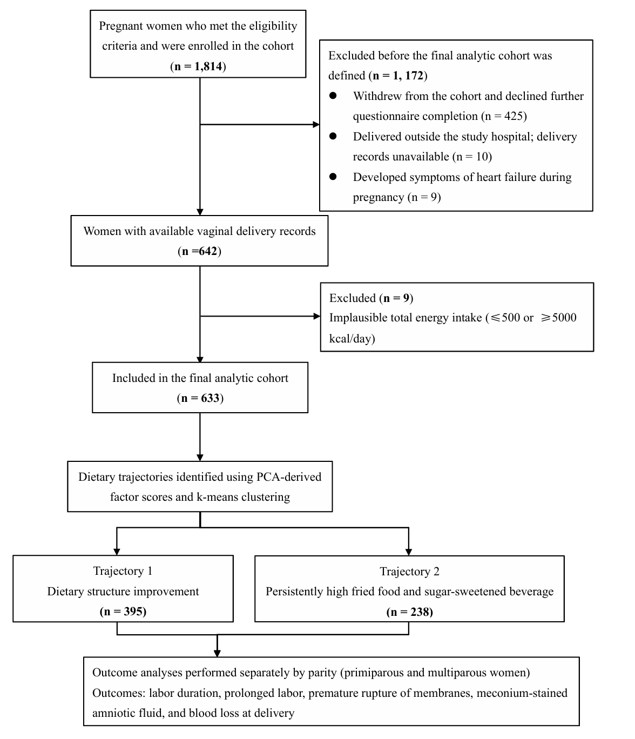
Supplementary Figure S1. Flowchart of the Study Participants Included in the Analysis

Supplementary Table S2. Model selection results for dietary trajectory classification
Number of clusters (K) | Average silhouette coefficient | Calinski–Harabasz index | Cluster sizes, n (%)
2 | 0.193 | 154.471 | Cluster 1: 395 (62.4%); Cluster 2: 238 (37.6%)
3 | 0.184 | 163.467 | Cluster 1: 158 (25.0%); Cluster 2: 257 (40.6%); Cluster 3: 218 (34.4%)
4 | 0.161 | 139.967 | Cluster 1: 177 (28.0%); Cluster 2: 80(12.6%); Cluster 3: 173 (27.3%); Cluster 4: 203 (32.1%)
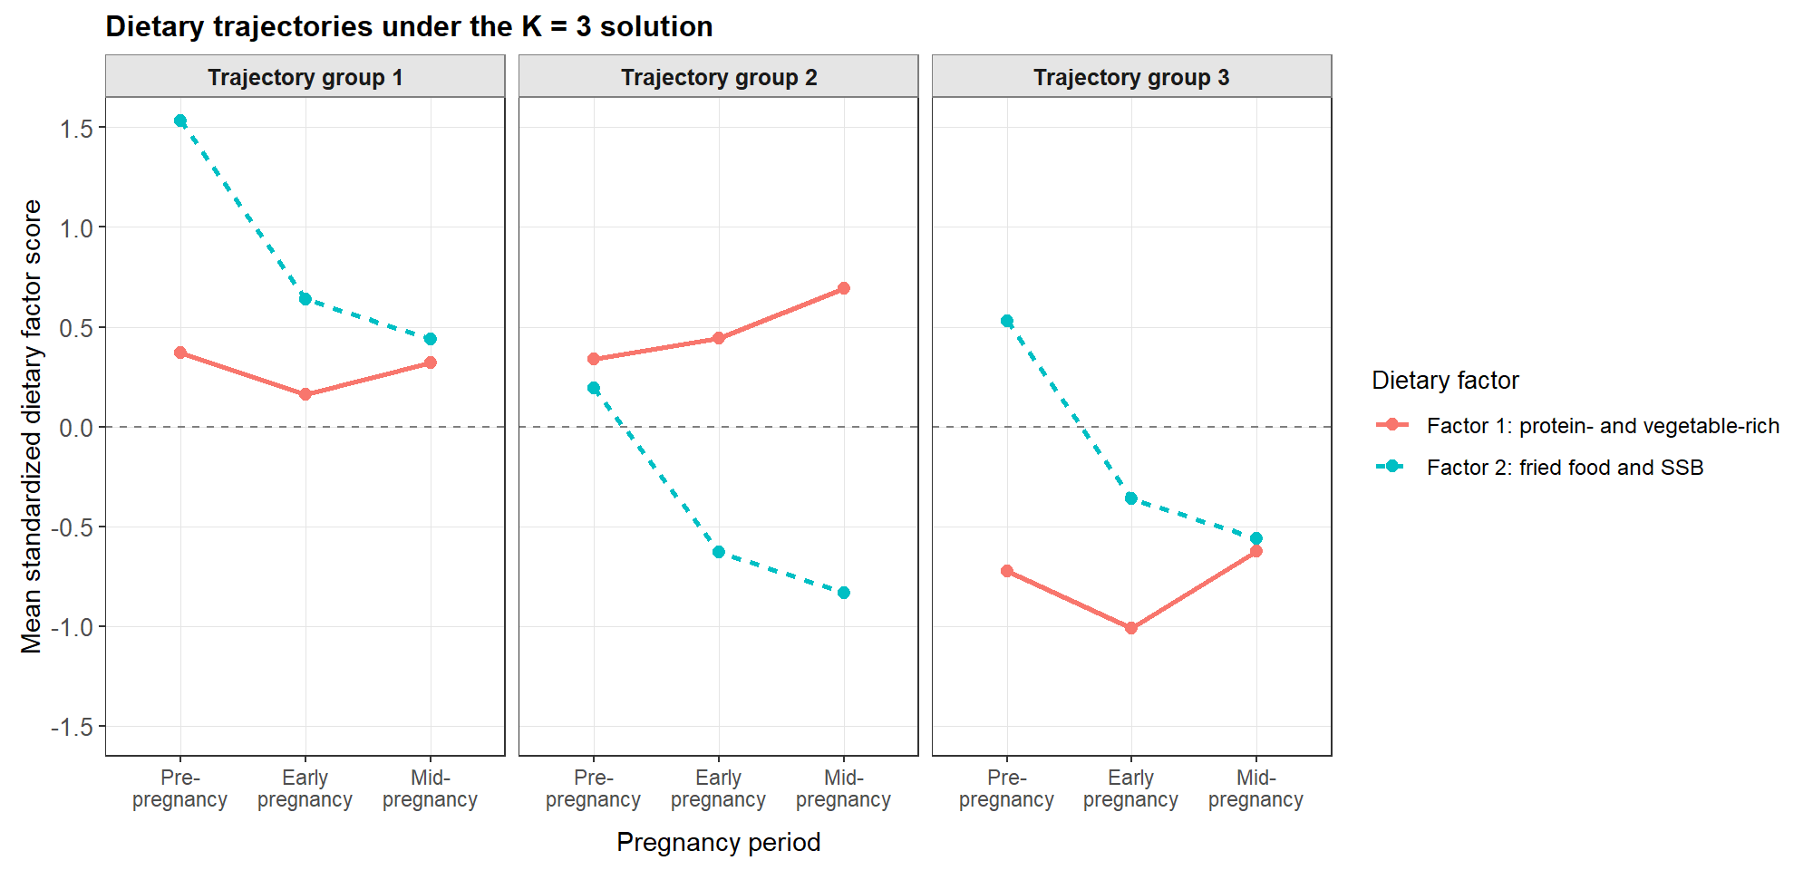

Supplementary Figure S2. Supplementary Figure 1. Dietary trajectories under the candidate K = 3 solution
Abbreviations: SSB, sugar-sweetened beverage.
Although the K = 3 solution yielded a slightly higher Calinski–Harabasz index than the K = 2 solution, the K = 2 solution had the highest average silhouette coefficient, indicating better overall cluster separation. Visual inspection of the K = 3 solution showed that the additional cluster mainly represented a subdivision of the dietary structure improvement trajectory, rather than a clearly distinct and interpretable new trajectory group. Therefore, considering clustering performance, parsimony, and interpretability together, the K = 2 solution was retained as the final dietary trajectory classification.

Supplementary Table S3. Mean PCA-derived dietary factor scores across pregnancy according to dietary trajectory group
Dietary trajectory group | PC1, pre-pregnancy | PC1, early pregnancy | PC1, mid-pregnancy | PC2, pre-pregnancy | PC2, early pregnancy | PC2, mid-pregnancy
Dietary structure improvement trajectory | -0.034 | -0.080 | 0.234 | 0.211 | -0.643 | -0.850
Persistently high fried and sweetened beverage trajectory | 0.008 | -0.208 | 0.001 | 1.363 | 0.480 | 0.285
Abbreviations: PC1, protein- and vegetable-rich pattern; PC2, fried food and sugar-sweetened beverage pattern.

Supplementary Table S4. Orthogonally rotated factor loadings for period-specific dietary factors at pre-pregnancy, early pregnancy, and mid-pregnancy
Food or food groups | Pre-pregnancy |  | Early pregnancy |  | Mid-pregnancy
Food or food groups | Factor 1 | Factor 2 | Factor 1 | Factor 2 | Factor 1 | Factor 2
Refined grainsª | -0.78 | 0.05 | -0.71 | 0.29 | -0.67 | 0.38
Coarse grains^{b} | 0.43 | -0.05 | 0.22 | -0.05 | 0.49 | -0.05
Deep-fried foods | -0.04 | 0.60 | 0.02 | 0.68 | 0.04 | 0.59
Dark- and light-colored vegetables^{c} | 0.37 | 0.01 | 0.25 | -0.03 | 0.46 | -0.13
Fungi and algae | 0.46 | 0.21 | 0.53 | 0.14 | 0.55 | 0.02
Fruits | 0.35 | -0.22 | 0.19 | -0.18 | -0.04 | -0.30
Nuts | 0.33 | -0.25 | 0.22 | -0.41 | 0.10 | -0.50
Livestock, poultry, and organ meats | 0.32 | 0.15 | 0.48 | -0.11 | 0.43 | 0.00
Aquatic products | 0.53 | -0.08 | 0.54 | 0.01 | 0.51 | -0.02
Eggs | 0.20 | -0.50 | 0.42 | -0.27 | 0.24 | -0.46
Pickled vegetables | 0.09 | 0.48 | -0.01 | 0.40 | 0.01 | 0.44
Legumes | 0.34 | 0.07 | 0.50 | 0.27 | 0.55 | 0.19
Dairy products | 0.55 | -0.06 | 0.31 | -0.45 | 0.25 | -0.36
Sugar-sweetened beverages | 0.19 | 0.66 | 0.19 | 0.59 | 0.05 | 0.57
Variance explained, % | 16.07 | 10.61 | 14.64 | 11.70 | 14.83 | 12.59
The bold font was used for absolute values that were≥0.4.
Food or food groups with a factor loading ≥0.4 or ≤-0.4 were considered to have a strong relation to a dietary factor.
PCA was conducted separately for pre-pregnancy, early pregnancy, and mid-pregnancy dietary intake. Factor scores derived from these period-specific PCA models were used in supplementary association analyses.
ª Refined grains mainly included rice, noodles, steamed bread, steamed twiste drolls, steamed dumplings and pastry.
^{b} Coarse grains mainly included oatmeal, whole-wheat bread, corn, potatoes and sweet potatoes.
^{c} Dark- and light-colored vegetables included leafy vegetables and other common vegetables, excluding fungi and algae.

Supplementary Table S5. Associations between period-specific PCA-derived dietary factor scores and continuous labor duration outcomes, stratified by parity
Outcome | Period-specific dietary factor score | Primiparous |  | Multiparous
Outcome | Period-specific dietary factor score | β (95% CI) | P | β (95% CI) | P
First stage duration | Pre-pregnancy Factor 1 score | 4.6 (-36.0, 45.1) | 0.824 | -17.0 (-52.1, 18.1) | 0.339
 | Pre-pregnancy Factor 2 score | 8.3 (-33.4, 50.0) | 0.695 | 18.8 (-14.6, 52.3) | 0.268
 | Early pregnancy Factor 1 score | -0.7 (-40.6, 39.2) | 0.973 | -9.3 (-46.2, 27.7) | 0.621
 | Early pregnancy Factor 2 score | 32.8 (-8.2, 73.8) | 0.117 | 13.2 (-18.7, 45.1) | 0.414
 | Mid-pregnancy Factor 1 score | 21.5 (-18.3, 61.2) | 0.289 | -17.6 (51.4, 16.3) | 0.306
 | Mid-pregnancy Factor 2 score | -2.2 (-43.0, 38.6) | 0.915 | 26.4 (-5.5, 58.3) | 0.104
Second stage duration | Pre-pregnancy Factor 1 score | 1.8 (-2.5, 6.1) | 0.415 | -0.2 (-3.8, 3.4) | 0.909
 | Pre-pregnancy Factor 2 score | -1.5 (-6.0, 2.9) | 0.501 | 0.0 (-3.5, 3.5) | 0.998
 | Early pregnancy Factor 1 score | 3.1 (-1.2, 7.3) | 0.158 | -0.9 (-4.7, 2.9) | 0.638
 | Early pregnancy Factor 2 score | -2.3 (-6.7, 2.1) | 0.314 | -1.5 (-4.8, 1.8) | 0.358
 | Mid-pregnancy Factor 1 score | -0.7 (-5.0, 3.6) | 0.750 | 2.0 (-1.5, 5.5) | 0.272
 | Mid-pregnancy Factor 2 score | -1.1 (-5.5, 3.2) | 0.606 | 0.4 (-3.0, 3.7) | 0.826
Third stage duration | Pre-pregnancy Factor 1 score | 0.1 (-0.2, 0.4) | 0.676 | 0.1 (-0.5, 0.7) | 0.797
 | Pre-pregnancy Factor 2 score | 0.0 (-0.3, 0.3) | 0.838 | 0.1 (-0.5, 0.7) | 0.800
 | Early pregnancy Factor 1 score | 0.1 (-0.2, 0.4) | 0.413 | -0.3 (-1.0, 0.3) | 0.284
 | Early pregnancy Factor 2 score | 0.0 (-0.3, 0.3) | 0.898 | -0.2 (-0.8, 0.3) | 0.424
 | Mid-pregnancy Factor 1 score | 0.0 (-0.3, 0.3) | 0.757 | -0.3 (-0.9, 0.3) | 0.314
 | Mid-pregnancy Factor 2 score | -0.1 (-0.4, 0.2) | 0.414 | 0.0 (-0.5, 0.6) | 0.916
Total labor duration | Pre-pregnancy Factor 1 score | 1.7 (-40.0, 43.4) | 0.935 | -17.1 (-52.7, 18.4) | 0.342
 | Pre-pregnancy Factor 2 score | 9.0 (-33.9, 51.8) | 0.681 | 18.9 (-15.0, 52.8) | 0.273
 | Early pregnancy Factor 1 score | 1.3 (-39.7, 42.3) | 0.952 | -10.5 (-48.0, 26.9) | 0.579
 | Early pregnancy Factor 2 score | 28.9 (-13.3, 71.1) | 0.180 | 11.5 (-20.9, 43.8) | 0.485
 | Mid-pregnancy Factor 1 score | 18.6 (-22.4, 59.5) | 0.373 | -15.9 (-50.3, 18.4) | 0.361
 | Mid-pregnancy Factor 2 score | -0.4 (-42.3, 41.6) | 0.986 | 26.8 (-5.5, 59.2) | 0.104
Abbreviations: CI, confidence interval; PCA, principal component analysis.
Notes: Values are β coefficients and 95% confidence intervals estimated using linear regression models. β coefficients represent the mean difference in labor duration, in minutes, per 1-standard-deviation increase in each period-specific PCA-derived dietary factor score. Results are from the main adjusted model. Model was adjusted for maternal age, educational level, income, ethnicity, pre-pregnancy body mass index, nutrition guidance before pregnancy, conception mode, pre-pregnancy smoking, alcohol consumption, regular physical activity, and sleep duration.

Supplementary Table S6. Associations between period-specific PCA-derived dietary factor scores and prolonged labor, stratified by parity
Outcome | Period-specific dietary factor score | Primiparous |  | Multiparous
Outcome | Period-specific dietary factor score | RR (95% CI) | P | RR (95% CI) | P
Prolonged first stage of labor | Pre-pregnancy Factor 1 score | 1.153 (0.879, 1.513) | 0.305 | 0.831 (0.384, 1.796) | 0.637
 | Pre-pregnancy Factor 2 score | 0.943 (0.702, 1.265) | 0.694 | 1.301 (0.794, 2.130) | 0.296
 | Early pregnancy Factor 1 score | 0.894 (0.660, 1.211) | 0.469 | 0.794 (0.423, 1.488) | 0.471
 | Early pregnancy Factor 2 score | 1.104 (0.833, 1.463) | 0.490 | 1.401 (0.864, 2.270) | 0.171
 | Mid-pregnancy Factor 1 score | 0.917 (0.679, 1.237) | 0.570 | 0.875 (0.536, 1.431) | 0.595
 | Mid-pregnancy Factor 2 score | 0.890 (0.633, 1.252) | 0.504 | 2.043 (1.467, 2.844) | ＜0.001
Prolonged second stage of labor | Pre-pregnancy Factor 1 score | 1.141 (0.874, 1.491) | 0.332 | 0.686 (0.441, 1.067) | 0.095
 | Pre-pregnancy Factor 2 score | 0.847 (0.633, 1.134) | 0.264 | 1.335 (0.737, 2.420) | 0.341
 | Early pregnancy Factor 1 score | 1.315 (0.992, 1.743) | 0.057 | 0.979 (0.563, 1.704) | 0.941
 | Early pregnancy Factor 2 score | 0.979 (0.736, 1.303) | 0.887 | 0.727 (0.403, 1.311) | 0.290
 | Mid-pregnancy Factor 1 score | 1.021 (0.795, 1.311) | 0.874 | 1.506 (0.710, 3.196) | 0.286
 | Mid-pregnancy Factor 2 score | 1.000 (0.776, 1.289) | 0.997 | 1.083 (0.679, 1.726) | 0.739
Prolonged third stage of labor | Pre-pregnancy Factor 1 score | 0.917 (0.698, 1.204) | 0.533 | 0.988 (0.653, 1.495) | 0.954
 | Pre-pregnancy Factor 2 score | 0.814 (0.610, 1.085) | 0.160 | 2.250 (1.400, 3.614) | 0.001
 | Early pregnancy Factor 1 score | 0.934 (0.674, 1.295) | 0.682 | 0.876 (0.559, 1.372) | 0.562
 | Early pregnancy Factor 2 score | 0.914 (0.671, 1.244) | 0.566 | 0.870 (0.585, 1.293) | 0.491
 | Mid-pregnancy Factor 1 score | 0.837 (0.648, 1.081) | 0.173 | 0.674 (0.391, 1.164) | 0.157
 | Mid-pregnancy Factor 2 score | 0.771 (0.569, 1.043) | 0.092 | 1.550 (1.072, 2.241) | 0.020
Prolonged total labor duration | Pre-pregnancy Factor 1 score | 1.110 (0.841, 1.466) | 0.460 | 0.936 (0.489, 1.791) | 0.841
 | Pre-pregnancy Factor 2 score | 1.034 (0.775, 1.379) | 0.821 | 1.386 (0.837, 2.298) | 0.205
 | Early pregnancy Factor 1 score | 0.893 (0.656, 1.217) | 0.474 | 0.672 (0.404, 1.117) | 0.125
 | Early pregnancy Factor 2 score | 1.056 (0.771, 1.446) | 0.733 | 1.336 (0.772, 2.314) | 0.301
 | Mid-pregnancy Factor 1 score | 0.835 (0.621, 1.123) | 0.232 | 0.748 (0.427, 1.310) | 0.309
 | Mid-pregnancy Factor 2 score | 0.953 (0.692, 1.312) | 0.767 | 1.972 (1.401, 2.775) | ＜0.001
Abbreviations: RR, relative risk; CI, confidence interval; PCA, principal component analysis.
Notes: Values are relative risks and 95% confidence intervals estimated using Poisson regression models with robust standard errors. Relative risks represent the risk of P90-defined prolonged labor per 1-standard-deviation increase in each period-specific PCA-derived dietary factor score. Results are from the main adjusted model. Model was adjusted for maternal age, educational level, income, ethnicity, pre-pregnancy body mass index, nutrition guidance before pregnancy, conception mode, pre-pregnancy smoking, alcohol consumption, regular physical activity, and sleep duration.Analyses were stratified by parity. Prolonged labor was defined as labor duration greater than or equal to the 90th percentile within each parity stratum.

Supplementary Table S7. Associations between period-specific PCA-derived dietary factor scores and MSAF, PROM, and blood loss at delivery, stratified by parity
Outcome | Period-specific dietary factor score | Primiparous |  | Multiparous
Outcome | Period-specific dietary factor score | OR/β (95% CI) | P | OR/β (95% CI) | P
MSAF | Pre-pregnancy Factor 1 score | 0.901 (0.677, 1.198) | 0.471 | 1.473 (0.489, 4.432) | 0.491
 | Pre-pregnancy Factor 2 score | 0.944 (0.690, 1.291) | 0.718 | 0.528 (0.182, 1.535) | 0.241
 | Early pregnancy Factor 1 score | 0.843 (0.631, 1.127) | 0.248 | 2.665 (0.753, 9.440) | 0.129
 | Early pregnancy Factor 2 score | 1.004 (0.738, 1.367) | 0.980 | 0.849 (0.308, 2.340) | 0.751
 | Mid-pregnancy Factor 1 score | 0.852 (0.647, 1.122) | 0.255 | 0.832 (0.320, 2.161) | 0.705
 | Mid-pregnancy Factor 2 score | 1.097 (0.812, 1.481) | 0.547 | 1.267 (0.448, 3.585) | 0.656
PROM | Pre-pregnancy Factor 1 score | 0.986 (0.797, 1.221) | 0.900 | 1.162 (0.682, 1.980) | 0.581
 | Pre-pregnancy Factor 2 score | 1.351 (1.083, 1.686) | 0.008 | 1.359 (0.841, 2.195) | 0.210
 | Early pregnancy Factor 1 score | 1.096 (0.885, 1.357) | 0.399 | 0.722 (0.429, 1.215) | 0.220
 | Early pregnancy Factor 2 score | 1.099 (0.885, 1.365) | 0.393 | 0.855 (0.548, 1.334) | 0.491
 | Mid-pregnancy Factor 1 score | 1.050 (0.850, 1.297) | 0.653 | 1.024 (0.621, 1.690) | 0.926
 | Mid-pregnancy Factor 2 score | 1.103 (0.891, 1.365) | 0.369 | 0.860 (0.554, 1.334) | 0.501
Blood loss at delivery | Pre-pregnancy Factor 1 score | 5.3 (-9.6, 20.2) | 0.486 | -11.7 (-50.4, 27.1) | 0.552
 | Pre-pregnancy Factor 2 score | -14.4 (-29.7, 0.8) | 0.063 | -14.2 (-51.2, 22.8) | 0.449
 | Early pregnancy Factor 1 score | -0.3 (-15.0, 14.3) | 0.966 | 17.7 (-23.0, 58.3) | 0.392
 | Early pregnancy Factor 2 score | -13.4 (-28.4, 1.7) | 0.081 | -12.7 (-47.9, 22.5) | 0.477
 | Mid-pregnancy Factor 1 score | 13.3 (-1.2, 27.9) | 0.072 | -13.4 (-50.8, 24.1) | 0.481
 | Mid-pregnancy Factor 2 score | -7.0 (-22.0, 8.0) | 0.359 | -7.0 (-42.5, 28.5) | 0.698
Bold font indicated results that were statistically significant (P < 0.05).
Abbreviations: CI, confidence interval; OR, odds ratio; β, regression coefficient; MSAF, meconium-stained amniotic fluid; PROM, premature rupture of membranes.
Notes: Values are odds ratios and 95% confidence intervals for MSAF and PROM, and β coefficients and 95% confidence intervals for blood loss at delivery. Results are from the main adjusted model. Model was adjusted for maternal age, educational level, income, ethnicity, pre-pregnancy body mass index, nutrition guidance before pregnancy, conception mode, pre-pregnancy smoking, alcohol consumption, regular physical activity, and sleep duration. Analyses were stratified by parity. ORs and β coefficients represent the change in outcome per 1-standard-deviation increase in each period-specific PCA-derived dietary factor score.

