Supplementary Tables and Figures

Supplementary Table 1: Sensitivity Analysis: Program-Specific Associations with Overweight and Obesity Among Adults Enrolled in One Program Only
Program | n | APR | 95% CI | p-value | β (BMI difference) | p-value
Obesity (APR)
SNAP only | 3,479 | 1.17 | (1.00, 1.37) | 0.045 | +0.79 | 0.0001
Non-SNAP (ref) | 10,310 | — | — | — | — | —
SSI only | 1,062 | 0.87 | (0.69, 1.09) | 0.219 | −0.41 | 0.109
Non-SSI (ref) | 13,861 | — | — | — | — | —
CalWORKs only ‡ | 182 | 0.89 | (0.50, 1.57) | 0.687 | −0.81 | 0.183
Non-CalWORKs (ref) | 15,068 | — | — | — | — | —
Overweight (APR)
SNAP only | 3,479 | 0.99 | (0.83, 1.17) | 0.901 | — | —
Non-SNAP (ref) | 10,310 | — | — | — | — | —
SSI only | 1,062 | 0.91 | (0.71, 1.16) | 0.432 | — | —
Non-SSI (ref) | 13,861 | — | — | — | — | —
CalWORKs only ‡ | 182 | 1.47 | (1.05, 2.07) | 0.027* | — | —
Non-CalWORKs (ref) | 15,068 | — | — | — | — | —
APR, adjusted prevalence ratio; CI = Confidence Interval; BMI = Body Mass Index.
All models adjusted for year, age, sex, race/ethnicity, birthplace, education, household size, smoking status, number of cigarettes, health insurance, and food security level.
Survey-weighted analyses using jackknife variance estimation (RAKEDW0; 80 replicate weights). Data source: California Health Interview Survey (CHIS), 2019–2024.
SNAP = Supplemental Nutrition Assistance Program; SSI = Supplemental Security Income; CalWORKs = California Work Opportunity and Responsibility to Kids.
† Each program's comparison group consists of non-participants in that program who also do not participate in the other two programs.
‡ CalWORKs only group: n = 182; results should be interpreted with caution due to limited statistical power.
* p < 0.05.

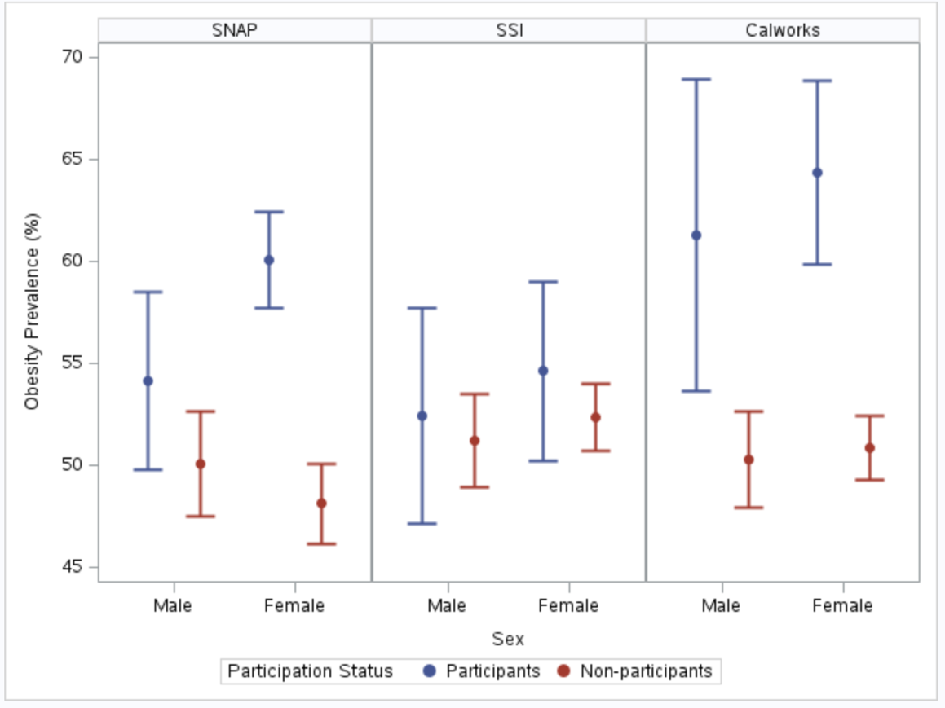

Supplementary Figure 1. Obesity prevalence by sex and participation status in SNAP, SSI, and CalWORKs

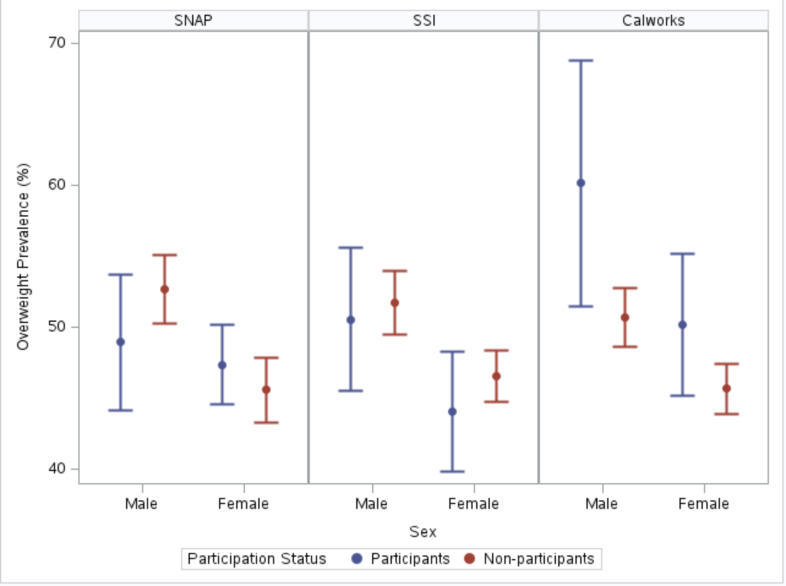
Supplementary Figure 2. Overweight prevalence by sex and participation status in SNAP, SSI, and CalWORKs

