SUPPLEMENTARY INFORMATION

Supplementary Table S1. Results of models testing associations of the combined fire frequency–seasonality (FF–FS) regime, fire frequency and fire seasonality with carbon stocks and allocation across all three ecosystems. Carbon responses were analysed with Gaussian models after log10(x + 0.01) transformation, except woody-vegetation carbon occurrence (p/a), which was analysed with a binomial GLM; positive woody-vegetation carbon values (p) were analysed separately with a Gaussian model. R² values are the semi-partial proportions of variance (Gaussian models) or deviance (binomial models) uniquely attributable to the fire term after accounting for preceding model terms. P values are from ANOVA tests of the fire term. Bold face indicates significance at p <0.05.
Full model | FF-FS |  | Fire frequency |  | Fire seasonality
 | R² | p | R² | p | R² | p
Ecosystem C | 0.00 | 0.97 | 0.00 | 0.58 | 0.00 | 0.87
AGC:BGC | 0.14 | 0.00 | 0.15 | 0.00 | 0.00 | 0.75
AGC | 0.11 | 0.00 | 0.11 | 0.00 | 0.00 | 0.88
BGC | 0.06 | 0.10 | 0.05 | 0.01 | 0.00 | 0.67
Woody vegetation C p/a | 0.25 | 0.00 | 0.25 | 0.00 | 0.00 | 1.00
Woody vegetation C p | 0.01 | 0.56 | 0.01 | 0.30 | 0.00 | 0.73
Ground vegetation C | 0.16 | 0.00 | 0.16 | 0.00 | 0.00 | 0.63
Litter C | 0.10 | 0.00 | 0.08 | 0.00 | 0.00 | 0.52
Fine roots C | 0.14 | 0.06 | 0.06 | 0.00 | 0.00 | 0.86
Topsoil C | 0.08 | 0.04 | 0.07 | 0.00 | 0.00 | 0.71

Supplementary Table S2. Ecosystem-specific model results for medium-altitude grasslands, testing associations of the combined fire frequency–seasonality (FF–FS) regime, fire frequency and fire seasonality with carbon stocks and allocation. Carbon responses were analysed with Gaussian models after log10(x + 0.01) transformation, except woody-vegetation carbon occurrence (p/a), which was analysed with a binomial GLM; positive woody-vegetation carbon values (p) were analysed separately with a Gaussian model. R² values are the proportions of variance or deviance explained by the fire term, and P values are from ANOVA tests of that term. Bold face indicates significance at p <0.05.
Medium altitude grasslands | FF-FS |  | Fire frequency |  | Fire seasonality
 | R² | p | R² | p | R² | p
Ecosystem C | 0.17 | 0.56 | 0.05 | 0.32 | 0.02 | 0.72
AGC:BGC | 0.73 | 0.00 | 0.65 | 0.00 | 0.16 | 0.33
AGC | 0.60 | 0.00 | 0.58 | 0.00 | 0.06 | 0.54
BGC | 0.41 | 0.08 | 0.24 | 0.03 | 0.12 | 0.40
Woody vegetation C p/a | 0.41 | 0.04 | 0.38 | 0.00 | 0.05 | 0.46
Woody vegetation C p | 0.36 | 0.51 | 0.25 | 0.31 | 0.92 | 0.17
Ground vegetation C | 0.58 | 0.00 | 0.56 | 0.00 | 0.07 | 0.54
Litter C | 0.54 | 0.02 | 0.28 | 0.02 | 0.22 | 0.25
Fine roots C | 0.24 | 0.36 | 0.29 | 0.02 | 0.02 | 0.76
Topsoil C | 0.47 | 0.04 | 0.30 | 0.01 | 0.13 | 0.37

Supplementary Table S3. Ecosystem-specific model results for high-altitude grasslands, testing associations of the combined fire frequency–seasonality (FF–FS) regime, fire frequency and fire seasonality with carbon stocks and allocation. Carbon responses were analysed with Gaussian models after log10(x + 0.01) transformation, except woody-vegetation carbon occurrence (p/a), which was analysed with a binomial GLM; positive woody-vegetation carbon values (p) were analysed separately with a Gaussian model. R² values are the proportions of variance or deviance explained by the fire term, and P values are from ANOVA tests of that term. Bold face indicates significance at p <0.05.
High altitude grasslands | Regime |  | Fire frequency |  | Fire seasonality
 | R² | p | R² | p | R² | p
Ecosystem C | 0.01 | 0.99 | 0.22 | 0.84 | 0.01 | 0.81
AGC:BGC | 0.70 | 0.00 | 0.79 | 0.00 | 0.08 | 0.49
AGC | 0.53 | 0.02 | 0.61 | 0.00 | 0.01 | 0.78
BGC | 0.09 | 0.84 | 0.05 | 0.35 | 0.04 | 0.63
Woody vegetation C p/a | 0.46 | 0.02 | 0.40 | 0.00 | 0.05 | 0.46
Woody vegetation C p | 0.08 | 0.82 | 0.04 | 0.62 | 0.12 | 0.56
Ground vegetation C | 0.48 | 0.04 | 0.57 | 0.00 | 0.00 | 0.96
Litter C | 0.44 | 0.05 | 0.29 | 0.02 | 0.01 | 0.78
Fine roots C | 0.24 | 0.35 | 0.24 | 0.03 | 0.02 | 0.73
Topsoil C | 0.13 | 0.69 | 0.09 | 0.19 | 0.08 | 0.51

Supplementary Table S4. Ecosystem-specific model results for tapia savannas, testing associations of the combined fire frequency–seasonality (FF–FS) regime, fire frequency and fire seasonality with carbon stocks and allocation. Carbon responses were analysed with Gaussian models after log10(x + 0.01) transformation, except woody-vegetation carbon occurrence (p/a), which was analysed with a binomial GLM; positive woody-vegetation carbon values (p) were analysed separately with a Gaussian model. R² values are the proportions of variance or deviance explained by the fire term, and P values are from ANOVA tests of that term. Bold face indicates significance at p <0.05.

Tapia savannas | Regime |  | Fire frequency |  | Fire seasonality
 | R² | p | R² | p | R² | p
Ecosystem C | 0.01 | 0.92 | 0.02 | 0.57 | 0.00 | 0.81
AGC:BGC | 0.04 | 0.71 | 0.00 | 0.88 | 0.01 | 0.76
AGC | 0.00 | 0.97 | 0.00 | 0.83 | 0.00 | 0.91
BGC | 0.21 | 0.14 | 0.08 | 0.23 | 0.04 | 0.49
Woody vegetation C p/a | NA | NA | NA | NA | NA | NA
Woody vegetation C p | 0.01 | 0.89 | 0.15 | 0.87 | 0.55 | 0.79
Ground vegetation C | 0.05 | 0.65 | 0.03 | 0.44 | 0.01 | 0.69
Litter C | 0.04 | 0.70 | 0.05 | 0.36 | 0.01 | 0.72
Fine roots C | 0.02 | 0.86 | 0.01 | 0.73 | 0.01 | 0.74
Topsoil C | 0.19 | 0.16 | 0.07 | 0.24 | 0.03 | 0.50

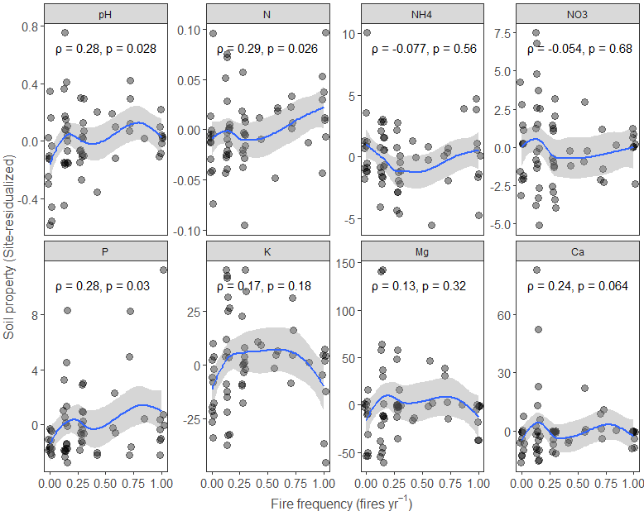
Supplementary Figure S1. Mean (±90% CI) values of each revisualized soil variable in relation to fire frequency calculated via loess fitting. Spearman correlation coefficients and significances are shown within each panel.
Supplementary Table S5. Results of redundancy analyses (RDAs) testing the multivariate association between fire frequency and soil fertility across all ecosystems (n = 60). The first model used the ecosystem-residualized matrix of eight log-transformed soil variables as the response and fire frequency as the predictor; the reciprocal model used fire frequency as the response and the residualized soil matrix as the predictor set. Values are adjusted R², and P values were obtained by permutation ANOVA.
RDA model | R² | P
Soil matrix ~ Fire frequency | -0.02 | 1.00
Fire frequency ~ soil matrix | 0.07 | 0.14

Supplementary Table S6. Sequential and marginal permutation tests for individual predictors in the global redundancy analysis relating fire frequency and soil fertility to multivariate carbon stocks across all ecosystems (n = 60). The response matrix comprised the nine log-transformed carbon variables, and soil and carbon variables were residualized for ecosystem effects before analysis. Sequential tests assess each predictor in the order shown, whereas marginal tests assess its unique contribution while controlling for all other predictors. R² is the proportion of total multivariate variance attributed to each term; P values were obtained by permutation ANOVA. Bold face indicates significance at p <0.05.

 | Sequential (type I)tests |  | Marginal tests
 | R² | P | R² | P
Fire frequency | 0.14 | 0.00 | 0.09 | 0.00
pH | 0.01 | 0.28 | 0.01 | 0.31
N | 0.02 | 0.05 | 0.01 | 0.26
NH4 | 0.06 | 0.00 | 0.05 | 0.00
NO3 | 0.01 | 0.23 | 0.02 | 0.09
P | 0.02 | 0.12 | 0.02 | 0.13
K | 0.00 | 0.69 | 0.01 | 0.39
Ca | 0.01 | 0.30 | 0.01 | 0.14
Mg | 0.02 | 0.09 | 0.02 | 0.10
Residual | 0.49 |  | 0.49

