Supplementary files separately
Supplementary Fig. S1. PCA loading plots for the hierarchical PCA framework.
(A) Loading plot for the fitness-domain PCA based on grip strength, modified sit-up, 20-m shuttle run, and sit-and-reach. (B) Loading plot for the body composition-domain PCA based on body fat mass, body fat percentage, and skeletal muscle mass. Body fat mass and body fat percentage were reverse coded before standardization so that higher component scores represented a more favorable body composition profile. (C) Proportion of variance explained by the retained first principal component in the fitness-domain and body composition-domain PCA models. The retained first principal components explained 52.67% and 68.58% of the total variance in the fitness-domain and body composition-domain PCA models, respectively.

Supplementary Fig. S2. Internal validation and stability assessment of the K-means phenotype solution.
(A) Elbow criterion based on the within-cluster sum of squares. (B) Average silhouette coefficient for candidate cluster solutions (K = 2–8). (C) Distribution of Adjusted Rand Index (ARI) values obtained from 500 repeated random 80% subsamples without replacement, comparing the cluster assignments obtained from each subsample with those from the original dataset. The vertical dashed line indicates the mean ARI, and the shaded region represents the empirical 95% percentile interval.

Supplementary Fig. S3. Baseline distribution and characteristics of the selected three-cluster phenotype solution.
(A) Distribution of baseline health-related fitness phenotypes in the control and resistance training groups. Values within the bars indicate group-specific percentages. (B) Distribution of baseline integrated HRF scores. Each point represents one participant; boxes indicate the interquartile range, center lines indicate medians, and whiskers indicate the 5th–95th percentiles. The horizontal dashed line indicates an integrated HRF score of zero. (C) Baseline standardized mean differences (Hedges' g) calculated for the control group relative to the resistance training group. Negative values indicate higher baseline values in the resistance training group, whereas positive values indicate higher baseline values in the control group. The vertical dashed line indicates no standardized difference between groups.
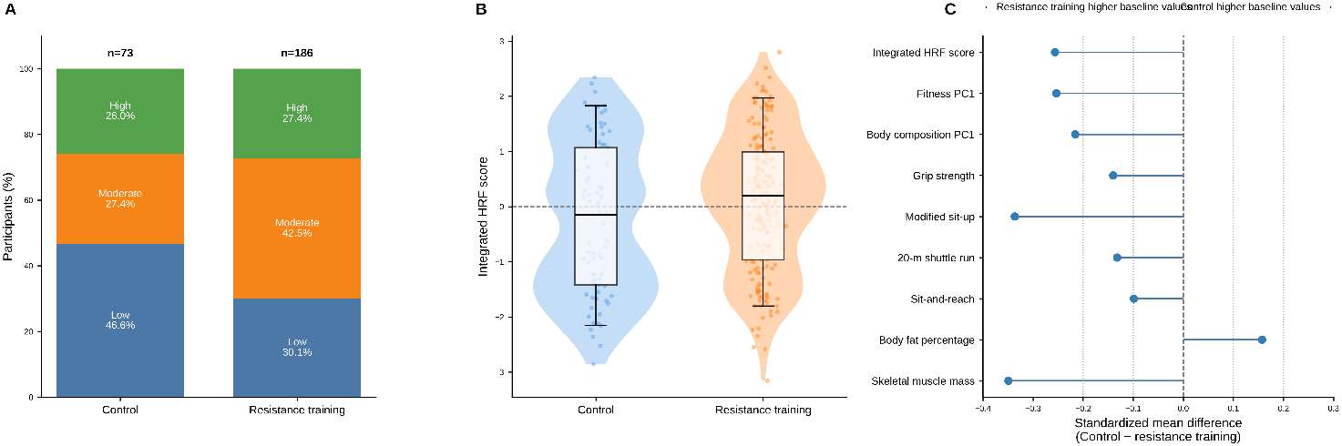

Supplementary Fig. S4. Phenotype-specific changes in the integrated health-related fitness score.
(A) Mean changes in the integrated HRF score according to baseline phenotype and intervention group. Values are presented as mean ± SEM. The horizontal dashed line indicates no change. (B) Proportion of participants with a positive change in the integrated HRF score (post-intervention minus baseline) in the control and resistance training groups. (C) Heatmap of mean changes in the integrated HRF score according to baseline phenotype and intervention group. Positive values indicate improvement, whereas negative values indicate decline.
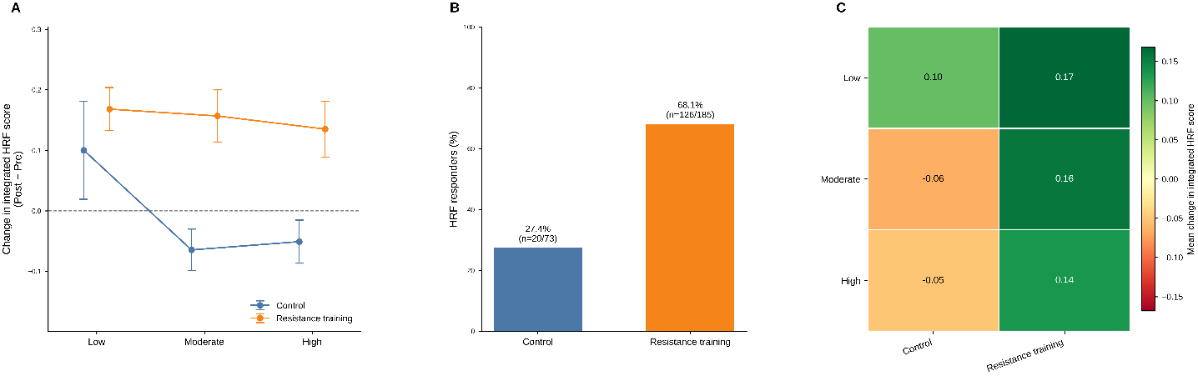

Supplementary Fig. S5. Correlation structure and component contributions to the integrated health-related fitness score.
(A) Pearson correlation matrix showing the relationships among the integrated HRF score, domain-specific principal component scores, and individual health-related fitness and body composition variables. Values within the cells indicate Pearson correlation coefficients. (B) Exploratory standardized regression coefficients with corresponding 95% confidence intervals from a multiple linear regression model illustrating the relative associations of individual HRF components with the integrated HRF score. All variables were standardized before analysis. (C) Distribution of integrated HRF scores across the Low, Moderate, and High baseline phenotypes. Boxes indicate the interquartile range, center lines indicate medians, whiskers extend to 1.5 times the interquartile range, and points beyond the whiskers indicate outliers.
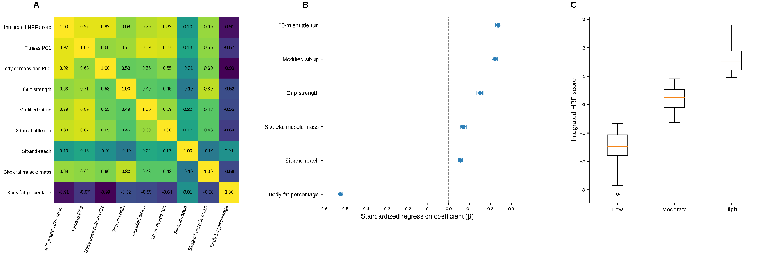

Supplementary Table S1. Class-based intervention protocol, delivery, and attendance over 16 weeks
Variables | Control group |  | Resistance training group
Section A. Class participation and adherence
Study population | Male and female university students enrolled in a health management class |  | Male and female university students enrolled in a weight training class
Class type | Health management class |  | Weight training class
Program duration, weeks | 16 |  | 16
Frequency, sessions/week | 2 |  | 2
Planned total sessions, n | 32 |  | 32
Class attendance, n (%) | 32/32 (100) |  | 32/32 (100)
Attended sessions, mean ± SD | 31.77 ± 0.43 |  | 31.82 ± 0.40
Attendance rate, mean ± SD, % | 99.27 ± 1.33 |  | 99.43 ± 1.25
Attendance range, sessions | 31–32 |  | 30–32
Participants completing all sessions, n (%) | 56 (76.7) |  | 153 (82.3)
Participants with class absence, n | 73 (100) |  | 186 (100)
Section B. Intervention condition
Structured exercise intervention | No |  | Yes
Exercise prescription | None |  | Progressive weight training
Additional organized exercise during study | Participants instructed not to initiate additional organized exercise |  | Not permitted beyond the assigned weight training class
Section C. Resistance training progression
Main intervention type | — | Progressive weight training
Target body regions | — | Lower body, back, chest, shoulders, arms, abdomen, and lower back
Weeks 1–4 | — | Low- to moderate-intensity training; 2 exercises per body region; 3 sets per exercise
Weeks 5–8 | — | Low- to moderate-intensity training; 2 exercises per body region; 4 sets per exercise
Weeks 9–12 | — | Moderate- to high-intensity training; 3 exercises per body region; 4 sets per exercise
Weeks 13–16 | — | High-intensity training; 3 exercises per body region; 5 sets per exercise

Values are presented as descriptive information on the class-based intervention protocol, intervention exposure, attendance, and resistance training progression. The resistance training group consisted of university students enrolled in a supervised weight training class, whereas the control group consisted of students enrolled in a health management class without structured resistance training. The planned intervention consisted of two supervised sessions per week for 16 weeks (32 planned sessions). Attendance rates were calculated from institutional class attendance records. RT, resistance training.

K | WCSS | Silhouette | CH index | DB index
2 | 72.81 | 0.609 | 657.40 | 0.513
3 (Selcted) | 31.49 | 0.602 | 924.63 | 0.484
4 | 20.62 | 0.547 | 982.76 | 0.532
5 | 13.33 | 0.537 | 1170.45 | 0.553
6 | 9.88 | 0.529 | 1276.01 | 0.539
7 | 6.77 | 0.556 | 1565.78 | 0.507
8 | 5.30 | 0.554 | 1715.03 | 0.503
Supplementary Table S2. Cluster validation indices for candidate K-means solutions of integrated HRF phenotypes
Candidate cluster solutions from K = 2 to K = 8 were evaluated using within-cluster sum of squares (WCSS), average silhouette coefficient, Calinski–Harabasz (CH) index, and Davies–Bouldin (DB) index. Lower values indicate better performance for WCSS and DB, whereas higher values indicate better performance for the average silhouette coefficient and CH index. Although K = 2 showed the highest average silhouette coefficient, the K = 3 solution was retained because it combined comparable silhouette performance with the lowest Davies–Bouldin index and provided an interpretable three-level phenotype framework (Low, Moderate, and High). WCSS, within-cluster sum of squares; CH, Calinski–Harabasz index; DB, Davies–Bouldin index; HRF, health-related fitness.

