Supplementary Figures
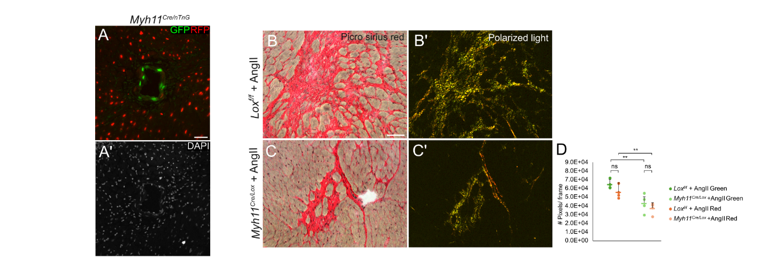
Supp. Figure 1. Immunostaining for GFP, RFP, and DAPI in Myh11^{Cre/nTnG} mice demonstrates Cre activity is specific to SMCs within the media in the cardiac blood vessel (Scale bars 50µm) (A, A'). Sirius Red staining and polarized light imaging of hypertensive control (B) and Myh11^{Cre/Lox} (C) mice. Quantification (D) demonstrates that although total collagen deposition is significantly reduced in Myh11^{Cre/Lox} mice, the relative abundance of collagen types I and III remains unchanged.

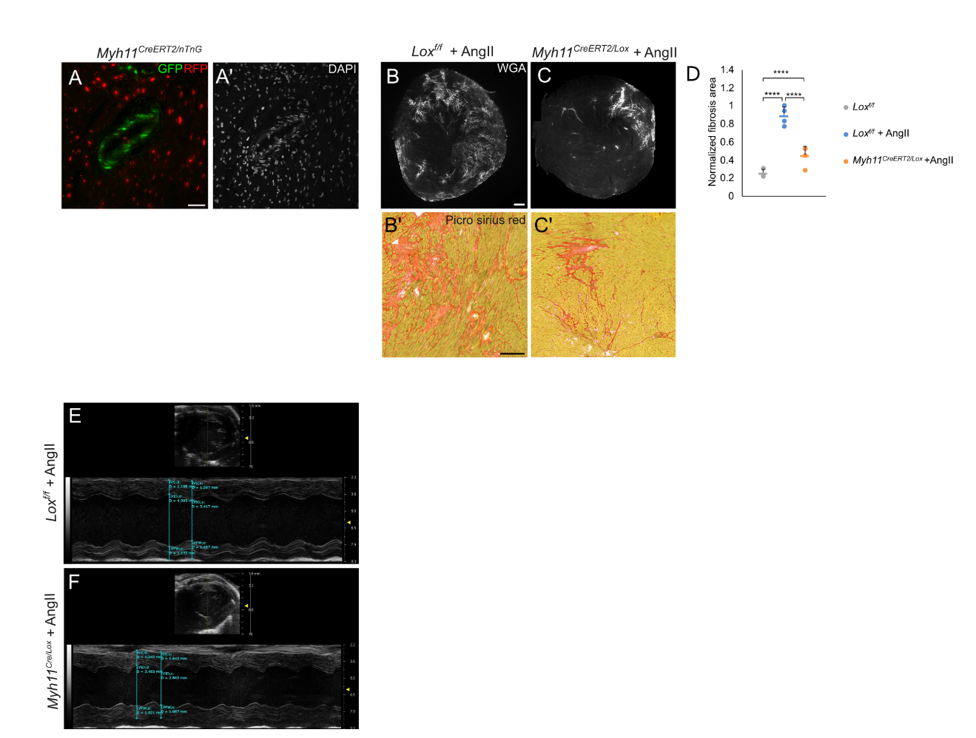

Supp. Figure 2. Immunostaining for GFP, RFP, and DAPI in Myh11^{CreERT2/nTnG} mice demonstrates Cre activity is specific to SMCs within the media in the cardiac blood vessel (Scale bars 50µm) (A). WGA and Sirius red staining (B,C) (Scale bars 500µm, 200µm, respectively) and quantification (D) of hypertensive AngII-treated Lox^{f/f} (B, B'; N=4) and Myh11^{CreERT2/Lox} (C,C'; N=4) mice. Representative M-mode echocardiographic images acquired at the mid-papillary level and used for FS measurements. Images highlight measurements of interventricular septum (IVS), left ventricular internal diameter (LVID), and left ventricular posterior wall (LVPW) at end-diastole and end-systole of hypertensive control (E) and Myh11^{Cre/Lox} (F). Similar left ventricular wall motion was observed in both groups. Data are presented as the mean ± SD. Statistical significance is represented by an asterisk as calculated using one-way ANOVA and post hoc Tukey’s test. n.s. = not significant. ****p < 0.0001.

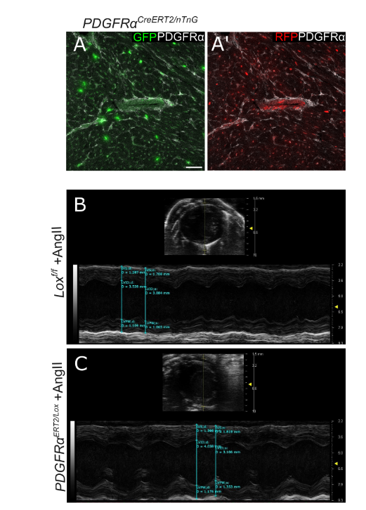
Supp. Figure 3. Immunostaining for GFP, RFP, and PDGFRα in PDGFRα^{CreERT2/nTnG} mice demonstrates Cre activity is specific to PDGFRα-positive fibroblasts within the heart interstitial area (Scale bar 50µm) (A). Representative M-mode echocardiographic images acquired at the mid-papillary level and used for FS measurements. Images highlight measurements of interventricular septum (IVS), left ventricular internal diameter (LVID), and left ventricular posterior wall (LVPW) at end-diastole and end-systole of hypertensive control (B) and PDGFRα^{Cre/Lox} (C). Similar left ventricular wall motion was observed in both groups.

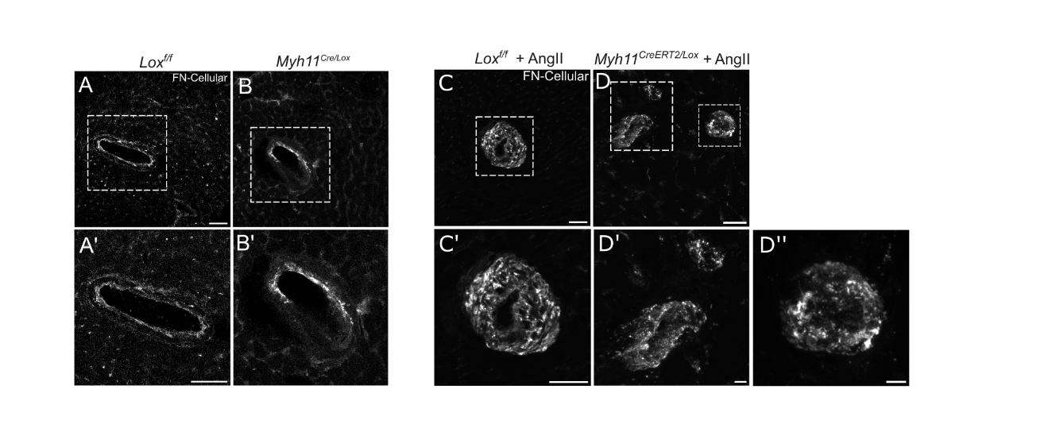
Supp. Figure 4. Immunostaining for cellular FN at baseline conditions in control (A,A') and Myh11^{Cre/Lox} (B,B') and in AngII-treated Lox^{f/f} (C) and Myh11^{CreERT2/Lox} (D) mice (Scale bar in A 20µm, in A' 5µm and in C,D 50µm).

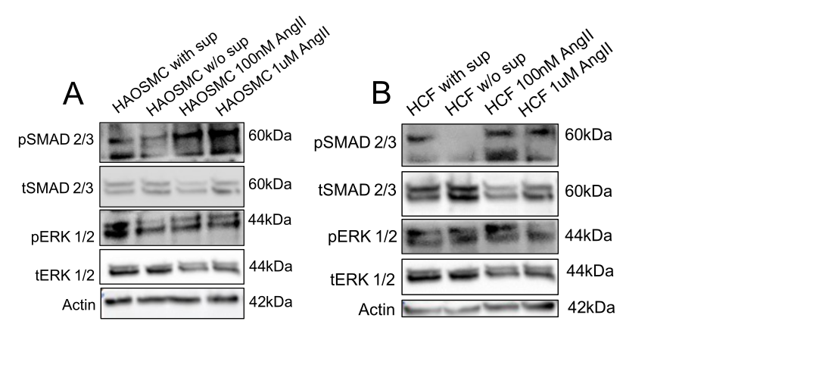
Supp. Figure 5. Western blot (A,B) for pSMAD 2/3, tSMAD 2/3, pERK 1/2 and tERK 1/2 of cultured control and βAPN–treated primary human SMCs or HCF in the presence or absence of AngII 100nM or 1µM AngII.

