Phenanthrene-enriched extract from Eulophia macrobulbon using subcritical dimethyl ether for phosphodiesterase-5A1 inhibition
Jukkarin Srivilaiª, Panatpong Boonnoun^{b}, Tongchai Saesong^{c}, Chitaporn Pingyoda^{c}, Nattiya Chaichamnong^{e}, Jinutda Engsuwanª, Prapapan Temkitthawon^{c}, C. Norman Scholfield^{c}, Nitra Nuengchamnong^{d}, Nantaka Khorana^{f}, Kornkanok Ingkaninan^{c*}
ªResearch and Innovation Center in Cosmetic Sciences and Natural products, Department of Cosmetic Sciences, School of Pharmaceutical Sciences, University of Phayao, Phayao 56000, Thailand.
^{b}Department of Industrial Engineering, Chemical Engineering Program, Faculty of Engineering, Naresuan University, Phitsanulok 65000, Thailand.
^{c}Center of Excellence in Cannabis Research, Department of Pharmaceutical Chemistry and Pharmacognosy, Faculty of Pharmaceutical Sciences and Center of Excellence for Innovation in Chemistry, Naresuan University, Phitsanulok 65000, Thailand.
^{d}Science Laboratory Center, Faculty of Sciences, Naresuan University. Phitsanulok 65000, Thailand.
^{e}Division of Applied Thai Traditional Medicine, Faculty of Public Health, Naresuan University, Phitsanulok 65000, Thailand
^{f}Research and Innovation Center in Cosmetic Sciences and Natural products, Department of Pharmaceutical Sciences, School of Pharmaceutical Sciences, University of Phayao, Phayao 56000, Thailand.
*Corresponding author: Kornkanok Ingkaninan, Faculty of Pharmaceutical Sciences, Naresuan University, Phitsanulok, 65000, Thailand. Fax:+66-55-963731; Telephone No:+66-55-961860; E-mail: kornkanoki@nu.ac.th, k_ingkaninan@yahoo.com

Additional file
1: Fig. S1. PDE5-1A inhibition against concentration (ug/ml) of extracts using different solvents: dimethyl ether (DME), dimethyl chloride (DCM, 1:10 and 1:20), ethyl acetate (EtOAc, 1:10 and 1:20), and ethanol (EtOH, 1:10 and 1:20). Each point are means of single determines from three extracts with each protocol. Bars are ±SEMs (hidden if smaller than symbol).
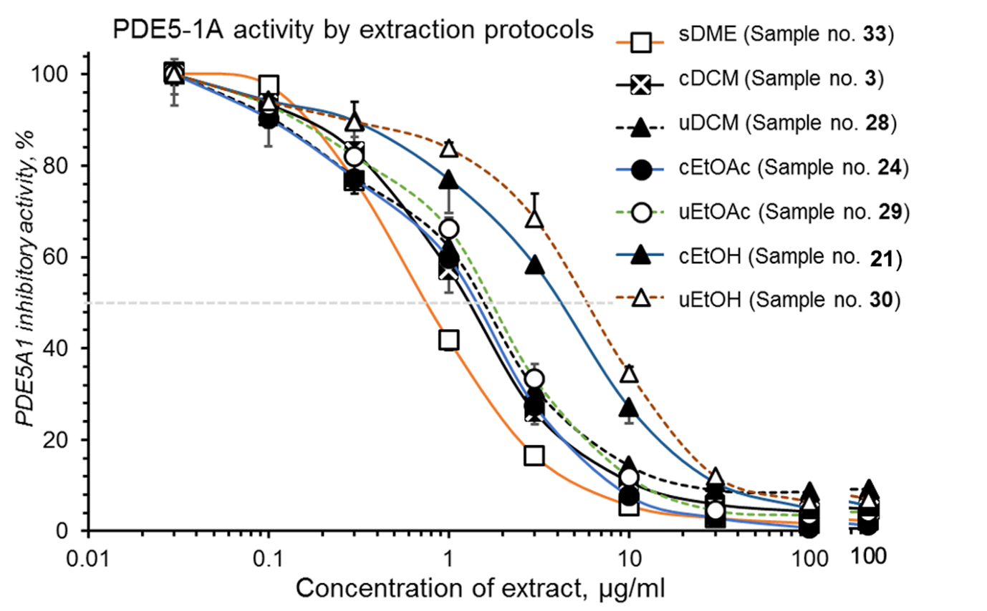

2: Table S1 Chemical structures and mass fragmentations of identifiable compounds in E. macrobulbon extract

Table S1 Chemical structures and mass fragmentations of identifiable compounds in E. macrobulbon extract
Cpd No. | Rt. (min) | Compound name | m/z | Chem. Formula | Ionized mass (m/z) | Proposed Structure | Fragmentation (Lose of m/z)
1 | 1.75 | Hexose | 180.0700 | C₆H₁₂O₆ | 179.0627 [M-H]⁻ |  | 89.0285,59.0173
2 | 1.92 | Sucrose | 388.1339 | C₁₂H₂₂O₁₁ | 387.1266 [M-HCOO]⁻ |  | 341.1172,179.0614,89.0283
3 | 3.69 | Arbutin | 286.1053 | C₁₃H₁₈O₇ | 331.1142 [M-HCOO]⁻ |  | 285.0982,244.9138,161.0452,123.0447
4 | 5.88 | N-Nitroso-3-hydroxypyrolidine | 176.0750 | C₄H₈N₂O₂ | 175.0677 [M-H]⁻ |  | 115.0447,85.0697,59.0172
5 | 7.15 | 2-ethyl-6-((4,7,8-trimethoxyphenanthren-2-yl)oxy)tetrahydro-2H-pyran-3,4,5-triol | 444.1768 | C₂₄H₂₈O₈ | 443.1695 [M-H]⁻ |  | 285.1054,113.0652
6 | 7.17 | 2-((6-ethyl-5-hydroxy-4-((4-hydroxybenzyl)oxy)-2-((4,7,8-trimethoxyphenanthren-2-yl)oxy)tetrahydro-2H-pyran-3-yl)oxy)-6-(hydroxymethyl)tetrahydro-2H-pyran-3,4,5-triol | 874.3348 | C₄₃H₅₄O₁₉ | 909.3255 [M+Cl]⁻ |  | 873.3163,605.2198,443.1649,323.1064
7 | 7.32 | 4-Hydroxybenzaldehyde | 122.0418 | C₇H₆O₂ | 121.0345 [M-H]⁻ |  | 92.0265,65.0396
8 | 7.69 | 2-((6-ethyl-5-hydroxy-4-((4-hydroxybenzyl)oxy)-2-((4,7,8-trimethoxyphenanthren-2-yl)oxy)tetrahydro-2H-pyran-3-yl)oxy)-6-(hydroxymethyl)tetrahydro-2H-pyran-3,4,5-triol | 712.2782 | C₃₇H₄₄O₁₄ | 711.2709 [M-H]⁻ |  | 605.2206,443.1654,285.1054,207.0719,123.0497
9 | 8.35 | 2-((6-ethyl-4-((4-hydroxybenzyl)oxy)-5-methoxy-2-((4,7,8-trimethoxyphenanthren-2-yl)oxy)tetrahydro-2H-pyran-3-yl)oxy)-6-(hydroxymethyl)tetrahydro-2H-pyran-3,4,5-triol | 726.2952 | C₃₈H₄₆O₁₄ | 761.2647 [M+Cl]⁻ |  | 457.1818,285.1055,153.061
10 | 8.80 | 2-ethyl-6-((2-ethyl-6-((2-ethyl-4-((4-hydroxybenzyl)oxy)-5-((3,4,5-trihydroxy-6-(hydroxymethyl)tetrahydro-2H-pyran-2-yl)oxy)-6-((4,7,8-trimethoxyphenanthren-2-yl)oxy)tetrahydro-2H-pyran-3-yl)oxy)-5-hydroxy-4-((4-hydroxybenzyl)oxy)tetrahydro-2H-pyran-3-yl)oxy)tetrahydro-2H-pyran-3,4,5-triol | 1138.4621 | C₅₈H₇₄O₂₃ | 1173.4110 [M+Cl]⁻ |  | 1137.4331,869.3214,753.2724,485.1765,443.1654
11 | 8.91 | 2-((6-ethyl-5-((3-hydroxybenzyl)oxy)-4-((4-hydroxybenzyl)oxy)-2-((4,7,8-trimethoxyphenanthren-2-yl)oxy)tetrahydro-2H-pyran-3-yl)oxy)-6-(hydroxymethyl)tetrahydro-2H-pyran-3,4,5-triol | 818.3234 | C₄₄H₅₀O₁₅ | 853.2932 [M+Cl]⁻ |  | 817.3453,711.2621,549.2094,443.1654,391.1459,285.1047
12 | 9.08 | 2-((6-ethyl-5-((6-ethyl-3,4-dihydroxy-5-methyltetrahydro-2H-pyran-2-yl)oxy)-4-((4-hydroxybenzyl)oxy)-2-((4,7,8-trimethoxyphenanthren-2-yl)oxy)tetrahydro-2H-pyran-3-yl)oxy)-6-(hydroxymethyl)tetrahydro-2H-pyran-3,4,5-triol | 870.3400 | C₄₅H₅₈O₇ | 869.3327 [M-H]⁻ |  | 711.2623,443.1653,285.1044
13 | 9.56 | 4-methoxy-9,10-dihydro-2,7-phenanthrenediol | 242.0943 | C₁₅H₁₄O₃ | 241.0881 [M-H]⁻ |  | ND
14 | 10. 73 | 4,7,8-trimethoxyphenanthren-2-ol | 284.1049 | C₁₇H₁₆O₄ | 283.0709 [M-H]⁻ |  | 240.0492
15 | 11.11 | 4-methoxy-2,7-phenanthrenediol | 240.0786 | C₁₅H₁₂O₃ | 239.0719 [M-H]⁻ |  | ND
16 | 11.46 | 8-(4-hydroxybenzyl)-1,5,7-trimethoxy-9,10-dihydrophenanthren-2-ol | 392.1387 | C₂₃H₂₀O₆ | 427.1085 [M-H]⁻ |  | 281.0891,109.0336
17 | 11.53 | 1,5-dimethoxy-2,7-phenanthrenediol | 270.0892 | C₁₆H₁₄O₄ | 269.0832 [M+Cl]⁻ |  | 254.0654,239.0416,211.0462
18 | 12.04 | 9,10‒dihydro‒4‒(4'‒hydroxy benzyl)‒2,5‒dimethoxyphenanthrene‒1,7‒diol | 378.1467 | C₂₃H₂₂O₅ | 377.1402 [M-H]⁻ |  | 362.1162, 331.0974, 301.0865, 253.0501, 138.4688, 93.0331
19 | 12.10 | 1-(4-hydroxybenzyl)-4-methoxy-9,10-dihydrophenanthrene-2,7-diol | 348.1476 | C₂₂H₂₀O₄ | 347.1399 [M-Cl]⁻ |  | 331.1054,253.0932
20 | 12.32 | 1-(4-hydroxybenzyl)-9-methoxyphenanthrene-2,7-diol | 346.1205 | C₂₂H₁₈O₄ | 345.1245 [M-H]⁻ |  | 330.0977,237.062,93.0384
21 | 12.70 | 1-(4-hydroxybenzyl)-4,8-dimethoxy-2,7-phenanthrenediol (HDP) | 376.1438 | C₂₃H₂₀O₅ | 375.1361 [M-H]⁻ |  | 360.1093,317.0903,93.0383
22 | 14.25 | 4,4'-((8-hydroxy-2,4,7-trimethoxyphenanthrene-1,9-diyl)bis(methylene))dicyclohexanol | 508.1679 | C₂₈H₂₈O₉ | 507.1606 [M-H]⁻ |  | 390.0984,304.9198
23 | 14.26 | 4,8,4',8'‒tetramethoxy‒(1,1'‒biphenanthrene)‒2,7,2',7'‒tetrol | 538.1795 | C₂₉H₃₀O₁₀ | 537.1722 [M-H]⁻ |  | 507.1186,420.1078,112.9196

