Maternal Antibody Interference and Hybrid Immune Responses to COVID-19 Vaccination in Young Children
Authors:
Srividhya Swaminathan, PhD¹; Nadia Bourdoud, MPH ¹; Danny Hoi Tsun Chu, MS²; Suchaya Osatis, MS^{1,4}; Karissa Choi, BS¹; Caryl L. Gay, PhD³; Lakshmi Warrier, BS⁴; Lin Li, MD, PhD^{5,6}; Corina Mong, BS^{1,5}; Megan A. Chidboy, BS⁵; Christine Lin, BS⁵; Amayrani Morales, BS⁵; Christine Blauvelt, MD⁵; Gillian Q. Rush, BA¹; Sirirak Buarpung, DVM, PhD^{5,6}; Nida Ozarslan, MD^{5,6}; Amelia N. Deitchman, PharmD, PhD²; Stephanie L. Gaw, MD, PhD^{5,6}; *Mary K. Prahl, MD¹
Affiliations:
- Department of Pediatrics, Division of Pediatric Infectious Disease and Global Health, University of California, San Francisco, CA, United States
- Department of Clinical Pharmacy, University of California, San Francisco, CA, United States
- Department of Family Health Care Nursing, University of California, San Francisco, San Francisco, CA, United States
- Department of Experimental Medicine, University of California, San Francisco, San Francisco, CA, United States
- Division of Maternal-Fetal Medicine, Department of Obstetrics, Gynecology, and Reproductive Sciences, University of California San Francisco, San Francisco, CA, United States
- Center for Reproductive Sciences, Department of Obstetrics, Gynecology, and Reproductive Sciences, University of California San Francisco, San Francisco, CA, United States

Corresponding Author: Mary Prahl MD, University of California, San Francisco. 550 16th St. San Francisco, CA 94158. Mary.prahl@ucsf.edu

Table of Contents:
Supplementary Figure 1: Post-primary vaccine series anti-S1 and anti-S2 IgG responses by exposure group
Supplementary Figure 2: Anti-S1 and anti-S2 association of pre-vaccine and post-primary series antibody Ig levels and comparison of pediatric to adult groups
Supplementary Figure 3: Longitudinal durability anti-S1 and anti-S2 IgG responses by exposure groups
Supplementary Figure 4: Comparison of post-primary anti-S1 and anti-S2 to young children age in months
Supplementary Figure 5: Post-vaccination anti-S1 and anti-S2 IgG responses by biological sex and vaccine type
Supplementary Figure 6: Longitudinal pediatric SARS-CoV-2 IgA and IgM antibody responses
Supplementary Table 1: Parameter values from fitted segmented mixed effect linear regression models.

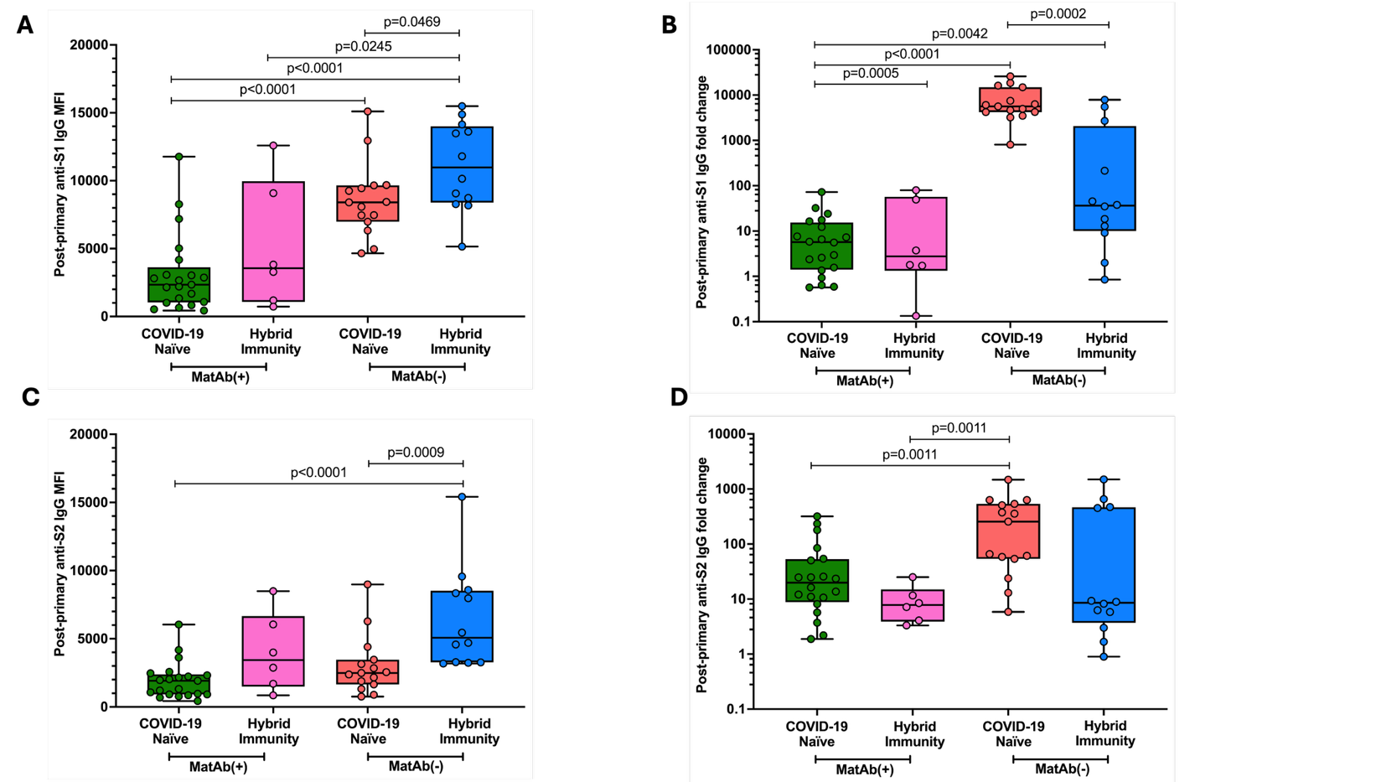
Supplementary Figure 1: Post-primary vaccine series anti-S1 and anti-S2 IgG responses by exposure group
Post-primary vaccine series IgG absolute levels MFI for A) anti-S1 and C) anti-S2. Anti-RBD IgG level MFI fold-change post-primary vaccine series MFI levels over pre-vaccine MFI levels by exposure group for B) anti-S1 and D) anti-S2. COVID-19 naïve MatAb(+) (n=21), Hybrid immunity MatAb(+) (n=6), COVID-19 naïve MatAb(-) (n=15), and Hybrid immunity MatAb(-) (n=12). Data presented as box and whisker plots represent median and IQR. Two-sided p values were calculated for all test statistics by Mann-Whitney U test, p<0.05 was considered significant, and significant values are indicated in graph brackets.

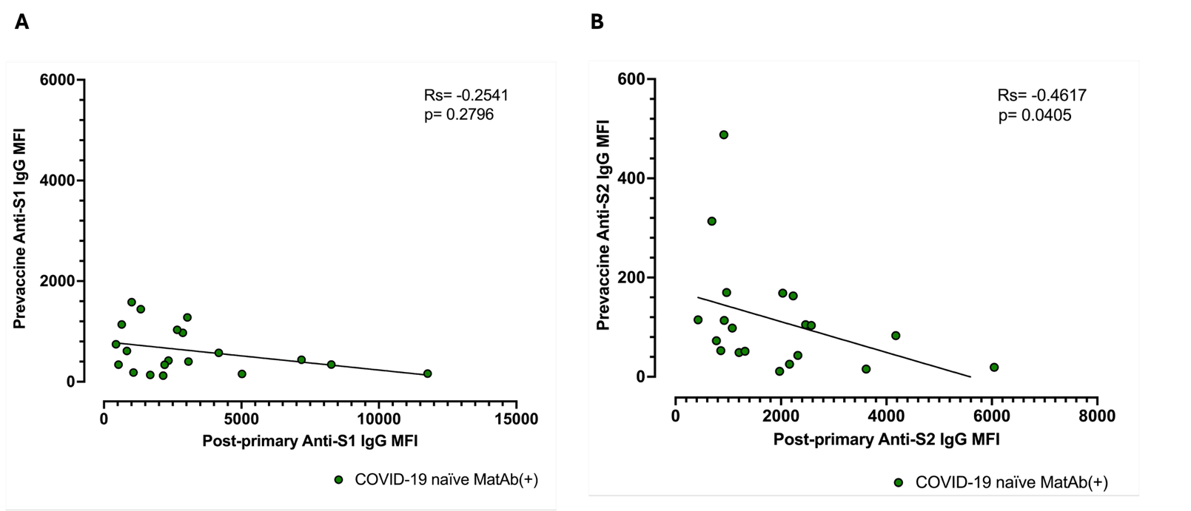Supplementary Figure 2: Anti-S1 and anti-S2 association of pre-vaccine and post-primary series antibody Ig levels and comparison of pediatric to adult groups
Correlation between pre-vaccine IgG MFI (passive maternal antibody) and post-primary vaccine IgG for (A) anti-S1 (B) anti-S2 in the COVID-19 naïve MatAb(+) cohort (green circles, n=20). The correlation line represents the linear regression fit for visualization only. Statistical correlation was assessed using Spearman’s rank correlation coefficient (R_{s}).

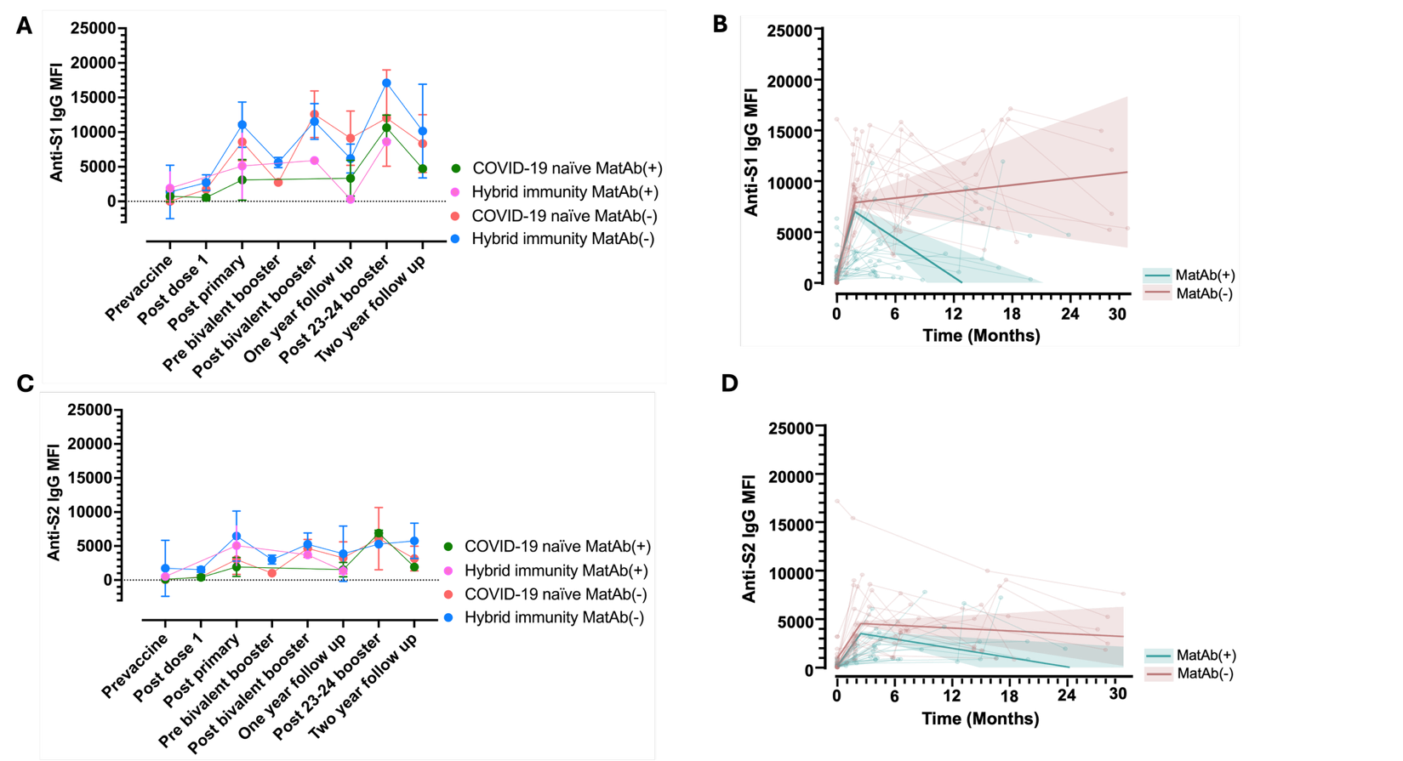
Supplementary Figure 3: Longitudinal durability anti-S1 and anti-S2 IgG responses by exposure groups
Longitudinal graph of A) anti-S1 and C) anti-S2 IgG antibody trajectory across timepoints pre-vaccine to two-year follow-up across exposure groups. Each connected data point represents the mean and standard deviation at each time point, stratified by exposure status. Infection status determined prior to primary vaccine follow-up timepoint. Segmented linear regression model fit of B) anti-S1 and D) anti-S2 level over time by presence or absence of maternal antibody (MatAb). Bold lines and shaded area are model prediction and 50% prediction intervals. Connected points represent raw data by participant.

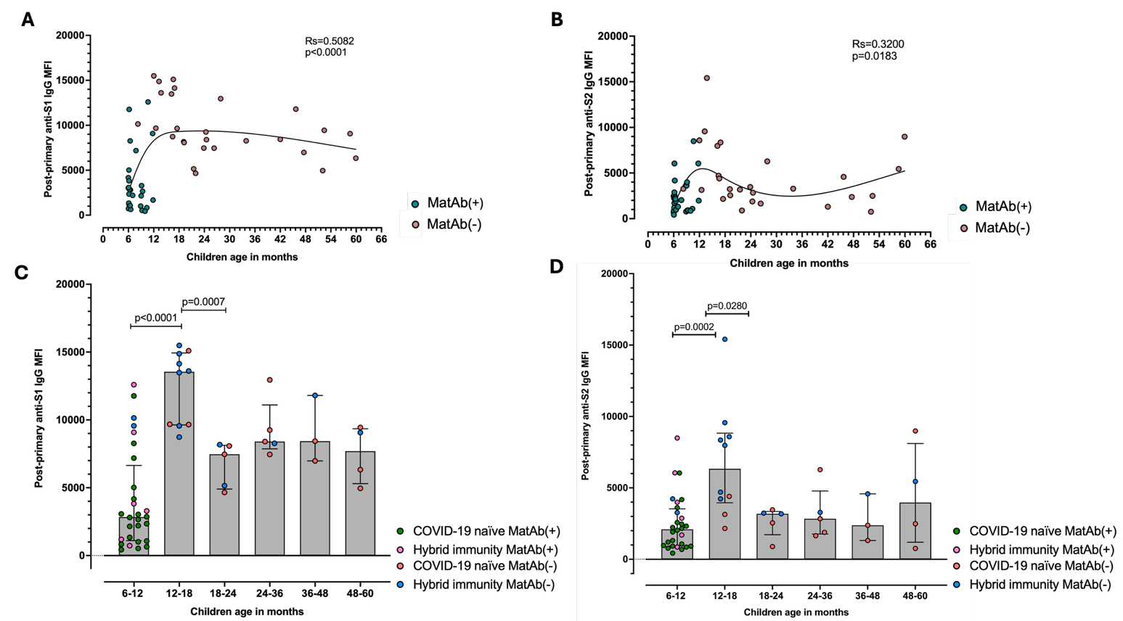
Supplementary Figure 4: Comparison of post-primary anti-S1 and anti-S2 to young children age in months
Correlation of post-vaccination timepoint A) anti-S1 B) anti-S2 IgG MFI levels by age in months, with infants with MatAb(+) in teal and MatAb(-) children in mauve. Line represents spline for visualization only, statistical correlation by spearman’s rank correlation coefficient. Post-primary series C) Anti-S1 D) anti-S2 IgG MFI levels stratified by age groups: 6-12 months (n=28), 12-18 months (n=10), 18-24 months (n=5), 24-36 months (n=5), 36-48 months (n=3), 48-60 months (n=4). Circles color by exposure group. Two-sided p values were calculated for all test statistics by Mann-Whitney U test, p<0.05 was considered significant.

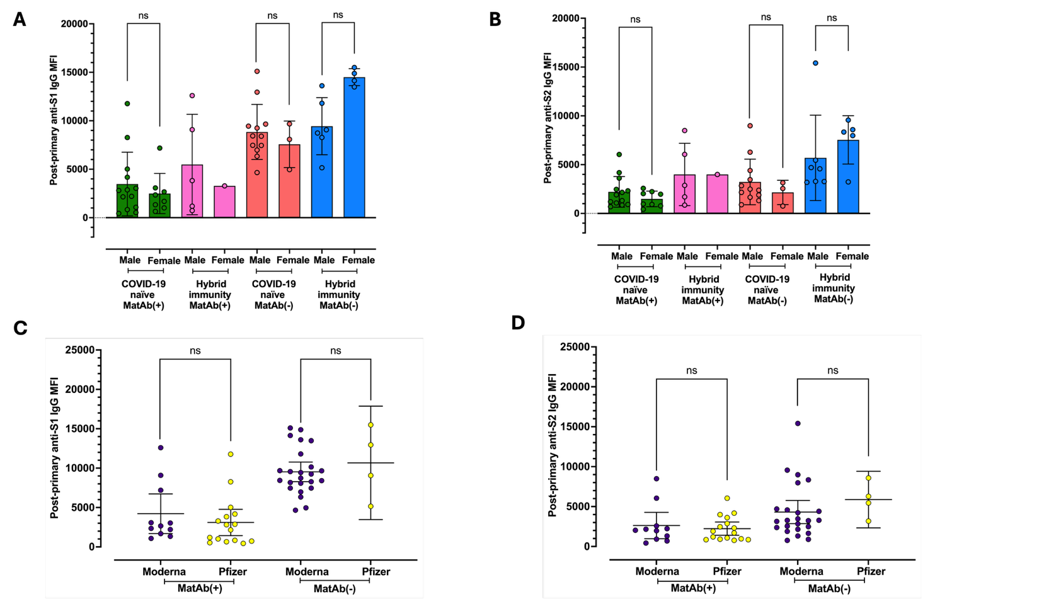
Supplementary Figure 5: Post-vaccination anti-S1 and anti-S2 IgG responses by biological sex and vaccine type
Post-primary series A) anti-S1 and B) anti-S2 IgG levels by biological sex stratified by exposure group. Box and whisker plots represent median with IQR with participant data points. Groups include: COVID-19 naïve MatAb(+) (Male (n)= 13, Female (n)= 8), Hybrid immunity MatAb(+) (Male (n)= 5, Female (n)= 1, COVID-19 naïve MatAb(-) (Male (n)= 12, Female (n)= 3), and Hybrid immunity MatAb(-) (Male (n)= 7, Female (n)= 5). Post-primary series C) anti-S1 and D) anti-S2 IgG levels by vaccine manufacturer: MatAb(+) infants who received Moderna (n = 11) or Pfizer (n = 16) and MatAb(-) infants who received Moderna (n = 24) or Pfizer (n = 4). Statistical analyses for biological sex and vaccine manufacturer were performed and two-sided p values were calculated for all test statistics by Mann-Whitney U test, p<0.05 was considered significant.

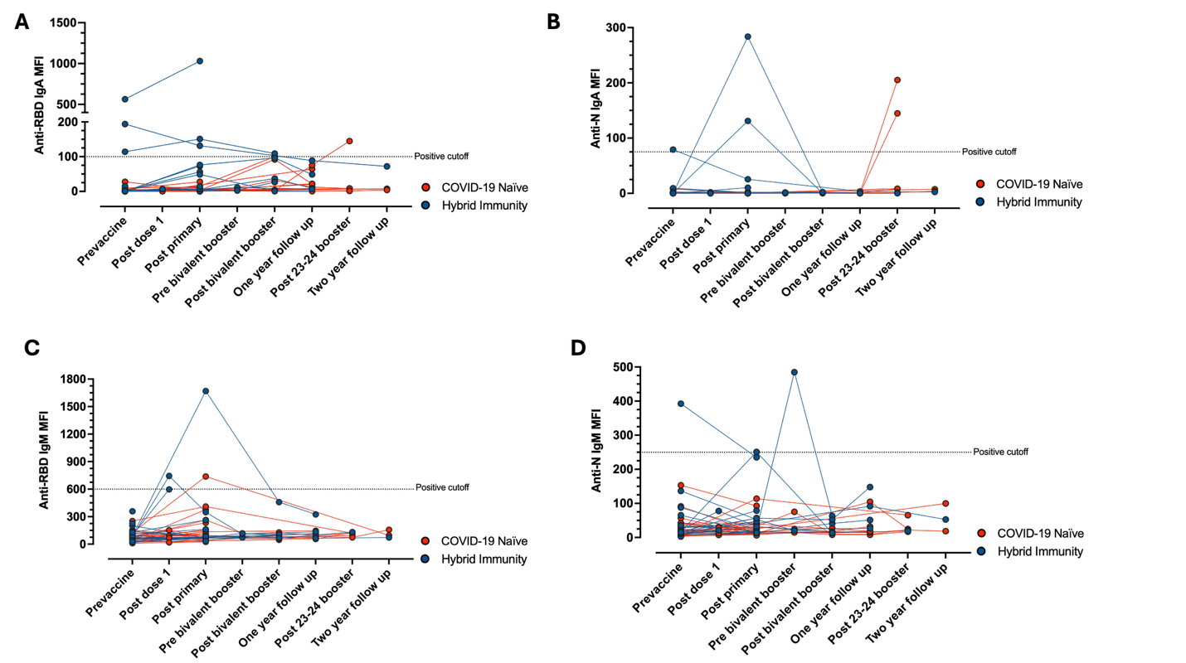
Supplementary Figure 6: Longitudinal pediatric SARS-CoV-2 IgA and IgM antibody responses.
Longitudinal connected antibody levels (MFI) by pediatric participant of A) Anti-RBD IgA (B) Anti-N IgA (C) Anti-RBD IgM (D) Anti-N IgM from pre-vaccine to two-year follow-up time point across participants either COVID-19 naïve or Hybrid-immunity (infection status determined prior to primary vaccine follow-up timepoint). Horizontal dashed lines indicate seropositive cut off values (Anti-RBD IgA: [100] MFI; Anti-RBD IgM: [650] MFI; Anti-N IgA: [75] MFI; Anti-N IgM: [250] MFI).

Supplementary Table 1: Parameter values from fitted segmented mixed effect linear regression models.
Parameter | Estimated value for MatAb(-) | Estimated value for MatAb(+) | p-value
Anti-RBD
Breakpoint (days) | 56.5 (42.6 to 70.3) |  | N/A
Rate of antibody change before breakpoint (unit/day) | 157.6 (124.3 to 190.8) | 116.9 (82.1 to 151.7) | <0.001
Rate of antibody change after breakpoint (unit/day) | 5.39 (-7.17 to 17.9) | -35.3 (-49.5 to -21.1) | <0.001
Between participant variability slope | 19.5 (11.7 to 32.5) |  | N/A
Standard deviation of residuals | 3339.7 (2888.4 to 3861.5) |  | N/A
Anti-S1
Breakpoint (days) | 54.9 (39.9 to 69.9) |  | N/A
Rate of antibody change before breakpoint (unit/day) | 131.4 (102.2 to 160.5) | 106.8 (76.7 to 136.9) | <0.001
Rate of antibody change after breakpoint (unit/day) | 3.45 (-5.39 to 12.3) | -21.1 (-31.66 to -10.6) | <0.001
Between participant variability slope | 12.3 (7.33 to 20.7)
Standard deviation of residuals | 3080.6 (2699.4 to 3515.6)
Anti-S2
Breakpoint (days) | 73.1 (52.9 to 93.3) |  | N/A
Rate of antibody change before breakpoint (unit/day) | 49.2 (38.3 to 60.0) | 45.5 (34.3 to 56.7) | <0.001
Rate of antibody change after breakpoint (unit/day) | -1.68 (-5.86 to 2.50) | -5.35 (-10.5 to -0.15) | <0.001
Between participant variability slope | 5.04 (3.28 to 7.75) |  | N/A
Standard deviation of residuals | 1669.5 (1481.8 to 1881.0) |  | N/A

