Table 1. Country-level number of charging locations, CCS chargers, MCS chargers, together with the median overhead cost (EUR/kWh), electricity cost (EUR/kWh), LCOC (EUR/kWh), and grid-connection fee (EUR/kWh). All costs are calculated under the baseline scenario, in which neither on-site solar PV nor energy storage is deployed. The overhead cost includes the CAPEX and O&M costs of charging infrastructure, while the grid-connection fee is calculated separately and excluded from the LCOC.

Country | Name | Charging locations | CCS chargers | MCS chargers | Total charger | Median Overhead cost | Median electricity cost | Median LCOC | Median grid connection cost
AL | Albania | 5 | 1 | 5 | 6 | 15.537 | 0.292 | 15.84 | 4.266
AT | Austria | 64 | 666 | 233 | 899 | 0.024 | 0.258 | 0.29 | 0.006
BA | Bosnia and Herzegovina | 21 | 13 | 21 | 34 | 0.136 | 0.108 | 0.24 | 0.041
BE | Belgium | 52 | 331 | 204 | 535 | 0.026 | 0.241 | 0.26 | 0.006
BG | Bulgaria | 43 | 69 | 65 | 134 | 0.05 | 0.169 | 0.22 | 0.015
BY | Belarus | 12 | 8 | 10 | 18 | 6.604 | 0.308 | 6.94 | 1.819
CH | Switzerland | 45 | 196 | 128 | 324 | 0.029 | 0.188 | 0.22 | 0.007
CZ | Czechia | 69 | 572 | 182 | 754 | 0.021 | 0.207 | 0.23 | 0.006
DE | Germany | 329 | 2839 | 1436 | 4275 | 0.023 | 0.229 | 0.26 | 0.006
DK | Denmark | 30 | 206 | 106 | 312 | 0.03 | 0.165 | 0.2 | 0.008
EE | Estonia | 23 | 25 | 23 | 48 | 0.138 | 0.177 | 0.32 | 0.039
ES | Spain | 162 | 847 | 649 | 1496 | 0.032 | 0.17 | 0.2 | 0.009
FI | Finland | 45 | 44 | 59 | 103 | 0.121 | 0.131 | 0.26 | 0.031
FR | France | 277 | 3302 | 1276 | 4578 | 0.026 | 0.227 | 0.26 | 0.007
GR | Greece | 41 | 66 | 73 | 139 | 0.071 | 0.207 | 0.28 | 0.021
HR | Croatia | 35 | 137 | 64 | 201 | 0.049 | 0.257 | 0.31 | 0.014
HU | Hungary | 63 | 329 | 118 | 447 | 0.024 | 0.272 | 0.32 | 0.007
IE | Ireland | 15 | 39 | 65 | 104 | 0.058 | 0.259 | 0.32 | 0.015
IT | Italy | 161 | 526 | 477 | 1003 | 0.032 | 0.254 | 0.29 | 0.009
LT | Lithuania | 26 | 96 | 31 | 127 | 0.039 | 0.174 | 0.22 | 0.012
LU | Luxembourg | 6 | 30 | 13 | 43 | 0.025 | 0.207 | 0.24 | 0.006
LV | Latvia | 25 | 28 | 32 | 60 | 0.039 | 0.179 | 0.22 | 0.011
MD | Moldova | 7 | 4 | 7 | 11 | 0.118 | 0.174 | 0.28 | 0.032
ME | Montenegro | 6 | 5 | 6 | 11 | 0.344 | 0.101 | 0.45 | 0.105
MK | North Macedonia | 13 | 16 | 25 | 41 | 0.282 | 0.19 | 0.48 | 0.086
NL | Netherlands | 48 | 140 | 115 | 255 | 0.042 | 0.277 | 0.33 | 0.011
NO | Norway | 58 | 70 | 85 | 155 | 0.075 | 0.131 | 0.21 | 0.018
PL | Poland | 137 | 1254 | 434 | 1688 | 0.022 | 0.247 | 0.27 | 0.006
PT | Portugal | 50 | 121 | 71 | 192 | 0.038 | 0.124 | 0.17 | 0.011
RO | Romania | 60 | 98 | 108 | 206 | 0.057 | 0.198 | 0.27 | 0.017
RS | Serbia | 42 | 368 | 82 | 450 | 0.038 | 0.17 | 0.21 | 0.011
SE | Sweden | 106 | 297 | 620 | 917 | 0.035 | 0.116 | 0.15 | 0.009
SI | Slovenia | 15 | 72 | 49 | 121 | 0.024 | 0.249 | 0.27 | 0.007
SK | Slovakia | 43 | 75 | 128 | 203 | 0.029 | 0.271 | 0.31 | 0.008
UA | Ukraine | 33 | 24 | 34 | 58 | 0.353 | 0.216 | 0.58 | 0.097
UK | United Kingdom | 143 | 655 | 270 | 925 | 0.047 | 0.325 | 0.39 | 0.013
Average |  | 64 | 377 | 203 | 580

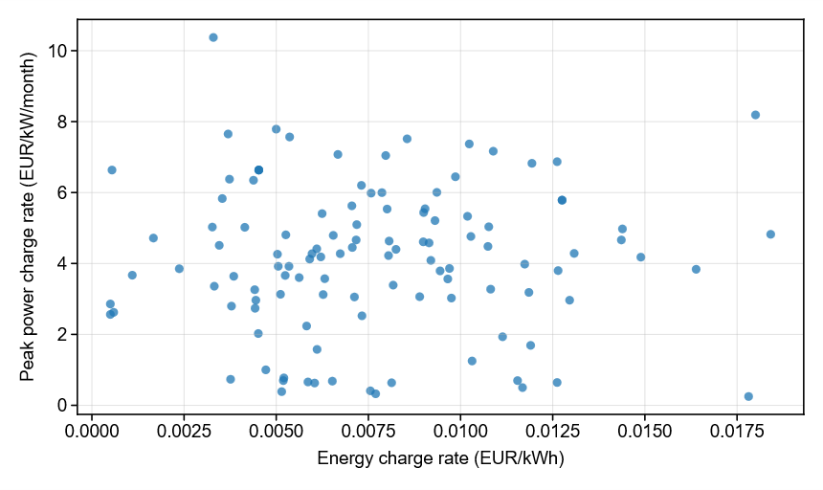
Figure 1. Peak power charge rate (EUR/kW/year) versus energy charge rate (EUR/kWh) across 115 DSOs in Pool-SE. Supplementary Data 1 provides the network tariff data and data source for each DSO in Pool-SE.

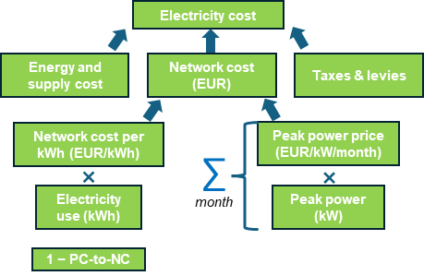

Figure 2. Electricity cost structure for individual charging locations, with network costs explicitly represented using Pool-SE tariffs.

The electricity cost includes three components: energy and supply cost, taxes and levies, and network cost. The energy and supply cost and taxes and levies are derived from country-level electricity prices reported by Eurostat [1]. The network cost consists of both energy-volume charges and power-based charges, using real network tariffs in Pool-SE.

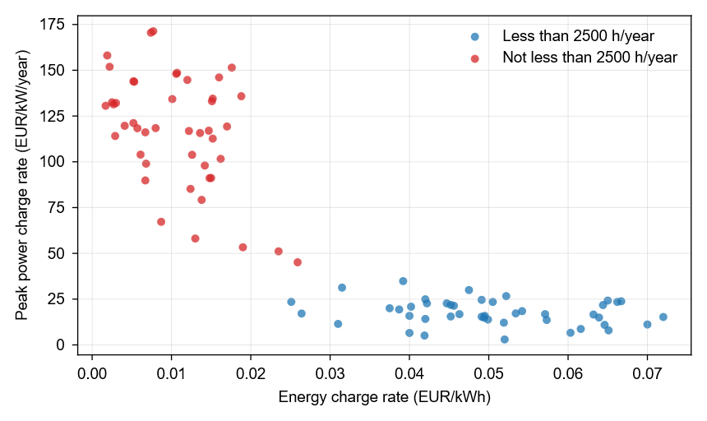
Figure 3. Peak power charge rate (EUR/kW/year) versus energy charge rate (EUR/kWh) across 45 DSOs in Pool-DE. Supplementary Data 1 provides network tariff data and data source for each DSO in Pool-DE.

Network costs in Pool-DE are determined according to annual equivalent usage hours, calculated as annual electricity consumption divided by annual peak power. Red dots indicate tariffs applied when equivalent usage hours are below 2,500 h, while blue dots indicate tariffs applied otherwise.

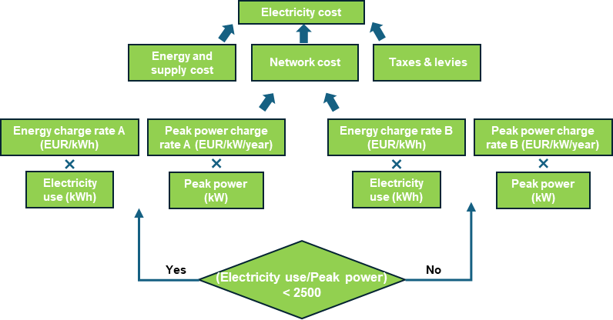
Figure 4. Electricity cost structure for individual charging locations, with network costs explicitly represented using Pool-DE tariffs. The applicable network tariff is determined based on annual equivalent usage hours.

Note 1. Differences between the Pool-SE and Pool-DE tariffs used in this study.

Based on our calculation results, for most charging locations, the worst and best tariffs in Pool-SE are approximately 98 EUR/kW/year and 0.018 EUR/kWh, and 8 EUR/kW/year and 0.004 EUR/kWh, respectively. This corresponds to a tariff spread of 90 EUR/kW/year for the peak power charge and 0.014 EUR/kWh for the energy charge. For Pool-DE, the corresponding worst and best tariffs are approximately 151 EUR/kW/year and 0.018 EUR/kWh, and 67 EUR/kW/year and 0.009 EUR/kWh, respectively. The resulting tariff spread is therefore 84 EUR/kW/year for the peak power charge and 0.009 EUR/kWh for the energy charge. These results indicate that the tariff spread in Pool-SE is slightly larger than that in Pool-DE, which explains why the LCOC difference between the worst- and best-tariff cases is also slightly larger in Pool-SE than in Pool-DE.

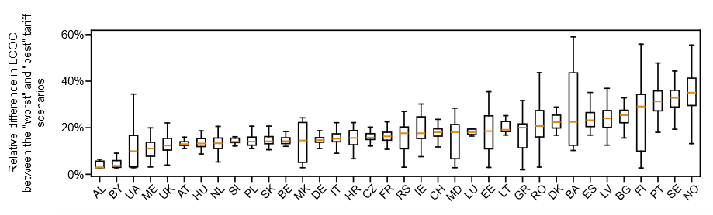
Figure 5. Distribution of the relative difference (%) in LCOC between the “worst” and “best” DSO tariff scenarios across countries in Pool-SE. For each boxplot, the central line denotes the median, the box spans the 25th to 75th percentiles, and the whiskers indicate the minimum and maximum values excluding outliers. The results suggest that countries with lower baseline LCOC are more sensitive to network tariff scenarios, as differences in network costs represent a larger proportion of total LCOC compared with countries with higher baseline LCOC.

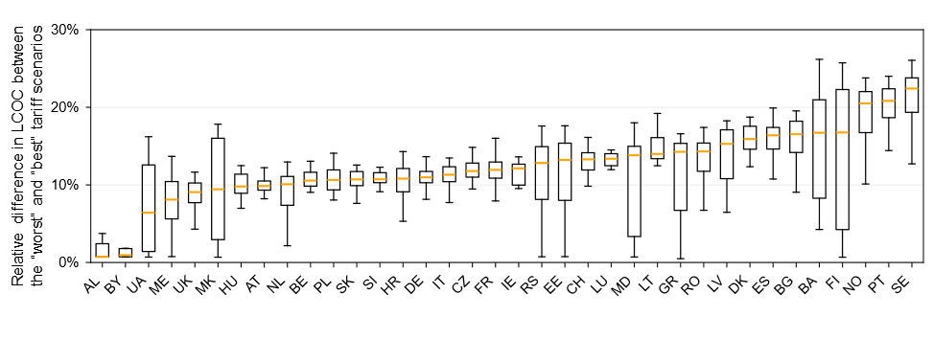
Figure 6. Distribution of the relative difference (%) in LCOC between the “worst” and “best” DSO tariff scenarios across countries in Pool-DE. For each boxplot, the central line denotes the median, the box spans the 25th to 75th percentiles, and the whiskers indicate the minimum and maximum values excluding outliers.

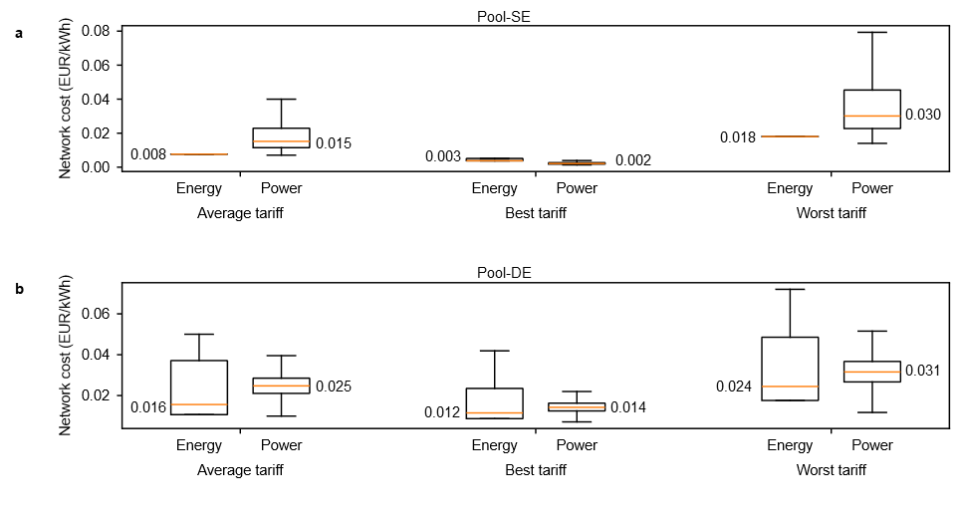
Figure 7. Energy- and power-charge components of network costs in (a) Pool-SE and (b) Pool-DE. For each boxplot, the central line denotes the median, the box spans the 25th to 75th percentiles, and the whiskers indicate the minimum and maximum values excluding outliers. The boxplots show the distributions of the energy-charge and power-charge components under the average, best-case, and worst-case tariff scenarios.

In Pool-SE, the worst-case tariff raises median energy- and power-charge components to roughly five and fifteen times their best-case values, respectively; in Pool-DE, both components roughly double. As explained in Note 1, the worst and best tariffs in Pool-SE are approximately 98 EUR/kW/year and 0.018 EUR/kWh, and 8 EUR/kW/year and 0.004 EUR/kWh, respectively. For Pool-DE, the corresponding worst and best tariffs are approximately 151 EUR/kW/year and 0.018 EUR/kWh, and 67 EUR/kW/year and 0.009 EUR/kWh, respectively. These differences explain why, in Pool-SE, the worst-case tariff increases the median energy- and power-charge components to approximately five and fifteen times their best-case values, respectively. In Pool-DE, both components increase to approximately twice their best-case values. These results confirm that tariff heterogeneity alone generates substantial uncertainties in LCOC and materially shape charging-location economics.

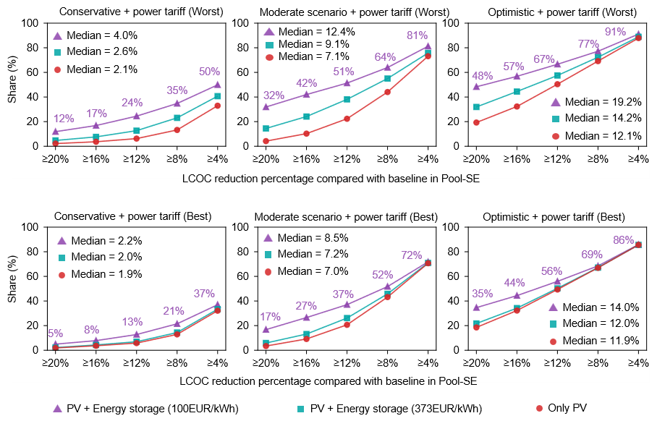
Figure 8. Distribution of LCOC reduction percentages across charging locations under conservative, moderate, and optimistic PV siting scenarios in Pool-SE, relative to the baseline scenario. The upper and lower rows represent the worst- and best-case DSO tariff settings, respectively. The x-axis indicates LCOC reduction thresholds, while the y-axis shows the share of charging locations achieving at least each threshold.

Larger PV siting potential and lower storage costs both increase LCOC reductions. Under the worst-case tariff setting, median reductions increase from 2.1%–4.0% in the conservative scenario to 12.1%–19.2% in the optimistic scenario, while the share of locations achieving at least a 12% reduction rises from 24% to 67%. Under the best-case tariff setting, the corresponding median reductions increase from 1.9%–2.2% to 11.9%–14.0%, with the share achieving at least a 12% reduction increasing from 15% to 59%.

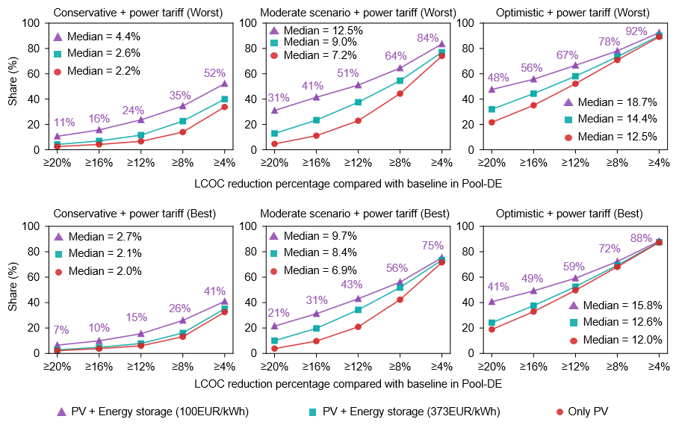
Figure 9. Distribution of LCOC reduction percentages across charging locations under conservative, moderate, and optimistic PV siting scenarios in Pool-DE, relative to the baseline scenario. The upper and lower rows represent the worst- and best-case DSO tariff settings, respectively. The x-axis indicates LCOC reduction thresholds, while the y-axis shows the share of locations achieving at least each threshold.

Larger PV siting potential and lower storage costs both increase LCOC reductions. Under the worst-case tariff setting, median reductions increase from 2.2%–4.4% in the conservative scenario to 12.5%–18.7% in the optimistic scenario, while the share of locations achieving at least a 4% reduction rises from 52% to 92%. Under the best-case tariff setting, the corresponding median reductions increase from 2.0%–2.7% to 12.0%–15.8%, with the share achieving at least a 4% reduction increasing from 41% to 88%.

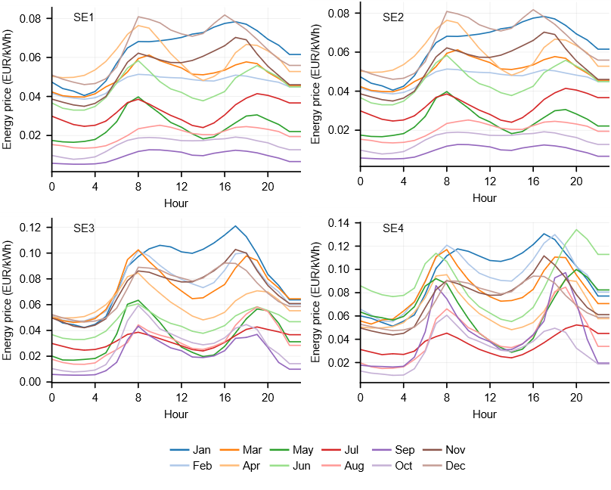
Figure 10. Hourly day-ahead energy price profiles in 2023 across the four Swedish bidding zones: SE1, SE2, SE3, and SE4 [2]. For each month, we calculate the average price for each hour of the day to construct representative hourly price profiles. These profiles are incorporated into the energy and supply component of electricity costs, while network costs, taxes, and levies are kept constant and passed through to CPOs.

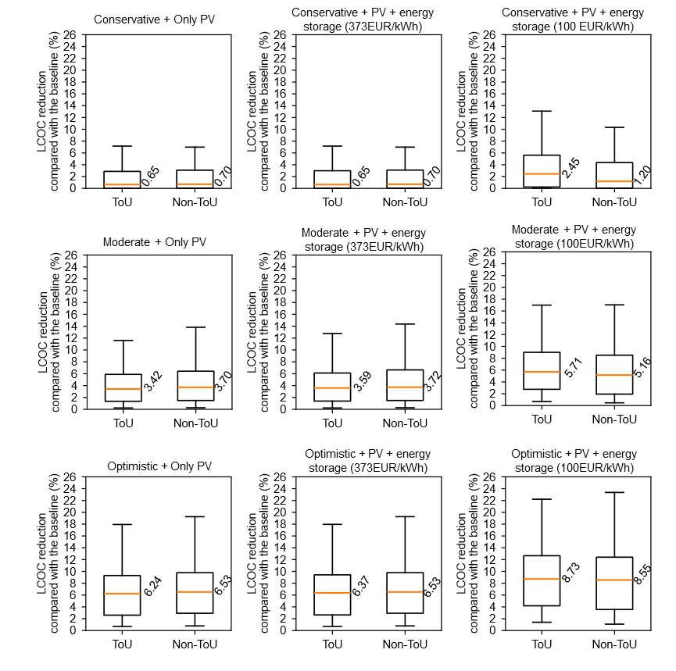
Figure 11. Distributions of LCOC reductions relative to the baseline under the time-of-use tariff scheme and without the time-of-use tariff scheme in Pool-SE, using average network tariff values. The rows represent conservative, moderate, and optimistic PV siting scenarios, while the columns represent different storage-cost assumptions. For each boxplot, the central line denotes the median, the box spans the 25th to 75th percentiles, and the whiskers indicate the minimum and maximum values excluding outliers. In most scenarios, ToU pricing marginally reduces estimated PV-and-storage LCOC reductions, with differences small enough to be considered negligible. At 100 EUR/kWh storage cost, ToU pricing yields even larger reductions.

Overall, the distributions under ToU and non-ToU pricing are very similar across all scenarios, indicating that the introduction of hourly energy prices has only a limited effect on the cost-saving potential of on-site PV and storage. The median LCOC reductions differ only slightly between the two pricing schemes. For example, under the moderate PV siting scenario, the median reductions are 3.42% and 3.70% without storage, 3.59% and 3.72% with storage at 373 EUR/kWh, and 5.71% and 5.16% with storage at 100 EUR/kWh under ToU and non-ToU pricing, respectively. Similar patterns are observed under the optimistic scenario, where the median reductions remain close under the two pricing schemes. The ToU effect is small mainly because the Swedish 2023 day-ahead price spread is limited relative to the average energy price, and because ToU pricing is applied only to the energy-and-supply component rather than to the full charging cost. The average spot price is about 0.12 EUR/kWh, while the average high-to-low ToU price spread is about 0.025 EUR/kWh. If we treat the average price as the midpoint between high- and low-price periods, then the low-price level is approximately 0.12 - 0.025/2 = 0.1075 EUR/kWh, and the high-price level is approximately 0.12 + 0.025/2 = 0.1325 EUR/kWh.
In PV-only and high-storage-cost cases, storage plays a limited role, so most of the LCOC reduction comes from direct PV self-consumption. The amount of charging demand covered by PV is almost unchanged between the flat-price and ToU-price assumptions. Therefore, ToU pricing mainly changes the unit value of the electricity displaced by PV, rather than the amount of PV electricity used. If PV generation mainly coincides with lower-price hours, the avoided electricity cost is about 0.1075 EUR/kWh, which is approximately 90% of the flat average price of 0.12 EUR/kWh. If PV generation coincides with higher-price hours, the avoided electricity cost is about 0.1325 EUR/kWh, which is approximately 110% of the flat-price value. Therefore, even in these two extreme cases, the ToU effect on PV-related savings is only around plus or minus 10%, which explains why the overall impact on LCOC reduction remains limited.
When storage becomes cheaper, especially at 100 EUR/kWh, the model deploys larger storage capacity. In this case, storage is not only used to increase PV self-consumption and reduce peak demand, but can also respond to ToU price signals by charging during lower-price hours and discharging during higher-price hours. Therefore, ToU pricing can increase the value of storage in the low-cost storage case, and the LCOC reduction under ToU can become larger than under the flat-price assumption. More generally, the smaller the ToU price spread is relative to the average spot price, the smaller the expected impact of ToU pricing on LCOC reduction.

Table 2. Country-level median percentage reduction in LCOC across charging locations under the conservative, moderate, and optimistic scenarios in Pool-SE, relative to the baseline. The energy storage capital cost is set to 373 EUR/kWh, and the power tariff is fixed at the average value across the 115 network tariff schemes in Pool-SE.

Country | Conservative | Moderate | Optimistic
AT | 3% | 8% | 14%
BE | 3% | 6% | 10%
BG | 5% | 13% | 20%
CH | 2% | 8% | 14%
CZ | 2% | 7% | 13%
DE | 2% | 6% | 11%
DK | 2% | 7% | 12%
EE | 8% | 11% | 16%
ES | 3% | 9% | 14%
FI | 1% | 4% | 7%
FR | 2% | 7% | 12%
HR | 5% | 14% | 21%
HU | 5% | 14% | 23%
IE | 1% | 8% | 15%
IT | 2% | 11% | 19%
LT | 4% | 9% | 13%
LU | 2% | 9% | 14%
LV | 3% | 9% | 14%
NL | 6% | 10% | 17%
NO | 0% | 2% | 3%
PL | 2% | 8% | 14%
PT | 5% | 11% | 16%
RO | 3% | 14% | 19%
SE | 1% | 4% | 7%
SI | 2% | 7% | 13%
SK | 6% | 15% | 23%
UK | 5% | 16% | 22%
GR | 5% | 10% | 16%
MK | 0% | 5% | 9%
BA | 3% | 5% | 9%
RS | 2% | 6% | 12%
ME | 2% | 4% | 7%
AL | 0% | 1% | 2%
MD | 1% | 8% | 10%
UA | 3% | 7% | 11%
BY | 1% | 1% | 3%

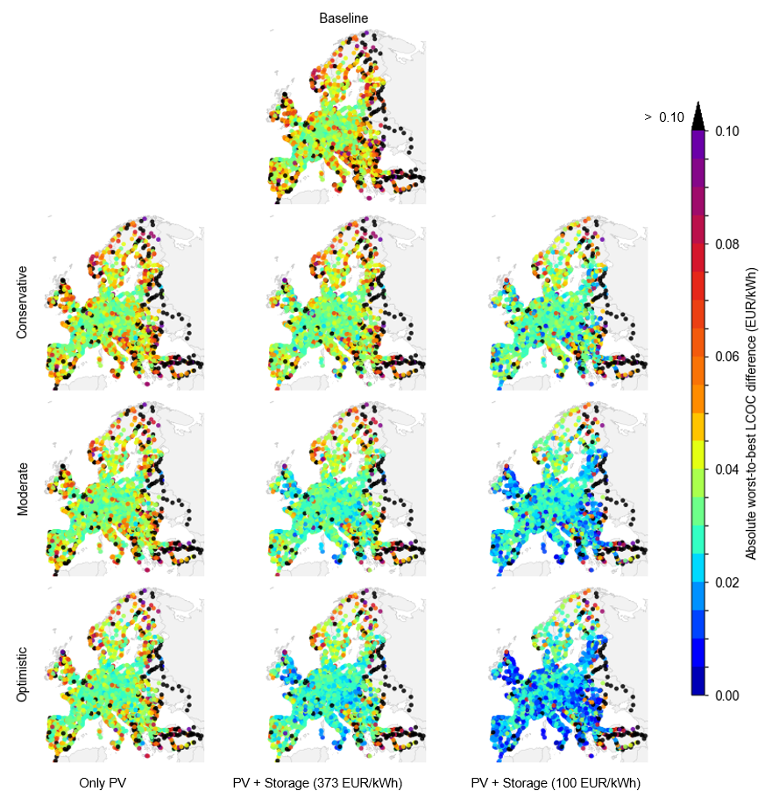
Figure 12. Spatial distributions of the absolute LCOC difference between the worst- and best-tariff scenarios in Pool-SE.

The first row shows the baseline scenario, in which neither solar PV nor battery storage is installed, while the remaining rows show the nine PV and storage scenarios formed by combining three PV siting assumptions with three battery cost assumptions. The unit is EUR/kWh. Compared with the baseline, the PV and storage scenarios show a clear reduction in the tariff-induced LCOC gap, especially when larger PV areas and low-cost storage are available. Nevertheless, the maps also reveal substantial spatial heterogeneity: while many locations shift toward lower gap values, some locations remain exposed to large worst-to-best tariff differences.

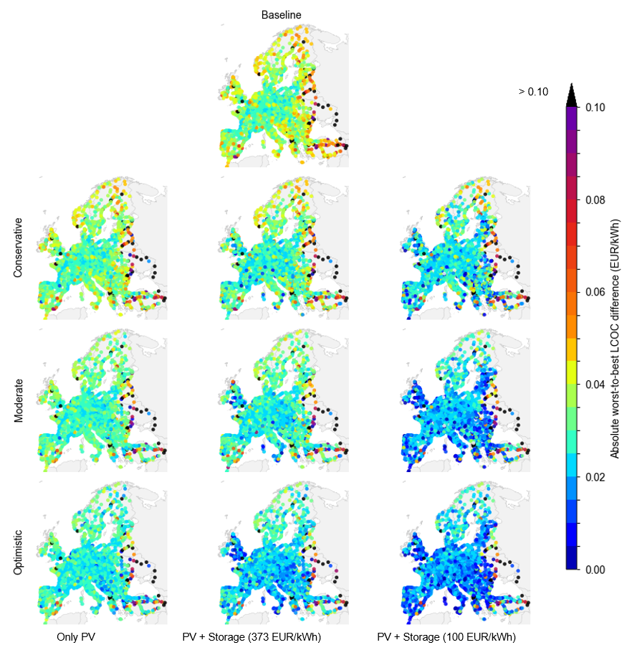
Figure 13. Spatial distributions of the absolute LCOC difference between the worst- and best-tariff scenarios in Pool-DE. The first row shows the baseline scenario, in which neither solar PV nor battery storage is installed, while the remaining rows show the nine PV and storage scenarios formed by combining three PV siting assumptions with three battery cost assumptions. The unit is EUR/kWh.

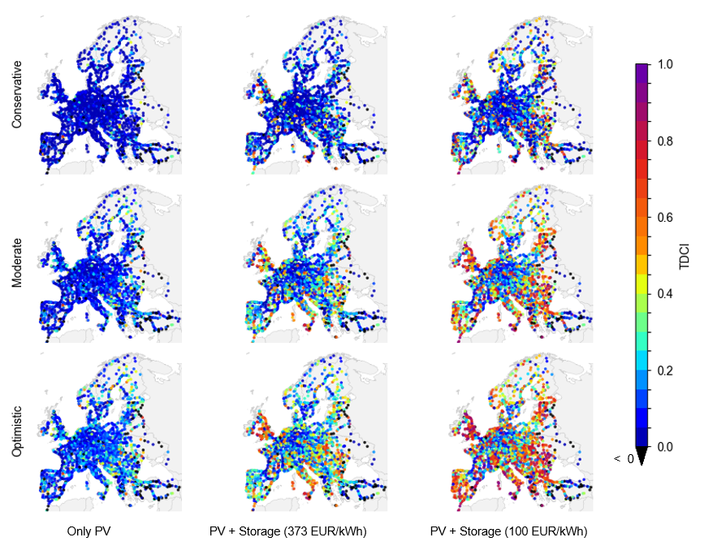

Figure 14. Spatial distributions of the TDCI in Pool-SE. The rows represent conservative, moderate, and optimistic PV siting scenarios, while the columns represent the three storage-cost assumptions: only PV, storage at 373 EUR/kWh, and storage at 100 EUR/kWh.

The TDCI measures the fractional reduction in the LCOC difference between the worst- and best-tariff scenarios after deploying on-site PV and storage, compared with the baseline. The results show that PV and storage generally compress the tariff-induced LCOC gap, especially when larger PV areas and low-cost storage are available. However, this compression effect is spatially heterogeneous. The only-PV cases are dominated by low TDCI values, whereas the storage cases, particularly under the moderate and optimistic PV sitting scenarios, show stronger spatial variation and higher TDCI values in several regions.

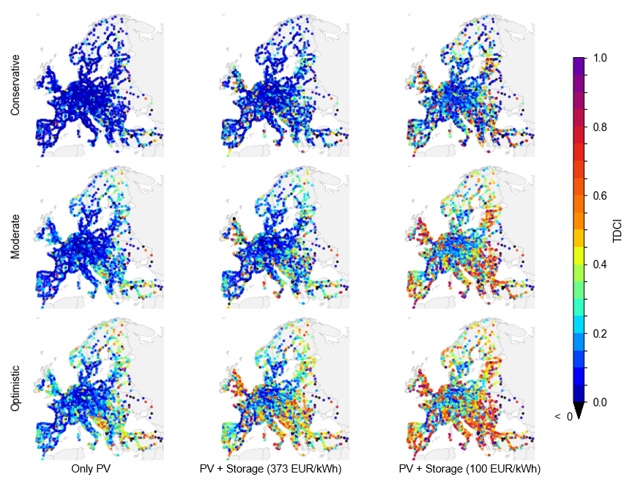
Figure 15. Spatial distributions of the TDCI in Pool-DE. The rows represent conservative, moderate, and optimistic PV siting scenarios, while the columns represent the three storage-cost assumptions: only PV, storage at 373 EUR/kWh, and storage at 100 EUR/kWh.

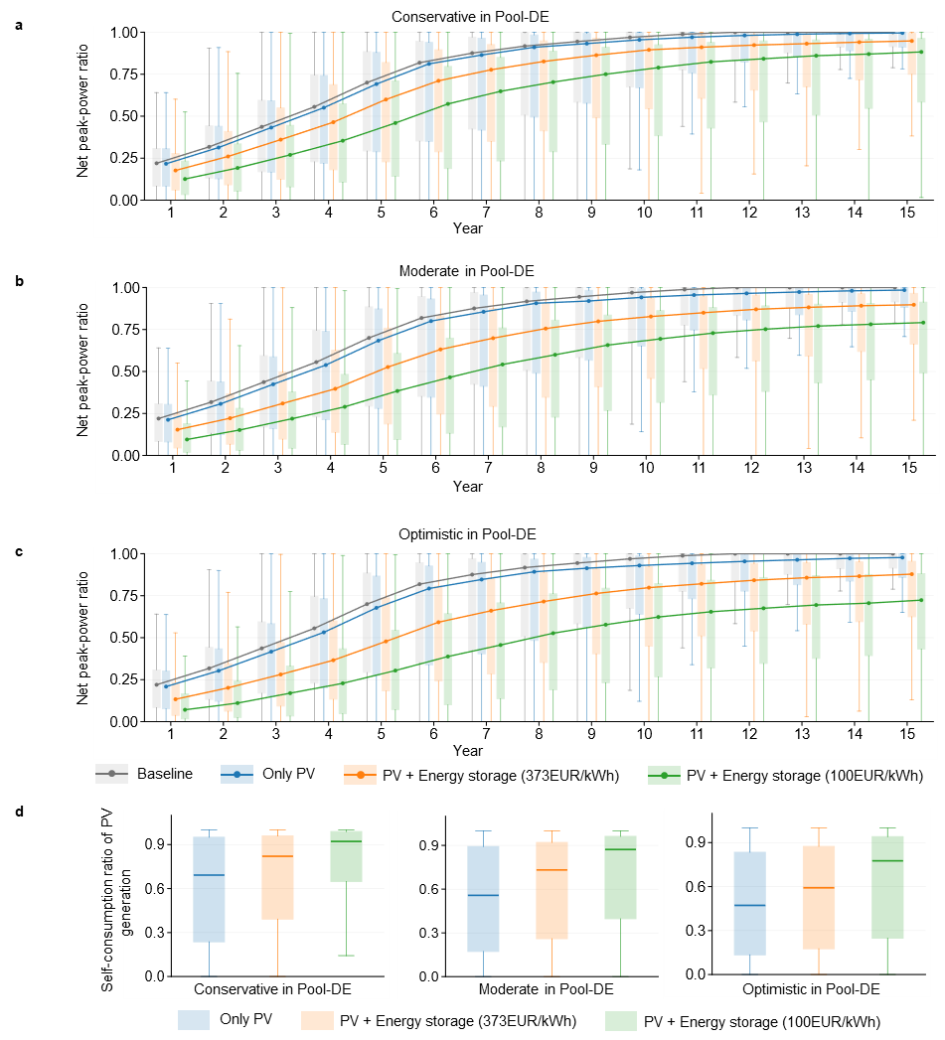

Figure 16. a-c, Distributions of the net peak-power ratio across charging locations over the 15-year planning horizon under (a) conservative, (b) moderate, and (c) optimistic PV-siting scenarios in Pool-DE. d, Distributions of the self-consumption ratio of PV generation across charging locations under the conservative, moderate, and optimistic PV-siting scenarios in Pool-DE. The scenarios include the baseline, PV only, PV with energy storage at an upfront cost of 373~EUR/kWh, and PV with energy storage at an upfront cost of 100~EUR/kWh. The average network-tariff values are used in Pool-DE. For each boxplot, the central line denotes the median, the box spans the 25th to 75th percentiles, and the whiskers indicate the minimum and maximum values excluding outliers.

Table 3. Country-specific labor costs. For countries not included in this table, we use the average values across the countries reported in the table.
Country | Labor cost (EUR/h) | Sources
AT | 40.9 | https://ec.europa.eu/eurostat/cache/metadata/en/lc_lci_lev_esms.htm
BE | 47.1 | https://ec.europa.eu/eurostat/cache/metadata/en/lc_lci_lev_esms.htm
BG | 9.3 | https://ec.europa.eu/eurostat/cache/metadata/en/lc_lci_lev_esms.htm
CH | 67 | https://www.bfs.admin.ch/bfs/en/home/statistics/work-income/wages-income-employment-labour-costs/labour-costs.html
CZ | 18 | https://ec.europa.eu/eurostat/cache/metadata/en/lc_lci_lev_esms.htm
DE | 41.3 | https://ec.europa.eu/eurostat/cache/metadata/en/lc_lci_lev_esms.htm
DK | 48.1 | https://ec.europa.eu/eurostat/cache/metadata/en/lc_lci_lev_esms.htm
EE | 18.3 | https://ec.europa.eu/eurostat/cache/metadata/en/lc_lci_lev_esms.htm
ES | 24.6 | https://ec.europa.eu/eurostat/cache/metadata/en/lc_lci_lev_esms.htm
FI | 37.1 | https://ec.europa.eu/eurostat/cache/metadata/en/lc_lci_lev_esms.htm
FR | 42.2 | https://ec.europa.eu/eurostat/cache/metadata/en/lc_lci_lev_esms.htm
GR | 15.7 | https://ec.europa.eu/eurostat/cache/metadata/en/lc_lci_lev_esms.htm
HR | 14.4 | https://ec.europa.eu/eurostat/cache/metadata/en/lc_lci_lev_esms.htm
HU | 12.8 | https://ec.europa.eu/eurostat/cache/metadata/en/lc_lci_lev_esms.htm
IE | 40.2 | https://ec.europa.eu/eurostat/cache/metadata/en/lc_lci_lev_esms.htm
IT | 29.8 | https://ec.europa.eu/eurostat/cache/metadata/en/lc_lci_lev_esms.htm
LT | 14.7 | https://ec.europa.eu/eurostat/cache/metadata/en/lc_lci_lev_esms.htm
LU | 53.9 | https://ec.europa.eu/eurostat/cache/metadata/en/lc_lci_lev_esms.htm
LV | 13.5 | https://ec.europa.eu/eurostat/cache/metadata/en/lc_lci_lev_esms.htm
NL | 43.3 | https://ec.europa.eu/eurostat/cache/metadata/en/lc_lci_lev_esms.htm
NO | 51.9 | https://ec.europa.eu/eurostat/cache/metadata/en/lc_lci_lev_esms.htm
PL | 14.5 | https://ec.europa.eu/eurostat/cache/metadata/en/lc_lci_lev_esms.htm
PT | 17 | https://ec.europa.eu/eurostat/cache/metadata/en/lc_lci_lev_esms.htm
RO | 11 | https://ec.europa.eu/eurostat/cache/metadata/en/lc_lci_lev_esms.htm
SE | 38.9 | https://ec.europa.eu/eurostat/cache/metadata/en/lc_lci_lev_esms.htm
SI | 25.5 | https://ec.europa.eu/eurostat/cache/metadata/en/lc_lci_lev_esms.htm
SK | 17.2 | https://ec.europa.eu/eurostat/cache/metadata/en/lc_lci_lev_esms.htm
UK | 29 | https://ec.europa.eu/eurostat/cache/metadata/en/lc_lci_lev_esms.htm
BA | 6.1 | https://altax.al/en/what-is-the-hourly-labor-cost-in-the-western-balkans-and-how-much-is-it-affected-by-productivity/?utm_source=chatgpt.com
RS | 10 | https://www.ons.gov.uk/employmentandlabourmarket/peopleinwork/earningsandworkinghours/bulletins/indexoflabourcostsperhourilch/julytoseptember2020
ME | 6 | https://altax.al/en/what-is-the-hourly-labor-cost-in-the-western-balkans-and-how-much-is-it-affected-by-productivity/?utm_source=chatgpt.com
MK | 4.9 | https://www.stat.gov.mk/PrikaziSoopstenie_en.aspx?rbrtxt=119&utm_source=chatgpt.com

Table 4. Country-specific solar PV and energy storage costs reported in recent years (2020-2025).
Country | Solar_Capital  (USD/kW) | Storage_Capital  (USD/kWh) | Solar_O&M (USD/kW) | Storage_O&M (USD/kWh)
AT | 678ª | 687 | 7.9ª | 17e
BE | 965ª | 687 | 7.9ª | 17e
BG | 659ª | 687 | 7.9ª | 17e
CZ | 663ª | 687 | 7.9ª | 17e
DE | 731ª | 687 | 7.9ª | 17e
DK | 645^{b} | 687 | 7.9ª | 17e
EE | 705ª | 687 | 7.9ª | 17e
ES | 671ª | 687 | 7.9ª | 17e
FR | 955ª | 687 | 7.9ª | 17e
GR | 1173^{c} | 687 | 7.9ª | 17e
HR | 1266^{c} | 687 | 7.9ª | 17e
HU | 1078ª | 687 | 7.9ª | 17e
IE | 686ª | 687 | 7.9ª | 17e
IT | 865^{b} | 687 | 7.9ª | 17e
LU | 684ª | 687 | 7.9ª | 17e
LV | 716ª | 687 | 7.9ª | 17e
NL | 753ª | 687 | 7.9ª | 17e
NO | 1018^{b} | 687 | 7.9ª | 17e
PL | 700ª | 687 | 7.9ª | 17e
PT | 723ª | 687 | 7.9ª | 17e
RO | 743ª | 687 | 7.9ª | 17e
SE | 685^{d} | 687 | 7.9ª | 17e
SK | 854ª | 687 | 7.9ª | 17e
UK | 933ª | 687 | 7.9ª | 17e
Note: “a” presents the data collected from Reference [3]. “b” presents the data collected from Reference [4]. “c” represents the data collected from Reference [5]. “d” denotes the data from Reference [6]. “e” denotes the data from Reference [7].

Note 2. Projecting country-specific solar PV and battery-storage costs in 2030.

According to the NREL Annual Technology Baseline (ATB) Cost and Performance Data for Electricity Generation Technologies [7], the system-level CAPEX of commercial battery storage is 683 USD/kWh for a 4-hour system and 1,679 USD/kWh for a 1-hour system in the United States. The implied ratio between 1-hour and 4-hour systems is therefore 2.46. To parameterize a high-power storage configuration consistent with the 1C operation (1-hour system) assumed in our optimization model in Europe context, we apply this duration-based cost ratio to the reported European 4-hour battery storage cost of 271 USD/kWh in 2023 [8]. This gives an estimated 1-hour storage capital cost of 2.46×271=667 USD/kWh. We further use 667 + 20 USD/kWh as a conservative rounded value for our estimation.
Let $C_{CAPEX,y}^{k}$ and $C_{O\&M,y}^{k}$ denote the CAPEX and O&M costs (in USD) for energy technology k in year y, where k = 1 represents solar PV and k = 2 represents battery storage. The costs are originally reported in USD and are converted to EUR using a fixed exchange rate. Assuming a linear annual cost reduction pathway, the projected 2030 costs are calculated as:

$C_{CAPEX,2030}^{k}=C_{CAPEX,y}^{k}×\left(1-\left(2030-y\right)×r_{CAPEX}^{k}\right)×Currency_rate_USD_EUR$,
$C_{O\&M,2030}^{k}=C_{O\&M,y}^{k}×\left(1-\left(2030-y\right)×r_{O\&M}^{k}\right)×Currency_rate_USD_EUR$.

Here, $r_{CAPEX}^{k}$ and $r_{O\&M}^{k}$ represent the average annual cost reduction rates between 2020 and 2030, respectively. We calculate the $r_{CAPEX}^{k}$ from the projected renewable technology CAPEX cost dataset reported in Reference [8]. We assume that $r_{O\&M}^{k}$ is equal to $r_{CAPEX}^{k}$. Here, the calculated $r_{CAPEX}^{1}=0.03$ and $r_{CAPEX}^{2}=0.053$. The USD-to-EUR exchange rate is set to 0.863. This gives a 1-hour battery storage capital cost of 373 EUR/kWh in 2030.
To define an optimistic low-cost storage scenario, we further refer to recent market evidence from China. According to statistics from the China Energy Storage Alliance [9], the average EPC bid price for 1-hour battery storage systems was 1,280.15 RMB/kWh, with reported prices ranging from 698.80 to 1,614.27 RMB/kWh, representing a 55.91% decrease compared with 2024. This indicates that substantially lower storage costs are already emerging in low-cost markets. Considering that cost reductions may slow toward 2030 and that European project costs are generally higher than those in China, we define 100 EUR/kWh as an optimistic low-cost storage scenario in our sensitivity analysis.

Table 5. Battery capacity configuration and the corresponding mass based on the trip distance.
OD distance (km) | Battery capacity (kWh) | Battery mass (kg) | $$F^{tech}$$
<= 444 | 600 | 2308 | 0.738739
[445,517] | 700 | 2692 | 0.738878
[518,588] | 800 | 3077 | 0.736395
[589,660] | 900 | 3462 | 0.734848
> 660 | 1000 | 3846 | 0.732606
Note: The battery energy density is set to 260 Wh/kg [10]. The values of $F^{tech}$ are also derived from the same source [10]. Battery capacity is assigned based on the total OD distance using five discrete battery-size classes from 600 to 1000 kWh. The distance thresholds are defined so that the ratio between battery capacity and the upper bound of each distance range is approximately 1.35–1.36 kWh/km, representing a full-battery driving range under a typical long-haul energy consumption level. The vehicle weight used in the energy consumption calculation includes the battery mass, and therefore energy consumption varies slightly across battery-size classes.

Table 6. Energy consumption rates of 30 trip types.
Battery capacity (kWh) | National, loaded, truck 1 (kWh/km) | National, loaded, truck 2 (kWh/km) | International, loaded, truck 1 (kWh/km) | International, loaded, truck 2 (kWh/km) | Empty, truck 1 (kWh/km) | Empty, truck 2 (kWh/km)
600 | 1.42 | 1.30 | 1.50 | 1.38 | 0.90 | 0.74
700 | 1.43 | 1.31 | 1.51 | 1.39 | 0.91 | 0.76
800 | 1.44 | 1.32 | 1.52 | 1.40 | 0.93 | 0.78
900 | 1.45 | 1.33 | 1.53 | 1.41 | 0.94 | 0.79
1000 | 1.46 | 1.34 | 1.54 | 1.42 | 0.96 | 0.80
Note: National trips refer to domestic transport operations with a payload of 13.5 tonnes, whereas international trips refer to cross-border transport operations with a payload of 15.9 tonnes. Truck 1 and Truck 2 denote two truck types with empty vehicle masses, excluding battery mass, of 11 tonnes and 8 tonnes, respectively. Empty trips refer to trips without payload.

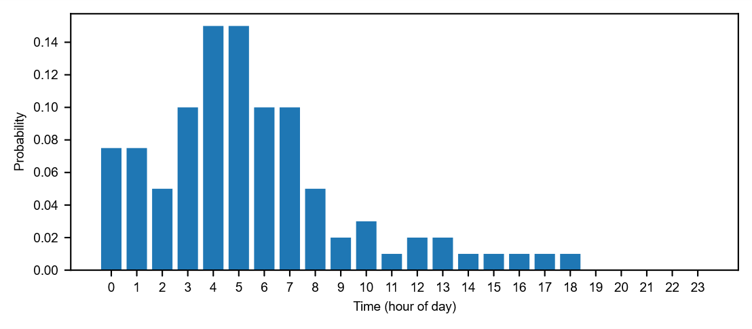
Figure 17. Discrete probability distribution of truck departure times, derived from the DT-CARGO dataset [11].

Table 7. Charging infrastructure parameters.
Parameters | CCS charger | MCS charger
Lifetime | 15 years [12] | 15 years
Discount rate | 9.5% [13] | 9.5%
Hardware cost | 338 EUR per kW in 2030 [13] | 338 EUR per kW in 2030
Installation cost | 151 EUR per kW in 2030 [13] | 151 EUR per kW in 2030
Labor cost share | 40% of the installation cost [14] | 40% of the installation cost
Annual operation and maintenance cost | 1% of capital cost [15] | 1.5% of capital cost
Cost for expanding additional parking areas | 56 EUR/m² [16] | 56 EUR/m²
Area requirement for a charger deployment and long-haul truck parking | 80 m² [17] | 80 m²

Note 3. Calculating country-specific installation costs of the charging infrastructure.

Given a specific country, the installation cost of the charging infrastructure ($IC_{country}$) is calculated based on the labor cost as follows.
$IC_{country}=\left(1-LCS\right)∙IC_{ave}+LCS∙IC_{ave}∙\frac{LC_country}{LC_ave}$ (1)
Let $LCS$ denote the labor cost share for all countries. Let $IC_{ave}$ denote the average installation cost (EUR/kW) of the charging infrastructure. $LC_country$ represents the labor cost (EUR/h) in the given country, while $LC_ave$ denotes the average labor cost (EUR/h) across countries.

Note 4. Pool-DE formulation for the PV-storage optimization.
This note provides the Pool-DE version of the PV and battery-storage optimization formulation. The Pool-DE formulation differs from the Pool-SE formulation only in the calculation of network costs. In Pool-SE, power charges are based on monthly peak power. In Pool-DE, the applicable German network-tariff category is determined by the annual equivalent full-load hours of each charging location. All PV-generation, battery-operation, and load-serving constraints are identical to those in the main PV-storage formulation, except for the annual peak-power and tariff-category constraints described below.
For a selected Pool-DE tariff scenario, let $c^{DE,en,L}$ and $c^{DE,pw,L}$ denote the energy-based network charge and annual peak-power charge for the low-utilization category, and let $c^{DE,en,H}$ and $c^{DE,pw,H}$ denote the corresponding charges for the high-utilization category. The threshold between the two categories is 2,500 equivalent full-load hours. The average Pool-DE scenario uses the arithmetic mean of the DSO tariffs within each category. Best- and worst-case scenarios use the corresponding DSO-specific tariff rates.
The objective function minimizes the equivalent annual cost:
min Z=​ccapPVCRFPV+comPVPPV+ccapBCRFB+comBEB+CRFCIy∈Y​NCyDE1+ry.
Here, $NC_{y}^{DE}$ denotes the annual net electricity cost under the Pool-DE tariff formulation. All other symbols are defined as in the main PV-storage formulation. Annual net grid-supplied charging demand is calculated as:
Gy=​365t∈T​o∈O​Ly,t,oΔo-h∈H​t∈T​o∈O​DhSy,h,t,oPV,E-h∈H​t∈T​o∈O​DhSy,h,t,oB,E+h∈H​t∈T​o∈O​DhSy,h,t,oG,B, ∀y.
This definition counts direct grid supply to truck charging and grid electricity used to charge the battery as grid-supplied demand, while subtracting the electricity supplied to trucks by PV and battery discharge. Exported PV electricity is calculated as:
Xy=​h∈H​t∈T​DhPPVPmodpy,h,tPV-h∈H​t∈T​o∈O​DhSy,h,t,oPV,E-h∈H​t∈T​o∈O​DhSy,h,t,oPV,B, ∀y.
For each year, month and hour, the net grid-supplied load is defined as:
Py,h,tnet=​o∈O​Ly,t,oΔo-o∈O​Sy,h,t,oPV,E-o∈O​Sy,h,t,oB,E+o∈O​Sy,h,t,oG,B, ∀y,h,t.
The monthly and annual net peak powers are constrained by:
$$P_{y,h}^{month}≥P_{y,h,t}^{net}, ∀y,h,t,$$
$$P_{y}^{peak,DE}≥P_{y,h}^{month}, ∀y,h.$$
An upper bound on annual peak power is optionally imposed using the gross charging-load peak:
$$P_{y}^{peak,DE}≤{\overline{P}}_{y}, ∀y,$$
where ${\overline{P}}_{y}$ is the maximum gross charging load before PV and storage operation in year $y$.
To represent the German full-load-hour tariff rule in a mixed-integer linear form, we introduce a binary variable $u_{y}$. The variable $u_{y}$ equals 1 if the charging location is assigned to the low-utilization category, that is, annual equivalent full-load hours are below 2,500 h. It equals 0 if the charging location is assigned to the high-utilization category. The category-selection constraints are:
$$G_{y}≤2500P_{y}^{peak,DE}-ε+M_{y}^{Φ}\left(1-u_{y}\right), ∀y,$$
$$G_{y}≥2500P_{y}^{peak,DE}-M_{y}^{Φ}u_{y}, ∀y,$$
$$u_{y}∈\{0,1\}, ∀y.$$
Here, $ε$ is a small positive tolerance and $M_{y}^{Φ}$ is a sufficiently large station-year-specific constant. These constraints enforce the low-utilization category when $G_{y}<2500P_{y}^{peak,DE}$ and the high-utilization category when $G_{y}≥2500P_{y}^{peak,DE}$.
The annual network tariff cost under the two possible German tariff categories is:
$${\hat{TC}}_{y}^{L}=c^{DE,en,L}G_{y}+c^{DE,pw,L}P_{y}^{peak,DE}, ∀y,$$
$${\hat{TC}}_{y}^{H}=c^{DE,en,H}G_{y}+c^{DE,pw,H}P_{y}^{peak,DE}, ∀y.$$
Let $TC_{y}^{DE}$ denote the annual network tariff cost actually applied in year $y$. The tariff-cost selection is linearized by the following big-$M$ constraints:
$$TC_{y}^{DE}≤{\hat{TC}}_{y}^{L}+M_{y}^{C}\left(1-u_{y}\right), ∀y,$$
$$TC_{y}^{DE}≥{\hat{TC}}_{y}^{L}-M_{y}^{C}\left(1-u_{y}\right), ∀y,$$
$$TC_{y}^{DE}≤{\hat{TC}}_{y}^{H}+M_{y}^{C}u_{y}, ∀y,$$
$$TC_{y}^{DE}≥{\hat{TC}}_{y}^{H}-M_{y}^{C}u_{y}, ∀y.$$
Here, $M_{y}^{C}$ is a sufficiently large station-year-specific constant for the annual tariff cost. When $u_{y}=1$, these constraints force $TC_{y}^{DE}={\hat{TC}}_{y}^{L}$. When $u_{y}=0$, they force $TC_{y}^{DE}={\hat{TC}}_{y}^{H}$.
Under Pool-DE, the annual net electricity cost consists of the non-network electricity cost, the selected German network tariff cost, and the revenue from exported PV electricity:
$$NC_{y}^{DE}=c_{y}^{oth}G_{y}+TC_{y}^{DE}-FiTX_{y}, ∀y.$$
For each charging location, $c_{y}^{oth}$ is derived by subtracting the network-cost component from the country-specific non-residential electricity price in the corresponding consumption band. The Pool-DE network energy and power charge rates are then applied explicitly through the full-load-hour category selection. All continuous decision variables are non-negative, and the binary variables include the battery charging/discharging mode variable from the main PV-storage formulation and the Pool-DE tariff-category variable $u_{y}$. The MILP models are solved using Gurobi in Python.

Table 8. The parameters of SunPower SPR-E20-327.
Parameters | Values
Efficiency | 20.1% [18]
Rated power | 327 W [18]
Life time | 25 years [18]
Temperature Coefficient | -0.0035/°C [18]
Output Decline | Year 1: 2% [18];  Years 2 to 25: 0.25% [18];  0.5% is used in this study for all years.
Nominal operating cell temperature | 45 °C [19]
Inverter efficiency | 0.97 [20]

Table 9. Temporal structure of the PV-storage optimization model.
Modeling Level | Element | Note
Planning horizon | 15 years | Each optimization instance covers a 15-year planning horizon.
Year | 12 representative months per year | For each year, the model considers 12 monthly representations. Monthly variation captures seasonal PV outputs.
Month | 1 typical day per month | For each month, a typical day is used to represent monthly PV generation conditions.
Representative day | 24 hourly periods | The model optimizes electricity flows and storage operation over hourly periods.
Hour | Multiple charging sessions | Case-specific, based on charging demand distribution within the hour.

Table 10. Number of optimization instances solved across tariff pools, tariff settings, PV siting assumptions, and storage-cost scenarios.
The number of instances | Conservative (373 EUR/kWh) | Conservative (100 EUR/kWh) | Conservative (Only PV) | Moderate (373 EUR/kWh) | Moderate (100 EUR/kWh) | Moderate (Only PV) | Optimistic (373 EUR/kWh) | Optimistic (100 EUR/kWh) | Optimistic (Only PV) | Total
Pool-SE (ave) | 1987 | 1987 | 1987 | 2452 | 2452 | 2452 | 2452 | 2452 | 2452 | 20673
Pool-SE (max) | 1987 | 1987 | 1987 | 2452 | 2452 | 2452 | 2452 | 2452 | 2452 | 20673
Pool-SE (min) | 1987 | 1987 | 1987 | 2452 | 2452 | 2452 | 2452 | 2452 | 2452 | 20673
Pool-DE (ave) | 1987 | 1987 | 1987 | 2452 | 2452 | 2452 | 2452 | 2452 | 2452 | 20673
Pool-DE (max) | 1987 | 1987 | 1987 | 2452 | 2452 | 2452 | 2452 | 2452 | 2452 | 20673
Pool-DE (min) | 1987 | 1987 | 1987 | 2452 | 2452 | 2452 | 2452 | 2452 | 2452 | 20673
Total | 11922 | 11922 | 11922 | 14712 | 14712 | 14712 | 14712 | 14712 | 14712 | 124038

This table reports the total number of PV-storage optimization instances. Each instance is defined by a charging location, a PV siting scenario, a storage-cost assumption, and a tariff setting. For each tariff setting, the nine PV-storage scenarios generate 20,673 instances. Across the six tariff settings, namely average, maximum (worst), and minimum (best) tariffs for both Pool-SE and Pool-DE, the total number of solved optimization instances is 124,038. Under the conservative PV siting assumption, 1,987 charging locations have non-zero available PV installation area and are therefore included in the optimization. In contrast, the moderate and optimistic assumptions allow PV deployment at 2,452 charging locations, resulting in a larger number of instances.
We also report the optimization results and the Gurobi optimality gap for all instances in Supplementary Data 2. The optimality gap is defined as the relative gap between the solver-reported upper and lower bounds. For the instances involving joint optimization of solar PV and energy storage, if an instance with a relatively large optimality gap yields a higher LCOC than the corresponding no-storage case, we replace its result with that of the no-storage case, since the no-storage solution is feasible for the joint optimization problem and provides a better objective value.

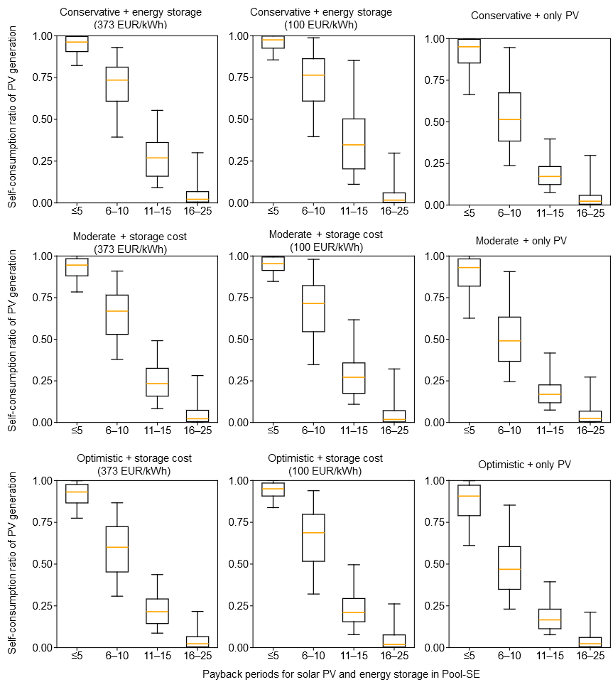

Figure 18. Self-consumption ratio of PV generation by payback-period group across PV-siting and storage-cost scenarios in Pool-SE, using average network tariff values. For each boxplot, the central line denotes the median, the box spans the 25th to 75th percentiles, and the whiskers indicate the minimum and maximum values excluding outliers.

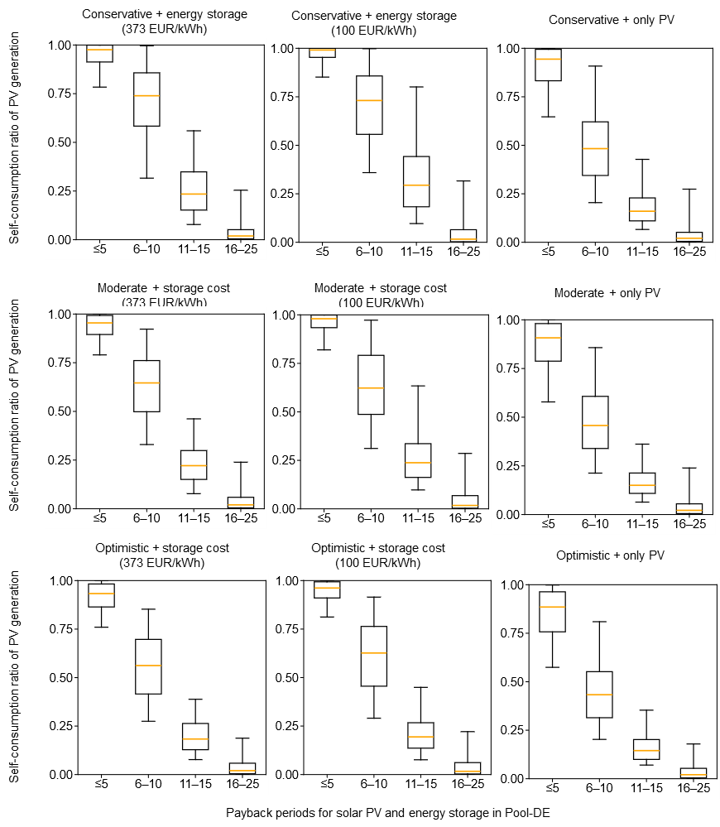
Figure 19. Self-consumption ratio of PV generation by payback-period group across PV-siting and storage-cost scenarios in Pool-DE, using average network tariff values. For each boxplot, the central line denotes the median, the box spans the 25th to 75th percentiles, and the whiskers indicate the minimum and maximum values excluding outliers.

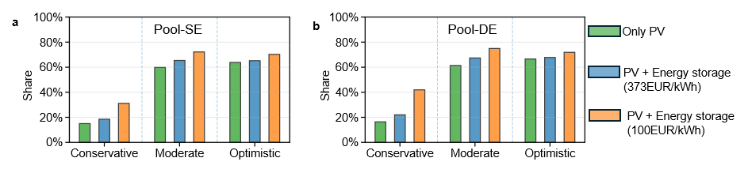
Figure 20. Share of charging locations where PV and energy storage achieve either at least a 10% reduction in LCOC or at least EUR 100,000 in annualized cost savings, with a payback period of no more than 10 years in (a) Pool-SE and (b) Pool-DE using average network tariff values.

Reference

- Eurostat. Database (2025). https://ec.europa.eu/eurostat/web/main/data/database
- entso-e. transparency platform (2026). https://transparency.entsoe.eu/
- International renewable energy agency. Renewable power generation costs in 2023 (2024). https://www.irena.org/-/media/Files/IRENA/Agency/Publication/2024/Sep/IRENA_Renewable_power_generation_costs_in_2023.pdf
- International energy agency, Nuclear energy, Organisation for economic co-operation and development. Projected costs of generating electricity (2020). https://iea.blob.core.windows.net/assets/ae17da3d-e8a5-4163-a3ec-2e6fb0b5677d/Projected-Costs-of-Generating-Electricity-2020.pdf.
- International renewable energy agency. Renewable power generation costs in 2022 (2023). https://www.irena.org/-/media/Files/IRENA/Agency/Publication/2023/Aug/IRENA_Renewable_power_generation_costs_in_2022.pdf
- Lindahl, J., Lingfors, D., Elmqvist, Å., & Mignon, I. (2022). Economic analysis of the early market of centralized photovoltaic parks in Sweden. Renewable energy, 185, 1192-1208.
- Open energy data initiative. 2024 annual technology baseline (ATB) cost and performance data for electricity generation technologies (2024). https://data.openei.org/submissions/6006
- Ghadim, H. V., Haas, J., Breyer, C., Gils, H. C., Read, E. G., Xiao, M., & Peer, R. (2025). Are we too pessimistic? Cost projections for solar photovoltaics, wind power, and batteries are over-estimating actual costs globally. Applied Energy, 390, 125856.
- China energy storage alliance. Analysis of energy storage bid prices in 2025 (2026). https://www.cnesa.org/information/detail/?column_id=2&id=7750&utm
- International council on clean transportation. Battery electric tractor-trailers in the European Union: A vehicle technology analysis (2021). https://theicct.org/publication/battery-electric-tractor-trailers-in-the-european-union-a-vehicle-technology-analysis/
- Balke, G., & Adenaw, L. (2023). Heavy commercial vehicles' mobility: Dataset of trucks' anonymized recorded driving and operation (DT-CARGO). Data in brief, 48, 109246
- Lanz, L., Noll, B., Schmidt, T. S., & Steffen, B. (2022). Comparing the levelized cost of electric vehicle charging options in Europe. Nature communications, 13(1), 5277.
- International council on clean transportation. Total cost of ownership for tractor-trailers in Europe: Battery electric versus diesel (2021). https://theicct.org/publication/total-cost-of-ownership-for-tractor-trailers-in-europe-battery-electric-versus-diesel/
- International council on clean transportation. Estimating electric vehicle charging infrastructure costs across major U.S. metropolitan areas (2019). https://theicct.org/publication/estimating-electric-vehicle-charging-infrastructure-costs-across-major-u-s-metropolitan-areas/
- Borlaug, B., Salisbury, S., Gerdes, M., & Muratori, M. (2020). Levelized cost of charging electric vehicles in the United States. Joule, 4(7), 1470-1485.
- Michigan concrete association. How expensive is a concrete parking lot? (2020). https://info.miconcrete.org/blog/how-expensive-is-a-concrete-parking-lot
- CharIN. MCS Construction Layout (2026). https://www.charin.global/media/pages/technology/mcs/f35dad3802-1626079602/charin-layout-5.5.21-revised.pdf
- energysage. SunPower SPR-E20-327 (2026). https://www.energysage.com/equipment/solar-panels/sunpower/spr-e20-327-ce9611fa/
- Chandra Mouli, G. R., Bauer, P. & Zeman, M (2016). System design for a solar powered electric vehicle charging station for workplaces. Applied Energy 168, 434-443.
- CanadianSolar. Three phase string inverter 255 kW (2019). https://static.csisolar.com/wp-content/uploads/2019/12/15142206/Canadian-Solar_Datasheet_Inverter_3ph-255KW-ROW_EN.pdf

