T1-T2  (pre) | Delta | Theta | Alpha | Beta | Gamma
Fp1-Fp2 | ↑ 24 | ↑ 24 | ↑ 0 | ↑ 0 | ↑ 0
Fp1-Fp2 | ↓ 0 | ↓ 0 | ↓ 24 | ↓ 24 | ↓ 24
F3-F4 | ↑ 0 | ↑ 22 | ↑ 0 | ↑ 23 | ↑1
F3-F4 | ↓ 24 | ↓ 1 =1 | ↓ 24 | ↓ 1 | ↓ 23
C3-C4 | ↑ 24 | ↑ 24 | ↑ 24 | ↑ 24 | ↑ 24
C3-C4 | ↓ 0 | ↓ 0 | ↓ 0 | ↓ 0 | ↓ 0
P3-P4 | ↑ 0 | ↑ 0 | ↑ 0 | ↑ 0 | ↑ 0
P3-P4 | ↓ 24 | ↓ 24 | ↓ 24 | ↓ 24 | ↓ 24
O1-O2 | ↑ 24 | ↑ 23 | ↑ 23 | ↑ 24 | ↑ 24
O1-O2 | ↓ 0 | ↓ 1 | ↓ 1 | ↓ 0 | ↓ 0
F7-F8 | ↑ 0 | ↑ 24 | ↑ 24 | ↑ 0 | ↑ 24
F7-F8 | ↓ 24 | ↓ 0 | ↓ 0 | ↓ 24 | ↓ 0
T3-T4 | ↑ 24 | ↑ 0 | ↑ 24 | ↑ 24 | ↑ 24
T3-T4 | ↓ 0 | ↓ 24 | ↓ 0 | ↓ 0 | ↓ 0
T5-T6 | ↑ 0 | ↑ 0 | ↑ 0 | ↑ 0 | ↑ 0
T5-T6 | ↓ 24 | ↓ 24 | ↓ 24 | ↓ 24 | ↓ 24
Supplementary File

Table 1 Number of participants showing increased or decreased EEG band power during the last 2 mins compared with the first 2 mins of the pre-baseline recording. ↑ denotes increase and ↓ denotes decrease at later timepoint.

Table 2 Number of participants showing increased or decreased EEG band power during the last 2 mins compared with the first 2 mins of the post-baseline recording. ↑ denotes increase and ↓ denotes decrease at later timepoint.

T1-T2  (post) | Delta | Theta | Alpha | Beta | Gamma
Fp1-Fp2 | ↑ 5 | ↑ 5 | ↑ 5 | ↑ 5 | ↑ 5
Fp1-Fp2 | ↓ 19 | ↓ 19 | ↓ 19 | ↓ 19 | ↓ 19
F3-F4 | ↑ 4 | ↑ 4 | ↑ 4 | ↑ 4 | ↑ 5
F3-F4 | ↓ 20 | ↓ 20 | ↓ 20 | ↓ 20 | ↓ 19
C3-C4 | ↑ 7 | ↑ 7 | ↑ 7 | ↑ 7 | ↑ 7
C3-C4 | ↓ 17 | ↓ 17 | ↓ 17 | ↓ 17 | ↓ 17
P3-P4 | ↑ 1 | ↑ 0 | ↑ 0 | ↑ 0 | ↑ 0
P3-P4 | ↓ 23 | ↓ 24 | ↓ 24 | ↓ 24 | ↓ 24
O1-O2 | ↑ 8 | ↑ 8 | ↑ 8 | ↑ 8 | ↑ 8
O1-O2 | ↓ 16 | ↓ 16 | ↓ 16 | ↓ 16 | ↓ 16
F7-F8 | ↑ 0 | ↑ 0 | ↑ 0 | ↑ 0 | ↑ 0
F7-F8 | ↓ 24 | ↓ 24 | ↓ 24 | ↓ 24 | ↓ 24
T3-T4 | ↑ 4 | ↑ 3 | ↑ 4 | ↑ 5 | ↑ 3
T3-T4 | ↓ 20 | ↓ 21 | ↓ 20 | ↓ 19 | ↓ 21
T5-T6 | ↑ 4 | ↑ 3 | ↑ 6 | ↑ 4 | ↑ 6
T5-T6 | ↓ 20 | ↓ 21 | ↓ 18 | ↓ 20 | ↓ 18

Fig. 1 Average band power at five time points (each of two mins) in prefrontal lobe (Fp1-Fp2). M1–M5: Five consecutive 2-minute intervals during MBRRT (total duration = 10 min).
Observation: There is a sustained increase in the power of all bands during the performance of MBRRT. A higher increasing spike in mean absolute power (abs. power) at M4 is evident across the band.

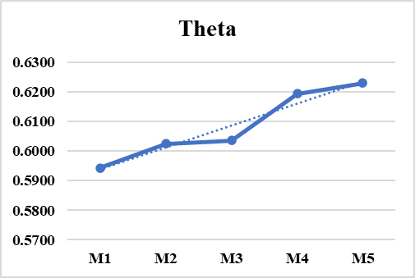
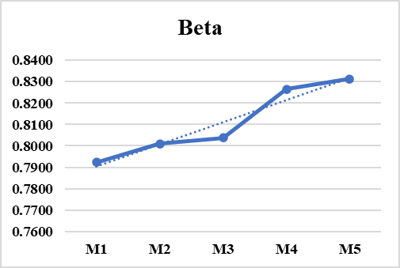
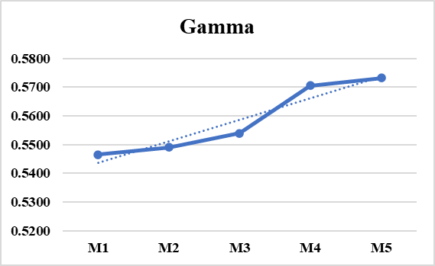
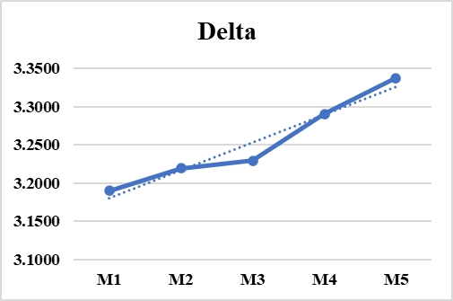
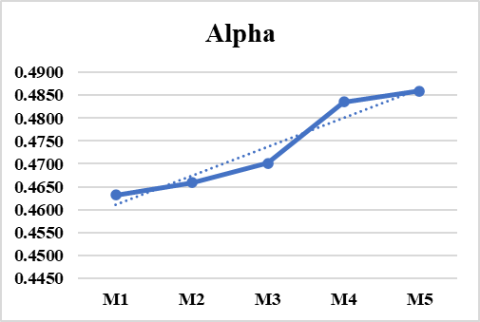
Time points
Abs. power (µV²)
Fig. 2 Average band power at five time points (each of two mins) in frontal lobe (F3-F4). M1–M5: Five consecutive 2-minute intervals during MBRRT (total duration = 10 min).
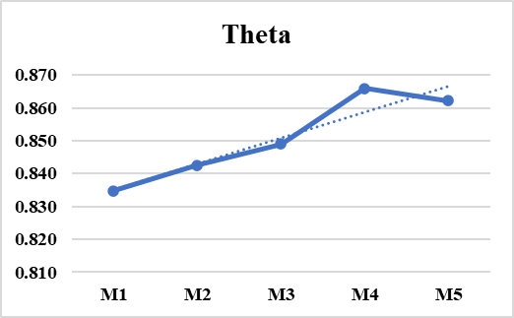
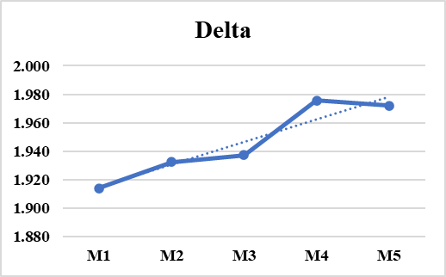
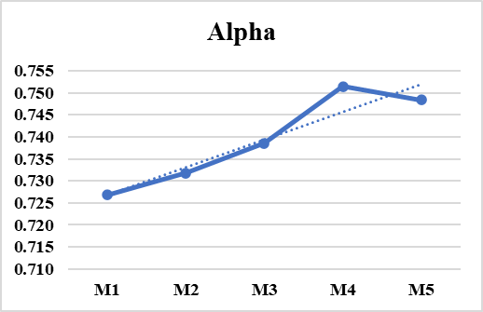
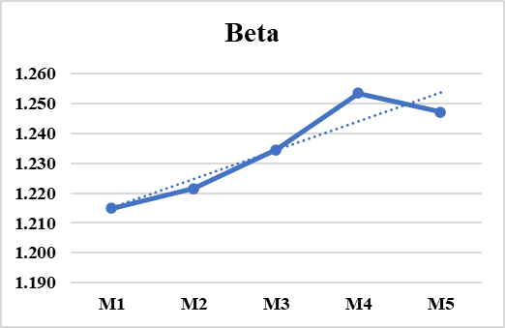
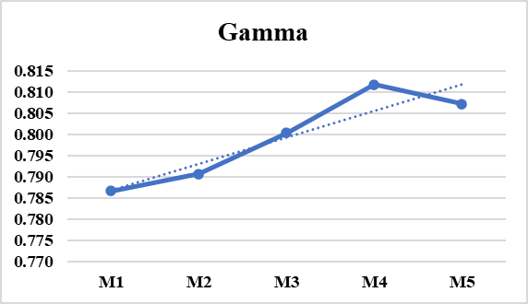
Observation: A similar increasing pattern here as in the prefrontal region up to M4. However, M4 is the peak threshold point, and power tends to return to normal levels after the last eight minutes. This behavior is different from prefrontal region.
Time points
Abs. power (µV²)

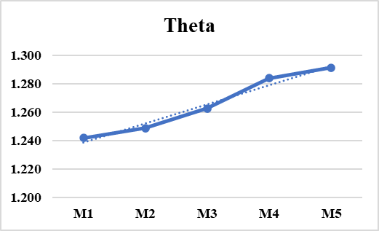
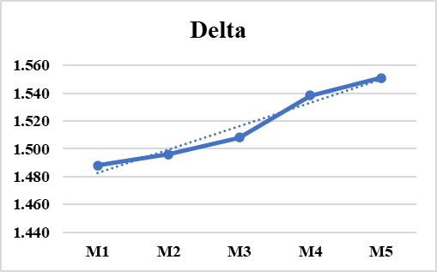
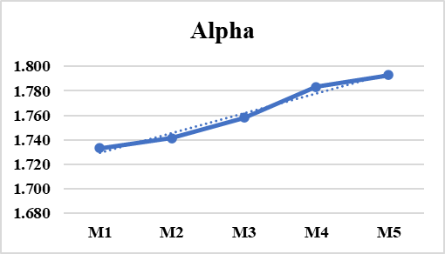
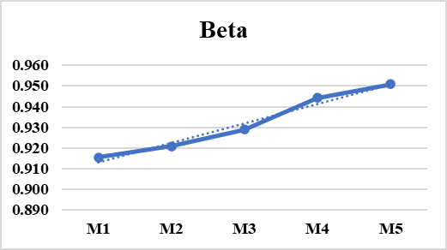
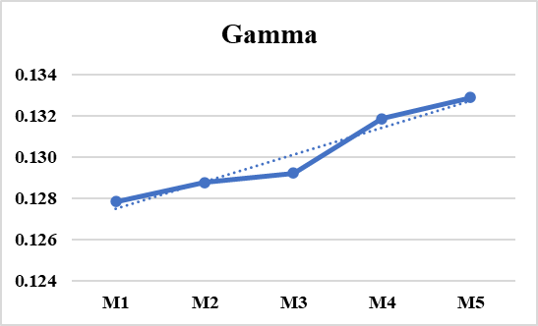
Time points
Abs. power (µV²)

Fig. 3 Average band power at five time points (each of two mins) in central lobe (C3-C4). M1–M5: Five consecutive 2-minute intervals during MBRRT (total duration = 10 min).
Observation: A progressive increase in mean power across all bands is observed.
Time points
Abs. power (µV²)

Fig. 4 Average band power at five time points (each of two mins) in parietal lobe (P3-P4). M1–M5: Five consecutive 2-minute intervals during MBRRT (total duration = 10 min).
Observation: Pattern at the parietal lobe shows delta continuing to increase, while theta, alpha, and beta remain roughly constant. Gamma exhibits a contrasting pattern, with a downward trend overall. At M3, theta, beta, and alpha display downward spikes, whereas gamma shows an upward spike. Gamma increases up to the M3 timepoint but falls thereafter, with fluctuations observed throughout the duration.
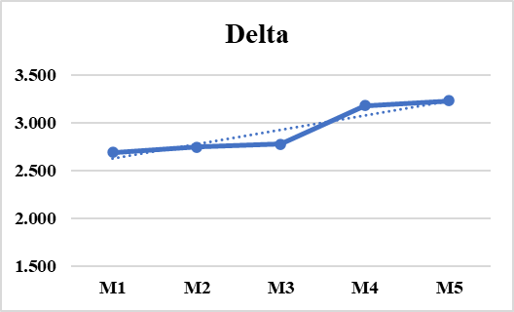
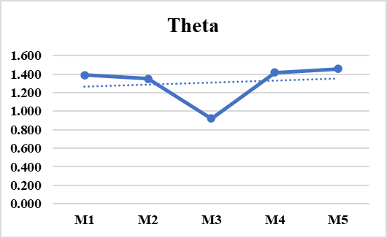
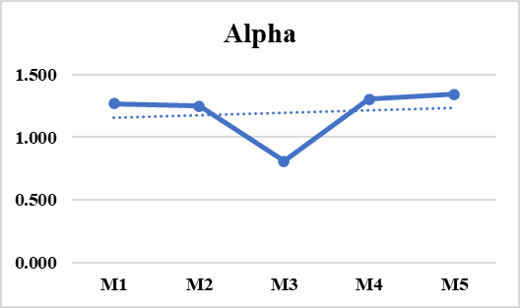
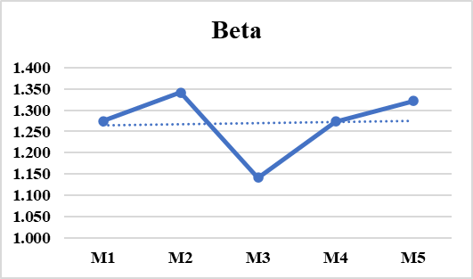
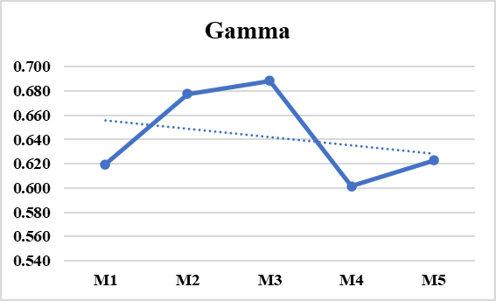
Time points
Abs. power (µV²)

Fig. 5 Average band power at five time points (each of two mins) in occipital lobe (O1-O2). M1–M5: Five consecutive 2-minute intervals during MBRRT (total duration = 10 min).
Observation: Overall, delta, theta, beta, and gamma powers are increasing. Alpha shows a downward pattern over time. Delta and theta remain constant at M2 and show a sharp upward spike at M3. For all bands except alpha, M4 is the peak threshold period from which power starts declining to normal. This EEG behavior resembles activity in the frontal region.
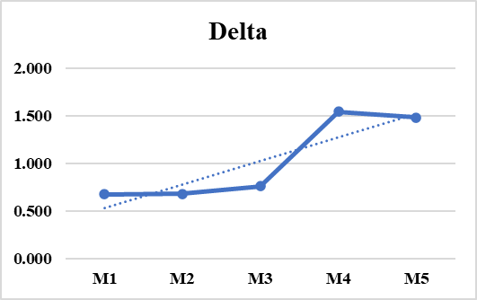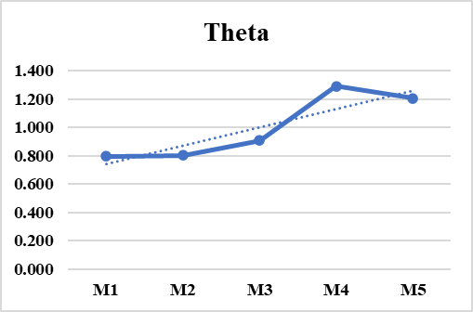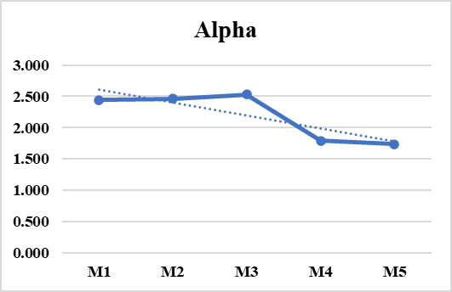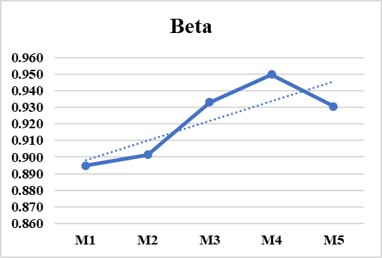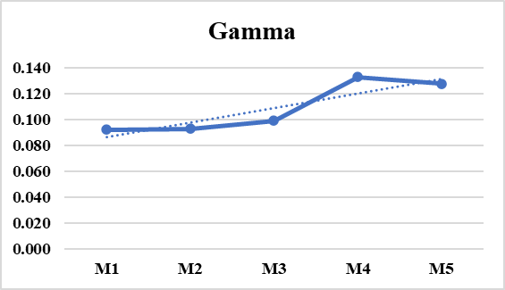
Time points
Abs. power (µV²)
Time points
Abs. power (µV²)

Fig. 6 Average band power at five time points (each of two mins) in mid temporal lobe (T3-T4). M1–M5: Five consecutive 2-minute intervals during MBRRT (total duration = 10 min).
Observation: Mid temporal region exhibits a distinct pattern from the others. Here, only two bands, delta and gamma, show progressively increasing power, while the powers of the other bands display an overall decreasing pattern. However, M2 increases from M1 for even those bands that show an overall declining pattern. M3 marks a point from which a sharp downward spike is seen for theta, alpha, and beta. Additionally, gamma shows an upward spike from M3.

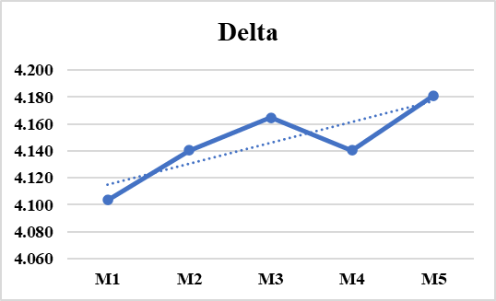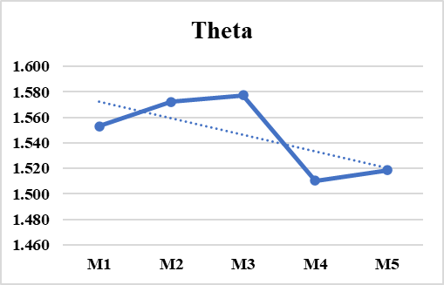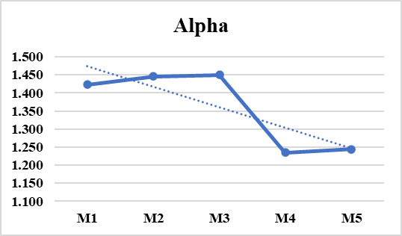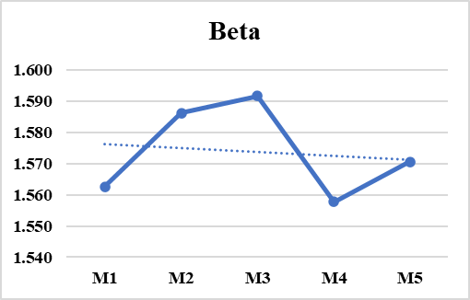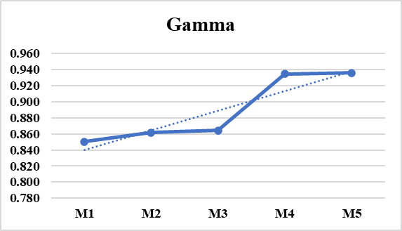
Time points
Abs. power (µV²)
Fig. 7 Average band power at five time points (each of two mins) in posterior temporal lobe (T5-T6). M1–M5: Five consecutive 2-minute intervals during MBRRT (total duration = 10 min).
Observation: At this region, band powers exhibit a smooth and sustained increase throughout the recording period, with no major fluctuations observed.

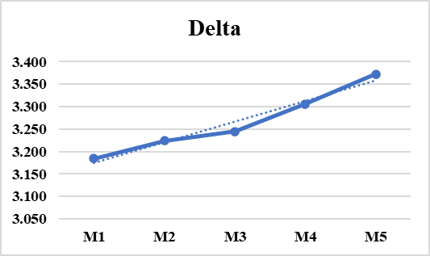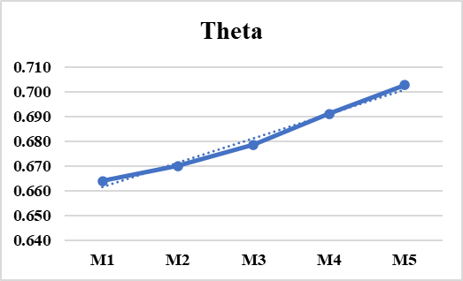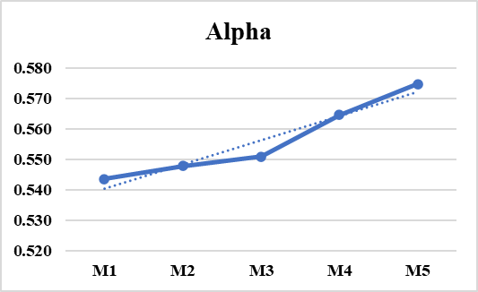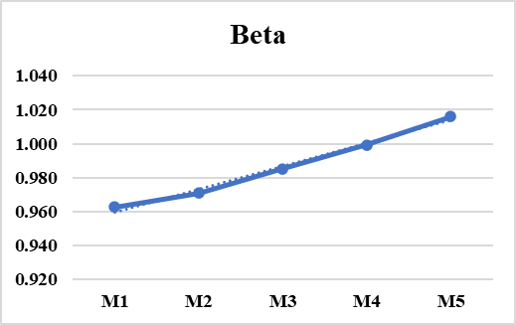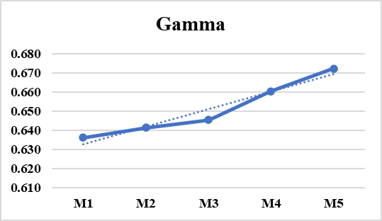
Time points
Abs. power (µV²)

Fig. 8 Average band power at five time points (each of two mins) in inferior frontal lobe (F7-F8). M1–M5: Five consecutive 2-minute intervals during MBRRT (total duration = 10 min).
Observation: An overall increasing pattern across the five bands is observed. At this region, a sharp upward spike at M3 is observed in all bands, which is distinct from the other regions.

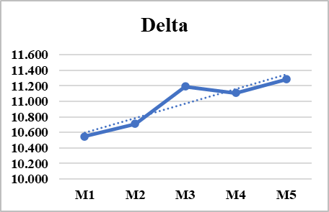
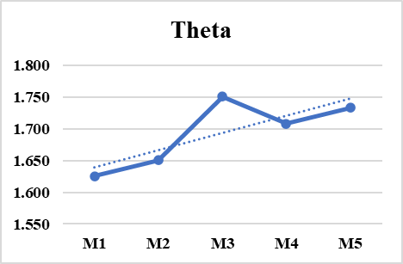
Time points
Abs. power (µV²)

