Supplementary Material
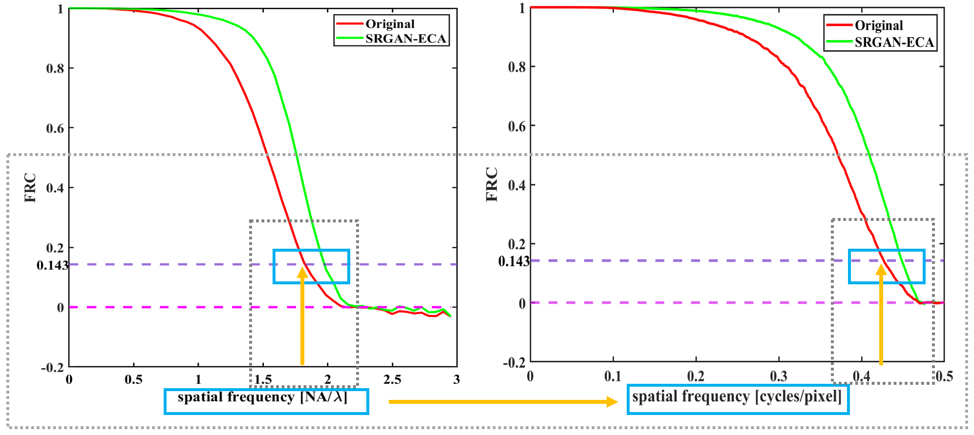
Supplementary Fig. S1 FRC frequency coordinate normalization. The left panel shows the FRC curve under the NA/λ frequency coordinate, while the right panel shows the FRC curve after conversion to cycles/pixel. In this study, the horizontal coordinate of FRC is unified as cycles/pixel to adapt to frequency-domain resolution evaluation of discrete digital fundus images, and the $1/7$threshold is adopted as the effective cutoff frequency criterion.

