Supplementary Figure S2: Software, equipment, and materials most frequently reported for splint manufacturing.
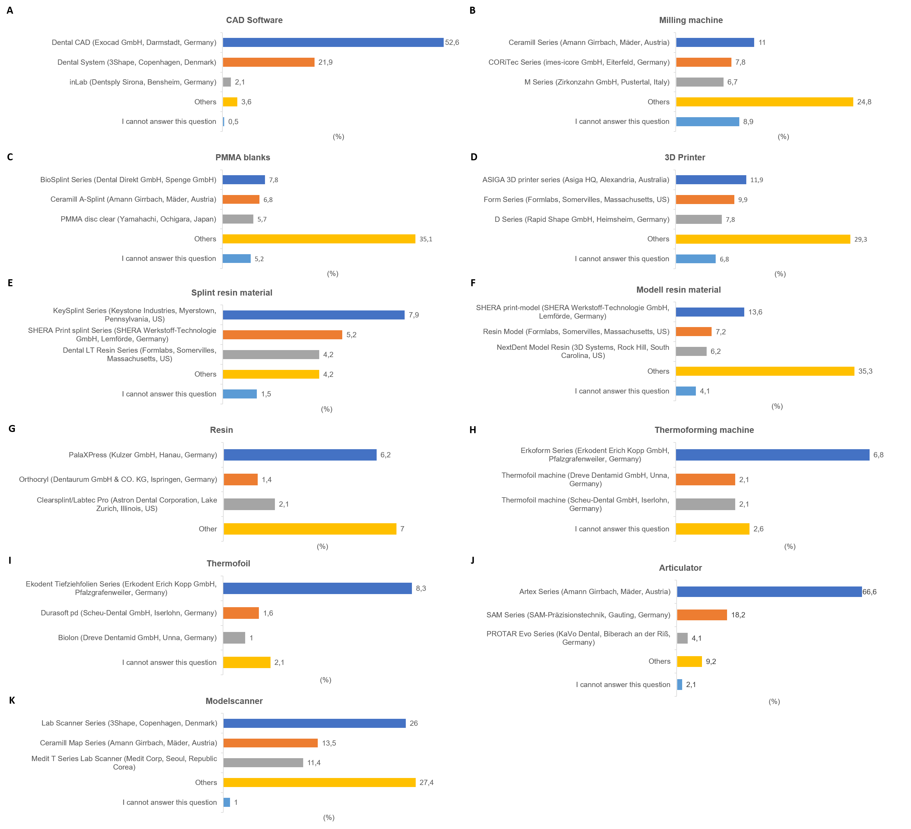
(A) CAD software; Subtractive (milled) workflow: (B) Milling machines and (C) PMMA blanks; Additive (printing) workflow: (D) 3D printers, (E) Splint resins, and (F) Model resins; Conventional workflow: (G) Resins, (H) Thermoforming machines, and (I) Thermofoil; and hybrid workflows: (J) Articulators and (K) Model scanners. The values show the percentages of the respondents (n=192). The three most frequently reported products are represented, while remaining products were summarized as “Others”.

