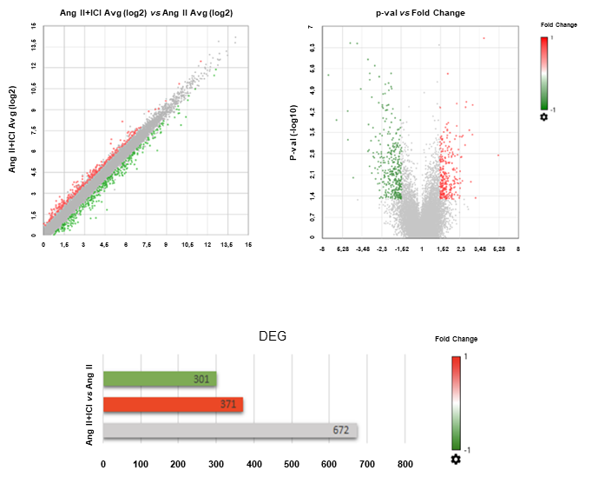

Supplementary Figure S1: Volcano plots of DEGs of the Ang II+ICI group vs Ang II. Green dots for downregulated genes, red dots for upregulated genes (upper panels). Bar graph showing number of DEGs highlithing upregulated (red), downregulated (green), and unchanged genes (grey) (lower panel).
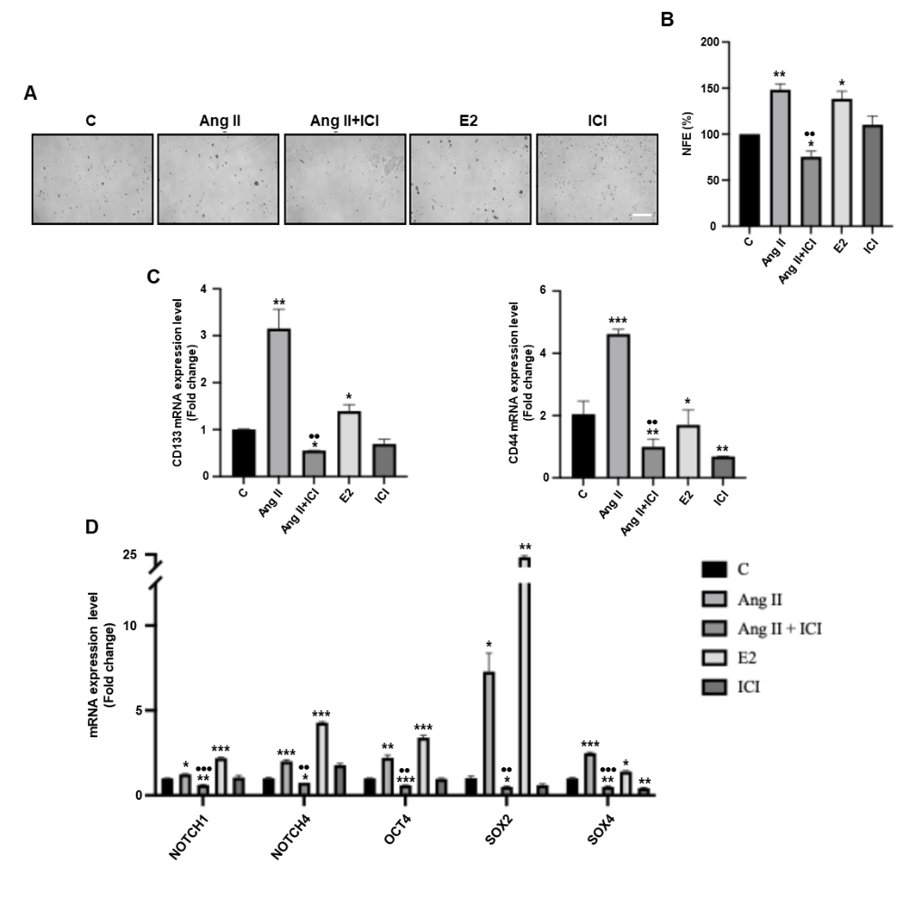

Supplementary Figure S2: Supplementary Figure S2. Glioblastoma stem cell enrichment in T98G neurospheres. (A) Representative bright-field images of primary T98G neurospheres untreated (Control) or treated with Ang II alone or in combination with ICI-182,780 (ICI, 1μM) or E2 (10nM) acquired using a sCMEX-3 microscope camera (Euromex, Spain) and ImageFocus Alpha software. Scale bar = 300 µm. (B) NFE assessed in T98G primary generation treated as indicated. qRT-PCR in T98G neurospheres to analyze (C) CD133 and CD44 or (D) NOTCH1, NOTCH4, OCT4, SOX2 and SOX4 mRNA levels. 18S rRNA was used to normalize the variability in template loading. The histograms represent the means ± S.D. of three different experiments each performed in triplicate. Statistical analysis was performed using one-way ANOVA with the GraphPad Prism 9 software. *p<0.05 vs C, **p<0.01 vs C and ***p<0.001 vs C; ••p<0.01 vs Ang II, •••p<0.001 vs Ang II.

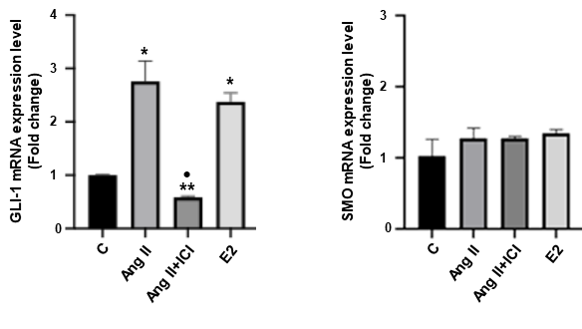

Supplementary Figure S3: GLI-1 (left panel) and SMO (right panel) mRNA expression in cells untreated (Control) or treated with Ang II (5μM) alone or in combination with ICI-182,780 (ICI, 1μM) or E2 (10nM). 18S rRNA was used as internal control. Histograms represent the mean ± S.D. of three independent experiments. Statistical analysis was performed using Student t-test with the GraphPad Prism 10 software. *p<0.05 vs C, and **p<0.01 vs C; •p<0.05 vs Ang II.

