Supporting Information
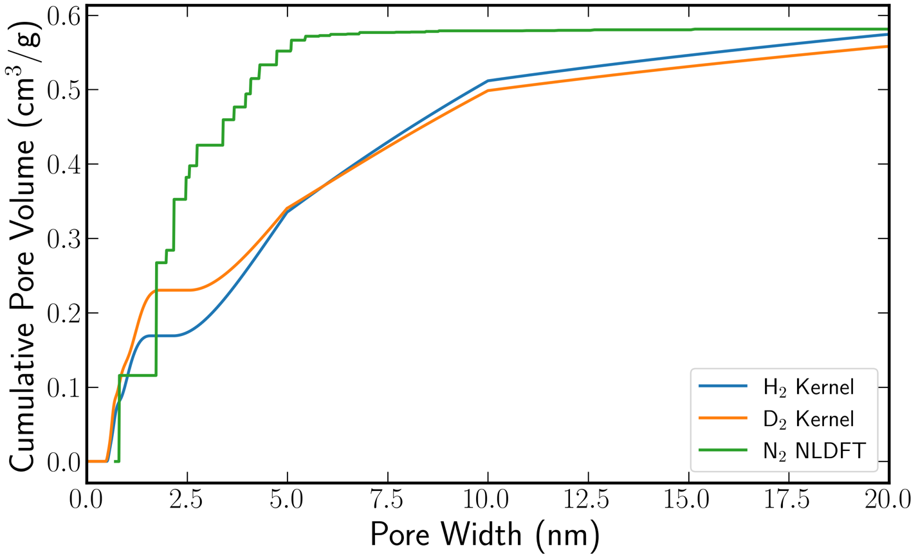
Figure S1: Cumulative Pore Size Distributions for ACC-ILL sample obtained from fitting the experimental isotherms to the theoretical kernels: H₂ (blue), D₂ (orange), and N₂ (green).
Figure S1 shows the cumulative pore size distributions for the H₂, D₂, and N₂ kernels. All three probes converge to a comparable total pore volume of ~0.59 cm³/g, consistent with previous calculations,⁸ confirming that the overall micropore volume of ACC-ILL is consistently recovered regardless of the probe molecule used. The N₂-derived curve rises more steeply and plateaus by ~5 nm, while the H₂ and D₂ curves continue to accumulate volume gradually up to 20 nm, reflecting differences in how each kernel distributes pore volume across the ultramicropore-to-mesopore range.

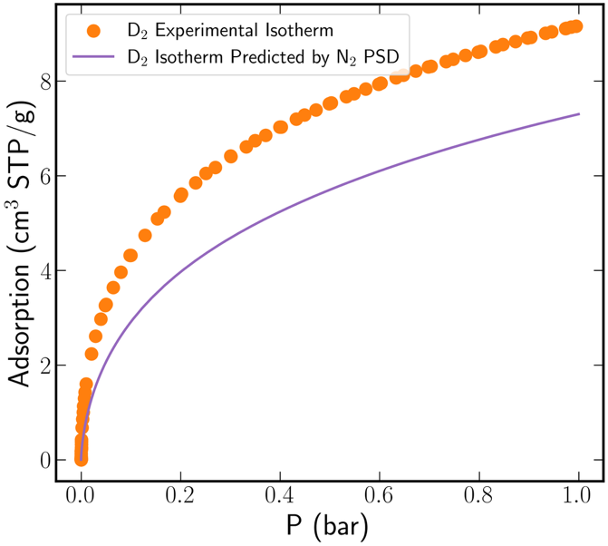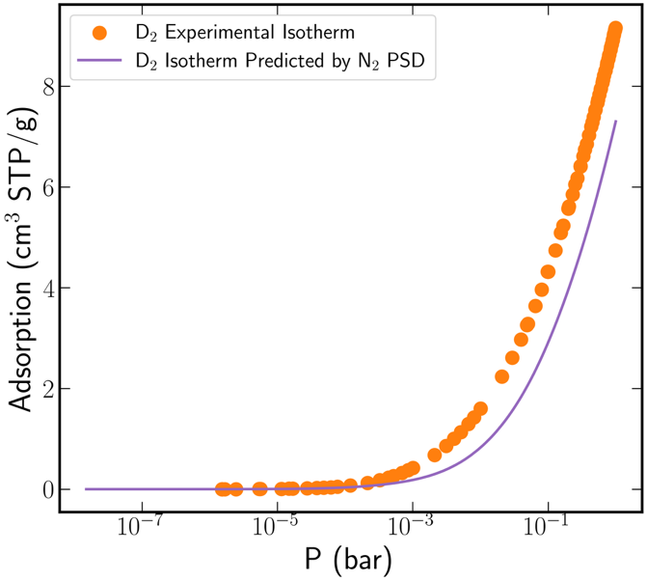
Figure S2: Predicted D₂ experimental isotherm from the PSD determined from the N₂ isotherm in semilog (left) and linear (right) scales.
Figure S2 shows the D₂ isotherm prediction obtained by convolving the N2-derived PSD with the D2 theoretical kernel, following the procedure used in Figure 5. The predicted isotherm consistently underestimates D₂ uptake over the full pressure range, in contrast to the excellent agreement observed with the H₂-derived PSD (Figure 5). This underprediction is consistent with the reduced resolution of the N₂-derived PSD in the sub-1 nm ultramicropore range (Figure 4), where N₂ fails to resolve several pore populations that contribute disproportionately to H₂/D₂ uptake due to strong confinement effects.

