Supplementary Information

A practical length–weight relationship for biomass estimation of Polychaeta larvae in Baltic Sea zooplankton monitoring
Elena Gorokhova, Department of Environmental Science, Stockholm University, Sweden
elena.gorokhova@aces.su.se

Table S1. Main characteristics of larval development of the Baltic polychaete species reported in the test samples by the analytical laboratories for zooplankton analysis. The basic morphology of the trochophore and nectochaete, their size ranges, and reported periods of occurrence in plankton are outlined.
Family | Species | Occurrence in plankton | Trochophore | Nectochaete | Size/segmentation
Spionidae | Marenzelleria spp. (viridis, neglecta, wireni) | Marenzelleria (Baltic Type II) larvae appear in the plankton from late August, peaking in October, opposite to the spring release reported for North Sea/North American (Type I) populations of the same species complex (Bochert, 1997; Daunys et al., 2000). | Compact unsegmented; one pair of black eyes; prototroch and telotroch well developed; positively phototactic; early development. | Progressive segmentation; setiger-driven growth; slender, elongating body; branchiae, gastrotrochs, and hooded hooks added stage by stage; spionid morphology; long pelagic phase (4–12 weeks, temperature-dependent). | Trochophore ~180 µm, 1-setiger ~200 µm, 6-setiger 420–570 µm, 9-setiger 620–800 µm, 15-setiger (metamorphosis-competent) 1100–1500 µm; metamorphosed bottom stage 1.5–2.0 mm (Bochert and Bick, 1995).
Spionidae | Pygospio elegans | Planktotrophic development is reduced in the Baltic Sea, where benthic (non-pelagic) larvae predominate, in contrast to fully marine populations (Kesäniemi et al., 2012); planktonic larvae, where they occur, are favored in winter (Thonig et al., 2016). | Hatches directly at the 3-setiger stage, with no separate free-swimming pre-setiger trochophore phase reported. | Slender elongating body. Shared among the brood-protecting spionid group (Spio, Microspio, Pygospio, Polydora): three pairs of black eyes, early parapodial/branchial differentiation, well-developed two-rowed nototrochs, and irregular/alternating gastrotrichs (Blake and Arnofsky, 1999). | At 3-setiger stage, 250–330 µm; 9-setiger ≈590 µm, 15-setiger (metamorphosis-competent) ≈1240 µm (Anger et al., 1986).  Setiger-driven growth; capsule-bound development is extended by nurse-egg consumption, so setiger number at metamorphosis varies with their supply; long pelagic phase when planktotrophic (Blake and Arnofsky, 1999).
Spionidae | Polydora (ciliata/ligni pooled) | Polydora ciliata larvae peak in spring, while water temperature is still low; P. ligni reproduces mainly in summer, at peak temperature (Anger et al., 1986). |  |  | At the 3-setiger stage: ≈250–330 µm; 9-setiger stage: ≈560–660 µm; 15-setiger stage (metamorphosis): ≈1100–1250 µm (Anger et al., 1986).
Polynoidae | Bylgides sarsi (former Harmothoe sarsi) | From February to August, numerous only April–June/July, with metamorphosis and main settlement in late June–early July (Sarvala, 1971) | Compact unsegmented; ciliated bands; apical sensory cilia; early development | Early segmentation; parapodia develop quickly; compact body; scaleworm (polynoid) morphology; shortened pelagic form | Trochophore 140–325 µm, metatrochophore I/II, nectochaete 520–800 µm, metamorphosed bottom stage 690–900 µm at 7–8 setigers (Sarvala, 1971).

Table S2. Coordinates of the sampling stations and their bottom depth (range over the sampling occasions; see also Figure S1)).
Station | Station name/subbasin | Coordinates ª | Nominal bottom depth ^{b}
B1 | Askö coastal station, WGB | 58°48′ N, 17°38′ E | 37-40 m
BY31 | Landsort Deep, WGB | 58°35.90′ N, 18°14.21′ E | 425-459 m
BY15 | Gotland Deep, EGB | 57°19.20′ N, 20°03.00′ E | 216-249 m
BY2 | Arkona | 55°00.00′ N, 14°05.00′ E | 45–49 m
RefM1V1 | Kalmar Sound, WGB | 56°22.20′ N, 16°12.00′ E | 20–21 m
BY5 | Bornholm Deep, Bornholm | 55°15.00′ N, 15°59.00′ E | 84-90 m
ª Latitude, longitude.
^{b} Recorded depth for the sampling occasion.

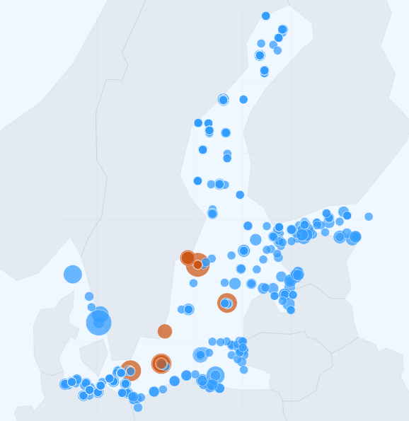

Figure S1. Map of zooplankton sampling stations included in the integrated Baltic abundance dataset. Points show station locations from the harmonized ICES DOME zooplankton data; circle size is proportional to the number of abundance records associated with each station-coordinate combination. Dark orange indicates stations from which material (40 samples) was sourced to generate the length-weight regressions (Table S2).

Table S3. ICES DOME records (mean, max, and median abundance; accessed on 15 April, 2025) of polychaete larvae in the zooplankton samples reported from different Baltic sub-basins. The listed taxa are the names recorded in the database and should be interpreted as indicative of likely assemblage composition, not as confirmed genus- or species-level identifications.
Subbasin | Mean, max, median (ind. m⁻³) | Polychaete taxa recorded as ‘Taxa_ID’
Bothnian Bay | 1; 9; 0 | Polychaeta, Pygospio elegans, Spionidae
The Quark | 52; 670; 16 | Polychaeta, Pygospio elegans, Spionidae
Bothnian Sea | 5; 116; 1 | Marenzelleria, Polychaeta, Pygospio elegans, Spionidae
Gulf of Finland | 83; 3488; 24 | Bylgides sarsi, Marenzelleria, Polychaeta, Pygospio elegans
Åland Sea | 10; 78; 2 | Bylgides sarsi, Polychaeta, Pygospio elegans
Northern Baltic Proper | 32; 582; 8 | Bylgides sarsi, Marenzelleria, Polychaeta, Pygospio elegans
Eastern Gotland Basin | 25; 606; 6 | Annelida, Bylgides sarsi, Polychaeta, Pygospio elegans
Western Gotland Basin | 8; 70; 4 | Bylgides sarsi, Polychaeta
Gulf of Riga | 486; 17388; 76 | Polychaeta
Gdansk Basin | 282; 8692; 27 | Polychaeta
Bornholm Basin | 122; 3388; 25 | Annelida, Polychaeta, Pygospio elegans, Spionidae
Arkona Basin | 531; 37688; 27 | Polychaeta, Polydora, Pygospio elegans, Spionidae
Kiel Bay | 364; 10400; 90 | Polychaeta, Polydora, Spionidae
Great Belt | 487; 8914; 10 | Phyllodoce groenlandica, Polychaeta, Polydora ciliata, Polydora cornuta, Prionospio malmgreni, Pygospio elegans, Spio, Spionidae
Bay of Mecklenburg | 271; 5146; 58 | Polychaeta, Spionidae
The Sound | 128; 2208; 27 | Annelida, Nereididae, Phyllodocidae, Polychaeta, Polydora, Polynoidae, Spionidae
Kattegat | 176; 6374; 20 | Nereididae, Nereimyra punctata, Nereis pelagica, Phyllodoce groenlandica, Polychaeta, Polydora, Polydora ciliata, Polydora cornuta, Polynoidae, Prionospio malmgreni, Proceraea, Pygospio elegans, Spionidae

Table S4. Published length-carbon regressions for planktotrophic polychaete larvae used in the present comparison. Equations originally reported with L in µm (Hansen 1999) have been converted to mm units. n: number of pooled biomass analyses ª. R² values as reported in the original sources.
Source | Taxon | Equation  L in mm, C in µg C ind⁻¹ | n | R² | Calibration range  L in mm
Anger et al. (1986) | Polydora ligni + Pygospio elegans (pooled) | C = 2.10 × L^{2.304} | 44 | 0.981 | 0.20–1.30 mm
Hansen (1999) | Polydora spp. | C = 2.807 × L^{1.38} | 15–20 per taxon | 0.996 | 0.20–1.00 mm
Hansen (1999) | Spio/Microspio spp. | C = 4.238 × L^{1.79} | 15–20 per taxon | 0.998 | 0.20–1.10 mm
Hansen (1999) | Nereis (Neanthes) succinea | C = 3.568 × L^{1.47} | 15–20 per taxon | 0.993 | 0.20–1.20 mm
ª Not explicitly stated in Hansen (1999). Approximate count based on data points visible in Fig. 7 of the original publication (carbon content vs body length panels); each taxon appears to be represented by approximately 15–20 individual measurements.
Abbreviations: C = individual carbon content (µg C ind⁻¹); L = body length (mm).

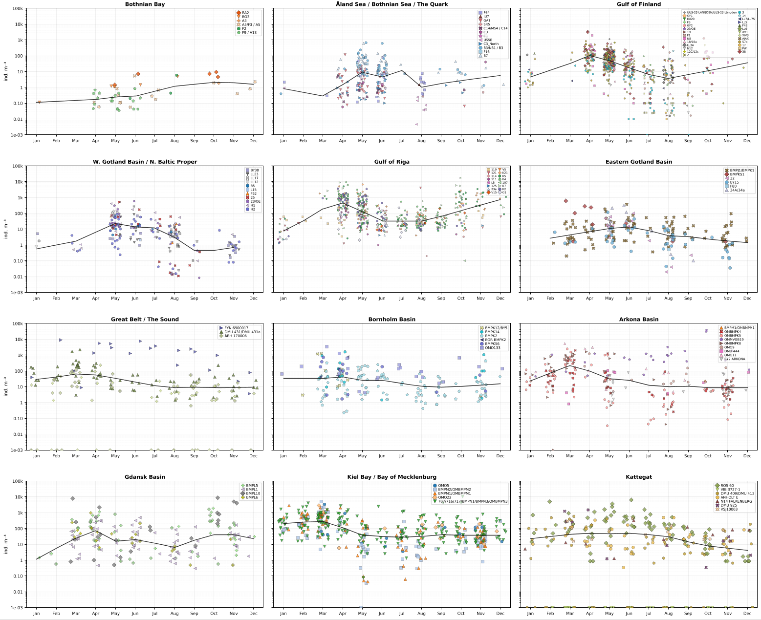

Month

Figure S2. Total polychaete larval abundance (ind./m³ as retrieved from ICES DOME; accessed 15 April, 2025; Figure S1) in the Baltic Sea subbasins (some were pooled when the data coverage was low). Each symbol represents one sampling occasion; the black curve is a LOWESS approximation; and the panels are ordered north to south, with a shared log y-axis.

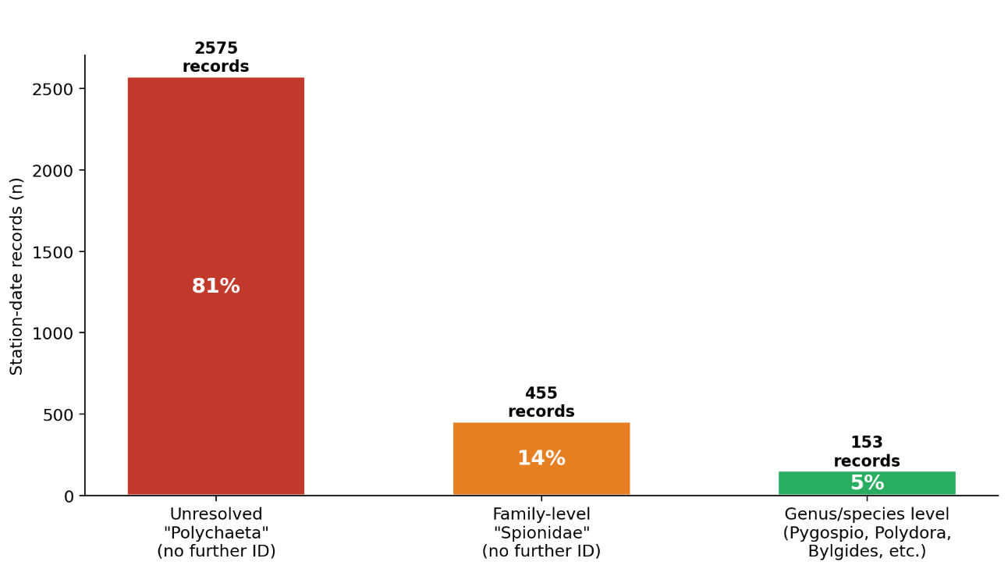
Figure S3. Taxonomic resolution of polychaete larval records in the dataset (n = 3183; visualized in Figure S1). Most station-date records were reported only as unresolved “Polychaeta” larvae, with no further identification. A smaller fraction was identified to family level as Spionidae, while only 5% were resolved to genus or species level, including Pygospio, Polydora, Bylgides, and related taxa (Table S3).

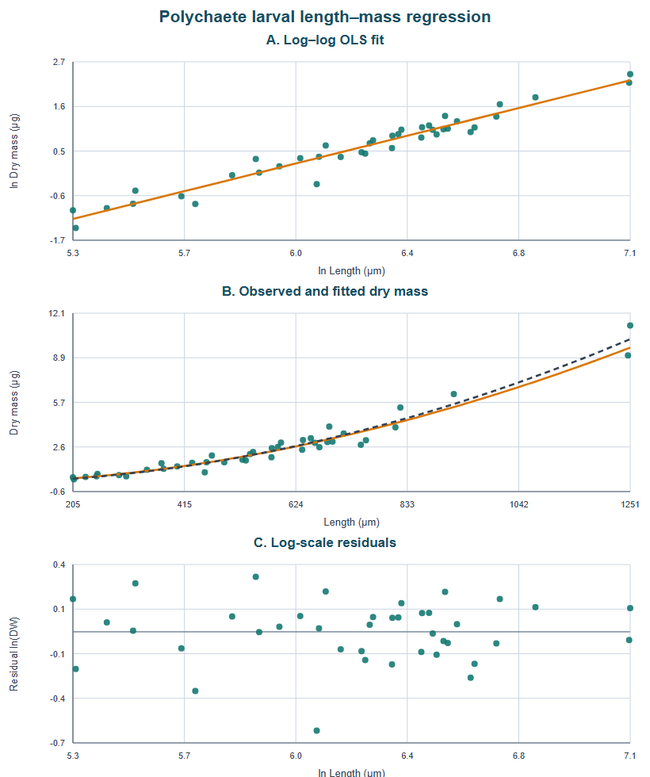
Figure S4. Polychaete larval dry mass-length relationship. (A) Primary log-log ordinary least squares (OLS) model. (B) Observed dry mass with the back-transformed log-log fit (orange) and original-scale nonlinear sensitivity fit (dashed). (C) Log-scale residuals. The nonlinear curve is shown only to assess sensitivity to the assumed error scale.

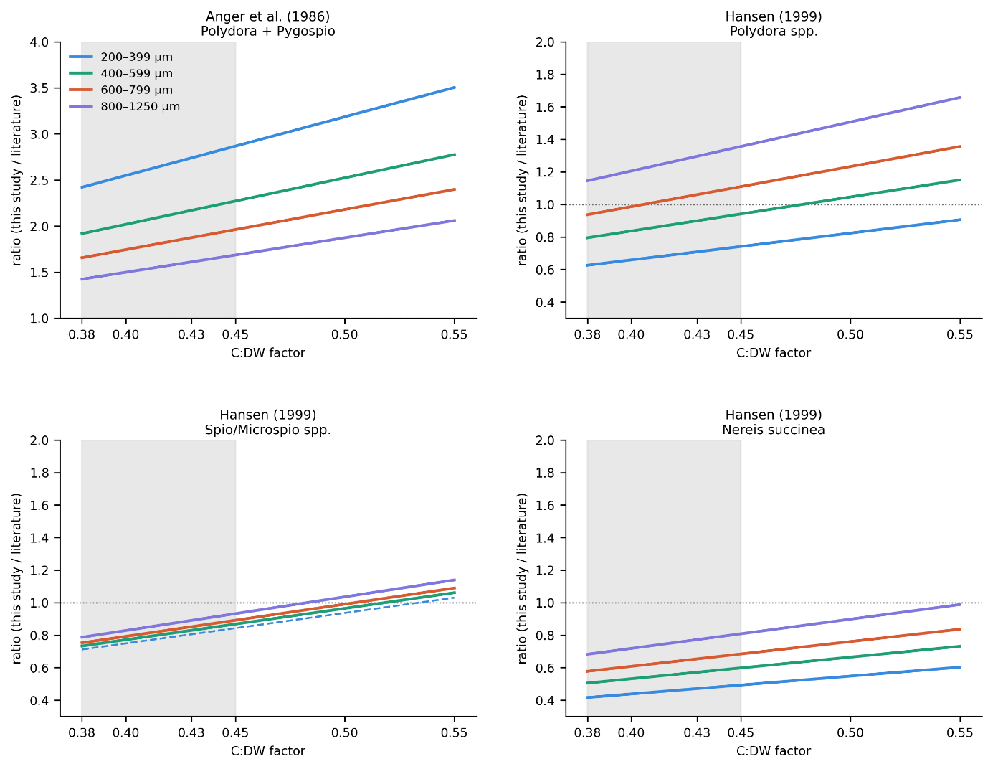
Figure S5. The carbon weight ratio (this study / literature) is used to compare the present regression with published equations. Its sensitivity to the assumed carbon content (C:DW factor) is shown for each of the four operational size classes. Class-average carbon was calculated as %C × DW (Table 3) and divided by carbon predicted at the class midpoint by each equation in the studies of Anger et al. 1986 and Hansen 1999. The grey band marks the C:DW range reported for polychaetes (0.38–0.45; Hrycik et al. 2024). Solid lines: class midpoint within the calibrated length range of the published equation; dashed lines: extrapolation. Dotted horizontal line at ratio = 1 indicates equal prediction. Note different y-axis scale in panel A.

