Table S1. List of ICD-10 codes and the definitions corresponding to variables in eFI
No. | eFI | ICD 10 code/definition
1 | Activity limitation | R26, S78, S88, S98, T13.6, Y83, Z99.3, G11, G81, G82, G83, M62
2 | Anaemia and haematinic deficiency | D50, D51, D52, D53, D64
3 | Arthritis | M05, M06, M07, M09, M10, M11, M12, M13, M15, M16, M17, M18, M19, M31.5, M32, M33, M34, M35, M36
4 | Atrial fibrillation | I44, I48, I49
5 | Cerebrovascular disease | G45, G46, I6, H34
6 | Chronic kidney disease | I12, I13, N01, N03, N05, N07, N08, N18, N19, N25, I77
7 | Diabetes | E10.9, E11.9, E12.9, E13.9, E14.9
8 | Dizziness | I95, R55, R42, E86, H81, H82, H83
9 | Dyspnoea | R06
10 | Falls | W00, W01, W02, W03, W04, W05, W06,  W07, W08, W09, W10, W11, W12, W13,  W14, W15, W16, W17, W18, W19
11 | Foot problems | B353, G575, G576, L60, M201, M202, M203, M204, M205, M206, M213, M214, M215,
12 | Fragility fracture | M484, S22, S32, S33, S42, S43, S62, S72, S73, M485, M800, M808, M843, M847, S02, S12, S52, S82, S92
13 | Hearing impairment | H833, H90, H91, G960, H60, H61, H62, H71,H73, H74, H92, H93
14 | Heart failure | I11, I13, I260, I27, I42, I43, I50, I51, I099,  I255
15 | Heart valve disease | I05, I06, I07, I08, I34, I35, I36, I37, I390, I391, I392, I393, I394, A520, I091, I098, I38, Q230, Q231, Q232, Q233
16 | Housebound | R40, Z50, Z74, Z75.5
17 | Hypertension | I10, I11, I12, I13, H350
18 | Hypotension/syncope | I95, R55, R42, E86
19 | Ischaemic heart disease | I20, I21, I22, I23, I24, I25
20 | Memory and cognitive problems | F00, F01, F02, F03, F04, F05, F06.7, G30, G31, R41, R54, F2, F3, F41, R44, R45
21 | Mobility and transfer problems | R26, S78, S88, S98, T136, G11, G81, G82, G83, M62
22 | Osteoporosis | M80, M81, M82
23 | Parkinsonism and tremor | G122, G20, G21, G22, G23, G25, G26, G32, G35, R25
24 | Peptic ulcer | K21, K25, K26, K27, K28, K29, R12
25 | Peripheral vascular disease | I65, I70, I71, I72, I73, I771, K551, K558, K559, R02, Z958, Z959, I790, I792, Z958
26 | Polypharmacy | ≥5 drugs prescriptions for a total of ≥6 months during the baseline period
27 | Requirement for care | R40
28 | Respiratory disease | J45, J46, J40, J41, J42, J43, J44, J47, J60, J61, J62, J63, J64, J65, J67, J684, J70, J13, J14, J15, J16, J18, J22, J20, J90, J961, J980
29 | Skin ulcer | I83, I98, L03, L08, L89, L97, L984
30 | Sleep disturbance | G47, F51
31 | Social vulnerability | F1, R460, R468, Z59, Z60, Z63, Z73
32 | Thyroid disease | E00, E01, E03, E04, E05, E06, E079, E890, R946
33 | Urinary incontinence | N31, N393, N394, R15, R32, Z466
34 | Urinary system disease | N30, N34, N390, N398, N399, R31, R33, T835
35 | Visual impairment | H25, H28, H35, H40, H43, H53, H54
36 | Weight loss and anorexia | E41, E43, E44, E46, E53, E55, E66, E83, E87, R53, R628, R63, R64, F500, F501, F508, F509

Table S2. International Classification of Diseases (ICD) Codes Used for Identification of Clinical Characteristics.
Variables | ICD 10 code/definition
Mechanical or bioprosthetic heart valve, or mitral valve repair | Z952, Z954
Rheumatic mitral valve disease | I050, I051, I052, I058, I059
Chronic obstructive pulmonary disease | J42, J430, J431, J432, J439, J440, J441, J448, J449
Diabetes mellitus | E10, E100, E101, E102, E103, E104, E105, E106, E107, E109, E11, E110, E111, E113, E114, E115, E116, E117, E119, E13, E133, E131, E130, E134, E132, E137, E136, E139, E135, E14,  E140, E141, E142, E143, E144, E145, E146, E149
Heart failure | I500, I501, I509
Hypertension | I110, I119, I120, I129, I150, I151, I152, I158, I159
Systemic Embolism | I740, I741, I742, I743, I744, I745, I748, I749
Vascular disease | E105, E115, E135, E145, I210, I211, I212, I213, I214, I219, I220, I221, I228, I229, I420, I421, I422,  I423, I424, I425, I426, I427, I428, I429, I700, I701, I702, I7020, I7021, I708, I709, I739
Ischaemic stroke | I633, I634, I635, I636, I638, I639, I64
TIA | G450, G451, G453, G454, G458, G459
Intracranial bleeding | I600, I601, I602, I603, I604, I605, I606, I607, I608, I609, I610, I611, I613, I614, I615, I618, I619, I620, I621, I629, I638, I690, I691
Gastrointestinal bleeding/bleeding with shock | K226, K228, K250, K252, K254, K260, K262, K264, K266, K290, K573, K922, R571
Cardiovascular Death (CVD) | I00-I99, T810, J951, J952

Table S3. Comparison and Improvement Assessment of Predictive Performance for Clinical Outcomes by Different Models in the Test Set (Using Baseline Model as Reference)
Endpoint | Model | AUC (95% CI) | P Value | IDI | NRI
MACEs | Baseline Model | 0.638 (0.607–0.669) | reference | reference | reference
 | Burden Model | 0.664 (0.633–0.694) | P=0.088 | 0.012 (0.004–0.021), P=0.008 | 0.256 (0.150–0.366), P<0.001
 | Comprehensive Model | 0.671 (0.641–0.702) | P=0.008 | 0.016 (0.009–0.024), P<0.001 | 0.404 (0.287–0.510), P<0.001
All-cause mortality | Baseline Model | 0.623 (0.589–0.656) | reference | reference | reference
 | Burden Model | 0.700 (0.668–0.732) | P<0.001 | 0.014 (0.002–0.026), P=0.020 | 0.391 (0.277–0.503), P<0.001
 | Comprehensive Model | 0.700 (0.668–0.732) | P<0.001 | 0.015 (0.007–0.024), P<0.001 | 0.415 (0.306–0.524), P<0.001
Cardiovascular death | Baseline Model | 0.670 (0.607–0.732) | reference | reference | reference
 | Burden Model | 0.695 (0.634–0.756) | P=0.341 | 0.004 (–0.006–0.014), P=0.424 | 0.333 (0.120–0.546), P=0.004
 | Comprehensive Model | 0.710 (0.650–0.769) | P=0.066 | 0.007 (0.001–0.014), P=0.036 | 0.469 (0.270–0.656), P<0.001
The Baseline Model includes Age, Sex, and Baseline Frailty; the Burden Model includes Age, Sex, and Frailty Burden; the Comprehensive Model includes Age, Sex, Baseline Frailty, and Frailty Burden.
Abbreviations: AUC, area under the receiver operating characteristic curve; IDI, integrated discrimination improvement; NRI, net reclassification improvement; CI, confidence interval; MACEs, major adverse cardiovascular events.

Table S4. Clinical outcomes across frailty burden quartiles
Outcome | Analysis population, n | Overall events, n (%) | Q1 | Q2 | Q3 | Q4 | HR (95% CI)1 | P for trend
Major adverse cardiovascular events (MACEs) | 4,657 | 1,321 (28.4%) | 174 (18.7%) | 132 (18.3%) | 315 (28.6%) | 700 (36.8%) | 1.92 (1.62-2.28) | <0.001
All-cause mortality | 6,116 | 1,510 (24.7%) | 126 (12.1%) | 126 (15.3%) | 283 (20.3%) | 975 (34.3%) | 2.10 (1.72-2.57) | <0.001
Cardiovascular death | 6,116 | 458 (7.5%) | 32 (3.1%) | 35 (4.2%) | 89 (6.4%) | 302 (10.6%) | 2.14 (1.46-3.15) | <0.001
1HR (95% CI) for Q4 versus Q1, from the fully adjusted Model 4 (adjusted for age, sex, BMI, smoking, alcohol consumption, and comorbidities).
P for trend across quartiles was < 0.001 for all endpoints.
Abbreviations: MACEs, major adverse cardiovascular events; HR, hazard ratio; CI, confidence interval.

Table S5. P values for interaction tests between cumulative frailty burden and subgroup variables
Subgroup Variable | MACEs | All-Cause Death | Cardiovascular Death
Age | 0.155 | 0.552 | 0.032
Hypertension | <0.001 | <0.001 | 0.038
Diabetes mellitus | 0.175 | 0.204 | 0.723
Heart failure | 0.672 | 0.571 | 0.829
COPD | 0.812 | 0.415 | 0.567
Previous stroke | 0.192 | 0.730 | 0.485
Sex | 0.476 | 0.452 | 0.900
BMI | 0.269 | 0.184 | 0.083
Smoking | 0.778 | 0.997 | 0.687
Baseline frailty (eFI) | 0.826 | 0.489 | 0.669
Alcohol consumption | 0.393 | 0.031 | 0.606
CHA2DS2-VA score | 0.157 | 0.795 | 0.059
Oral anticoagulant use | <0.001 | <0.001 | 0.009
Data are P values for the multiplicative interaction between cumulative frailty burden (quartiles treated as an ordinal variable) and each subgroup variable in the fully adjusted Cox model (Model 4: adjusted for age, sex, BMI, smoking, alcohol consumption, and comorbidities).
Abbreviations: eFI, electronic Frailty Index; OAC, oral anticoagulant; CHA2DS2-VA, a thromboembolic risk score; MACEs, major adverse cardiovascular events; COPD, chronic obstructive pulmonary disease; BMI, body mass index.

Figure S1. Study enrollment flow

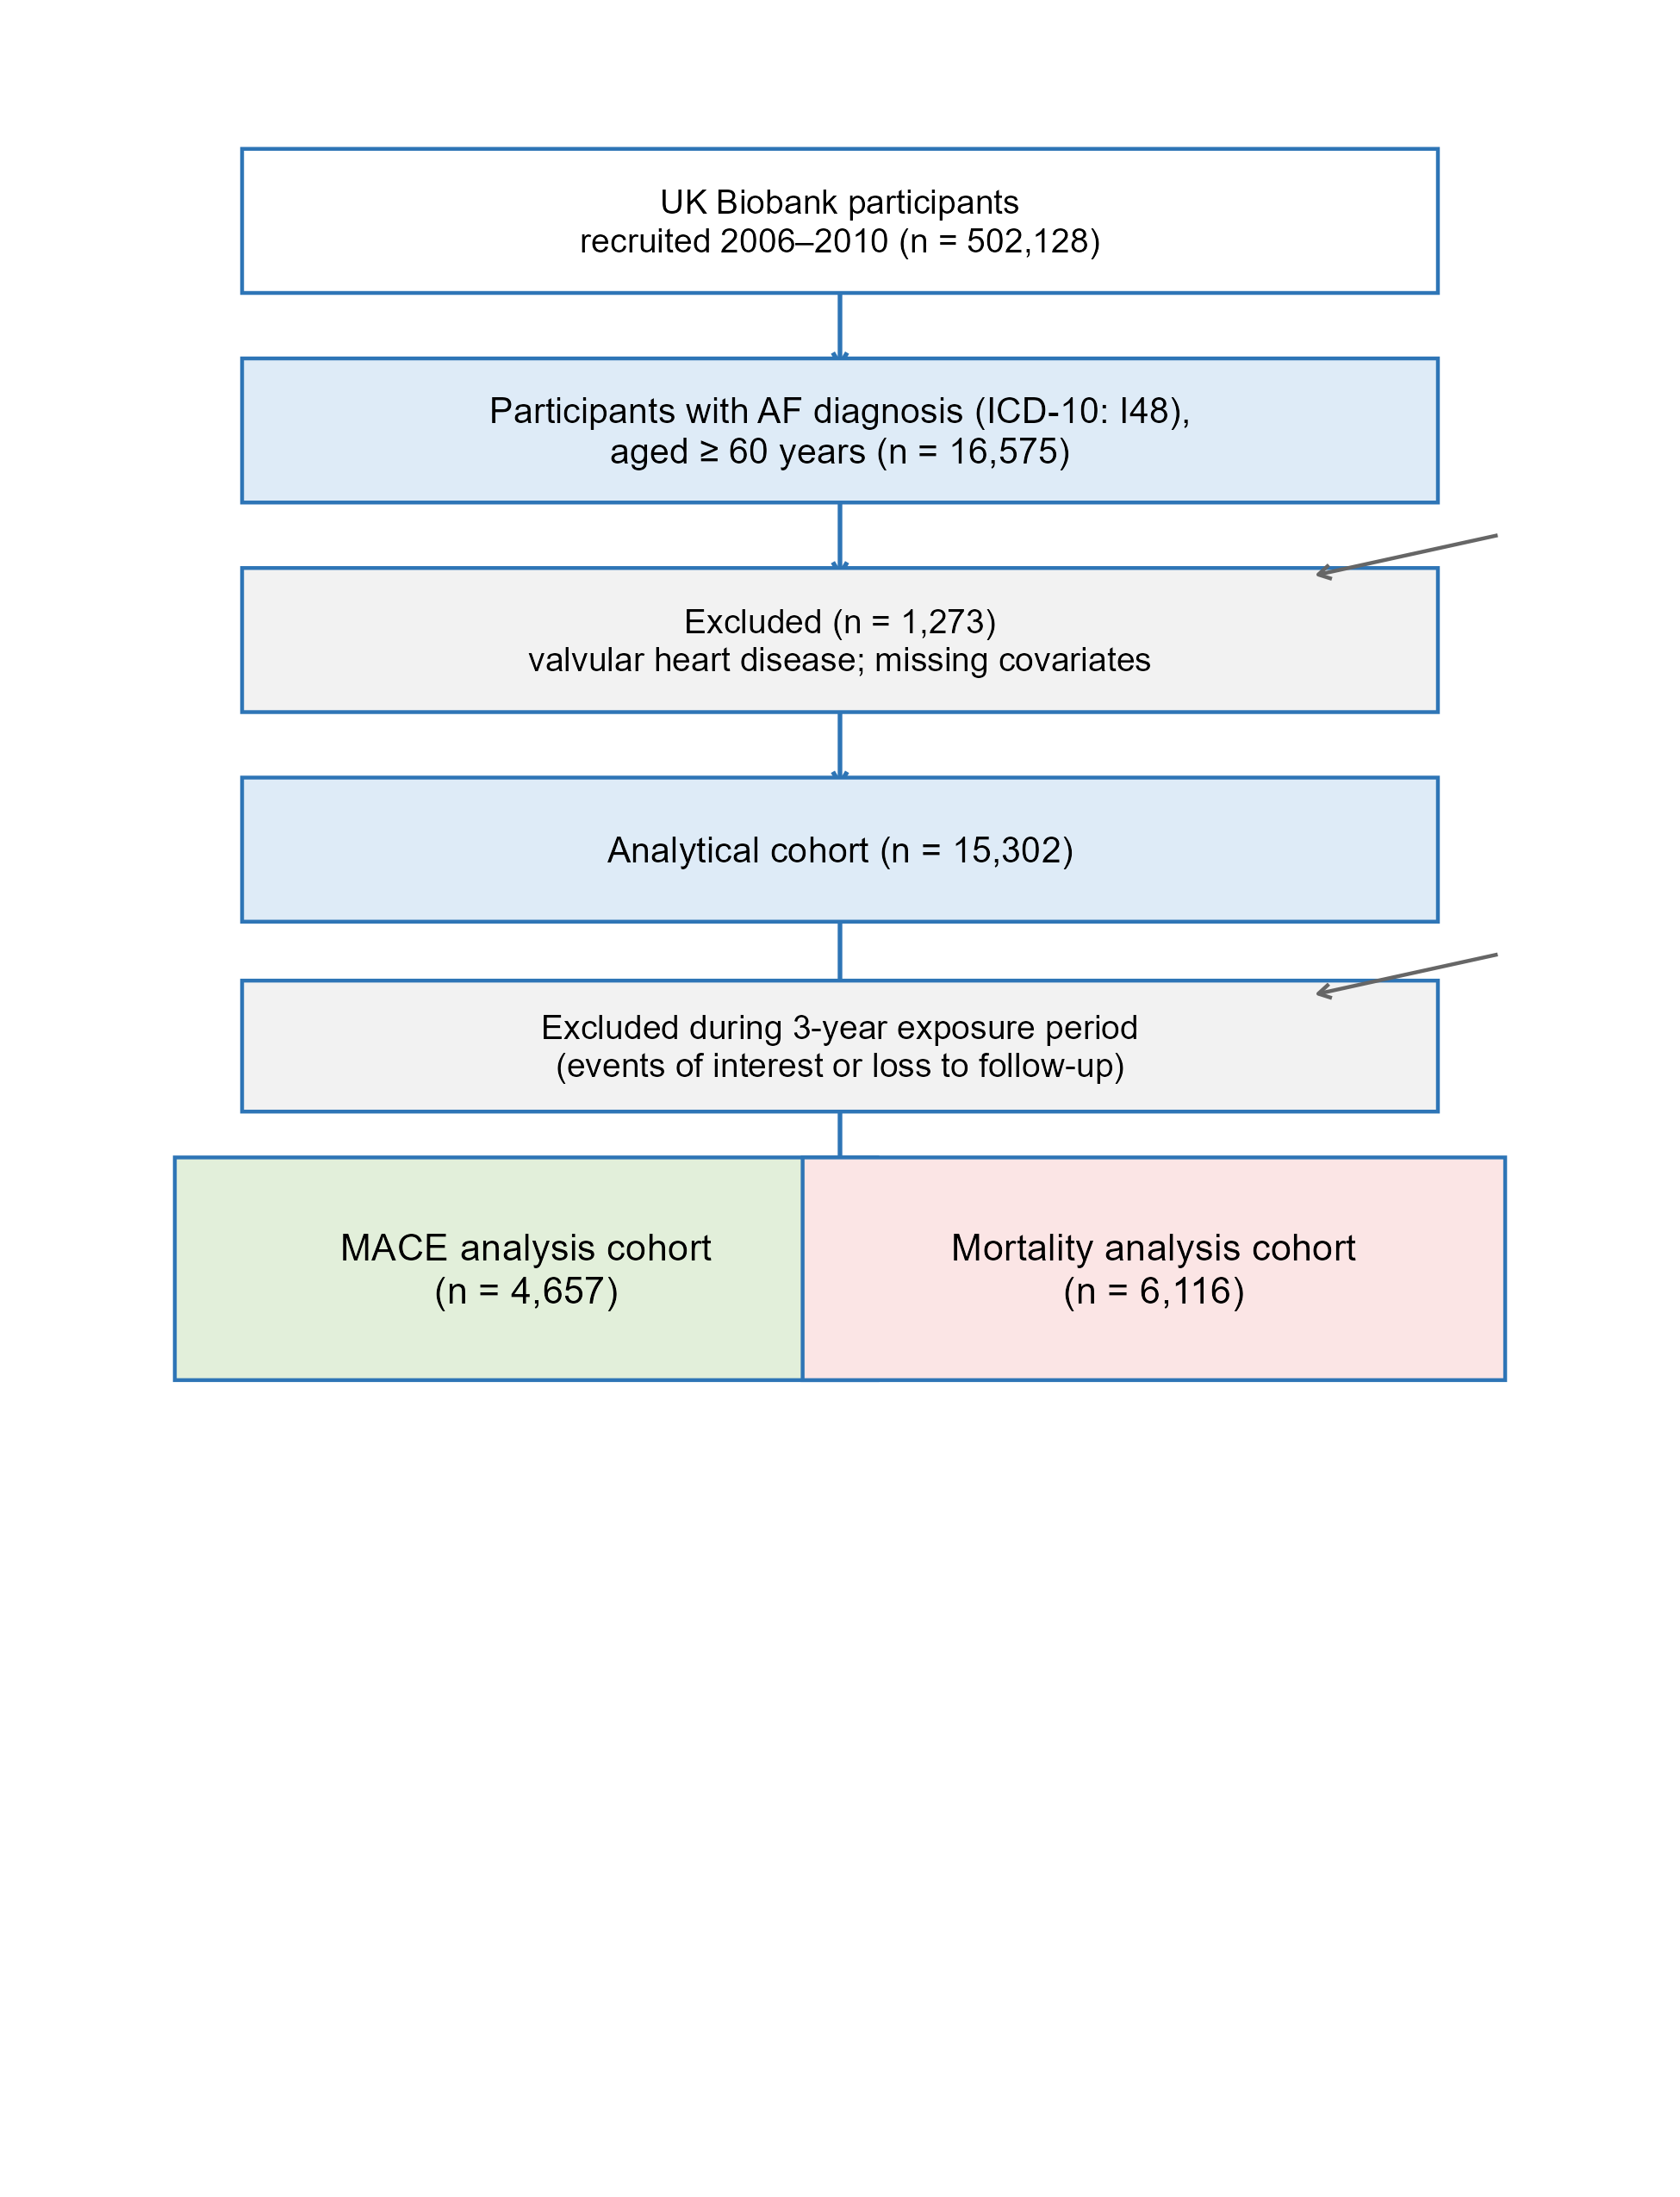

_{Figure S2. Timeline Schematic}

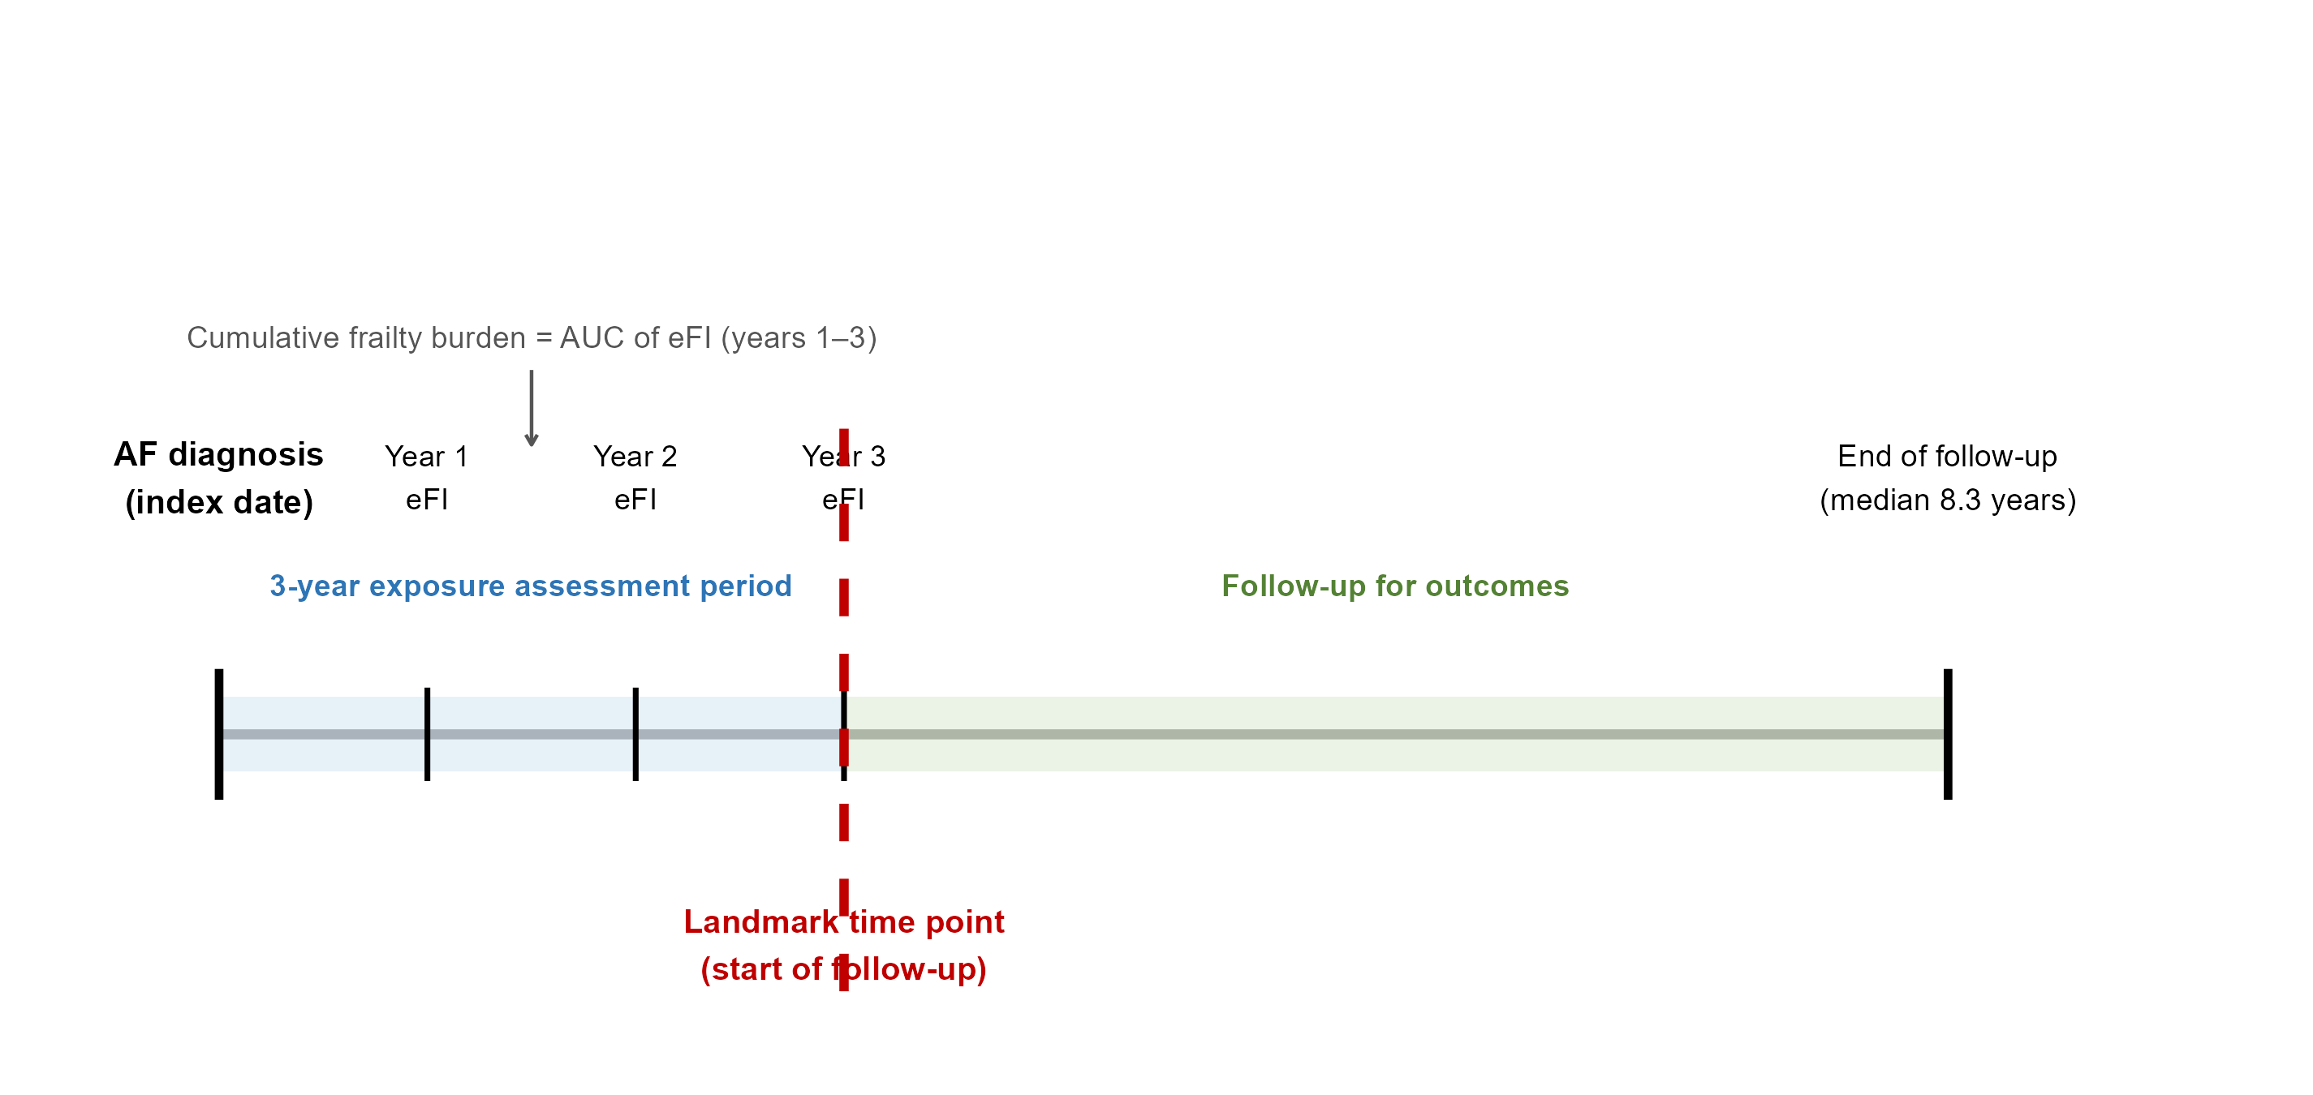
Figure S3. Comparison of machine learning methods (XGBoost, random forest, and logistic regression) using the comprehensive model framework (age, sex, baseline frailty, and cumulative frailty burden) for (A) MACEs, (B) All-cause mortality, and (C) Cardiovascular death in the test set. AUC values are annotated for each method. Abbreviations: AUC, area under the curve; MACEs, major adverse cardiovascular events.

Figure S4. Forest plot of subgroup analyses for MACEs by cumulative frailty burden, with P values for interaction tests.
Abbreviations: MACEs, major adverse cardiovascular events; HR, hazard ratio; CI, confidence interval.

