Supplementary Figures
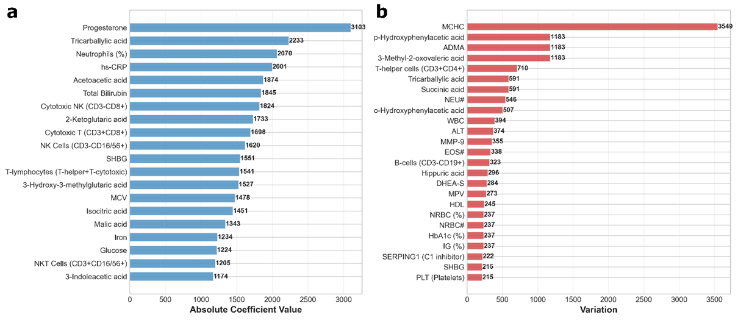
Fig. S1. Ranked feature histograms (a) featuring the strongest impact on age prediction in the regression model, and (b) exhibiting the highest variability in values.

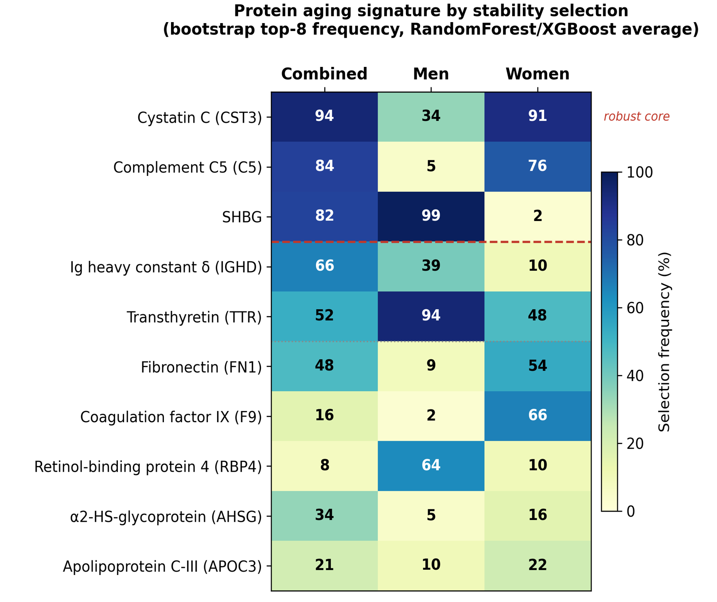
Fig. S2. Stability of feature selection for aging-associated biomarkers. Bars represent the mean proportion of top‑8 selections (averaged over Random Forest and XGBoost) for each protein and clinical parameter in the combined cohort (left), men (center), and women (right). The red line marks the 75 % stability cutoff.

