Species-specific effects of microplastics on juvenile fish

Chaonan Zhang^{1,2,3}, Qiujie Wang¹, Zhiheng Zuo¹, Zhengkun Pan¹, Shaodan Wang¹, Guohuan Xu^{3*}, Jixing Zou^{1,2**}

¹Joint Laboratory of Guangdong Province and Hong Kong Region on Marine Bioresource Conservation and Exploitation, College of Marine Sciences, South China Agricultural University, Guangzhou 510642, China
²Guangdong Laboratory for Lingnan Modern Agriculture, South China Agricultural University, Guangzhou 510642, China
³State Key Laboratory of Applied Microbiology Southern China, Guangdong Provincial Key Laboratory of Microbial Culture Collection and Application, Guangdong Institute of Microbiology, Guangdong Academy of Sciences, Guangzhou 510070, China

Correspondence authors:
*xghfish@163.com (G. Xu);
**zoujixing@scau.edu.cn (J. Zou).

Numbers of figures: 3
Numbers of tables: 1
Numbers of texts: 2
Numbers of pages: 7

Supplementary figure 1. Intestinal muscular thickness and intestinal villi length of grass carp.
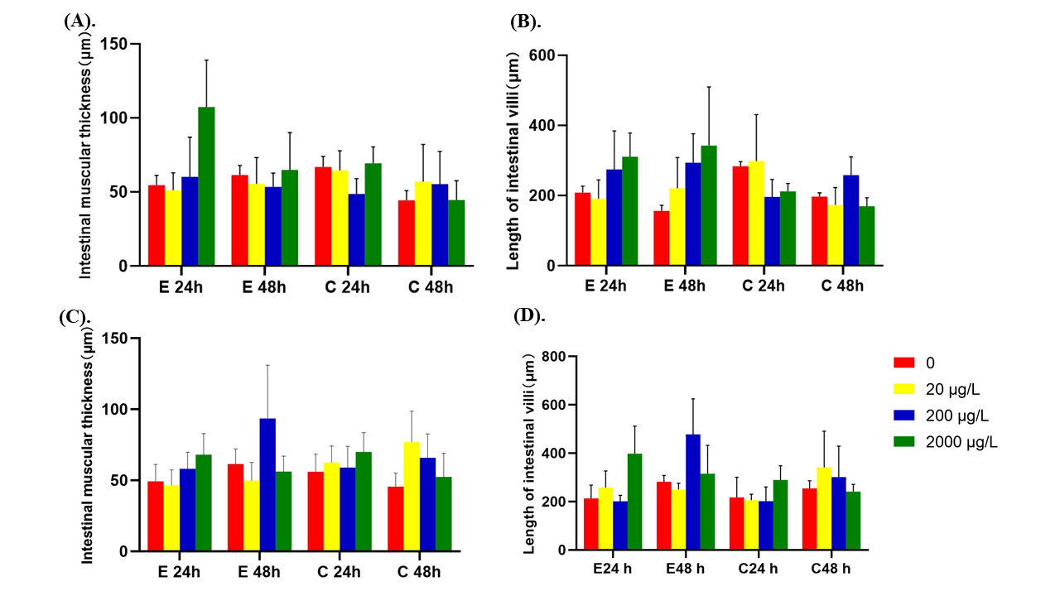

Supplementary figure 2. Histopathological analysis of intestines of grass carp juvenile exposed to polystyrene microspheres. Scale bar = 50 μm.
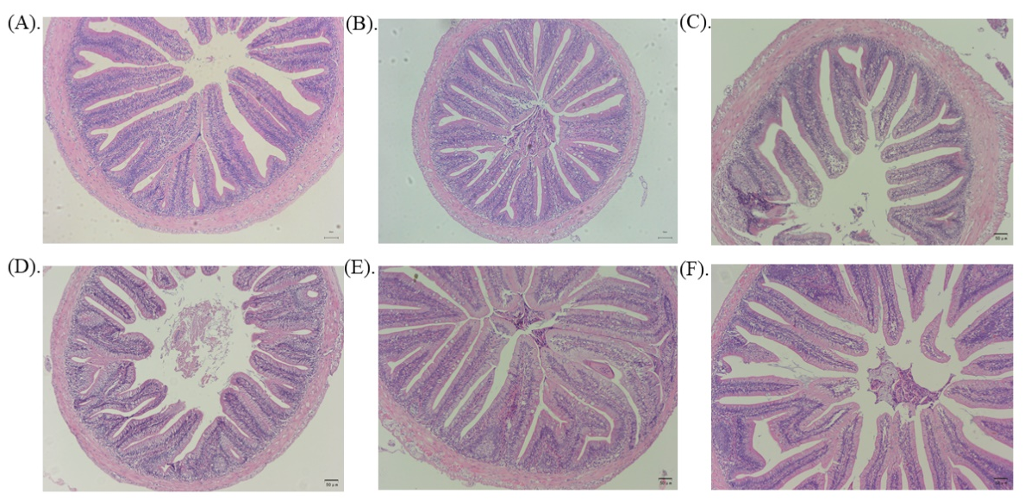

Supplementary figure 3 Histopathological analysis of intestines of Jian carp juvenile exposed to polystyrene microspheres. Scale bar = 50 μm.
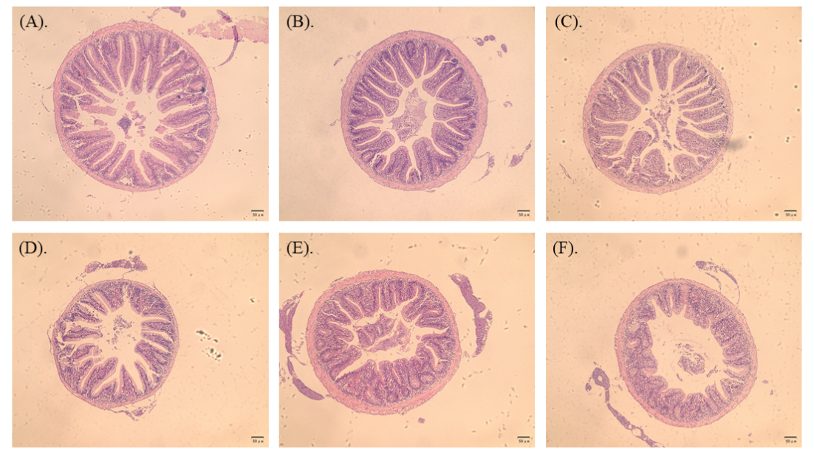

Supplementary table 1. Intestinal muscular thickness and intestinal villi length of Jian carp
Size | Concentration | Intestinal villi length (μm) |  | Intestinal muscular thickness (μm)
 |  | E48h | C48h | E48h | C48h
80 nm | 0 | 168.46±50.18 | 136.94±34.17 | 23.78±5.66 | 25.16±3.3
80 nm | 20 μg/L | 201.27±28.03 | 122.06±25.93 | 36.62±6.52 | 27.19±11.18
80 nm | 200 μg/L | 135.18±22.49 | 133.61±18.71 | 21.52±6.51 | 29.82±4.16
80 nm | 2000 μg/L | 146.47±26.32 | 152.21±35.87 | 34.59±9.98 | 33.66±6.45
8 μm | 0 | 160.9±28.72 | 115.58±19.62 | 22.49±5.22 | 26.39±5.97
8 μm | 20 μg/L | 139.89±33.24 | 142.07±27.9 | 28.12±7.08 | 35.2±7.92
8 μm | 200 μg/L | 109.02±35.3 | 141.54±42.61 | 25.83±6.84 | 30.41±9.67
8 μm | 2000 μg/L | 138.47±39.92 | 116.32±16.04 | 30.63±5.68 | 27.12±0.92

Supplement Text 1. Details of experimental methods of RNA extraction and cDNA synthesis.
Total RNA was extracted using AG RNAex Pro Rreagent (Accurate Biotechnology Co., Ltd, Hunan, China) following the manufacturer’s protocol. RNA quality was assessed by electrophoresis on a 1.0% agarose gel and its concentration was tested by mySPEC (VWR, Radnor, PA, USA). 1 μg total RNA was purified and the first-strand cDNA was synthesized using Evo M-ML RT Kit with gDNA Clean for qPCR (Accurate Biotechnology Co., Ltd, Hunan, China) according to the manufacturer’s instructions.

Supplement Text 2. Details of the qPCR program.
The real-time PCR program was set at 30 s for 95 ℃, followed by 40 cycles of 95℃ for 5s, 60℃ for 30s. Melting curves were obtained by increasing the temperature from 60 to 95℃ (0.5℃/s) to denature the double-stranded DNA. Each amplification reaction was run in triplicate. After finishing the program, the threshold cycle (Ct) values were obtained from each sample. Relative gene expression levels were evaluated using 2^{−ΔΔCT} method.

