Supporting Information to

Host-guest Encapsulation of Photosensitizer to Construct Antibacterial Silicon Rubber: Enhanced Homogeneity and Dual-action.
Jin Han¹, Yaocheng Zhu¹, Ziqiang Zhang¹, Taolei Qiu¹, Lei Wang¹, Zhengping Zhao¹, Xiaoxue Yin², Dawei Zhang², Kun Shen^{2,}*, Dong Xu³, Boshi Yu³, Tongdong Shen⁴, Zhixiong Liu⁵
1) State Key Laboratory of Advanced Separation Membrane Materials, Zhejiang Key Laboratory of Advanced Polymer Materials Modification and Application Technology, Zhejiang University of Technology, Hangzhou, 310014, PR China
2) Zhejiang Tongxuan Medical Technology Co., Ltd., Hangzhou, 317300, PR China
3) Polymer Research Institute, Wenzhou Gettel High-Tech Materials Co., Ltd, Wenzhou, 325802, PR China
4) Zhejiang Collaborative Innovation Center for Full-Process Monitoring and Green Governance of Emerging Contaminants, Interdisciplinary Research Academy, Hangzhou 310015, China
5) College of Chemistry and Chemical Engineering, Shanxi Datong University, Datong, 037009, PR China

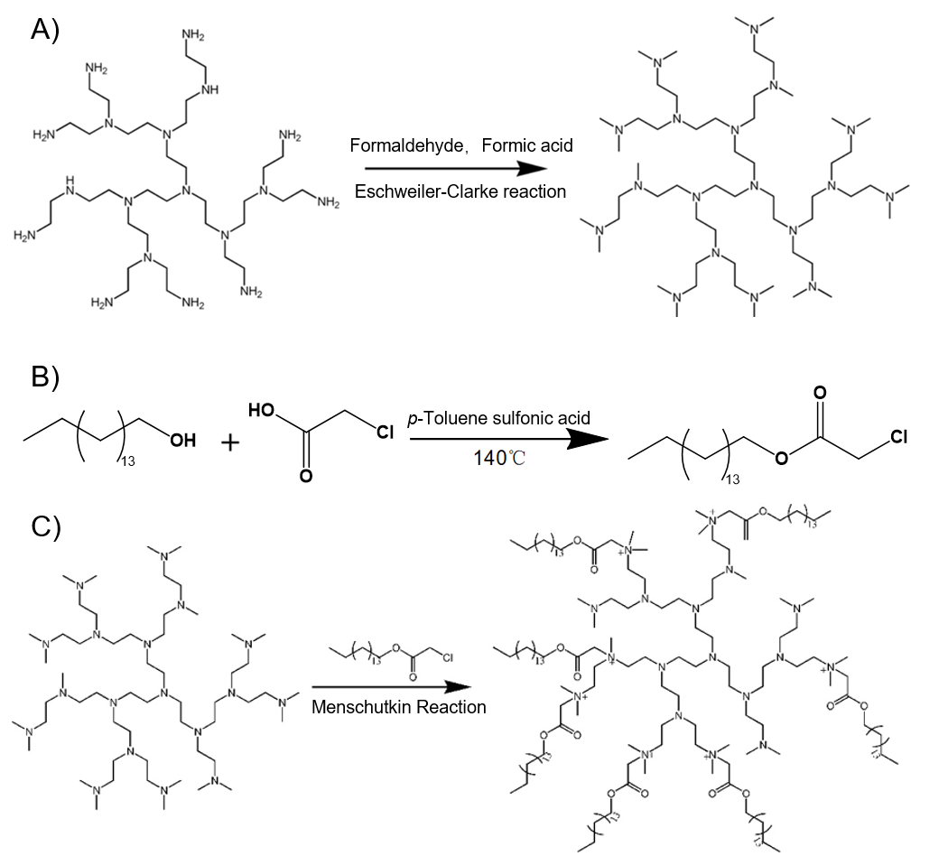
Scheme S1 Synthetic route of MeHPEI, CCA and Am-HQAS nanocapsule host.
Table S1 The feeding ratios of the amphiphilic hyperbranched QAS Nanocapsules
Sample | Quaternization degree (%) | MeHPEI (g) | CCA (g)
Am₃₀-HQAS | 30 | 1.0 | 1.6865
Am₄₀-HQAS | 40 | 1.0 | 2.2487
Am₅₀-HQAS | 50 | 1.0 | 2.8109
Am₆₀-HQAS | 60 | 1.0 | 3.3730
Am₇₀-HQAS | 70 | 1.0 | 3.9352

Table S2 The Feeding ratios of the various silicone rubber
Sample | PDMS  (g) | Am_{x}-HQAS  (g) | KH-560  (g) | R812S (g) | TEOS (g) | DBTDL  (g)
RTV | 10 | / | 3.0 | / | / | 0.005
RTV-Am₃₀ | 10 | 1.23  (Am₃₀-HQAS) | 3.0 | / | / | 0.005
RTV-Am₄₀ | 10 | 1.49  (Am₄₀-HQAS) | 3.0 | / | / | 0.005
RTV-Am₅₀ | 10 | 1.74  (Am₅₀-HQAS) | 3.0 | / | / | 0.005
RTV-Am₆₀ | 10 | 2.00  (Am₆₀-HQAS) | 3.0 | / | / | 0.005
RTV-Am₇₀ | 10 | 2.26  (Am₇₀-HQAS) | 3.0 | / | / | 0.005
e-RTV | 10 | / | 0.2 | 0.5 | 1.5 | 0.005
e-RTV-Am₆₀ | 10 | 1.00  (Am₆₀-HQAS) | 0.2 | 0.5 | 1.5 | 0.005
e-RTV-Am₆₀-RB | 10 | 1.20  (RB@Am₆₀-HQAS) | 0.2 | 0.5 | 1.5 | 0.005

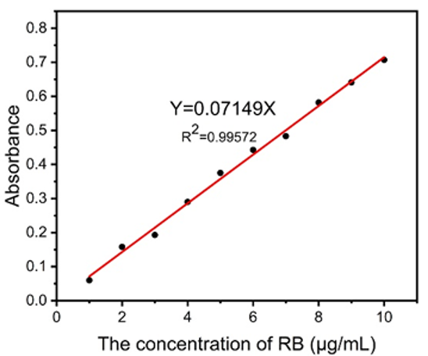
Fig. S1 A standard work curve of RB in ultrapure water (λ=540nm)
Fig. S2 A plot of encapsulating capability vs the RB concentration
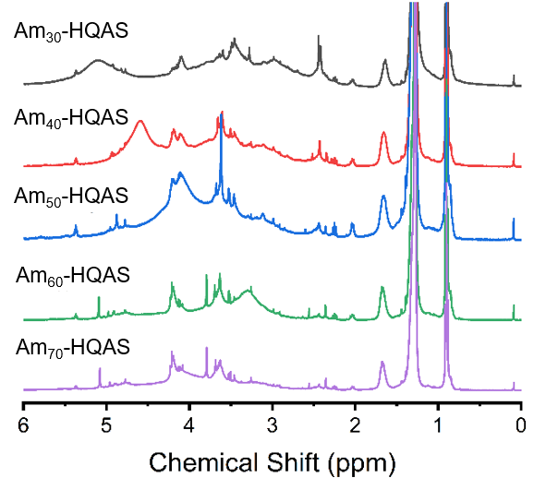
Fig. S3 ¹H-NMR spectra of Am_{x}-HQAS.
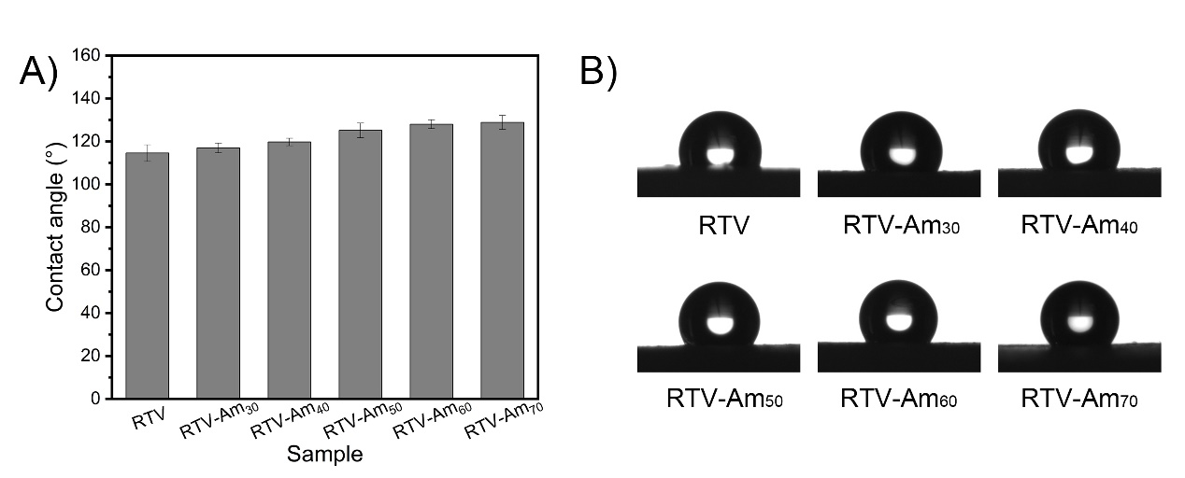
Fig. S4 The static water contact angle (A) and the contact angle images (B) of RTV and RTV-Am_{x}.
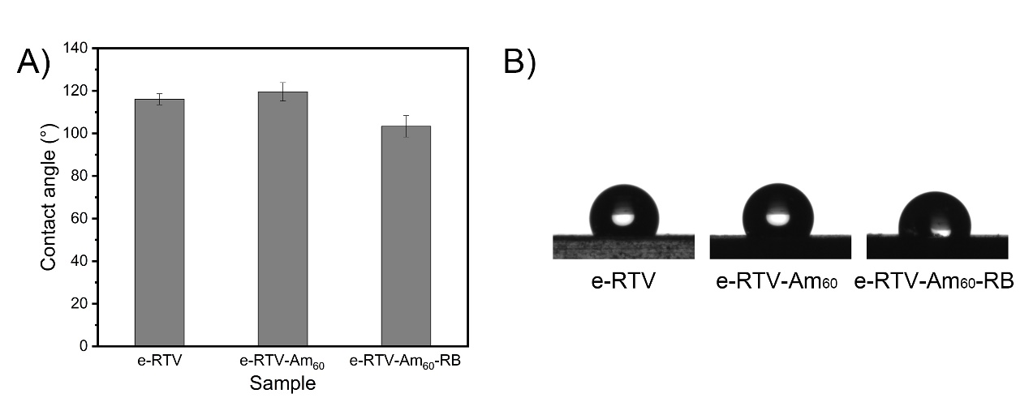
Fig. S5 The static water contact angle (A) and the contact angle images (B) of e-RTV, e-RTV-Am₆₀ and e-RTV-Am₆₀-RB.
Fig. S6 The stress-strain diagram of the various silicone rubber samples.
Fig. S7 60% compressive stress-strain diagram of the various silicone rubber samples.
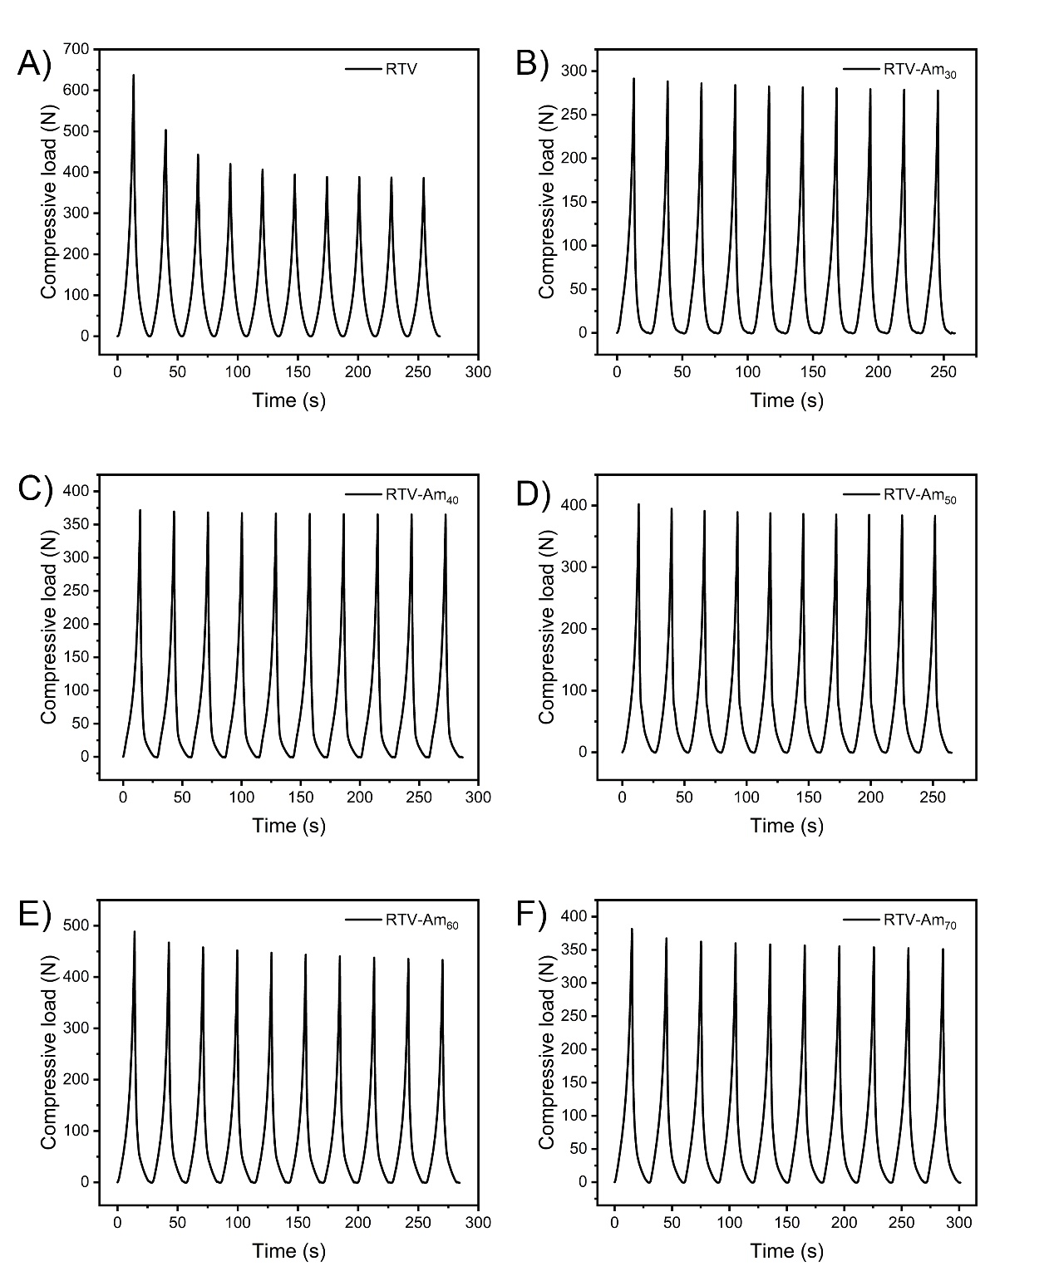
Fig. S8 The compressive stress-strain diagram of the various silicone rubber samples during the 10 loading-unloading cycles with 60% deformation (A: RTV, B: RTV-Am₃₀, C: RTV-Am₄₀, D: RTV-Am₅₀, E: RTV-Am₆₀, F: RTV-Am₇₀).
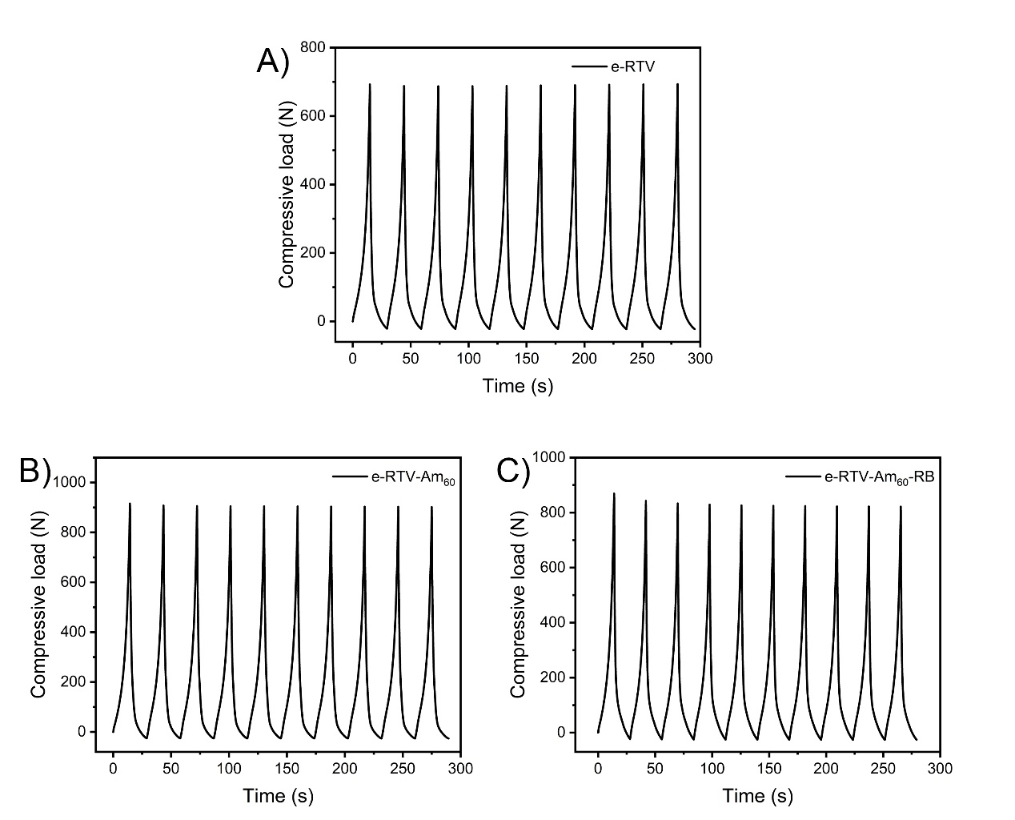
Fig. S9 The compressive stress-strain diagram of the various silicone rubber samples during the 10 loading-unloading cycles with 60% deformation (A: e-RTV, B: e-RTV-Am₆₀, C: e-RTV-Am₆₀₋RB).
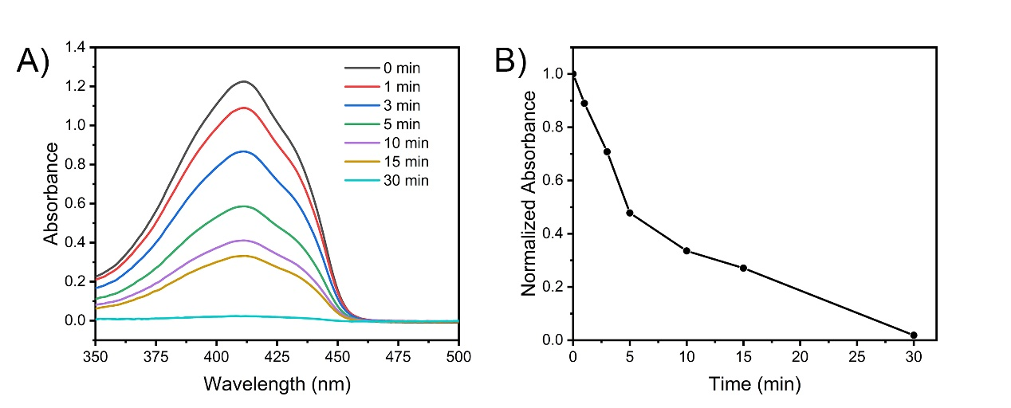
Fig. S10 A) UV scanning spectrum of DPBF of e-RTV-Am₆₀-RB under LED light irradiation; B) changing trend of intensity of characteristic absorption peak (410 nm) of DPBF of e-RTV-Am₆₀-RB under LED light irradiation.
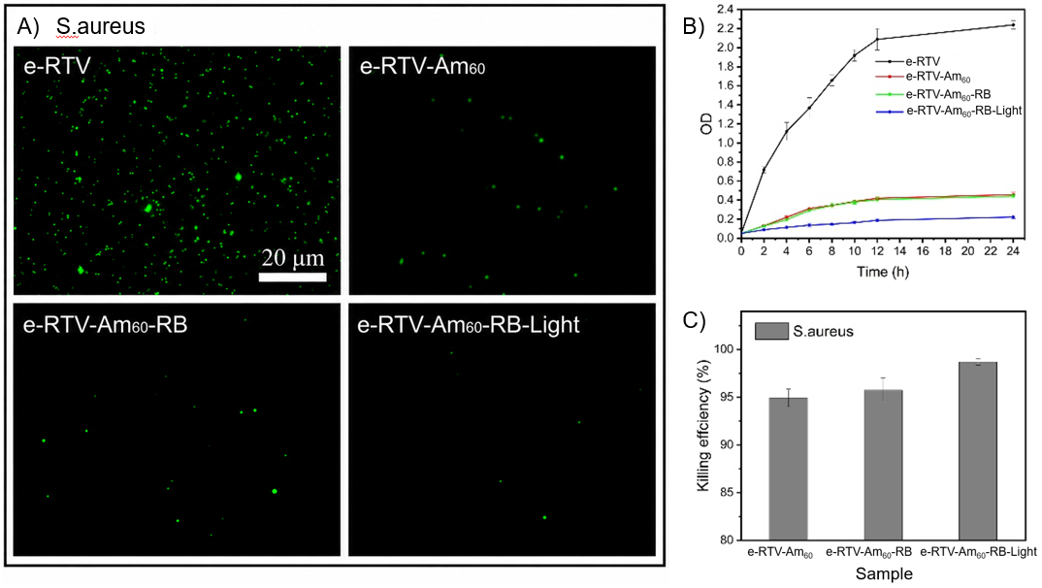
Fig. S11 (A) Confocal images of S. aureus adhered on the e-RTV, e-RTV-Am₆₀ , e-RTV-Am₆₀-RB and e-RTV-Am₆₀-RB-Light samples; (B) Bacterial growth curve of S. aureus on the various silicone rubber before and after LED light irradiation; (C) The killing efficiency of the various silicone rubbers towards S. aureus before and after LED light irradiation

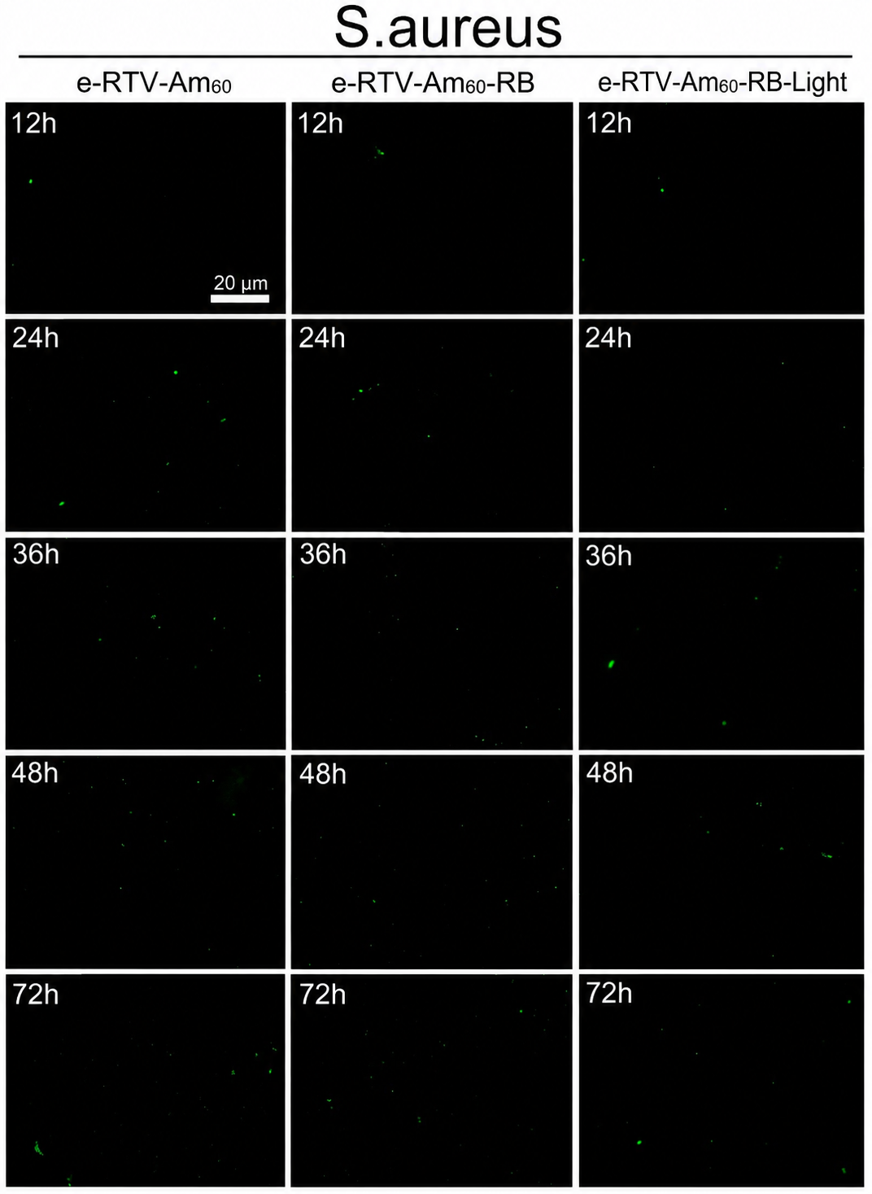

Fig. S12 Fluorescence image of the e-RTV-Am₆₀, e-RTV-Am₆₀-RB and e-RTV-Am₆₀-RB-Light samples after culturing in S. aureus at regular time interval.

